Contents

1. Barbershop Springs 3
2. Bear Springs 10
3. Big Moqui Spring 15
4. Big Spring 21
5. Bootlegger Spring 27
6. Chimney Spring 33
7. Clark Well 38
8. Crackerbox Spring 41
9. Curley Seep 47
10. Dairy Spring 50
11. Dane Spring 54
12. Double Springs 61
13. Dove Spring 65
14. Fues Spring 70
15. Griffiths Spring 75
16. Griffiths Spring 78
17. Hat Tank lower 86
18. Hat Tank upper 92
19. Hi Fuller Spring 98
20. Hoxworth Springs 104
21. Kehl Spring 109
22. Kendrick Spring 116
23. Little Elden Spring 118
24. Lockwood Spring 122
25. Lockwood Spring 127
26. Lower McDermit Spring 131
27. Maple Spring 136
28. Mashed Potato Spring 144
29. Middle Kehl Meadow Spring 150
30. Middle Kehl Spring 158
31. Mineral Spring 165
32. Mint Spring 171
33. Mud Spring 176
34. Pat Spring 184
35. Poison Springs 187
36. Railroad Spring 192
37. Railroad Spring 194
38. Rock Top Spring 197
39. Rocky Tule spring 201
40. Rosilda Spring 204
41. Sawmill Spring 209
42. Sawmill Springs 212
43. Scott Spring 216
44. Seven Anchor Spring 218
45. Sheep Spring 223
46. Smith Spring 229
47. Spikerush Spring 234
48. Spitz Spring lower 241
49. Spitz Spring upper 245
50. Stewart Spring 248

1. Barbershop Springs
1. Barbershop Springs
Survey Summary Report, Site ID 414
Submitted June 3, 2019 by Springs Stewardship Institute
Location: The Barbershop Springs ecosystem is located in Coconino County in the Middle Little Colorado Arizona 15020008 HUC, managed by the US Forest Service. The spring is located in the Coconino NF, Mogollon Rim RD, in the Dane Canyon USGS Quad, at 34.43833, -111.19430 measured using a GPS (NAD83). The elevation is approximately 2292 meters. Larry Stevens, Jeri Ledbetter, Valerie Hallam, Julaire Scott surveyed the site on 8/22/09 for 02:45 hours, beginning at 8:55, and collected data in 10 of 10 categories. This survey was conducted under the NEPA Cleared List project using the Stevens et al. Level 2 protocol.

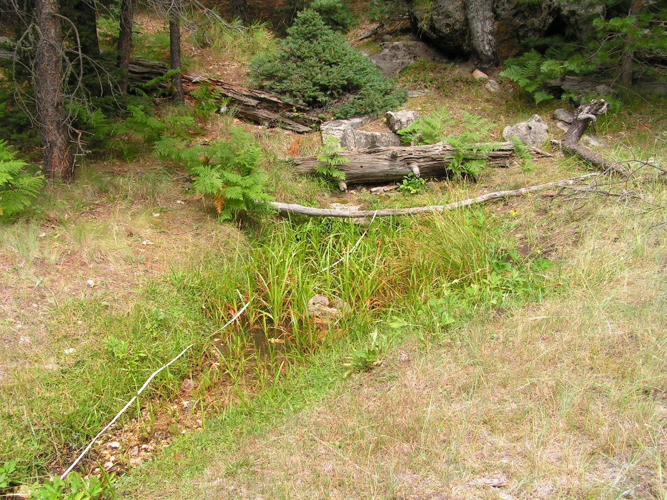
Fig 1.1 Barbershop Springs: View upslope toward one of two primary sources.

Physical Description: Barbershop Springs is a hillslope spring. This is a large site with multiple flowing sources. The microhabitats associated with the spring cover 398 sqm. The site has 7 microhabitats, including A -- a 3 sqm pool, B -- a 42 sqm channel, C -- a 3 sqm low gradient cienega, D -- a 4 sqm channel, E -- a 80 sqm channel, F -- a 26 sqm backwall, G -- a 240 sqm terrace. The geomorphic diversity is 0.51, based on the Shannon-Weiner diversity index.

Table 1.1 Barbershop Springs Microhabitat characteristics.
Code | A | B | C | D | E | F | G
Name | Pool-source | Seepage Source | Cutbank Source | East Source | Channel | Bedrock | Terrace
Area sqm | 3.00 | 42.00 | 3.00 | 4.00 | 80.00 | 26.00 | 240.00
Surface type | P | CH | LGC | CH | CH | BW | TE
Surface subtype |  | run |  | run | run |  | LRZ
Slope variability | Low | Low | Med | Low | Low | High | Med
Aspect TN | 143 | 13 | 78 | 13 | 133 | 143 | 133
Slope degrees | 0 | 4 | 11 | 8 | 3 | 19 | 3
Moisture (scale 1-10) | 10 | 10 | 10 | 10 | 10 | 4 | 4
Water depth cm | 7.00 | 4.00 | 2.00 | 2.00 | 10.00 | 0.00 | 0.00
Area % open water | 100.00 | 100.00 | 100.00 | 100.00 | 100.00 | 0.00 | 0.00
Substrate
1 - Clay % | 0 | 0 | 0 | 0 | 0 | 0 | 0
2 - Silt % | 0 | 0 | 0 | 0 | 0 | 5 | 0
3 - Sand % | 10 | 0 | 0 | 0 | 0 | 5 | 0
4 - Fine gravel % | 0 | 2 | 0 | 20 | 10 | 5 | 8
5 - Coarse gravel % | 5 | 1 | 0 | 1 | 8 | 5 | 8
6 - Cobble % | 5 | 1 | 5 | 3 | 2 | 0 | 1
7 - Boulder % | 0 | 0 | 0 | 0 | 0 | 0 | 0
8 - Bedrock % | 0 | 0 | 0 | 0 | 0 | 30 | 0
Organic % | 80 | 96 | 95 | 76 | 80 | 50 | 83
Other % (anthropogenic) | 0 | 0 | 0 | 0 | 0 | 0 | 0
Precipitate % | 0.00 | 0.00 | 0.00 | 0.00 | 0.00 | 0.00 | 0.00
Litter % | 5.00 | 80.00 | 90.00 | 80.00 | 80.00 | 60.00 | 80.00
Wood % | 0.00 | 5.00 | 0.30 | 10.00 | 1.00 | 8.00 | 5.00
Litter Depth (cm) | 1.00 | 1.00 | 1.00 | 2.00 | 1.00 | 1.50 | 2.00

Geomorphology: Barbershop Springs emerges as a fracture spring from the Kaibab Limestone, a sedimentary, limestone rock layer. The emergence environment is subaerial, with a gravity flow force mechanism. The site receives approximately 88% of available solar radiation, with 6431 Mj annually.

Access Directions: From Forest Rd 300 (Rim Dr) turn north (left) on Forest Road 139, then right on FR139C. In .5 mi turn right on an unmarked jeep trail. In about .3 miles, the spring is on the right at the bottom of the draw.

Survey Notes: This survey was conducted by Grand Canyon Wildlands Council surveyors on the Mogollon Rim project, funded by the Nina Mason Pulliam Charitable Trust. Soil was more moist than usual due to heavy rain on the previous day. Some old fencing remains. There are well marked trailheads to the site. There was some visitation during the survey, including a person hiking with a dog off leash.

Flow: Surveyors measured a flow of 0.25 liters/second, using a timed flow volume capture method. Surveyors took three discharge measurements to represent flow from all sources. Flow was difficult to measure because it was diffuse and had multiple sources. This spring is perennial.

Water Quality: Samples were collected at two different source locations: #1 at source polygon A and #2 at source polygon B. Location 1: at the spring source in flowing water at 10:00:00.Location 2: at the spring source in flowing water at 10:00:00.

Table 1.2 Barbershop Springs Water Quality with multiple readings averaged.
Characteristic Measured | Average Value | Site Number | Device | Comments
18-Oxygen results % | -12.32 | 1 |  | Polygon A
2-Hydrogen results % | -81.895 | 2 |  | Polygon B
Alkalinity, Total (mg/L) | 158.75 | 1 |  | U of A
Bromide (Br-) (mg/L) | <0.1 | 1 |  | U of A
Calcium (Ca) (mg/L) | 36.15 | 1 |  | U of A
Chloride (CL-) (mg/L) | 1.1155 | 1 |  | U of A
Fluorine (F) (mg/L) | 0.098 | 1 |  | U of A
Magnesium (Mg) (mg/L) | 18.215 | 1 |  | U of A
Nitrogen, Nitrate (NO3) as NO3 (mg/L) | 0.3485 | 1 |  | U of A
Nitrogen, Nitrite (NO2) as NO2 (mg/L) | <0.1 | 1 |  | U of A
pH (field) | 7.235 | 1 |  | polygon A
Phosphate (PO4) (mg/L) | <0.5 | 1 |  | U of A
Potassium (K) (mg/L) | 0.4525 | 1 |  | U of A
Sodium (Na) mg/L | 1.1365 | 1 |  | U of A
Specific conductance (field) (uS/cm) | 300 | 1 |  | polygon A
Sulfur, sulfate (SO4) as SO4 (mg/L) | 2.3485 | 1 |  | U of A
Temperature, air C | 22
Temperature, water C | 9.1 | 1 |  | polygon A

Flora: Carex alma or spiceata - unusual for Mogollon Rim (per G. Waring) Surveyors identified 43 plant species at the site, with 0.108 species/sqm. These included 32 native and 10 nonnative species; the native status of 1 species remains unknown.

Table 1.3 Barbershop Springs Cover Type.
Cover Type | Species Count | Wetland Species Count
Ground | 40 | 19
Shrub | 4 | 0
Mid-canopy | 3 | 0
Tall canopy | 0 | 0
Basal | 0 | 0
Aquatic | 0 | 0
Non-vascular | 1 | 0

Table 1.4 Barbershop Springs Vegetation % Cover in Microhabitats.
Species | Cover Code | Native Status | Wetland Status | Comments | A | B | C | D | E | F | G
Abies concolor | GC | N | U |  | 0 | 0 | 0 | 0.3 | 0 | 0 | 0
Abies concolor | SC | N | U |  | 0 | 0 | 0 | 0 | 0 | 10 | 0
Achillea millefolium | GC | NI | U |  | 0 | 0 | 0 | 0 | 0 | 1 | 0.3
Agrostis stolonifera | GC | I | W | Waring ID | 1 | 0 | 0 | 5 | 0 | 0 | 10
Brickellia grandiflora | GC | N | F |  | 0 | 0 | 0 | 0 | 0 | 0.01 | 0
Bromus | GC | I | F | Waring ID | 0.01 | 0 | 0 | 0 | 0 | 0 | 0
Carex | GC | N |  | Waring ID alma o spiceata | 0 | 25 | 0 | 0 | 0 | 0 | 1
Carex aurea | GC | N | U |  | 0 | 0 | 0 | 0 | 0 | 1 | 0
Carex lasiocarpa | GC | N | W | ? Waring ID (or pellita) | 0 | 0 | 1 | 0 | 0 | 0 | 0
Elymus lanceolatus | GC | N | F | Waring ID | 0 | 0 | 0 | 0 | 0 | 0.01 | 0
Epilobium ciliatum | GC | N | W | Waring ID | 0 | 0.5 | 0.5 | 2 | 0 | 0 | 0.01
Equisetum arvense | GC | N | WR |  | 0 | 0.1 | 0 | 0 | 0.1 | 0 | 0.1
Eriogonum racemosum | GC | N | F |  | 0 | 5 | 0 | 0 | 0 | 0.2 | 0
Fragaria | GC | N | U |  | 0 | 0 | 0 | 0 | 0 | 0.3 | 0
Galium | GC | I | F |  | 0 | 0 | 0 | 0 | 0 | 0.2 | 0
Geranium caespitosum | GC | N | F |  | 0.1 | 0 | 0 | 0 | 0 | 1 | 0.01
Goodyera oblongifolia | GC | N | F |  | 0 | 0 | 0 | 0 | 0 | 0.2 | 0
Juncus balticus | GC | N | W | Waring ID | 11 | 2 | 80 | 0 | 17 | 0 | 16
Juncus ensifolius | GC | N | W | ? Waring ID | 0 | 2 | 0 | 3 | 5 | 0 | 5
Juncus ensifolius | GC | N | W | Waring ID | 3 | 5 | 0 | 0 | 5 | 0 | 3
Lathyrus | GC | N | R |  | 0 | 0 | 0 | 0 | 0 | 0.3 | 0
Lepidium | GC |  | F | ? | 0 | 0 | 0 | 0 | 0 | 0.01 | 0
Medicago lupulina | GC | I | WR | Waring ID | 5 | 5 | 0 | 3 | 0.01 | 0.01 | 3
Perideridia parishii | GC | N | F | Waring ID | 0 | 0 | 0 | 0 | 0 | 0 | 0.2
Phleum pratense | GC | I | F | Waring ID | 0.01 | 0 | 0 | 0 | 0 | 0 | 0
Pinus flexilis | MC | N | U |  | 0 | 0 | 0 | 0 | 0 | 5 | 0
Pinus flexilis | SC | N | U |  | 0 | 0 | 0 | 0 | 0 | 5 | 0
Pinus ponderosa | MC | N | F |  | 5 | 0 | 0 | 0 | 0 | 10 | 0
Pinus ponderosa | SC | N | F |  | 5 | 0 | 0 | 0 | 3 | 10 | 0
Plantago major | GC | I | WR |  | 0 | 2 | 0.2 | 0 | 0.1 | 0 | 1
Poa pratensis | GC | I | F | Waring ID | 1 | 5 | 0 | 5 | 3 | 15 | 8
Polygonum douglasii | GC | N | W | Waring ID | 0 | 5 | 0.1 | 1 | 1 | 0 | 0
Potentilla | GC | N | F | silver | 0 | 0 | 0 | 0 | 0 | 2 | 0.1
Pteridium aquilinum | GC | N | U |  | 5 | 1 | 0 | 7 | 0.1 | 15 | 0.2
Quercus gambelii | GC | N | F |  | 0 | 0 | 0 | 0 | 0 | 3 | 0
Quercus gambelii | MC | N | F |  | 0 | 0 | 0 | 0 | 0 | 5 | 0
Quercus gambelii | SC | N | F |  | 0 | 0 | 0 | 0 | 0 | 5 | 0
Ranunculus | GC | N | WR |  | 0 | 0 | 0 | 0 | 0.2 | 0 | 0.1
Rudbeckia laciniata | GC | N | F |  | 7 | 5 | 1 | 5 | 0 | 2 | 4
Rumex crispus | GC | I | WR | Waring ID | 0 | 0.3 | 0 | 0 | 0 | 0 | 0
Scirpus microcarpus | GC | N | W | Waring ID | 25 | 0 | 5 | 3 | 20 | 0 | 20
Sidalcea neomexicana | GC | N | WR |  | 0 | 0 | 0.1 | 0 | 0 | 0 | 0
Sisyrinchium | GC | N | WR |  | 0.2 | 0 | 0 | 0 | 0 | 0 | 0.1
Taraxacum officinale | GC | I | F |  | 0 | 0 | 0 | 0 | 0.01 | 0 | 10
Trifolium wormskioldii | GC | N | WR | Waring ID | 0.1 | 0 | 0 | 0 | 0 | 0 | 0.01
unknown Bryophyte (moss, liverwort, hornwort) | NV | N | F |  | 3 | 0 | 1 | 5 | 0 | 1 | 2
Veronica | GC | I | A |  | 0 | 8 | 2 | 15 | 12 | 0 | 0
Viola | GC | N | F |  | 0 | 1 | 1 | 0 | 0 | 0.1 | 0.1

Fauna: Surveyors collected or observed 9 aquatic and 18 terrestrial invertebrates and 3 vertebrate specimens.

Table 1.5 Barbershop Springs Invertebrates.
Species | Lifestage | Habitat | Method | Rep# | Count | Species Detail
Coleoptera | Ad |  | Spot |  | 1
Coleoptera Chrysomelidae | Ad | T | Spot |  | 1
Coleoptera Chrysomelidae Disonycha brevicornis | Ad | T | Spot |  | 1
Coleoptera Dytiscidae Agabus lugens | Ad | A | Spot |  | 1
Coleoptera Dytiscidae Stictotarsus corvinus | Ad | A | Spot |  | 1
Coleoptera Oedemeridae |  |  | Spot |  | 1
Coleoptera Scarabaeidae | Ad | T | Spot |  | 1
Coleoptera Staphylinidae | Ad | T | Spot |  | 1
Hemiptera Gerridae Aquarius remigis | Ad | A | Spot |  | 1
Hymenoptera Apidae Bombus | Ad | T | Spot |  | 1
Lepidoptera Nymphalidae Speyeria nokomis | Ad | T | Spot |  | 1
Neuroptera | Ad | T | Spot |  | 1
Odonata | L | A | Spot |  | 3
Odonata Aeshnidae Rhionaeschna | Ad | T | Spot |  | 1
Odonata Coenagrionidae |  |  | Spot |  | 1
Plecoptera | Ad | T | Spot |  | 1
Trichoptera | L | A | Spot |  | 2

Table 1.6 Barbershop Springs Vertebrates.
Vertebrate Species Common Name | Count | Detection | Comments
gopher |  |  | holes
elk |  |  | scat
Northern Goshawk |  | obs

Assessment: Assessment scores were compiled in 6 categories and 42 subcategories, with 0 null condition scores, and 2 null risk scores. Aquifer functionality and water quality are good with significant restoration potential and there is low risk. Geomorphology condition is good with significant restoration potential and there is moderate risk. Habitat condition is moderate with some restoration potential and there is moderate risk. Biotic integrity is good with significant restoration potential and there is moderate risk. Human influence of site is good with significant restoration potential and there is moderate risk. Administrative context status is good with significant restoration potential and there is low risk. Overall, the site condition is good with significant restoration potential and there is moderate risk.

Table 1.7 Barbershop Springs Assessment Scores.
Category | Condition | Risk
Aquifer Functionality & Water Quality | 4.3 | 2.4
Geomorphology | 4 | 3.2
Habitat | 3.8 | 3.4
Biota | 4.1 | 3.6
Human Influence | 4 | 2.9
Administrative Context | 4.2 | 2.8
Overall Ecological Score | 4 | 3

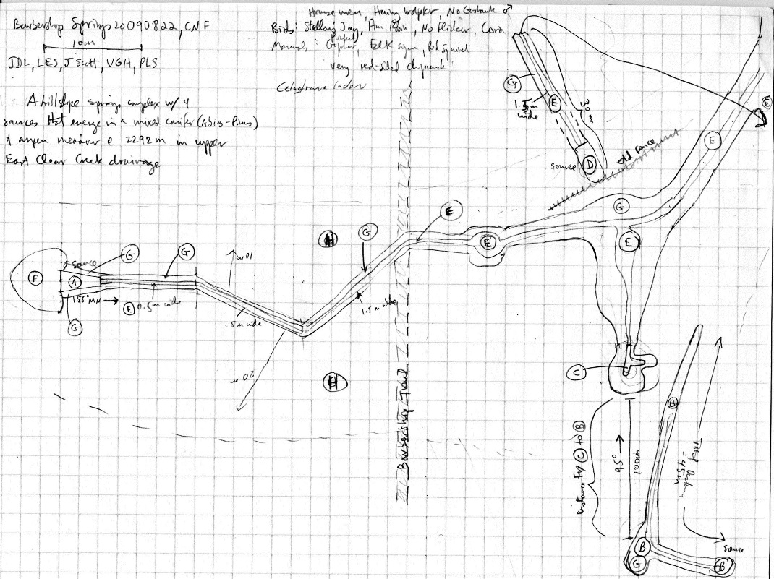
Fig 1.2 Barbershop Springs Sketchmap.

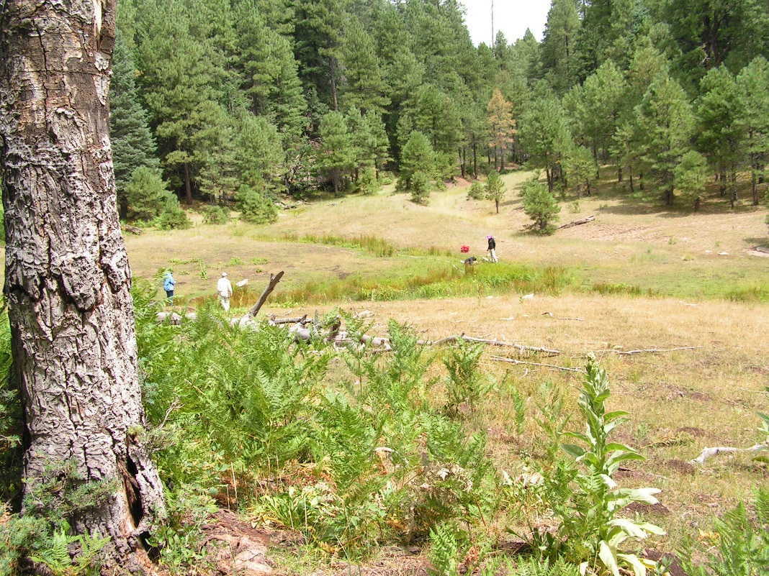
Fig 1.3 Barbershop Springs: Overview of the springs ecosystem.

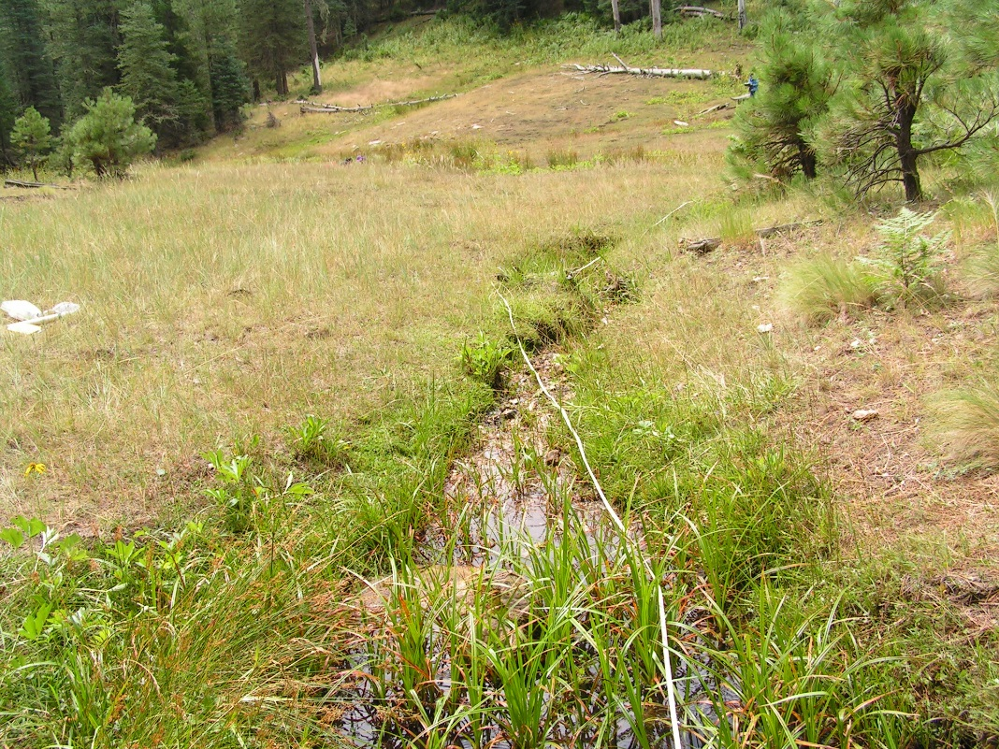
Fig 1.4 Barbershop Springs: View downslope from below the springs source.

2. Bear Springs
2. Bear Springs
Survey Summary Report, Site ID 579
Submitted June 3, 2019 by Springs Stewardship Institute
Location: The Bear Springs ecosystem is located in Coconino County in the Upper Verde Arizona 15060202 HUC, managed by the US Forest Service. The spring is located in the Kaibab NF, Williams RD, in the May Tank Pocket USGS Quad, at 35.08688, -112.18007 measured using a GPS (NAD83). The elevation is approximately 2016 meters. Larry Stevens, Jeri Ledbetter, Marguerite Hendrie, and Anya Fayfer surveyed the site on 5/10/12 for 01:5 hours, beginning at 14:45, and collected data in 10 of 10 categories. This survey was conducted under the NEPA Cleared List project using the Stevens et al. Level 2 protocol.

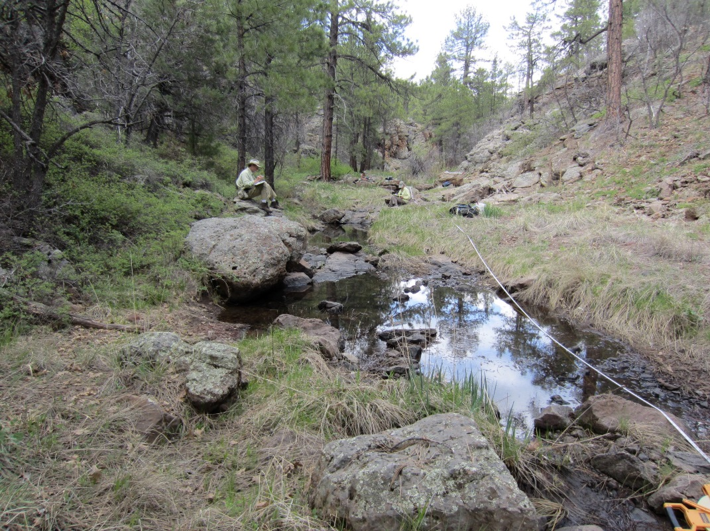
Fig 2.1 Bear Springs.

Physical Description: Bear Springs is a rheocrene spring. This rheocrene spring emerges in a forested cliff-lined canyon and re-emerges downstream, as mapped. The microhabitats associated with the spring cover 273 sqm. The site has 2 microhabitats, including A -- a 66 sqm channel, B -- a 207 sqm terrace. The geomorphic diversity is 0.24, based on the Shannon-Weiner diversity index.

Table 2.1 Bear Springs Microhabitat characteristics.
Code | A | B
Name | Source Channel | Terrace
Area sqm | 66.00 | 207.00
Surface type | CH | TE
Surface subtype | run | LRZ
Slope variability | Low | Med
Aspect TN | 207 | 207
Slope degrees | 1 | 1
Moisture (scale 1-10) | 10 | 2
Water depth cm | 12.00 | 0.00
Area % open water | 80.00 | 0.00
Substrate
1 - Clay % | 0 | 0
2 - Silt % | 0 | 0
3 - Sand % | 5 | 10
4 - Fine gravel % | 15 | 20
5 - Coarse gravel % | 10 | 15
6 - Cobble % | 20 | 15
7 - Boulder % | 15 | 20
8 - Bedrock % | 35 | 20
Organic % | 0 | 0
Other % (anthropogenic) | 0 | 0
Precipitate % | 0.00 | 0.00
Litter % | 10.00 | 30.00
Wood % | 1.00 | 1.00
Litter Depth (cm) | 0.50 | 1.00

Geomorphology: Bear Springs emerges as a seepage or filtration spring from the basalt flow, an igneous, basalt rock layer. The emergence environment is subaerial, with a gravity flow force mechanism. The site receives approximately 92% of available solar radiation, with 6347 Mj annually.

Access Directions: From the town of Williams, travel south on CR-73 for 12.3 mi. Turn left on NF-57 (Bear Springs Rd) for 0.3 mi. Turn right onto NF-4218A and continue south for 0.5 mi. Springs is located 300 m southwest in the bottom of a small canyon.

Survey Notes: There is little evidence of human visitation at this site, although it has been subjected to grazing. The spring is runoff dominated.

Flow: Surveyors measured a flow of 0.13000 liters/second, using a timed flow volume capture method. Flow was adjusted for an estimate of 1.00% of site flow capture. This spring is perennial, with a neorefugium persistence.

Water Quality: Water quality measurements were taken from surface runoff from dripping moss at a depth of 1 cm.

Table 2.2 Bear Springs Water Quality with multiple readings averaged.
Characteristic Measured | Average Value | Site Number | Device | Comments
Alkalinity, Total (mg/L) | 40 |  | test strips
Hardness, Ca + Mg (mg/L) | 25 |  | test strips
Nitrogen, Nitrate (NO3) as NO3 (mg/L) | 0 |  | test strips
Nitrogen, Nitrite (NO2) as NO2 (mg/L) | 0 |  | test strips
pH (field) | 7.77 |  | Hanna/Ph Spear
Specific conductance (field) (uS/cm) | 160 |  | Hanna/Ph Spear
Temperature, air C | 28.3
Temperature, water C | 14.3 |  | Hanna/Ph Spear

Flora: Surveyors identified 28 plant species at the site, with 0.1026 species/sqm. These included 22 native and 4 nonnative species; the native status of 2 species remains unknown.

Table 2.3 Bear Springs Cover Type.
Cover Type | Species Count | Wetland Species Count
Ground | 20 | 4
Shrub | 5 | 1
Mid-canopy | 1 | 1
Tall canopy | 0 | 0
Basal | 1 | 1
Aquatic | 0 | 0
Non-vascular | 2 | 0

Table 2.4 Bear Springs Vegetation % Cover in Microhabitats.
Species | Cover Code | Native Status | Wetland Status | Comments | A | B
Achillea millefolium | GC | NI | U |  | 0 | 1
Carex aurea | GC | N | U |  | 6 | 2
Elymus elymoides | GC | N | F | "Sitamion" | 0 | 0.01
Geum | GC | N | U | or potentilla annual | 0 | 0.2
Gypsophila | GC | I | U |  | 0 | 0.2
Iris missouriensis | GC | N | F |  | 0.5 | 0.1
Juncus | GC | N |  |  | 10 | 3
Juncus ensifolius | GC | N | W |  | 0.1 | 0.2
Juniperus deppeana | SC | N | U |  | 0 | 0.5
Koeleria macrantha | GC | N | F |  | 0 | 5
Lathyrus | GC | N | R |  | 0 | 1
Lichen | NV | N | U |  | 0.01 | 2
Melilotus | GC | I | WR |  | 0 | 0.1
Pinus ponderosa | SC | N | F |  | 3 | 1
Poa pratensis | GC | I | F |  | 0.1 | 5
Rosa woodsii | SC | N | F |  | 0.1 | 0.2
Salix gooddingii | BC | N | R |  | 0 | 1
Salix gooddingii | SC | N | R |  | 2 | 6
Sidalcea neomexicana | MC | N | WR |  | 8 | 2
Solidago | GC | N | F |  | 0 | 1
Sporobolus contractus | GC | N | F | ? | 0 | 10
Symphoricarpos | SC | N | U |  | 0.1 | 7
Thalictrum | GC | N | U |  | 0 | 1
unknown Bryophyte (moss, liverwort, hornwort) | NV | N | F |  | 0.2 | 0
unknown dicot | GC |  |  |  | 0 | 1
unknown dicot | GC |  |  | "Tall top" (last year) | 0 | 0.2
Verbascum | GC | I | F |  | 0 | 0.1
Vicia | GC | N | WR | "vicinia?" | 0 | 1
Viola | GC | N | F |  | 0 | 0.1

Fauna: Surveyors collected or observed 10 aquatic and 16 terrestrial invertebrates and 6 vertebrate specimens.

Table 2.5 Bear Springs Invertebrates.
Species | Lifestage | Habitat | Method | Rep# | Count | Species Detail
Araneae | Ad | T | Spot |  | 1
Coleoptera | Ad |  | Spot |  | 1
Coleoptera Dytiscidae | Ad | A | Spot |  | 4
Diptera | Ad | T | Spot |  | 1
Diptera Tipulidae | L | A | Spot |  | 1
Ephemeroptera | L | A | Spot |  | 10
Hemiptera | Ad | T | Spot |  | 1
Hemiptera Notonectidae | Ad | A | Spot |  | 2
Lepidoptera Hesperiidae Erynnis icelus | Ad | T | Spot |  | 1
Lepidoptera Hesperiidae Erynnis meridianus | Ad | T | Spot |  | 1
Lepidoptera Hesperiidae Pyrgus communis | Ad | T | Spot |  | 1
Lepidoptera Nymphalidae Nymphalis antiopa | Ad | T | Spot |  | 1
Lepidoptera Papilionidae Papilio rutulus | Ad | T | Spot |  | 1
Mollusca |  |  | Spot |  | 2
Odonata Coenagrionidae Argia | Ad | T | Spot |  | 1
Odonata Coenagrionidae Enallagma | Ad | T | Spot |  | 1
Orthoptera | L | T | Spot |  | 1
Trichoptera | L | A | Spot |  | 1

Table 2.6 Bear Springs Vertebrates.
Vertebrate Species Common Name | Count | Detection | Comments
woodpecker |  | call
Lewis's Woodpecker |  | obs
coyote |  | obs
elk |  | sign | scat
tree frog |  | obs
chickadee |  | obs

Assessment: Assessment scores were compiled in 6 categories and 42 subcategories, with 0 null condition scores, and 1 null risk score. Aquifer functionality and water quality are good with significant restoration potential and there is negligible risk. Geomorphology condition is good with significant restoration potential and there is negligible risk. Habitat condition is good with significant restoration potential and there is negligible risk. Biotic integrity is good with significant restoration potential and there is low risk. Human influence of site is good with significant restoration potential and there is negligible risk. Administrative context status is good with significant restoration potential and there is low risk. Overall, the site condition is good with significant restoration potential and there is negligible risk.

Table 2.7 Bear Springs Assessment Scores.
Category | Condition | Risk
Aquifer Functionality & Water Quality | 4.17 | 1.17
Geomorphology | 4.2 | 1.2
Habitat | 4.2 | 1.6
Biota | 4.25 | 1.88
Human Influence | 4.22 | 1.5
Administrative Context | 3.89 | 2.38
Overall Ecological Score | 4.2 | 1.46

Management Recommendations: The springs are likely ephemeral. The channel appears to be functional in all respects. This is a low priority site for management action, as it is subject to natural surface flooding and is unlikely to support rare species. Occasional monitoring is warranted.

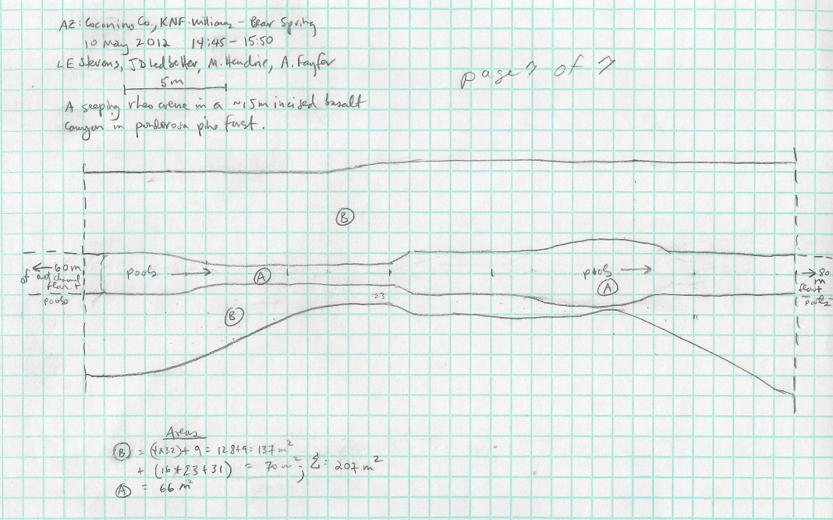
Fig 2.2 Bear Springs Sketchmap.

3. Big Moqui Spring
3. Big Moqui Spring
Survey Summary Report, Site ID 438
Submitted June 3, 2019 by Springs Stewardship Institute
Location: The Big Moqui Spring ecosystem is located in Coconino County in the Middle Little Colorado Arizona 15020008 HUC, managed by the US Forest Service. The spring is located in the Coconino NF, Mogollon Rim RD, in the Blue Ridge Reservoir USGS Quad, at 34.58633, -111.19816 measured using a GPS (WGS84, estimated position error 4 meters). The elevation is approximately 2190 meters. Jeri Ledbetter, Gloria Hardwick, and Melissa Carrillo-Galaviz surveyed the site on 6/02/17 for 00:42 hours, beginning at 16:50, and collected data in 10 of 10 categories. This survey was conducted under the NEPA Cleared List project using the Stevens et al. Level 2 protocol.

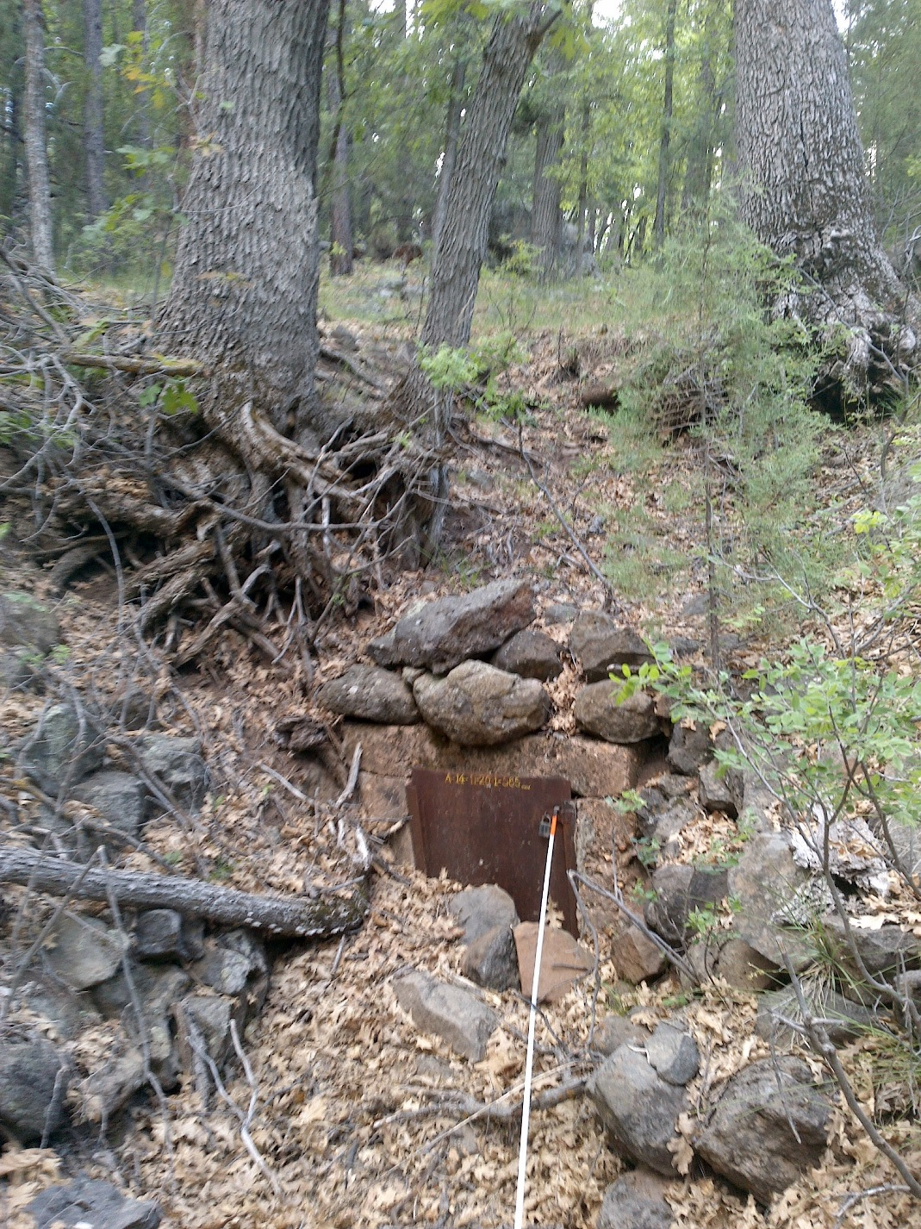
Fig 3.1 Big Moqui Spring: View upslope at the springbox from 4 meters below

Physical Description: Big Moqui Spring is a hillslope spring. There is an old springbox made out of concrete at the source. A steel door blocked by alluvium (rocks) is inset in the concrete box. The site is located in an oak, ponderosa pine, and juniper forest. The spring is close to a road. Metal pipes were most likely developed under this hillslope spring and leaked over time. A metal tank is about 100 meters downslope of the spring, the tank was empty. The tank includes a metal cover, so it is not a hazard to wildlife. The microhabitat associated with the spring covers 100 sqm. The site has 1 microhabitat, X -- a 100 sqm channel.

Table 3.1 Big Moqui Spring Microhabitat characteristics.
Code | X
Name | Entire Site
Area sqm | 100
Surface type | CH
Surface subtype
Slope variability | Low
Aspect TN
Slope degrees | 15
Moisture (scale 1-10) | 6
Water depth cm | 2
Area % open water | 10
Substrate
1 - Clay % | 0
2 - Silt % | 10
3 - Sand % | 10
4 - Fine gravel % | 20
5 - Coarse gravel % | 20
6 - Cobble % | 20
7 - Boulder % | 0
8 - Bedrock % | 0
Organic % | 15
Other % (anthropogenic) | 5
Precipitate % | 0
Litter % | 15
Wood % | 1
Litter Depth (cm) | 1

Geomorphology: Big Moqui Spring emerges from the Kaibab Limestone, a sedimentary, limestone rock layer. The emergence environment is subaerial, with a gravity flow force mechanism. The site receives approximately 96% of available solar radiation, with 6655 Mj annually.

Access Directions: From Clints Well go east on 87 about 8 miles. Turn right on FR 138. In about 1.5 miles, the spring is about 120 meters from the road on the right.

Survey Notes: Flow emerges about 20 meters from the springbox on a rocky slope, possibly from a leaking pipe. Old barbwire fencing is down near the site. The entire area is heavily trampled by elk. A constructed pond about 35 meters downslope is full of water.

Flow: Surveyors measured a flow of 0.019 liters/second, using a timed flow volume capture method. Flow was adjusted for an estimate of 80% of site flow capture. Measurements were taken 23m downslope of the spring box.

Water Quality: Surveyors measured water chemistry 15 meters down from the springbox where water first emerged. All instruments were calibrated 6/2/2017.Location 1: down-gradient from the spring source in flowing water at 00:00:00.

Table 3.2 Big Moqui Spring Water Quality with multiple readings averaged.
Characteristic Measured | Average Value | Site Number | Device | Comments
Dissolved oxygen (field) (mg/L) | 4.5 | 1 | CHEMets DO kit
pH (field) | 6.95 | 1 | Hanna Combo
Salinity (field) (ppt) | 0.36 | 1 | Hanna Combo
Specific conductance (field) (uS/cm) | 978 | 1 | Hanna Combo | Adjusted for temp from 702 EC
Temperature, air C | 29.4 |  | Hanna Combo | Converted to Celsius from 85 F
Temperature, water C | 10.9 | 1 | Hanna Combo

Flora: Gloria Hardwick was the botanist for the survey. Surveyors identified 12 plant species at the site. These included 7 native and 5 nonnative species.

Table 3.3 Big Moqui Spring Cover Type.
Cover Type | Species Count | Wetland Species Count
Ground | 8 | 2
Shrub | 1 | 0
Mid-canopy | 2 | 0
Tall canopy | 1 | 0
Basal | 0 | 0
Aquatic | 0 | 0
Non-vascular | 0 | 0

Table 3.4 Big Moqui Spring Vegetation % Cover in Microhabitats.
Species | Cover Code | Native Status | Wetland Status | Comments | X
Epilobium | GC |  | WR | ciliatum?
Iris missouriensis | GC | N | F
Juniperus scopulorum | MC | N | U
Medicago lupulina | GC | I | WR
Quercus gambelii | TC | N | F
Robinia neomexicana | MC | N | F
Rosa woodsii | SC | N | F
Taraxacum officinale | GC | NI | F
Thalictrum fendleri | GC | N | F
unknown Graminoid (grass or grasslike) | GC |  |  | Like at Kehl #1, Agrostis?
Verbascum thapsus | GC | I | F
Vinca | GC |  |  | vine, opp. lvs. no blooms

Fauna: Surveyors collected or observed 1 aquatic and 1 terrestrial invertebrates and 4 vertebrate specimens.

Table 3.5 Big Moqui Spring Invertebrates.
Species | Lifestage | Habitat | Method | Rep# | Count | Species Detail
Diptera Culicidae | L | A | Spot |  |  | Many were observed in spring pool.
Lepidoptera Nymphalidae Adelpha eulalia | Ad | T | Spot |  | 1

Table 3.6 Big Moqui Spring Vertebrates.
Vertebrate Species Common Name | Count | Detection | Comments
American Robin | 1 | obs
Northern Flicker | 1 | call
Elk |  | sign
Mountain Chickadee |  | call

Assessment: Assessment scores were compiled in 5 categories and 33 subcategories, with 9 null condition scores, and 9 null risk scores. Aquifer functionality and water quality are moderate with some restoration potential and there is low risk. Geomorphology condition is poor with limited restoration potential and there is moderate risk. Habitat condition is moderate with some restoration potential and there is low risk. Biotic integrity is good with significant restoration potential and there is low risk. Human influence of site is moderate with some restoration potential and there is moderate risk. Administrative context status is undetermined due to null scores and there is undetermined risk due to null scores. Overall, the site condition is moderate with some restoration potential and there is moderate risk.

Table 3.7 Big Moqui Spring Assessment Scores.
Category | Condition | Risk
Aquifer Functionality & Water Quality | 3 | 2.8
Geomorphology | 2.4 | 3.8
Habitat | 3.8 | 2.8
Biota | 3.9 | 2.1
Human Influence | 3.4 | 3.4
Administrative Context | 0 | 0
Overall Ecological Score | 3.4 | 3

Management Recommendations: Surveyors recommend repair or removal of fencing around the spring source. Consider removal of the spring box as it is no longer functioning. Monitor regularly.

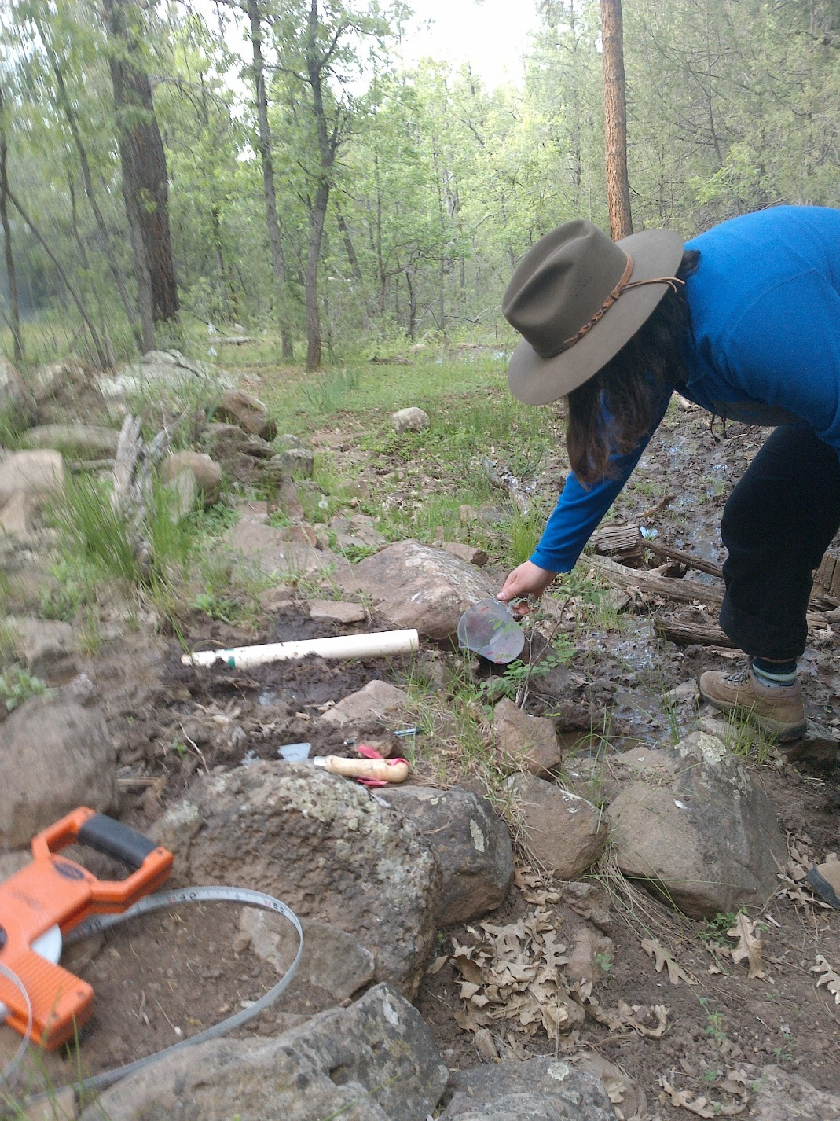
Fig 3.2 Big Moqui Spring: Flow measurement.

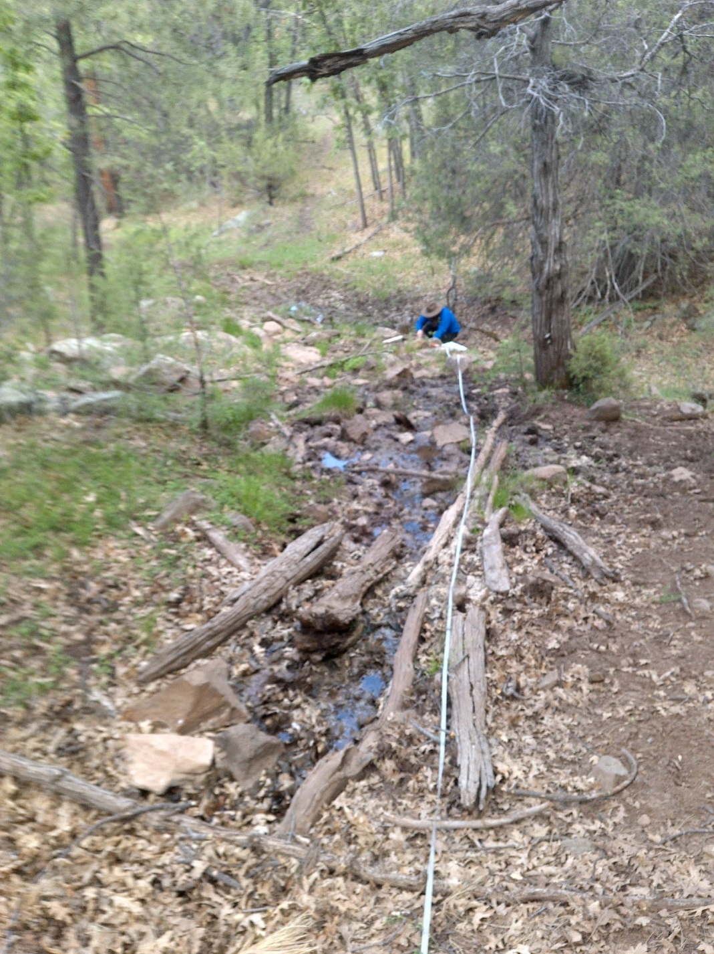
Fig 3.3 Big Moqui Spring: View downslope from 11 meters below the springbox.

4. Big Spring
4. Big Spring
Survey Summary Report, Site ID 739
Submitted June 3, 2019 by Springs Stewardship Institute
Location: The Big Spring ecosystem is located in Coconino County in the Upper Verde Arizona 15060202 HUC, managed by the US Forest Service. The spring is located in the Kaibab NF, Williams RD, in the Davenport Hill USGS Quad, at 35.15803, -112.08078 measured using a GPS (NAD83, estimated position error 2 meters). The elevation is approximately 2072 meters. Jeri Ledbetter, Marguerite Hendrie, Anya Fayfer, and Vera Markgraf surveyed the site on 5/12/12 for 01:00 hours, beginning at 15:30, and collected data in 10 of 10 categories. This survey was conducted under the NEPA Cleared List project using the Stevens et al. Level 2 protocol.

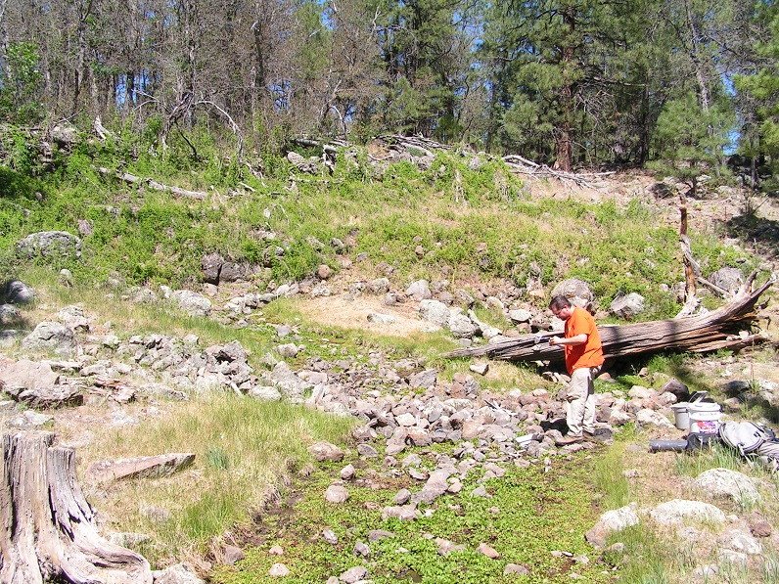
Fig 4.1 Big Spring.

Physical Description: Big Spring is a hillslope spring. This is a hillslope spring that emerges from boulders in a decomposing basalt flow margin. There is seepage along the base of a steep bank in the drainage. The surrounding area is heavily forested. The source has been manipulated with piping. The microhabitats associated with the spring cover 359 sqm. The site has 3 microhabitats, including A -- a 109 sqm channel, B -- a 32 sqm terrace, C -- a 218 sqm colluvial slope. The geomorphic diversity is 0.38, based on the Shannon-Weiner diversity index.

Table 4.1 Big Spring Microhabitat characteristics.
Code | A | B | C
Name | Source Channel | Terrace | Colluvial slope
Area sqm | 109.00 | 32.00 | 218.00
Surface type | CH | TE | CS
Surface subtype | riffle
Slope variability | Med | Med | Med
Aspect TN | 92 | 92 | 92
Slope degrees | 5 | 5 | 18
Moisture (scale 1-10) | 9 | 1 | 0
Water depth cm | 1.00
Area % open water | 20.00
Substrate
1 - Clay % | 0 | 0 | 0
2 - Silt % | 0 | 0 | 0
3 - Sand % | 0 | 0 | 0
4 - Fine gravel % | 19 | 5 | 0
5 - Coarse gravel % | 30 | 10 | 0
6 - Cobble % | 40 | 20 | 100
7 - Boulder % | 1 | 2 | 0
8 - Bedrock % | 0 | 1 | 0
Organic % | 10 | 62 | 0
Other % (anthropogenic) | 0 | 0 | 0
Precipitate % | 0.00 | 0.00 | 0.00
Litter % | 5.00 | 60.00 | 5.00
Wood % | 5.00 | 2.00 | 0.50
Litter Depth (cm) | 0.10 | 1.00 | 0.10

Geomorphology: Big Spring emerges as a contact spring from an igneous, basalt rock layer in an unknown unit. The emergence environment is subaerial, with a gravity flow force mechanism. The site receives approximately 95% of available solar radiation, with 6510 Mj annually.

Access Directions: From the town of Williams, travel south on County Rd 73 for 7.15 mi. Turn left and head east onto NF-139 (Overland) for 6.4 miles. Turn right onto NF-161 and continue for 0.9 mi before bearing right on Whiting Ranch Rd for 0.3 mi. Turn right onto Overland and continue for 1.5 mi. Spring is located 130 m due south from this location.

Survey Notes: There is one pipe buried near the source; some flow emerges from the pipe. There is little evidence of recent visitation although human activity is nearby (upslope). The site has been heavily trampled by livestock.

Flow: Surveyors measured a flow of 0.62000 liters/second, using a timed flow volume capture method. Flow was adjusted for an estimate of 1.00% of site flow capture. Flow was measured on a return visit 6/10/12, 20 meters downstream from the source. This spring is perennial, with a neorefugium persistence.

Water Quality: Water quality measurements were taken at the right source branch at a depth of 1 cm.

Table 4.2 Big Spring Water Quality with multiple readings averaged.
Characteristic Measured | Average Value | Site Number | Device | Comments
pH (field) | 7.01 |  | Hanna/Ph Spear
Specific conductance (field) (uS/cm) | 108 |  | Hanna/Ph Spear
Temperature, air C | 29.4
Temperature, water C | 10.1 |  | Hanna/Ph Spear

Flora: Vera Markgraf was the botanist. On a return visit, 6/10/12, Larry Stevens added polygon C and additional vegetation. Surveyors identified 26 plant species at the site, with 0.0724 species/sqm. These included 17 native and 8 nonnative species; the native status of 1 species remains unknown.

Table 4.3 Big Spring Cover Type.
Cover Type | Species Count | Wetland Species Count
Ground | 21 | 11
Shrub | 4 | 0
Mid-canopy | 1 | 0
Tall canopy | 0 | 0
Basal | 0 | 0
Aquatic | 0 | 0
Non-vascular | 1 | 0

Table 4.4 Big Spring Vegetation % Cover in Microhabitats.
Species | Cover Code | Native Status | Wetland Status | Comments | A | B | C
Brassicaceae | GC | I | F |  | 1 | 0 | 0
Bromus tectorum | GC | I | F |  | 0 | 0 | 22
Carex hassei | GC | N | W | species B VM 107 | 0 | 2 | 0
Carex nebrascensis | GC | N | W | question mark on species | 0.01 | 0 | 0
Carex subfusca | GC | N | W | species A VM 108 | 0 | 80 | 0
Cirsium | GC | I | F |  | 0 | 0.1 | 0
Equisetum arvense | GC | N | WR |  | 0.01 | 0 | 0
Humulus lupulus | SC | N | F |  | 0 | 0.1 | 0
Hypericum | GC | N | F |  | 0 | 0.1 | 0
Iris missouriensis | GC | N | F |  | 0 | 0.1 | 0
Juncus | GC | N |  |  | 0 | 0.1 | 0
Mimulus guttatus | GC | N | W |  | 40 | 0 | 0
Parthenocissus quinquefolia | SC | N | F |  | 0 | 0 | 1
Poa pratensis | GC | I | F |  | 0 | 2 | 0
Quercus gambelii | MC | N | F |  | 0 | 0 | 3
Quercus gambelii | SC | N | F |  | 0 | 0 | 5
Ranunculus | GC | N | WR |  | 30 | 0 | 0
Rosa woodsii | SC | N | F |  | 0 | 0.1 | 2
Rumex crispus | GC | I | WR |  | 0 | 0.1 | 0
Sidalcea neomexicana | GC | N | WR |  | 0 | 0.1 | 0
Taraxacum officinale | GC | I | F |  | 0 | 0.1 | 0
Thermopsis | GC | N | F |  | 0 | 0.01 | 0
Trifolium pratense | GC | I | WR |  | 0 | 0.01 | 0
unknown Bryophyte (moss, liverwort, hornwort) | NV | N | F |  | 0 | 0 | 1
unknown dicot | GC |  |  |  | 0.01 | 0 | 0
Verbascum thapsus | GC | I | F |  | 0 | 0.1 | 0.1
Viola nephrophylla | GC | N | WR |  | 0.1 | 0.1 | 0

Fauna: Surveyors collected or observed 13 aquatic and 15 terrestrial invertebrates and 4 vertebrate specimens.

Table 4.5 Big Spring Invertebrates.
Species | Lifestage | Habitat | Method | Rep# | Count | Species Detail
Araneae | Ad | T | Spot |  | 1
Araneae Lycosidae | M | T | Spot
Coleoptera Chrysomelidae | Ad | T | Spot |  | 1
Coleoptera Dytiscidae Agabus | Ad | A | Spot |  | 1
Coleoptera Dytiscidae Sanfilippodytes | Ad | A | Spot |  | 1
Coleoptera Hydraenidae | Ad | A | Spot |  |  | unusual species
Coleoptera Hydrophilidae | Ad | A | Spot
Diptera Tipulidae Tipula | L | A | Spot
Hemiptera Belostomatidae Abedus breviceps | L | A | Spot |  | 1
Hemiptera Belostomatidae Abedus herberti | M | A | Spot
Lepidoptera Hesperiidae Epargyreus clarus | Ad | T | Spot
Lepidoptera Hesperiidae Erynnis | Ad | T | Spot
Lepidoptera Nymphalidae Phyciodes | Ad | T | Spot
Lepidoptera Nymphalidae Phyciodes campestris | Ad | T | Spot
Lepidoptera Nymphalidae Polygonia | Ad | T | Spot
Lepidoptera Pieridae Colias alexandra | Ad | T | Spot
Lepidoptera Pieridae Colias eurytheme | Ad | T | Spot
Mollusca | Ad |  | Spot |  | 2
Odonata | L | A | Spot |  | 2
Odonata Coenagrionidae Argia | Ad | T | Spot
Odonata Libellulidae Libellula saturata | Ad | T | Spot
Trichoptera Limnephilidae | L | A | Spot |  | 2

Table 4.6 Big Spring Vertebrates.
Vertebrate Species Common Name | Count | Detection | Comments
hawk | 1 | obs
elk |  | sign | scat
northern flicker | 1 | obs
American robin | 1 | obs

Assessment: Assessment scores were compiled in 6 categories and 41 subcategories, with 1 null condition score, and 1 null risk score. Aquifer functionality and water quality are good with significant restoration potential and there is moderate risk. Geomorphology condition is good with significant restoration potential and there is low risk. Habitat condition is good with significant restoration potential and there is low risk. Biotic integrity is moderate with some restoration potential and there is moderate risk. Human influence of site is moderate with some restoration potential and there is low risk. Administrative context status is very good with excellent restoration potential and there is low risk. Overall, the site condition is good with significant restoration potential and there is moderate risk.

Table 4.7 Big Spring Assessment Scores.
Category | Condition | Risk
Aquifer Functionality & Water Quality | 4 | 3.17
Geomorphology | 4.2 | 2.2
Habitat | 4 | 2.8
Biota | 3.25 | 3.13
Human Influence | 3.67 | 2.63
Administrative Context | 4.89 | 2.38
Overall Ecological Score | 3.86 | 2.82

Management Recommendations: This should be a high priority for management attention. Restoration should include a minor amount of clean-up, construction of an elk fence around the source and first 50 meters of the channel, and occasional monitoring. This is a worthy reference site for control and restoration.

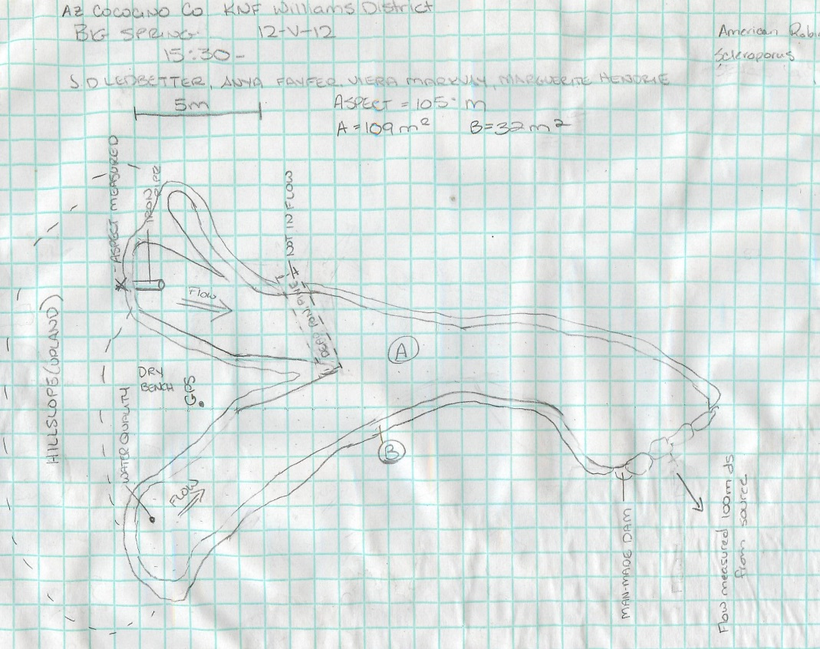
Fig 4.2 Big Spring Sketchmap.

5. Bootlegger Spring
5. Bootlegger Spring
Survey Summary Report, Site ID 909
Submitted June 3, 2019 by Springs Stewardship Institute
Location: The Bootlegger Spring ecosystem is located in Coconino County in the Upper Verde Arizona 15060202 HUC, managed by the US Forest Service. The spring is located in the Coconino NF, Mormon Lake RD, in the Mormon Mountain USGS Quad, at 34.91185, -111.53809 measured using a GPS (WGS84, estimated position error 4 meters). The elevation is approximately 2257 meters. Larry Stevens, Jeri Ledbetter, Gloria Hardwick, Joseph Holway, Leanna Begay, and David Sabata surveyed the site on 10/12/16 for 00:45 hours, beginning at 15:35, and collected data in 10 of 10 categories. This survey was conducted under the NEPA Cleared List project using the Stevens et al. Level 2 protocol.

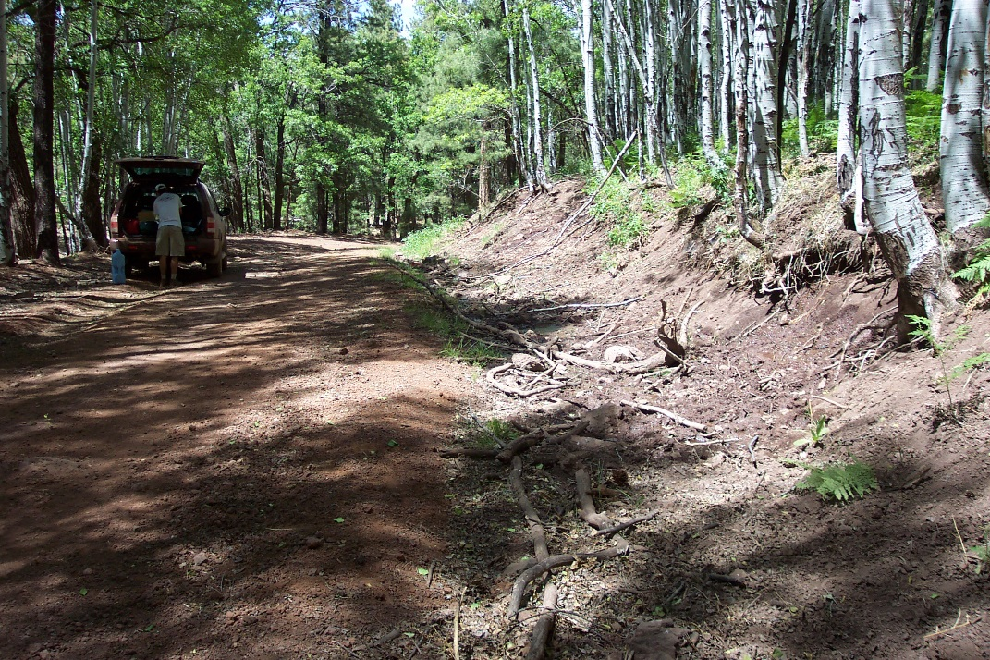
Fig 5.1 Bootlegger Spring: The spring emerges from a roadcut, and flows onto the road.

Physical Description: Bootlegger Spring is a hillslope spring. This site was imported from the SSI geodatabase, a compilation from multiple sources. The spring emerges from cutbank along the road bed on FR 91B. Flow runs into a ditch along the road in a ponderosa, aspen, and oak forest. The microhabitat associated with the spring covers 90 sqm. The site has 1 microhabitat, X -- a 90 sqm colluvial slope.

Table 5.1 Bootlegger Spring Microhabitat characteristics.
Code | X
Name | Entire Site
Area sqm | 90
Surface type | CS
Surface subtype | anthro
Slope variability | Med
Aspect TN
Slope degrees | 23
Moisture (scale 1-10) | 8
Water depth cm | .5
Area % open water | 7
Substrate
1 - Clay % | 2
2 - Silt % | 3
3 - Sand % | 5
4 - Fine gravel % | 55
5 - Coarse gravel % | 5
6 - Cobble % | 1
7 - Boulder % | 0
8 - Bedrock % | 10
Organic % | 19
Other % (anthropogenic) | 0
Precipitate % | 0
Litter % | 10
Wood % | 7
Litter Depth (cm) | .5

Geomorphology: Bootlegger Spring emerges as a seepage or filtration spring from an igneous, basalt rock layer in an unknown unit. The emergence environment is subaerial, with a gravity flow force mechanism. The site receives approximately 92% of available solar radiation, with 6384 Mj annually.

Access Directions: From Munds Park travel east on W Pinewood Blvd to Mormon Lake Rd 5.75 mi. Continue on NF-700 for 0.8 mi before turning right on NF-91 to NF-91B for 1 mi. The spring is located 30 m east from the road on a hillslope 25 m up from the road.

Survey Notes: Surveyors observed heavy trampling, trailing, and exposed roots. The road from which the hillslope emerges has been closed.

Flow: Surveyors measured a flow of 0.022 liters/second, using a timed flow volume capture method. Flow was adjusted for an estimate of 95% of site flow capture. Measurement was taken 18m from the source.

Water Quality: Collected at uppermost source and the YSI and Hanna combo were calibrated on day of survey. There was no recent precipitation.

Table 5.2 Bootlegger Spring Water Quality with multiple readings averaged.
Characteristic Measured | Average Value | Site Number | Device | Comments
Alkalinity, Total (mg/L) | 65 |  | LaMotte
Dissolved oxygen (field) % saturation | 41 |  | YSI Multiprobe
Dissolved oxygen (field) (mg/L) | 4.57 |  | YSI Multiprobe
Salinity (field) (ppt) | 0.091 |  | Hanna Combo | Hanna Green
Specific conductance (field) (uS/cm) | 262 |  | Hanna Combo | Hanna Green
Temperature, air C | 21.5 |  | candy thermometer
Temperature, water C | 10.1 |  | YSI Multiprobe

Flora: Surveyors identified 19 plant species at the site. These included 11 native and 8 nonnative species.

Table 5.3 Bootlegger Spring Cover Type.
Cover Type | Species Count | Wetland Species Count
Ground | 16 | 6
Shrub | 1 | 0
Mid-canopy | 0 | 0
Tall canopy | 1 | 0
Basal | 1 | 0
Aquatic | 0 | 0
Non-vascular | 0 | 0

Table 5.4 Bootlegger Spring Vegetation % Cover in Microhabitats.
Species | Cover Code | Native Status | Wetland Status | Comments | X
Aquilegia | GC |  | W | probably chrysantha
Bromus ciliatus | GC | N | F
Carex | GC |  |  | collected
Cirsium | GC |  | F | Native
Eleocharis | GC | N | W
Epilobium ciliatum | GC | N | W | dead
Geranium | GC | N | F
Linaria dalmatica | GC | I | F
Medicago lupulina | GC | I | WR
Muhlenbergia longiligula | GC | N |  | collected
Muhlenbergia wrightii | GC | N | U | collected
Populus tremuloides | BC | N | U
Populus tremuloides | TC | N | U | some dead
Pteridium aquilinum | GC | N | U
Quercus gambelii | SC | N | F
Taraxacum officinale | GC | NI | F
Thermopsis | GC |  | F
Trifolium | GC | I | WR
Vicia | GC |  | WR

Fauna: Surveyors collected or observed 1 aquatic and 1 terrestrial invertebrates and 8 vertebrate specimens.

Table 5.5 Bootlegger Spring Invertebrates.
Species | Lifestage | Habitat | Method | Rep# | Count | Species Detail
Diptera Tipulidae | L | A | Spot |  | 1
Lepidoptera Nymphalidae Danaus plexippus | Ad | T | Spot |  | 1

Table 5.6 Bootlegger Spring Vertebrates.
Vertebrate Species Common Name | Count | Detection | Comments
Northern Flicker |  | call
Western Scrub-jay |  | call
Acorn Woodpecker |  | call
Leopard Frog |  | obs
Squirrel | 4 | obs | Tassel-eared squirrel
White-breasted Nuthatch |  | call
Mule Deer |  | sign
Elk |  | sign | uncertain

Assessment: Assessment scores were compiled in 5 categories and 33 subcategories, with 9 null condition scores, and 9 null risk scores. Aquifer functionality and water quality are good with significant restoration potential and there is negligible risk. Geomorphology condition is very poor with very limited restoration potential and there is high risk. Habitat condition is poor with limited restoration potential and there is low risk. Biotic integrity is moderate with some restoration potential and there is moderate risk. Human influence of site is good with significant restoration potential and there is low risk. Administrative context status is undetermined due to null scores and there is undetermined risk due to null scores. Overall, the site condition is moderate with some restoration potential and there is low risk.

Table 5.7 Bootlegger Spring Assessment Scores.
Category | Condition | Risk
Aquifer Functionality & Water Quality | 4 | 1.5
Geomorphology | 1.8 | 4
Habitat | 2.8 | 2.8
Biota | 3.4 | 3.1
Human Influence | 3.9 | 2.4
Administrative Context | 0 | 0
Overall Ecological Score | 3.3 | 2.7

Management Recommendations: Consider managing for aspen falling onto the road. Consider the effects of constructing roads through springs.

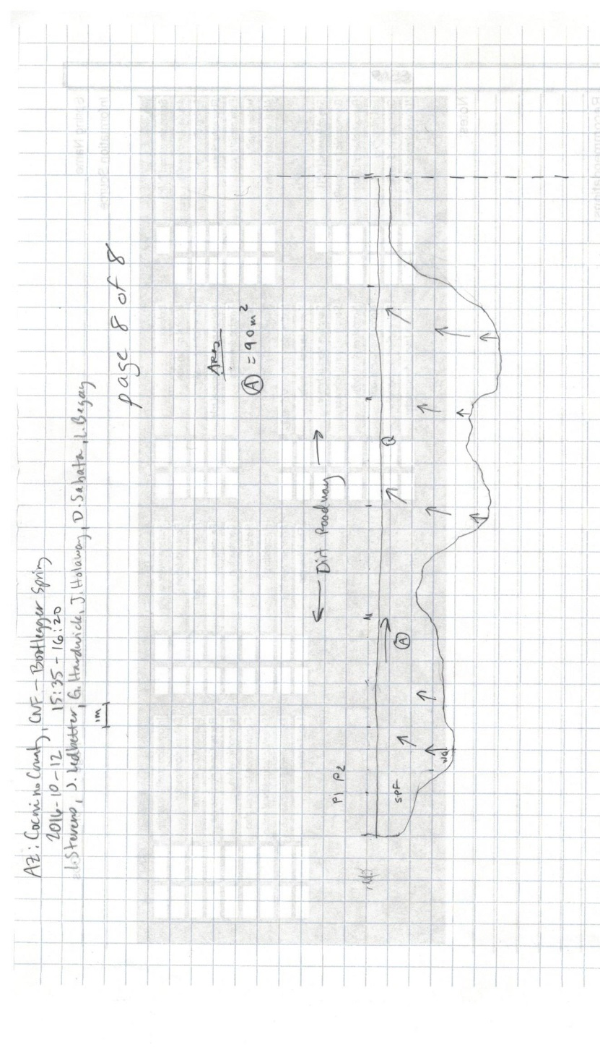
Fig 5.2 Bootlegger Spring Sketchmap.

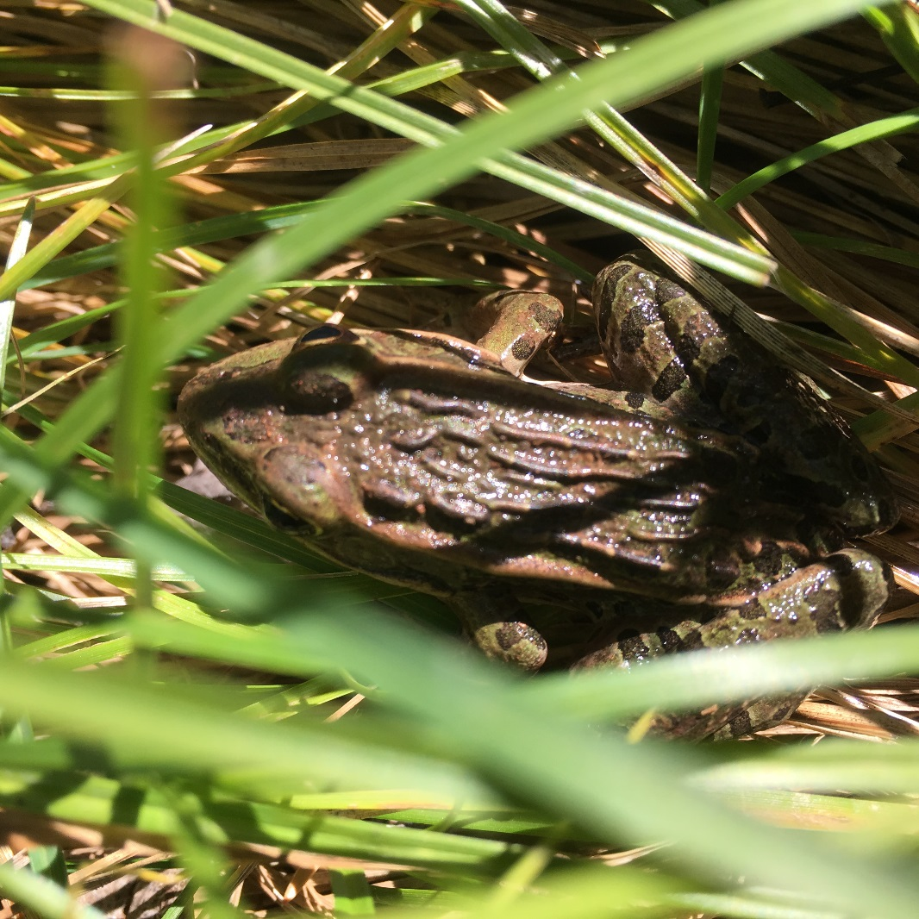
Fig 5.3 Bootlegger Spring: Leopard frog photographed by surveyors.

6. Chimney Spring
6. Chimney Spring
Survey Summary Report, Site ID 802
Submitted June 3, 2019 by Springs Stewardship Institute
Location: The Chimney Spring ecosystem is located in Coconino County in the Canyon Diablo Arizona 15020015 HUC, managed by the US Forest Service. The spring is located in the Coconino NF, Peaks RD, in the Humphreys Peak USGS Quad, at 35.26389, -111.67477 measured using a GPS (NAD83, estimated position error 3 meters). The elevation is approximately 2292 meters. J. Norris, V. Markgraf, D. Meuser, J. Jackson, S. Ordway, and J. Mason surveyed the site on 8/08/10 for 03:15 hours, beginning at 9:15, and collected data in 7 of 10 categories. This survey was conducted under the NEPA Cleared List project using the Stevens/NPS 2000 protocol.

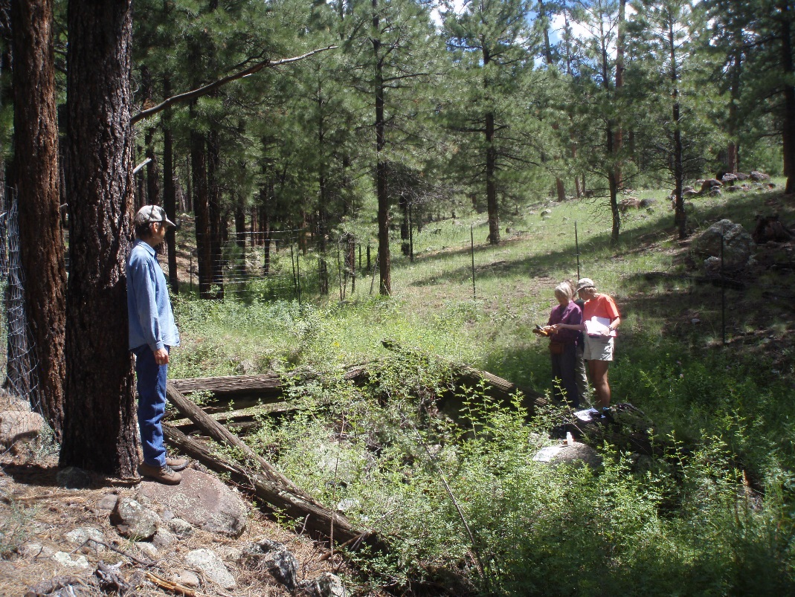
Fig 6.1 Chimney Spring.

Physical Description: Chimney Spring is a rheocrene spring. This small rheocrene springs emerges in a shallow drainage of basalt cobble. A concrete spring box has been constructed at the source. The microhabitats associated with the spring cover 230 sqm. The site has 2 microhabitats, including A -- a 130 sqm channel, B -- a 100 sqm terrace. The geomorphic diversity is 0.30, based on the Shannon-Weiner diversity index.

Table 6.1 Chimney Spring Microhabitat characteristics.
Code | A | B
Name | Channel | Terrace
Area sqm | 130.00 | 100.00
Surface type | CH | TE
Surface subtype
Slope variability
Aspect TN | 167
Slope degrees | 2
Moisture (scale 1-10)
Water depth cm
Area % open water
Substrate
1 - Clay % | 0 | 0
2 - Silt % | 0 | 0
3 - Sand % | 0 | 0
4 - Fine gravel % | 0 | 0
5 - Coarse gravel % | 0 | 0
6 - Cobble % | 0 | 0
7 - Boulder % | 0 | 0
8 - Bedrock % | 0 | 0
Organic % | 0 | 0
Other % (anthropogenic) | 0 | 0
Precipitate % | 0 | 0
Litter % | 0 | 0
Wood % | 0 | 0
Litter Depth (cm)

Geomorphology: Chimney Spring emerges from an igneous, basalt rock layer in an unknown unit. The emergence environment is subaerial, with a gravity flow force mechanism.

Access Directions: From N Fort Valley Rd (US-180) turn right onto NF-164B and continue north for 0.95 mi. Turn right onto NF-9002 and travel for 0.75 mi. Spring is located 50 m due east. Access under south end of fence enclosure.

Survey Notes: This survey was conducted by volunteers under the CNF volunteers project, under the direction of Steve Monroe. There was a distinct waterline with moss approximately 6 in. above cement. The spring was not flowing; there was only a small pool (size of pool less than one cubic foot). However, there had been a lot of rain within the last 24 hours of time of survey and during previous weeks. Above the spring, the main runoff channel is shunted around the spring pool by a berm; this channel rejoins the spring outflow just below the man-made spring pool. The channel was mostly vegetated; there were cobbles and boulders in soil matrix. There were roads/OHV trails at the site, and there was evidence of recreational use, historic human occupation/use, and pine thinning. There was flow modification (encasement and excavation). There was a fence around the site.

Flow: Surveyors measured a flow of 0.00000 liters/second. The spring was not flowing; there was only a small pool present.

Water Quality: Measurements were made in small pool in concrete trough at a depth of 4 in.; there was litter in trough. Water quality data are suspect due to recent heavy rain. The flow condition was still/pooled.

Table 6.2 Chimney Spring Water Quality with multiple readings averaged.
Characteristic Measured | Average Value | Site Number | Device | Comments
pH (field) | 6.6833333333333
Specific conductance (field) (uS/cm) | 388.33333333333
Temperature, water C | 14.333333333333

Flora: Surveyors identified 32 plant species at the site, with 0.1391 species/sqm. These included 28 native and 4 nonnative species.

Table 6.3 Chimney Spring Cover Type.
Cover Type | Species Count | Wetland Species Count
Ground | 29 | 7
Shrub | 2 | 0
Mid-canopy | 0 | 0
Tall canopy | 0 | 0
Basal | 0 | 0
Aquatic | 0 | 0
Non-vascular | 1 | 0

Table 6.4 Chimney Spring Vegetation % Cover in Microhabitats.
Species | Cover Code | Native Status | Wetland Status | Comments | A | B
Achillea millefolium | GC | NI | U |  | 0 | 0.5
Agrostis scabra | GC | N | W |  | 0 | 0.5
Carex subfusca | GC | N | W |  | 0 | 10
Elymus elymoides | GC | N | F |  | 0 | 0.5
Elymus trachycaulus | GC | N | F |  | 0 | 0.5
Epilobium ciliatum | GC | N | W |  | 20 | 0
Festuca arizonica | GC | N | U |  | 0 | 0.5
Geranium caespitosum | GC | N | F |  | 0 | 0.5
Geranium richardsonii | GC | N | F |  | 0 | 0.5
Iris missouriensis | GC | N | F |  | 0 | 0.5
Juncus longistylis | GC | N | W |  | 10 | 0
Mahonia repens | SC | N | U |  | 0 | 0.5
Mimulus guttatus | GC | N | W |  | 1 | 0
Monarda fistulosa | GC | N | F |  | 0 | 0.5
Muhlenbergia rigens | GC | N | U |  | 0 | 0.5
Muhlenbergia wrightii | GC | N | U |  | 0 | 0.5
Oxytropis lambertii | GC | N | U |  | 0 | 0.5
Perideridia parishii | GC | N | F |  | 0 | 0.5
Poa pratensis | GC | I | F |  | 0 | 1
Polygonum lapathifolium | GC | N | F |  | 0 | 0.5
Pterospora andromedea | GC | N | U |  | 0 | 0.5
Rosa woodsii | SC | N | F |  | 0 | 70
Rumex crispus | GC | I | WR |  | 0 | 0.5
Solidago missouriensis | GC | N | U |  | 0 | 1
Symphyotrichum ericoides | GC | N | U |  | 0 | 0.01
Taraxacum officinale | GC | I | F |  | 0 | 0.5
Thalictrum fendleri | GC | N | F |  | 0 | 0.5
Thermopsis montana | GC | N | U |  | 0 | 5
unknown Bryophyte (moss, liverwort, hornwort) | NV | N | F |  | 20 | 0
Verbascum thapsus | GC | I | F |  | 0 | 0.5
Veronica peregrina | GC | N | W |  | 0 | 0.5
Vicia americana | GC | N | F |  | 0 | 0.5

Fauna: Surveyors collected or observed 1 aquatic invertebrates and 2 vertebrate specimens.

Table 6.5 Chimney Spring Invertebrates.
Species | Lifestage | Habitat | Method | Rep# | Count | Species Detail
Unknown |  | A | Spot |  |  | macroinvertebrates present

Table 6.6 Chimney Spring Vertebrates.
Vertebrate Species Common Name | Count | Detection | Comments
hummingbird
western bluebird

Assessment: Assessment scores were compiled in 3 categories and 3 subcategories, with 39 null condition scores, and 39 null risk scores. Aquifer functionality and water quality are eliminated with no restoration potential and there is very high risk. Geomorphology condition is poor with limited restoration potential and there is very high risk. Habitat condition is undetermined due to null scores and there is undetermined risk due to null scores. Biotic integrity is undetermined due to null scores and there is undetermined risk due to null scores. Human influence of site is excellent with no need for restoration and there is extreme risk. Administrative context status is undetermined due to null scores and there is undetermined risk due to null scores. Overall, the site condition is moderate with some restoration potential and there is extreme risk.

Table 6.7 Chimney Spring Assessment Scores.
Category | Condition | Risk
Aquifer Functionality & Water Quality | 0 | 5
Geomorphology | 2 | 5
Habitat | 0 | 0
Biota | 0 | 0
Human Influence | 8 | 13
Administrative Context | 0 | 0
Overall Ecological Score | 3.33 | 7.67

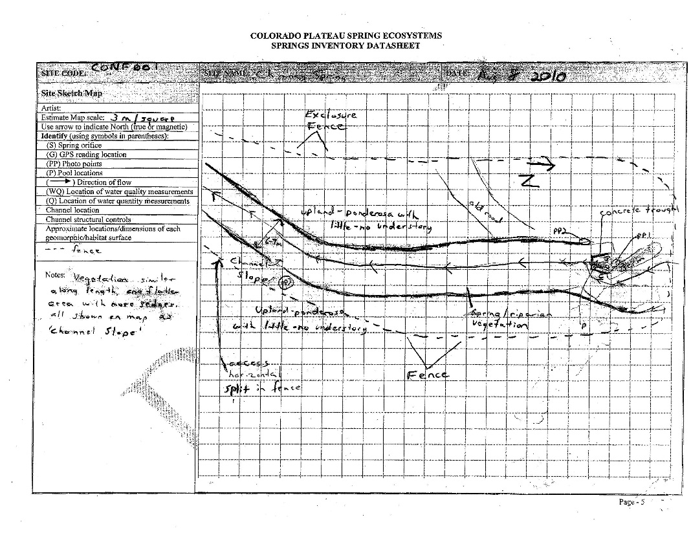
Fig 6.2 Chimney Spring Sketchmap.

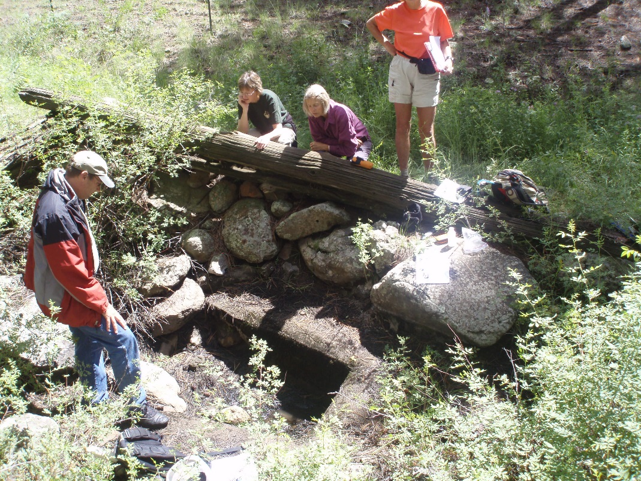
Fig 6.3 Chimney Spring.

7. Clark Well
7. Clark Well
Survey Summary Report, Site ID 933
Submitted June 3, 2019 by Springs Stewardship Institute
Location: The Clark Well ecosystem is located in Coconino County in the Canyon Diablo Arizona 15020015 HUC, managed by the US Forest Service. The spring is located in the Coconino NF, Mormon Lake RD, in the Lower Lake Mary USGS Quad, at 35.06712, -111.57964 (WGS84). The elevation is approximately 2108 meters. Krista Sparks and Spencer Harris surveyed the site on 7/17/13 for 00:45 hours, beginning at 12:30, and collected data in 5 of 10 categories. This survey was conducted under the NEPA Cleared List project using the Stevens et al. Level 2 protocol.

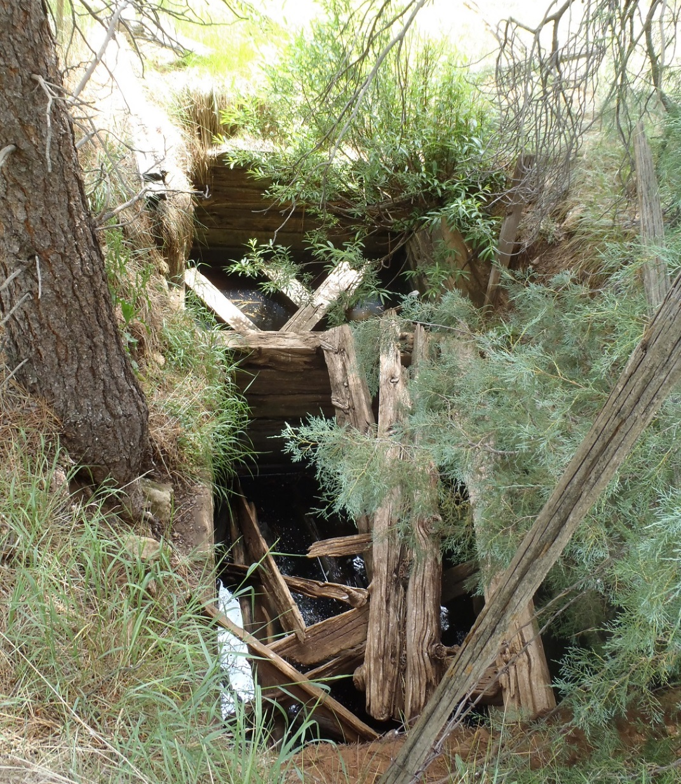
Fig 7.1 Clark Well.

Physical Description: Clark Well is an anthropogenic spring. This site was imported from the geodatabase, a compilation from multiple sources. It is a 2 meter x 5 meter hand dug well rather than a spring, and is adjacent to a historic ephemeral stream.

Geomorphology: Clark Well emerges as a fracture spring from an igneous, basalt rock layer in an unknown unit. The emergence environment is subaerial, with a gravity flow force mechanism.

Access Directions: From Lower Lake Mary, travel south on Crimson Rd (NF-132) for 5 mi. Continue 60 m northwest on foot.

Survey Notes: Water quality measurements were made from the well water and flow was visually estimated.
Flow: Flow was adjusted for an estimate of 1.00% of site flow capture. No flow from well.
Water Quality: Measurements taken at well.

Table 7.1 Clark Well Water Quality with multiple readings averaged.
Characteristic Measured | Average Value | Site Number | Device | Comments
Dissolved oxygen (field) (mg/L) | 0.16 |  | YSI Multiprobe
pH (field) | 7.12 |  | YSI Multiprobe
Specific conductance (field) (uS/cm) | 422.3 |  | YSI Multiprobe
Temperature, water C | 11.4 |  | YSI Multiprobe

Assessment: Assessment scores were compiled in 6 categories and 42 subcategories, with 0 null condition scores, and 1 null risk score. Aquifer functionality and water quality are moderate with some restoration potential and there is low risk. Geomorphology condition is poor with limited restoration potential and there is low risk. Habitat condition is poor with limited restoration potential and there is moderate risk. Biotic integrity is poor with limited restoration potential and there is moderate risk. Human influence of site is good with significant restoration potential and there is moderate risk. Administrative context status is poor with limited restoration potential and there is low risk. Overall, the site condition is poor with limited restoration potential and there is moderate risk.

Table 7.2 Clark Well Assessment Scores.
Category | Condition | Risk
Aquifer Functionality & Water Quality | 3.67 | 2
Geomorphology | 2.8 | 2.6
Habitat | 2.2 | 3.5
Biota | 2.25 | 3.63
Human Influence | 4 | 3
Administrative Context | 2.56 | 2.44
Overall Ecological Score | 2.73 | 2.93

Management Recommendations: Surveyors did not note any management recommendations.

8. Crackerbox Spring
8. Crackerbox Spring
Survey Summary Report, Site ID 942
Submitted June 3, 2019 by Springs Stewardship Institute
Location: The Crackerbox Spring ecosystem is located in Coconino County in the Middle Little Colorado Arizona 15020008 HUC, managed by the US Forest Service. The spring is located in the Coconino NF, Mogollon Rim RD, in the Dane Canyon USGS Quad, at 34.49960, -111.24458 measured using a GPS (WGS84, estimated position error 5 meters). The elevation is approximately 2176 meters. Jeri Ledbetter, Gloria Hardwick, Bernie Murrieta, and Sam Goddard surveyed the site on 8/06/17 for 01:40 hours, beginning at 8:50, and collected data in 9 of 10 categories. This survey was conducted under the NEPA Cleared List project using the Stevens et al. Level 2 protocol.

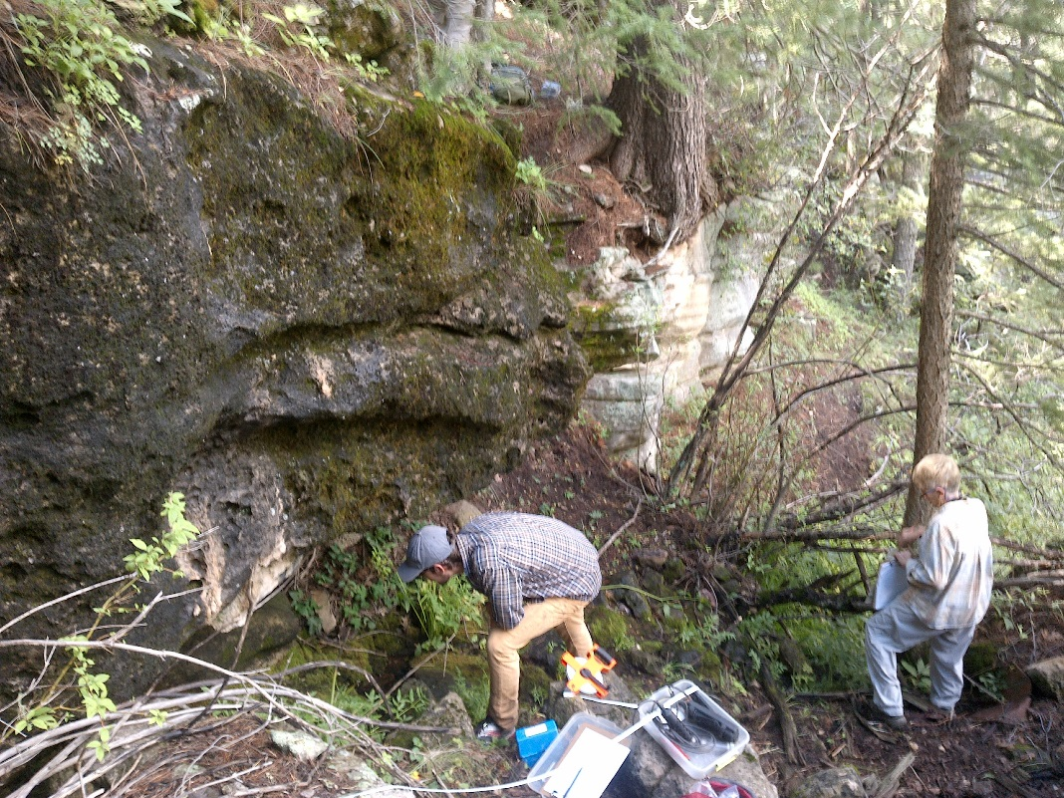
Fig 8.1 Crackerbox Spring: View of source outflow and drainage from above

Physical Description: Crackerbox Spring is a hillslope/hanging garden spring. This site was originally reported in 1999 by a US Forest Service fire crew in a dataset that shifted the springs about 220 meters south-southwest of its actual location. An SSI survey team found the site in July 2017 and adjusted the coordinates. Flow emerges on a steep (25°) colluvial slope, under a large Kaibab boulder, and flows down a steep rocky channel, then over a Coconino sandstone cliff. The surrounding forest is thick mixed conifer and oak. The spring has been developed with piping and a trough about 18 meters north of the source. The microhabitats associated with the spring cover 176 sqm. The site has 4 microhabitats, including A -- a 32 sqm channel, B -- a 30 sqm backwall, C -- a 64 sqm sloping bedrock, D -- a 50 sqm sloping bedrock. The geomorphic diversity is 0.58, based on the Shannon-Weiner diversity index.

Table 8.1 Crackerbox Spring Microhabitat characteristics.
Code | A | B | C | D
Name | Channel | Backwall | Terraces | Cliff
Area sqm | 32 | 30 | 64 | 50
Surface type | CH | BW | SB | SB
Surface subtype
Slope variability | High | High | Med | Med
Aspect TN
Slope degrees | 25 | 140 | 60 | 90
Moisture (scale 1-10) | 9 | 8 | 3 | 5
Water depth cm | 3 | 0 | 0 | 0
Area % open water | 15 | 0 | 0 | 0
Substrate
1 - Clay % | 0 | 0 | 0 | 0
2 - Silt % | 0 | 0 | 0 | 0
3 - Sand % | 0 | 0 | 0 | 0
4 - Fine gravel % | 0 | 0 | 0 | 0
5 - Coarse gravel % | 0 | 0 | 0 | 0
6 - Cobble % | 0 | 0 | 0 | 0
7 - Boulder % | 0 | 0 | 0 | 0
8 - Bedrock % | 0 | 0 | 0 | 0
Organic % | 0 | 0 | 0 | 0
Other % (anthropogenic) | 0 | 0 | 0 | 0
Precipitate % | 0 | 0 | 0 | 0
Litter % | 0 | 0 | 0 | 0
Wood % | 0 | 0 | 0 | 0
Litter Depth (cm)

Geomorphology: Crackerbox Spring emerges as a contact spring from the Kaibab Limestone, a sedimentary, limestone rock layer. The emergence environment is subaerial, with a gravity flow force mechanism.

Access Directions: From Rim road take FS123 north to junction with FS 9724V. Go about 400 meters, to 34.50031, -111.24096. Hike down the ridge on the left side to the Kaibab/Coconino formations contact. There are old roads and trails.

Survey Notes: The site is in good condition, although the source and channel are trampled by elk and the vegetation has been heavily grazed. The piping has been repaired relatively recently with black tape, but it does not appear to be functioning. Although the trough has water, there is no outflow and heavy rains in the past weeks could have contributed all or part of this. The backwall is dripping and covered with moss and lichen. A game and/or human trail is just upslope that leads to a FS road. There are few aquatic insects in the source or runout, and this could be attributed to the site receiving very little light. There is some evidence of human visitation to the site, with metal near the source. There were signs of a fairly recent fire nearby. There is a red painted stake, likely placed by the forest service fire crew in 1999. SSI crews have found several similar stakes at other springs discovered by the forest service fire crew.

Flow: Surveyors measured a flow of 0.091 liters/second, using a timed flow volume capture method. Flow was adjusted for an estimate of 80% of site flow capture. Measurements were taken 12.4 meters from source. This spring is perennial.

Water Quality: Measurements were taken 8 meters from source.

Table 8.2 Crackerbox Spring Water Quality with multiple readings averaged.
Characteristic Measured | Average Value | Site Number | Device | Comments
Alkalinity, Total (mg/L) | 270 |  | LaMotte
Dissolved oxygen (field) % saturation | 7.21 |  | YSI Multiprobe
Dissolved oxygen (field) (mg/L) | 8.27 |  | YSI Multiprobe
Oxygen Reduction Potential in mV | 296.7 |  | YSI Multiprobe
pH (field) | 7.56 |  | YSI Multiprobe
Salinity (field) (ppt) | 264 |  | Hanna Combo
Specific conductance (field) (uS/cm) | 591.9 |  | YSI Multiprobe
Temperature, air C | 19 |  | Handheld therm
Temperature, water C | 9.3 |  | YSI Multiprobe

Flora: Gloria Hardwick was the botanist on the survey. Surveyors identified 18 plant species at the site, with 0.1023 species/sqm. These included 12 native and 6 nonnative species.

Table 8.3 Crackerbox Spring Cover Type.
Cover Type | Species Count | Wetland Species Count
Ground | 10 | 1
Shrub | 4 | 2
Mid-canopy | 1 | 0
Tall canopy | 1 | 0
Basal | 1 | 0
Aquatic | 0 | 0
Non-vascular | 2 | 0

Table 8.4 Crackerbox Spring Vegetation % Cover in Microhabitats.
Species | Cover Code | Native Status | Wetland Status | Comments | A | B | C | D
Abies concolor | MC | N | U |  | 60 | 20 | 5 | 0
Aquilegia desertorum | GC | N | W | no blooms | 0 | 0.08 | 0 | 0
Berberis repens | SC | N | U | Dry part of cave | 0 | 0.05 | 0 | 0
Bromus | GC |  | F | Grass 2, Collected. 1 plant | 0 | 0.01 | 0 | 0
Conium maculatum | GC | I |  |  | 0 | 0 | 0 | 50
Conium maculatum | GC | I |  | Collected - Heavily grazed | 10 | 6 | 0 | 0
Cornus sericea | SC | N | R | Collected | 0.1 | 0.7 | 0 | 0
Festuca | GC |  | U | Collected | 0 | 0.03 | 0 | 0
Fragaria | GC | N | U |  | 0.01 | 0.3 | 0 | 0.01
Galium wrightii | GC | N |  |  | 0 | 0.02 | 0 | 0
Lichen | NV | N | U |  | 0.01 | 0.05 | 5 | 5
Pinus flexilis | BC | N | U |  | 0 | 0 | 2 | 0
Pinus flexilis | TC | N | U |  | 0.08 | 0.5 | 0.8 | 0.05
Polemonium | GC |  | U |  | 0 | 0.01 | 0 | 0
Pteridium aquilinum | GC | N | U |  | 0 | 0.05 | 0 | 0.5
Rosa arizonica | SC | N |  |  | 0 | 0.8 | 0.02 | 0
Salix | SC | N | WR | Dying back-some aren’t grazed | 12 | 10 | 0 | 0
Smilacina racemosa | GC | N |  |  | 0.01 | 0.02 | 0.01 | 0.01
unknown Moss | NV |  |  |  | 60 | 0.5 | 45 | 10

Fauna: Surveyors collected or observed 5 aquatic and 1 terrestrial invertebrates and 5 vertebrate specimens.

Table 8.5 Crackerbox Spring Invertebrates.
Species | Lifestage | Habitat | Method | Rep# | Count | Species Detail
Coleoptera Scirtidae | L | A | Spot |  | 2
Diptera Chironomidae | L | A | Spot |  | 3
Ephemeroptera | L | A | Spot |  |  | Mayfly
Neoophora Planariidae Dugesia | M | A | Spot |  | 3
Plecoptera | L | A | Spot |  | 3
Stylommatophora Euconulidae Euconulus | Ad | T | Spot |  | 1

Table 8.6 Crackerbox Spring Vertebrates.
Vertebrate Species Common Name | Count | Detection | Comments
Acorn Woodpecker |  | call
Red-breasted Nuthatch |  | call
Steller's Jay |  | call
Mountain Chickadee |  | call
Elk |  | sign | Tracks and scat

Assessment: Assessment scores were compiled in 5 categories and 33 subcategories, with 9 null condition scores, and 9 null risk scores. Aquifer functionality and water quality are good with significant restoration potential and there is low risk. Geomorphology condition is very good with excellent restoration potential and there is low risk. Habitat condition is good with significant restoration potential and there is low risk. Biotic integrity is good with significant restoration potential and there is low risk. Human influence of site is very good with excellent restoration potential and there is low risk. Administrative context status is undetermined due to null scores and there is undetermined risk due to null scores. Overall, the site condition is good with significant restoration potential and there is low risk.

Table 8.7 Crackerbox Spring Assessment Scores.
Category | Condition | Risk
Aquifer Functionality & Water Quality | 4.7 | 2
Geomorphology | 5 | 2
Habitat | 4 | 2
Biota | 4.4 | 1.9
Human Influence | 5 | 2
Administrative Context | 0 | 0
Overall Ecological Score | 4.6 | 2

Management Recommendations: Thinning of the surrounding area would benefit the site. Additionally the spring box, piping, and metal at this site could be removed as they are all no longer functional. This site rehabilitation could be accomplished by volunteers with hand tools. Monitor occasionally.

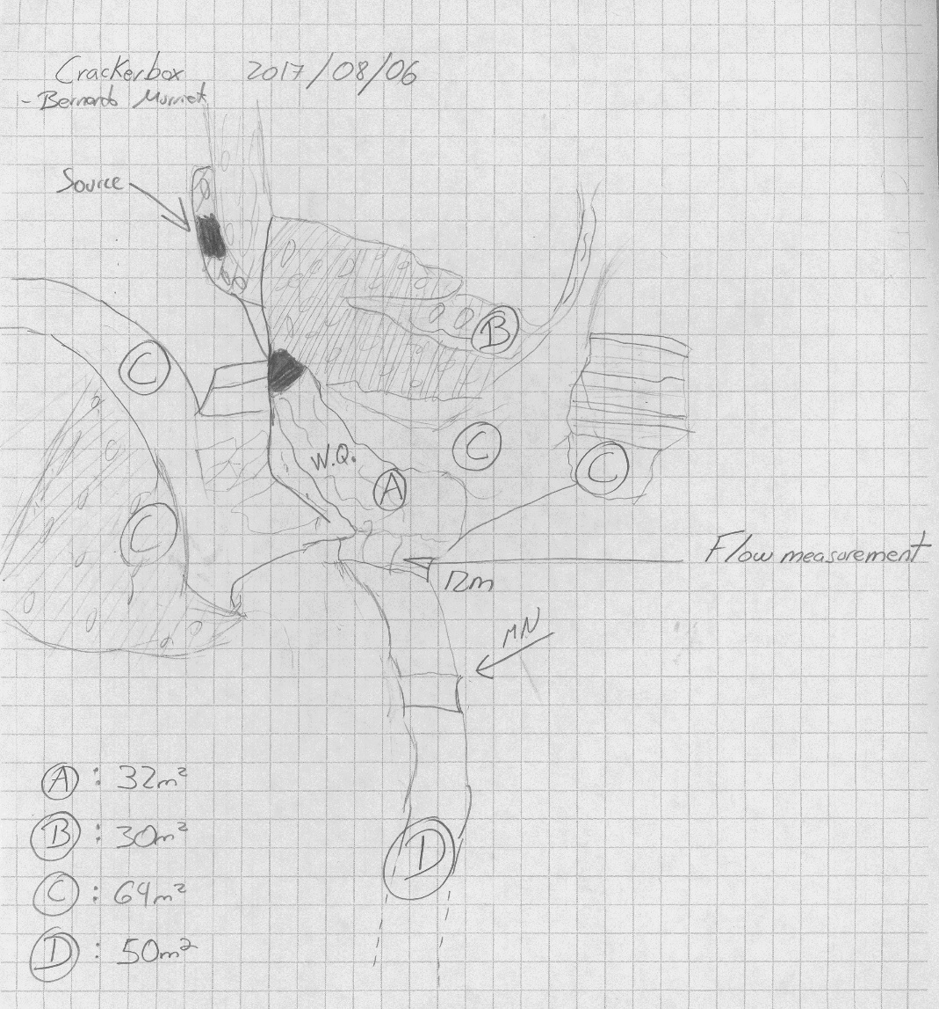
Fig 8.2 Crackerbox Spring Sketchmap.

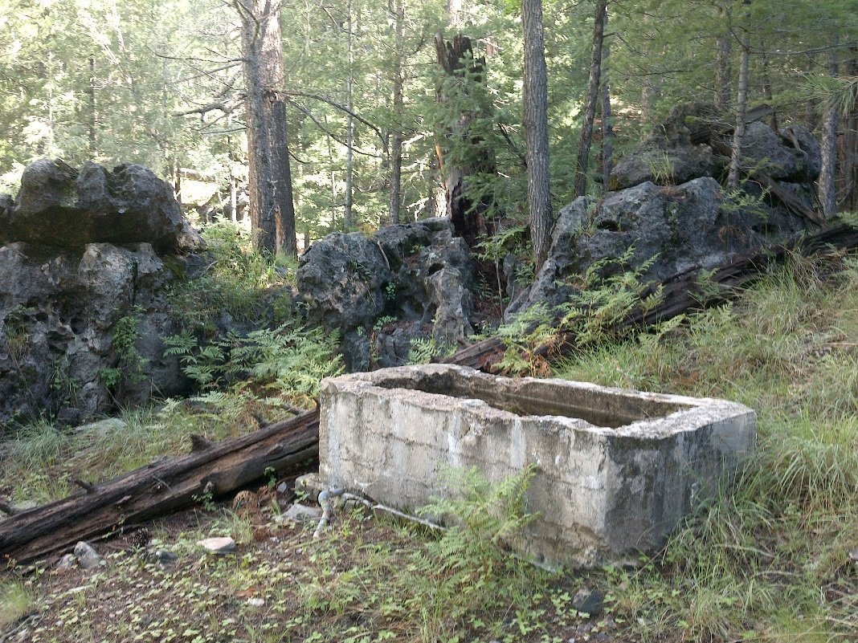
Fig 8.3 Crackerbox Spring: Trough

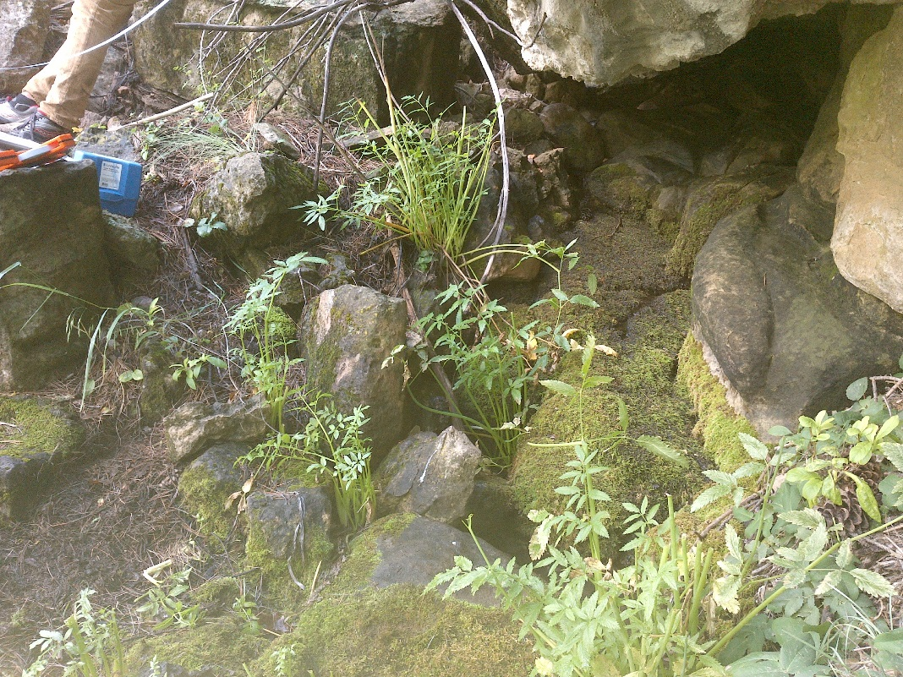
Fig 8.4 Crackerbox Spring: Matching photograph from previous USFS survey

9. Curley Seep
9. Curley Seep
Survey Summary Report, Site ID 945
Submitted June 3, 2019 by Springs Stewardship Institute
Location: The Curley Seep ecosystem is located in Coconino County in the Lower Little Colorado Arizona 15020016 HUC, managed by the US Forest Service. The spring is located in the Coconino NF, Peaks RD, in the Kendrick Peak USGS Quad, at 35.44218, -111.76352 measured using a Map (NAD83). The elevation is approximately 2318 meters. Kyle Paffett and Quintin Van Dyke surveyed the site on 6/10/12 for 01:00 hours, beginning at 9:00, and collected data in 4 of 10 categories. This survey was conducted under the NEPA Cleared List project using the Stevens et al. Level 2 protocol.

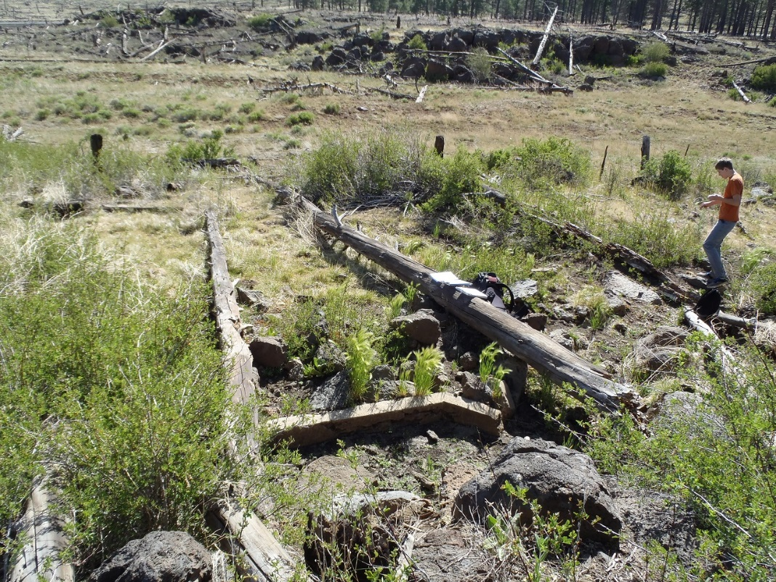
Fig 9.1 Curley Seep.

Physical Description: Curley Seep is a hillslope/rheocrene spring. The spring discharges from a basalt outcrop and flows down a hillslope into a drainage channel.

Table 9.1 Curley Seep Microhabitat characteristics.
Code | X
Name | Entire Site
Area sqm
Surface type
Surface subtype
Slope variability
Aspect TN
Slope degrees
Moisture (scale 1-10)
Water depth cm
Area % open water
Substrate
1 - Clay % | 0
2 - Silt % | 0
3 - Sand % | 0
4 - Fine gravel % | 0
5 - Coarse gravel % | 0
6 - Cobble % | 0
7 - Boulder % | 0
8 - Bedrock % | 0
Organic % | 0
Other % (anthropogenic) | 0
Precipitate % | 0
Litter % | 0
Wood % | 0
Litter Depth (cm)

Geomorphology: Curley Seep emerges as a fracture spring from an igneous, basalt rock layer in an unknown unit. The emergence environment is subaerial, with a gravity flow force mechanism.

Access Directions: From the intersection of N Snow Bowl Rd and US-180, travel northbound on US-180 for 15.23 mi. Turn left and head west and then north on NF-191C for 0.2 mi. Hike 80 m due northeast.

Survey Notes: This survey was conducted under the Pulliam project by students of Northern Arizona University and volunteers, under the direction of Dr. Abe Springer. The spring site has evidence of development for livestock water: remnants of a concrete spring box/stock tank and barbed wire fencing.

Flow: Flow was adjusted for an estimate of 1.00% of site flow capture. The site was dry at the time of the visit.

Water Quality: Spring site was dry at time of visit.

Flora: Surveyors identified 3 plant species at the site. These included 1 native and 1 nonnative species; the native status of 1 species remains unknown.

Table 9.2 Curley Seep Cover Type.
Cover Type | Species Count | Wetland Species Count
Ground | 2 | 2
Shrub | 1 | 0
Mid-canopy | 0 | 0
Tall canopy | 0 | 0
Basal | 0 | 0
Aquatic | 0 | 0
Non-vascular | 0 | 0

Table 9.3 Curley Seep Vegetation % Cover in Microhabitats.
Species | Cover Code | Native Status | Wetland Status | Comments | X
Amelanchier | SC |  | F
Carex subfusca | GC | N | W
Rumex crispus | GC | I | WR

Assessment: Assessment scores were compiled in 6 categories and 42 subcategories, with 0 null condition scores, and 1 null risk score. Aquifer functionality and water quality are very poor with very limited restoration potential and there is very high risk. Geomorphology condition is moderate with some restoration potential and there is negligible risk. Habitat condition is poor with limited restoration potential and there is moderate risk. Biotic integrity is very poor with very limited restoration potential and there is high risk. Human influence of site is moderate with some restoration potential and there is moderate risk. Administrative context status is poor with limited restoration potential and there is low risk. Overall, the site condition is poor with limited restoration potential and there is moderate risk.

Table 9.4 Curley Seep Assessment Scores.
Category | Condition | Risk
Aquifer Functionality & Water Quality | 0.67 | 5
Geomorphology | 3.6 | 1.8
Habitat | 2.6 | 3.5
Biota | 1.13 | 4.38
Human Influence | 3.5 | 2.86
Administrative Context | 2.33 | 2.56
Overall Ecological Score | 2 | 3.67

Management Recommendations: We recommend to remove the fence and concrete structures at spring source.

10. Dairy Spring
10. Dairy Spring
Survey Summary Report, Site ID 946
Submitted June 3, 2019 by Springs Stewardship Institute
Location: The Dairy Spring ecosystem is located in Coconino County in the Canyon Diablo Arizona 15020015 HUC, managed by the US Forest Service. The spring is located in the Coconino NF, Mormon Lake RD, in the Mormon Lake USGS Quad, at 34.95363, -111.48227 measured using a GPS (NAD83, estimated position error 3 meters). The elevation is approximately 2173 meters. Kyle Paffett, Krista Sparks, and Spencer Harris surveyed the site on 6/25/13 for 01:30 hours, beginning at 9:30, and collected data in 7 of 10 categories. This survey was conducted under the NEPA Cleared List project using the Stevens et al. Level 2 protocol.

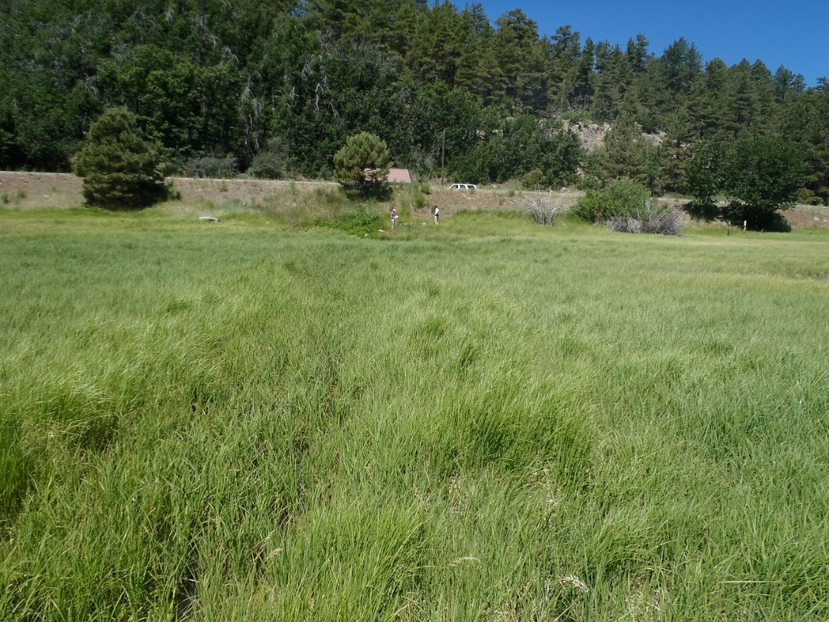
Fig 10.1 Dairy Spring.

Physical Description: Dairy Spring is a hillslope spring. This spring discharges from a spring house and diverts water to private residences and a campground. Some spring water flows out from a culvert under the road and into Mormon Lake.

Table 10.1 Dairy Spring Microhabitat characteristics.
Code | X
Name | Entire Site
Area sqm
Surface type
Surface subtype
Slope variability
Aspect TN
Slope degrees
Moisture (scale 1-10)
Water depth cm
Area % open water
Substrate
1 - Clay % | 0
2 - Silt % | 0
3 - Sand % | 0
4 - Fine gravel % | 0
5 - Coarse gravel % | 0
6 - Cobble % | 0
7 - Boulder % | 0
8 - Bedrock % | 0
Organic % | 0
Other % (anthropogenic) | 0
Precipitate % | 0
Litter % | 0
Wood % | 0
Litter Depth (cm)

Geomorphology: Dairy Spring emerges as a contact spring from an igneous, basalt rock layer in an unknown unit. The emergence environment is subaerial, with a gravity flow force mechanism.

Access Directions: From the intersection of Country Rd 3 (Lake Mary Rd) and County Rd 90 (Mormon Lake Rd), travel west and then south on CR-90 for 3.85 mi. Spring is located 30 m due west. Park at the spring house; the spring is 30 meters from the road, on the west side.

Survey Notes: This survey was conducted under the Pulliam project by students of Northern Arizona University and volunteers, under the direction of Dr. Abe Springer. Multiple sources (more than 5) exist along the road bed. The culvert is the largest source, contributing about 50% of the spring water to the system. Other sources are too diffuse to measure flow.

Flow: Surveyors measured a flow of 0.59 liters/second, using a timed flow volume capture method. Flow was adjusted for an estimate of 50.00% of site flow capture. A springhouse diverts water to a campground and private homes, but a portion of the spring water escapes through a culvert under the road and flows into Mormon Lake. Measurements were taken at the end of the culvert that travels under the road. This spring is perennial.

Water Quality: Measurements and samples were taken at the culvert. Samples were collected for 2H and 18O isotope analyses.

Table 10.2 Dairy Spring Water Quality with multiple readings averaged.
Characteristic Measured | Average Value | Site Number | Device | Comments
Dissolved oxygen (field) (mg/L) | 7.58 |  | YSI Multiprobe
Oxygen Reduction Potential in mV | 224.8 |  | YSI Multiprobe
pH (field) | 7.63 |  | YSI Multiprobe
Specific conductance (field) (uS/cm) | 85.6 |  | YSI Multiprobe
Temperature, water C | 9.5 |  | YSI Multiprobe

Flora: wetland outside Pinus ponderosa forest Surveyors identified 20 plant species at the site. These included 18 native and 2 nonnative species.

Table 10.3 Dairy Spring Cover Type.
Cover Type | Species Count | Wetland Species Count
Ground | 18 | 14
Shrub | 1 | 1
Mid-canopy | 0 | 0
Tall canopy | 0 | 0
Basal | 0 | 0
Aquatic | 0 | 0
Non-vascular | 0 | 0

Table 10.4 Dairy Spring Vegetation % Cover in Microhabitats.
Species | Cover Code | Native Status | Wetland Status | Comments | X
Carex atherodes | GC | N
Carex pellita | GC | N | W | VM 244
Carex simulata | GC | N | W | VM 246
Carex utriculata | GC | N | W | VM242
Cicuta douglasii | GC | N | W
Coreopsis tinctoria | GC | N
Gratiola neglecta |  | N
Juncus effusus | GC | N | W
Juncus ensifolius | GC | N | W
Juncus interior | GC | N
Juncus laccatus | GC | N | W
Juncus saximontanus | GC | N | W
Medicago lupulina | GC | I | WR
Mimulus guttatus | GC | N | W
Phalaris arundinacea | GC | N | WR
Poa pratensis | GC | I | F
Salix laevigata | SC | N | R
Schoenoplectus acutus | GC | N | W
Sidalcea neomexicana | GC | N | WR
Typha latifolia | GC | N | A

Fauna: Surveyors collected or observed 1 vertebrate specimens.

Table 10.5 Dairy Spring Vertebrates.
Vertebrate Species Common Name | Count | Detection | Comments
domestic cow |  | sign

Assessment: Assessment scores were compiled in 6 categories and 42 subcategories, with 0 null condition scores, and 1 null risk score. Aquifer functionality and water quality are good with significant restoration potential and there is moderate risk. Geomorphology condition is poor with limited restoration potential and there is low risk. Habitat condition is moderate with some restoration potential and there is moderate risk. Biotic integrity is poor with limited restoration potential and there is low risk. Human influence of site is moderate with some restoration potential and there is moderate risk. Administrative context status is moderate with some restoration potential and there is low risk. Overall, the site condition is moderate with some restoration potential and there is moderate risk.

Table 10.6 Dairy Spring Assessment Scores.
Category | Condition | Risk
Aquifer Functionality & Water Quality | 3.83 | 3
Geomorphology | 2 | 2.6
Habitat | 3.8 | 3
Biota | 2.63 | 2.75
Human Influence | 3.75 | 3
Administrative Context | 3.56 | 2.44
Overall Ecological Score | 3.06 | 2.84

Management Recommendations: We recommend not salting the road above the spring source, and fencing off the spring from domestic cattle.

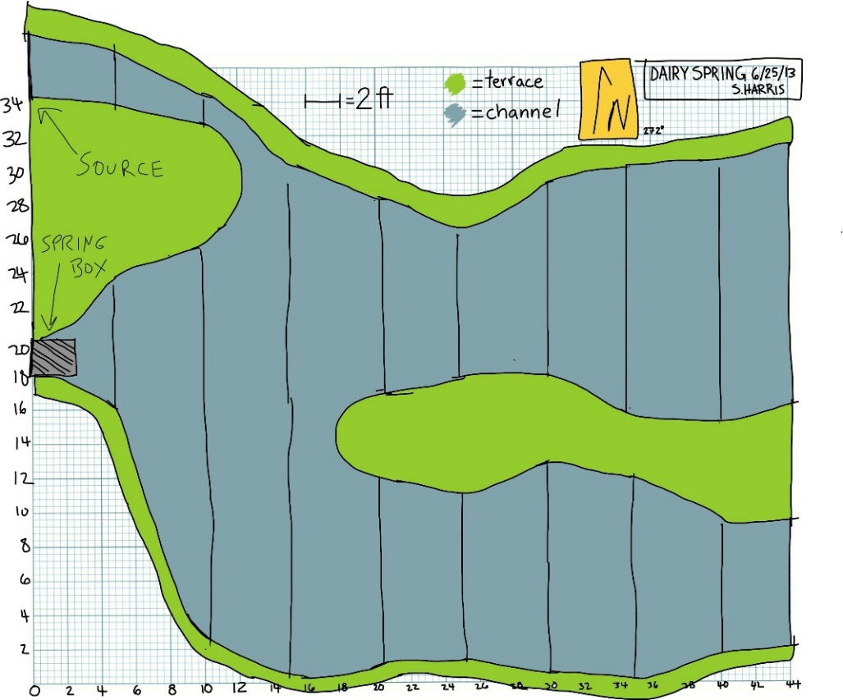
Fig 10.2 Dairy Spring Sketchmap.
11. Dane Spring
Survey Summary Report, Site ID 392
Submitted June 3, 2019 by Springs Stewardship Institute
Location: The Dane Spring ecosystem is located in Coconino County in the Middle Little Colorado Arizona 15020008 HUC, managed by the US Forest Service. The spring is located in the Coconino NF, Mogollon Rim RD, in the Dane Canyon USGS Quad, at 34.46706, -111.14947 measured using a GPS (WGS84, estimated position error 6 meters). The elevation is approximately 2178 meters. Jeri Ledbetter, Gloria Hardwick, Bernie Murrieta, and Sam Goddard surveyed the site on 8/07/17 for 01:40 hours, beginning at 11:50, and collected data in 10 of 10 categories. This survey was conducted under the NEPA Cleared List project using the Stevens et al. Level 2 protocol.

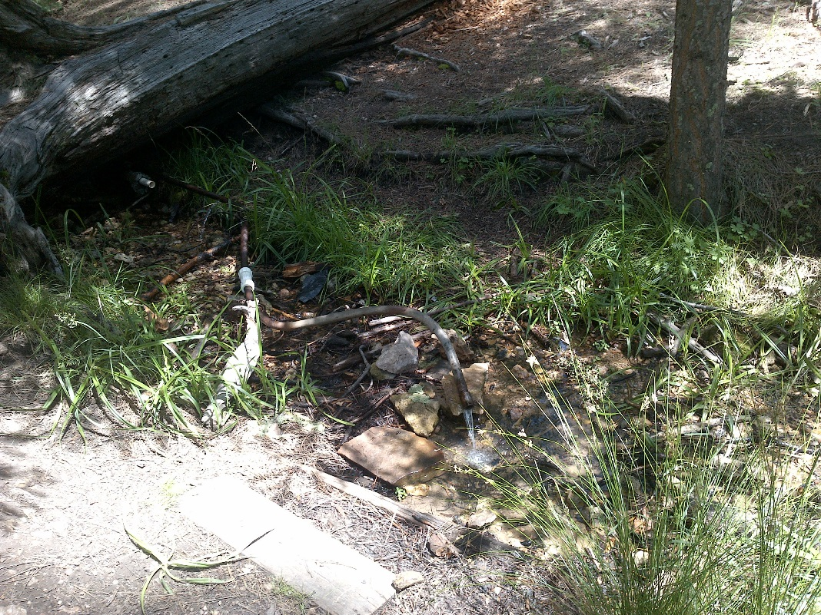
Fig 11.1 Dane Spring: Outflow from pipe and pool, matched photo from 2009 survey

Physical Description: Dane Spring is a hillslope/anthropogenic spring. Flow emerges inside a springbox, where it is piped downstream into the channel below. The springbox is constructed at the base of a Kaibab limestone outcrop in upper Dane Canyon, in a gently sloping area of a mixed conifer forest. An historic cabin is located nearby, with an established trail passing through the runout where water pours out of a pipe. A sign from Forest Road 321 guides visitors to a parking area and the trail leading to the site. The channel is narrow, entrenched, and rocky. The runout drops off steep Coconino sandstone bedrock about 50 meters below the source. The microhabitats associated with the spring cover 183 sqm. The site has 3 microhabitats, including A -- an 80 sqm channel, B -- a 100 sqm terrace, C -- a 3 sqm other. The geomorphic diversity is 0.33, based on the Shannon-Weiner diversity index.

Table 11.1 Dane Spring Microhabitat characteristics.
Code | A | B | C
Name | Channel | Terrace | Boxed-in source
Area sqm | 80 | 100 | 3
Surface type | CH | TE | OTH
Surface subtype | run |  | anthro
Slope variability | Low | Low | Low
Aspect TN
Slope degrees | 5 | 5 | 0
Moisture (scale 1-10) | 9 | 4 | 10
Water depth cm | 9 | 0 | 10
Area % open water | 80 | 0 | 100
Substrate
1 - Clay % | 5 | 5 | 5
2 - Silt % | 5 | 5 | 5
3 - Sand % | 10 | 5 | 5
4 - Fine gravel % | 35 | 8 | 5
5 - Coarse gravel % | 25 | 6 | 5
6 - Cobble % | 4 | 10 | 0
7 - Boulder % | 0 | 20 | 0
8 - Bedrock % | 5 | 0 | 0
Organic % | 10 | 40 | 0
Other % (anthropogenic) | 1 | 1 | 75
Precipitate % | 0 | 0 | 0
Litter % | 5 | 80 | 2
Wood % | 15 | 15 | 0
Litter Depth (cm) | .5 | 1 | .05

Geomorphology: Dane Spring emerges as a contact spring from the Kaibab Limestone, a sedimentary, limestone rock layer. The emergence environment is subaerial, with a gravity flow force mechanism. The site receives approximately 97% of available solar radiation, with 7089 Mj annually.

Access Directions: From Forest Road 300 (Rim Dr), take 321 north to 321A, to parking area. Walk about 100 meters west to the gate and follow a trail down the hill, about 200 meters to the spring.

Survey Notes: All of the piping is either non-functional or leaking. The springbox has no door, which may be a concern since visitors are presumably taking water from the pipe. Boards have been placed to stabilize the bank where a trail crosses, and it seems to be relatively effective. However, the trail leads visitors to the site, but then doesn’t guide them to a good spot to cross the runout channel. The site is moderately trampled by elk and humans, and elk have heavily grazed the vegetation. Young trees have been browsed and are stunted. Two willows at the site (perhaps Bebbs?) are not healthy. Some of the young firs have moth infestations. In addition, there is an old metal barrel around a small pine tree, and trash lying about.

Flow: Surveyors measured a flow of 0.44 liters/second, using a timed flow volume capture method. Flow was adjusted for an estimate of 80% of site flow capture. Surveyors measured flow at the exit of one of the pipes, 11.6 m from the springbox, and at leak in pipe, at 6 m. This spring is perennial.

Water Quality: Water quality measurements were taken inside the springbox in standing water.

Table 11.2 Dane Spring Water Quality with multiple readings averaged.
Characteristic Measured | Average Value | Site Number | Device | Comments
Alkalinity, Total (mg/L) | 145 |  | LaMotte
Dissolved oxygen (field) % saturation | 50.4 |  | YSI Multiprobe
Dissolved oxygen (field) (mg/L) | 5.75 |  | YSI Multiprobe
Oxygen Reduction Potential in mV | 284.3 |  | YSI Multiprobe
pH (field) | 6.89 |  | YSI Multiprobe
Salinity (field) (ppt) | 0.145 |  | Hanna Combo
Specific conductance (field) (uS/cm) | 587.3 |  | YSI Multiprobe
Temperature, air C | 22 |  | Handheld therm
Temperature, water C | 9.2 |  | YSI Multiprobe

Flora: Gloria Hardwick was the botanist. A (Bebbs?) willow is 8 meters beyond the end of the tape. Surveyors identified 36 plant species at the site, with 0.1967 species/sqm. These included 26 native and 10 nonnative species.

Table 11.3 Dane Spring Cover Type.
Cover Type | Species Count | Wetland Species Count
Ground | 25 | 8
Shrub | 4 | 1
Mid-canopy | 3 | 0
Tall canopy | 2 | 0
Basal | 4 | 0
Aquatic | 1 | 1
Non-vascular | 3 | 0

Table 11.4 Dane Spring Vegetation % Cover in Microhabitats.
Species | Cover Code | Native Status | Wetland Status | Comments | A | B | C
Abies concolor | BC | N | U |  | 0 | 3 | 0
Abies concolor | MC | N | U |  | 4 | 2 | 0
Abies concolor | SC | N | U |  | 0 | 0.2 | 0
Achillea millefolium | GC | NI | U |  | 0 | 0.5 | 0
Amelanchier utahensis | SC | N | F | unhealthy - dying back | 0 | 0.2 | 0
Carex | GC |  |  | collected | 0.01 | 0.01 | 0
Cirsium | GC |  | F |  | 0 | 0.02 | 0
Dactylis glomerata | GC | I | W |  | 0.01 | 0.09 | 0
Fragaria | GC | N | U |  | 0.01 | 0.3 | 0
Geranium caespitosum | GC | N | F |  | 0 | 0.01 | 0
Geranium richardsonii | GC | N | F |  | 0 | 3 | 0
Glyceria elata | GC | N | W |  | 0.02 | 0.02 | 0
Helenium hoopesii | GC | N | F |  | 0 | 0.2 | 0
Iris missouriensis | GC | N | F | dry parts of terrace | 0 | 0.01 | 0
Juncus laccatus | GC | N | W |  | 0.4 | 10 | 0
Lichen | NV | N | U |  | 0.02 | 0.03 | 0
Medicago lupulina | GC | I | WR |  | 0.01 | 1 | 0
Pinus flexilis | BC | N | U |  | 0 | 2 | 0
Pinus flexilis | TC | N | U |  | 0.5 | 1 | 0
Pinus ponderosa | BC | N | F |  | 0 | 4 | 0
Pinus ponderosa | TC | N | F |  | 2 | 1 | 0
Populus tremuloides | MC | N | U |  | 0 | 0.2 | 0
Potentilla hippiana | GC | N | U | drier parts of terrace | 0 | 0.01 | 0
Prunella vulgaris | GC | N | F |  | 0 | 1 | 0
Pseudocymopterus montanus | GC | N | F |  | 0 | 0.01 | 0
Pseudotsuga menziesii var. glauca | BC | N | U |  | 0 | 2 | 0
Pseudotsuga menziesii var. glauca | MC | N |  |  | 1 | 0.5 | 0
Pseudotsuga menziesii var. glauca | SC | N | U |  | 0 | 0.1 | 0
Pteridium aquilinum | GC | N | U |  | 0 | 0.4 | 0
Rosa arizonica | GC | N |  |  | 0 | 1 | 0
Rudbeckia laciniata | GC | N | F |  | 0 | 1 | 0
Salix bebbiana | SC | N | WR |  | 0.09 | 0.07 | 0
Scirpus | GC | N | W | microcarpus? | 2 | 3 | 0
Thalictrum fendleri | GC | N | F |  | 0 | 0.07 | 0
Trifolium | GC | I | WR |  | 0.5 | 2 | 0
unknown dicot | GC |  |  | “Conselium-?” | 1 | 0.5 | 0
unknown dicot | GC |  |  | palmate (vs red no petals) | 0 | 0.07 | 0
unknown Fungus | NV |  |  |  | 0 | 0.07 | 0
unknown Graminoid (grass or grasslike) | GC |  |  | purple panicles fr 8/6 spgs | 0.02 | 0.02 | 0
unknown moss | NV |  |  |  | 8 | 4 | 0
Veratrum californicum | GC | N | W |  | 0 | 0.3 | 0
Veronica americana | AQ | N | A |  | 30 | 0 | 0

Fauna: L.E. Stevens reviewed invertebrate specimens and entered data. Surveyors collected or observed 11 aquatic invertebrates and 2 vertebrate specimens.

Table 11.5 Dane Spring Invertebrates.
Species | Lifestage | Habitat | Method | Rep# | Count | Species Detail
Coleoptera Scirtidae | L | A | Spot |  | 2
Diptera Chironomidae | L | A | Spot |  | 1
Ephemeroptera Baetidae | L | A | Spot |  | 1 | sp 1
Ephemeroptera Baetidae | L | A | Spot |  | 3 | sp 2
Ephemeroptera Heptageniidae Heptagenia | L | A | Spot |  | 1
Hemiptera Saldidae | Ad | A | Spot |  | 1
Neoophora Planariidae Dugesia | Ad | A | Spot |  | 1
Plecoptera | M | A | Spot |  | 6 | Sp 1; 6 L, 1 Ad
Trichoptera | L | A | Spot |  | 1 | sp 1
Trichoptera | L | A | Spot |  | 2 | sp 2
Trichoptera Limnephilidae | P | A | Spot |  | 1 | sp 3

Table 11.6 Dane Spring Vertebrates.
Vertebrate Species Common Name | Count | Detection | Comments
Elk |  | sign | tracks, scat, and browsing
Broad-tailed Hummingbird |  | call

Assessment: Assessment scores were compiled in 5 categories and 33 subcategories, with 9 null condition scores, and 9 null risk scores. Aquifer functionality and water quality are good with significant restoration potential and there is low risk. Geomorphology condition is moderate with some restoration potential and there is low risk. Habitat condition is good with significant restoration potential and there is low risk. Biotic integrity is good with significant restoration potential and there is low risk. Human influence of site is good with significant restoration potential and there is low risk. Administrative context status is undetermined due to null scores and there is undetermined risk due to null scores. Overall, the site condition is good with significant restoration potential and there is low risk.

Table 11.7 Dane Spring Assessment Scores.
Category | Condition | Risk
Aquifer Functionality & Water Quality | 4.7 | 2
Geomorphology | 3.6 | 2
Habitat | 4.4 | 2.2
Biota | 4.5 | 2.3
Human Influence | 4.3 | 2.2
Administrative Context | 0 | 0
Overall Ecological Score | 4.3 | 2.2

Management Recommendations: The trail has been well established to direct visitors to the spring, and multiple trails have been blocked off. However, once visitors reach the site the established trail fades out, and it is unclear where it is best to cross the creek. Continue the trail to a more stable area that will result in less trampling. Remove nonfunctional (or all) piping, metal, and trash, and consider replacing the springbox door. Monitor occasionally.

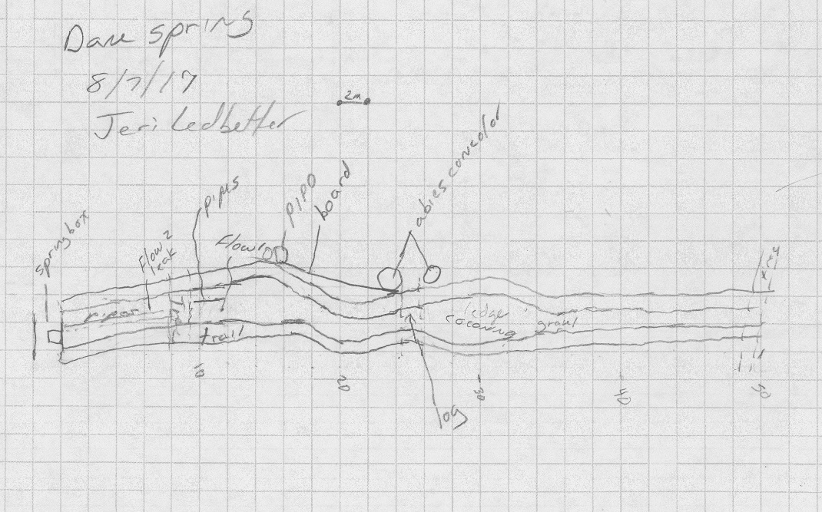
Fig 11.2 Dane Spring Sketchmap.

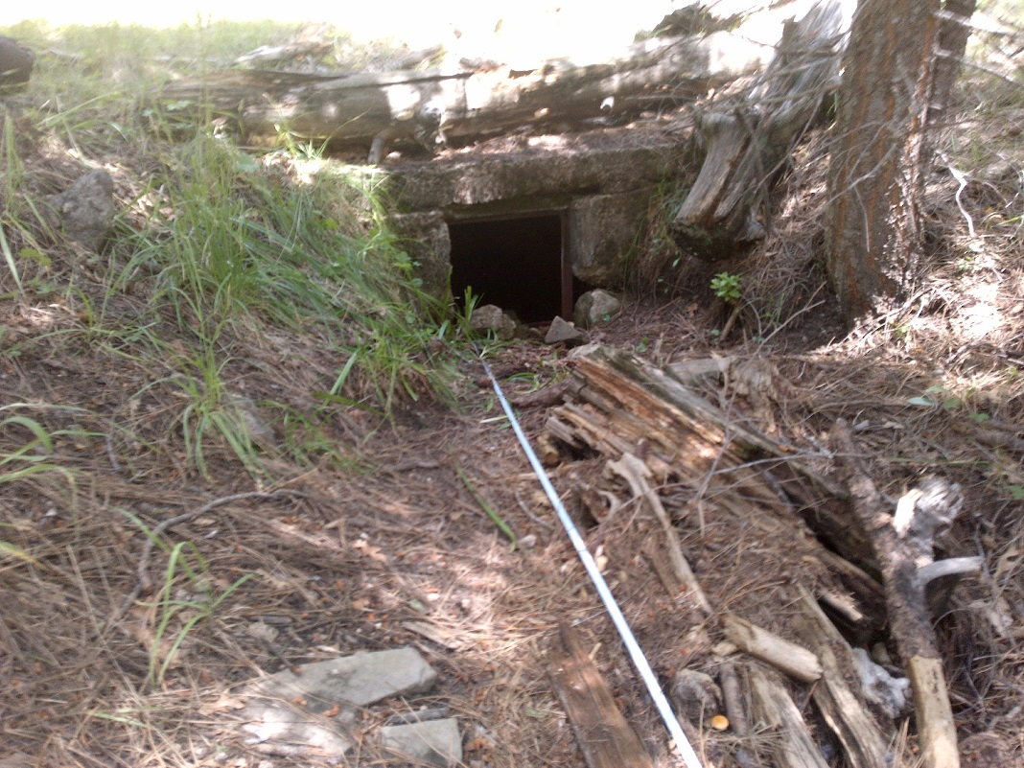
Fig 11.3 Dane Spring: Springbox from 4 meters below

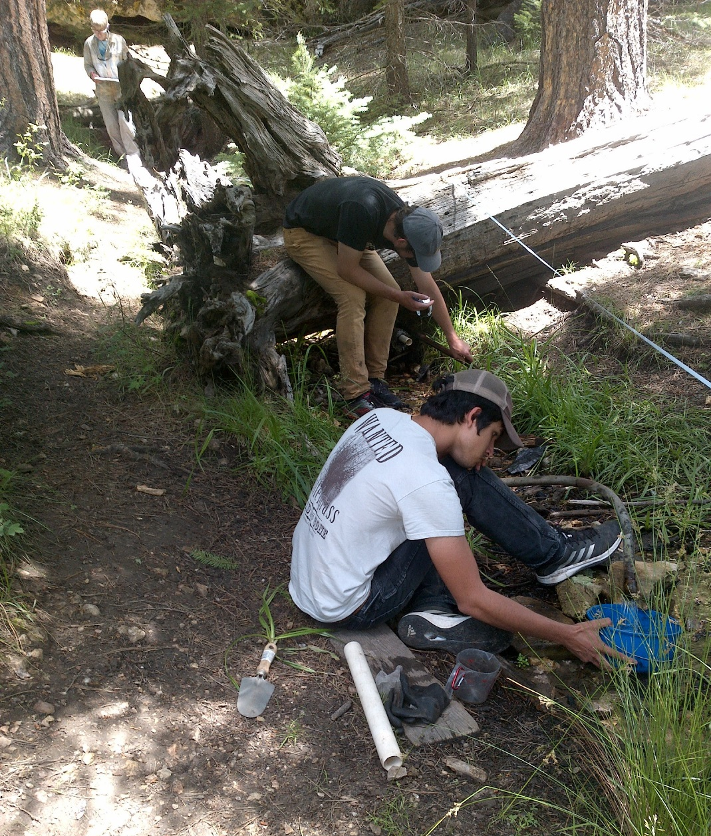
Fig 11.4 Dane Spring: Flow measurement from pipe at 11.5 meters

12. Double Springs
12. Double Springs
Survey Summary Report, Site ID 955
Submitted June 3, 2019 by Springs Stewardship Institute
Location: The Double Springs ecosystem is located in Coconino County in the Canyon Diablo Arizona 15020015 HUC, managed by the US Forest Service. The spring is located in the Coconino NF, Mormon Lake RD, in the Mormon Lake USGS Quad, at 34.94112, -111.49402 measured using a GPS (NAD83). The elevation is approximately 2188 meters. Kyle Paffett, Krista Sparks, and Spencer Harris surveyed the site on 6/25/13 for 01:00 hours, beginning at 12:00, and collected data in 7 of 10 categories. This survey was conducted under the NEPA Cleared List project using the Stevens et al. Level 2 protocol.

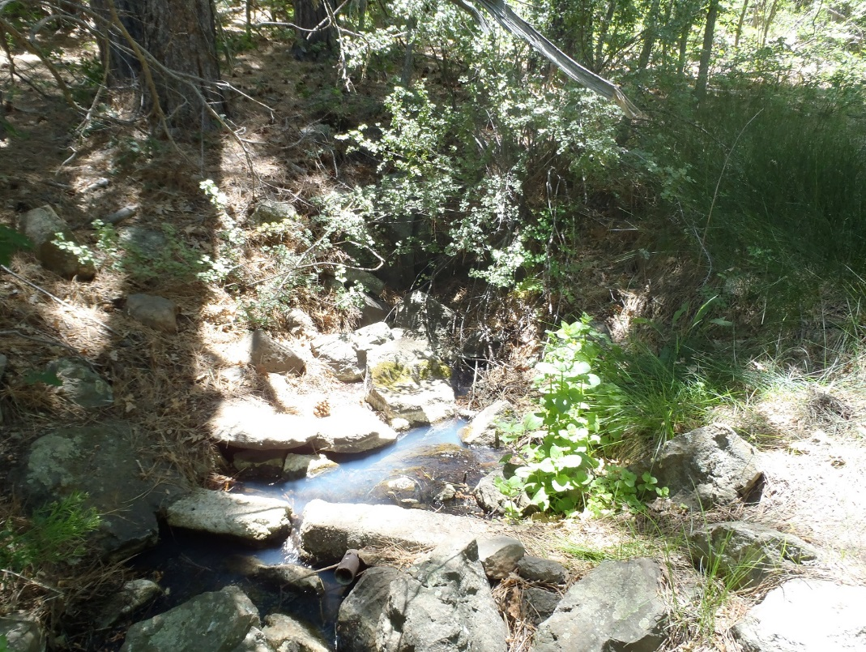
Fig 12.1 Double Springs.

Physical Description: Double Springs is a hillslope spring. The spring discharges out of a basalt outcrop into a stream channel. There is no piping at this site. The channel joins the channel from Double Springs 2 at 29 m. The microhabitats associated with the spring cover 18.7 sqm. The site has 2 microhabitats, including A -- a 9 sqm channel, B -- a 10 sqm terrace. The geomorphic diversity is 0.30, based on the Shannon-Weiner diversity index.

Table 12.1 Double Springs Microhabitat characteristics.
Code | A | B
Name | Channel | Terrace
Area sqm | 8.50 | 10.20
Surface type | CH | TE
Surface subtype
Slope variability
Aspect TN | 15
Slope degrees
Moisture (scale 1-10)
Water depth cm
Area % open water
Substrate
1 - Clay % | 0 | 0
2 - Silt % | 0 | 0
3 - Sand % | 0 | 0
4 - Fine gravel % | 0 | 0
5 - Coarse gravel % | 0 | 0
6 - Cobble % | 0 | 0
7 - Boulder % | 0 | 0
8 - Bedrock % | 0 | 0
Organic % | 0 | 0
Other % (anthropogenic) | 0 | 0
Precipitate % | 0 | 0
Litter % | 0 | 0
Wood % | 0 | 0
Litter Depth (cm)

Geomorphology: Double Springs emerges as a contact spring from an igneous, basalt rock layer in an unknown unit. The emergence environment is subaerial, with a gravity flow force mechanism.

Access Directions: From the intersection of County Rd 3 (Lake Mary Rd) and Country Rd 90 (Mormon Lake Rd), travel west on CR-90 for 5 mi. Turn right and continue west on NF-90F (Double Springs Campground Rd) for 0.18 mi. Hike due south for 120 m.

Flow: Surveyors measured a flow of 0.43 liters/second, using a v-notch weir. Flow was adjusted for an estimate of 75.00% of site flow capture. Flow measurements were taken at the concrete dam at the source. This spring is perennial.

Water Quality: Measurements and samples were taken at the spring source. Samples were collected for 2H and 18O isotope analyses and duplicates were taken.

Table 12.2 Double Springs Water Quality with multiple readings averaged.
Characteristic Measured | Average Value | Site Number | Device | Comments
Dissolved oxygen (field) (mg/L) | 8.11 |  | YSI Multiprobe
Oxygen Reduction Potential in mV | 243.4 |  | YSI Multiprobe
pH (field) | 7.76 |  | YSI Multiprobe
Specific conductance (field) (uS/cm) | 82.1 |  | YSI Multiprobe
Temperature, water C | 7.7 |  | YSI Multiprobe

Flora: Pinus ponderosa, Pseudotsuga menziesii, Quercus gambelii forest Surveyors identified 21 plant species at the site, with 1.123 species/sqm. These included 18 native and 3 nonnative species.

Table 12.3 Double Springs Cover Type.
Cover Type | Species Count | Wetland Species Count
Ground | 14 | 13
Shrub | 4 | 1
Mid-canopy | 1 | 0
Tall canopy | 1 | 0
Basal | 0 | 0
Aquatic | 0 | 0
Non-vascular | 1 | 0

Table 12.4 Double Springs Vegetation % Cover in Microhabitats.
Species | Cover Code | Native Status | Wetland Status | Comments | A | B
Amelanchier utahensis | SC | N | F |  | 0 | 0
Carex | GC | N |  |  | 0 | 3
Carex nebrascensis | GC | N | W | VM 245 | 0 | 0
Carex pellita | GC | N | W |  | 0 | 0
Carex subfusca | GC | N | W | VM 243 | 0 | 0
Glyceria grandis | GC | N | WR |  | 0 | 0
Hypericum scouleri | GC | N | WR |  | 0 | 0
Juncus ensifolius | GC | N | W |  | 0 | 0
Mentha arvensis | GC | N | WR |  | 0 | 0
Mimulus guttatus | GC | N | W |  | 9 | 30
Montia chamissoi | GC | N |  | VM251 | 18 | 2
Phleum pratense | GC | I | F |  | 0 | 4
Pinus ponderosa | TC | N | F |  | 20 | 35
Quercus gambelii | MC | N | F |  | 3 | 4
Ribes cereum | SC | N | U |  | 5 | 6
Rorippa sylvestris | GC | I |  |  | 0 | 0.5
Rosa woodsii | SC | N | F |  | 4 | 5
Rumex crispus | GC | I | WR |  | 0 | 1
Salix lasiolepis | SC | N | WR |  | 25 | 35
Sidalcea neomexicana | GC | N | WR |  | 0 | 0
unknown Bryophyte (moss, liverwort, hornwort) | NV | N | F |  | 5 | 0

Assessment: Assessment scores were compiled in 6 categories and 42 subcategories, with 0 null condition scores, and 1 null risk score. Aquifer functionality and water quality are good with significant restoration potential and there is moderate risk. Geomorphology condition is poor with limited restoration potential and there is low risk. Habitat condition is poor with limited restoration potential and there is moderate risk. Biotic integrity is poor with limited restoration potential and there is low risk. Human influence of site is good with significant restoration potential and there is moderate risk. Administrative context status is moderate with some restoration potential and there is low risk. Overall, the site condition is moderate with some restoration potential and there is low risk.

Table 12.5 Double Springs Assessment Scores.
Category | Condition | Risk
Aquifer Functionality & Water Quality | 4 | 3.17
Geomorphology | 2.8 | 2.4
Habitat | 2.6 | 3
Biota | 2.25 | 2.38
Human Influence | 4.25 | 2.86
Administrative Context | 3.44 | 2.44
Overall Ecological Score | 2.91 | 2.74

Management Recommendations: Surveyors did not note any management recommendations.

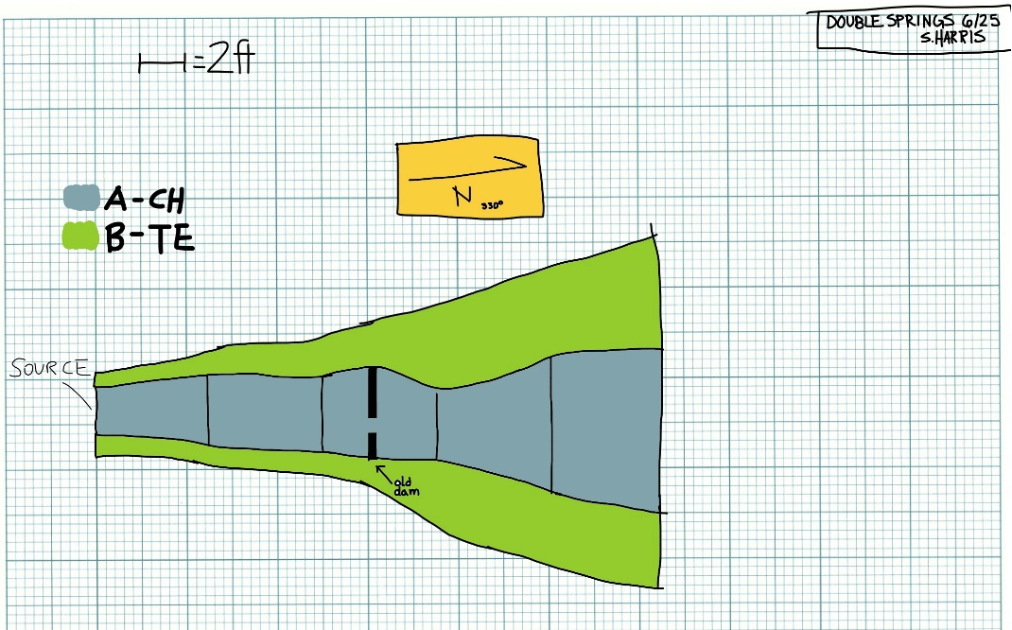
Fig 12.2 Double Springs Sketchmap.

13. Dove Spring
13. Dove Spring
Survey Summary Report, Site ID 956
Submitted June 3, 2019 by Springs Stewardship Institute
Location: The Dove Spring ecosystem is located in Coconino County in the Canyon Diablo Arizona 15020015 HUC, managed by the US Forest Service. The spring is located in the Coconino NF, Mogollon Rim RD, in the Jaycox Mountain USGS Quad, at 34.87330, -111.37337 (NAD83). The elevation is approximately 2229 meters. Lisa Winters, Winnie Taney, Cathy Morin, and Diane Meuser surveyed the site on 9/07/16 for 01:15 hours, beginning at 12:45, and collected data in 8 of 10 categories. This survey was conducted under the NEPA Cleared List project using the Stevens et al. Level 2 protocol.

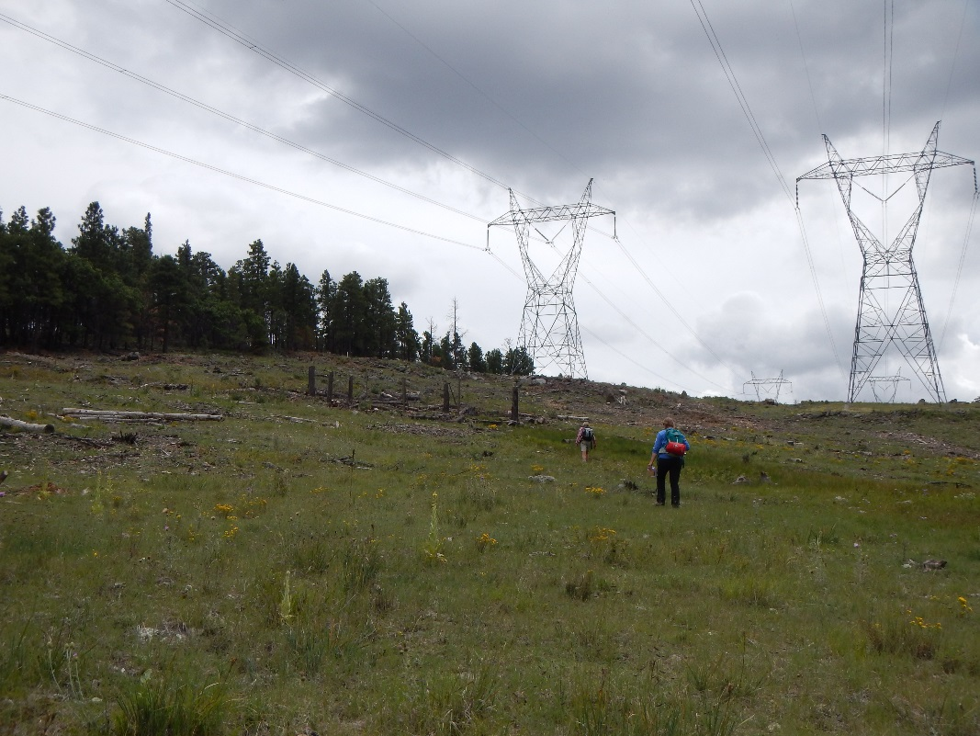
Fig 13.1 Dove Spring: Dove Spring Site

Physical Description: Dove Spring is a hillslope spring. Spring discharges from a basalt outcrop and flows down a hillslope. The microhabitats associated with the spring cover 146 sqm. The site has 3 microhabitats, including A -- a 23 sqm pool, B -- a 13 sqm pool margin, C -- a 110 sqm channel. The geomorphic diversity is 0.31, based on the Shannon-Weiner diversity index.

Table 13.1 Dove Spring Microhabitat characteristics.
Code | A | B | C
Name | Pond | Pond Margin | Channel
Area sqm | 23 | 13 | 110
Surface type | P | PM | CH
Surface subtype
Slope variability | Low | Low | Low
Aspect TN | 316 | 316 | 316
Slope degrees | 14 | 14 | 14
Moisture (scale 1-10) | 10 | 4 | 10
Water depth cm | 5 | 0 | 1
Area % open water | 50 | 15 | 40
Substrate
1 - Clay % | 0 | 0 | 0
2 - Silt % | 0 | 0 | 0
3 - Sand % | 0 | 0 | 0
4 - Fine gravel % | 0 | 0 | 0
5 - Coarse gravel % | 0 | 0 | 0
6 - Cobble % | 0 | 0 | 0
7 - Boulder % | 0 | 0 | 0
8 - Bedrock % | 0 | 0 | 0
Organic % | 0 | 0 | 0
Other % (anthropogenic) | 0 | 0 | 0
Precipitate % | 0 | 0 | 0
Litter % | 0 | 0 | 0
Wood % | 0 | 0 | 0
Litter Depth (cm)

Geomorphology: Dove Spring emerges as a contact spring from an igneous, basalt rock layer in an unknown unit. The emergence environment is subaerial, with a gravity flow force mechanism.

Access Directions: From the intersection of County Rd 3 (Lake Mary Rd) and NF-124, travel east on NF-124 for 3.92 mi. Turn left and travel north on NF-9483L for 0.9 mi. Turn right on NF-124D for 0.3 mi. Spring is located immediately west of the road.

Survey Notes: This site consists of a fenced-in pond directly below power lines on a clear-cut hillside. The fenced in area is a shallow pool with a trickle of water coming out of the hillside. The channel below the fenced area is heavily trampled with hummocking and channel braiding. The pool substrates were fine silt and mud at the time of the survey.

Flow: Surveyors measured a flow of 0.029 liters/second, using a timed flow volume capture method. Flow was adjusted for an estimate of 95% of site flow capture. A couple meters below the pond (on the outside of fencing).

Table 13.2 Dove Spring Water Quality with multiple readings averaged.
Characteristic Measured | Average Value | Site Number | Device | Comments
pH (field) | 7.84 |  | DigitalAid meter
Specific conductance (field) (uS/cm) | 136 |  | DigitalAid meter

Flora: Surveyors identified 16 plant species at the site, with 0.1096 species/sqm. These included 9 native and 7 nonnative species.

Table 13.3 Dove Spring Cover Type.
Cover Type | Species Count | Wetland Species Count
Ground | 14 | 3
Shrub | 1 | 0
Mid-canopy | 0 | 0
Tall canopy | 0 | 0
Basal | 0 | 0
Aquatic | 0 | 0
Non-vascular | 1 | 0

Table 13.4 Dove Spring Vegetation % Cover in Microhabitats.
Species | Cover Code | Native Status | Wetland Status | Comments | A | B | C
Abildgaardia | GC |  |  |  | 5 | 2 | 8
Achillea millefolium | GC | NI | U |  | 0 | 0 | 1
Aster canescens | GC |  |  |  | 0 | 0 | 2
Cirsium vulgare | GC | I | F |  | 0 | 2 | 0
Erigeron | GC | N | F |  | 0 | 0 | 3
Geranium caespitosum var. caespitosum | GC | N |  |  | 0 | 3 | 0
Iris missouriensis | GC | N | F |  | 0 | 0 | 3
Juncus | GC | N | W |  | 3 | 0 | 2
Mimulus | GC | N | W |  | 3 | 0 | 3
Poa pratensis ssp. alpigena | GC | N |  |  | 0 | 2 | 1
Rosa woodsii | SC | N | F |  | 0 | 0 | 2
Rumex | GC |  | WR |  | 0 | 0 | 0
Taraxacum | GC |  | F |  | 0 | 2 | 0
Trifolium | GC | I | WR |  | 0 | 1 | 0
unknown Bryophyte (moss, liverwort, hornwort) | NV | N | F |  | 0 | 1 | 1
Verbascum | GC | I | F |  | 0 | 2 | 0

Fauna: Surveyors collected or observed 2 terrestrial invertebrates and 4 vertebrate specimens.

Table 13.5 Dove Spring Invertebrates.
Species | Lifestage | Habitat | Method | Rep# | Count | Species Detail
Hymenoptera |  | T |  |  |  | several
Orthoptera |  | T

Table 13.6 Dove Spring Vertebrates.
Vertebrate Species Common Name | Count | Detection | Comments
Northern Leopard Frog | 1 | obs
Garter Snake | 1 | obs
Turkey Vulture | 3 | obs
Domestic Cow |  | sign

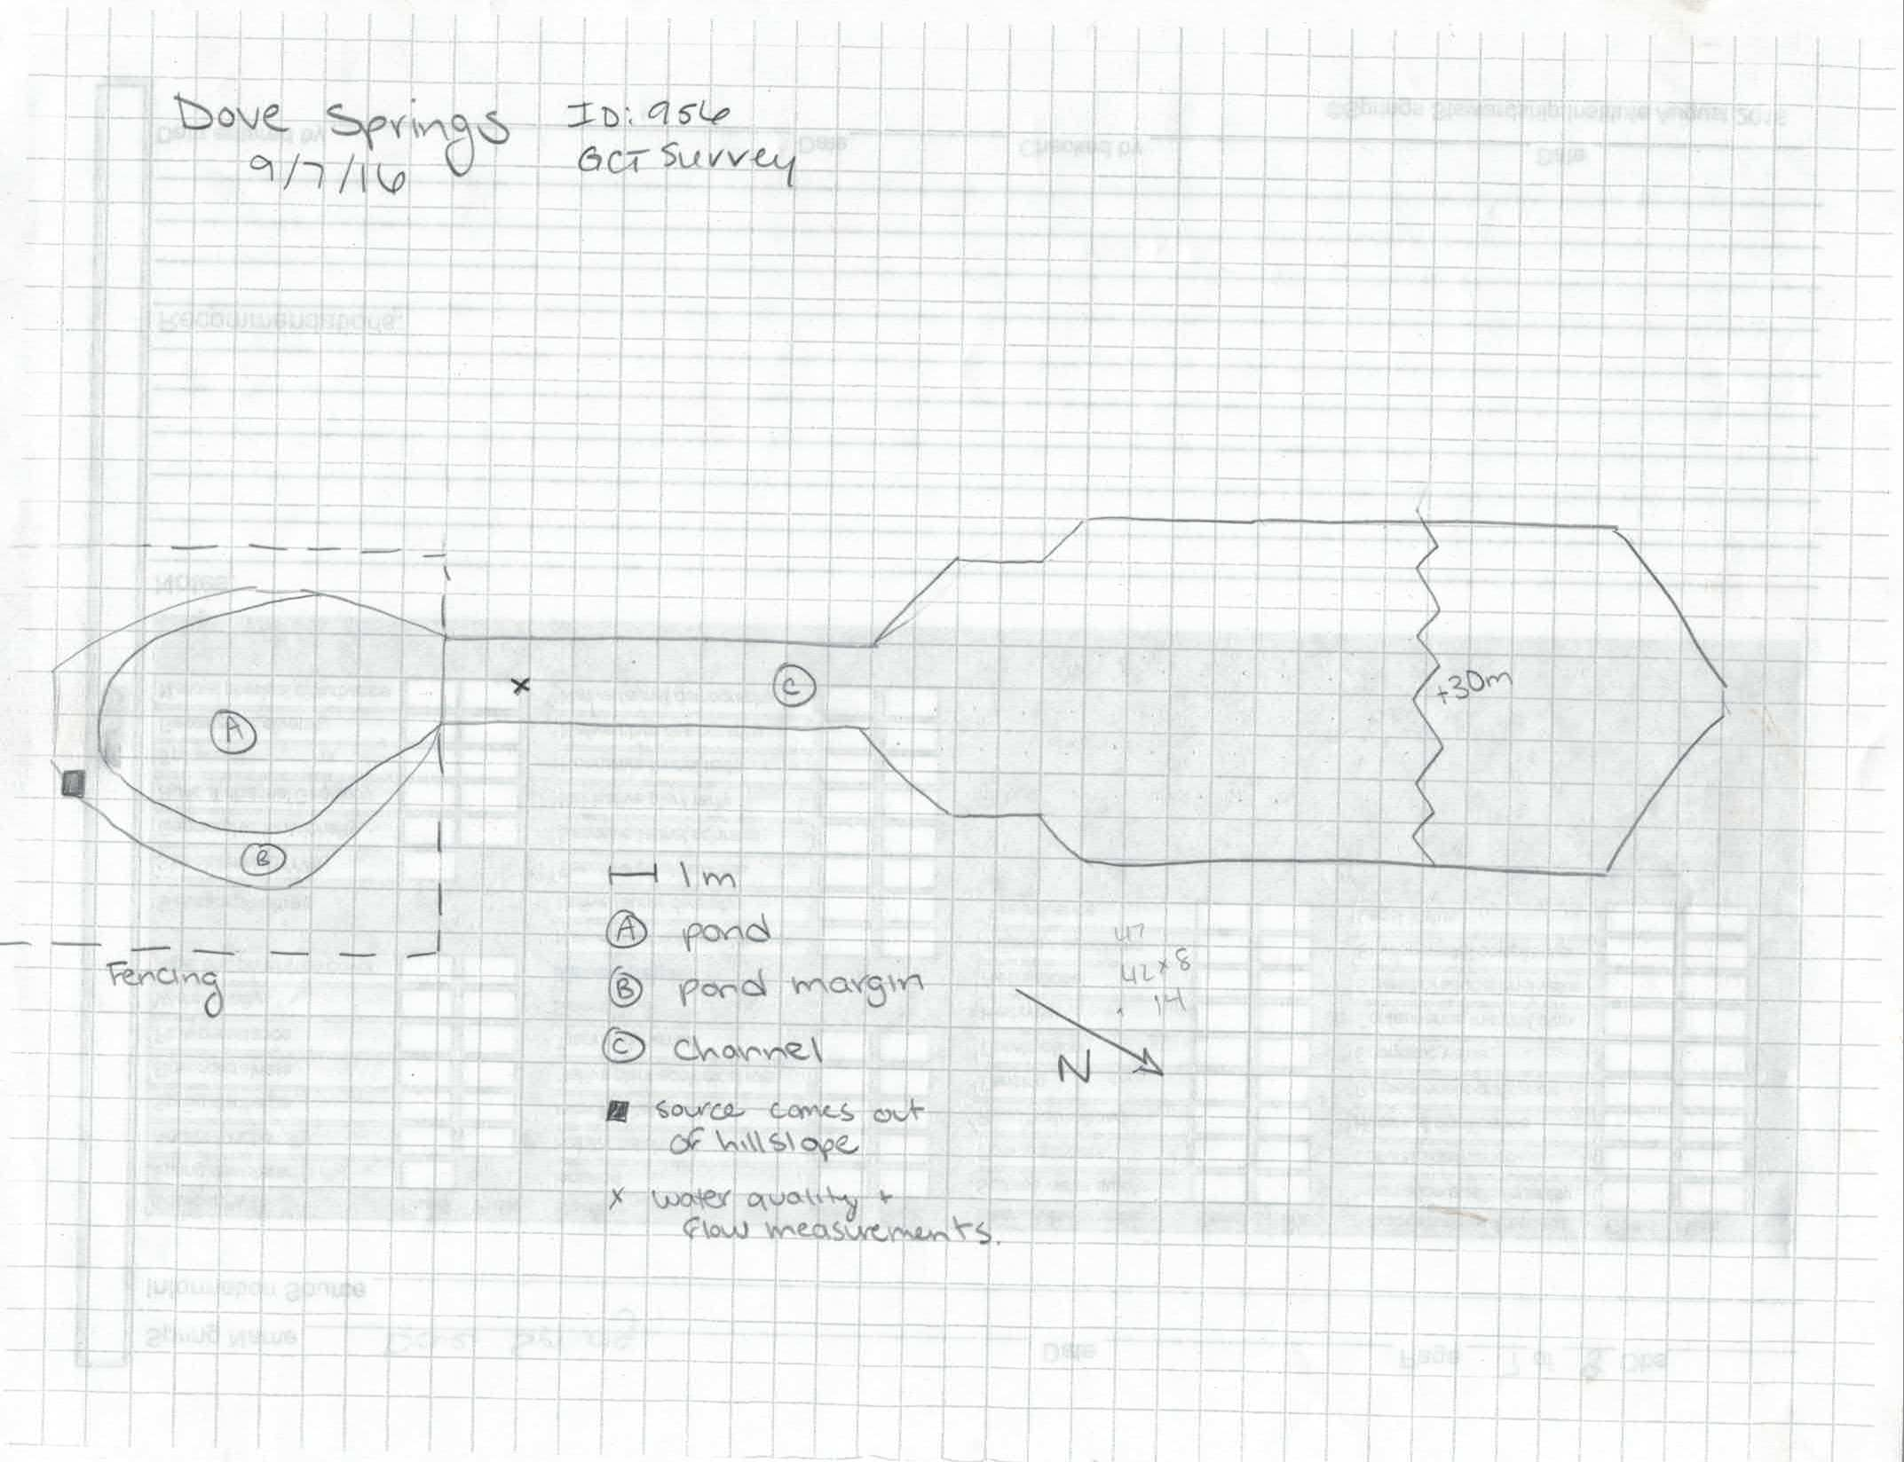
Fig 13.2 Dove Spring Sketchmap.

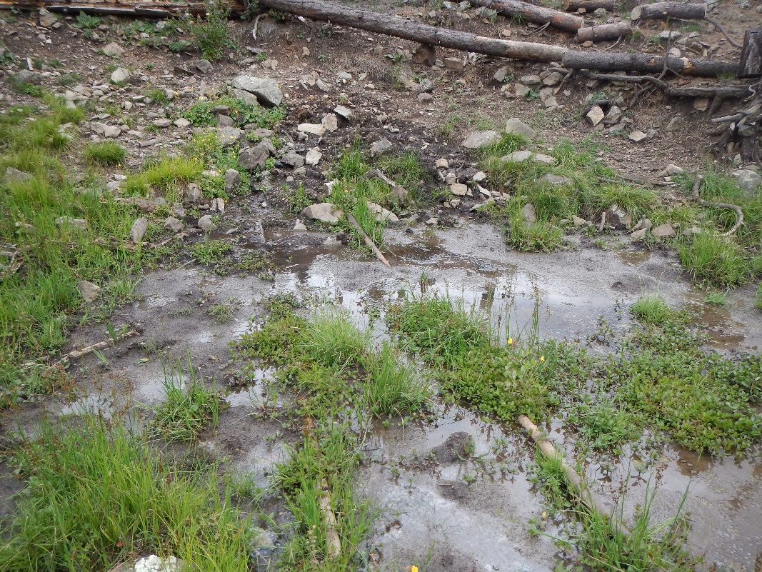
Fig 13.3 Dove Spring: Dove Spring pool looking at source

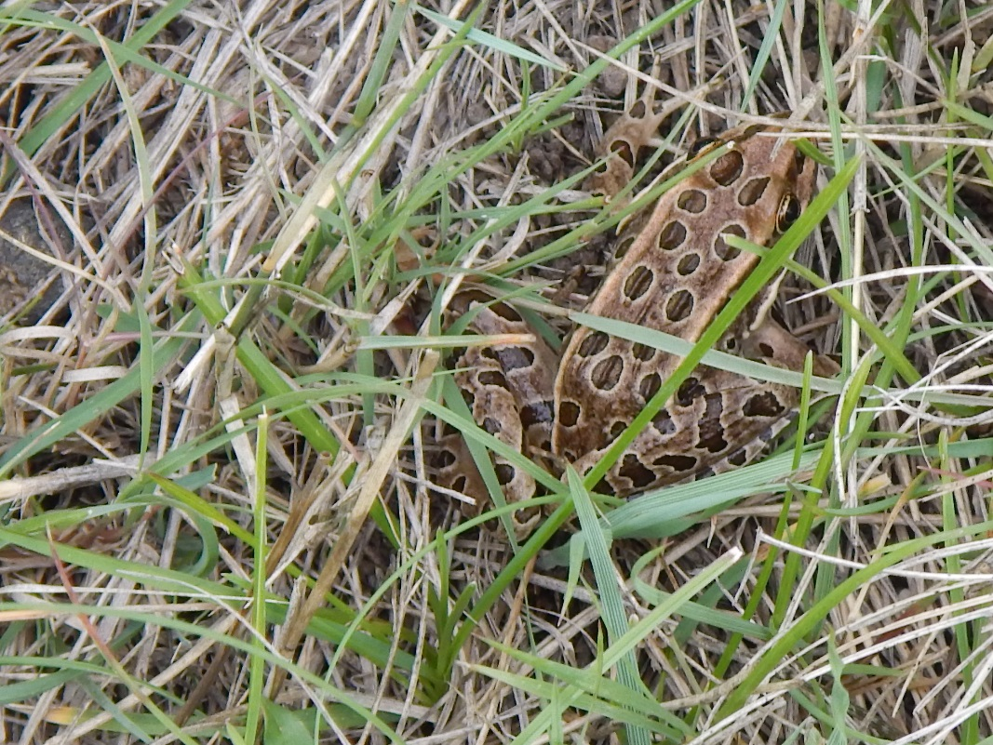
Fig 13.4 Dove Spring: Leopard frog found in lower channel

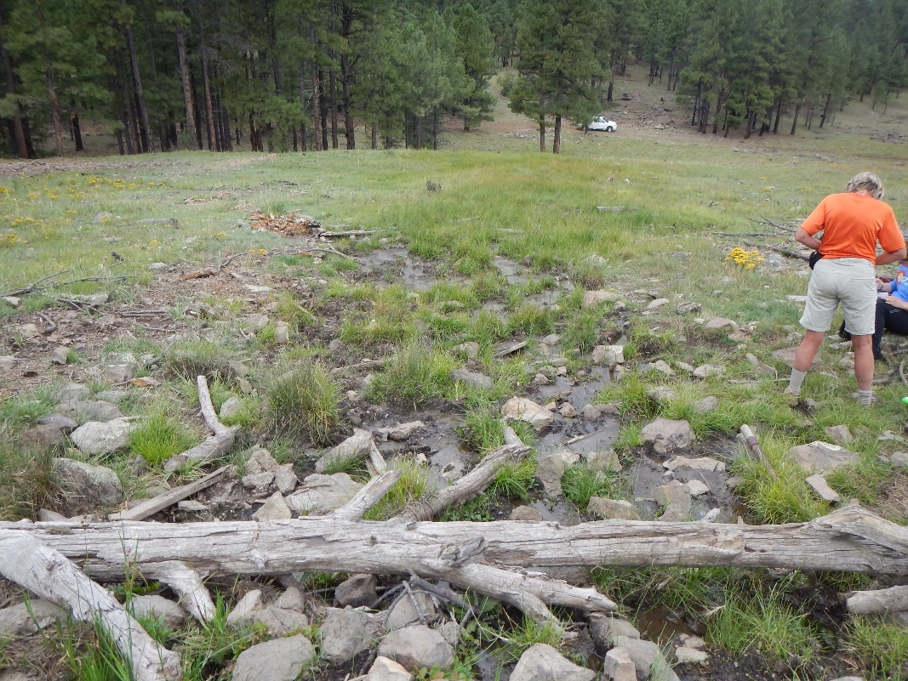
Fig 13.5 Dove Spring: Channel below pool

14. Fues Spring
14. Fues Spring
Survey Summary Report, Site ID 740
Submitted June 3, 2019 by Springs Stewardship Institute
Location: The Fues Spring ecosystem is located in Coconino County in the Havasu Canyon Arizona 15010004 HUC, managed by the US Forest Service. The spring is located in the Kaibab NF, Williams RD, in the Williams North USGS Quad, at 35.29862, -112.14101 measured using a map (NAD83). The elevation is approximately 2075 meters. A Prescott College Class, Jeri Ledbetter, Larry Stevens, Glenn Rink, and Mason Stansfield surveyed the site on 5/26/14 for 00:50 hours, beginning at 9:50, and collected data in 9 of 10 categories. This survey was conducted under the NEPA Cleared List project using the Stevens et al. Level 2 protocol.

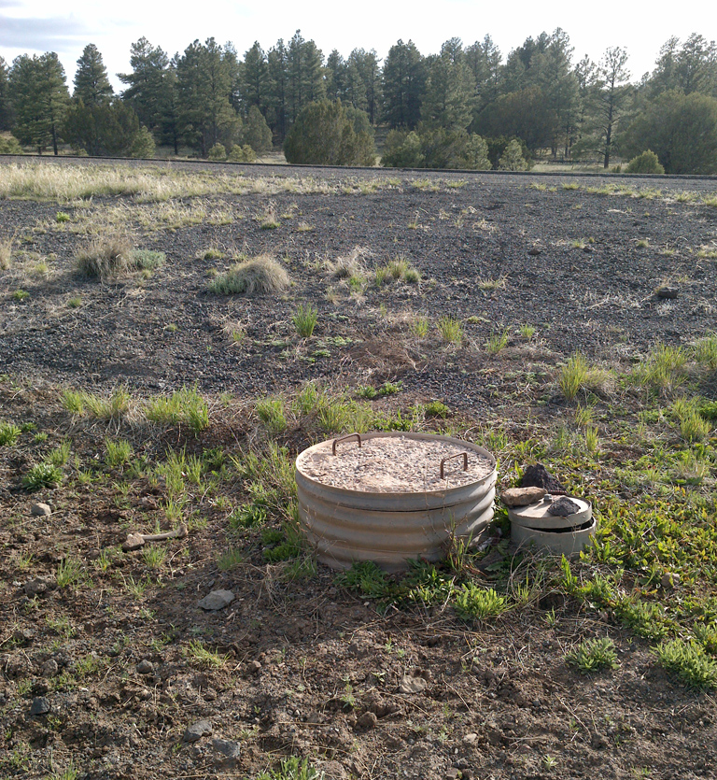
Fig 14.1 Fues Spring.

Physical Description: This site is depicted on the DRG and consists of a large pipe in the ground with a circular man-hole type cover over a vertical culvert that is 80 cm in diameter with water in it. The site is eight meters from Hwy 64. There are four pipes inside the cylindrical tank. The microhabitats associated with the spring cover 9.62 sqm. The site has 2 microhabitats, including A -- a 1 sqm pool, B -- a 9 sqm colluvial slope. The geomorphic diversity is 0.11, based on the Shannon-Weiner diversity index.

Table 14.1 Fues Spring Microhabitat characteristics.
Code | A | B
Name | vertical culvert source | surrounding 2m wide band
Area sqm | 0.64 | 8.98
Surface type | P | CS
Surface subtype | anthro | anthro
Slope variability | Low | Low
Aspect TN |  | 77
Slope degrees | 0 | 25
Moisture (scale 1-10) | 10 | 0
Water depth cm | 97.00 | 0.00
Area % open water | 100.00 | 0.00
Substrate
1 - Clay % | 0 | 0
2 - Silt % | 0 | 25
3 - Sand % | 0 | 10
4 - Fine gravel % | 0 | 50
5 - Coarse gravel % | 0 | 5
6 - Cobble % | 0 | 1
7 - Boulder % | 0 | 0
8 - Bedrock % | 0 | 0
Organic % | 0 | 9
Other % (anthropogenic) | 0 | 0
Precipitate % | 0 | 0
Litter % | 0 | 10.00
Wood % | 0 | 0.50
Litter Depth (cm) |  | 0.10

Geomorphology: Fues Spring emerges as a seepage or filtration spring from an igneous, basalt rock layer in an unknown unit. The emergence environment is subaerial, with a gravity flow force mechanism.

Access Directions: From Flagstaff take 40 West, turn North (right) on highway 64, and the site is approximately 2.7 miles up the highway on the right shoulder. The spring is 10 meters from the edge of highway. It is 156 paces past a sign that reads: Passing Lane 500 ft.

Survey Notes: There is a cylindrical vertical culvert with approximately three feet of water in it. There are four pipes 3 1/2 feet down and another four pipes further down, near the bottom of the tank. There is a small tube next to the main culvert that is closed with a bent lid. There was a dead lizard at the bottom of the tank.

Flow: Surveyors were unable to measure flow, as the spring is confined to a vertical culvert.

Water Quality: The water quality was measured from a Tupperware box that was filled with water out of the cylindrical tank.

Table 14.2 Fues Spring Water Quality with multiple readings averaged.
Characteristic Measured | Average Value | Site Number | Device | Comments
pH (field) | 8.13 |  | Hanna/Ph Spear
Salinity (field) (ppt) | 2.81 |  | Hanna/Ph Spear
Specific conductance (field) (uS/cm) | 5366 |  | Hanna/Ph Spear
Temperature, water C | 14.7 |  | Hanna/Ph Spear

Flora: Surveyors identified 15 plant species at the site, with 1.5593 species/sqm. These included 2 native and 7 nonnative species; the native status of 6 species remains unknown.

Table 14.3 Fues Spring Cover Type.
Cover Type | Species Count | Wetland Species Count
Ground | 15 | 5
Shrub | 0 | 0
Mid-canopy | 0 | 0
Tall canopy | 0 | 0
Basal | 0 | 0
Aquatic | 0 | 0
Non-vascular | 0 | 0

Table 14.4 Fues Spring Vegetation % Cover in Microhabitats.
Species | Cover Code | Native Status | Wetland Status | Comments | A | B
Ambrosia | GC | I? | F |  | 0 | 1
Amsonia | GC |  |  | cf tomentosa | 0 | 0.01
Bromus tectorum | GC | I | F |  | 0 | 1
Elymus elymoides | GC | N | F |  | 0 | 10
Gaura hexandra | GC | N |  |  | 0 | 2
Grindelia | GC |  | F |  | 0 | 5
Hordeum | GC |  | WR |  | 0 | 20
Kochia scoparia | GC | I | F |  | 0 | 1
Lactuca serriola | GC | I | WR |  | 0 | 1
Lamiaceae | GC |  |  |  | 0 | 0.5
Melilotus | GC | I | WR | officiale | 0 | 1
Polygonum aviculare | GC | I | W |  | 0 | 0.5
Rumex spinosus | GC | I |  |  | 0 | 6
unknown Forb (herbaceous, not grass nor grasslike) | GC |  |  |  | 0 | 10
unknown Forb (herbaceous, not grass nor grasslike) | GC |  |  | laminacea | 0 | 0.5

Fauna: Surveyors collected or observed 1 terrestrial invertebrates and 2 vertebrate specimens.

Table 14.5 Fues Spring Invertebrates.
Species | Lifestage | Habitat | Method | Rep# | Count | Species Detail
Coleoptera | Ad |  | Spot |  | 1
Coleoptera Carabidae Nebria |  |  | Spot |  | 1 | collected
Coleoptera Coccinellidae Hippodamia convergens | Ad | T | Spot |  | 1

Table 14.6 Fues Spring Vertebrates.
Vertebrate Species Common Name | Count | Detection | Comments
lizard |  | obs | dead in tank
elk |  | sign | scat and trampling

Assessment: Assessment scores were compiled in 6 categories and 39 subcategories, with 3 null condition scores, and 1 null risk score. Aquifer functionality and water quality are very poor with very limited restoration potential and there is very high risk. Geomorphology condition is very poor with very limited restoration potential and there is very high risk. Habitat condition is poor with limited restoration potential and there is high risk. Biotic integrity is very poor with very limited restoration potential and there is high risk. Human influence of site is poor with limited restoration potential and there is moderate risk. Administrative context status is poor with limited restoration potential and there is low risk. Overall, the site condition is poor with limited restoration potential and there is high risk.

Table 14.7 Fues Spring Assessment Scores.
Category | Condition | Risk
Aquifer Functionality & Water Quality | 1.8 | 5
Geomorphology | 1 | 5
Habitat | 2.2 | 4.4
Biota | 1.1 | 4.5
Human Influence | 2.6 | 3.3
Administrative Context | 2.3 | 2.8
Overall Ecological Score | 1.9 | 4

Management Recommendations: This site can be used to monitor roadway salt contribution to shallow groundwater, which is alarmingly high here. The site has been sacrificed to ADOT and road construction/maintenance.

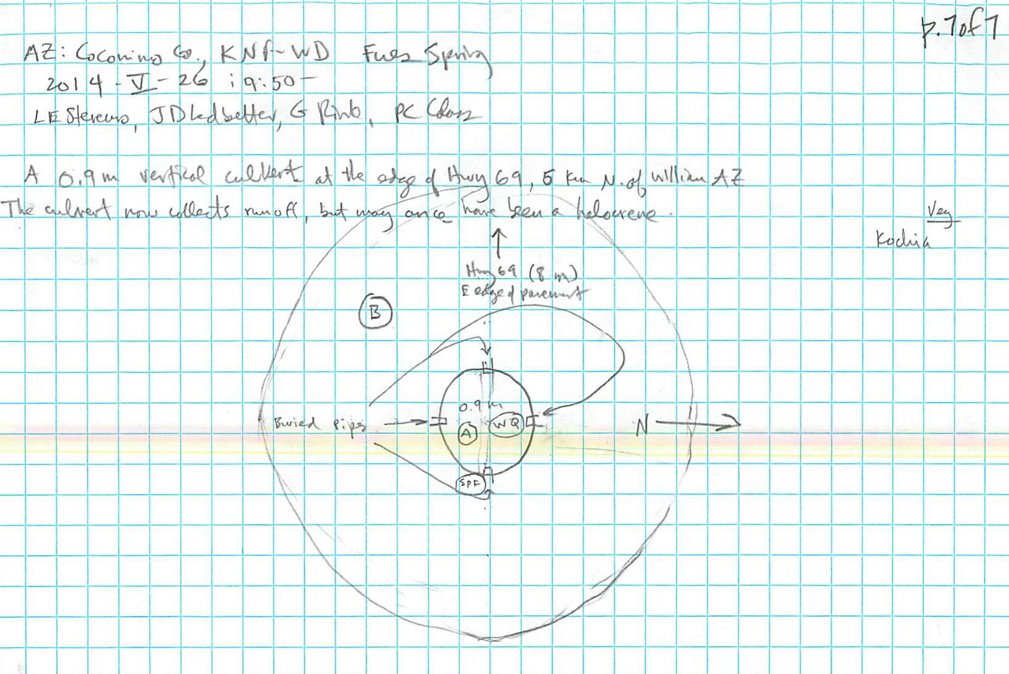
Fig 14.2 Fues Spring Sketchmap.

15. Griffiths Spring
15. Griffiths Spring
Survey Summary Report, Site ID 855
Submitted June 3, 2019 by Springs Stewardship Institute
Location: The Griffiths Spring ecosystem is located in Coconino County in the Upper Verde Arizona 15060202 HUC, managed by the US Forest Service. The spring is located in the Coconino NF, Mormon Lake RD, in the Mountainaire USGS Quad, at 35.11724, -111.70925 measured using a GPS (WGS84). The elevation is approximately 2092 meters. Larry Stevens, Jeri Ledbetter, Kit MacDonald, John Rihs, Heather Greene and other workshop participants surveyed the site on 6/01/16 for 02:00 hours, beginning at 13:20, and collected data in 8 of 10 categories. This survey was conducted under the NEPA Cleared List project using the Stevens et al. Level 2 protocol.

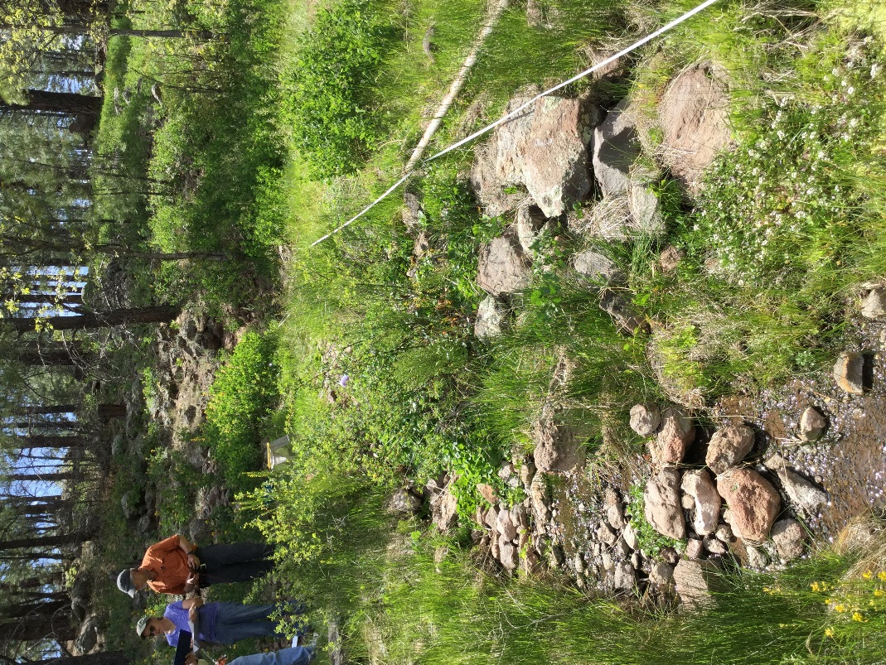
Fig 15.1 Griffiths Spring.

Physical Description: Griffiths Spring is a hillslope/anthropogenic spring. This is a small rehabilitated spring that emerges from the base of a basalt flow, passes through a formerly (removed) bermed pond, and descends into a low gradient cienega. The source is on a rocky hillslope about 100 meters downslope of Highway 89A. The microhabitat associated with the spring covers 9 sqm. The site has 1 microhabitat, A -- a 9 sqm channel.

Table 15.1 Griffiths Spring Microhabitat characteristics.
Code | A
Name | Source
Area sqm | 9
Surface type | CH
Surface subtype | riffle
Slope variability | Low
Aspect TN
Slope degrees | 3
Moisture (scale 1-10) | 9
Water depth cm | 3
Area % open water | 90
Substrate
1 - Clay % | 0
2 - Silt % | 20
3 - Sand % | 30
4 - Fine gravel % | 10
5 - Coarse gravel % | 5
6 - Cobble % | 5
7 - Boulder % | 0
8 - Bedrock % | 0
Organic % | 30
Other % (anthropogenic) | 0
Precipitate % | 3
Litter % | 0
Wood % | 0
Litter Depth (cm)

Geomorphology: Griffiths Spring emerges as a contact spring from an igneous, basalt rock layer in an unknown unit. The emergence environment is subaerial, with a gravity flow force mechanism. The site receives approximately 97% of available solar radiation, with 7139 Mj annually.

Access Directions: Follow highway 89A south from the Pulliam airport exit off of I17 for about 3 miles. You will see a sign to the left for Griffith Spring.

Survey Notes: The trail obstruction to divert visitors away from the spring is ineffective. Ponderosa pine thicket (Dog hair) incursion is increasing.

Flow: Surveyors measured a flow of 0.051 liters/second, using a timed flow volume capture method. Flow was adjusted for an estimate of 95% of site flow capture. Measured flow at the base of polygon A This spring is perennial.

Water Quality: Collected at the source

Table 15.2 Griffiths Spring Water Quality with multiple readings averaged.
Characteristic Measured | Average Value | Site Number | Device | Comments
pH (field) | 6.58 |  | Hanna Combo | Hanna green
Salinity (field) (ppt) | 0.485 |  | Hanna Combo | Hanna green

Fauna: Surveyors collected or observed 2 aquatic and 1 terrestrial invertebrates and 5 vertebrate specimens.

Table 15.3 Griffiths Spring Invertebrates.
Species | Lifestage | Habitat | Method | Rep# | Count | Species Detail
Coleoptera Dytiscidae Agabus lugens | Ad | A | Spot |  | 1 | under rocks near the source
Odonata Coenagrionidae Argia | Ad | T | Spot |  | 3
Odonata Coenagrionidae Argia | L | A | Spot |  | 1 | near the source

Table 15.4 Griffiths Spring Vertebrates.
Vertebrate Species Common Name | Count | Detection | Comments
White-breasted Nuthatch |  | call
Domestic Dog |  | obs
Common Raven | 1 | obs
Chipmunk | 1 | obs
Elk |  | sign | tracks and scat

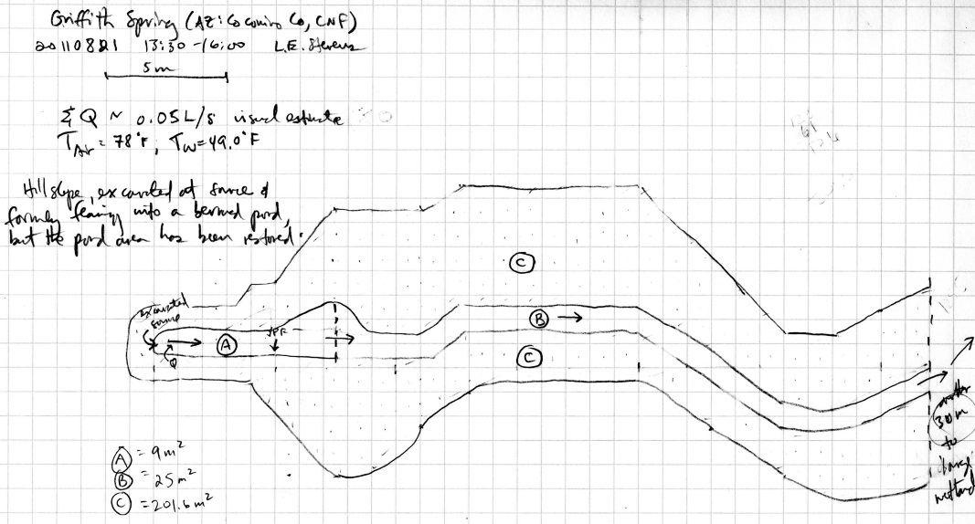
Fig 15.2 Griffiths Spring Sketchmap.

16. Griffiths Spring
16. Griffiths Spring
Survey Summary Report, Site ID 855
Submitted June 3, 2019 by Springs Stewardship Institute
Location: The Griffiths Spring ecosystem is located in Coconino County in the Upper Verde Arizona 15060202 HUC, managed by the US Forest Service. The spring is located in the Coconino NF, Mormon Lake RD, in the Mountainaire USGS Quad, at 35.11724, -111.70925 measured using a GPS (WGS84). The elevation is approximately 2092 meters. Larry Stevens and Workshop Participants surveyed the site on 5/29/19 for 02:00 hours, beginning at 10:45, and collected data in 10 of 10 categories. This survey was conducted under the NEPA Cleared List project using the Stevens et al. Level 2 protocol.

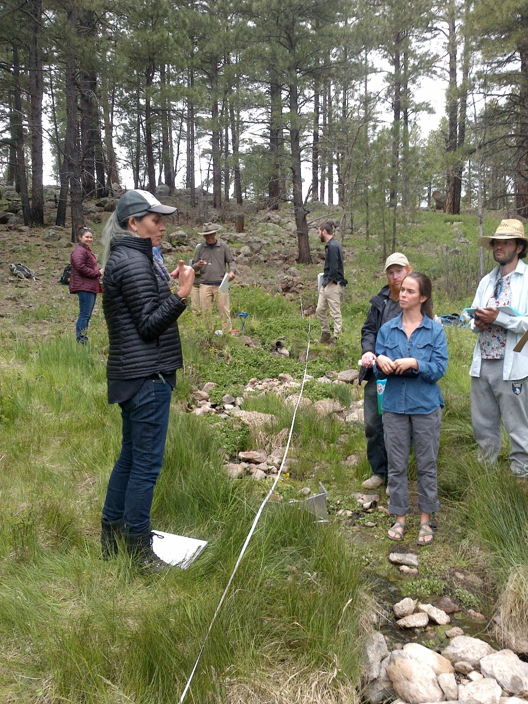
Fig 16.1 Griffiths Spring: View upslope toward the source from 19 meters on the tape, in the runout channel.

Physical Description: Griffiths Spring is a hillslope/anthropogenic spring. This is a small rehabilitated spring that emerges from the base of a basalt flow, passes through a formerly (removed) bermed pond, and descends into a low gradient cienega. The source is on a rocky hillslope about 100 meters downslope of Highway 89A. The microhabitats associated with the spring cover 153 sqm. The site has 3 microhabitats, including A -- a 5 sqm channel, B -- a 25 sqm channel, C -- a 123 sqm low gradient cienega. The geomorphic diversity is 0.25, based on the Shannon-Weiner diversity index.

Table 16.1 Griffiths Spring Microhabitat characteristics.
Code | A | B | C
Name | Source | Runout | LGC
Area sqm | 5 | 25 | 123
Surface type | CH | CH | LGC
Surface subtype | anthro | riffle
Slope variability | Med | Low | Low
Aspect TN | 81 | 81 | 18
Slope degrees | 8 | 6 | 6
Moisture (scale 1-10) | 7 | 8 | 5
Water depth cm | 8 | 6 | 0
Area % open water | 10 | 60 | 0
Substrate
1 - Clay % | 0 | 0 | 0
2 - Silt % | 5 | 15 | 40
3 - Sand % | 20 | 15 | 40
4 - Fine gravel % | 5 | 30 | 0
5 - Coarse gravel % | 30 | 30 | 0
6 - Cobble % | 40 | 5 | 0
7 - Boulder % | 0 | 0 | 0
8 - Bedrock % | 0 | 0 | 0
Organic % | 0 | 5 | 20
Other % (anthropogenic) | 0 | 0 | 0
Precipitate % | 0 | 5 | 0
Litter % | 5 | 5 | 5
Wood % | 0 | 0 | 1
Litter Depth (cm) | 0

Geomorphology: Griffiths Spring emerges as a contact spring from an igneous, basalt rock layer in an unknown unit. The emergence environment is subaerial, with a gravity flow force mechanism. The site receives approximately 97% of available solar radiation, with 7139 Mj annually.

Access Directions: Follow highway 89A south from the Pulliam airport exit off of I17 for about 3 miles. You will see a sign to the left for Griffith Spring.

Survey Notes: The site is subject to recreational use and the trail crosses over the source channel. Surveyors observed that heavy vegetation in the channel slows down head-water flow from spring source. The spring had signs of elk presence, such as scat and tracks.

Flow: Surveyors measured a flow of 0.42 liters/second, using a timed flow volume capture method. Flow was adjusted for an estimate of 85% of site flow capture. The flow measurement was taken 8.5 meters from downstream of the source channel. This spring is regular Intermittent.

Water Quality: The water quality was taken directly at the basalt spring source. Location 1: at the spring source in flowing water at 11:40:00.

Table 16.2 Griffiths Spring Water Quality with multiple readings averaged.
Characteristic Measured | Average Value | Site Number | Device | Comments
Alkalinity, Total (mg/L) | 42 | 1 | LaMotte
Dissolved oxygen (field) (mg/L) | 5.5 | 1 | CHEMets DO kit
pH (field) | 6.26 | 1 | Hanna Combo
Specific conductance (field) (uS/cm) | 1153 | 1 | Hanna Combo | Converted from EC=814
Temperature, air C | 18 | 1 | Handheld therm
Temperature, water C | 10.3 | 1 | Hanna Combo

Flora: The botany team did not have time to finish the survey. Cover values for microhabitat A are complete, but microhabitats B and C are incomplete. Surveyors identified 23 plant species at the site, with 0.1503 species/sqm. These included 21 native and 2 nonnative species.

Table 16.3 Griffiths Spring Cover Type.
Cover Type | Species Count | Wetland Species Count
Ground | 19 | 6
Shrub | 2 | 0
Mid-canopy | 2 | 0
Tall canopy | 0 | 0
Basal | 0 | 0
Aquatic | 1 | 1
Non-vascular | 0 | 0

Table 16.4 Griffiths Spring Vegetation % Cover in Microhabitats.
Species | Cover Code | Native Status | Wetland Status | Comments | A | B | C
algae | AQ | N | A |  | 8 | 0 | 0
Ambrosia psilostachya | GC | N | F |  | 0 | 1 | 0
Artemisia | GC | N | F |  | 0 | 0 | 2
Brassicaceae | GC | NI | F | yellow flowers | 1 | 0 | 0
Carex | GC | N | W |  | 5 | 15 | 0
Geranium richardsonii | GC | N | F |  | 2 | 0 | 0
Iris missouriensis | GC | N | F |  | 0.1 | 0.1 | 0
Lathyrus lanszwertii | GC | N |  |  | 5 | 2 | 0
Mimulus guttatus | GC | N | W |  | 10 | 0 | 0
Monarda | GC |  | F |  | 0 | 0 | 1
Nasturtium officinale | GC | I | W |  | 40 | 25 | 0
Pinus ponderosa | MC | N | F |  | 0 | 5 | 0
Pinus ponderosa | SC | N | F |  | 0 | 1 | 0
Poa fendleriana | GC | N | F |  | 2 | 1 | 10
Poaceae | GC | NI |  |  | 0 | 0 | 15
Poaceae | GC | NI |  | grass with blue-green blades | 3 | 15 | 0
Polygonum | GC | N | WR |  | 0 | 1 | 0
Quercus gambelii | MC | N | F |  | 5 | 0 | 0
Ranunculus | GC | N | WR |  | 0 | 1 | 0
Rosa woodsii | SC | N | F |  | 5 | 0.1 | 0
Rumex | GC | NI | F |  | 1 | 1 | 0
Solidago | GC | N | F |  | 0 | 1 | 0
Taraxacum officinale | GC | NI | F |  | 0 | 1 | 1
Veronica | GC | N | A |  | 0 | 1 | 0

Fauna: Surveyors collected or observed 13 aquatic and 10 terrestrial invertebrates and 14 vertebrate specimens.

Table 16.5 Griffiths Spring Invertebrates.
Species | Lifestage | Habitat | Method | Rep# | Count | Species Detail
Acarina | Ad | A | Benthic | 2 | 1 | water mite
Amphipoda | I | A | Benthic | 1 | 2
Amphipoda Hyalellidae Hyalella | Ad | A | Benthic | 2 | 2
Araneae Lycosidae | Ad | T | Spot |  |  | many
Basommatophora Physidae | Ad | A | Benthic | 2 | 3
Basommatophora Physidae | L | A | Benthic | 1 | 1 | with egg mass
Coleoptera Dytiscidae | Ad | A | Benthic | 2 | 5 | small predacious diving beetle
Coleoptera Dytiscidae Agabus | L | A | Benthic | 1 | 1
Diptera | Ad | T | Spot |  | 1 | housefly
Diptera Asilidae Efferia | Ad | T | Spot |  | 1
Diptera Chironomidae | L | A | Benthic | 2 | 1
Diptera Chironomidae | Ad | T | Spot |  | 1 | male
Diptera Simuliidae | L | A | Benthic | 2 | 21
Diptera Tipulidae | L | A | Benthic | 1 | 3
Diptera Tipulidae Limnophila | L | A | Benthic | 1 | 22
Hemiptera Anthocoridae Anthocoris | Ad | T | Spot |  | 1
Hemiptera Lygaeidae Lygaeus | Ad | T | Spot |  |  | many
Hemiptera Pentatomidae Chlorochroa uhleri | Ad | T | Spot |  | 1
Hymenoptera Formicidae Formica | Ad | T | Spot |  | 2
Lepidoptera Pieridae Colias eurytheme | Ad | T | Spot |  | 1
Orthoptera Acrididae | I | T | Spot |  | 1
Trichoptera Limnephilidae Hesperophylax | L | A | Benthic | 2 | 3
Zooplankton Ostracoda | Ad | A | Benthic | 1 | 1

Table 16.6 Griffiths Spring Benthic Invertebrate Sampling.
Rep# | Velocity (m/sec) | Depth (cm) | Area (sq m) | Time (sec) | Location | Substrate | Comments
1 | 0.10 | 2 | 0.09 | 60 | 19.5 m on tape | 30% 4, 30% 5, 40% 6
2 | 0.10 | 1 | 0.09 | 60 | 17.5 m on tape | 30% 5, 10% 4, 60% 3

Table 16.7 Griffiths Spring Vertebrates.
Vertebrate Species Common Name | Count | Detection | Comments
Steller's Jay | 2 | obs | also calls
Northern Flicker |  | call
Brown Creeper |  | call
Dark-eyed Junco |  | obs
Western Meadowlark |  | call
Violet-green Swallow |  | obs
American Robin |  | call
Elk |  | sign
Purple Martin | 1 | obs
Garter Snake | 1 | obs
American Black Bear |  | sign | scat
Deer |  | sign | scat and tracks
Plateau Fence Lizard | 1 | obs
American Crow | 1 | obs

Assessment: Assessment scores were compiled in 5 categories and 33 subcategories, with 9 null condition scores, and 9 null risk scores. Aquifer functionality and water quality are moderate with some restoration potential and there is low risk. Geomorphology condition is moderate with some restoration potential and there is low risk. Habitat condition is moderate with some restoration potential and there is low risk. Biotic integrity is good with significant restoration potential and there is low risk. Human influence of site is good with significant restoration potential and there is low risk. Administrative context status is undetermined due to null scores and there is undetermined risk due to null scores. Overall, the site condition is good with significant restoration potential and there is low risk.

Table 16.8 Griffiths Spring Assessment Scores.
Category | Condition | Risk
Aquifer Functionality & Water Quality | 3.3 | 2.8
Geomorphology | 3.2 | 2.8
Habitat | 3.8 | 2.4
Biota | 4.5 | 2.4
Human Influence | 4.2 | 2.4
Administrative Context | 0 | 0
Overall Ecological Score | 3.9 | 2.5

Management Recommendations: Geomorphic restoration of the source would be inexpensive and easily accomplished. Remove the hogwire. The primary management concern involves highway salt infiltrating the aquifer.

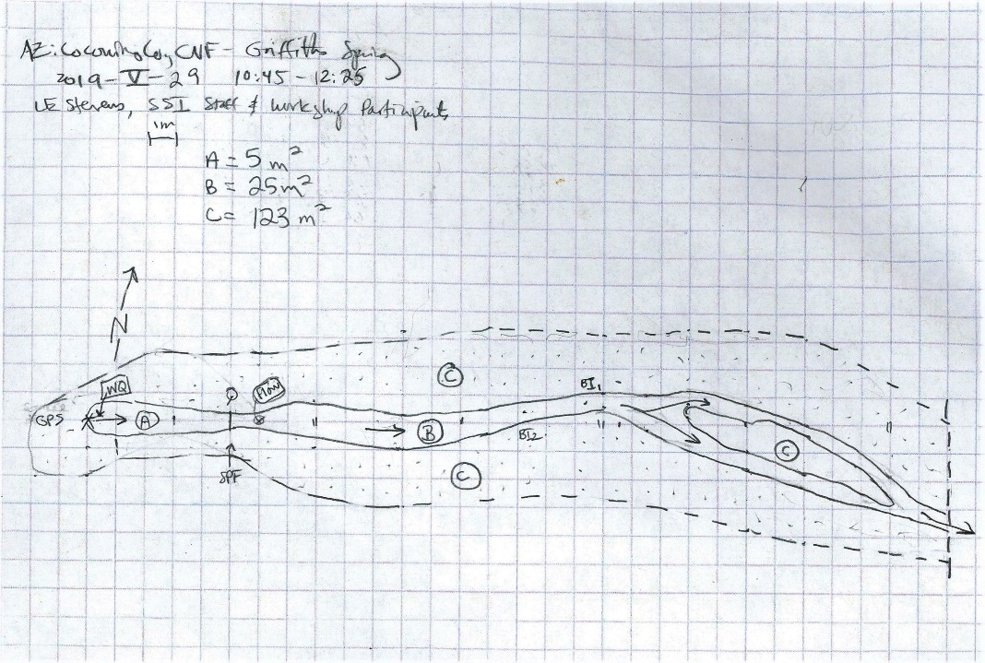
Fig 16.2 Griffiths Spring Sketchmap: Scanned image of sketch map.

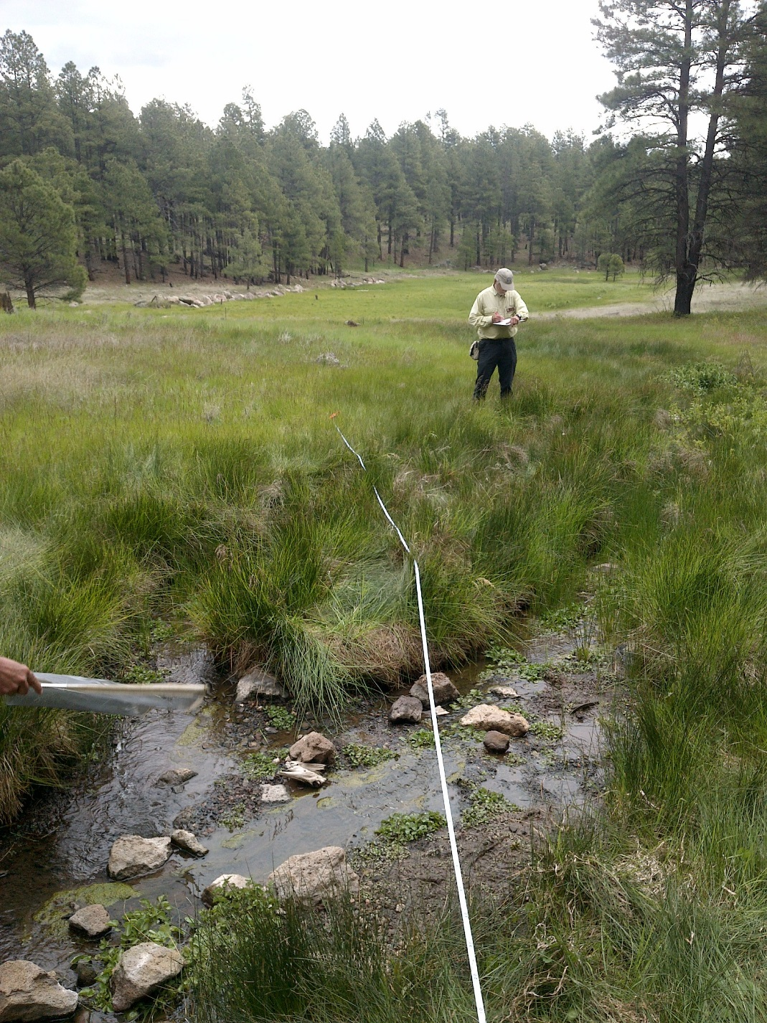
Fig 16.3 Griffiths Spring: View down the runout channel from 19 meters on the tape.

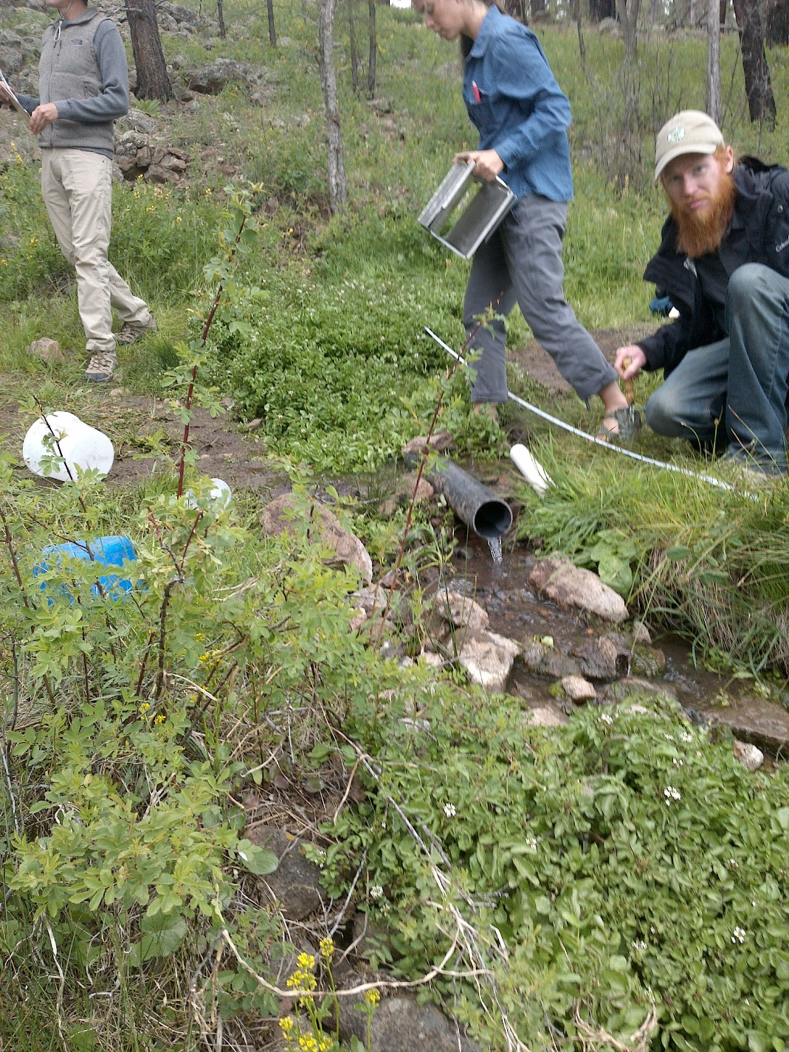
Fig 16.4 Griffiths Spring: Flow measurement location in the runout channel, below the source channel.

17. Hat Tank lower
17. Hat Tank lower
Survey Summary Report, Site ID 765
Submitted June 3, 2019 by Springs Stewardship Institute
Location: The Hat Tank lower ecosystem is located in Coconino County in the Upper Verde Arizona 15060202 HUC, managed by the US Forest Service. The spring is located in the Kaibab NF, Williams RD, in the May Tank Pocket USGS Quad, at 35.09281, -112.17659 measured using a GPS (NAD83, estimated position error 2 meters). The elevation is approximately 2036 meters. Larry Stevens, Jeri Ledbetter, and Anya Fayfer surveyed the site on 5/08/12 for 02:20 hours, beginning at 10:50, and collected data in 10 of 10 categories. This survey was conducted under the NEPA Cleared List project using the Stevens et al. Level 2 protocol.

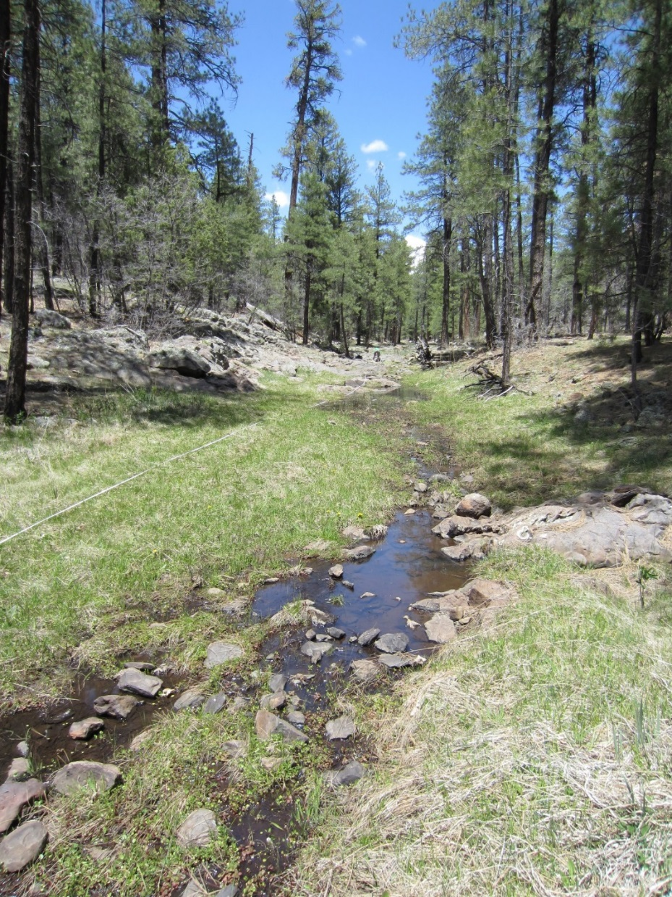
Fig 17.1 Hat Tank lower.

Physical Description: Hat Tank lower is a rheocrene spring. This rheocrene spring emerges in a small runoff-dominated channel in a heavily forested area. The microhabitats associated with the spring cover 674 sqm. The site has 2 microhabitats, including A -- a 114 sqm channel, B -- a 560 sqm terrace. The geomorphic diversity is 0.20, based on the Shannon-Weiner diversity index.

Table 17.1 Hat Tank lower Microhabitat characteristics.
Code | A | B
Name | Source Channel | Terrace
Area sqm | 114.00 | 560.00
Surface type | CH | TE
Surface subtype | run | LRZ
Slope variability | Low | Low
Aspect TN | 139 | 139
Slope degrees | 1 | 1
Moisture (scale 1-10) | 10 | 5
Water depth cm | 4.00
Area % open water | 50.00 | 0.00
Substrate
1 - Clay % | 0 | 0
2 - Silt % | 0 | 30
3 - Sand % | 2 | 25
4 - Fine gravel % | 13 | 20
5 - Coarse gravel % | 30 | 10
6 - Cobble % | 25 | 0
7 - Boulder % | 5 | 5
8 - Bedrock % | 0 | 5
Organic % | 25 | 5
Other % (anthropogenic) | 0 | 0
Precipitate % | 0.00 | 0.00
Litter % | 25.00 | 65.00
Wood % | 0.00 | 1.00
Litter Depth (cm) | 1.00 | 3.00

Geomorphology: Hat Tank lower emerges as a contact spring from an igneous, basalt rock layer in an unknown unit. The emergence environment is subaerial, with a gravity flow force mechanism. The site receives approximately 95% of available solar radiation, with 6495 Mj annually.

Access Directions: From the town of Williams, travel south on County Rd 73 for 12.3 mi. Turn left on NF-57 (Bear Springs Rd) and continue for 0.32 mi before turning right on NF-4218A and traveling south for 0.45 mi. Continue left onto Overland Rd for 0.3 mi. Spring is 430 m due east.

Survey Notes: Water at the spring during the survey was likely heavily influenced by recent precipitation, but the vegetation indicates that flow is more continuous than that provided only by runoff. There is little evidence of human use; however, the site is heavily grazed and trampled by elk. There are several natural pools, and the flow continues 260 m downstream.

Flow: Surveyors measured a flow of 21 liters/second, using a timed flow volume capture method. Flow was adjusted for an estimate of 1.00% of site flow capture. Flow was measured 59 m downstream from source pool. Site is likely ephemeral. This spring is regular Intermittent, with a neorefugium persistence.

Water Quality: Measurement device was the Hanna. Measurements were taken at a depth of 10cm. The EC calibration standard at 1413 microS/cm as 1630 on Hanna Combo EC & pH; pH standard @ 7.00, read as 7.07 Standing water, likely rainwater.

Table 17.2 Hat Tank lower Water Quality with multiple readings averaged.
Characteristic Measured | Average Value | Site Number | Device | Comments
pH (field) | 7.38 |  | Hanna/Ph Spear
Specific conductance (field) (uS/cm) | 95 |  | Hanna/Ph Spear
Temperature, air C | 20 |  | Handheld therm
Temperature, water C | 10.8 |  | Hanna/Ph Spear

Flora: Larry Stevens was the botanist. Surveyors identified 27 plant species at the site, with 0.0401 species/sqm. These included 20 native and 6 nonnative species; the native status of 1 species remains unknown.

Table 17.3 Hat Tank lower Cover Type.
Cover Type | Species Count | Wetland Species Count
Ground | 19 | 5
Shrub | 3 | 0
Mid-canopy | 1 | 0
Tall canopy | 1 | 0
Basal | 0 | 0
Aquatic | 3 | 3
Non-vascular | 2 | 0

Table 17.4 Hat Tank lower Vegetation % Cover in Microhabitats.
Species | Cover Code | Native Status | Wetland Status | Comments | A | B
Achillea millefolium | GC | NI | U |  | 0.1 | 5
Agrostis stolonifera | GC | I | W |  | 10 | 2
Artemisia ludoviciana | GC | N | F |  | 0 | 0.1
Carex aurea | GC | N | U |  | 2 | 15
Cirsium | GC | N | F |  | 0 | 1
Geranium richardsonii | GC | N | F |  | 0 | 0.1
Iris missouriensis | GC | N | F |  | 0 | 0.2
Juniperus | GC | N | U |  | 0 | 0.2
Juniperus deppeana | SC | N | U |  | 0 | 1
Lathyrus | GC | N | R |  | 0 | 3
Lichen | NV | N | U |  | 0 | 2
Mentha arvensis | GC | N | WR |  | 1 | 0.1
Mimulus | AQ | N | W |  | 0.2 | 0
Pinus ponderosa | MC | N | F |  | 1 | 7
Pinus ponderosa | SC | N | F |  | 0 | 8
Pinus ponderosa | TC | N | F |  | 1 | 5
Poa pratensis | GC | I | F |  | 1 | 20
Quercus gambelii | SC | N | F |  | 0 | 0.1
Ranunculus | AQ | N | WR |  | 2 | 0.1
Rumex | GC | I | WR | old | 0 | 1
Sidalcea neomexicana | GC | N | WR |  | 0 | 0.5
Taraxacum officinale | GC | I | F |  | 0 | 10
Thalictrum | GC | N | U |  | 0 | 0.1
Trifolium | GC | I | WR |  | 2 | 20
unknown Bryophyte (moss, liverwort, hornwort) | NV | N | F |  | 3 | 0
unknown dicot | GC |  |  | last year's | 0 | 0.1
Verbascum | GC | I | F |  | 0 | 0.1
Veronica | AQ | N | A |  | 3 | 0
Viola | GC | N | F |  | 0.1 | 3

Fauna: Surveyors collected or observed 18 aquatic and 50 terrestrial invertebrates and 8 vertebrate specimens.

Table 17.5 Hat Tank lower Invertebrates.
Species | Lifestage | Habitat | Method | Rep# | Count | Species Detail
Coleoptera | Ad |  | Spot |  | 8
Coleoptera Carabidae | Ad | T | Spot |  | 1
Coleoptera Chrysomelidae | Ad | T | Spot |  | 1
Coleoptera Dytiscidae | Ad | A | Spot |  | 1
Coleoptera Dytiscidae Agabus | Ad | A | Spot |  | 1
Coleoptera Hydrophilidae Enochrus | Ad | A | Spot |  | 1
Diplopoda | Ad | T | Spot |  | 1
Diptera | Ad | T | Spot |  | 1
Diptera Conopidae | Ad | T | Spot |  | 1
Diptera Sepsidae | Ad | T | Spot |  | 1
Diptera Stratiomyidae | Ad | T | Spot |  | 1
Diptera Tachinidae | Ad | T | Spot |  | 1
Ephemeroptera | L | A | Spot |  | 2
Hemiptera Cicadellidae | Ad | T | Spot |  | 1
Hemiptera Cixiidae | Ad | T | Spot |  | 1
Hemiptera Gerridae Aquarius remigis | Ad | A | Spot |  | 1
Hymenoptera Apidae Bombus | Ad | T | Spot |  | 1 | Taraxacum of
Hymenoptera Apidae Bombus | Ad | T | Spot |  | 1 | Taraxacum officinale
Lepidoptera | Ad | T | Spot |  | 1
Lepidoptera Hesperiidae Erynnis brizo | Ad | T | Spot |  | 1
Lepidoptera Hesperiidae Erynnis icelus | Ad | T | Spot |  | 1
Lepidoptera Hesperiidae Erynnis meridianus | Ad | T | Spot |  | 1
Lepidoptera Hesperiidae Erynnis telemachus | Ad | T | Spot |  | 1
Lepidoptera Hesperiidae Zestusa dorus | Ad | T | Spot |  | 1
Lepidoptera Lycaenidae Callophrys eryphon | Ad | T | Spot |  | 1
Lepidoptera Nymphalidae Nymphalis antiopa | Ad | T | Spot |  | 1
Lepidoptera Nymphalidae Speyeria | Ad | T | Spot |  | 1
Lepidoptera Nymphalidae Vanessa annabella | Ad | T | Spot |  | 1
Lepidoptera Papilionidae Papilio rutulus | Ad | T | Spot |  | 1
Lepidoptera Pieridae Pontia sisymbrii | Ad | T | Spot |  | 1
Mollusca | Ad |  | Spot |  | 2
Odonata | L | A | Spot |  | 1
Odonata Aeshnidae | L | A | Spot |  | 1
Odonata Coenagrionidae | Ad | T | Spot |  | 1
Odonata Coenagrionidae Argia nahuana | Ad | T | Spot |  | 1
Odonata Coenagrionidae Argia vivida | Ad | T | Spot |  | 1
Odonata Coenagrionidae Hesperagrion heterodoxum | Ad | T | Spot |  | 1
Odonata Libellulidae Libellula saturata | Ad | T | Spot |  | 1
Orthoptera Acrididae | Ad | T | Spot |  | 1
Trichoptera | L | A | Spot |  | 3
Trichoptera Limnephilidae | Ad | T | Spot
Veneroida Sphaeriidae Pisidium | Ad | A | Spot |  | 4

Table 17.6 Hat Tank lower Vertebrates.
Vertebrate Species Common Name | Count | Detection | Comments
hairy woodpecker | 1 | call
elk |  | sign | scat
chorus frog |  | call
deer |  | sign | jawbone
gopher |  | sign | holes
Virginia's warbler |  | obs
American robin |  | obs
domestic cow |  | sign | scat nearby

Assessment: Assessment scores were compiled in 6 categories and 41 subcategories, with 1 null condition score, and 1 null risk score. Aquifer functionality and water quality are good with significant restoration potential and there is low risk. Geomorphology condition is good with significant restoration potential and there is low risk. Habitat condition is moderate with some restoration potential and there is low risk. Biotic integrity is good with significant restoration potential and there is moderate risk. Human influence of site is good with significant restoration potential and there is negligible risk. Administrative context status is moderate with some restoration potential and there is low risk. Overall, the site condition is good with significant restoration potential and there is low risk.

Table 17.7 Hat Tank lower Assessment Scores.
Category | Condition | Risk
Aquifer Functionality & Water Quality | 4 | 2
Geomorphology | 4.2 | 2.6
Habitat | 3.8 | 2.6
Biota | 3.88 | 3
Human Influence | 4.56 | 1.63
Administrative Context | 3.67 | 2.5
Overall Ecological Score | 3.97 | 2.55

Management Recommendations: This site is subject to substantial natural flood flows, and therefore management priority is low. However, occasional monitoring is warranted.

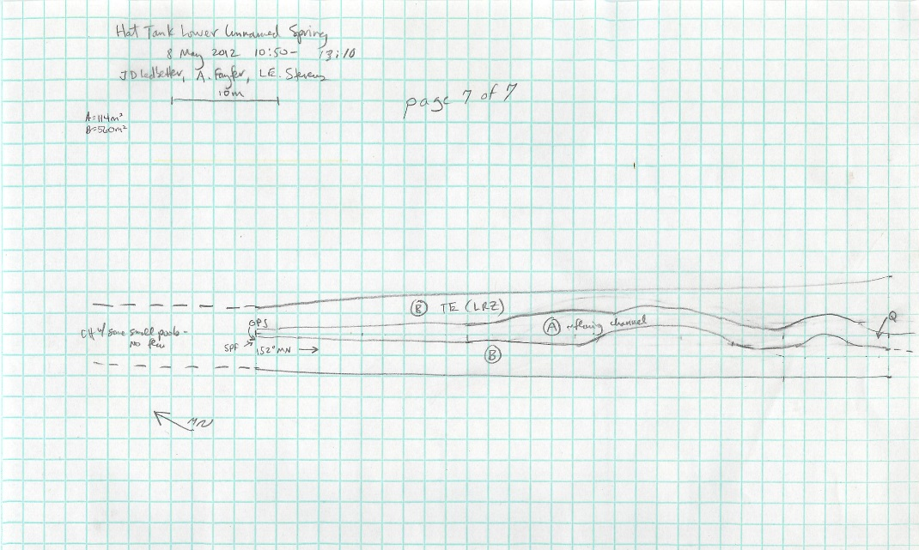
Fig 17.2 Hat Tank lower Sketchmap.

18. Hat Tank upper
18. Hat Tank upper
Survey Summary Report, Site ID 764
Submitted June 3, 2019 by Springs Stewardship Institute
Location: The Hat Tank upper ecosystem is located in Coconino County in the Upper Verde Arizona 15060202 HUC, managed by the US Forest Service. The spring is located in the Kaibab NF, Williams RD, in the May Tank Pocket USGS Quad, at 35.09550, -112.17070 measured using a GPS (NAD83, estimated position error 3 meters). The elevation is approximately 2065 meters. Larry Stevens, Jeri Ledbetter, and Anya Fayfer surveyed the site on 5/08/12 for 01:20 hours, beginning at 13:50, and collected data in 10 of 10 categories. This survey was conducted under the NEPA Cleared List project using the Stevens et al. Level 2 protocol.

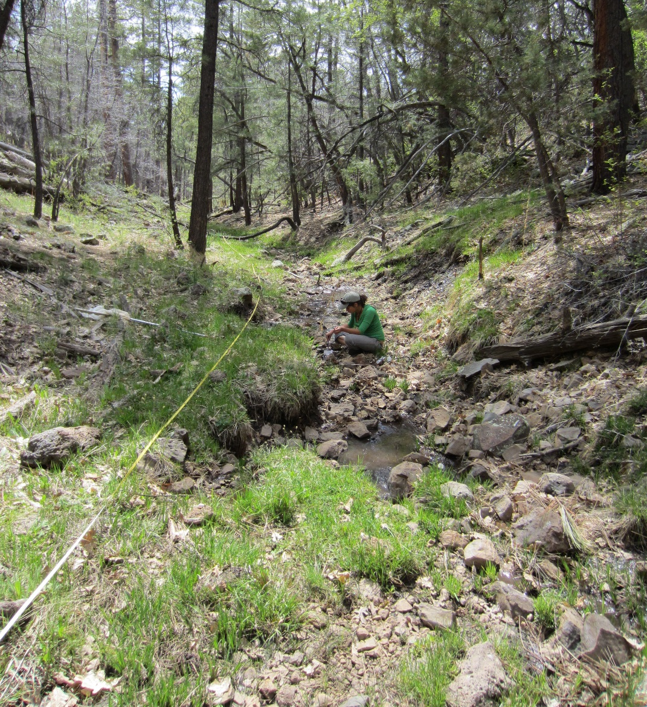
Fig 18.1 Hat Tank upper.

Physical Description: Hat Tank upper is a rheocrene/hillslope spring. This is a small rheocrene hillslope spring. There is some seepage in the channel and some from the bank. Two hundred meters downstream is Hat Tank that has been excavated to capture flow. The microhabitats associated with the spring cover 178 sqm. The site has 3 microhabitats, including A -- a 38 sqm channel, B -- a 36 sqm colluvial slope, C -- a 104 sqm terrace. The geomorphic diversity is 0.42, based on the Shannon-Weiner diversity index.

Table 18.1 Hat Tank upper Microhabitat characteristics.
Code | A | B | C
Name | Source Channel | Source Seeping Bank | Terrace
Area sqm | 38.00 | 36.00 | 104.00
Surface type | CH | CS | TE
Surface subtype | run |  | LRZ
Slope variability | Low | Med | Med
Aspect TN | 242 | 312 | 242
Slope degrees | 2 | 60 | 2
Moisture (scale 1-10) | 10 | 8 | 1
Water depth cm | 2.00
Area % open water | 80.00
Substrate
1 - Clay % | 0 | 0 | 0
2 - Silt % | 0 | 0 | 0
3 - Sand % | 0 | 0 | 0
4 - Fine gravel % | 5 | 0 | 5
5 - Coarse gravel % | 35 | 10 | 25
6 - Cobble % | 10 | 5 | 10
7 - Boulder % | 0 | 0 | 0
8 - Bedrock % | 0 | 0 | 0
Organic % | 50 | 85 | 60
Other % (anthropogenic) | 0 | 0 | 0
Precipitate % | 0.00 | 0.00 | 0.00
Litter % | 5.00 | 0.00 | 0.00
Wood % | 1.00 | 5.00 | 3.00
Litter Depth (cm) | 0.50 | 1.00 | 1.00

Geomorphology: Hat Tank upper emerges as a seepage or filtration spring from an igneous, basalt rock layer in an unknown unit. The emergence environment is subaerial, with a gravity flow force mechanism. The site receives approximately 98% of available solar radiation, with 6717 Mj annually.

Access Directions: From the town of Williams, travel south on County Rd 73 for 12.3 mi. Turn left on NF-57 (Bear Springs Rd) and continue for 0.54 mi before turning right on NF-4216A and traveling SE for 0.2 mi. Turn right on NF-4217 and travel south for 0.7 mi. Spring is 150 m due SE.

Survey Notes: There has been some trailing by animals and maybe humans. The recent rain/snow is likely influencing water quality values.

Flow: Surveyors measured a flow of 11 liters/second, using a timed flow volume capture method. Flow was adjusted for an estimate of 1.00% of site flow capture. Flow was measured 40 m below first emergence. This spring is perennial, with a neorefugium persistence.

Water Quality: Water quality measurements were taken at the top end of source pool and in a hillslope tributary seep at about 28 m on main transect. The first point was at 1.5 cm depth and the second two in the tributary were at 2.0 cm.

Table 18.2 Hat Tank upper Water Quality with multiple readings averaged.
Characteristic Measured | Average Value | Site Number | Device | Comments
Alkalinity, Total (mg/L) | 30 |  | test strips | in the tributary seep pt 2
Hardness, Ca + Mg (mg/L) | 20 |  | test strips | in the tributary seep pt 2
pH (field) | 6.97 |  | Hanna/Ph Spear | at the top end of source pool
Specific conductance (field) (uS/cm) | 108.5 |  | Hanna/Ph Spear | at the top end of source pool
Temperature, air C | 20 |  | Handheld therm
Temperature, water C | 10.1 |  | Hanna/Ph Spear | at the top end of source pool

Flora: Larry Stevens was the botanist. Surveyors identified 25 plant species at the site, with 0.1404 species/sqm. These included 20 native and 4 nonnative species; the native status of 1 species remains unknown.

Table 18.3 Hat Tank upper Cover Type.
Cover Type | Species Count | Wetland Species Count
Ground | 21 | 7
Shrub | 3 | 0
Mid-canopy | 1 | 0
Tall canopy | 1 | 0
Basal | 0 | 0
Aquatic | 0 | 0
Non-vascular | 0 | 0

Table 18.4 Hat Tank upper Vegetation % Cover in Microhabitats.
Species | Cover Code | Native Status | Wetland Status | Comments | A | B | C
Achillea millefolium | GC | N | U |  | 0 | 0 | 5
Agrostis stolonifera | GC | I | W |  | 10 | 15 | 20
Carex aurea | GC | N | U |  | 5 | 5 | 15
Cirsium | GC | N | F |  | 0 | 0 | 0.3
Geranium | GC | N | F |  | 0 | 0 | 1
Gnaphalium chilense | GC | N | WR | question mark on species | 0 | 0 | 0.1
Iris missouriensis | GC | N | F |  | 0.1 | 1 | 2
Juniperus deppeana | SC | N | U |  | 3 | 20 | 4
Lupinus | GC | N | F |  | 0 | 0 | 0.2
Mimulus guttatus | GC | N | W |  | 1 | 1 | 0
Pinus ponderosa | MC | N | F |  | 6 | 25 | 15
Pinus ponderosa | TC | N | F |  | 5 | 30 | 15
Polygonum | GC | N | WR |  | 0 | 0 | 0.1
Quercus gambelii | SC | N | F |  | 1 | 0 | 3
Ranunculus | GC | N | WR |  | 0.2 | 0.2 | 1
Rosa woodsii | SC | N | F |  | 1 | 8 | 5
Solidago | GC | N | F |  | 0 | 0 | 0.2
Taraxacum officinale | GC | I | F |  | 0 | 0 | 8
Thalictrum | GC | N | U |  | 0 | 0 | 1
Trifolium | GC | I | WR |  | 0.1 | 5 | 8
unknown grass | GC |  |  | poa? | 5 | 20 | 20
Verbascum | GC | I | F |  | 0 | 0 | 1
Veronica | GC | N | A |  | 1 | 1 | 0
Vicia | GC | N | WR | species 2 | 0 | 0 | 2
Vicia | GC | N | WR | unknown vetch | 0 | 0 | 0.5
Viola | GC | N | F |  | 0 | 0 | 0.1

Fauna: Surveyors collected or observed 1 aquatic and 9 terrestrial invertebrates and 9 vertebrate specimens.

Table 18.5 Hat Tank upper Invertebrates.
Species | Lifestage | Habitat | Method | Rep# | Count | Species Detail
Diptera Syrphidae | Ad | T | Spot |  | 1
Lepidoptera Hesperiidae Epargyreus clarus | Ad | T | Spot |  | 1
Lepidoptera Hesperiidae Erynnis icelus | Ad | T | Spot |  | 1
Lepidoptera Hesperiidae Zestusa dorus | Ad | T | Spot |  | 1 | Taraxacum of
Lepidoptera Hesperiidae Zestusa dorus | Ad | T | Spot |  | 1 | Taraxacum officinale
Lepidoptera Pieridae Pontia sisymbrii | Ad | T | Spot |  | 1 | Taraxacum of
Lepidoptera Pieridae Pontia sisymbrii | Ad | T | Spot |  | 1 | Taraxacum officinale

Table 18.6 Hat Tank upper Vertebrates.
Vertebrate Species Common Name | Count | Detection | Comments
American robin | 1 | obs
white-breasted nuthatch |  | call
elk |  | sign | scat
Common raven |  | call
hermit thrush |  | obs
warbler |  | call
hummingbird |  | call
domestic cow |  | sign | scat
Terrestrial Gartersnake |  | obs

Assessment: Assessment scores were compiled in 6 categories and 42 subcategories, with 0 null condition scores, and 1 null risk score. Aquifer functionality and water quality are good with significant restoration potential and there is low risk. Geomorphology condition is moderate with some restoration potential and there is low risk. Habitat condition is moderate with some restoration potential and there is moderate risk. Biotic integrity is good with significant restoration potential and there is low risk. Human influence of site is good with significant restoration potential and there is low risk. Administrative context status is good with significant restoration potential and there is moderate risk. Overall, the site condition is good with significant restoration potential and there is low risk.

Table 18.7 Hat Tank upper Assessment Scores.
Category | Condition | Risk
Aquifer Functionality & Water Quality | 4.17 | 1.83
Geomorphology | 3.6 | 2.8
Habitat | 3.8 | 3
Biota | 4.5 | 2.13
Human Influence | 4.44 | 1.88
Administrative Context | 3.89 | 3.38
Overall Ecological Score | 4.02 | 2.44

Management Recommendations: As a rheocrene, this spring is subject to natural flood disturbance. Elk fencing would prevent trampling and allow regrowth of riparian vegetation. As Hat Tank is just downstream, faunal species will still have access to water. Monitoring is appropriate.

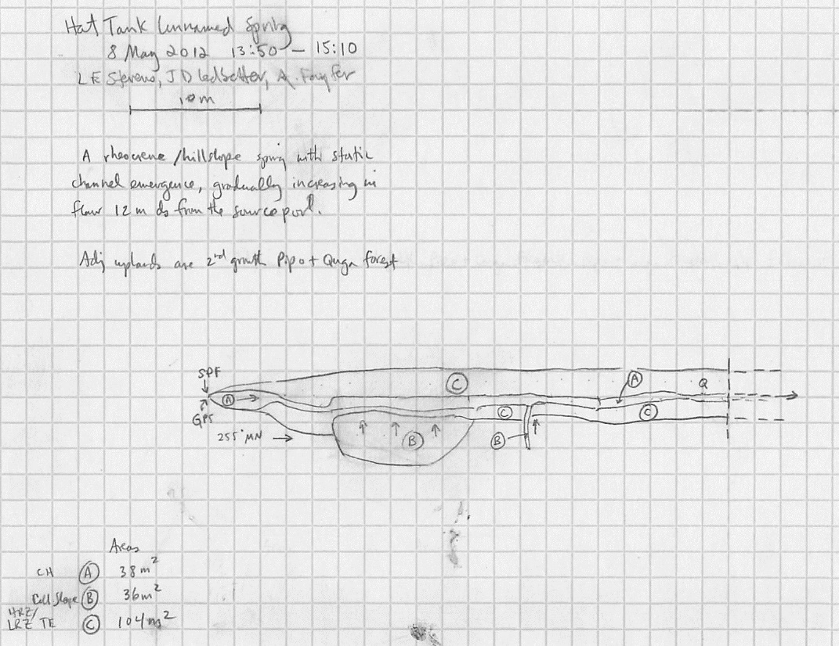
Fig 18.2 Hat Tank upper Sketchmap.

19. Hi Fuller Spring
19. Hi Fuller Spring
Survey Summary Report, Site ID 429
Submitted June 3, 2019 by Springs Stewardship Institute
Location: The Hi Fuller Spring ecosystem is located in Coconino County in the Middle Little Colorado Arizona 15020008 HUC, managed by the US Forest Service. The spring is located in the Coconino NF, Mogollon Rim RD, in the Kehl Ridge USGS Quad, at 34.47114, -111.26112 measured using a GPS (NAD83, estimated position error 4 meters). The elevation is approximately 2216 meters. Larry Stevens, Glenn Rink, Beep Jenkins, William S. Talashoma surveyed the site on 7/04/10 for 01:40 hours, beginning at 8:35, and collected data in 10 of 10 categories. This survey was conducted under the NEPA Cleared List project using the Stevens et al. Level 2 protocol.

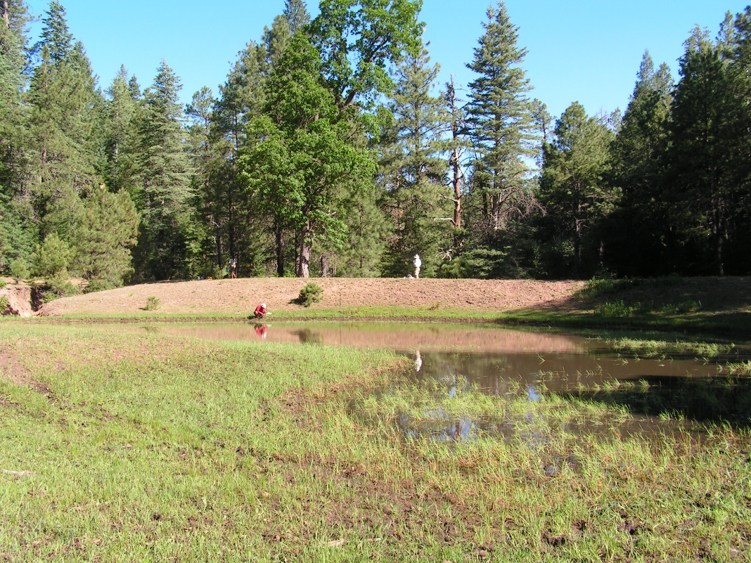
Fig 19.1 Hi Fuller Spring.

Physical Description: Hi Fuller Spring is a helocrene/exposure spring. This is a large wet Helocrene Cienega that appears to be anthropogenic. There is seepage from a bermed pond with some possible spring seepage continuation from the South side. This spring discharges into large drainage channels. A berm at the source has created a stock tank wherein the spring discharges. The microhabitats associated with the spring cover 1030 sqm. The site has 2 microhabitats, including A -- a 710 sqm low gradient cienega, B -- a 320 sqm colluvial slope. The geomorphic diversity is 0.27, based on the Shannon-Weiner diversity index.

Table 19.1 Hi Fuller Spring Microhabitat characteristics.
Code | A | B
Name | Source LGC | colluvial slope
Area sqm | 710.00 | 320.00
Surface type | LGC | CS
Surface subtype
Slope variability | Low | Low
Aspect TN | 253
Slope degrees | 2 | 6
Moisture (scale 1-10) | 8 | 5
Water depth cm | 12.00
Area % open water | 90.00 | 0.00
Substrate
1 - Clay % | 0 | 0
2 - Silt % | 0 | 0
3 - Sand % | 0 | 0
4 - Fine gravel % | 0 | 0
5 - Coarse gravel % | 0 | 0
6 - Cobble % | 0 | 0
7 - Boulder % | 0 | 0
8 - Bedrock % | 0 | 0
Organic % | 100 | 100
Other % (anthropogenic) | 0 | 0
Precipitate % | 0.00 | 0.00
Litter % | 95.00 | 98.00
Wood % | 3.00 | 2.00
Litter Depth (cm) | 5.00 | 3.00

Geomorphology: Hi Fuller Spring emerges as a contact spring from the Kaibab Limestone, a sedimentary, unconsolidated rock layer. The emergence environment is subaerial, with a gravity flow force mechanism. The site receives approximately 97% of available solar radiation, with 7112 Mj annually.

Access Directions: From Rim Rd (FR 300) go north on FS Rd 501 1/2 mile to intersection with 141H. Continue north on 501 about 2.5 km (1.5 miles). Spring is about 220 meters west of the road, in the Hi Fuller Canyon drainage.

Survey Notes: This survey was conducted by Grand Canyon Wildlands Council surveyors on the Mogollon Rim project, funded by the Nina Mason Pulliam Charitable Trust. The site has been heavily manipulated; the seepage emerges from a bermed pond.

Flow: There was no outflow to measure. Surveyors were unable to measure flow due to no outflow.

Water Quality: No water samples were taken because there was only standing water.

Table 19.2 Hi Fuller Spring Water Quality with multiple readings averaged.
Characteristic Measured | Average Value | Site Number | Device | Comments
pH (field) | 8.226
Specific conductance (field) (uS/cm) | 81.2
Temperature, air C | 19
Temperature, water C | 10.1

Flora: The ID numbers in the vegetation species detail field are from Glenn Rink, who conducted the vegetation survey. Surveyors identified 32 plant species at the site, with 0.0311 species/sqm. These included 23 native and 8 nonnative species; the native status of 1 species remains unknown.

Table 19.3 Hi Fuller Spring Cover Type.
Cover Type | Species Count | Wetland Species Count
Ground | 18 | 6
Shrub | 2 | 1
Mid-canopy | 1 | 0
Tall canopy | 3 | 0
Basal | 0 | 0
Aquatic | 7 | 5
Non-vascular | 1 | 0

Table 19.4 Hi Fuller Spring Vegetation % Cover in Microhabitats.
Species | Cover Code | Native Status | Wetland Status | Comments | A | B
Abies concolor | TC | N | U |  | 4 | 5
Achillea millefolium | GC | NI | U |  | 0 | 0.05
Amelanchier alnifolia | SC | N | F |  | 0 | 0.5
Barbarea vulgaris | GC | I | W | GR 9743 | 3 | 2
Carex | AQ | N |  | CR 9742 | 0.1 | 0
Carex microptera | GC | N | W |  | 0.1 | 0.1
Dactylis glomerata | GC | I | W |  | 0 | 1
Fragaria | GC | N | U |  | 0 | 0.05
Galium | AQ | I? | F | GR Glvd, broad | 0.01 | 0
Geranium richardsonii | GC | N | F |  | 1 | 1
Hymenoxys hoopesii | GC | N | F | GR Helenium hoopsii | 0 | 1
Hypericum frondosum | GC | N | F |  | 0.01 | 0.03
Juncus | AQ | N |  | GR 9736 | 65 | 15
Lamiaceae | AQ |  | WR |  | 1 | 1
Mertensia franciscana | GC | N | F |  | 0 | 0.3
Pinus flexilis | MC | N | U |  | 0.3 | 3
Pinus ponderosa | TC | N | F |  | 5 | 10
Platanthera | GC | N | W | GR 9744 | 0.02 | 0
Poa pratensis | GC | I | F |  | 1 | 2
Pteridium aquilinum | GC | N | U |  | 0 | 15
Quercus gambelii | TC | N | F |  | 0 | 2
Rudbeckia laciniata | GC | N | F |  | 20 | 5
Rumex acetosella | GC | I | W | GR 9749 | 0.01 | 0
Rumex crispus | AQ | I | WR |  | 1 | 0.01
Salix bebbiana | SC | N | WR | GR 9745 | 3 | 2
Stellaria longifolia | AQ | N | F | GR 9741 | 1 | 0
Taraxacum officinale | GC | I | F |  | 0 | 1
Thermopsis divaricarpa | GC | N | F | GR pinetorum | 1 | 40
Trifolium | GC | I | WR |  | 3 | 5
unknown Bryophyte (moss, liverwort, hornwort) | NV | N | F |  | 3 | 1
Veronica americana | AQ | N | A |  | 0.01 | 0
Vicia americana | GC | N | F |  | 0.5 | 1

Fauna: Surveyors collected or observed 7 aquatic and 55 terrestrial invertebrates and 10 vertebrate specimens.

Table 19.5 Hi Fuller Spring Invertebrates.
Species | Lifestage | Habitat | Method | Rep# | Count | Species Detail
Araneae | Ad | T | Spot |  | 2
Coleoptera | Ad |  | Spot |  | 1
Coleoptera Elateridae | Ad | T | Spot |  | 1
Coleoptera Gyrinidae | Ad | A | Spot |  | 1 | Pond
Coleoptera Tenebrionidae | Ad | T | Spot |  | 1 | Pond
Diptera | L |  | Spot |  | 5
Diptera Bombyliidae | Ad | T | Spot |  | 1
Diptera Dolichopodidae | Ad | T | Spot |  | 1
Diptera Muscidae | Ad | T | Spot |  | 1
Diptera Tipulidae | Ad | T | Spot |  | 1
Ephemeroptera | L | A | Spot |  | 1
Hemiptera | Ad | T | Spot |  | 1
Hemiptera Gerridae | Ad | A | Spot |  | 1
Hemiptera Gerridae Aquarius remigis | Ad | A | Spot |  | 1 | Pond
Hemiptera Miridae | Ad | T | Spot |  | 1
Homoptera | E |  | Spot |  | 7
Hymenoptera | Ad | T | Spot |  | 1
Hymenoptera Crabronidae | Ad | T | Spot |  | 1
Hymenoptera Formicidae | Ad | T | Spot |  | 4
Hymenoptera Formicidae Formica | Ad | T | Spot |  | 6
Hymenoptera Formicidae Formica | Ad | T | Spot |  | 1 | pond
Hymenoptera Formicidae Formica fusca complex | Ad | T | Spot |  | 1
Hymenoptera Formicidae Pheidole | Ad | T | Spot |  | 3
Lepidoptera Hesperiidae Polites themistocles | Ad | T | Spot |  | 1
Lepidoptera Hesperiidae Pyrgus communis complex | Ad | T | Spot |  | 1
Lepidoptera Lycaenidae Celastrina echo | Ad | T | Spot |  | 1
Lepidoptera Lycaenidae Plebejus glandon | Ad |  | Spot |  | 1
Lepidoptera Nymphalidae Adelpha bredowii | Ad | T | Spot |  | 1
Lepidoptera Nymphalidae Speyeria |  | T | Spot
Lepidoptera Nymphalidae Speyeria nokomis | Ad | T | Spot |  | 1
Lepidoptera Nymphalidae Vanessa cardui | Ad | T | Spot |  | 1
Lepidoptera Pieridae Colias alexandra | Ad | T | Spot |  | 1
Odonata | L | A | Spot |  | 2
Odonata Aeshnidae Rhionaeschna multicolor | Ad | T | Spot
Odonata Coenagrionidae Enallagma boreale | Ad | T | Spot |  | 1 | pond
Odonata Libellulidae Libellula pulchella | Ad | T | Spot |  | 1
Odonata Libellulidae Libellula quadrimaculata | Ad | T | Spot |  | 1
Odonata Libellulidae Plathemis lydia |  | T | Spot
Odonata Zygoptera |  | T | Spot
Trichoptera | L | A | Spot |  | 6

Table 19.6 Hi Fuller Spring Vertebrates.
Vertebrate Species Common Name | Count | Detection | Comments
American robin
hermit thrush |  |  | ?
violet-green swallow
band-tailed pigeon
Terrestrial Gartersnake |  |  | eating a tadpole
tiger salamander
striped chorus frog
chipping sparrow
red squirrel
elk |  |  | heavy trampling, some browsing

Assessment: Assessment scores were compiled in 5 categories and 32 subcategories, with 10 null condition scores, and 10 null risk scores. Aquifer functionality and water quality are moderate with some restoration potential and there is moderate risk. Geomorphology condition is moderate with some restoration potential and there is high risk. Habitat condition is good with significant restoration potential and there is moderate risk. Biotic integrity is moderate with some restoration potential and there is moderate risk. Human influence of site is good with significant restoration potential and there is low risk. Administrative context status is undetermined due to null scores and there is undetermined risk due to null scores. Overall, the site condition is moderate with some restoration potential and there is moderate risk.

Table 19.7 Hi Fuller Spring Assessment Scores.
Category | Condition | Risk
Aquifer Functionality & Water Quality | 3.2 | 3
Geomorphology | 3 | 4
Habitat | 4 | 3
Biota | 3.3 | 3.4
Human Influence | 3.9 | 2.8
Administrative Context | 0 | 0
Overall Ecological Score | 3.5 | 3.2

Management Recommendations: The bermed tank is eroding and already incising a channel off to the side of the natural channel. When the tank breaks completely, that new side channel likely will cause erosion and abandonment of the original channel. The presence of decadent bebb’s willow further indicates that elk, livestock grazing, as well as tank construction, have created serious geomorphic and ecological impacts on this likely former rheocrenic helocrene.

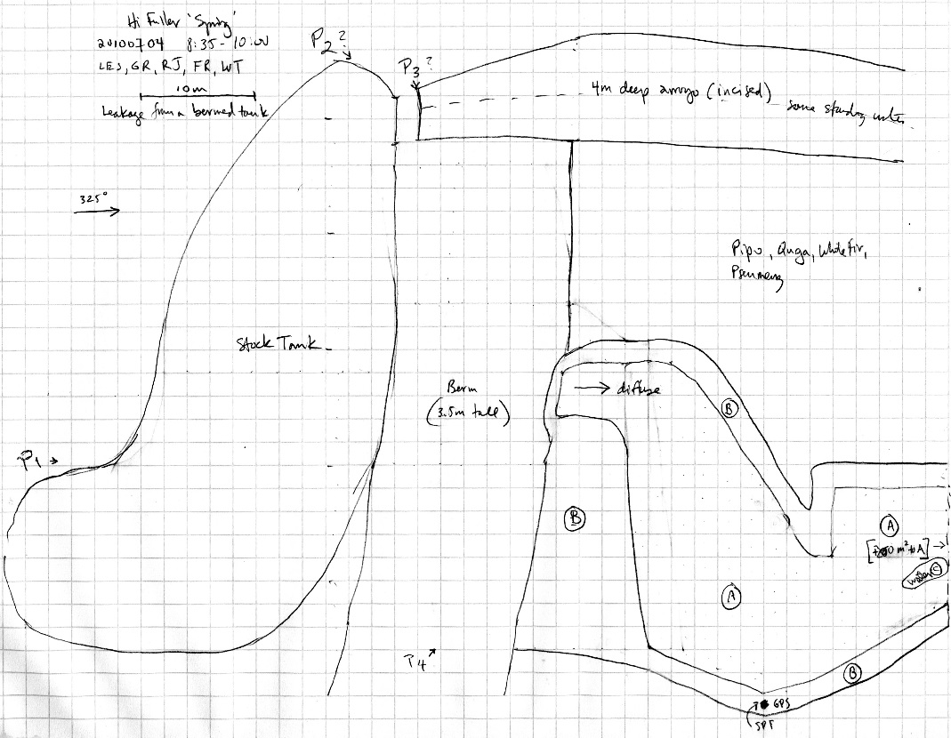
Fig 19.2 Hi Fuller Spring Sketchmap.

20. Hoxworth Springs
20. Hoxworth Springs
Survey Summary Report, Site ID 996
Submitted June 3, 2019 by Springs Stewardship Institute
Location: The Hoxworth Springs ecosystem is located in Coconino County in the Canyon Diablo Arizona 15020015 HUC, managed by the US Forest Service. The spring is located in the Coconino NF, Mormon Lake RD, in the Lower Lake Mary USGS Quad, at 35.04044, -111.57491 (WGS84). The elevation is approximately 2143 meters. Larry Stevens and SSI Workshop participants surveyed the site on 6/12/18 for 01:20 hours, beginning at 10:15, and collected data in 8 of 10 categories. This survey was conducted under the NEPA Cleared List project using the Stevens et al. Level 2 protocol.

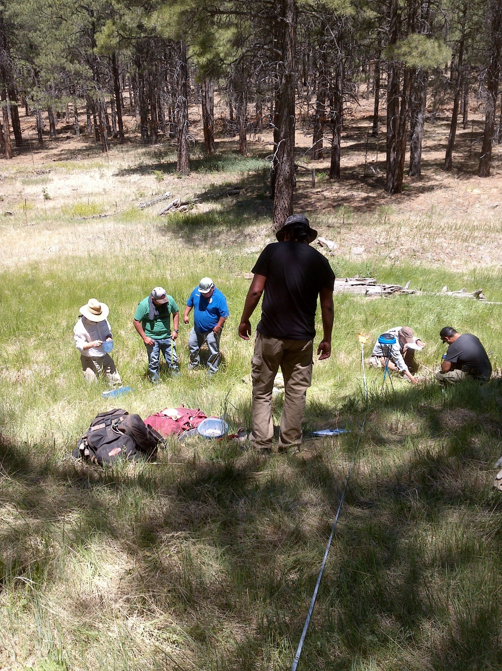
Fig 20.1 Hoxworth Springs.

Physical Description: Hoxworth Springs is a hillslope/rheocrene spring. Dr. Abe Springer from NAU refers to this site as Hoxworth Fracture. It is one of several sources that support a large wet meadow. The source is approximately 100 meters upslope of site 997, Hoxworth Springs at the Fault. It is bound on the east side by an exposed Kaibab Limestone bedrock slope and a fence. The microhabitats associated with the spring cover 64.5 sqm. The site has 2 microhabitats, including A -- a 47 sqm terrace, B -- a 18 sqm channel. The geomorphic diversity is 0.26, based on the Shannon-Weiner diversity index.

Table 20.1 Hoxworth Springs Microhabitat characteristics.
Code | A | B
Name | Terrace | Channel
Area sqm | 46.75 | 17.75
Surface type | TE | CH
Surface subtype | MRZ | eph
Slope variability | Low | Low
Aspect TN | 297 | 7
Slope degrees | 10 | 3
Moisture (scale 1-10) | 1 | 8
Water depth cm | 0 | 8
Area % open water | 0 | 20
Substrate
1 - Clay % | 50 | 20
2 - Silt % | 28 | 15
3 - Sand % | 5 | 9
4 - Fine gravel % | 5 | 1
5 - Coarse gravel % | 1 | 10
6 - Cobble % | 1 | 20
7 - Boulder % | 0 | 15
8 - Bedrock % | 0 | 0
Organic % | 10 | 10
Other % (anthropogenic) | 0 | 0
Precipitate % | 0 | 0
Litter % | 85 | 3
Wood % | 1 | 1
Litter Depth (cm) | 5 | 1

Geomorphology: Hoxworth Springs emerges as a fracture spring from the Kaibab Limestone, a sedimentary, limestone rock layer. The emergence environment is subaerial, with a gravity flow force mechanism.

Access Directions: From Lake Mary Rd (CR-3), travel SE on Crimson Rd for 0.5 mi. Turn left on NF-296 and continue for 4.5 mi, connecting to NF-132B for 0.6 mi. Keep left on Hoxworth Springs Rd for 1.5 mi. Spring is 325 m due SW.

Survey Notes: There are fences on the east and west that are approximately seven feet tall, with six inch square mesh from ground to approximately four feet high, with upper wire that has five single strands to the top. There is a standing pool of stagnant ground water. There is a standing body of water approximately 20 meters upchannel, outside of the site map, roughly twice the size of the mapped pool. The largely dry, narrow stream channel is approximately one meter wide in most places, and runs through the middle of the long meadow. There is a new road on the west side about forty meters from the pool. The mapped terrace is actually two terraces, although vegetation and vegetative cover are similar.

Flow: Flow was adjusted for an estimate of 100% of site flow capture. Meter nine. This spring is dry intermittent, with a neorefugium persistence.

Water Quality: Surface water is unlikely from spring; it is stagnant. Location 1: in a pool in standing water at 11:00:00.

Table 20.2 Hoxworth Springs Water Quality with multiple readings averaged.
Characteristic Measured | Average Value | Site Number | Device | Comments
Alkalinity, Total (mg/L) | 376 | 1 | LaMotte
Dissolved oxygen (field) (mg/L) | 3 | 1 | CHEMets DO kit
pH (field) | 8.24 | 1 | Hanna | red
Specific conductance (field) (uS/cm) | 906.1 | 1 | Hanna Combo | red - calculated value
Temperature, water C | 11.2 | 1 | Hanna | red

Flora: Surveyors identified 19 plant species at the site, with 0.2946 species/sqm. These included 13 native and 6 nonnative species.

Table 20.3 Hoxworth Springs Cover Type.
Cover Type | Species Count | Wetland Species Count
Ground | 17 | 7
Shrub | 2 | 1
Mid-canopy | 1 | 0
Tall canopy | 1 | 0
Basal | 0 | 0
Aquatic | 0 | 0
Non-vascular | 0 | 0

Table 20.4 Hoxworth Springs Vegetation % Cover in Microhabitats.
Species | Cover Code | Native Status | Wetland Status | Comments | A | B
Achillea millefolium | GC | NI | U |  | 0.2 | 0
Agrostis stolonifera | GC | I | W | bent grass | 0 | 1
Carex praegracilis | GC | N | W |  | 0 | 2
Cerastium fontanum ssp. vulgare | GC | I |  |  | 0.3 | 0
Equisetum laevigatum | GC | N | WR |  | 15 | 0
Fabaceae | GC | NI | F | purple annual | 0.5 | 0
Juncus balticus | GC | N | W |  | 0 | 0.1
Juncus saximontanus | GC | N | W |  | 0.2 | 0
Medicago | GC | I | F |  | 0 | 0.8
Mimulus guttatus | GC | N | W |  | 0 | 12
Pinus ponderosa | MC | N | F |  | 30 | 0
Pinus ponderosa | SC | N | F |  | 7 | 0
Pinus ponderosa | TC | N | F |  | 5 | 0
Poa pratensis | GC | NI | F |  | 40 | 0
Potentilla | GC | N | F | annual | 0 | 0.1
Rumex | GC | NI | F |  | 0 | 0.5
Salix lasiolepis | SC | N | R | upstream from plot | 0 | 0
Taraxacum officinale | GC | NI | F |  | 0.5 | 0
Tragopogon dubius | GC | I | F |  | 0.2 | 0
Verbascum thapsus | GC | I | F |  | 0.1 | 0
Veronica anagallis-aquatica | GC | I | A |  | 0 | 0.1

Fauna: Surveyors collected or observed 4 terrestrial invertebrates and 8 vertebrate specimens.

Table 20.5 Hoxworth Springs Invertebrates.
Species | Lifestage | Habitat | Method | Rep# | Count | Species Detail
Diptera Culicidae Ochlerotatus | Ad | T | Spot |  | 3
Hymenoptera Pompilidae Hemipepsis ustulata | Ad | T | Spot |  | 1
Lepidoptera Lycaenidae Plebejus | Ad | T | Spot |  | 1
Lepidoptera Pieridae Colias alexandra | Ad | T | Spot |  | 3
Odonata |  |  | Spot |  | 1

Table 20.6 Hoxworth Springs Vertebrates.
Vertebrate Species Common Name | Count | Detection | Comments
American Robin | 2 | obs | Larry obs
Coyote |  | sign | tracks
Hummingbird | 1 | obs
Lizard | 1 | obs
Western Screech Owl | 1 | sign | feather
Pocket Gopher | 1
Plateau Fence Lizard | 1 | obs
Northern Goshawk | 2 | obs

Assessment: Assessment scores were compiled in 5 categories and 30 subcategories, with 12 null condition scores, and 11 null risk scores. Aquifer functionality and water quality are moderate with some restoration potential and there is low risk. Geomorphology condition is good with significant restoration potential and there is moderate risk. Habitat condition is good with significant restoration potential and there is low risk. Biotic integrity is good with significant restoration potential and there is low risk. Human influence of site is good with significant restoration potential and there is low risk. Administrative context status is undetermined due to null scores and there is undetermined risk due to null scores. Overall, the site condition is good with significant restoration potential and there is low risk.

Table 20.7 Hoxworth Springs Assessment Scores.
Category | Condition | Risk
Aquifer Functionality & Water Quality | 3.5 | 2.8
Geomorphology | 4.7 | 3
Habitat | 4.5 | 2
Biota | 4.6 | 2.3
Human Influence | 4.3 | 2
Administrative Context | 0 | 0
Overall Ecological Score | 4.3 | 2.3

Management Recommendations: Channel has +/- 0.5 meter incision. Monitor site and fence maintenance.

21. Kehl Spring
21. Kehl Spring
Survey Summary Report, Site ID 1005
Submitted June 3, 2019 by Springs Stewardship Institute
Location: The Kehl Spring ecosystem is located in Coconino County in the Middle Little Colorado Arizona 15020008 HUC, managed by the US Forest Service. The spring is located in the Coconino NF, Mogollon Rim RD, in the Kehl Ridge USGS Quad, at 34.43563, -111.31711 measured using a GPS (WGS84, estimated position error 3 meters). The elevation is approximately 2268 meters. Jeri Ledbetter, Gloria Hardwick, and Melissa Carrillo-Galaviz surveyed the site on 6/02/17 for 02:10 hours, beginning at 13:10, and collected data in 10 of 10 categories. This survey was conducted under the NEPA Cleared List project using the Stevens et al. Level 2 protocol.

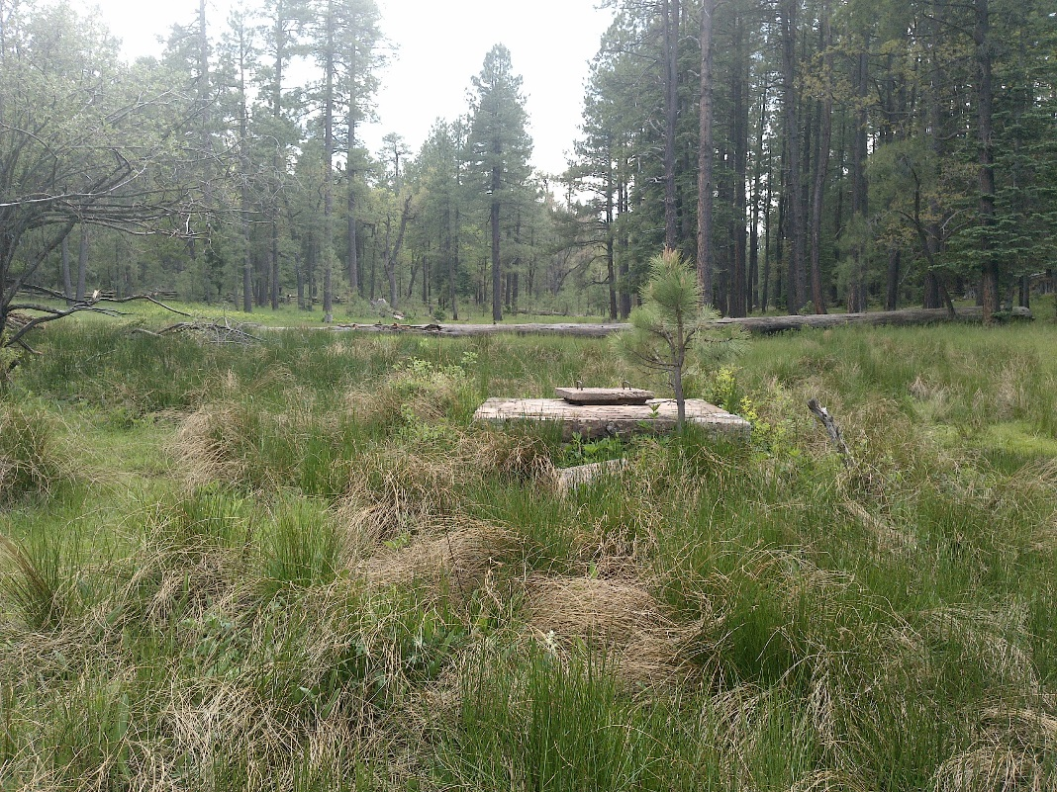
Fig 21.1 Kehl Spring: Below springbox, view upslope

Physical Description: Kehl Spring is a helocrene spring. This is a developed spring with metal pipes and a concrete spring box. The flow supports a wet meadow that is surrounded by Ponderosa pine forest. This spring is adjacent to a heavily visited Forest Service Campground on Rim Road. The microhabitat associated with the spring covers 400 sqm. The site has 1 microhabitat, X -- a 400 sqm low gradient cienega.

Table 21.1 Kehl Spring Microhabitat characteristics.
Code | X
Name | Entire Site
Area sqm | 400
Surface type | LGC
Surface subtype
Slope variability | Low
Aspect TN
Slope degrees | 2
Moisture (scale 1-10) | 6
Water depth cm | 2
Area % open water | 2
Substrate
1 - Clay % | 0
2 - Silt % | 5
3 - Sand % | 5
4 - Fine gravel % | 5
5 - Coarse gravel % | 5
6 - Cobble % | 20
7 - Boulder % | 0
8 - Bedrock % | 10
Organic % | 45
Other % (anthropogenic) | 5
Precipitate % | 0
Litter % | 5
Wood % | 3
Litter Depth (cm) | 2

Geomorphology: Kehl Spring emerges as a seepage or filtration spring from a sedimentary, sandstone rock layer in an unknown unit. The emergence environment is subaerial, with a gravity flow force mechanism.

Survey Notes: The channel and wet meadow were heavily trampled by elk, with copious tracks and scat. No flow was going through the metal pipes in the channel. The spring box has two openings, and the smaller lid is missing, posing a threat to small animals. The channel was incised and there is also evidence of head-cutting. There are signs that lead people to this spring from the adjacent campground. A small group of people walked over to the spring from their campsite during the survey. Surveyors found used toilet paper at the spring. Surveyors did not identify microhabitats, but inventoried the entire site.

Flow: Surveyors measured a flow of 0.1 liters/second, using a timed flow volume capture method. Flow was adjusted for an estimate of 90% of site flow capture. The flow crosses bedrock below the confluence of 2 channels. This spring is perennial.

Water Quality: Surveyors measured water chemistry upslope from the spring box. Instruments were calibrated on 6/02/2017.Location 1: at the spring source in flowing water at 00:00:00.

Table 21.2 Kehl Spring Water Quality with multiple readings averaged.
Characteristic Measured | Average Value | Site Number | Device | Comments
Dissolved oxygen (field) (mg/L) | 4.5 | 1 | CHEMets DO kit
pH (field) | 5.7 | 1 | Hanna Combo
Salinity (field) (ppt) | 0.025 | 1 | Hanna Combo
Specific conductance (field) (uS/cm) | 65 | 1 | Hanna Combo | Corr for temp from 50 EC
Temperature, air C | 29.4 |  | Handheld therm | Converted to Celsius from 85F
Temperature, water C | 13.5 | 1 | Hanna Combo

Flora: Gloria Hardwick was the botanist for this survey. Surveyors identified 35 plant species at the site. These included 24 native and 11 nonnative species.

Table 21.3 Kehl Spring Cover Type.
Cover Type | Species Count | Wetland Species Count
Ground | 31 | 13
Shrub | 1 | 1
Mid-canopy | 1 | 0
Tall canopy | 1 | 0
Basal | 0 | 0
Aquatic | 0 | 0
Non-vascular | 1 | 0

Table 21.4 Kehl Spring Vegetation % Cover in Microhabitats.
Species | Cover Code | Native Status | Wetland Status | Comments | X
Achillea millefolium | GC | NI | U
Antennaria | GC | N | U
Carex | GC |  |  | 1
Carex | GC |  |  | 2
Carex athrostachya | GC | N | W
Cymopterus | GC | N
Dactylis glomerata | GC | I | W
Geranium caespitosum | GC | N | F
Heuchera | GC | N | F
Houstonia wrightii | GC | N | F
Hypericum | GC |  | F
Juncus saximontanus | GC | N | W | Collected
Lathyrus | GC | N | R
Medicago lupulina | GC | I | WR
Montia chamissoi | GC | N | W | White flowers were observed.
Polygonum | GC | N | WR
Potentilla | GC | N | F | Tall and yellow characteristics.
Potentilla hippiana | GC | N | U
Pseudotsuga menziesii var. glauca | MC | N | U
Pteridium aquilinum | GC | N | U
Quercus gambelii | TC | N | F
Ranunculus | GC | N | WR | no bloom
Rumex | GC |  | WR
Rumex | GC |  | WR | 2
Salix bebbiana | SC | N | WR
Senecio | GC |  | F
Sidalcea neomexicana | GC | N | WR | neomexicana?, no blooms
Taraxacum officinale | GC | NI | F
Thermopsis pinetorum | GC | N | F
Trifolium repens | GC | I | WR
Triteleia lemmoniae | GC | N |  | Picture was taken.
unknown Graminoid (grass or grasslike) | GC |  |  | Purple glumes were observed.
unknown moss | NV
Veratrum californicum | GC | N | W
Viola sororia | GC | N | F | Not many in bloom

Fauna: Surveyors collected or observed 6 aquatic and 8 terrestrial invertebrates and 3 vertebrate specimens.

Table 21.5 Kehl Spring Invertebrates.
Species | Lifestage | Habitat | Method | Rep# | Count | Species Detail
 | Ad | A | Spot |  | 2
Coleoptera Coccinellidae | Ad | T | Spot
Coleoptera Dytiscidae | Ad | A | Spot |  | 4 | Medium small
Coleoptera Dytiscidae Agabus | Ad | A | Spot |  | 3
Coleoptera Erotylidae | Ad | T | Spot |  | 1
Hemiptera Cicadellidae | Ad | T | Spot |  | 1
Hemiptera Gerridae Aquarius remigis | Ad | A | Spot |  | 2
Hymenoptera Formicidae Camponotus | Ad | T | Spot
Lepidoptera Lycaenidae Celastrina | Ad | T | Spot
Lepidoptera Nymphalidae Nymphalis antiopa | Ad | T | Spot
Lepidoptera Papilionidae Papilio rutulus | Ad | T | Spot
Odonata Libellulidae Libellula | Ad | T | Spot |  |  | A female was observed.
Trichoptera Limnephilidae | L | A | Spot |  | 3
Trichoptera Sericostomatidae | L | A | Spot |  | 2

Table 21.6 Kehl Spring Vertebrates.
Vertebrate Species Common Name | Count | Detection | Comments
American Robin | 2 | call
Elk |  | sign | Tracks were observed.
Gopher |  | sign | Holes were observed.

Assessment: Assessment scores were compiled in 5 categories and 33 subcategories, with 9 null condition scores, and 9 null risk scores. Aquifer functionality and water quality are good with significant restoration potential and there is low risk. Geomorphology condition is moderate with some restoration potential and there is low risk. Habitat condition is good with significant restoration potential and there is low risk. Biotic integrity is good with significant restoration potential and there is low risk. Human influence of site is good with significant restoration potential and there is low risk. Administrative context status is undetermined due to null scores and there is undetermined risk due to null scores. Overall, the site condition is good with significant restoration potential and there is low risk.

Table 21.7 Kehl Spring Assessment Scores.
Category | Condition | Risk
Aquifer Functionality & Water Quality | 4.2 | 2
Geomorphology | 3.8 | 2
Habitat | 4 | 2
Biota | 4 | 2
Human Influence | 4.1 | 2.1
Administrative Context | 0 | 0
Overall Ecological Score | 4 | 2

Management Recommendations: Consider removing the springbox altogether. If not, replace the smaller springbox lid that may present a hazard to wildlife, and remove piping that is no longer functional. Monitor regularly.

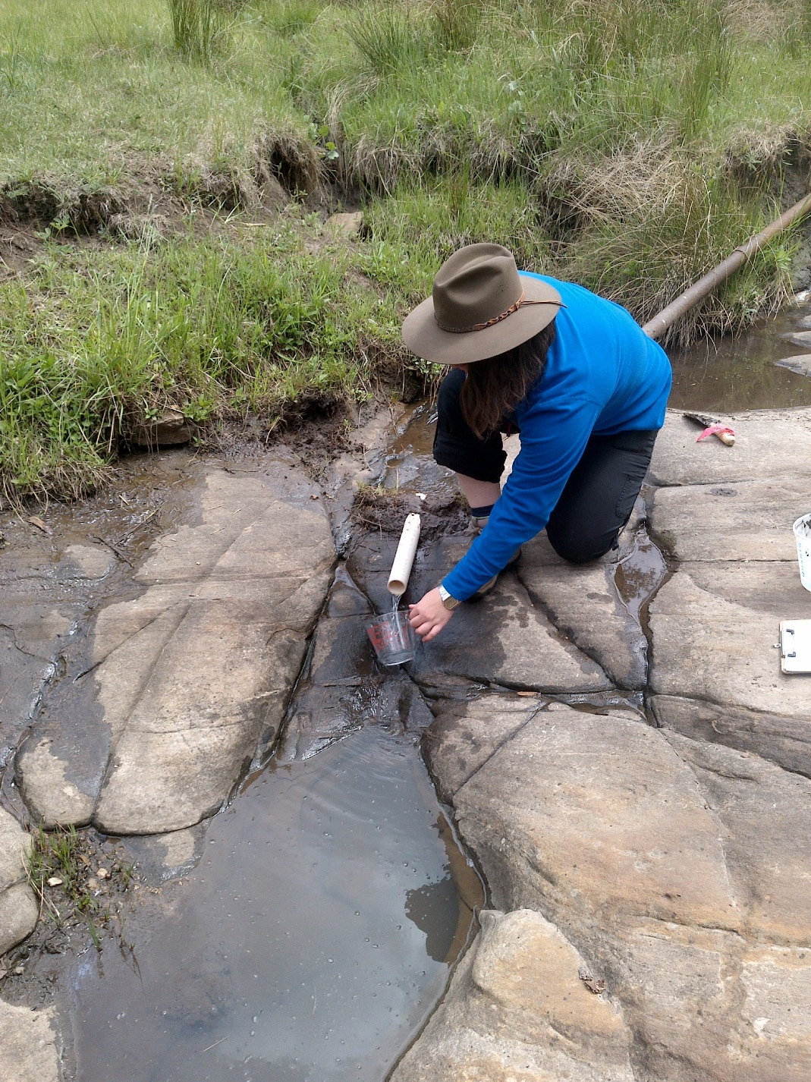
Fig 21.2 Kehl Spring: Flow measurement location at Kehl Spring.

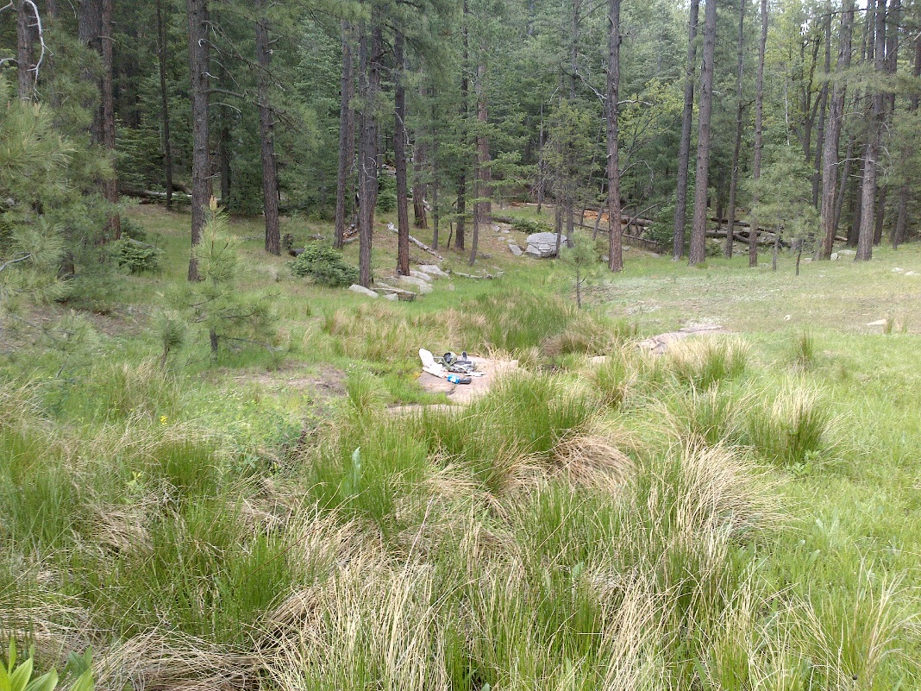
Fig 21.3 Kehl Spring: Below springbox, view downslope

22. Kendrick Spring
22. Kendrick Spring
Survey Summary Report, Site ID 1008
Submitted June 3, 2019 by Springs Stewardship Institute
Location: The Kendrick Spring ecosystem is located in Coconino County in the Lower Little Colorado Arizona 15020016 HUC, managed by the US Forest Service. The spring is located in the Coconino NF, Peaks RD, in the Kendrick Peak USGS Quad, at 35.44391, -111.83994 measured using a Map (NAD83). The elevation is approximately 2319 meters. Kyle Paffett and Quintin Van Dyke surveyed the site on 6/10/12 for 01:00 hours, beginning at 10:00, and collected data in 4 of 10 categories. This survey was conducted under the NEPA Cleared List project using the Stevens et al. Level 2 protocol.

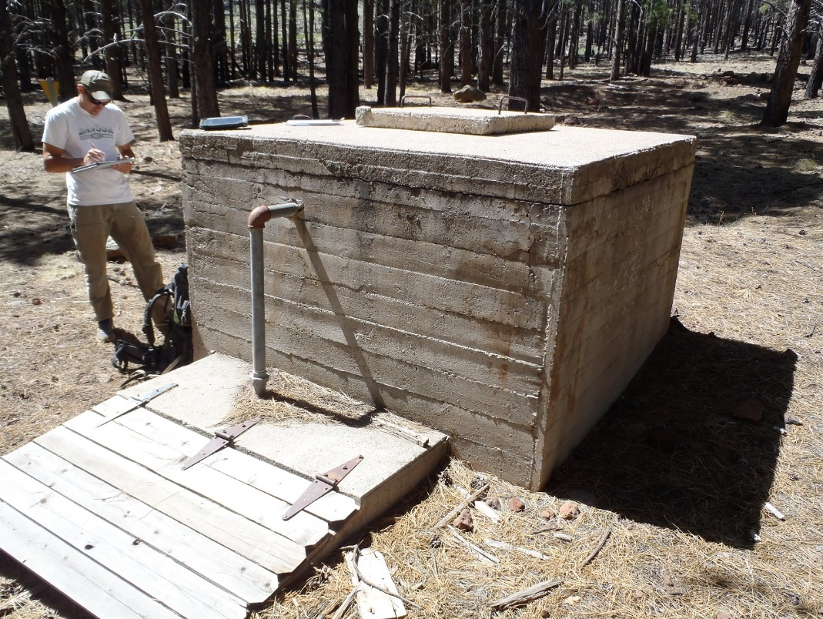
Fig 22.1 Kendrick Spring.

Physical Description: Kendrick Spring is a rheocrene spring. This site was imported from the geodatabase, a compilation from multiple sources. There is a large spring box present that diverts water to a large stock tank.

Geomorphology: Kendrick Spring emerges as a fracture spring from an igneous, basalt rock layer in an unknown unit. The emergence environment is subaerial, with a gravity flow force mechanism.

Access Directions: From US-180, turn on NF-191C and travel west for 2.8 mi. Turn right on NF-767 for 1.9 mi and continue on NF-760A for 0.4 mi. Turn left on NF-9002G and continue for 0.16 mi.

Survey Notes: This survey was conducted under the Pulliam project by students of Northern Arizona University and volunteers, under the direction of Dr. Abe Springer. There is no wetland vegetation or spring water present. The only evidence of a spring are large concrete structures.

Flow: Surveyors measured a flow of 0.00000 liters/second, using a non-traditional method. Flow was adjusted for an estimate of 1.00% of site flow capture. Spring site is completely dry.

Fauna: Surveyors collected or observed 2 vertebrate specimens.

Table 22.1 Kendrick Spring Vertebrates.
Vertebrate Species Common Name | Count | Detection | Comments
domestic cow |  | sign
elk |  | sign

Assessment: Assessment scores were compiled in 6 categories and 42 subcategories, with 0 null condition scores, and 1 null risk score. Aquifer functionality and water quality are eliminated with no restoration potential and there is extreme risk. Geomorphology condition is very poor with very limited restoration potential and there is moderate risk. Habitat condition is very poor with very limited restoration potential and there is very high risk. Biotic integrity is very poor with very limited restoration potential and there is extreme risk. Human influence of site is moderate with some restoration potential and there is moderate risk. Administrative context status is poor with limited restoration potential and there is low risk. Overall, the site condition is very poor with very limited restoration potential and there is very high risk.

Table 22.2 Kendrick Spring Assessment Scores.
Category | Condition | Risk
Aquifer Functionality & Water Quality | 0 | 6
Geomorphology | 1.6 | 3.6
Habitat | 1.2 | 5.75
Biota | 0.13 | 5.88
Human Influence | 3.5 | 3.43
Administrative Context | 2.56 | 2.78
Overall Ecological Score | 0.73 | 5.31

Management Recommendations: Remove concrete structures and the very large stock tank. Redevelop the natural discharge channel at the spring site. Fence off spring orifice from ungulates.

23. Little Elden Spring
23. Little Elden Spring
Survey Summary Report, Site ID 1019
Submitted June 3, 2019 by Springs Stewardship Institute
Location: The Little Elden Spring ecosystem is located in Coconino County in the Canyon Diablo Arizona 15020015 HUC, managed by the US Forest Service. The spring is located in the Coconino NF, Peaks RD, in the Sunset Crater West USGS Quad, at 35.27691, -111.57934 measured using a GPS (NAD83). The elevation is approximately 2190 meters. SSI Staff and Workshop Participants surveyed the site on 5/19/16 for 01:10 hours, beginning at 13:35, and collected data in 8 of 10 categories. This survey was conducted under the NEPA Cleared List project using the Stevens et al. Level 1 protocol.

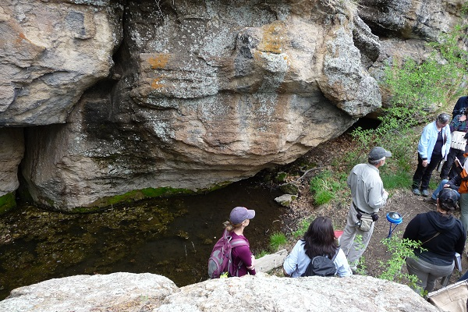
Fig 23.1 Little Elden Spring: SSI workshop group 2016-05-19

Physical Description: Little Elden Spring is a hillslope/limnocrene spring. This site was imported from the geodatabase, a compilation from multiple sources. The seepages emerge from rhyolite, forming a pool at the base of a cliff. Larry Stevens has visited this site at least 10 times at different times of year, and reports that there has always been water. Cut stumps, fencing, piping, and a concrete tank below indicate long term historic use. The microhabitats associated with the spring cover 91 sqm. The site has 4 microhabitats, including A -- a 12 sqm pool, B -- a 36 sqm backwall, C -- a 41 sqm pool margin, D -- a 2 sqm pool. The geomorphic diversity is 0.47, based on the Shannon-Weiner diversity index.

Table 23.1 Little Elden Spring Microhabitat characteristics.
Code | A | B | C | D
Name | Pool | Vertical sloping bedrock | Terrace | Muddy pool
Area sqm | 12 | 36 | 41 | 2
Surface type | P | BW | PM | P
Surface subtype
Slope variability | Low | Med |  | Low
Aspect TN
Slope degrees | 0 | 280 | 16 | 8
Moisture (scale 1-10) | 10 | 2 | 3 | 9
Water depth cm | 10 | 0 | 0 | 9
Area % open water | 95 | 0 | 0 | 40
Substrate
1 - Clay % | 0 | 0 | 0 | 0
2 - Silt % | 0 | 0 | 0 | 0
3 - Sand % | 0 | 0 | 0 | 0
4 - Fine gravel % | 0 | 0 | 0 | 0
5 - Coarse gravel % | 0 | 0 | 0 | 0
6 - Cobble % | 0 | 0 | 0 | 0
7 - Boulder % | 0 | 0 | 0 | 0
8 - Bedrock % | 0 | 0 | 0 | 0
Organic % | 0 | 0 | 0 | 0
Other % (anthropogenic) | 0 | 0 | 0 | 0
Precipitate % | 0 | 0 | 0 | 0
Litter % | 0 | 0 | 0 | 0
Wood % | 0 | 0 | 0 | 0
Litter Depth (cm)

Geomorphology: Little Elden Spring emerges as a fracture spring from an igneous, rhyolite rock layer in an unknown unit. The emergence environment is subaerial, with a gravity flow force mechanism. The site receives approximately 0% of available solar radiation, with 0 Mj annually.

Access Directions: From US-89, exit onto E Elden Springs Rd (NF-556) and travel west for 2 mi. Spring is 85 m due SW.

Survey Notes: Trails with signs have been blocked off. The forest service has done a poor job of indicating which trail they want the public to use when hiking to spring. Four- Fri thinning projects are in progress across the road from the spring. There has been recent rain. The pool has lots of dying algae this year and appears to have less water than the previous year’s survey.

Water Quality: Pool was covered with dying algae; there seemed to be less water than last year.

Table 23.2 Little Elden Spring Water Quality with multiple readings averaged.
Characteristic Measured | Average Value | Site Number | Device | Comments
Alkalinity, Total (mg/L) | 76 |  | LaMotte
Dissolved oxygen (field) (mg/L) | 8 |  | CHEMets DO kit
pH (field) | 7.26 |  | Hanna Combo
Salinity (field) (ppt) | 0.061 |  | Hanna Combo
Temperature, water C | 12.8 |  | Hanna Combo

Flora: Surveyors identified 20 plant species at the site, with 0.2198 species/sqm. These included 18 native and 2 nonnative species.

Table 23.3 Little Elden Spring Cover Type.
Cover Type | Species Count | Wetland Species Count
Ground | 9 | 0
Shrub | 5 | 0
Mid-canopy | 2 | 0
Tall canopy | 0 | 0
Basal | 0 | 0
Aquatic | 1 | 1
Non-vascular | 3 | 0

Table 23.4 Little Elden Spring Vegetation % Cover in Microhabitats.
Species | Cover Code | Native Status | Wetland Status | Comments | A | B | C | D
Abies concolor | SC | N | U |  | 0 | 0 | 2 | 0
Acer grandidentatum | MC | N | F |  | 0 | 0 | 10 | 0
Agropyron smithii | GC | N | F |  | 0 | 0 | 1 | 0
algae | AQ | N | A |  | 60 | 0 | 0 | 0
Amelanchier utahensis | SC | N | F | on boulder | 0 | 0 | 0.5 | 0
Carex aurea | GC | N | U | on boulder and terrace | 0 | 0.3 | 2 | 0
Lichen | NV | N | U | boulder and b.wall | 0 | 20 | 0 | 0
Muhlenbergia | GC | N | U |  | 0 | 0 | 2 | 0
Prunus virginiana | SC | N | F |  | 0 | 2 | 0 | 1
Quercus gambelii | GC | N | F | seedling | 0 | 0 | 0.5 | 0
Quercus gambelii | MC | N | F |  | 0 | 0 | 4 | 0
Ribes cereum | SC | N | U |  | 0 | 0 | 3 | 0
Solidago | GC | N | F |  | 0 | 0 | 0.5 | 0
Taraxacum officinale | GC | NI | F |  | 0 | 0 | 0.5 | 0
Thalictrum fendleri | GC | N | F |  | 0 | 3 | 0 | 1
Toxicodendron rydbergii | SC | N | F |  | 0 | 1 | 0 | 0
unknown Bryophyte (moss, liverwort, hornwort) | NV | N | F |  | 5 | 5 | 0 | 0
unknown composite | GC |  | F | boulder above pool | 0 | 0.1 | 0 | 0
unknown Fungus, fleshy (mushroom) | NV | N | F | 3-4 Coprinus | 0 | 0 | 0.1 | 0
unknown grass | GC |  |  | no fruit | 0 | 0 | 2 | 0

Fauna: Surveyors collected or observed 1 aquatic and 3 terrestrial invertebrates and 6 vertebrate specimens.

Table 23.5 Little Elden Spring Invertebrates.
Species | Lifestage | Habitat | Method | Rep# | Count | Species Detail
Coleoptera Coccinellidae Anatis lecontei | Ad | T | Spot |  | 3
Diptera Culicidae | Ad | T | Spot |  | 1
Diptera Syrphidae | Ad | T | Spot |  | 1
Hemiptera Gerridae Aquarius remigis |  | A | Spot |  | 4 | Adult and larvae

Table 23.6 Little Elden Spring Vertebrates.
Vertebrate Species Common Name | Count | Detection | Comments
Deer |  | sign | tracks
Horse | 1 | sign | tracks
Bobcat | 1 | sign | scat
Grace's Warbler | 1 | call
Hepatic Tanager | 1 | call
Dark-eyed Junco | 2 | obs

Assessment: Assessment scores were compiled in 6 categories and 38 subcategories, with 4 null condition scores, and 7 null risk scores. Aquifer functionality and water quality are good with significant restoration potential and there is low risk. Geomorphology condition is good with significant restoration potential and there is moderate risk. Habitat condition is good with significant restoration potential and there is moderate risk. Biotic integrity is good with significant restoration potential and there is low risk. Human influence of site is good with significant restoration potential and there is low risk. Administrative context status is good with significant restoration potential and there is low risk. Overall, the site condition is good with significant restoration potential and there is low risk.

Table 23.7 Little Elden Spring Assessment Scores.
Category | Condition | Risk
Aquifer Functionality & Water Quality | 4 | 2
Geomorphology | 4.6 | 3.8
Habitat | 4.2 | 3.2
Biota | 4.4 | 2
Human Influence | 4.1 | 2.4
Administrative Context | 4 | 2
Overall Ecological Score | 4.2 | 2.5

Management Recommendations: Fix fencing; remove old tank and piping as funding permits; monitor occasionally

24. Lockwood Spring
24. Lockwood Spring
Survey Summary Report, Site ID 432
Submitted June 3, 2019 by Springs Stewardship Institute
Location: The Lockwood Spring ecosystem is located in Coconino County in the Middle Little Colorado Arizona 15020008 HUC, managed by the US Forest Service. The spring is located in the Coconino NF, Mogollon Rim RD, in the Blue Ridge Reservoir USGS Quad, at 34.54811, -111.14170 measured using a GPS (NAD83, estimated position error 7 meters). The elevation is approximately 2098 meters. Jeri Ledbetter, Eric North, RJ Johnson, Valerie Hallam, Denise Hudson, Julaire Scott, Karissa Davis surveyed the site on 9/18/09 for 01:45 hours, beginning at 15:30, and collected data in 9 of 10 categories. This survey was conducted under the NEPA Cleared List project using the Stevens et al. Level 2 protocol.

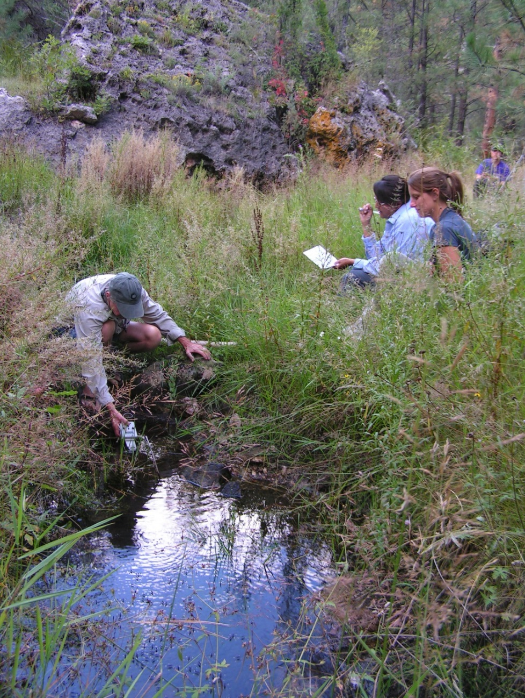
Fig 24.1 Lockwood Spring.

Physical Description: Lockwood Spring is an exposure spring. This site is a small seep that forms a pool and is located at the apex of two moderately steep canyons, in the bottom of a drainage. The microhabitats associated with the spring cover 160 sqm. The site has 5 microhabitats, including A -- a 4 sqm pool, B -- a 15 sqm pool, C -- a 11 sqm channel, D -- a 110 sqm terrace, E -- a 20 sqm sloping bedrock. The geomorphic diversity is 0.44, based on the Shannon-Weiner diversity index.

Table 24.1 Lockwood Spring Microhabitat characteristics.
Code | A | B | C | D | E
Name | Source pool | Lower pool | Channel | Terrace | Big slab
Area sqm | 4.00 | 15.00 | 11.00 | 110.00 | 20.00
Surface type | P | P | CH | TE | SB
Surface subtype |  |  | eph | LRZ
Slope variability | Low | Low | Low | Med | Med
Aspect TN | 268 | 268 | 258 | 268 | 78
Slope degrees | 0 | 0 | 0 | 24 | 50
Moisture (scale 1-10) | 10 | 10 | 4 | 1 | 0
Water depth cm | 36.00 | 29.00
Area % open water | 100.00 | 100.00 | 0.00 | 0.00 | 0.00
Substrate
1 - Clay % | 0 | 0 | 0 | 0 | 0
2 - Silt % | 8 | 10 | 10 | 30 | 0
3 - Sand % | 0 | 0 | 15 | 0 | 0
4 - Fine gravel % | 2 | 10 | 15 | 15 | 0
5 - Coarse gravel % | 5 | 5 | 5 | 10 | 0
6 - Cobble % | 10 | 25 | 0 | 5 | 0
7 - Boulder % | 0 | 0 | 0 | 3 | 98
8 - Bedrock % | 0 | 0 | 55 | 0 | 0
Organic % | 75 | 50 | 0 | 37 | 2
Other % (anthropogenic) | 0 | 0 | 0 | 0 | 0
Precipitate % | 0.00 | 0.00 | 0.00 | 0.00 | 0.00
Litter % | 5.00 | 5.00 | 85.00 | 50.00 | 5.00
Wood % | 0.00 | 0.50 | 1.00 | 2.00 | 3.00
Litter Depth (cm) | 0.50 | 0.20 | 1.00 | 2.00 | 0.10

Geomorphology: Lockwood Spring emerges as a seepage or filtration spring from the Kaibab Limestone, a sedimentary, limestone rock layer. The emergence environment is subaerial, with a gravity flow force mechanism. The site receives approximately 93% of available solar radiation, with 6853 Mj annually.

Access Directions: From SR 87 turn S on 95. After bridge over East Clear Creek turn left on FR 96. Pass jct with 321 & continue to 96C. Turn north & proceed about 1/2 mile.

Survey Notes: This survey was conducted by Grand Canyon Wildlands Council surveyors on the Mogollon Rim project, funded by the Nina Mason Pulliam Charitable Trust. The spring is surrounded by an intact elk fence and there is no evidence of browsing. Dense vegetation surrounds the two pools that are possibly two distinct spring sources.

Flow: pool; no flowing water, no apparent discharge into pool source A This spring is perennial. Surveyors were unable to measure flow due to no outflow.

Water Quality: samples collected in source pool

Table 24.2 Lockwood Spring Water Quality with multiple readings averaged.
Characteristic Measured | Average Value | Site Number | Device | Comments
18-Oxygen results % | -12 |  |  | Source A?
2-Hydrogen results % | -81.27 |  |  | Source A?
Alkalinity, Total (mg/L) | 295 |  |  | U of A
Bromide (Br-) (mg/L) | <0.1 |  |  | U of A
Calcium (Ca) (mg/L) | 63.41 |  |  | U of A
Chloride (CL-) (mg/L) | 2.516 |  |  | U of A
Fluorine (F) (mg/L) | 0.222 |  |  | U of A
Magnesium (Mg) (mg/L) | 36.22 |  |  | U of A
Missing parameter | 0.832 |  |  | U of A
Nitrogen, Nitrate (NO3) as NO3 (mg/L) | <0.1 |  |  | U of A
Nitrogen, Nitrite (NO2) as NO2 (mg/L) | <0.1 |  |  | U of A
pH (field) | 6.6971428571429 |  |  | source A
Phosphate (PO4) (mg/L) | 0.832 |  |  | U of A
Potassium (K) (mg/L) | 0.542 |  |  | U of A
Sodium (Na) mg/L | 1.939 |  |  | U of A
Specific conductance (field) (uS/cm) | 527.125 |  |  | source A
Sulfur, sulfate (SO4) as SO4 (mg/L) | 4.738 |  |  | U of A
Temperature, air C | 67
Temperature, water C | 13.45 |  |  | source A

Flora: Survey polygon D vegetation was 113%; higher percentages reduced - JDL Pinus ponderosa, Pseudotsuga menziesii, Quercus gambelii, Abies arizonica forest (VM) Surveyors identified 39 plant species at the site, with 0.2438 species/sqm. These included 32 native and 6 nonnative species; the native status of 1 species remains unknown.

Table 24.3 Lockwood Spring Cover Type.
Cover Type | Species Count | Wetland Species Count
Ground | 38 | 12
Shrub | 0 | 0
Mid-canopy | 2 | 0
Tall canopy | 1 | 0
Basal | 0 | 0
Aquatic | 0 | 0
Non-vascular | 0 | 0

Table 24.4 Lockwood Spring Vegetation % Cover in Microhabitats.
Species | Cover Code | Native Status | Wetland Status | Comments | A | B | C | D | E
Achillea millefolium | GC | NI | U |  | 0 | 0 | 0 | 3 | 0
Aquilegia | GC | N? | W |  | 0 | 0 | 3 | 2 | 4
Blepharoneuron tricholepis | GC | N | U | Waring ID | 0 | 0 | 0 | 2 | 0
Carex subfusca | GC | N | W | Vera Markgraf 6/28/2013 | 0 | 0 | 0 | 0 | 0
Chenopodium | GC | N? | F | #5 Waring ID | 0 | 0 | 0 | 1 | 0
Cirsium | GC | N? | F |  | 0 | 0 | 0 | 1 | 0
Cystopteris | GC | N? | WR |  | 0 | 0 | 0 | 0 | 5
Dactylis glomerata | GC | I | W | Waring ID | 0 | 0 | 0 | 1 | 0
Elymus canadensis | GC | N | F | Waring ID | 0 | 0 | 0 | 1 | 3
Elymus trachycaulus | GC | N | F | Waring ID | 0 | 0 | 0 | 11 | 0
Epilobium ciliatum | GC | N | W |  | 2 | 0 | 15 | 1 | 0
Equisetum arvense | GC | N | WR |  | 0 | 0 | 0 | 1 | 0
Erigeron | GC | N | F | #6 divergens? | 0 | 0 | 0 | 1 | 0
Erigeron divergens | GC | N | F | Waring ID | 0 | 0 | 3 | 1 | 0
Geranium richardsonii | GC | N | F | ? #11 | 0 | 0 | 0 | 1 | 0
Geranium richardsonii | GC | N | F | Waring ID | 2 | 0 | 3 | 1 | 0
Geum macrophyllum | GC | N | U |  | 0 | 5 | 0 | 0 | 0
Hypericum scouleri | GC | N | WR | #10 Waring ID | 0 | 0 | 20 | 0 | 0
Ipomopsis | GC | N? | U |  | 0 | 0 | 0 | 0 | 3
Juncus ensifolius | GC | N | W | #9 Waring ID | 0 | 10 | 20 | 0 | 0
Juncus interior | GC | N |  | Vera Markgraf 6/28/2013 | 0 | 0 | 0 | 0 | 0
Juniperus | GC | N | U |  | 0 | 0 | 0 | 0 | 2
Juniperus | MC | N | U |  | 0 | 0 | 5 | 0 | 0
Leucanthemum vulgare | GC | I | F |  | 0 | 0 | 0 | 1 | 0
Lotus wrightii | GC | N | F | Waring ID | 0 | 0 | 0 | 3 | 0
Monarda fistulosa | GC | N | F | Waring ID | 0 | 0 | 0 | 3 | 0
Muhlenbergia andina | GC | N | WR | Waring ID | 0 | 0 | 0 | 0 | 5
Parthenocissus quinquefolia | GC | N | F |  | 0 | 0 | 0 | 0 | 2
Pinus ponderosa | MC | N | F |  | 0 | 0 | 20 | 0 | 0
Pinus ponderosa | TC | N | F |  | 0 | 0 | 15 | 0 | 0
Plantago | GC | N? | WR |  | 0 | 1 | 0 | 0 | 0
Poa | GC |  | F | ? #4 | 2 | 5 | 30 | 55 | 0
Pteridium aquilinum | GC | N | U |  | 0 | 0 | 0 | 1 | 0
Rosa | GC | N? | F |  | 0 | 0 | 0 | 1 | 0
Rumex | GC | N? | WR |  | 1 | 1 | 0 | 0 | 0
Taraxacum officinale | GC | I | F |  | 0 | 0 | 0 | 1 | 4
Tragopogon dubius | GC | I | F |  | 0 | 0 | 0 | 1 | 0
Trifolium | GC | I? | WR | #8 | 0 | 0 | 0 | 1 | 0
Verbascum thapsus | GC | I | F |  | 0 | 0 | 0 | 0.01 | 0.01
Veronica americana | GC | N | A | Waring ID | 1 | 0 | 0 | 0 | 0
Vicia pulchella | GC | N | F | #7 Waring ID | 0 | 0 | 0 | 4 | 0

Fauna: Surveyors collected or observed 2 terrestrial invertebrate specimens.

Table 24.5 Lockwood Spring Invertebrates.
Species | Lifestage | Habitat | Method | Rep# | Count | Species Detail
Diptera | Ad | T | Spot |  | 1

Assessment: Assessment scores were compiled in 6 categories and 35 subcategories, with 7 null condition scores, and 7 null risk scores. Aquifer functionality and water quality are very good with excellent restoration potential and there is negligible risk. Geomorphology condition is very good with excellent restoration potential and there is low risk. Habitat condition is good with significant restoration potential and there is low risk. Biotic integrity is good with significant restoration potential and there is low risk. Human influence of site is very good with excellent restoration potential and there is low risk. Administrative context status is good with significant restoration potential and there is moderate risk. Overall, the site condition is good with significant restoration potential and there is low risk.

Table 24.6 Lockwood Spring Assessment Scores.
Category | Condition | Risk
Aquifer Functionality & Water Quality | 5 | 1.67
Geomorphology | 5 | 2
Habitat | 4.2 | 2.4
Biota | 4.17 | 2.67
Human Influence | 5.29 | 2
Administrative Context | 3.89 | 3
Overall Ecological Score | 4.59 | 2.29

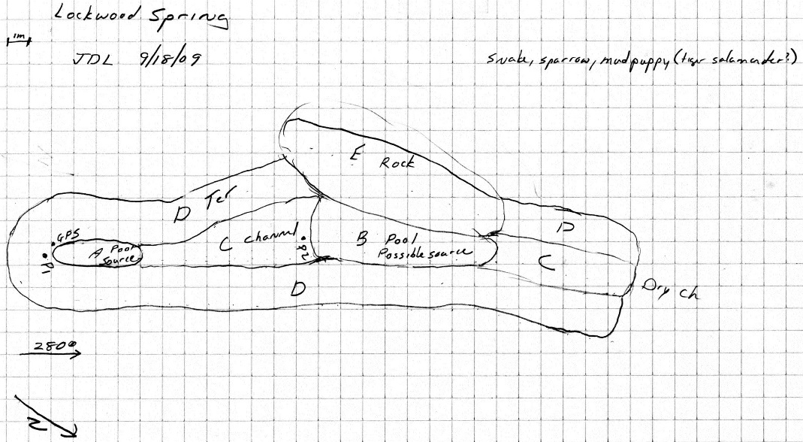
Fig 24.2 Lockwood Spring Sketchmap.

25. Lockwood Spring
25. Lockwood Spring
Survey Summary Report, Site ID 1022
Submitted June 3, 2019 by Springs Stewardship Institute
Location: The Lockwood Spring ecosystem is located in Coconino County in the Upper Verde Arizona 15060202 HUC, managed by the US Forest Service. The spring is located in the Coconino NF, Peaks RD, in the Dutton Hill USGS Quad, at 35.04672, -111.86354 measured using a Map (NAD83). The elevation is approximately 2103 meters. Kyle Paffett, Vera Markgraf, and Quintin Van Dyke surveyed the site on 8/04/12 for 01:10 hours, beginning at 9:20, and collected data in 6 of 10 categories. This survey was conducted under the NEPA Cleared List project using the Stevens et al. Level 2 protocol.

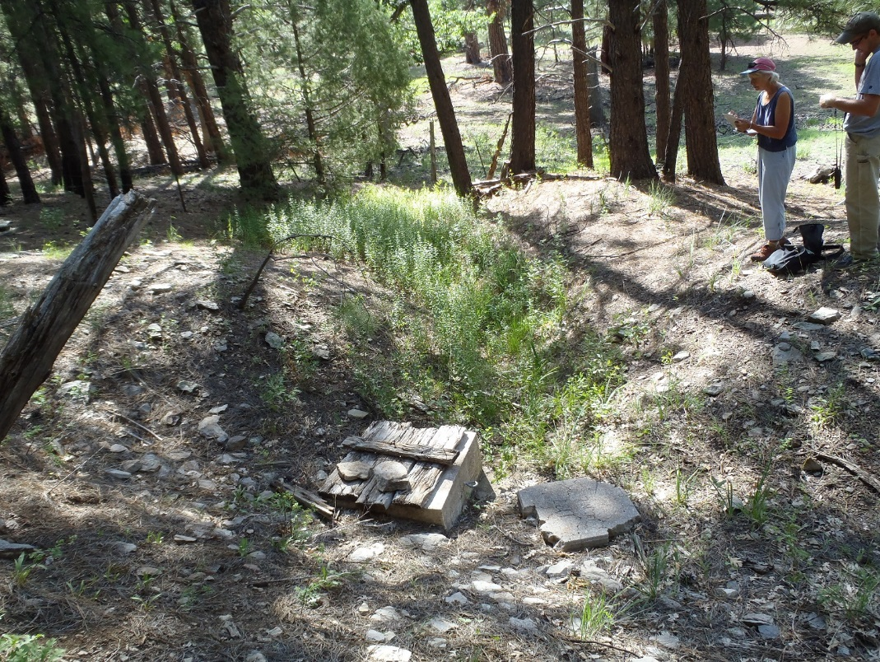
Fig 25.1 Lockwood Spring.

Physical Description: Lockwood Spring is a hillslope/anthropogenic spring. This site was imported from a compilation from multiple sources. The spring discharges from a hillslope. The spring area has been dug out to install a spring box that feeds a metal stock tank.

Table 25.1 Lockwood Spring Microhabitat characteristics.
Code | X
Name | Entire Site
Area sqm
Surface type
Surface subtype
Slope variability
Aspect TN
Slope degrees
Moisture (scale 1-10)
Water depth cm
Area % open water
Substrate
1 - Clay % | 0
2 - Silt % | 0
3 - Sand % | 0
4 - Fine gravel % | 0
5 - Coarse gravel % | 0
6 - Cobble % | 0
7 - Boulder % | 0
8 - Bedrock % | 0
Organic % | 0
Other % (anthropogenic) | 0
Precipitate % | 0
Litter % | 0
Wood % | 0
Litter Depth (cm)

Geomorphology: Lockwood Spring emerges as a contact spring from an igneous, basalt rock layer in an unknown unit. The emergence environment is subaerial, with a gravity flow force mechanism.

Access Directions: From AZ-89-ALT, exit onto NF-535 and travel west 7 mi to NF-231. Continue SW on NF-231 and NF-9011G for approx. 3 mi.

Flow: Surveyors measured a flow of 0.032 liters/second, using a timed flow volume capture method. Flow was adjusted for an estimate of 1.00% of site flow capture. Measurement taken at stock tank. This spring is perennial.

Water Quality: Measurements taken at spring box.

Table 25.2 Lockwood Spring Water Quality with multiple readings averaged.
Characteristic Measured | Average Value | Site Number | Device | Comments
Oxygen Reduction Potential in mV | 272.4 |  | YSI Multiprobe
pH (field) | 7.69 |  | YSI Multiprobe
Specific conductance (field) (uS/cm) | 418.5 |  | YSI Multiprobe
Temperature, water C | 14.1 |  | YSI Multiprobe

Flora: Quercus gambelii, Pinus ponderosa, Juniperus deppeana woodland Surveyors identified 16 plant species at the site. These included 14 native and 2 nonnative species.

Table 25.3 Lockwood Spring Cover Type.
Cover Type | Species Count | Wetland Species Count
Ground | 15 | 11
Shrub | 0 | 0
Mid-canopy | 0 | 0
Tall canopy | 0 | 0
Basal | 0 | 0
Aquatic | 0 | 0
Non-vascular | 1 | 0

Table 25.4 Lockwood Spring Vegetation % Cover in Microhabitats.
Species | Cover Code | Native Status | Wetland Status | Comments | X
Agrostis scabra | GC | N | W
Carex | GC | N |  | "broad leaf"
Carex subfusca | GC | N | W | VM 187
Eleocharis palustris | GC | N | W
Epilobium ciliatum | GC | N | W
Geranium caespitosum | GC | N | F
Iris missouriensis | GC | N | F
Juncus ensifolius | GC | N | W
Juncus interior | GC | N |  | VM 186
Mentha arvensis | GC | N | WR
Plantago major | GC | I | WR
Rumex crispus | GC | I | WR
Solidago canadensis | GC | N | WR
Thermopsis divaricarpa | GC | N | F
Trifolium pinetorum | GC | N | WR
unknown Bryophyte (moss, liverwort, hornwort) | NV | N | F

Assessment: Assessment scores were compiled in 6 categories and 42 subcategories, with 0 null condition scores, and 1 null risk score. Aquifer functionality and water quality are moderate with some restoration potential and there is negligible risk. Geomorphology condition is poor with limited restoration potential and there is moderate risk. Habitat condition is poor with limited restoration potential and there is low risk. Biotic integrity is poor with limited restoration potential and there is low risk. Human influence of site is good with significant restoration potential and there is low risk. Administrative context status is poor with limited restoration potential and there is low risk. Overall, the site condition is poor with limited restoration potential and there is low risk.

Table 25.5 Lockwood Spring Assessment Scores.
Category | Condition | Risk
Aquifer Functionality & Water Quality | 3.17 | 1.33
Geomorphology | 2.6 | 3
Habitat | 2.8 | 2.5
Biota | 2.63 | 2.63
Human Influence | 4.25 | 2.29
Administrative Context | 2.78 | 2.44
Overall Ecological Score | 2.8 | 2.36

Management Recommendations: We recommend removing the spring box and stock tank, and closing the road.

26. Lower McDermit Spring
26. Lower McDermit Spring
Survey Summary Report, Site ID 582
Submitted June 3, 2019 by Springs Stewardship Institute
Location: The Lower McDermit Spring ecosystem is located in Coconino County in the Upper Verde Arizona 15060202 HUC, managed by the US Forest Service. The spring is located in the Kaibab NF, Williams RD, in the Parks USGS Quad, at 35.25786, -111.91766 measured using a GPS (NAD83, estimated position error 3 meters). The elevation is approximately 2165 meters. Larry Stevens and Jeri Ledbetter surveyed the site on 8/30/11 for 01:40 hours, beginning at 11:30, and collected data in 10 of 10 categories. This survey was conducted under the NEPA Cleared List project using the Stevens et al. Level 2 protocol.

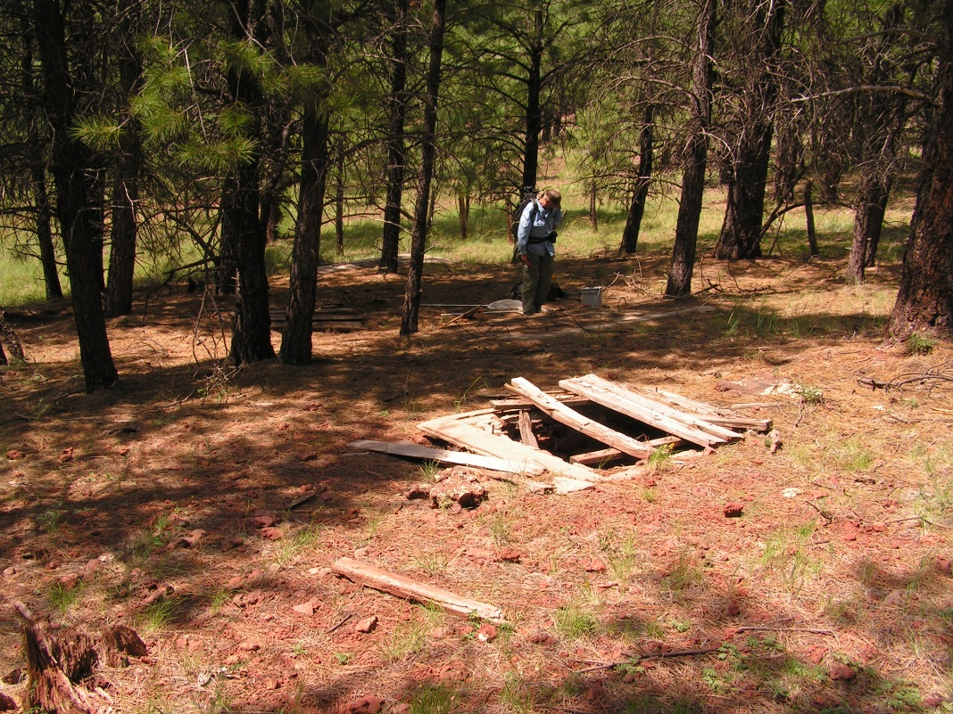
Fig 26.1 Lower McDermit Spring.

Physical Description: Lower McDermit Spring is a hypocrene/anthropogenic spring. This site was likely a hillslope spring that has been heavily manipulated over the past century or so. Six tanks have been installed with piping leading to a trough. The site has been heavily logged, probably clear-cut. The microhabitats associated with the spring cover 1670 sqm. The site has 2 microhabitats, including A -- a 552 sqm other, B -- a 1118 sqm low gradient cienega. The geomorphic diversity is 0.28, based on the Shannon-Weiner diversity index.

Table 26.1 Lower McDermit Spring Microhabitat characteristics.
Code | A | B
Name | Well Pit | Ephemeral
Area sqm | 552.00 | 1118.00
Surface type | OTH | LGC
Surface subtype
Slope variability | Low | Low
Aspect TN | 227 | 227
Slope degrees | 2 | 8
Moisture (scale 1-10) | 1 | 0
Water depth cm | 15.00
Area % open water | 3.00 | 1.00
Substrate
1 - Clay % | 0 | 0
2 - Silt % | 15 | 15
3 - Sand % | 40 | 15
4 - Fine gravel % | 30 | 50
5 - Coarse gravel % | 4 | 15
6 - Cobble % | 1 | 5
7 - Boulder % | 0 | 0
8 - Bedrock % | 10 | 0
Organic % | 0 | 0
Other % (anthropogenic) | 0 | 0
Precipitate % | 0.00 | 0.00
Litter % | 85.00 | 80.00
Wood % | 6.00 | 3.00
Litter Depth (cm) | 5.00 | 2.00

Geomorphology: Lower McDermit Spring emerges as a seepage or filtration spring from an igneous, basalt rock layer in an unknown unit. The emergence environment is subaerial, with a gravity flow force mechanism. The site receives approximately 100% of available solar radiation, with 7333 Mj annually.

Access Directions: From exit 178 on I-40, travel north on Parks Rd for 0.15 mi. Turn right onto E Old Highway 66 for 0.5 mi and continue east to NF-2328 for 0.7 mi.

Survey Notes: This site has been heavily grazed/browsed and trampled by cows and elk. Two tanks have water, although this is likely influenced by recent heavy rain. The area is littered with old wood, steel, and downed barbed wire fence. Some of the tank lids are broken or removed. The trough has a water level of approximately 12 cm in the upslope half.

Flow: Surveyors measured a flow of 0.00100 liters/second, using a non-traditional method. We estimated the flow rate as less than .001 L/s. There is scarce seepage on inner, upslope wall of well #1. The quantity is approximately 1 drip per second. This spring is dry intermittent.

Water Quality: Measurements were taken from northern-most tank that contained water. Samples were in a bucket.

Table 26.2 Lower McDermit Spring Water Quality with multiple readings averaged.
Characteristic Measured | Average Value | Site Number | Device | Comments
pH (field) | 7.86 |  |  | YSI
Specific conductance (field) (uS/cm) | 236 |  |  | HM digital
Temperature, air C | 28.3
Temperature, water C | 15 |  |  | HM digital

Flora: Pinus ponderosa live basal cover in A 3.0 square meters and 1 square meter in B. Pinus ponderosa dead basal cover 1.5 square meters in B. Surveyors identified 29 plant species at the site, with 0.0174 species/sqm. These included 19 native and 10 nonnative species.

Table 26.3 Lower McDermit Spring Cover Type.
Cover Type | Species Count | Wetland Species Count
Ground | 25 | 5
Shrub | 3 | 0
Mid-canopy | 1 | 0
Tall canopy | 1 | 0
Basal | 0 | 0
Aquatic | 0 | 0
Non-vascular | 1 | 0

Table 26.4 Lower McDermit Spring Vegetation % Cover in Microhabitats.
Species | Cover Code | Native Status | Wetland Status | Comments | A | B
Achillea millefolium | GC | NI | U |  | 0 | 2
Agropyron | GC | I | F |  | 0 | 5
Bouteloua gracilis | GC | N | U |  | 0 | 10
Carex aurea | GC | N | U |  | 0 | 0.5
Cirsium | GC | I | F |  | 0.1 | 0.2
Convolvulus | GC | I | F | white | 0 | 0.1
Elymus elymoides | GC | N | F |  | 0.2 | 0.1
Ericameria nauseosa | SC | N | F |  | 2 | 3
Erigeron | GC | N | F |  | 0.1 | 0.5
Geranium richardsonii | GC | N | F | pink | 0.2 | 0
Heliomeris | GC | N | U |  | 0 | 5
Iris missouriensis | GC | N | F |  | 2 | 2
Juncus balticus | GC | N | W |  | 0.3 | 1
Juniperus scopulorum | SC | N | U |  | 0 | 0.1
Koeleria macrantha | GC | N | F |  | 0 | 1
Lathyrus | GC | N | R | "little" | 0.3 | 0.2
Lepidium | GC | I | F |  | 0 | 0.1
Lichen | NV | N | U |  | 0 | 0.8
Lupinus | GC | N | F |  | 0 | 0.1
Medicago lupulina | GC | I | WR |  | 0 | 1
Melilotus officinalis | GC | I | WR |  | 0 | 0.1
Packera | GC | N | F |  | 0 | 0.2
Pinus ponderosa | MC | N | F |  | 65 | 15
Pinus ponderosa | SC | N | F |  | 35 | 5
Pinus ponderosa | TC | N | F |  | 15 | 5
Poa pratensis | GC | I | F |  | 5 | 38
Potentilla | GC | N | F | annual | 0 | 10
Quercus gambelii | GC | N | F |  | 0.1 | 0
Rumex crispus | GC | I | WR |  | 0.1 | 0
Taraxacum officinale | GC | I | F |  | 0 | 2
Verbascum | GC | I | F |  | 0 | 0.1

Fauna: Surveyors collected or observed 8 terrestrial invertebrates and 8 vertebrate specimens.

Table 26.5 Lower McDermit Spring Invertebrates.
Species | Lifestage | Habitat | Method | Rep# | Count | Species Detail
Coleoptera Scarabaeidae | Ad | T | Spot |  | 1
Diptera | L |  | Spot |  | 20
Lepidoptera | Ad | T | Spot |  | 1
Lepidoptera Lycaenidae Echinargus isola | Ad | T | Spot |  | 1

Table 26.6 Lower McDermit Spring Vertebrates.
Vertebrate Species Common Name | Count | Detection | Comments
pocket gopher |  | sign
domestic cow |  | sign | scat
elk |  | sign | scat
Steller's jay |  | sign | feather
pygmy nuthatch |  | obs
chickadee |  | call | call
plumbeous vireo |  | call | call
western wood-pewee |  | obs

Assessment: Assessment scores were compiled in 6 categories and 42 subcategories, with 0 null condition scores, and 1 null risk score. Aquifer functionality and water quality are very poor with very limited restoration potential and there is very high risk. Geomorphology condition is very poor with very limited restoration potential and there is high risk. Habitat condition is moderate with some restoration potential and there is high risk. Biotic integrity is moderate with some restoration potential and there is high risk. Human influence of site is poor with limited restoration potential and there is moderate risk. Administrative context status is moderate with some restoration potential and there is low risk. Overall, the site condition is poor with limited restoration potential and there is high risk.

Table 26.7 Lower McDermit Spring Assessment Scores.
Category | Condition | Risk
Aquifer Functionality & Water Quality | 1.17 | 5
Geomorphology | 1.4 | 4.6
Habitat | 3.2 | 4.2
Biota | 2.88 | 4
Human Influence | 2.78 | 3.63
Administrative Context | 3.67 | 2.25
Overall Ecological Score | 2.16 | 4.45

Management Recommendations: This is a low management priority site as there is no surface water.

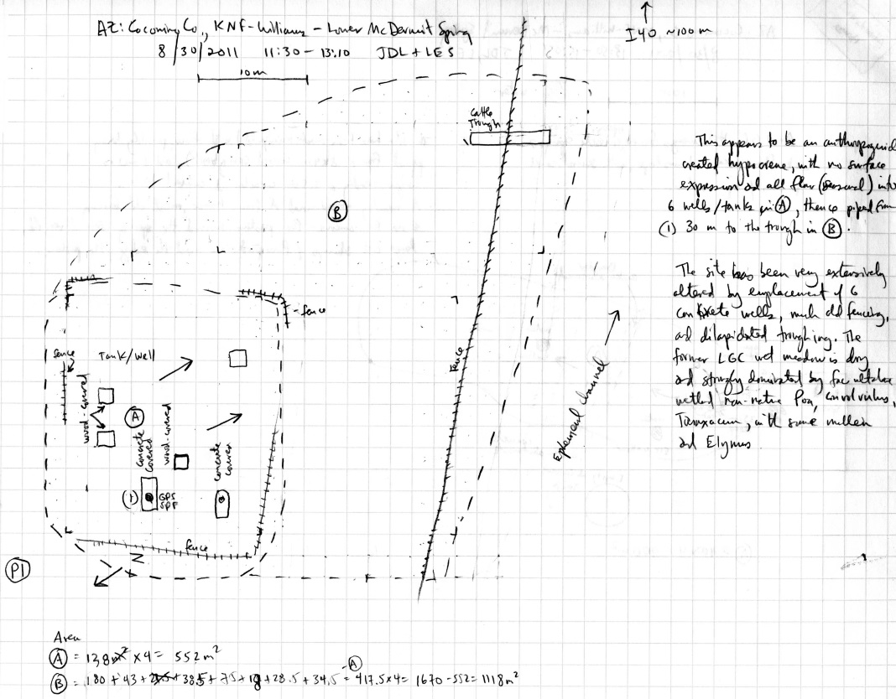
Fig 26.2 Lower McDermit Spring Sketchmap.

27. Maple Spring
27. Maple Spring
Survey Summary Report, Site ID 1145
Submitted June 3, 2019 by Springs Stewardship Institute
Location: The Maple Spring ecosystem is located in Coconino County in the Middle Little Colorado Arizona 15020008 HUC, managed by the US Forest Service. The spring is located in the Coconino NF, Mogollon Rim RD, in the Dane Canyon USGS Quad, at 34.43988, -111.17230 measured using a GPS (WGS84, estimated position error 4 meters). The elevation is approximately 2334 meters. Jeri Ledbetter, Gloria Hardwick, Mellisa Yin, and Joseph Holway surveyed the site on 7/21/17 for 01:25 hours, beginning at 8:45, and collected data in 10 of 10 categories. This survey was conducted under the NEPA Cleared List project using the Stevens et al. Level 2 protocol.

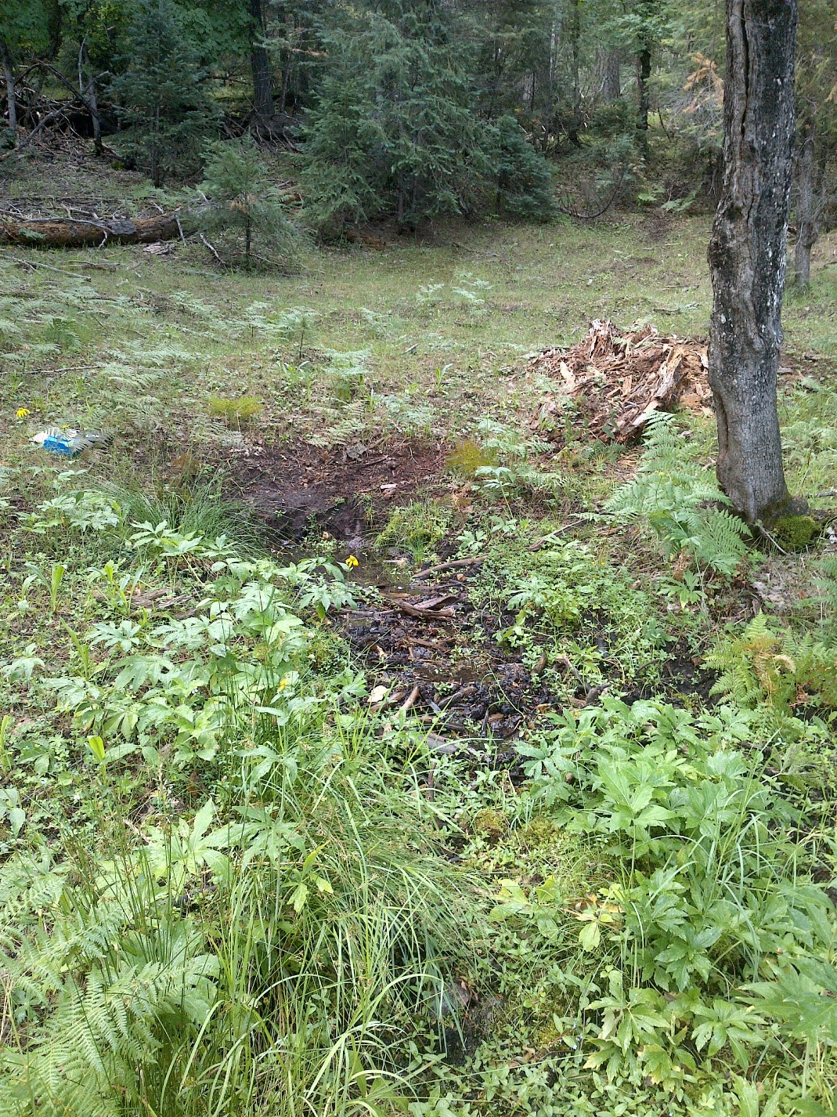
Fig 27.1 Maple Spring: View upslope toward the source from 5 meters below

Physical Description: Maple Spring is a hillslope spring. Flow emerges in an excavated pool in an open area surrounded by mixed conifer and maple forest, about 50 meters upslope of a closed FS road 9707L. Flow was bermed near the road and diverted under a wooden bridge. The general area around the site has been disturbed and manipulated, with berms. It may have once been a helocrene. The microhabitats associated with the spring cover 170 sqm. The site has 3 microhabitats, including A -- a 18 sqm pool, B -- a 44 sqm channel, C -- a 108 sqm terrace. The geomorphic diversity is 0.38, based on the Shannon-Weiner diversity index.

Table 27.1 Maple Spring Microhabitat characteristics.
Code | A | B | C
Name | Source: Pool/pools | Channel | Terraces
Area sqm | 18 | 44 | 108
Surface type | P | CH | TE
Surface subtype | anthro
Slope variability | Low | Low | Low
Aspect TN
Slope degrees | 0 | 8 | 8
Moisture (scale 1-10) | 10 | 9 | 4
Water depth cm | 8 | 2 | 0
Area % open water | 100 | 60 | 0
Substrate
1 - Clay % | 0 | 0 | 0
2 - Silt % | 45 | 15 | 10
3 - Sand % | 5 | 15 | 10
4 - Fine gravel % | 4 | 30 | 2
5 - Coarse gravel % | 2 | 30 | 2
6 - Cobble % | 0 | 0 | 2
7 - Boulder % | 0 | 0 | 0
8 - Bedrock % | 0 | 0 | 0
Organic % | 44 | 10 | 74
Other % (anthropogenic) | 0 | 0 | 0
Precipitate % | 0 | 0 | 0
Litter % | 5 | 10 | 15
Wood % | 25 | 20 | 15
Litter Depth (cm) | 0.5 | 0.5 | 1

Geomorphology: Maple Spring emerges as a contact spring from the Kaibab Limestone, a sedimentary, limestone rock layer. The emergence environment is subaerial, with a gravity flow force mechanism.

Survey Notes: The source pool was either excavated or caused by elk trampling, or possibly both. The channel is incised from trampling. The upper pool is round, about 1.5 meters diameter and 8 centimeters deep. Flow appears to gain as it moves downstream through the channel. The second pool is about 2.4 meters long, 2 meters wide and formed by a berm. The third pool is 2.8 meters long and 2 meters wide, and not as deep (1-2cm). It appears that rock and pieces of wood have been placed in the channel, possibly for stabilization.

Flow: Surveyors measured a flow of 0.034 liters/second, using a timed flow volume capture method. Flow was adjusted for an estimate of 95% of site flow capture. Measurements were taken 45.7 meters from first emergence. This spring is perennial.

Water Quality: Measurements were taken 0.65 meters from first emergence (source pool). Location 1: down-gradient from the spring source in standing water at 00:00:00.

Table 27.2 Maple Spring Water Quality with multiple readings averaged.
Characteristic Measured | Average Value | Site Number | Device | Comments
Alkalinity, Total (mg/L) | 128 | 1 | LaMotte
Dissolved oxygen (field) (mg/L) | 4.8 | 1 | CHEMets DO kit
pH (field) | 7.34 | 1 | Hanna Combo
Salinity (field) (ppt) | 0.135 | 1 | Hanna Combo
Specific conductance (field) (uS/cm) | 275 | 1 | Hanna Combo | Adjusted for temp from EC: 257
Temperature, air C | 21.75 |  | Handheld therm
Temperature, water C | 9.3 | 1 | Hanna Combo

Flora: Gloria Hardwick was the botanist for this survey. Surveyors identified 32 plant species at the site, with 0.1882 species/sqm. These included 28 native and 4 nonnative species.

Table 27.3 Maple Spring Cover Type.
Cover Type | Species Count | Wetland Species Count
Ground | 26 | 9
Shrub | 1 | 0
Mid-canopy | 2 | 0
Tall canopy | 1 | 0
Basal | 2 | 0
Aquatic | 1 | 1
Non-vascular | 3 | 1

Table 27.4 Maple Spring Vegetation % Cover in Microhabitats.
Species | Cover Code | Native Status | Wetland Status | Comments | A | B | C
Acer grandidentatum | BC | N | F |  | 0 | 0 | 0.02
Acer grandidentatum | MC | N | F |  | 0.5 | 0.05 | 0.05
Achillea millefolium | GC | NI | U |  | 0 | 0 | 0.1
Antennaria | GC | N | U |  | 0 | 0 | 0.01
Carex stipata | GC | N | W | Collected | 0.5 | 0.01 | 0.01
Cicuta maculata | GC | N | W | Cicuta? coll. - H. veins variable | 0 | 10 | 0
Clinopodium vulgare | GC | N | F |  | 0 | 0 | 0.1
Epilobium ciliatum | GC | N | W |  | 0 | 0.01 | 0.03
Equisetum | GC | N | WR |  | 0.01 | 0 | 0
Festuca arizonica | GC | N | U |  | 0 | 0 | 0.03
Festuca sororia | GC | N |  |  | 0 | 0 | 0.02
Fragaria | GC | N | U |  | 0 | 0 | 0.05
Geranium richardsonii | GC | N | F |  | 0 | 0 | 6
Glyceria elata | GC | N | W | Collected | 0.01 | 0.01 | 0
Helenium hoopesii | GC | N | F |  | 0 | 0 | 0.05
Juncus laccatus | GC | N | W |  | 0.02 | 0.01 | 2
Marchantia polymorpha | NV | N | WR | Collected - in channel | 0 | 40 | 0
Medicago | GC |  | F | likely lupulina, no blooms | 0 | 0 | 4
Perideridia parishii | GC | N | F |  | 0 | 0 | 0.01
Poa pratensis | GC | NI | F |  | 0 | 0 | 0.5
Polypodium | NV |  |  | Small fern | 0 | 0 | 0.03
Prunella vulgaris | GC | N | F |  | 0 | 0 | 1
Pseudotsuga menziesii var. glauca | BC | N | U |  | 0 | 0 | 0.04
Pseudotsuga menziesii var. glauca | MC | N | U |  | 0 | 0 | 0.2
Pseudotsuga menziesii var. glauca | SC | N | U |  | 0 | 0 | 0.5
Pseudotsuga menziesii var. glauca | TC | N | U |  | 0 | 0.05 | 0
Pteridium aquilinum | GC | N | U |  | 0 | 0 | 4
Ranunculus macounii | GC | N | W | Collected | 0 | 5 | 0.2
Rudbeckia laciniata | GC | N | F |  | 0 | 0 | 7
Thermopsis pinetorum | GC | N | F |  | 0 | 0 | 5
Trifolium wormskioldii | GC | N | WR |  | 0 | 0.04 | 0.4
unknown Moss | NV |  |  |  | 0.5 | 15 | 7
Veratrum californicum | GC | N | W |  | 0 | 0 | 5
Veronica americana | AQ | N | A |  | 20 | 10 | 0.2
Vicia | GC |  | WR |  | 0 | 0 | 0.01
Viola | GC | N | F |  | 0 | 0.02 | 3

Fauna: Surveyors collected or observed 5 aquatic and 2 terrestrial invertebrates and 5 vertebrate specimens.

Table 27.5 Maple Spring Invertebrates.
Species | Lifestage | Habitat | Method | Rep# | Count | Species Detail
Diptera Culicidae | L | A | Spot
Hymenoptera Formicidae Camponotus | Ad | T | Spot
Isopoda | Ad | A | Spot
Neoophora Planariidae Dugesia | Ad | A | Spot |  |  | flatworms
Plecoptera | Ad | T | Spot
Trichoptera | L | A | Spot

Table 27.6 Maple Spring Vertebrates.
Vertebrate Species Common Name | Count | Detection | Comments
Red Squirrel |  | obs
Steller's Jay |  | call
Northern Flicker |  | obs
Mountain Chickadee |  | call
Elk | many | sign

Assessment: Assessment scores were compiled in 5 categories and 33 subcategories, with 9 null condition scores, and 9 null risk scores. Aquifer functionality and water quality are good with significant restoration potential and there is low risk. Geomorphology condition is good with significant restoration potential and there is low risk. Habitat condition is good with significant restoration potential and there is low risk. Biotic integrity is good with significant restoration potential and there is low risk. Human influence of site is good with significant restoration potential and there is low risk. Administrative context status is undetermined due to null scores and there is undetermined risk due to null scores. Overall, the site condition is good with significant restoration potential and there is low risk.

Table 27.7 Maple Spring Assessment Scores.
Category | Condition | Risk
Aquifer Functionality & Water Quality | 4.3 | 2
Geomorphology | 4 | 2.4
Habitat | 4.2 | 2
Biota | 4.4 | 2
Human Influence | 4.3 | 2.3
Administrative Context | 0 | 0
Overall Ecological Score | 4.3 | 2.2

Management Recommendations: This site would benefit from thinning of the surrounding forest. Due to its relatively high flow volume, good condition, and closure of the road, this spring would be a high priority for management attention. Consider returning the site to a more natural condition—spreading out the flow, filling and stabilizing the incised channels, removing the berms, and allowing the outflow to cross the road more naturally. Volunteers could rehabilitate the site with hand tools. Monitor regularly.

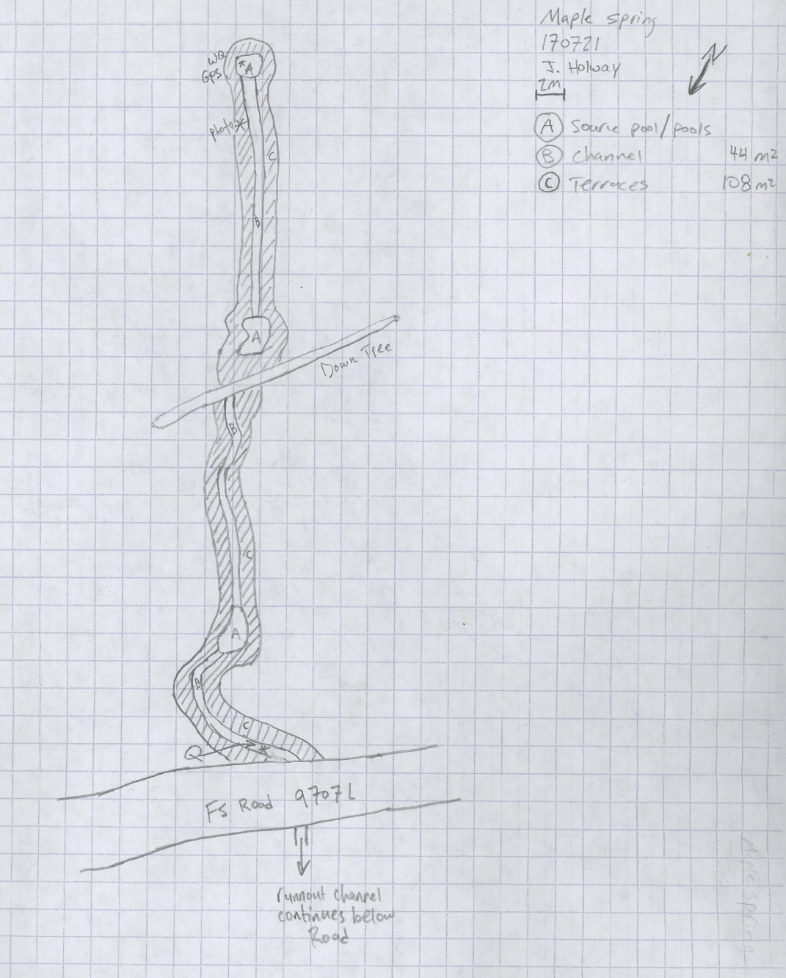
Fig 27.2 Maple Spring Sketchmap.

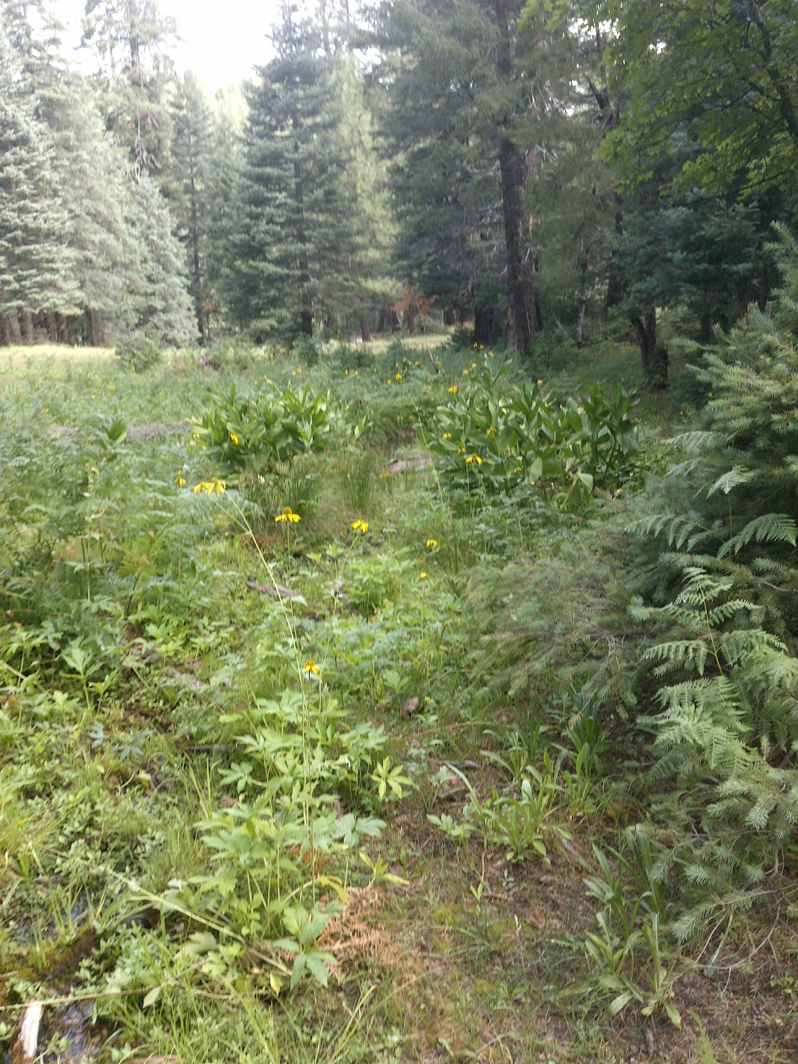
Fig 27.3 Maple Spring: View downslope from 5 meters below the source, toward the road

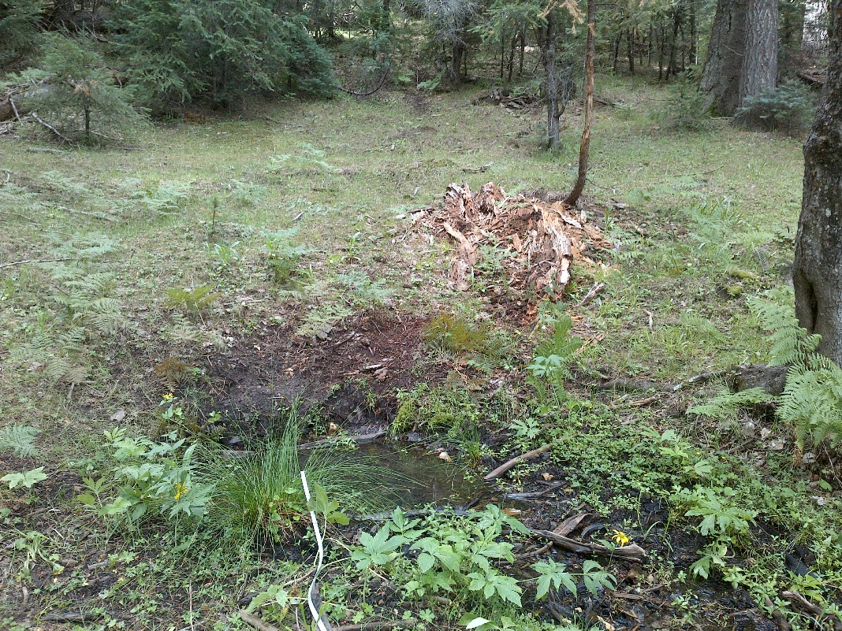
Fig 27.4 Maple Spring: Matching photograph from previous USFS survey, below the source

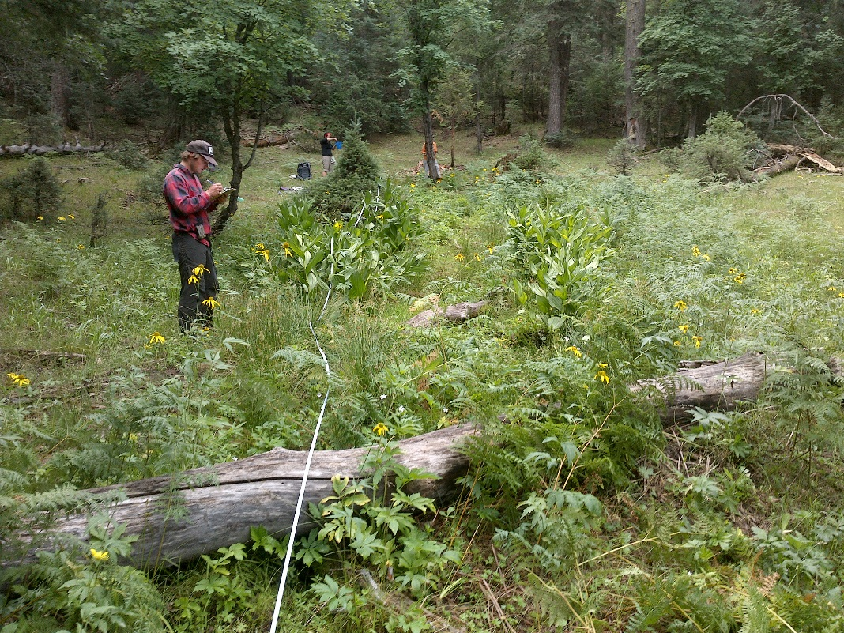
Fig 27.5 Maple Spring: Matching photograph from previous USFS survey, below the second pool

28. Mashed Potato Spring
28. Mashed Potato Spring
Survey Summary Report, Site ID 226450
Submitted June 3, 2019 by Springs Stewardship Institute
Location: The Mashed Potato Spring ecosystem is located in Coconino County in the Middle Little Colorado Arizona 15020008 HUC, managed by the US Forest Service. The spring is located in the Coconino NF, Mogollon Rim RD, in the Kehl Ridge USGS Quad, at 34.46203, -111.35230 measured using a GPS (WGS84, estimated position error 5 meters). The elevation is approximately 2207 meters. Jeri Ledbetter, Glenn Rink, Joseph Holway and Melissa Carrillo-Galaviz surveyed the site on 6/22/17 for 00:55 hours, beginning at 12:15, and collected data in 10 of 10 categories. This survey was conducted under the NEPA Cleared List project using the Stevens et al. Level 2 protocol.

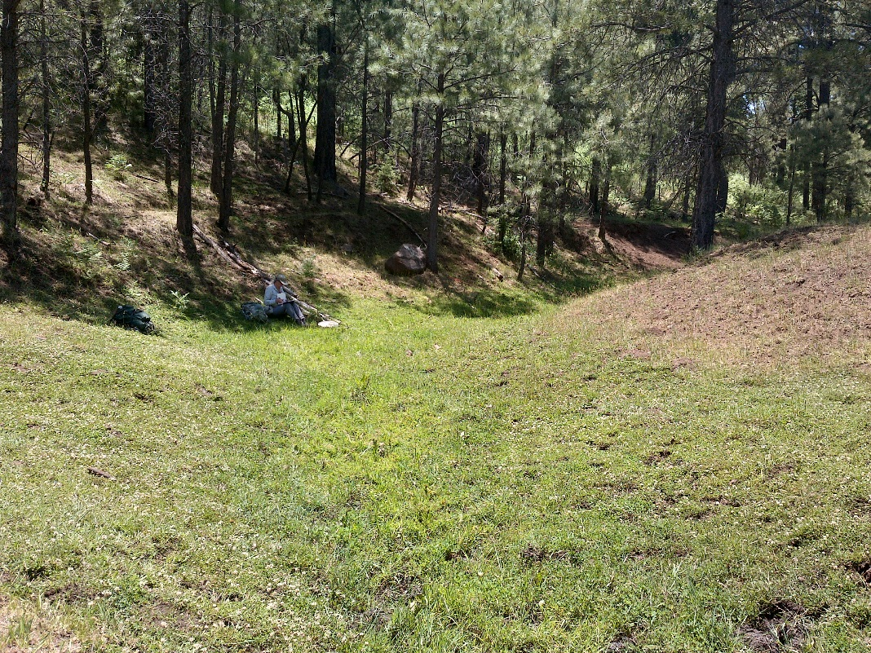
Fig 28.1 Mashed Potato Spring: Upslope view from first pool

Physical Description: Mashed Potato Spring is a rheocrene/helocrene spring. Flow emerges in a trenched channel along an old closed road in Potato Draw in what was once a wet meadow. The microhabitat associated with the spring covers 300 sqm. The site has 1 microhabitat, A -- a 300 sqm channel.

Table 28.1 Mashed Potato Spring Microhabitat characteristics.
Code | A
Name | Constructed Channel
Area sqm | 300
Surface type | CH
Surface subtype | anthro
Slope variability | Low
Aspect TN
Slope degrees | 1
Moisture (scale 1-10) | 7
Water depth cm | 8
Area % open water | 5
Substrate
1 - Clay % | 0
2 - Silt % | 0
3 - Sand % | 0
4 - Fine gravel % | 0
5 - Coarse gravel % | 1
6 - Cobble % | 1
7 - Boulder % | 0
8 - Bedrock % | 0
Organic % | 88
Other % (anthropogenic) | 0
Precipitate % | 0
Litter % | 80
Wood % | 1
Litter Depth (cm) | 2

Geomorphology: Mashed Potato Spring emerges as a seepage or filtration spring from the Coconino, a sedimentary, sandstone rock layer. The emergence environment is subaerial, with a gravity flow force mechanism.

Survey Notes: The site has been heavily trampled, grazed, and browsed by many elk. Seepage begins in a constructed meandering channel with check dams in varying levels of functionality. Pinus ponderosa are encroaching. Road closures have, in no doubt, helped to protect the area, but the elk presence is very damaging. There was high diversity of dragonflies and butterflies at this site. No crayfish were observed, although many are present in Potato Lake. The constructed channel and a dam diverts surface flow into Potato Lake.

Flow: Surveyors measured a flow of 0.50 liters/second, using a timed flow volume capture method. Flow was adjusted for an estimate of 100% of site flow capture. Surveyors measured flow 260 meters downstream from the spring source. The stream appears to be gaining throughout this distance. This spring is perennial.

Water Quality: Surveyors measured water chemistry in a pool 16.5 meters below the source. No flow was apparent at this collection location. These measurements may not be representational of the aquifer. Appropriate instruments were calibrated on 6/22/2017.Location 1: down-gradient from the spring source in standing water at 00:00:00.

Table 28.2 Mashed Potato Spring Water Quality with multiple readings averaged.
Characteristic Measured | Average Value | Site Number | Device | Comments
Alkalinity, Total (mg/L) | 100 | 1 | LaMotte
Dissolved oxygen (field) % saturation | 8 | 1 | YSI Multiprobe
Dissolved oxygen (field) (mg/L) | 0.59 | 1 | YSI Multiprobe
pH (field) | 6.41 | 1 | YSI Multiprobe
Salinity (field) (ppt) | 0.198 | 1 | Hanna Combo
Specific conductance (field) (uS/cm) | 315 | 1 | Hanna Combo | Adjusted for temp from 348 EC
Temperature, air C | 31 |  | Handheld therm

Flora: Glenn Rink was the botanist for this survey; the ID numbers are his. Surveyors identified 19 plant species at the site, with 0.0633 species/sqm. These included 13 native and 6 nonnative species.

Table 28.3 Mashed Potato Spring Cover Type.
Cover Type | Species Count | Wetland Species Count
Ground | 17 | 12
Shrub | 0 | 0
Mid-canopy | 0 | 0
Tall canopy | 1 | 0
Basal | 0 | 0
Aquatic | 1 | 1
Non-vascular | 0 | 0

Table 28.4 Mashed Potato Spring Vegetation % Cover in Microhabitats.
Species | Cover Code | Native Status | Wetland Status | Comments | A
Barbarea orthoceras | GC | N | W |  | 0.01
Callitriche heterophylla | AQ | N | W | #14722 | 0.01
Carex subfusca | GC | N | W |  | 0.1
Cerastium | GC |  | WR |  | 0.1
Cirsium vulgare | GC | I | F |  | 0.01
Eleocharis palustris | GC | N | W |  | 1
Equisetum arvense | GC | N | WR |  | 0.01
Festuca sororia | GC | N |  |  | 50
Glyceria borealis | GC | N | W |  | 2
Juncus laccatus | GC | N | W |  | 0.1
Medicago lupulina | GC | I | WR |  | 0.1
Pinus ponderosa | TC | N | F |  | 1
Plantago major | GC | I | WR |  | 1
Poa pratensis | GC | NI | F |  | 25
Rumex crispus | GC | I | WR |  | 2
Trifolium repens | GC | I | WR | #14717 | 15
unknown moss | GC | N | F |  | 0.1
Veronica peregrina | GC | N | W |  | 0.01
Viola nephrophylla | GC | N | WR |  | 0.01

Fauna: Surveyors collected or observed 3 aquatic and 5 terrestrial invertebrates and 5 vertebrate specimens.

Table 28.5 Mashed Potato Spring Invertebrates.
Species | Lifestage | Habitat | Method | Rep# | Count | Species Detail
Hemiptera Gerridae | Ad | A | Spot
Hemiptera Notonectidae | Ad | A | Spot
Hymenoptera Apidae Apis mellifera | Ad | T | Spot
Lepidoptera Lycaenidae Celastrina | Ad | T | Spot
Lepidoptera Nymphalidae Junonia | Ad | T | Spot
Lepidoptera Nymphalidae Nymphalis antiopa | Ad | T | Spot
Lepidoptera Pieridae Phoebis sennae | Ad | T | Spot
Odonata Coenagrionidae Argia | Ad | A | Spot

Table 28.6 Mashed Potato Spring Vertebrates.
Vertebrate Species Common Name | Count | Detection | Comments
Elk |  | sign | Tracks and scat were observed.
Domestic Cow |  | sign | Old scat was observed.
Western Bluebird | 1 | obs
Mountain Chickadee | 1 | call
Northern Flicker | 1 | obs

Assessment: Assessment scores were compiled in 5 categories and 33 subcategories, with 9 null condition scores, and 9 null risk scores. Aquifer functionality and water quality are good with significant restoration potential and there is low risk. Geomorphology condition is moderate with some restoration potential and there is low risk. Habitat condition is good with significant restoration potential and there is low risk. Biotic integrity is good with significant restoration potential and there is low risk. Human influence of site is good with significant restoration potential and there is low risk. Administrative context status is undetermined due to null scores and there is undetermined risk due to null scores. Overall, the site condition is good with significant restoration potential and there is low risk.

Table 28.7 Mashed Potato Spring Assessment Scores.
Category | Condition | Risk
Aquifer Functionality & Water Quality | 4.3 | 2.2
Geomorphology | 3.6 | 2.2
Habitat | 4 | 2.2
Biota | 4.8 | 2.3
Human Influence | 4.7 | 2.2
Administrative Context | 0 | 0
Overall Ecological Score | 4.3 | 2.2

Management Recommendations: Surveyors recommend removing or repairing the enclosure fence, since it is no longer functional. Monitor occasionally.

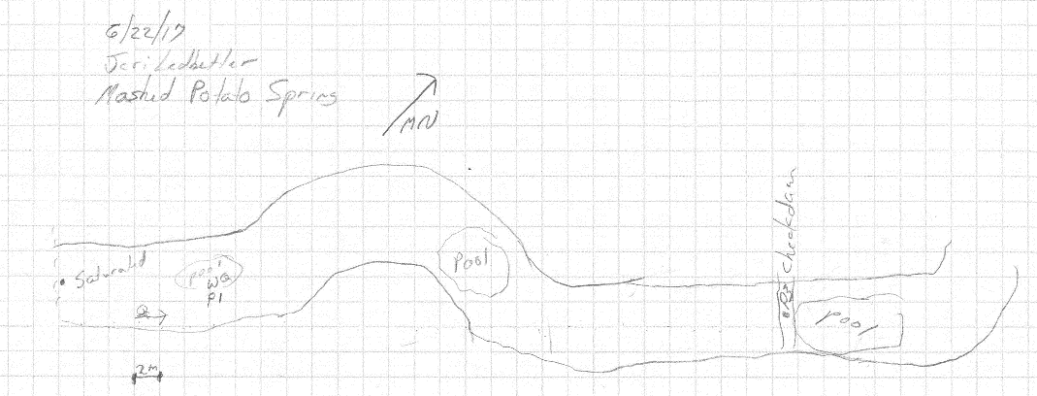
Fig 28.2 Mashed Potato Spring Sketchmap.

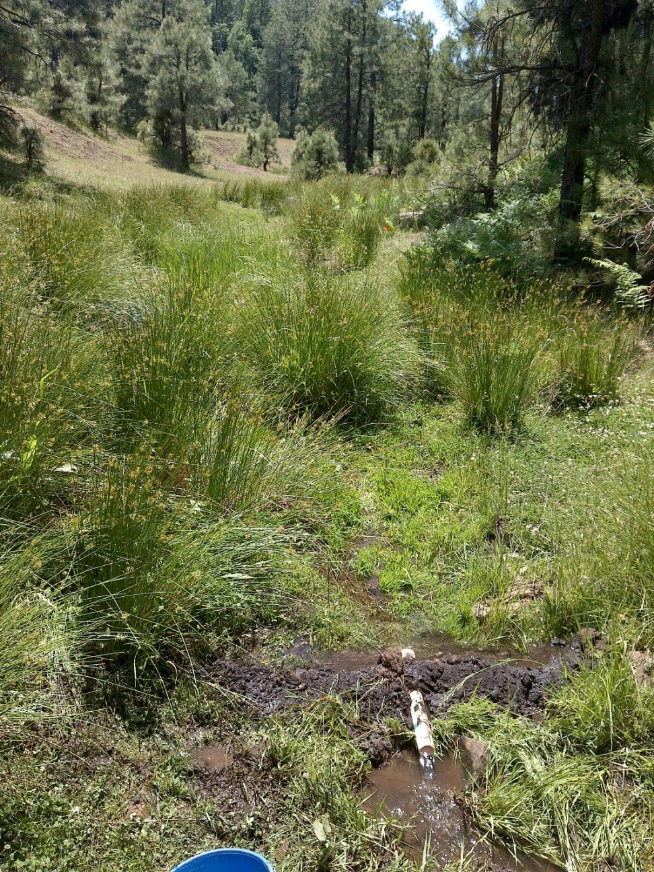
Fig 28.3 Mashed Potato Spring: Flow measurement

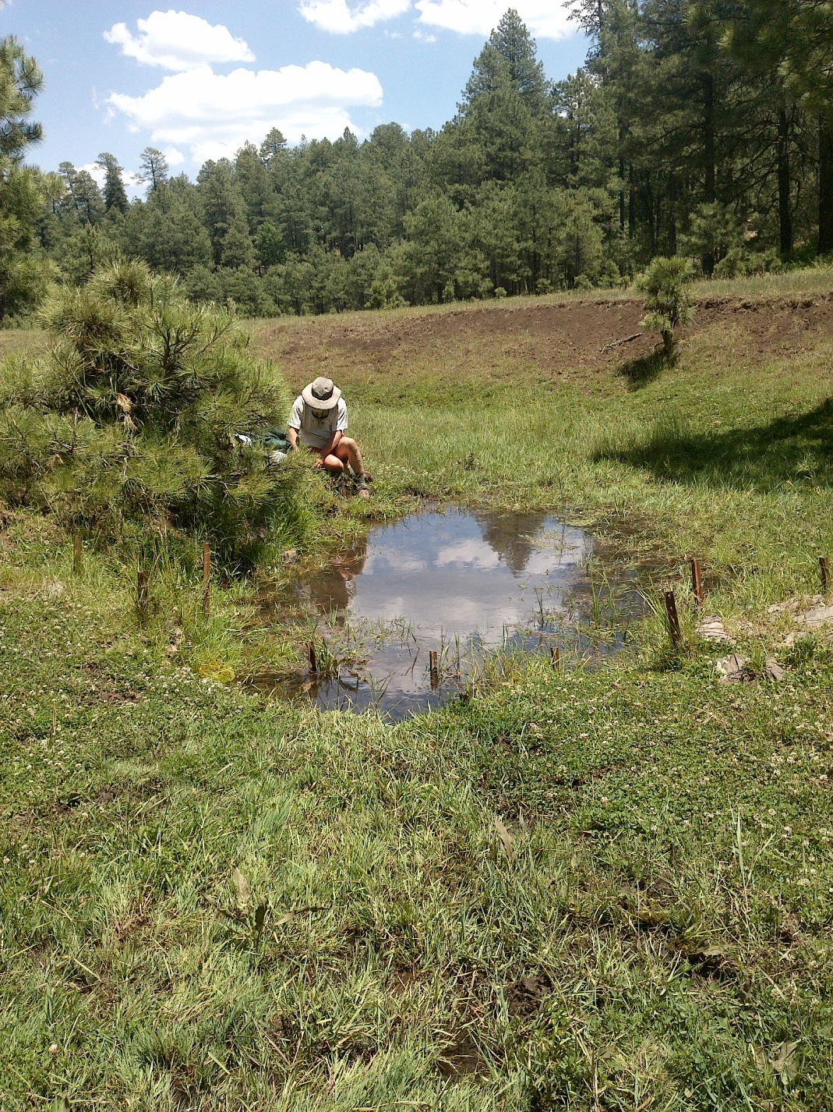
Fig 28.4 Mashed Potato Spring: Pool below check dam

29. Middle Kehl Meadow Spring
29. Middle Kehl Meadow Spring
Survey Summary Report, Site ID 1036
Submitted June 3, 2019 by Springs Stewardship Institute
Location: The Middle Kehl Meadow Spring ecosystem is located in Coconino County in the Middle Little Colorado Arizona 15020008 HUC, managed by the US Forest Service. The spring is located in the Coconino NF, Mogollon Rim RD, in the Kehl Ridge USGS Quad, at 34.44512, -111.31852 measured using a GPS (WGS84, estimated position error 4 meters). The elevation is approximately 2311 meters. Jeri Ledbetter, Glenn Rink, Gloria Hardwick, and Melissa Carrillo-Galaviz surveyed the site on 6/23/17 for 00:45 hours, beginning at 16:00, and collected data in 10 of 10 categories. This survey was conducted under the NEPA Cleared List project using the Stevens et al. Level 2 protocol.

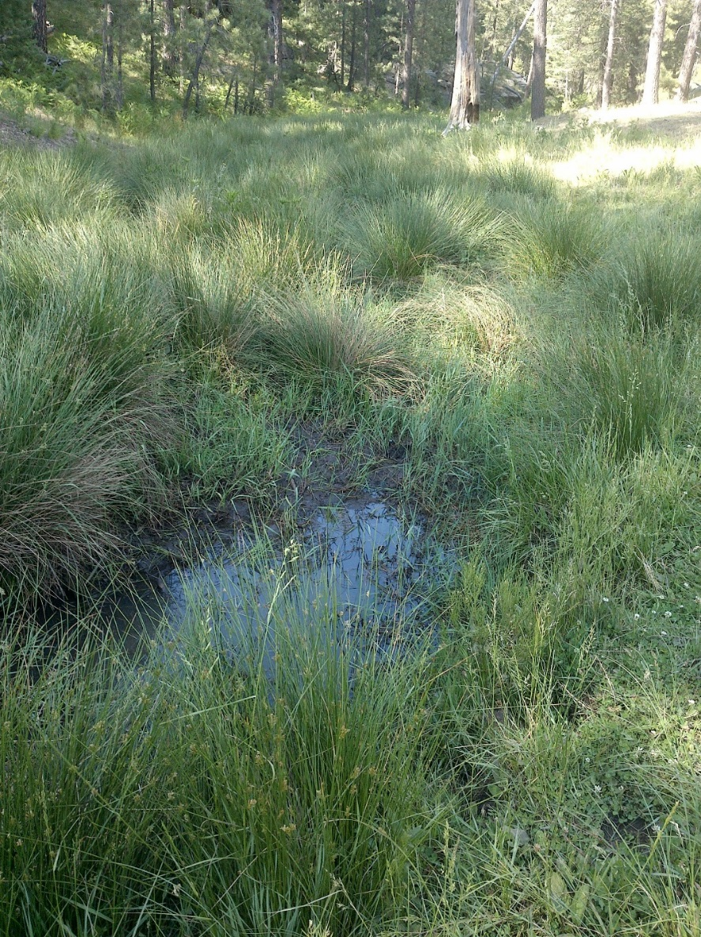
Fig 29.1 Middle Kehl Meadow Spring: 10 meters down from first expression of surface flow, view downslope

Physical Description: Middle Kehl Meadow Spring is a helocrene/rheocrene spring. The spring discharges from a limestone outcrop at the bottom of a drainage channel. This spring emerges in what was once a wet meadow, but has been channelized by heavy trampling of ungulates and by human manipulation. An old, little used road leads directly to the open meadow in a shallow drainage adjacent to the site. The site is close to its marked location on topographic maps, but there is a 70 meter difference from that reported in the NHD database. The microhabitat associated with the spring covers 220 sqm. The site has 1 microhabitat, A -- a 220 sqm channel.

Table 29.1 Middle Kehl Meadow Spring Microhabitat characteristics.
Code | A
Name | Channel
Area sqm | 220
Surface type | CH
Surface subtype
Slope variability | Low
Aspect TN
Slope degrees | 2
Moisture (scale 1-10) | 9
Water depth cm | 5
Area % open water | 20
Substrate
1 - Clay % | 0
2 - Silt % | 15
3 - Sand % | 15
4 - Fine gravel % | 1
5 - Coarse gravel % | 1
6 - Cobble % | 0
7 - Boulder % | 0
8 - Bedrock % | 0
Organic % | 68
Other % (anthropogenic) | 0
Precipitate % | 0
Litter % | 40
Wood % | 2
Litter Depth (cm) | 2

Geomorphology: Middle Kehl Meadow Spring emerges as a seepage or filtration spring from the Coconino, a sedimentary, sandstone rock layer. The emergence environment is subaerial, with a gravity flow force mechanism.

Survey Notes: Two large watering hole excavations, about 1 meter deep, have been trampled heavily by elk. The first emergence is a muddy, trampled pool about 0.5 m by 1 m long with no obvious flow. Sources downstream contribute additional flow, and it gains downstream for less than 100 m. There were many birds and a high diversity of butterflies. No dragonflies were present. Flow begins to channelize downstream as the channel narrows and becomes rockier.

Flow: Surveyors measured a flow of 0.079 liters/second, using a timed flow volume capture method. Flow was adjusted for an estimate of 95% of site flow capture. Measurements were taken 70m down from the first emergence pool. This spring is perennial.

Water Quality: Measurements were taken 8.5m down from the first emergence. Down flow was occurring at the collection location. Appropriate instruments were calibrated on 6/23/2017.

Table 29.2 Middle Kehl Meadow Spring Water Quality with multiple readings averaged.
Characteristic Measured | Average Value | Site Number | Device | Comments
Alkalinity, Total (mg/L) | 53 |  | LaMotte
Dissolved oxygen (field) % saturation | 12.5 |  | YSI Multiprobe
Dissolved oxygen (field) (mg/L) | 1.37 |  | YSI Multiprobe
pH (field) | 6.54 |  | YSI Multiprobe
Salinity (field) (ppt) | 0.56 |  | Hanna Combo
Specific conductance (field) (uS/cm) | 202 |  | Hanna Combo | Corr for temp from EC 145
Temperature, air C | 30.5 |  | Handheld therm
Temperature, water C | 10.9 |  | YSI Multiprobe

Flora: Glenn Rink was the botanist. Surveyors identified 31 plant species at the site, with 0.1409 species/sqm. These included 22 native and 9 nonnative species.

Table 29.3 Middle Kehl Meadow Spring Cover Type.
Cover Type | Species Count | Wetland Species Count
Ground | 29 | 17
Shrub | 0 | 0
Mid-canopy | 0 | 0
Tall canopy | 0 | 0
Basal | 0 | 0
Aquatic | 1 | 1
Non-vascular | 1 | 0

Table 29.4 Middle Kehl Meadow Spring Vegetation % Cover in Microhabitats.
Species | Cover Code | Native Status | Wetland Status | Comments | A
Agrostis | GC | I | W |  | 0.1
Barbarea orthoceras | GC | N | W |  | 0.1
Carex pellita | GC | N | W |  | 0.5
Carex senta | GC | N | W |  | 0.1
Carex subfusca | GC | N | W |  | 0.3
Cerastium | GC |  | WR |  | 0.2
Cirsium vulgare | GC | I | F |  | 0.03
Dugaldia hoopesii | GC | N |  |  | 0.1
Eleocharis palustris | GC | N | W |  | 0.01
Festuca sororia | GC | N |  |  | 1
Geranium caespitosum | GC | N | F |  | 0
Hypericum scouleri | GC | N | WR |  | 0.01
Juncus laccatus | GC | N | W |  | 40
Juncus saximontanus | GC | N | W |  | 0.01
Mentha arvensis | GC | N | WR |  | 0.01
Montia chamissoi | GC | N | W |  | 0
Plantago major | GC | I | WR |  | 0.5
Poa pratensis | GC | NI | F |  | 2
Polygonum aviculare | GC | I | W |  | 0.01
Polygonum bistortoides | GC | N |  |  | 0.1
Rudbeckia laciniata | GC | N | F |  | 2
Rumex acetosella | GC | I | W |  | 0
Rumex crispus | GC | I | WR |  | 0.1
Stellaria longipes | GC | N | F |  | 0
Taraxacum officinale | GC | NI | F |  | 0.02
Thinopyrum intermedium | GC | I | F |  | 0.1
Trifolium | GC | I | WR |  | 5
unknown moss | NV | N | F |  | 0.01
Veronica americana | AQ | N | A |  | 0.03
Vicia americana | GC | N | F |  | 0.01
Viola | GC | N | F |  | 0.1

Fauna: L.E. Stevens reviewed invertebrate specimens and entered data. Surveyors collected or observed 5 aquatic and 4 terrestrial invertebrates and 5 vertebrate specimens.

Table 29.5 Middle Kehl Meadow Spring Invertebrates.
Species | Lifestage | Habitat | Method | Rep# | Count | Species Detail
Coleoptera Dytiscidae | Ad | A | Spot |  | 2 | Small
Coleoptera Dytiscidae Agabus | Ad | A | Spot |  | 1
Diptera Asilidae | Ad | T | Spot |  | 1
Diptera Dolichopodidae | Ad | T | Spot |  | 1
Hemiptera Gerridae Aquarius remigis | Ad | A | Spot |  | 2
Hemiptera Veliidae Microvelia | Ad | A | Spot |  | 1
Hymenoptera Vespidae Vespula pensylvanica | Ad | T | Spot |  | 1
Lepidoptera Nymphalidae Speyeria hesperis | Ad | T | Spot
Trichoptera Limnephilidae | L | A | Spot |  | 7

Table 29.6 Middle Kehl Meadow Spring Vertebrates.
Vertebrate Species Common Name | Count | Detection | Comments
Northern Flicker |  | call
Steller's Jay |  | call | This could also be a scrub jay.
Common Raven |  | call
Elk |  | sign | Tracks and scat were observed.
Western Tanager | 1 | obs

Assessment: Assessment scores were compiled in 5 categories and 33 subcategories, with 9 null condition scores, and 9 null risk scores. Aquifer functionality and water quality are good with significant restoration potential and there is low risk. Geomorphology condition is moderate with some restoration potential and there is low risk. Habitat condition is moderate with some restoration potential and there is low risk. Biotic integrity is good with significant restoration potential and there is low risk. Human influence of site is good with significant restoration potential and there is low risk. Administrative context status is undetermined due to null scores and there is undetermined risk due to null scores. Overall, the site condition is moderate with some restoration potential and there is low risk.

Table 29.7 Middle Kehl Meadow Spring Assessment Scores.
Category | Condition | Risk
Aquifer Functionality & Water Quality | 4.2 | 2.2
Geomorphology | 3 | 2.6
Habitat | 3.4 | 2.2
Biota | 3.9 | 2
Human Influence | 4.1 | 2.3
Administrative Context | 0 | 0
Overall Ecological Score | 3.8 | 2.2

Management Recommendations: This site could benefit from management attention. Surveyors recommend filling in the excavated areas, controlling nonnative vegetation, fencing the source, and allowing elk and other wildlife to access water in the runout channel downstream where the substrate is more rocky. Improving the condition of this site could also benefit the ecological integrity of the meadow habitat as well as of the riparian area downstream, where the channel enters a canyon.

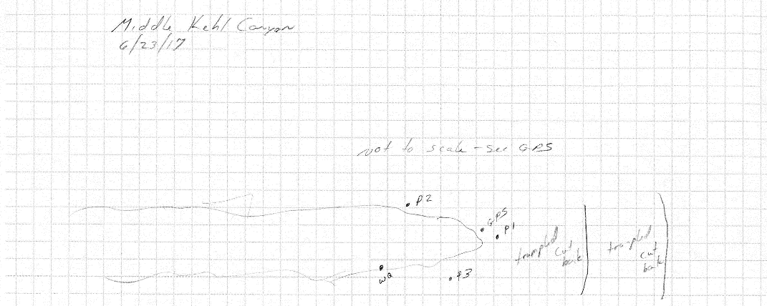
Fig 29.2 Middle Kehl Meadow Spring Sketchmap.

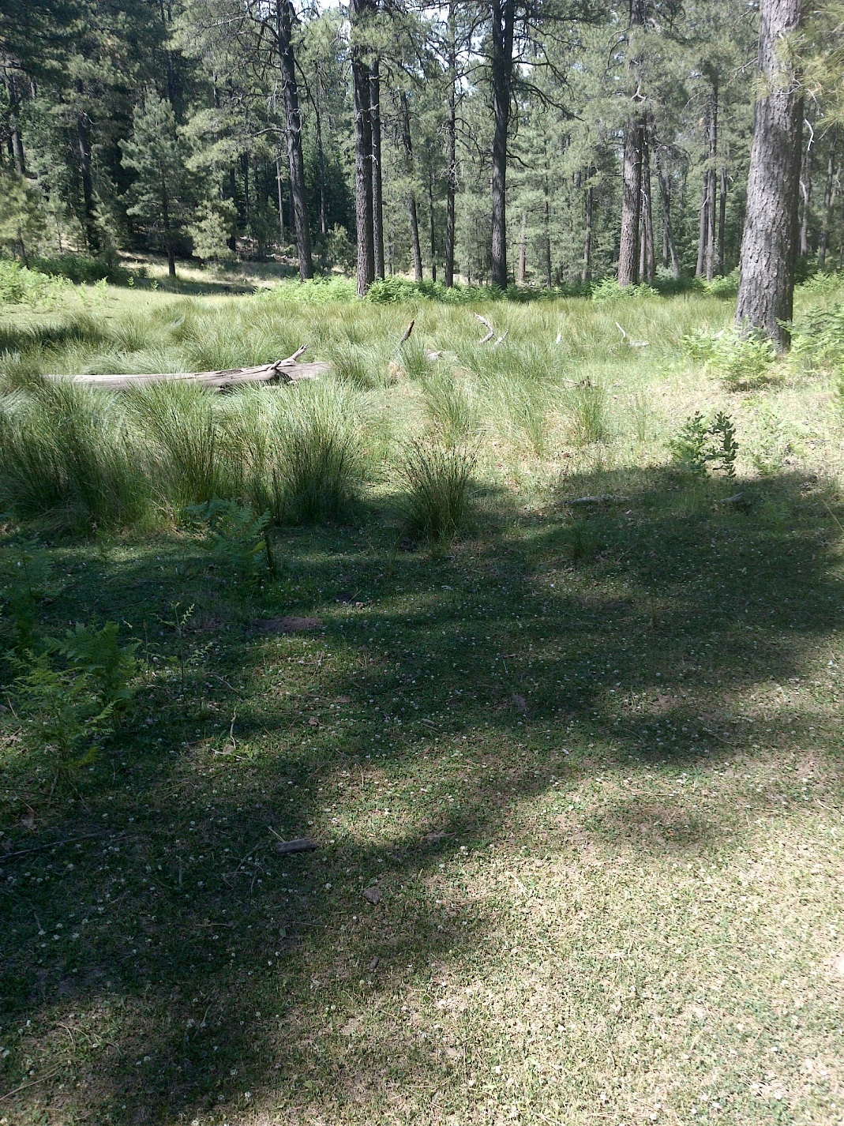
Fig 29.3 Middle Kehl Meadow Spring: First expression of surface flow, view downslope

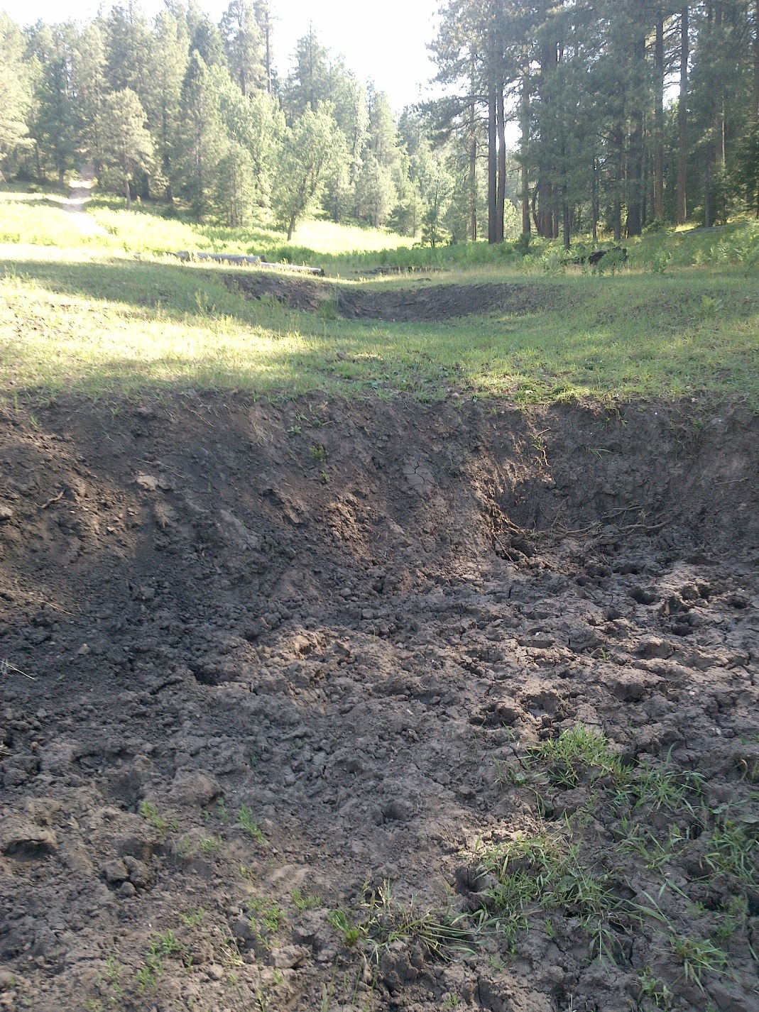
Fig 29.4 Middle Kehl Meadow Spring: View upslope toward heavily trampled area, cutbanks, and meadow

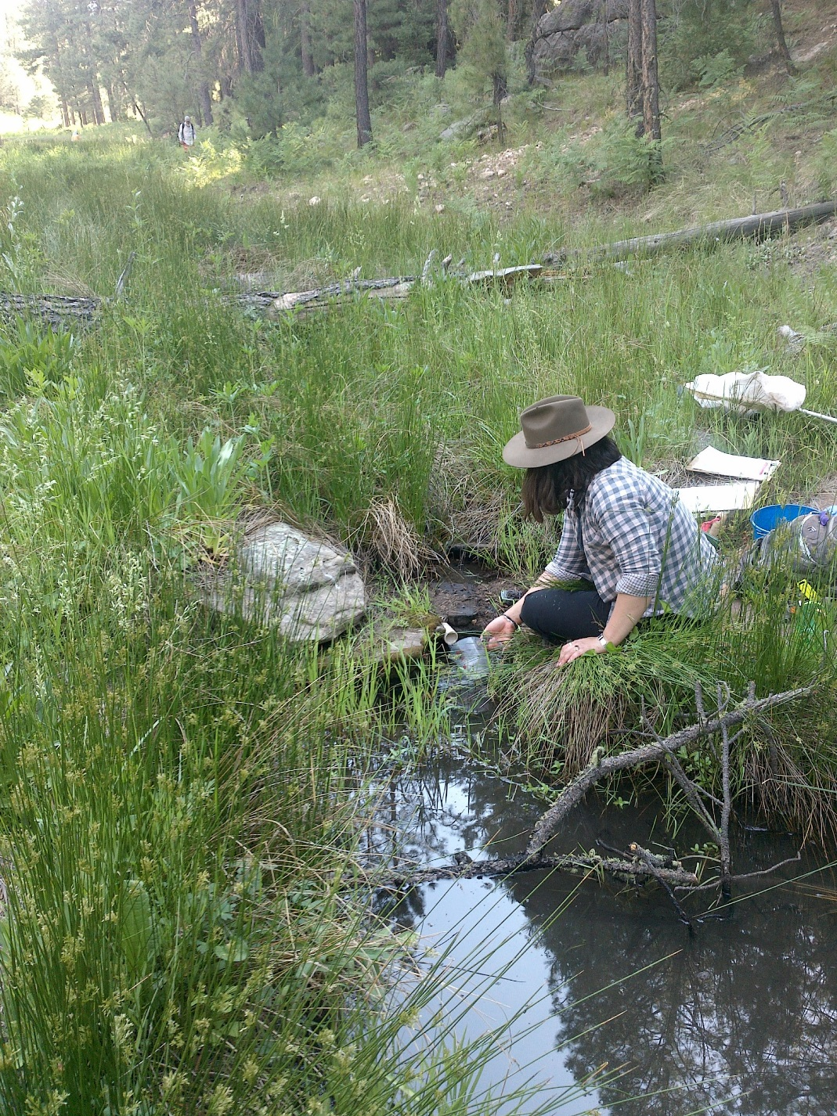
Fig 29.5 Middle Kehl Meadow Spring: Flow measurement location, 70 meters downstream of the source

30. Middle Kehl Spring
30. Middle Kehl Spring
Survey Summary Report, Site ID 1037
Submitted June 3, 2019 by Springs Stewardship Institute
Location: The Middle Kehl Spring ecosystem is located in Coconino County in the Middle Little Colorado Arizona 15020008 HUC, managed by the US Forest Service. The spring is located in the Coconino NF, Mogollon Rim RD, in the Kehl Ridge USGS Quad, at 34.44715, -111.31676 measured using a GPS (WGS84, estimated position error 4 meters). The elevation is approximately 2300 meters. Jeri Ledbetter, Glenn Rink, Gloria Hardwick, and Melissa Carrillo-Galaviz surveyed the site on 6/23/17 for 01:15 hours, beginning at 17:00, and collected data in 10 of 10 categories. This survey was conducted under the NEPA Cleared List project using the Stevens et al. Level 2 protocol.

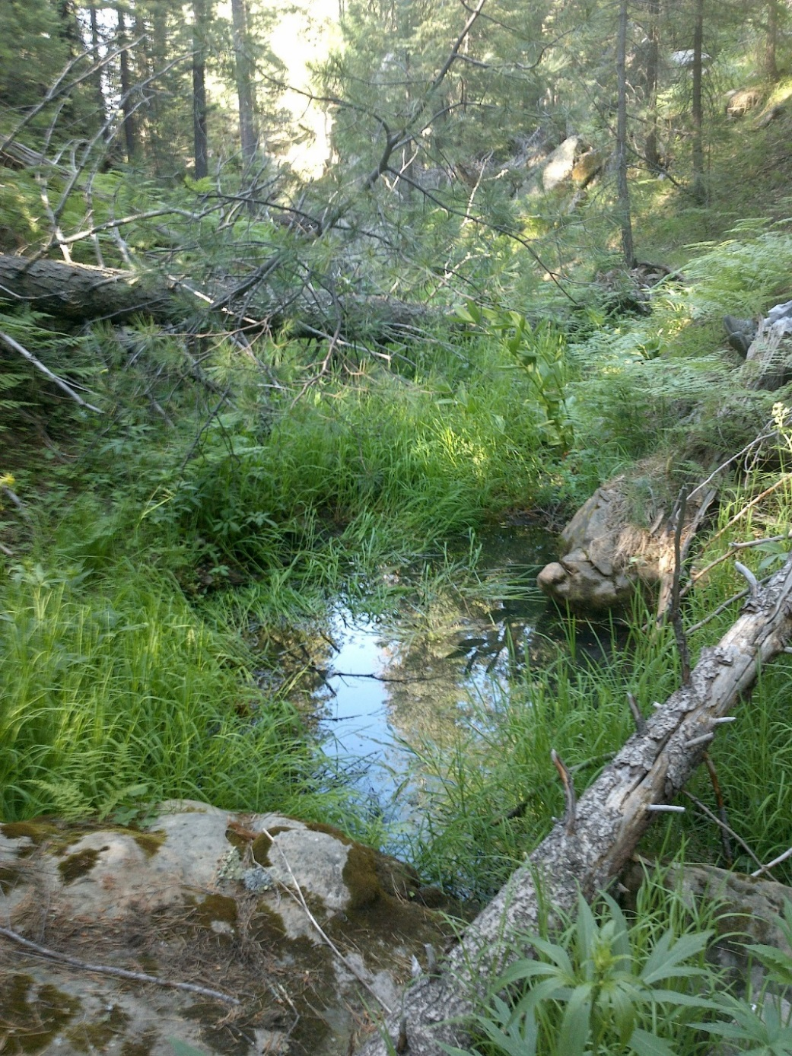
Fig 30.1 Middle Kehl Spring: View of the source pool and runout channel, from the large boulder above the source

Physical Description: Middle Kehl Spring is a rheocrene spring. Flow emerges below a large boulder in a narrow channel, forming pools. Downstream, the spring gains flow. The spring is subject to regular surface flow from spring runoff. The channel has large outcrops and boulders. This site is likely a re-emergence of an upstream spring. In August 2017, surveyors found much more standing and flowing water upstream of this site. The microhabitat associated with the spring covers 150 sqm. The site has 1 microhabitat, A -- a 150 sqm channel.

Table 30.1 Middle Kehl Spring Microhabitat characteristics.
Code | A
Name | Channel
Area sqm | 150
Surface type | CH
Surface subtype
Slope variability | Low
Aspect TN | 20
Slope degrees | 4
Moisture (scale 1-10) | 9
Water depth cm | 50
Area % open water | 10
Substrate
1 - Clay % | 0
2 - Silt % | 0
3 - Sand % | 10
4 - Fine gravel % | 10
5 - Coarse gravel % | 20
6 - Cobble % | 20
7 - Boulder % | 5
8 - Bedrock % | 5
Organic % | 0
Other % (anthropogenic) | 0
Precipitate % | 0
Litter % | 60
Wood % | 166
Litter Depth (cm) | 1

Geomorphology: Middle Kehl Spring emerges as a seepage or filtration spring from the Coconino, a sedimentary, sandstone rock layer. The emergence environment is subaerial, with a gravity flow force mechanism.

Access Directions: From NF-208, park at these coordinates: 34.44995. -111.32207. Then, hike southeast into the drainage.

Survey Notes: There are several fallen trees near the source and large cutbanks along the channel. The site receives very little sunlight due to high, steep banks. Flow goes subsurface, then re-emerges several times, forming a series of pools. A much larger and deeper pool forms 55 meters downslope. Surveyors did not identify microhabitats, but inventoried the channel.

Flow: Surveyors measured a flow of 0.099 liters/second, using a timed flow volume capture method. Flow was adjusted for an estimate of 100% of site flow capture. Measurements were taken 200m down from first emergence pool. Abundant litter and aquatic plants were present at the location where measurements took place. This spring is perennial.

Water Quality: Measurements were taken at the first emergence pool of the spring. There was an abundant amount of aquatic grasses at the collection location.

Table 30.2 Middle Kehl Spring Water Quality with multiple readings averaged.
Characteristic Measured | Average Value | Site Number | Device | Comments
Alkalinity, Total (mg/L) | 48 |  | LaMotte
Dissolved oxygen (field) % saturation | 6.3 |  | YSI Multiprobe
Dissolved oxygen (field) (mg/L) | 0.67 |  | YSI Multiprobe
pH (field) | 6.48 |  | YSI Multiprobe
Salinity (field) (ppt) | 0.95 |  | Hanna Combo
Specific conductance (field) (uS/cm) | 153 |  | Hanna Combo | Corr for temp from 115 EC
Temperature, air C | 25 |  | Handheld therm
Temperature, water C | 12.6 |  | YSI Multiprobe

Flora: Gloria Hardwick and Glenn Rink were the botanists for this survey. Surveyors identified 42 plant species at the site, with 0.28 species/sqm. These included 37 native and 5 nonnative species.

Table 30.3 Middle Kehl Spring Cover Type.
Cover Type | Species Count | Wetland Species Count
Ground | 39 | 15
Shrub | 0 | 0
Mid-canopy | 1 | 0
Tall canopy | 1 | 0
Basal | 0 | 0
Aquatic | 0 | 0
Non-vascular | 1 | 0

Table 30.4 Middle Kehl Spring Vegetation % Cover in Microhabitats.
Species | Cover Code | Native Status | Wetland Status | Comments | A
Aconitum columbianum | GC | N | F |  | 0.03
Agrostis | GC | I | W | Scabra? | 0.01
Aquilegia chrysantha | GC | N | W |  | 0.5
Barbarea orthoceras | GC | N | W |  | 0.05
Carex bolanderi | GC | N | F |  | 0.1
Carex bolanderi | GC | N | F | #14726 | 0.03
Carex leptopoda | GC | N | F |  | 0.02
Carex stipata | GC | N | W |  | 0.01
Carex subfusca | GC | N | W |  | 0.1
Cerastium | GC |  | WR |  | 0.01
Clinopodium vulgare | GC | N | F |  | 0.01
Cystopteris | GC | N | WR | purple, blk stems | 0.01
Dryopteris filix-mas | GC | N | R |  | 0.01
Epilobium ciliatum | GC | N | W |  | 0.05
Fragaria | GC | N | U |  | 0.1
Geranium caespitosum | GC | N | F |  | 2
Geranium richardsonii | GC | N | F |  | 2
Glyceria elata | GC | N | W |  | 60
Glycyrrhiza | GC |  | F |  | 0.1
Helenium hoopesii | GC | N | F |  | 0.1
Hypericum | GC |  | F |  | 0.01
Juncus laccatus | GC | N | W |  | 2
Maianthemum racemosum | GC | N | U |  | 0.02
Mertensia franciscana | GC | N | F | Pyrola - collected | 0.01
Montia chamissoi | GC | N | W |  | 0.01
Pinus flexilis | MC | N | U | GR#14709 | 8
Polemonium | GC | NI | U |  | 0.05
Pseudotsuga menziesii var. glauca | TC | N | U |  | 5
Pteridium aquilinum | GC | N | U |  | 2
Rubus triflorus | GC | N |  |  | 0.1
Rudbeckia laciniata | GC | N | F |  | 5
Rumex acetosella | GC | I | W |  | 0
Stellaria longifolia | GC | N | F | #14727 | 0.01
Stellaria longipes ssp. longipes | GC | N |  |  | 0.01
Thalictrum fendleri | GC | N | F |  | 0.02
unknown moss | NV | N | F |  | 3
Veratrum californicum | GC | N | W |  | 0.05
Veronica americana | GC | N | A |  | 0.01
Veronica peregrina ssp. peregrina | GC | N |  |  | 0.01
Vicia americana | GC | N | F |  | 0.01
Viola | GC | N | F | White | 0.5
Viola sororia | GC | N | F |  | 0.5

Fauna: Surveyors collected or observed 16 aquatic and 8 terrestrial invertebrates and 4 vertebrate specimens.

Table 30.5 Middle Kehl Spring Invertebrates.
Species | Lifestage | Habitat | Method | Rep# | Count | Species Detail
Annelida Oligochaetae | Ad | A | Spot |  | 1
Coleoptera Dytiscidae | Ad | A | Spot |  | 3
Coleoptera Dytiscidae | Ad | A | Spot |  | 1 | small
Coleoptera Dytiscidae Rhantus gutticollis | M | A | Spot |  | 2
Coleoptera Elmidae | Ad | A | Spot |  | 5
Coleoptera Hydraenidae | Ad | A | Spot |  | 4 | convex
Coleoptera Hydrophilidae | L | A | Spot
Coleoptera Hydrophilidae | Ad | A | Spot |  | 2 | small
Coleoptera Hydrophilidae Tropisternus affinis | Ad | A |  |  | 1 | Observed
Coleoptera Scarabaeidae | Ad | T | Spot |  | 1
Diptera Chironomidae | L | A | Spot |  | 2
Diptera Culicidae Culiseta | L | A | Spot
Diptera Sciaridae | Ad | T | Spot |  | 1
Diptera Sepsidae | Ad | T | Spot |  | 1
Diptera Therevidae | Ad | T | Spot |  | 1
Diptera Tipulidae | Ad | T | Spot |  | 2
Ephemeroptera | L | A | Spot |  | 3 | Sp 1; many were observed.
Ephemeroptera Baetidae | Ad |  | Spot |  | 1 | Sp 2
Hemiptera Notonectidae Notonecta kirbyi | Ad | A | Spot |  | 1
Hymenoptera Apidae Bombus | Ad | T | Spot |  | 1
Odonata Aeshnidae Rhionaeschna | Ad | T | Spot
Odonata Coenagrionidae Argia | Ad | T | Spot
Trichoptera Limnephilidae | L | A | Spot |  | 1 | Sp 3
Trichoptera Limnephilidae Hesperophylax | L | A | Spot |  | 2 | Many were observed.

Table 30.6 Middle Kehl Spring Vertebrates.
Vertebrate Species Common Name | Count | Detection | Comments
Northern Flicker |  | call
Hermit Thrush |  | call
Squirrel |  | call | The sound appeared as anger.
Frog

Assessment: Assessment scores were compiled in 5 categories and 33 subcategories, with 9 null condition scores, and 9 null risk scores. Aquifer functionality and water quality are good with significant restoration potential and there is low risk. Geomorphology condition is good with significant restoration potential and there is low risk. Habitat condition is good with significant restoration potential and there is low risk. Biotic integrity is very good with excellent restoration potential and there is negligible risk. Human influence of site is very good with excellent restoration potential and there is negligible risk. Administrative context status is undetermined due to null scores and there is undetermined risk due to null scores. Overall, the site condition is very good with excellent restoration potential and there is negligible risk.

Table 30.7 Middle Kehl Spring Assessment Scores.
Category | Condition | Risk
Aquifer Functionality & Water Quality | 4.8 | 2
Geomorphology | 4.4 | 2
Habitat | 4.2 | 2
Biota | 5 | 1.6
Human Influence | 5.4 | 1.2
Administrative Context | 0 | 0
Overall Ecological Score | 4.9 | 1.7

Management Recommendations: This site is heavily influenced by surface runoff. No management action is indicated at this time, other than regular monitoring.

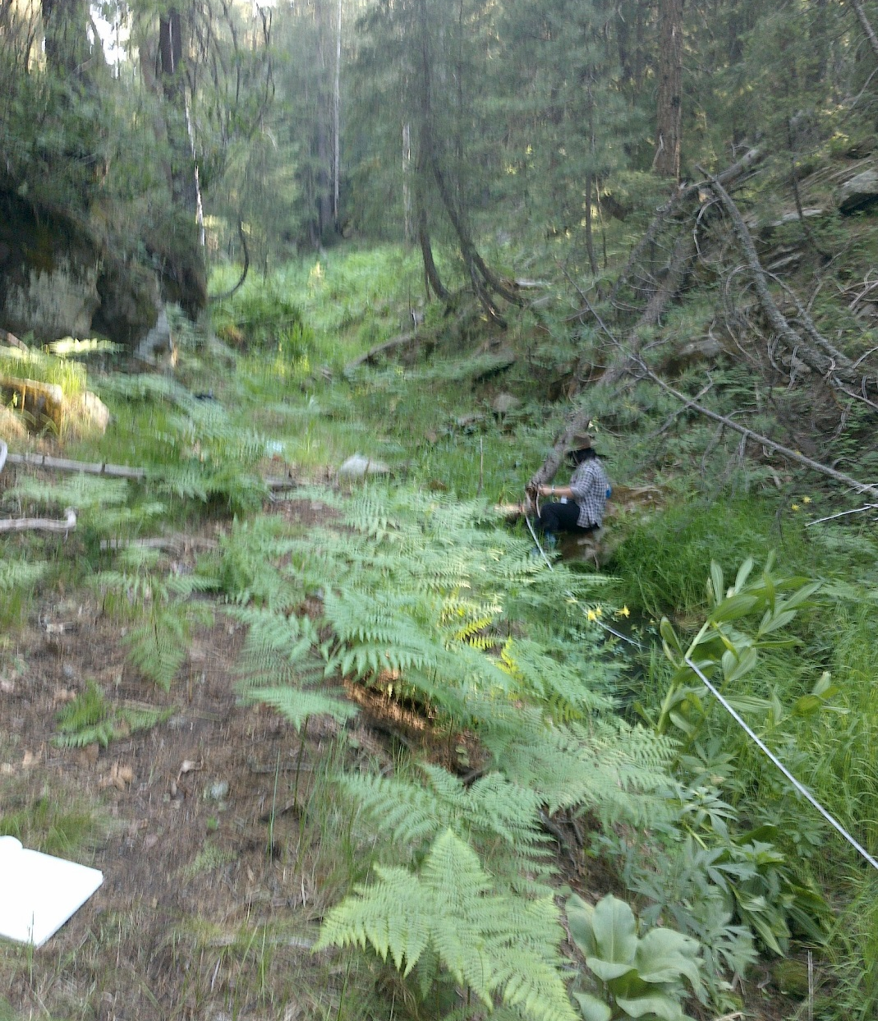
Fig 30.2 Middle Kehl Spring: View upstream from the source from 6 meters downstream

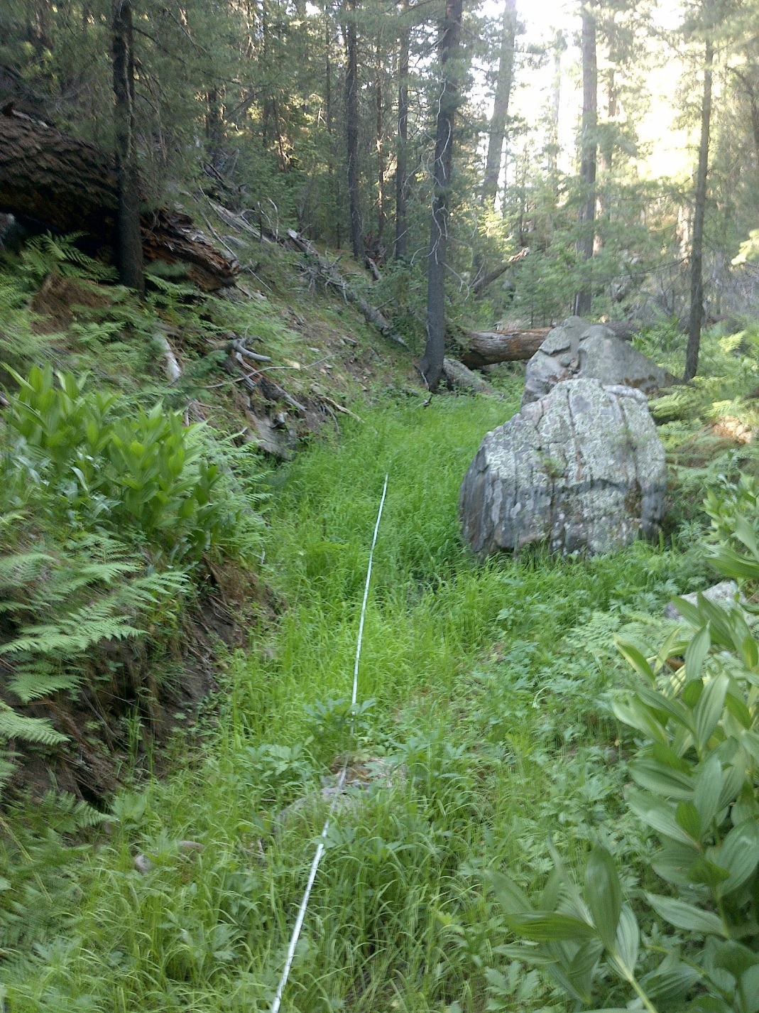
Fig 30.3 Middle Kehl Spring: View downstream from 9 meters below the source

31. Mineral Spring
31. Mineral Spring
Survey Summary Report, Site ID 768
Submitted June 3, 2019 by Springs Stewardship Institute
Location: The Mineral Spring ecosystem is located in Coconino County in the Upper Verde Arizona 15060202 HUC, managed by the US Forest Service. The spring is located in the Kaibab NF, Williams RD, in the Parks USGS Quad, at 35.25186, -111.99942 measured using a GPS (WGS84, estimated position error 4 meters). The elevation is approximately 2124 meters. Prescott College Springs Ecology Class 2014: Glenn Rink, Jeri Ledbetter, Larry Stevens surveyed the site on 5/27/14 for 01:55 hours, beginning at 11:10, and collected data in 10 of 10 categories. This survey was conducted under the NEPA Cleared List project using the Stevens et al. Level 2 protocol.

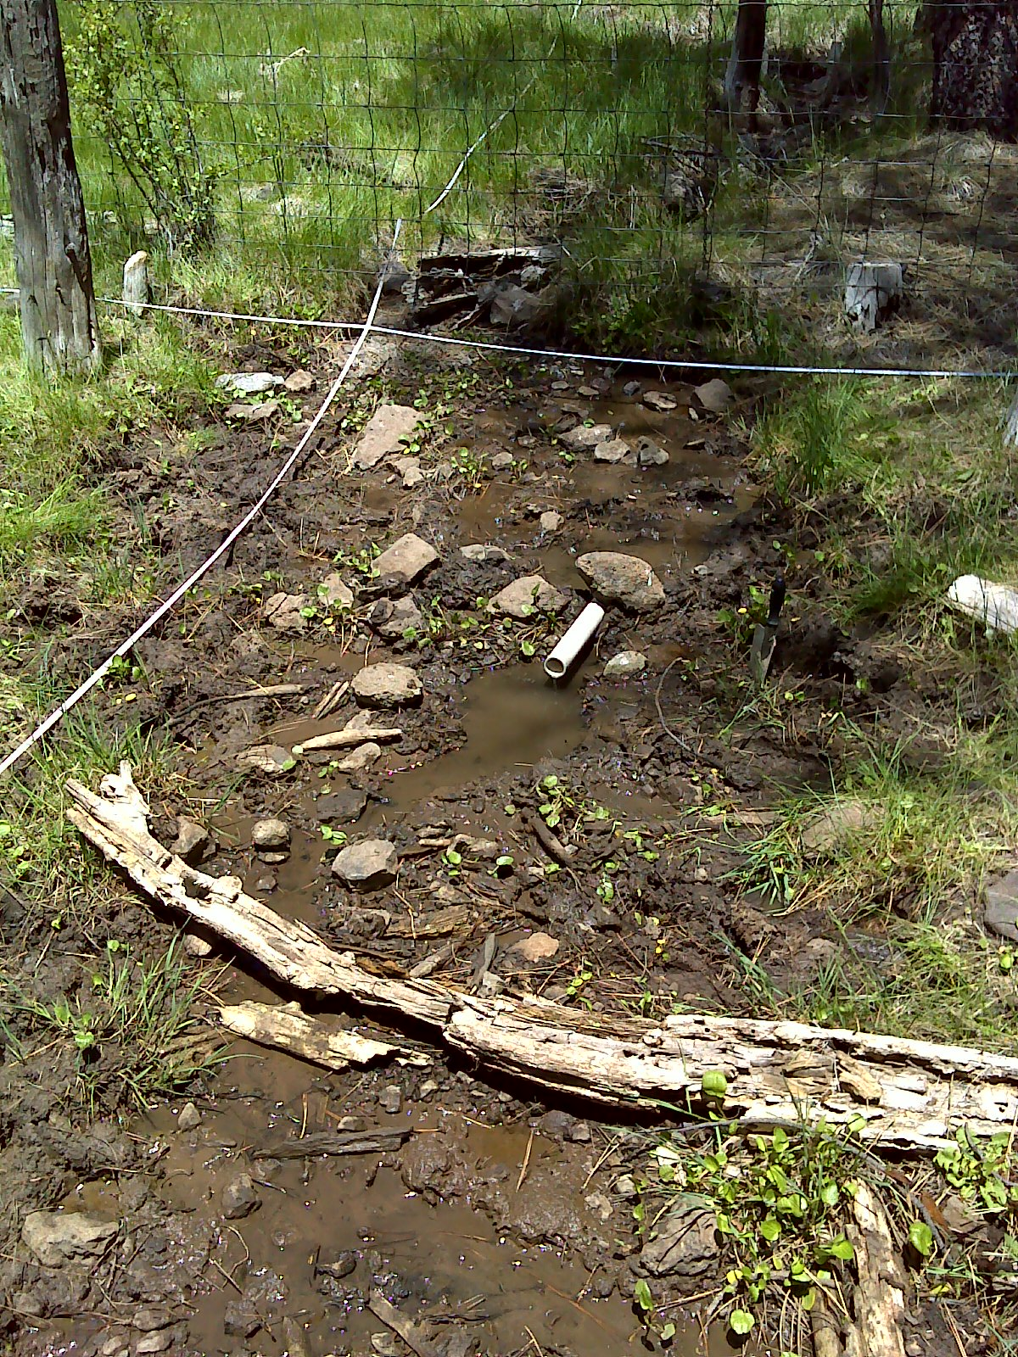
Fig 31.1 Mineral Spring.

Physical Description: Mineral Spring is a helocrene spring. The spring is a low gradient cienega in a forested area. Interstate 40 was constructed over the source. From the source the water channelizes for approximately 70 meters into a pool. The microhabitats associated with the spring cover 514 sqm. The site has 6 microhabitats, including A -- a 121 sqm low gradient cienega, B -- a 50 sqm channel, C -- a 50 sqm channel, D -- a 130 sqm terrace, E -- a 33 sqm channel, F -- a 130 sqm terrace. The geomorphic diversity is 0.72, based on the Shannon-Weiner diversity index.

Table 31.1 Mineral Spring Microhabitat characteristics.
Code | A | B | C | D | E | F
Name | Wet meadow | Upper channels | Lower West Channel | West Terrace | Lower East Channel | East Terrace
Area sqm | 121.00 | 50.00 | 50.00 | 130.00 | 33.00 | 130.00
Surface type | LGC | CH | CH | TE | CH | TE
Surface subtype |  | run | run | LRZ | run | anthro
Slope variability | Low | Low | Low | Low | Low | Low
Aspect TN | 159 | 159 | 159 | 159 | 184 | 184
Slope degrees | 1 | 1 | 1 | 1 | 1 | 1
Moisture (scale 1-10) | 2 | 6 | 7 | 1 | 1 | 0
Water depth cm | 0.00 | 0.50 | 0.50 | 0.00 | 0.00 | 0.00
Area % open water | 0.00 | 75.00 | 35.00 | 0.00 | 0.00 | 0.00
Substrate
1 - Clay % | 20 | 5 | 5 | 2 | 5 | 2
2 - Silt % | 30 | 40 | 5 | 20 | 5 | 20
3 - Sand % | 30 | 20 | 5 | 15 | 5 | 15
4 - Fine gravel % | 2 | 7 | 0 | 20 | 0 | 20
5 - Coarse gravel % | 2 | 5 | 35 | 20 | 35 | 20
6 - Cobble % | 5 | 2 | 35 | 20 | 35 | 20
7 - Boulder % | 2 | 1 | 0 | 0 | 0 | 0
8 - Bedrock % | 0 | 0 | 0 | 0 | 0 | 0
Organic % | 9 | 20 | 13 | 3 | 13 | 3
Other % (anthropogenic) | 0 | 0 | 2 | 0 | 2 | 0
Precipitate % | 0 | 0 | 0 | 0 | 0 | 0
Litter % | 80.00 | 7.00 | 2.00 | 80.00 | 2.00 | 80.00
Wood % | 4.00 | 5.00 | 5.00 | 10.00 | 5.00 | 10.00
Litter Depth (cm) | 1.00 | 0.10 | 0.10 | 1.50 | 0.10 | 1.50

Geomorphology: Mineral Spring emerges as a seepage or filtration spring from an igneous, basalt rock layer in an unknown unit. The emergence environment is subaerial, with a gravity flow force mechanism.

Access Directions: From I-40 east, take exit 178, then turn left on Parks Rd. Turn left at stop sign onto Old Route 66, then left on N. Spitz Spring Rd, R on S Spitz Spring Rd, R on Somerset Ranch Rd, then R on 781 J. Follow a bumpy dirt road for about 1 mile; the spring emerges from below the Interstate.

Survey Notes: The fence 12.5 m from the source is effective; the rest of the channel and pool outside the fence is well trampled. Ponderosa Pines near Interstate 40 as well as those that flank the channel below the source to over 100 meters downstream are dying (likely from salt run off from the interstate). Ponderosa Pines in surrounding area are evenly aged and abundant. There is trash on the terrace on both sides of the outflow channel. Outflow is shallow and limited. The water is dirty and mucky looking, particularly outside the fenced area.

Flow: Surveyors measured a flow of 0.014 liters/second, using a timed flow volume capture method. Flow was adjusted for an estimate of .98% of site flow capture. Surveyors measured the flow just below the confluence of the two channels. This spring is perennial, with a neorefugium persistence.

Water Quality: Surveyors measured water quality by digging a hole in the channel near the source, letting it settle, and taking readings at a depth of 1-2cm.

Table 31.2 Mineral Spring Water Quality with multiple readings averaged.
Characteristic Measured | Average Value | Site Number | Device | Comments
pH (field) | 7.995 |  | Hanna/Ph Spear
Salinity (field) (ppt) | 1.31 |  | Hanna/Ph Spear
Specific conductance (field) (uS/cm) | 2746 |  | Hanna/Ph Spear | EC converted to SC
Temperature, air C | 29.4 |  | Handheld therm
Temperature, water C | 19.6 |  | Hanna/Ph Spear

Flora: Onopordum acanthium present nearby Surveyors identified 20 plant species at the site, with 0.0389 species/sqm. These included 10 native and 9 nonnative species; the native status of 1 species remains unknown.

Table 31.3 Mineral Spring Cover Type.
Cover Type | Species Count | Wetland Species Count
Ground | 17 | 8
Shrub | 1 | 0
Mid-canopy | 0 | 0
Tall canopy | 1 | 0
Basal | 0 | 0
Aquatic | 1 | 1
Non-vascular | 0 | 0

Table 31.4 Mineral Spring Vegetation % Cover in Microhabitats.
Species | Cover Code | Native Status | Wetland Status | Comments | A | B | C | D | E | F
Achillea | GC | N | U |  | 1 | 0 | 0 | 0 | 0 | 0
algae | AQ | N | A |  | 0 | 0.2 | 2 | 0 | 0 | 0
Aster | GC |  |  |  | 5 | 0 | 0 | 0 | 0 | 0
Bromus tectorum | GC | I | F |  | 0 | 0 | 0 | 0 | 0.01 | 0
Carex occidentalis | GC | N | W |  | 5 | 0.1 | 0 | 1 | 3 | 2
Carex subfusca | GC | N | W |  | 0 | 0 | 0.5 | 0.1 | 0 | 0
Cirsium vulgare | GC | I | F |  | 1 | 0 | 0 | 0 | 0 | 0
Dactylis glomerata | GC | I | W |  | 0 | 0 | 0 | 0 | 0 | 0.01
Elymus | GC | I | F |  | 0 | 0 | 3 | 1 | 1 | 0
Iris missouriensis | GC | N | F |  | 3 | 0.1 | 0 | 5 | 0.5 | 5
Juncus saximontanus | GC | N | W |  | 2 | 0 | 0.1 | 0 | 0 | 0
Melilotus officinalis | GC | I | WR |  | 0 | 0 | 0 | 0 | 0 | 0.2
Pinus ponderosa | TC | N | F |  | 4 | 40 | 0 | 6 | 12 | 12
Poa pratensis | GC | I | F |  | 70 | 1 | 1 | 40 | 20 | 8
Ranunculus | GC | N | WR |  | 0 | 0.02 | 8 | 0.2 | 5 | 0
Ribes cereum | SC | N | U |  | 5 | 4 | 0 | 0.1 | 0.2 | 2
Rumex crispus | GC | I | WR |  | 1 | 0 | 0 | 0.2 | 0.01 | 0.2
Symphyotrichum falcatum | GC | N | WR |  | 5 | 0 | 0 | 0 | 0 | 0
Taraxacum officinale | GC | I | F |  | 3 | 0.02 | 0.1 | 0.5 | 0.01 | 0.1
Verbascum thapsus | GC | I | F |  | 0.5 | 0 | 0 | 0 | 0 | 0

Fauna: Surveyors collected or observed 3 aquatic and 16 terrestrial invertebrates and 10 vertebrate specimens.

Table 31.5 Mineral Spring Invertebrates.
Species | Lifestage | Habitat | Method | Rep# | Count | Species Detail
Amphipoda | Ad | A | Spot |  | 10
Chilopoda |  |  | Spot |  | 1
Coleoptera | Ad |  | Spot |  | 1
Coleoptera | Ad |  | Spot |  | 1 | Iris Vacinity of Mineral Spring
Coleoptera | Ad |  | Spot |  | 1 | West of Parks
Coleoptera Dytiscidae | Ad | A | Spot |  | 1
Diplopoda | Ad | T | Spot |  | 1
Diptera | L |  | Spot |  | 1
Diptera | Ad | T | Spot |  | 1 | West of Parks, AZ
Hymenoptera | Ad | T | Spot |  | 1 | Iris Vacinity of Mineral Spring
Hymenoptera | Ad | T | Spot |  | 1 | West of Parks, AZ
Isopoda | Ad | T | Spot |  | 1
Lepidoptera | Ad | T | Spot |  | 1
Mollusca |  |  | Spot |  | 1
Odonata | L | A | Spot |  | 4
Odonata Coenagrionidae Ischnura | Ad | T | Spot |  | 1 | Along springs outflow
Odonata Coenagrionidae Ischnura | Ad | T | Spot |  | 1 | Along springs outflow channel
Odonata Coenagrionidae Ischnura damula | Ad | T | Spot |  | 1 | Along springs outflow
Odonata Libellulidae Erythemis collocata | Ad | T | Spot |  | 1
Odonata Libellulidae Erythemis collocata | Ad | T | Spot |  | 1 | Forest springs
Odonata Libellulidae Libellula luctuosa | Ad | T | Spot |  | 3
Odonata Libellulidae Libellula lydia | Ad | T | Spot |  | 1
Odonata Libellulidae Libellula saturata | Ad | T | Spot |  | 7
Odonata Libellulidae Tramea | Ad | T | Spot |  | 1

Table 31.6 Mineral Spring Vertebrates.
Vertebrate Species Common Name | Count | Detection | Comments
American robin | 3 | obs
Steller's jay | 3 | obs
violet-green swallow | 15 | obs
mountain chickadee | 1 | obs
Brewer's Blackbird | 1 | obs
dove | 2 | obs | species unknown
western bluebird | 1 | obs
common raven | 6-8 | obs
mule deer |  | sign
Fence Lizard | 1 | obs

Assessment: Assessment scores were compiled in 6 categories and 40 subcategories, with 2 null condition scores, and 2 null risk scores. Aquifer functionality and water quality are poor with limited restoration potential and there is moderate risk. Geomorphology condition is moderate with some restoration potential and there is moderate risk. Habitat condition is moderate with some restoration potential and there is low risk. Biotic integrity is moderate with some restoration potential and there is low risk. Human influence of site is very poor with very limited restoration potential and there is moderate risk. Administrative context status is good with significant restoration potential and there is moderate risk. Overall, the site condition is moderate with some restoration potential and there is moderate risk.

Table 31.7 Mineral Spring Assessment Scores.
Category | Condition | Risk
Aquifer Functionality & Water Quality | 2.3 | 3.3
Geomorphology | 3 | 3
Habitat | 3.6 | 2.8
Biota | 3.1 | 2.6
Human Influence | 1.5 | 3
Administrative Context | 3.9 | 3.3
Overall Ecological Score | 3 | 3.1

Management Recommendations: Encourage dialogue with ADOT and land managers regarding high salinity water runoff. Maintain fencing to protect the source, and monitor the health of trees.

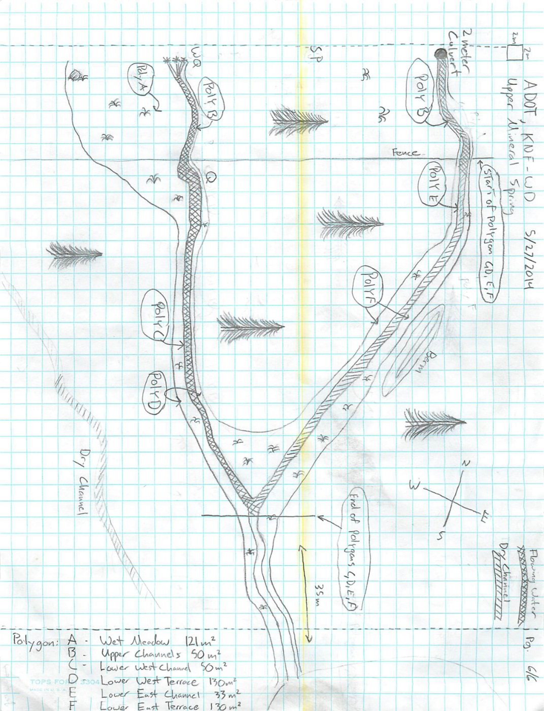
Fig 31.2 Mineral Spring Sketchmap.

32. Mint Spring
32. Mint Spring
Survey Summary Report, Site ID 1040
Submitted June 3, 2019 by Springs Stewardship Institute
Location: The Mint Spring ecosystem is located in Coconino County in the Canyon Diablo Arizona 15020015 HUC, managed by the US Forest Service. The spring is located in the Coconino NF, Mormon Lake RD, in the Hutch Mountain USGS Quad, at 34.86411, -111.40975 (WGS84). The elevation is approximately 2327 meters. Lisa Winters, Winnie Taney, and Cathy Morin surveyed the site on 9/07/16 for 01:15 hours, beginning at 8:45, and collected data in 6 of 10 categories. This survey was conducted under the NEPA Cleared List project using the Stevens et al. Level 2 protocol.

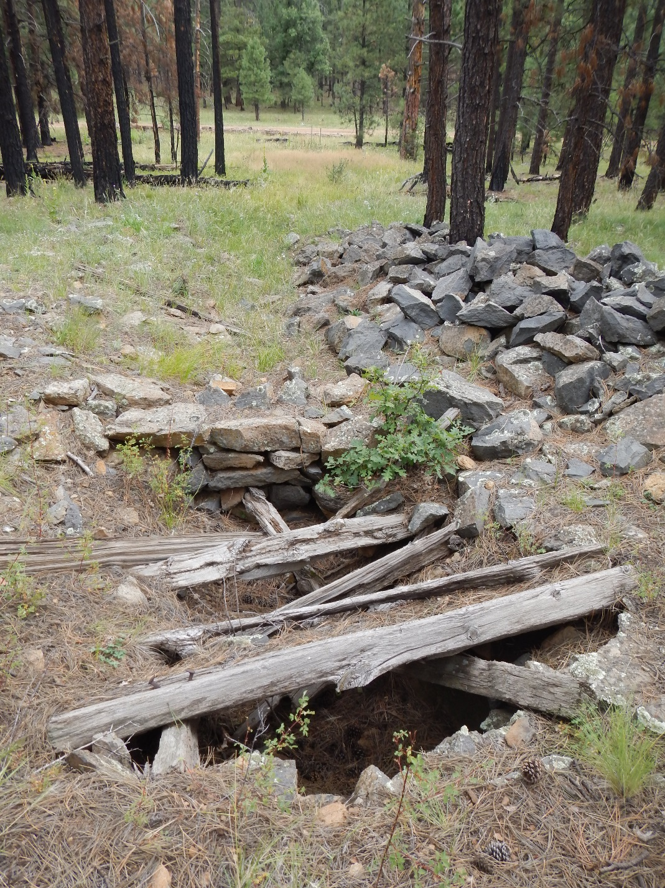
Fig 32.1 Mint Spring: View of spring looking downhill

Physical Description: This site was imported from the geodatabase and is a compilation from multiple sources. The microhabitat associated with the spring covers 41 sqm. The site has 1 microhabitat, A -- a 41 sqm channel.

Table 32.1 Mint Spring Microhabitat characteristics.
Code | A
Name | Channel
Area sqm | 41
Surface type | CH
Surface subtype
Slope variability | Low
Aspect TN | 10
Slope degrees | 12
Moisture (scale 1-10) | 2
Water depth cm | 0
Area % open water | 0
Substrate
1 - Clay % | 0
2 - Silt % | 0
3 - Sand % | 0
4 - Fine gravel % | 0
5 - Coarse gravel % | 0
6 - Cobble % | 0
7 - Boulder % | 0
8 - Bedrock % | 0
Organic % | 0
Other % (anthropogenic) | 0
Precipitate % | 0
Litter % | 0
Wood % | 0
Litter Depth (cm)

Survey Notes: Surveyors note that the historic channel is dry. The pipe has no flow at the time of the survey, but there is some moisture in it. Monkey flowers and leopard frog indicate regular moisture may be present. There is evidence of recent fire.

Flow: There was no flow and no water present. Surveyors were unable to measure flow due to no outflow.

Water Quality: There was no flow and no water present.

Flora: Surveyors identified 17 plant species at the site, with 0.4146 species/sqm. These included 9 native and 8 nonnative species.

Table 32.2 Mint Spring Cover Type.
Cover Type | Species Count | Wetland Species Count
Ground | 8 | 1
Shrub | 1 | 0
Mid-canopy | 0 | 0
Tall canopy | 1 | 0
Basal | 0 | 0
Aquatic | 1 | 1
Non-vascular | 1 | 0

Table 32.3 Mint Spring Vegetation % Cover in Microhabitats.
Species | Cover Code | Native Status | Wetland Status | Comments | A
Abildgaardia |  |  |  |  | 15
Achillea | GC |  | U |  | 1
Aster canescens |  |  |  |  | 2
Cirsium vulgare | GC | I | F |  | 1
Geranium caespitosum | GC | N | F |  | 0
Iris missouriensis | GC | N | F |  | 5
Juncus | GC | N | W |  | 15
Leersia monandra |  | N |  |  | 5
Mimulus guttatus | AQ | N | W |  | 1
Poa pratensis | GC | NI | F |  | 20
Quercus gambelii | TC | N | F |  | 1
Rosa woodsii | SC | N | F |  | 5
Rumex | GC |  | WR |  | 2
Salsola |  |  |  |  | 1
unknown Bryophyte (moss, liverwort, hornwort) | NV | N | F |  | 1
unknown Fungus, fleshy (mushroom) |  |  |  |  | 1
Verbascum | GC | I | F |  | 1

Fauna: Surveyors collected or observed 1 terrestrial invertebrates and 2 vertebrate specimens.

Table 32.4 Mint Spring Invertebrates.
Species | Lifestage | Habitat | Method | Rep# | Count | Species Detail
Orthoptera Acrididae |  | T

Table 32.5 Mint Spring Vertebrates.
Vertebrate Species Common Name | Count | Detection | Comments
Northern Leopard Frog | 1 | obs
Chipmunk | 1 | obs

Assessment: Assessment scores were compiled in 5 categories and 32 subcategories, with 10 null condition scores, and 10 null risk scores. Aquifer functionality and water quality are very poor with very limited restoration potential and there is negligible risk. Geomorphology condition is poor with limited restoration potential and there is negligible risk. Habitat condition is poor with limited restoration potential and there is moderate risk. Biotic integrity is poor with limited restoration potential and there is high risk. Human influence of site is moderate with some restoration potential and there is negligible risk. Administrative context status is undetermined due to null scores and there is undetermined risk due to null scores. Overall, the site condition is poor with limited restoration potential and there is low risk.

Table 32.6 Mint Spring Assessment Scores.
Category | Condition | Risk
Aquifer Functionality & Water Quality | 0.3 | 0.2
Geomorphology | 2.4 | 1.4
Habitat | 2.8 | 3.3
Biota | 1.9 | 4
Human Influence | 3.6 | 1.4
Administrative Context | 0 | 0
Overall Ecological Score | 2.3 | 2.1

Management Recommendations: We suggest that the removal of scotch thistle would be helpful in restoration efforts at this spring. Managers may also explore the possibility of restoring natural channel and fill in man-dug well and rock berm.

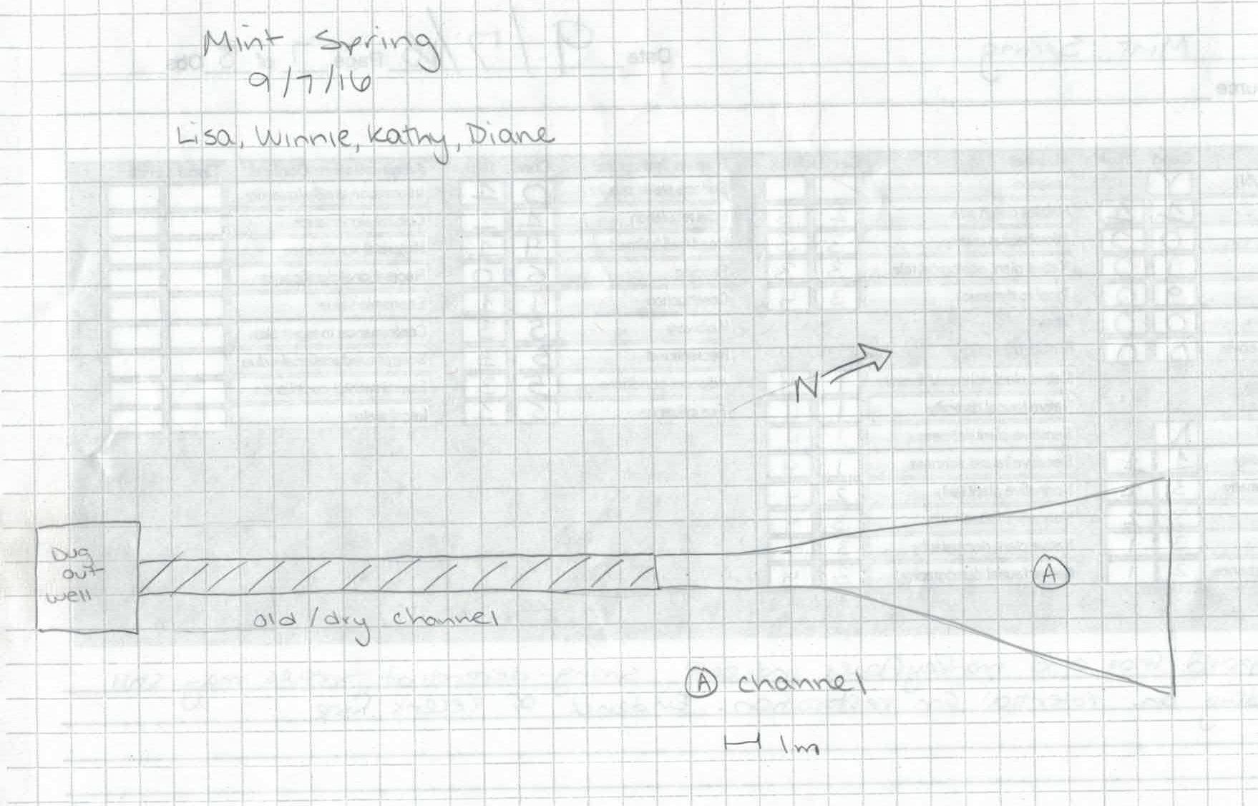
Fig 32.2 Mint Spring Sketchmap.

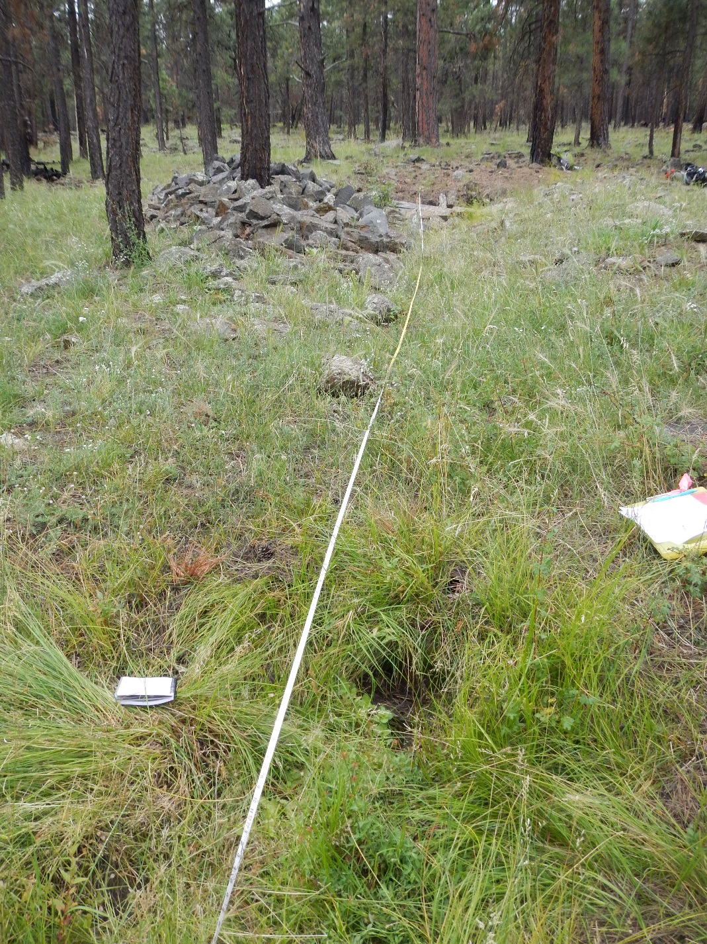
Fig 32.3 Mint Spring: View from spring pipe looking upstream to well

33. Mud Spring
33. Mud Spring
Survey Summary Report, Site ID 1146
Submitted June 3, 2019 by Springs Stewardship Institute
Location: The Mud Spring ecosystem is located in Coconino County in the Middle Little Colorado Arizona 15020008 HUC, managed by the US Forest Service. The spring is located in the Coconino NF, Mogollon Rim RD, in the Kehl Ridge USGS Quad, at 34.46563, -111.31361 measured using a GPS (WGS84, estimated position error 4 meters). The elevation is approximately 2283 meters. Jeri Ledbetter, Glenn Rink, Gloria Hardwick, and Melissa Carrillo-Galaviz surveyed the site on 6/23/17 for 01:45 hours, beginning at 12:50, and collected data in 10 of 10 categories. This survey was conducted under the NEPA Cleared List project using the Stevens et al. Level 2 protocol.

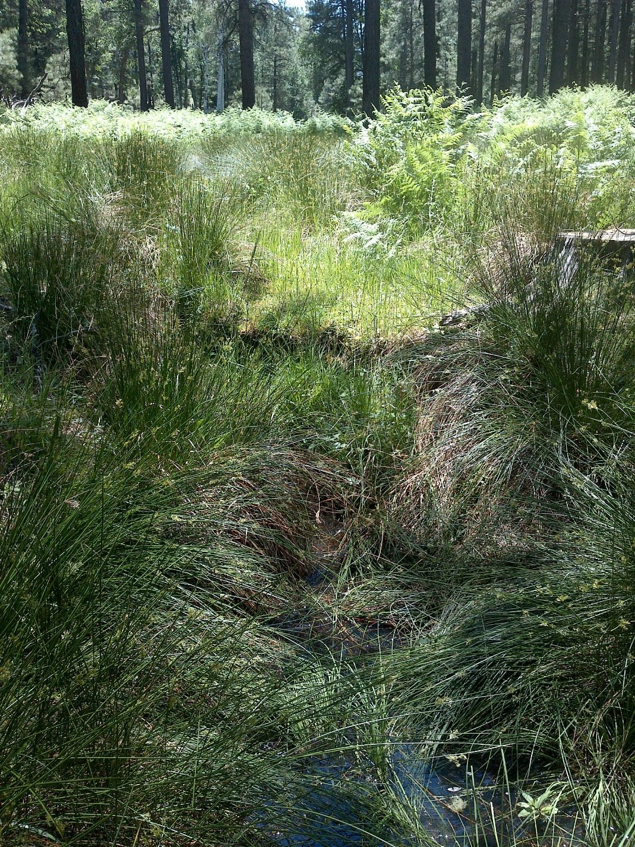
Fig 33.1 Mud Spring: Upslope view toward cutbank from 4 meters of distance

Physical Description: Mud Spring is a rheocrene/helocrene spring. This site was imported from the geodatabase, a compilation from multiple sources. The spring emerges along an old road bed in an area that was heavily used in the past for camping. There was no sign of fencing at this site. This site was located in a shallow drainage dominated by ponderosa pine, Gamble oak, aspen, and Douglas fir. The microhabitats associated with the spring cover 145 sqm. The site has 3 microhabitats, including A -- a 45 sqm pool, B -- a 45 sqm terrace, C -- a 55 sqm low gradient cienega. The geomorphic diversity is 0.48, based on the Shannon-Weiner diversity index.

Table 33.1 Mud Spring Microhabitat characteristics.
Code | A | B | C
Name | Source and Pools | Terraces | Low Gradient Cienega
Area sqm | 45 | 45 | 55
Surface type | P | TE | LGC
Surface subtype
Slope variability | Low | Low | Low
Aspect TN
Slope degrees | 2 | 2 | 4
Moisture (scale 1-10) | 9 | 2 | 8
Water depth cm | 5 | 0 | 0
Area % open water | 20 | 0 | 0
Substrate
1 - Clay % | 0 | 0 | 0
2 - Silt % | 5 | 5 | 0
3 - Sand % | 5 | 15 | 0
4 - Fine gravel % | 5 | 1 | 0
5 - Coarse gravel % | 1 | 1 | 0
6 - Cobble % | 1 | 1 | 0
7 - Boulder % | 0 | 0 | 0
8 - Bedrock % | 0 | 0 | 0
Organic % | 82 | 76 | 100
Other % (anthropogenic) | 1 | 1 | 0
Precipitate % | 0 | 0 | 0
Litter % | 30 | 40 | 40
Wood % | 2 | 3 | 2
Litter Depth (cm) | 4 | 4 | 4

Geomorphology: Mud Spring emerges as a seepage or filtration spring from the Coconino, a sedimentary, sandstone rock layer. The emergence environment is subaerial, with a gravity flow force mechanism.

Access Directions: From NF-208, park at the junction at NF-308E. Follow NF-308E to NF-6110; both of these roads are currently closed, but are passable for management actions. The hike is about 1.3 km down the closed road.

Survey Notes: Although there were muddy spots near where the spring is marked, surface expression did not begin until about 65m downslope. Water emerged under a log/cutbank forming shallow pools with no obvious flow. At 10.8m below the cutbank and first flow, there is a culvert about 7m long with pools below. A 1 square meter pool was about 200m downslope. This site was likely a wet meadow but has been channelized with cutbanks and pedestals, likely due to human, livestock, and elk use. There is little evidence of recent human visitation.

Flow: Surveyors measured a flow of 0.014 liters/second, using a timed flow volume capture method. Flow was adjusted for an estimate of 100% of site flow capture. Measurements were taken 21.5m down from the bank pool of the spring. This spring is perennial.

Water Quality: Measurements were taken at the cut-bank pool at the first emergence of water. Appropriate instruments were calibrated on 6/23/2017.

Table 33.2 Mud Spring Water Quality with multiple readings averaged.
Characteristic Measured | Average Value | Site Number | Device | Comments
Alkalinity, Total (mg/L) | 29 |  | LaMotte
Dissolved oxygen (field) % saturation | 21 |  | YSI Multiprobe
Dissolved oxygen (field) (mg/L) | 2.01 |  | YSI Multiprobe
pH (field) | 6.16 |  | YSI Multiprobe
Salinity (field) (ppt) | 0.35 |  | Hanna Combo
Specific conductance (field) (uS/cm) | 79 |  | Hanna Combo | Corr for temp from 65 EC
Temperature, air C | 33 |  | Handheld therm
Temperature, water C | 16.3 |  | YSI Multiprobe

Flora: Surveyors identified 25 plant species at the site, with 0.1724 species/sqm. These included 19 native and 6 nonnative species.

Table 33.3 Mud Spring Cover Type.
Cover Type | Species Count | Wetland Species Count
Ground | 20 | 9
Shrub | 0 | 0
Mid-canopy | 1 | 0
Tall canopy | 1 | 0
Basal | 0 | 0
Aquatic | 2 | 2
Non-vascular | 1 | 0

Table 33.4 Mud Spring Vegetation % Cover in Microhabitats.
Species | Cover Code | Native Status | Wetland Status | Comments | A | B | C
Achillea millefolium | GC | NI | U |  | 0 | 10 | 0
Antennaria parvifolia | GC | N | U |  | 0 | 0.04 | 0
Carex kelloggii | AQ | N |  |  | 1 | 0 | 0
Carex stipata | GC | N | W |  | 0 | 0 | 1
Carex subfusca | GC | N | W |  | 0 | 1 | 0
Cerastium fontanum | GC | I | WR |  | 0 | 1 | 0
Chrysanthemum leucanthemum | GC | I |  |  | 0 | 0.1 | 0
Cirsium vulgare | GC | I | F |  | 1 | 5 | 3
Dactylis glomerata | GC | I | W |  | 0 | 4 | 0
Epilobium ciliatum | GC | N | W |  | 1 | 4 | 3
Festuca sororia | GC | N |  |  | 0 | 2 | 0
Fragaria | GC | N | U |  | 0.1 | 0 | 0
Geranium caespitosum | GC | N | F |  | 0 | 4 | 2
Juncus laccatus | GC | N | W |  | 30 | 20 | 40
Luzula comosa var. laxa | GC | N | R |  | 0 | 0.05 | 0
Pinus ponderosa | TC | N | F |  | 8 | 5 | 3
Poa pratensis | GC | NI | F |  | 0 | 1 | 0
Pseudotsuga menziesii var. glauca | MC | N | U |  | 0 | 5 | 0
Rumex crispus | GC | I | WR |  | 0 | 0 | 3
Thermopsis pinetorum | GC | N | U |  | 0 | 1 | 1
Trifolium | GC | I | WR |  | 1 | 20 | 1
unknown moss | NV | N | F |  | 30 | 0 | 0
Veronica americana | AQ | N | A | Collected | 10 | 0 | 0
Vicia americana | GC | N | F |  | 0 | 1 | 0
Viola | GC | N | F |  | 1 | 8 | 10

Fauna: L.E. Stevens reviewed invertebrate specimens and entered data. Surveyors collected or observed 6 aquatic and 8 terrestrial invertebrates and 4 vertebrate specimens.

Table 33.5 Mud Spring Invertebrates.
Species | Lifestage | Habitat | Method | Rep# | Count | Species Detail
Coleoptera Dytiscidae | Ad | A | Spot |  | 1 | sp 1
Coleoptera Dytiscidae | Ad | A | Spot |  | 10 | sp 2
Coleoptera Dytiscidae | Ad | A | Spot |  | 3 | sp 3
Coleoptera Dytiscidae Rhantus gutticollis | Ad | A | Spot |  | 1
Diptera Culicidae Culiseta | M | A | Spot |  | 5 | larvae and pupae
Hemiptera Gerridae | Ad | A | Spot
Hymenoptera Apidae Apis mellifera | Ad | T | Spot
Hymenoptera Ichneumonidae | Ad | T | Spot |  | 1
Lepidoptera Lycaenidae Celastrina echo | Ad | T | Spot |  |  | Many were observed.
Lepidoptera Nymphalidae Junonia | Ad | T | Spot
Lepidoptera Nymphalidae Nymphalis antiopa | Ad | T | Spot
Lepidoptera Papilionidae Papilio rutulus | Ad | T | Spot
Lepidoptera Pieridae | Ad | T |  |  |  | Many were observed.
Odonata Coenagrionidae | Ad | T | Spot

Table 33.6 Mud Spring Vertebrates.
Vertebrate Species Common Name | Count | Detection | Comments
Elk |  | sign | Tracks and scat were observed.
Mountain Chickadee |  | call
Vole |  | sign | Holes were observed.
Common Raven |  | call

Assessment: Assessment scores were compiled in 5 categories and 33 subcategories, with 9 null condition scores, and 9 null risk scores. Aquifer functionality and water quality are good with significant restoration potential and there is negligible risk. Geomorphology condition is good with significant restoration potential and there is low risk. Habitat condition is good with significant restoration potential and there is low risk. Biotic integrity is very good with excellent restoration potential and there is low risk. Human influence of site is moderate with some restoration potential and there is moderate risk. Administrative context status is undetermined due to null scores and there is undetermined risk due to null scores. Overall, the site condition is good with significant restoration potential and there is low risk.

Table 33.7 Mud Spring Assessment Scores.
Category | Condition | Risk
Aquifer Functionality & Water Quality | 4.3 | 1.8
Geomorphology | 4.2 | 2.6
Habitat | 4.6 | 2
Biota | 5 | 2
Human Influence | 3.7 | 3.2
Administrative Context | 0 | 0
Overall Ecological Score | 4.3 | 2.4

Management Recommendations: Closure of the road has no doubt benefitted this site, although it would benefit from further management attention. Surveyors recommend removing the culvert and bermed area, but leaving the wood, as it is most likely stabilizing the spring source.

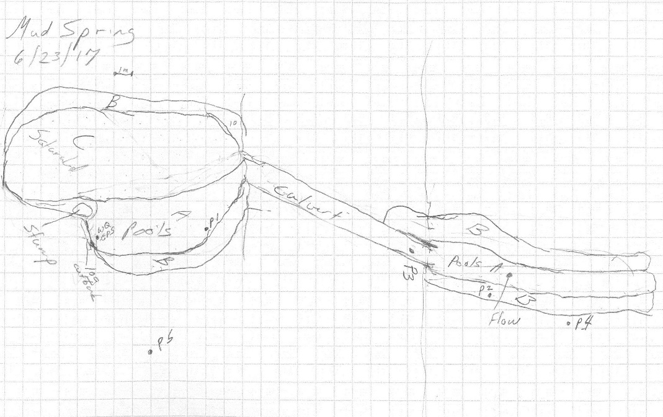
Fig 33.2 Mud Spring Sketchmap.

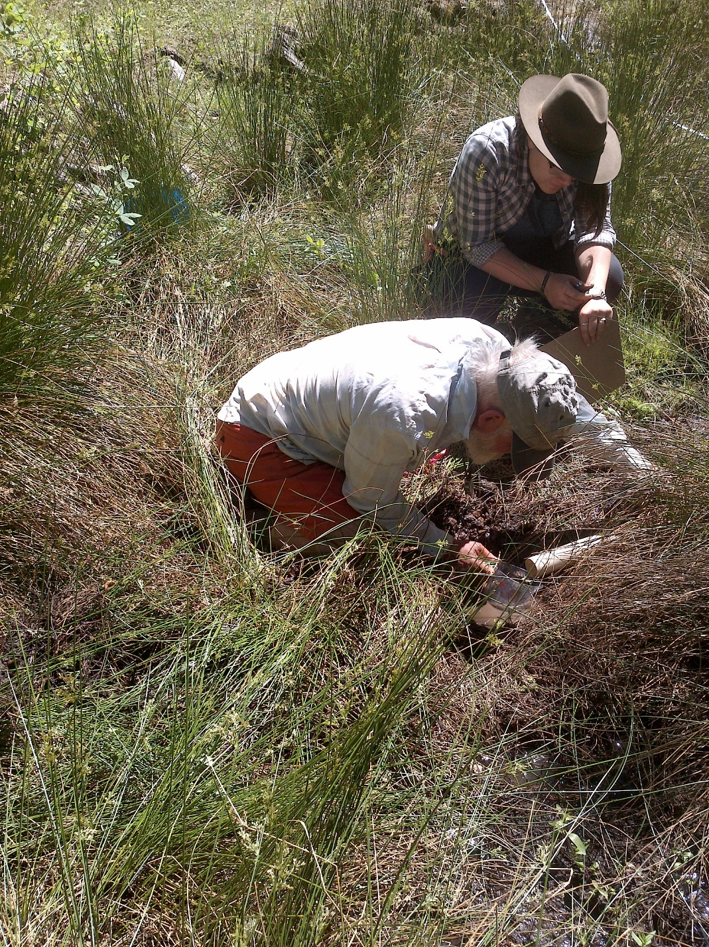
Fig 33.3 Mud Spring: Flow measurement

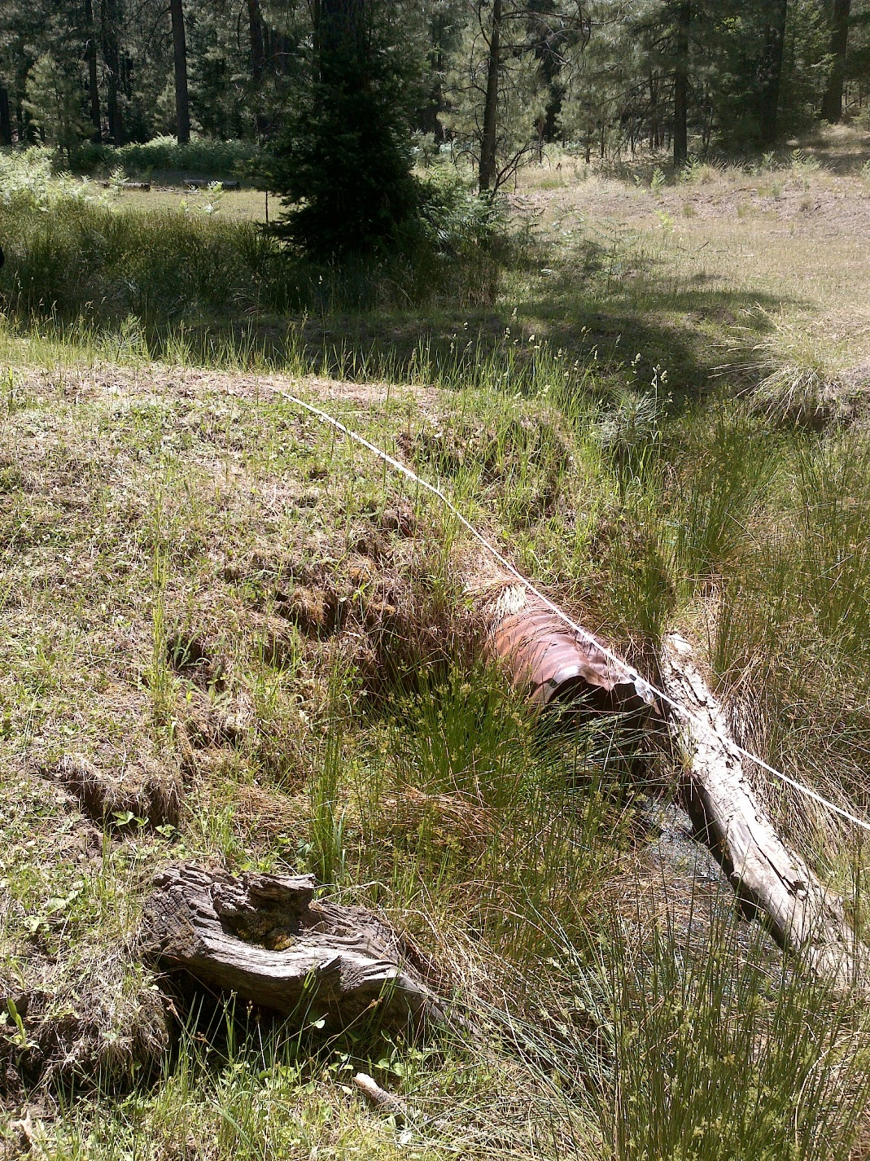
Fig 33.4 Mud Spring: Upslope view below the culvert

34. Pat Spring
34. Pat Spring
Survey Summary Report, Site ID 1056
Submitted June 3, 2019 by Springs Stewardship Institute
Location: The Pat Spring ecosystem is located in Coconino County in the Lower Little Colorado Arizona 15020016 HUC, managed by the US Forest Service. The spring is located in the Coconino NF, Peaks RD, in the White Horse Hills USGS Quad, at 35.39239, -111.68971 measured using a GPS (NAD83, estimated position error 3 meters). The elevation is approximately 2580 meters. Larry Stevens surveyed the site on 9/25/13 for 00:45 hours, beginning at 15:00, and collected data in 4 of 10 categories. This survey was conducted under the NEPA Cleared List project using the Stevens et al. Level 1 protocol.

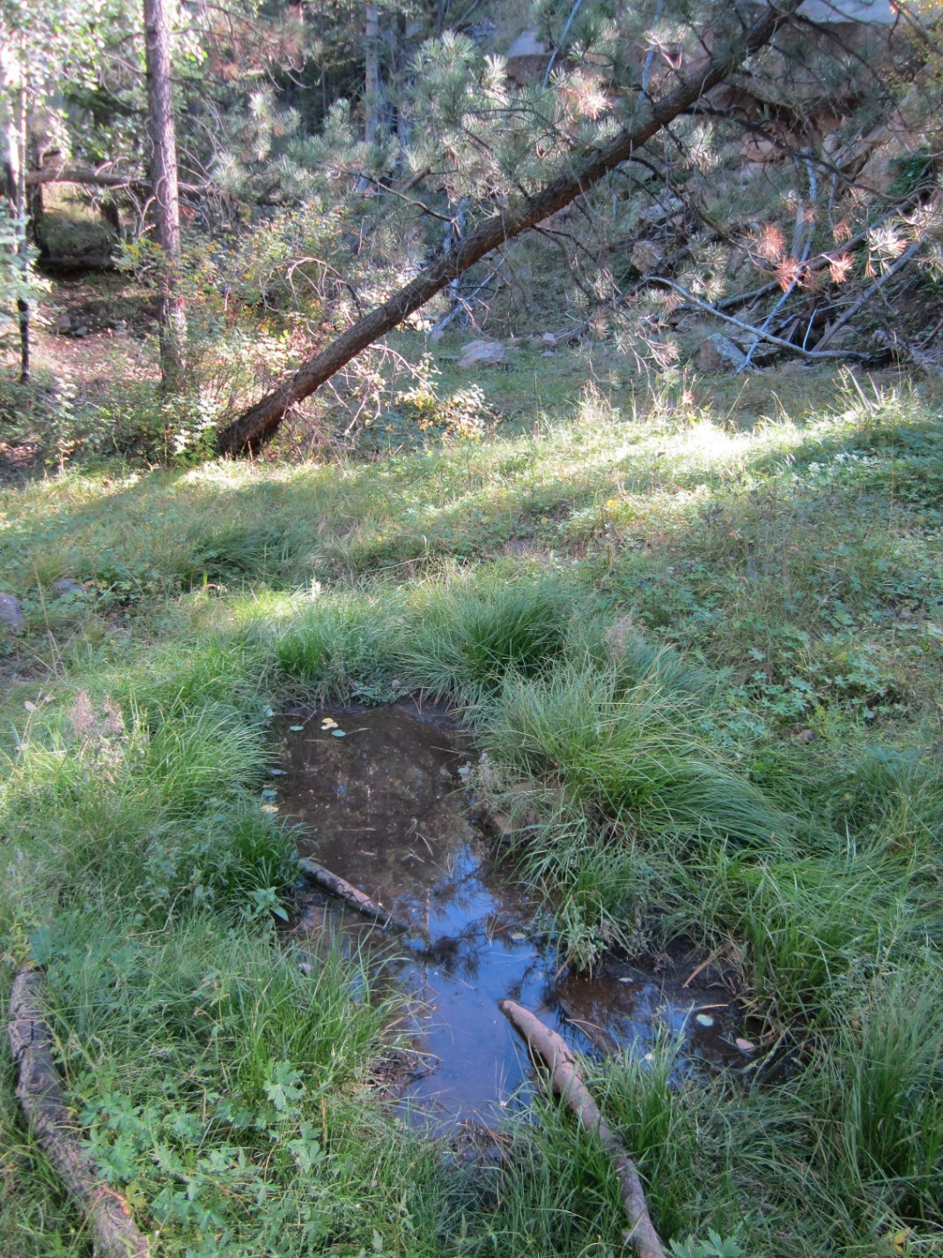
Fig 34.1 Pat Spring: View of site

Physical Description: Pat Spring is a hillslope spring. This site was imported from the SSI geodatabase, a compilation from multiple sources. This is a manipulated spring in a rocky, heavily forested drainage. The spring has been boxed and piped to a tank downstream.

Geomorphology: The emergence environment is subaerial, with a gravity flow force mechanism.

Access Directions: From US-180 turn onto NF-151 (Heart Prairie Rd) and travel SE for 1.6 mi. Continue on NF-418 for 3 mi. Turn left on NF-9123R and continue NW for 0.4 mi. Spring is 70 m due west.

Survey Notes: This survey was conducted by SSI staff under the San Francisco Peaks project for Coconino National Forest. Originally this was likely a fairly large flow that emerged from a basalt flow, but has been captured and piped into an open 10,000 gallon tank. The original source area has been largely dewatered. There was a small pool with about 3 sq. m. of open water, and no outflow. The pool is likely the product of a leaking pipe. The spring has been boxed, and a 2-inch vinyl pipe delivers water to a huge tank downstream. The aspen in the area have been heavily browsed. There is a huge stand of native geranium, and some sedge. The area just upstream of the spring was burned about 20 years ago. There was no outflow from the pool.

Flow: Surveyors were unable to measure flow due to no outflow.

Fauna: Surveyors collected or observed 2 aquatic invertebrates and 2 vertebrate specimens.

Table 34.1 Pat Spring Invertebrates.
Species | Lifestage | Habitat | Method | Rep# | Count | Species Detail
Hemiptera Gerridae | Ad | A | Spot |  | 1

Table 34.2 Pat Spring Vertebrates.
Vertebrate Species Common Name | Count | Detection | Comments
elk
Clark's Nutcracker

Assessment: Assessment scores were compiled in 5 categories and 24 subcategories, with 18 null condition scores, and 17 null risk scores. Aquifer functionality and water quality are moderate with some restoration potential and there is low risk. Geomorphology condition is poor with limited restoration potential and there is moderate risk. Habitat condition is poor with limited restoration potential and there is high risk. Biotic integrity is poor with limited restoration potential and there is high risk. Human influence of site is moderate with some restoration potential and there is moderate risk. Administrative context status is undetermined due to null scores and there is undetermined risk due to null scores. Overall, the site condition is poor with limited restoration potential and there is moderate risk.

Table 34.3 Pat Spring Assessment Scores.
Category | Condition | Risk
Aquifer Functionality & Water Quality | 3.4 | 2.67
Geomorphology | 2.8 | 3.6
Habitat | 2.8 | 4.4
Biota | 2 | 4
Human Influence | 3.44 | 3.5
Administrative Context | 0 | 0
Overall Ecological Score | 2.75 | 3.67

Management Recommendations: A wildlife rescue feature is needed for the tank. The overflow water should be returned to the source, or a shutoff valve installed, as it is presently being wasted by flowing down the side of it.

35. Poison Springs
35. Poison Springs
Survey Summary Report, Site ID 141
Submitted June 3, 2019 by Springs Stewardship Institute
Location: The Poison Springs ecosystem is located in Coconino County in the Upper Verde Arizona 15060202 HUC, managed by the US Forest Service. The spring is located in the Coconino NF, Peaks RD, in the Garland Prairie USGS Quad, at 35.13391, -111.97493 measured using a GPS (NAD83, estimated position error 11 meters). The elevation is approximately 2008 meters. Larry Stevens and Emily Omana surveyed the site on 10/22/06 for 01:30 hours, beginning at 11:45, and collected data in 9 of 10 categories. This survey was conducted under the NEPA Cleared List project using the Stevens et al. Level 2 protocol.

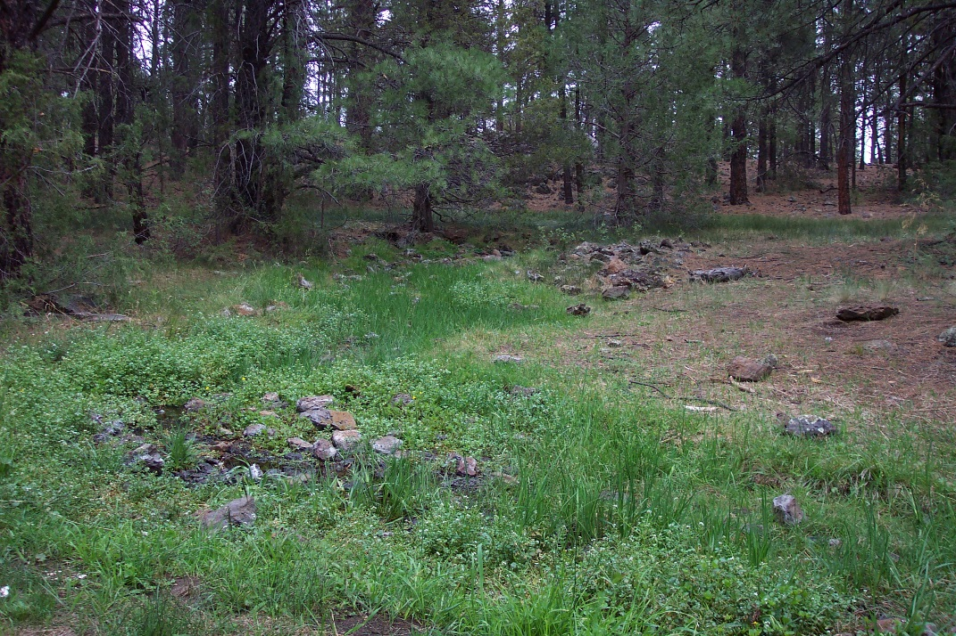
Fig 35.1 Poison Springs: View of site

Physical Description: Poison Springs is a rheocrene spring. This spring emerges as a hillslope spring at the base of a basalt flow and feeds a low gradient cienega. The microhabitats associated with the spring cover 385.8 sqm. The site has 4 microhabitats. The geomorphic diversity is 0.47, based on the Shannon-Weiner diversity index.

Table 35.1 Poison Springs Microhabitat characteristics.
Code | A | B | C | D
Name | Lotic-chan slow | Lotic-slow | Wet Mdw | Dry Mdw
Area sqm | 22.30 | 30.00 | 186.80 | 146.70
Surface type
Surface subtype
Slope variability
Aspect TN | 217 |  | 217 | 217
Slope degrees | 8 | 2 | 5 | 2
Moisture (scale 1-10)
Water depth cm
Area % open water
Substrate
1 - Clay % | 0 | 0 | 0 | 25
2 - Silt % | 40 | 0 | 0 | 0
3 - Sand % | 5 | 0 | 0 | 5
4 - Fine gravel % | 5 | 0 | 0 | 5
5 - Coarse gravel % | 30 | 0 | 1 | 5
6 - Cobble % | 10 | 5 | 5 | 10
7 - Boulder % | 0 | 0 | 0 | 0
8 - Bedrock % | 0 | 0 | 0 | 0
Organic % | 10 | 95 | 94 | 50
Other % (anthropogenic) | 0 | 0 | 0 | 0
Precipitate % | 0.00 | 0.00 | 0.00 | 0.00
Litter % | 85.00 | 98.00 | 95.00 | 75.00
Wood % | 2.00 | 0.20 | 1.00 | 0.10
Litter Depth (cm) | 2.00 | 6.00 | 2.00 | 1.00

Geomorphology: Poison Springs emerges from a, basalt rock layer in an unknown unit.

Access Directions: From exit 178 on I-40, travel south on S Garland Prairie Rd (CR-141) for 8.13 mi. Turn left onto S Boy Scout Camp Rd (CR-527) and continue for 2.16 mi.

Survey Notes: This survey was conducted by Grand Canyon Wildlands Council surveyors on the Mogollon Rim project, funded by the Nina Mason Pulliam Charitable Trust. Hillslope spring that feeds a Low Gradient Cienega. Spring emerges at the base of a basalt flow.

Table 35.2 Poison Springs Water Quality with multiple readings averaged.
Characteristic Measured | Average Value | Site Number | Device | Comments
Temperature, air C | 19
Temperature, water C | 11.5

Flora: Spring is located in a Pinus ponderosa- Juniperus scopulorum forest woodland. Surveyors identified 26 plant species at the site, with 0.0674 species/sqm. These included 19 native and 7 nonnative species.

Table 35.3 Poison Springs Cover Type.
Cover Type | Species Count | Wetland Species Count
Ground | 22 | 9
Shrub | 4 | 0
Mid-canopy | 2 | 0
Tall canopy | 0 | 0
Basal | 0 | 0
Aquatic | 0 | 0
Non-vascular | 0 | 0

Table 35.4 Poison Springs Vegetation % Cover in Microhabitats.
Species | Cover Code | Native Status | Wetland Status | Comments | A | B | C | D
Achillea millefolium | GC | N | U |  | 1 | 0 | 2 | 0.1
Ambrosia | GC | N | F |  | 0 | 0 | 0.2 | 0
Carex | GC | N |  |  | 1 | 5 | 2 | 0
Carex aurea | GC | N | U |  | 0 | 0 | 0 | 90
Epilobium ciliatum | GC | N | W |  | 0 | 0 | 0.2 | 0.2
Geranium richardsonii | GC | N | F |  | 0 | 0 | 0 | 0.2
Helianthus annuus | GC | N | F |  | 0 | 0 | 0.1 | 0
Iris missouriensis | GC | N | F |  | 1 | 0 | 0.2 | 1
Juncus ensifolius | GC | N | W |  | 50 | 0 | 1 | 0
Juniperus scopulorum | MC | N | U |  | 5 | 0 | 1 | 12
Juniperus scopulorum | SC | N | U |  | 5 | 0 | 5 | 8
Melilotus albus | GC | I | WR |  | 0 | 2 | 8 | 0
Melilotus officinalis | GC | I | WR |  | 0 | 0 | 0.1 | 0
Nasturtium officinale | GC | I | W |  | 1 | 8 | 1 | 0
Oenothera | GC | N | F |  | 0 | 0 | 0.1 | 0.2
Phleum | GC | N | F |  | 0 | 1 | 3 | 0
Pinus ponderosa | MC | N | F |  | 8 | 0 | 8 | 8
Pinus ponderosa | SC | N | F |  | 5 | 0 | 5 | 5
Poa pratensis | GC | I | F |  | 30 | 10 | 10 | 0
Ranunculus | GC | N | WR |  | 0 | 0 | 1 | 0
Ribes cereum | SC | N | U |  | 0 | 0 | 0.1 | 0
Rosa woodsii | SC | N | F |  | 0.1 | 0 | 1 | 0
Rumex | GC | I | WR |  | 0.5 | 0.6 | 0.5 | 0
Taraxacum officinale | GC | I | F |  | 0 | 0 | 0.1 | 0
Typha domingensis | GC | N | A |  | 0 | 1 | 0 | 0
unknown | GC | N |  | Sida useu? | 0.1 | 0 | 0.5 | 0
Verbascum thapsus | GC | I | F |  | 0.1 | 0 | 0.1 | 0
Viola | GC | N | F |  | 0.1 | 0 | 1 | 0

Fauna: Surveyors took three quantitative invert samples. Surveyors collected or observed 5 aquatic and 14 terrestrial invertebrates and 5 vertebrate specimens.

Table 35.5 Poison Springs Invertebrates.
Species | Lifestage | Habitat | Method | Rep# | Count | Species Detail
Amphipoda |  | A | Spot |  | 7
Araneae |  | T | Spot |  | 1 | sp1
Araneae |  | T | Spot |  | 1 | sp2
Araneae |  | T | Spot |  | 1 | sp3
Coleoptera |  | T | Spot |  | 3 | sp1
Coleoptera |  | T | Spot |  | 3 | sp2
Coleoptera |  | T | Spot |  | 1 | sp3
Coleoptera |  | A | Spot |  | 3 | sp4
Coleoptera Hydrophilidae Anacaena | Ad | A | Spot |  | 1 | Sent to R. Durfee 14 May 2006
Diptera |  | T | Spot |  | 1 | sp1
Diptera |  | T | Spot |  | 1 | sp2
Diptera |  | T | Spot |  | 1 | sp3
Hemiptera |  | T | Spot |  | 1 | sp1
Hymenoptera |  | T | Spot |  | 1 | sp1
Hymenoptera Formicidae |  | T | Spot |  | 1 | small
Mollusca |  | T | Spot |  | 2 | sp1
Mollusca |  | T | Spot |  | 52 | sp2
Trichoptera |  | A | Spot |  | 1 | sp1
Trichoptera |  | A | Spot |  | 3 | sp2

Table 35.6 Poison Springs Vertebrates.
Vertebrate Species Common Name | Count | Detection | Comments
American crow | 1
mourning dove | 1
pygmy nuthatch | 1
hairy woodpecker | 1
cottontail rabbit | 1

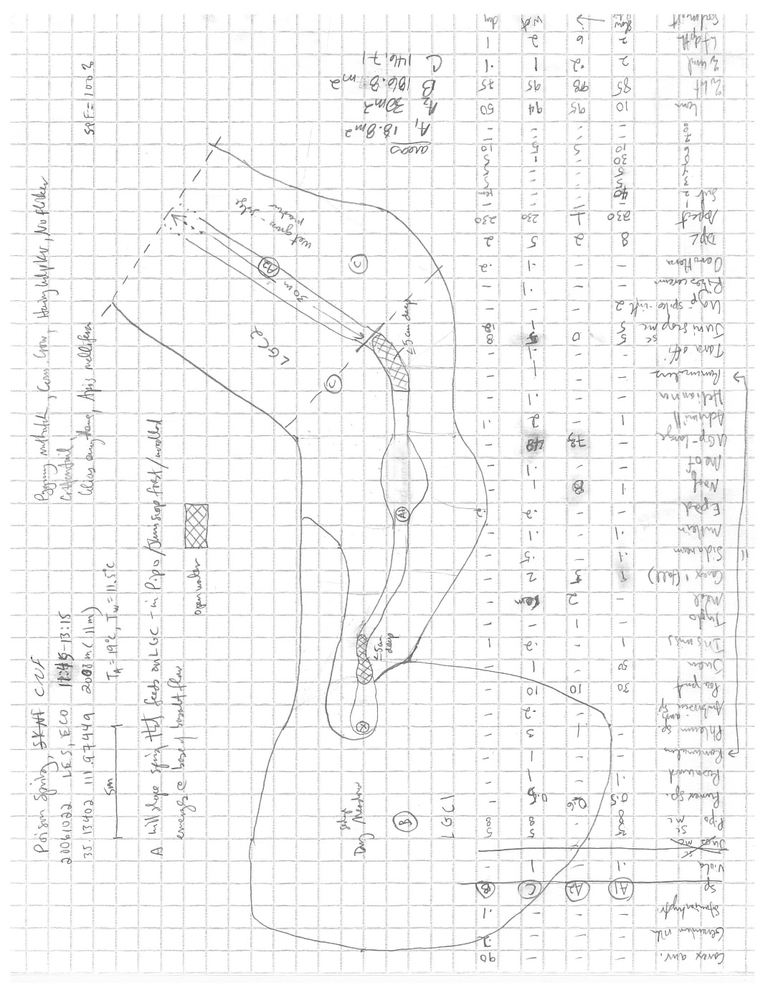
Fig 35.2 Poison Springs Sketchmap.

36. Railroad Spring
36. Railroad Spring
Survey Summary Report, Site ID 1148
Submitted June 3, 2019 by Springs Stewardship Institute
Location: The Railroad Spring ecosystem is located in Coconino County in the Upper Verde Arizona 15060202 HUC, managed by the US Forest Service. The spring is located in the Coconino NF, Peaks RD, in the Garland Prairie USGS Quad, at 35.13586, -111.96015 measured using a Map (NAD83). The elevation is approximately 2044 meters. Jeri Ledbetter surveyed the site on 5/28/16, and collected data in 4 of 10 categories. This survey was conducted under the NEPA Cleared List project using the Stevens et al. Level 1 protocol.

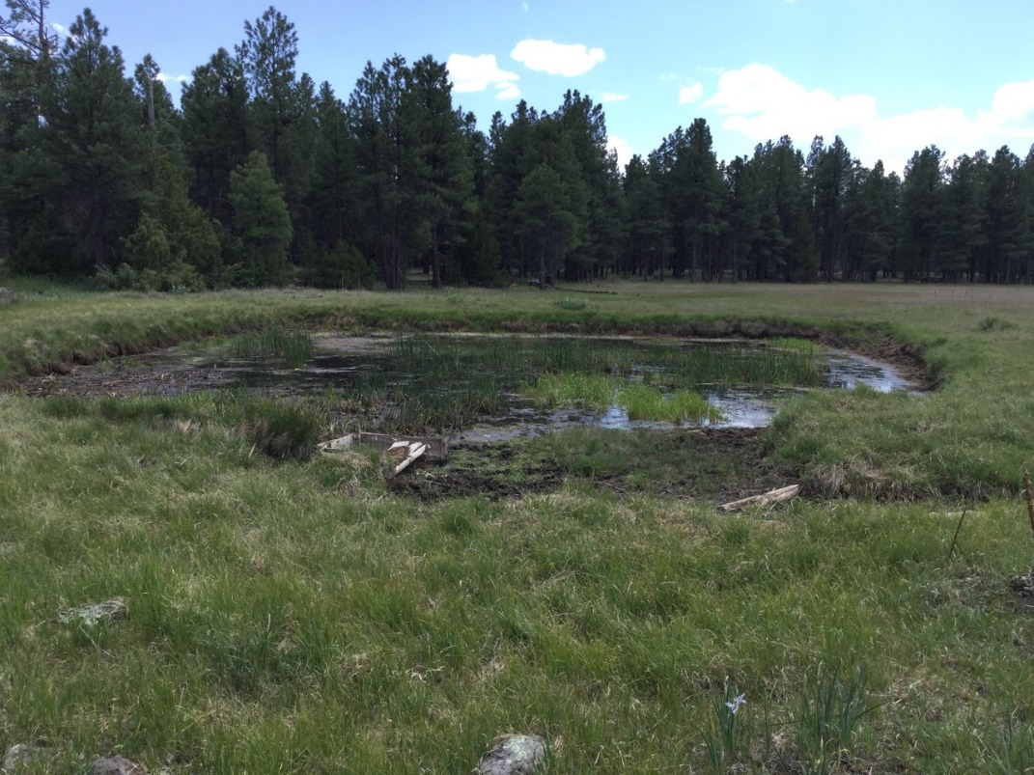
Fig 36.1 Railroad Spring: View of site

Physical Description: Railroad Spring is a limnocrene spring. This spring emerges into a pond and outflows approximately 300 m to another pond. This site was imported from a compilation from multiple sources.

Access Directions: From exit 178 on I-40 travel south on S Garland Prairie Rd for 8.13 mi. Turn left on Scout Camp Rd and continue for 1 mi. Continue left on S Manterola Ranch Rd for 1 mi.

Survey Notes: The site has been heavily trampled and grazed. The surveyor did not take water quality field variables as there was no obvious source, but standing, rather disgusting water.

Flow: It was not possible to measure flow due to no spring outflow. Surveyors were unable to measure flow due to no outflow.

Fauna: Surveyors collected or observed 2 vertebrate specimens.

Table 36.1 Railroad Spring Vertebrates.
Vertebrate Species Common Name | Count | Detection | Comments
Elk |  | sign | Heavy trampling and scat
Domestic Cow |  | sign | Heavy trampling

Assessment: Assessment scores were compiled in 3 categories and 0 subcategories, with 42 null condition scores, and 42 null risk scores. Aquifer functionality and water quality are undetermined due to null scores and there is undetermined risk due to null scores. Geomorphology condition is very poor with very limited restoration potential and there is undetermined risk due to null scores. Habitat condition is poor with limited restoration potential and there is undetermined risk due to null scores. Biotic integrity is undetermined due to null scores and there is undetermined risk due to null scores. Human influence of site is very poor with very limited restoration potential and there is undetermined risk due to null scores. Administrative context status is undetermined due to null scores and there is undetermined risk due to null scores. Overall, the site condition is undetermined due to null scores and there is undetermined risk due to null scores.

Table 36.2 Railroad Spring Assessment Scores.
Category | Condition | Risk
Aquifer Functionality & Water Quality | 0 | 0
Geomorphology | 1 | 0
Habitat | 2 | 0
Biota | 0 | 0
Human Influence | 1 | 0
Administrative Context | 0 | 0
Overall Ecological Score | 0 | 0

37. Railroad Spring
37. Railroad Spring
Survey Summary Report, Site ID 1067
Submitted June 3, 2019 by Springs Stewardship Institute
Location: The Railroad Spring ecosystem is located in Coconino County in the Canyon Diablo Arizona 15020015 HUC, managed by the US Forest Service. The spring is located in the Coconino NF, Mormon Lake RD, in the Hutch Mountain USGS Quad, at 34.87473, -111.45102 measured using a GPS (NAD83). The elevation is approximately 2202 meters. Sally Henkel, Emily Thompson, Lisa Winters, Winnie Taney, Sue Ordway, Cliff Evans, Roy May, and Cathy Morin surveyed the site on 9/19/17 for 01:50 hours, beginning at 14:40, and collected data in 6 of 10 categories. This survey was conducted under the NEPA Cleared List project using the Stevens/GDE hybrid protocol.

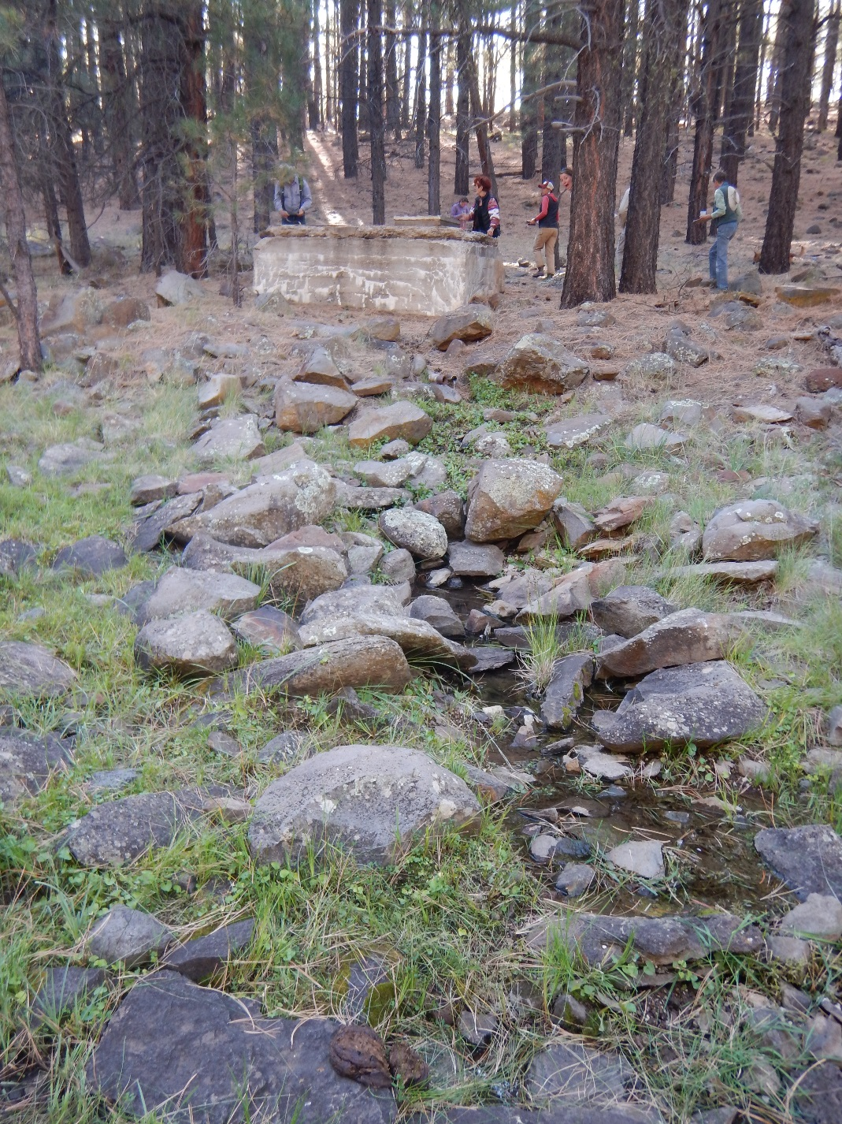
Fig 37.1 Railroad Spring: Northern spring box and outflow of Railroad Spring

Physical Description: Railroad Spring is a hillslope spring. The spring discharges out of two small spring boxes and pools on an old dirt road. The flow reemerges in a drainage channel below the source.

Geomorphology: Railroad Spring emerges as a fracture spring from an igneous, basalt rock layer in an unknown unit. The emergence environment is subaerial, with a gravity flow force mechanism.

Access Directions: From Lake Mary Rd (CR-3) turn onto NF-9488k near Fulton Canyon and travel NW for 1.1 mi. Spring is 300 m due NW.

Survey Notes: The second of the two spring boxes has water piped out of it and there is water pooling downstream. This provides ample water access to wildlife. There are plenty of rocks around the spring that act as an escape ramp for wildlife.

Flow: Surveyors measured a flow of 0.036 liters/second, using a timed flow volume capture method. Flow was adjusted for an estimate of 80% of site flow capture. The spring site has two spring boxes. Point 1 is at the first spring box and Point 2 is at the second spring box.

Water Quality: Measurements taken from Site 1 is spring box one and measurements from Site 2 are from spring box two. Location 1: at the spring source in standing water at 14:40:00.Location 2: in a pool in standing water at 14:40:00.

Table 37.1 Railroad Spring Water Quality with multiple readings averaged.
Characteristic Measured | Average Value | Site Number | Device | Comments
Dissolved Solids (field) | 89 | 1 | DigitalAid meter
pH (field) | 6.7 | 1 | DigitalAid meter
Specific conductance (field) (uS/cm) | 249.16666666667 | 1 | DigitalAid meter | Adjusted for temperature

Fauna: Surveyors collected or observed 5 vertebrate specimens.

Table 37.2 Railroad Spring Vertebrates.
Vertebrate Species Common Name | Count | Detection | Comments
Domestic Cow | 9 | obs
Abert's Squirrel | 2 | obs
Steller's Jay | 2 | obs
Common Raven | 1 | obs
Turkey Vulture | 1 | obs

Management Recommendations: This spring is a candidate for a restoration site. We would recommend that the road leading to the spring be decommissioned where the road splits shortly before you get to the spring. This area is very rocky and more information is needed to determine whether fencing is an option or not. Fencing would help keep cattle from trampling the spring. We recommend that the spring boxes be restored and restoring the first spring to its original channel. Lastly, we recommend that the troughs be restored so that they are more functional.

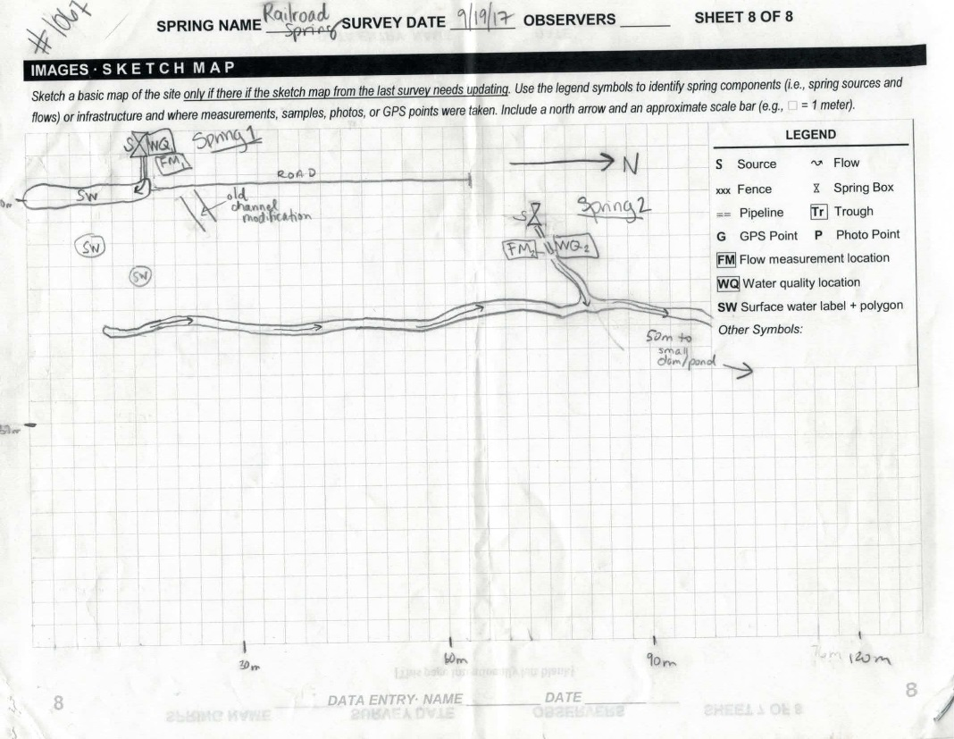
Fig 37.2 Railroad Spring Sketchmap: Sketch map for Railroad Spring

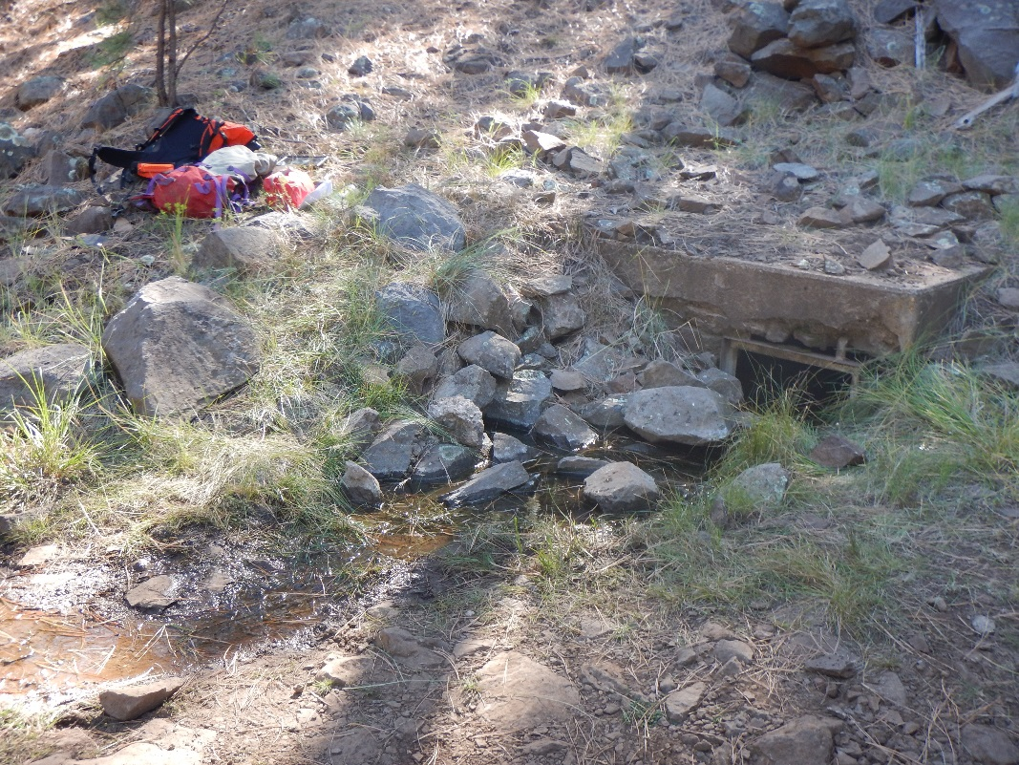
Fig 37.3 Railroad Spring: Southern spring box at Railroad Spring

38. Rock Top Spring
38. Rock Top Spring
Survey Summary Report, Site ID 1075
Submitted June 3, 2019 by Springs Stewardship Institute
Location: The Rock Top Spring ecosystem is located in Coconino County in the Upper Verde Arizona 15060202 HUC, managed by the US Forest Service. The spring is located in the Coconino NF, Mormon Lake RD, in the Stoneman Lake USGS Quad, at 34.85256, -111.54802 measured using a Map (NAD83). The elevation is approximately 2134 meters. Kyle Paffett, Vera Markgraf, and Quintin Van Dyke surveyed the site on 6/21/12 for 02:00 hours, beginning at 14:00, and collected data in 6 of 10 categories. This survey was conducted under the NEPA Cleared List project using the Stevens et al. Level 2 protocol.

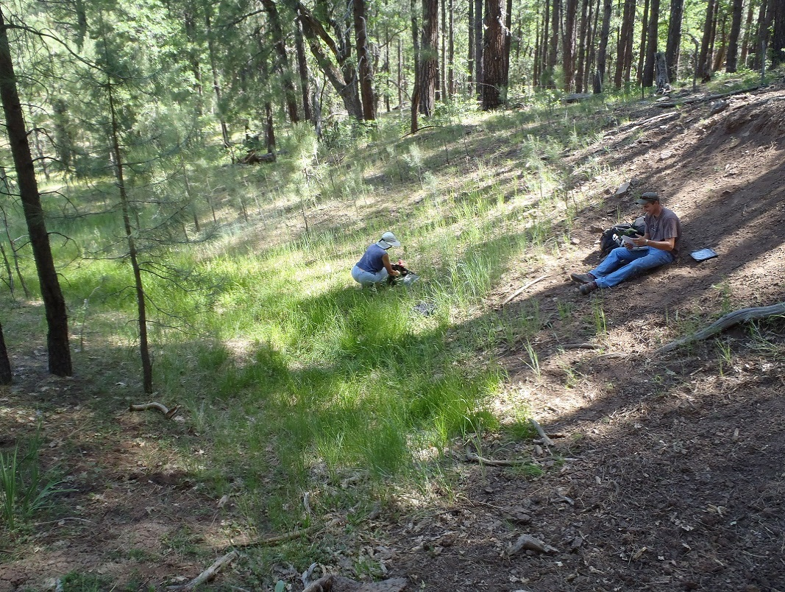
Fig 38.1 Rock Top Spring.

Physical Description: Rock Top Spring is a hillslope/helocrene spring. This site was imported from the SSI geodatabase, a compilation from multiple sources. The spring discharges from a basalt outcrop near the summit of a small hill. The spring flows for 2 m into a shallow pool with no outflow. A spring box is located 10 m below pool but was dry when surveyors visited in 2016.

Table 38.1 Rock Top Spring Microhabitat characteristics.
Code | X
Name | Entire Site
Area sqm
Surface type
Surface subtype
Slope variability
Aspect TN
Slope degrees
Moisture (scale 1-10)
Water depth cm
Area % open water
Substrate
1 - Clay % | 0
2 - Silt % | 0
3 - Sand % | 0
4 - Fine gravel % | 0
5 - Coarse gravel % | 0
6 - Cobble % | 0
7 - Boulder % | 0
8 - Bedrock % | 0
Organic % | 0
Other % (anthropogenic) | 0
Precipitate % | 0
Litter % | 0
Wood % | 0
Litter Depth (cm)

Geomorphology: Rock Top Spring emerges as a fracture spring from an igneous, basalt rock layer in an unknown unit. The emergence environment is subaerial, with a gravity flow force mechanism.

Access Directions: From exit 315 on I-17 travel N on NF-127 for 0.8 mi. Turn right and travel SE on NF-741 to NF-127 for 3.5 mi. Turn left and head north on NF-226 for 1.3 mi. Spring is 260 m due east. Road to Rock top goes directly to spring.

Survey Notes: This survey was conducted under the Pulliam project by students of Northern Arizona University and volunteers, under the direction of Dr. Abe Springer. A road exists next to the spring with indications of high volume traffic.

Flow: Flow was adjusted for an estimate of 1.00% of site flow capture. There is not enough flow to measure with volumetric flow measurement equipment.

Water Quality: Measurements taken at small pool located 2 m below spring source. YSI Professional Plus Multiprobe was used.

Table 38.2 Rock Top Spring Water Quality with multiple readings averaged.
Characteristic Measured | Average Value | Site Number | Device | Comments
Oxygen Reduction Potential in mV | 253.6 |  | YSI Multiprobe
pH (field) | 8.62 |  | YSI Multiprobe
Specific conductance (field) (uS/cm) | 115.3 |  | YSI Multiprobe
Temperature, water C | 30.1 |  | YSI Multiprobe

Flora: Pinus ponderosa forest Surveyors identified 15 plant species at the site. These included 10 native and 5 nonnative species.

Table 38.3 Rock Top Spring Cover Type.
Cover Type | Species Count | Wetland Species Count
Ground | 11 | 5
Shrub | 3 | 0
Mid-canopy | 0 | 0
Tall canopy | 0 | 0
Basal | 0 | 0
Aquatic | 0 | 0
Non-vascular | 0 | 0

Table 38.4 Rock Top Spring Vegetation % Cover in Microhabitats.
Species | Cover Code | Native Status | Wetland Status | Comments | X
Carex subfusca | GC | N | W | VM 147
Eleocharis | GC | N | W
Epilobium ciliatum | GC | N | W
Iris missouriensis | GC | N | F
Juncus saximontanus | GC | N | W
Poa pratensis | GC | I | F
Prunus emarginata | SC | N | F | VM 145
Ribes cereum |  | N | U
Robinia neomexicana | SC | N | F
Rosa woodsii | SC | N | F
Rumex crispus | GC | I | WR
Schedonorus pratensis | GC | I | F | VM 144
Taraxacum officinale | GC | I | F
Thermopsis divaricarpa | GC | N | F
Verbascum thapsus | GC | I | F

Assessment: Assessment scores were compiled in 6 categories and 42 subcategories, with 0 null condition scores, and 1 null risk score. Aquifer functionality and water quality are good with significant restoration potential and there is low risk. Geomorphology condition is good with significant restoration potential and there is low risk. Habitat condition is moderate with some restoration potential and there is low risk. Biotic integrity is moderate with some restoration potential and there is low risk. Human influence of site is good with significant restoration potential and there is low risk. Administrative context status is poor with limited restoration potential and there is low risk. Overall, the site condition is moderate with some restoration potential and there is low risk.

Table 38.5 Rock Top Spring Assessment Scores.
Category | Condition | Risk
Aquifer Functionality & Water Quality | 4 | 2.33
Geomorphology | 4.2 | 2.2
Habitat | 3.8 | 2.75
Biota | 2.88 | 2.5
Human Influence | 4.63 | 2.14
Administrative Context | 2 | 2.44
Overall Ecological Score | 3.72 | 2.45

Management Recommendations: Remove spring box and remove road.

39. Rocky Tule spring
39. Rocky Tule spring
Survey Summary Report, Site ID 639
Submitted June 3, 2019 by Springs Stewardship Institute
Location: The Rocky Tule spring ecosystem is located in Coconino County in the Upper Verde Arizona 15060202 HUC, managed by the US Forest Service. The spring is located in the Kaibab NF, Williams RD, in the White Horse Lake USGS Quad, at 35.05647, -112.12281 measured using a GPS (NAD83). The elevation is approximately 2012 meters. Glenn Rink surveyed the site on 9/27/10 for 00:40 hours, beginning at 12:20, and collected data in 4 of 10 categories. This survey was conducted under the NEPA Cleared List project using the Stevens et al. Level 2 protocol.

Physical Description: Rocky Tule spring is an anthropogenic spring. A square area (about 10 by 10 meters) is fenced in, and contains a metal well and cement trough. The site has 2 microhabitats, including A -- a 10 sqm low gradient cienega, B -- a 350 sqm low gradient cienega. The geomorphic diversity is 0.06, based on the Shannon-Weiner diversity index.

Table 39.1 Rocky Tule spring Microhabitat characteristics.
Code | A | B
Name | Wet area | Dry area
Area sqm | 10.00 | 350.00
Surface type | LGC | LGC
Surface subtype
Slope variability
Aspect TN
Slope degrees
Moisture (scale 1-10)
Water depth cm
Area % open water
Substrate
1 - Clay % | 0 | 0
2 - Silt % | 0 | 0
3 - Sand % | 0 | 0
4 - Fine gravel % | 0 | 0
5 - Coarse gravel % | 0 | 0
6 - Cobble % | 0 | 0
7 - Boulder % | 0 | 0
8 - Bedrock % | 0 | 0
Organic % | 0 | 0
Other % (anthropogenic) | 0 | 0
Precipitate % | 0 | 0
Litter % | 0 | 0
Wood % | 0 | 0
Litter Depth (cm)

Geomorphology: Rocky Tule spring emerges from the basalt flow, an igneous, basalt rock layer. The site receives approximately 100% of available solar radiation, with 7333 Mj annually.

Access Directions: Take COC-73 to Forest Rd 354. Walk along Forest Rd 3244A for 1.2 miles.

Survey Notes: The spring has been heavily manipulated, with a vertical pipe about 20 inches in diameter. Flow is very low, estimated at 1 liter an hour.

Flora: Rink plant dets have been updated. Surveyors identified 20 plant species at the site, with 0.0556 species/sqm. These included 15 native and 4 nonnative species; the native status of 1 species remains unknown.

Table 39.2 Rocky Tule spring Cover Type.
Cover Type | Species Count | Wetland Species Count
Ground | 16 | 6
Shrub | 2 | 0
Mid-canopy | 1 | 0
Tall canopy | 1 | 0
Basal | 0 | 0
Aquatic | 0 | 0
Non-vascular | 0 | 0

Table 39.3 Rocky Tule spring Vegetation % Cover in Microhabitats.
Species | Cover Code | Native Status | Wetland Status | Comments | A | B
Achillea millefolium | GC | NI | U |  | 0 | 2
Ambrosia artemisiifolia | GC | N | F |  | 0 | 2
Anoda cristata | GC | N | F | Rink 10329 | 0 | 0.01
Bouteloua gracilis | GC | N | U |  | 1 | 1
Bouteloua simplex | GC | N | U | Rink 10328, annual | 0 | 2
Carex occidentalis | GC | N | W |  | 0 | 0.5
Echinochloa crus-galli | GC | I | W |  | 30 | 0
Elymus elymoides | GC | N | F |  | 0 | 1
Eragrostis | GC | I | WR |  | 20 | 0
Eriogonum pharnaceoides | GC | N | U | Rink 10307 | 0 | 3
Gayophytum | GC |  | F |  | 0 | 3
Gnaphalium exilifolium | GC | N | W |  | 1 | 0
Heliomeris multiflora | SC | N | U |  | 1 | 30
Juncus xiphioides | GC | N | W |  | 1 | 0
Juniperus deppeana | SC | N | U |  | 0 | 4
Muhlenbergia minutissima | GC | N | U |  | 1 | 10
Pinus ponderosa | TC | N | F |  | 0 | 7
Quercus gambelii | MC | N | F |  | 0 | 4
Verbascum thapsus | GC | I | F |  | 0 | 1
Veronica anagallis-aquatica | GC | I | A |  | 2 | 0

Assessment: Assessment scores were compiled in 5 categories and 7 subcategories, with 35 null condition scores, and 34 null risk scores. Aquifer functionality and water quality are moderate with some restoration potential and there is moderate risk. Geomorphology condition is very poor with very limited restoration potential and there is moderate risk. Habitat condition is poor with limited restoration potential and there is low risk. Biotic integrity is poor with limited restoration potential and there is moderate risk. Human influence of site is poor with limited restoration potential and there is moderate risk. Administrative context status is undetermined due to null scores and there is undetermined risk due to null scores. Overall, the site condition is poor with limited restoration potential and there is moderate risk.

Table 39.4 Rocky Tule spring Assessment Scores.
Category | Condition | Risk
Aquifer Functionality & Water Quality | 3.8 | 3.2
Geomorphology | 1.5 | 3
Habitat | 2.33 | 2.75
Biota | 2.75 | 3
Human Influence | 2 | 3.14
Administrative Context | 0 | 0
Overall Ecological Score | 2.48 | 3.02

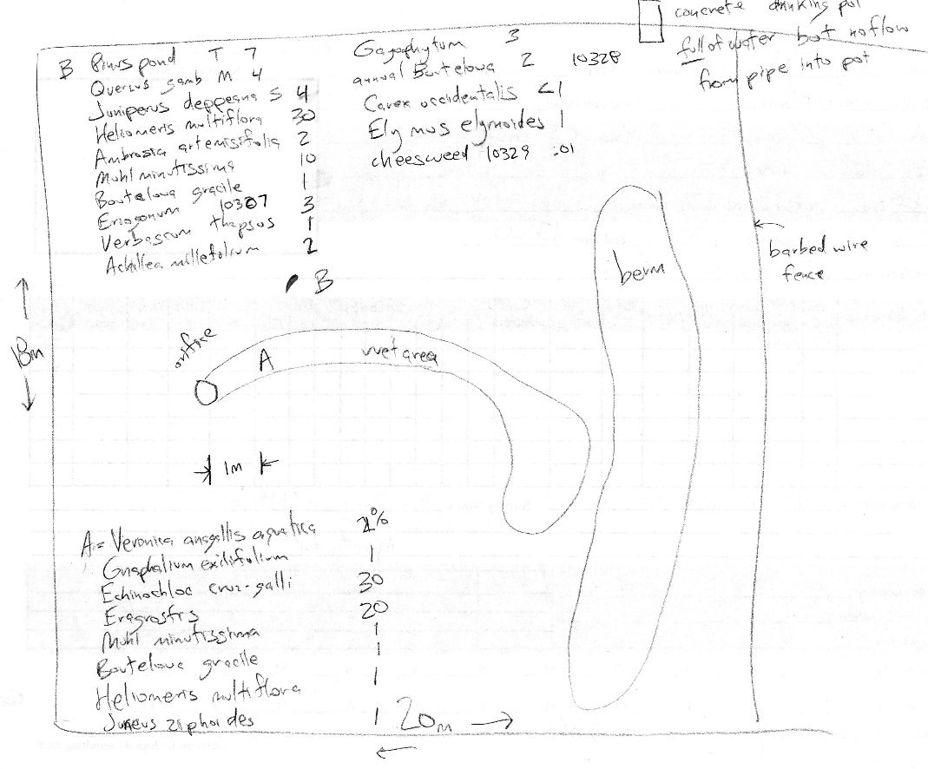
Fig 39.1 Rocky Tule spring Sketchmap

40. Rosilda Spring
40. Rosilda Spring
Survey Summary Report, Site ID 588
Submitted June 3, 2019 by Springs Stewardship Institute
Location: The Rosilda Spring ecosystem is located in Coconino County in the Upper Verde Arizona 15060202 HUC, managed by the US Forest Service. The spring is located in the Kaibab NF, Williams RD, in the Davenport Hill USGS Quad, at 35.17512, -112.06255 measured using a GPS (NAD83, estimated position error 3 meters). The elevation is approximately 1985 meters. Winnie Taney, Chantel Cook, Irene Hamilton and Lisa Winters surveyed the site on 9/08/16 for 02:15 hours, beginning at 12:15, and collected data in 7 of 10 categories. This survey was conducted under the NEPA Cleared List project using the Stevens et al. Level 2 protocol.

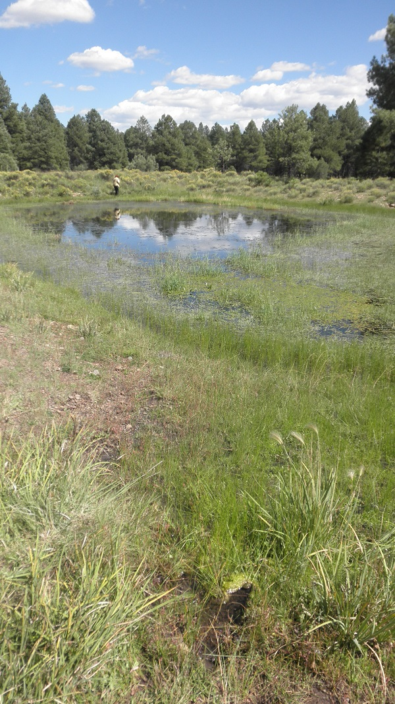
Fig 40.1 Rosilda Spring: View of site

Physical Description: Rosilda Spring is a helocrene spring. This is a low gradient cienega that has been excavated. A 3 m well has been rocked-in and piped into a bermed pond. The site is 150 m from where it is mapped on the DRG. The total area in 2016 was about 379.5 sq. meters. The site has 3 microhabitats, including A -- a 0 sqm channel, B -- a 0 sqm pool, C -- a 0 sqm pool margin.

Table 40.1 Rosilda Spring Microhabitat characteristics.
Code | A | B | C
Name | Pipe Channel | Pond | Pond Perimeter
Area sqm
Surface type | CH | P | PM
Surface subtype
Slope variability | Low | Low | Low
Aspect TN
Slope degrees | 13 | 0 | 0
Moisture (scale 1-10) | 9 | 10 | 9
Water depth cm | 4 | 76 | 1
Area % open water | 70 | 70 | 5
Substrate
1 - Clay % | 0 | 0 | 0
2 - Silt % | 0 | 0 | 0
3 - Sand % | 0 | 0 | 0
4 - Fine gravel % | 0 | 0 | 0
5 - Coarse gravel % | 0 | 0 | 0
6 - Cobble % | 0 | 0 | 0
7 - Boulder % | 0 | 0 | 0
8 - Bedrock % | 0 | 0 | 0
Organic % | 0 | 0 | 0
Other % (anthropogenic) | 0 | 0 | 0
Precipitate % | 0 | 0 | 0
Litter % | 0 | 0 | 0
Wood % | 0 | 0 | 0
Litter Depth (cm)

Geomorphology: Rosilda Spring emerges as a seepage or filtration spring from an igneous, basalt rock layer in an unknown unit. The emergence environment is subaerial, with a gravity flow force mechanism. The site receives approximately 100% of available solar radiation, with 0 Mj annually.

Access Directions: From exit 167 on I-40, travel south on S Garland Prairie Rd for 7 mi. Turn right onto NF-18 and continue for 1.6 mi. Hike 600 m due west up drainage.

Survey Notes: The source well is dugout and lined with rocks, then covered with logs. No pipe is apparent but water is emerging from the hillslope just downhill of the dugout and flows into a man-made pond. Pond has much aquatic vegetation and bullfrogs present. There is a duck blind located on the far side of pond.

Flow: Surveyors measured a flow of 0.17 liters/second, using a timed flow volume capture method. Flow was adjusted for an estimate of 100% of site flow capture. At channel flow into pond.

Water Quality: Water was collected from the outflow pipe.

Table 40.2 Rosilda Spring Water Quality with multiple readings averaged.
Characteristic Measured | Average Value | Site Number | Device | Comments
pH (field) | 6.23 |  | DigitalAid meter
Specific conductance (lab) umhos/cm | 41 |  | DigitalAid meter
Temperature, air C | 26.67 |  | DigitalAid meter
Temperature, water C | 20 |  | DigitalAid meter

Flora: Surveyors identified 18 plant species at the site. These included 14 native and 4 nonnative species.

Table 40.3 Rosilda Spring Cover Type.
Cover Type | Species Count | Wetland Species Count
Ground | 15 | 6
Shrub | 1 | 0
Mid-canopy | 0 | 0
Tall canopy | 0 | 0
Basal | 0 | 0
Aquatic | 2 | 2
Non-vascular | 0 | 0

Table 40.4 Rosilda Spring Vegetation % Cover in Microhabitats.
Species | Cover Code | Native Status | Wetland Status | Comments | A | B | C
Achillea millefolium | GC | NI | U |  | 0 | 0 | 2
Aster canescens | GC |  |  |  | 0 | 0 | 1
Bouteloua gracilis | GC | N | U |  | 0 | 0 | 3
Carex occidentalis | GC | N | W |  | 0 | 0 | 2
Cladophora glomerata | AQ | N | A |  | 15 | 0 | 0
Eleocharis | GC | N | W |  | 0 | 1 | 15
Iris missouriensis | GC | N | F |  | 0 | 0 | 4
Juncus interior | GC | N | U |  | 0 | 0 | 5
Juniperus deppeana | SC | N | U |  | 0 | 0 | 0.1
Marsilea vestita | GC | N | A |  | 0 | 5 | 0
Poa pratensis | GC | NI | F |  | 0 | 0 | 2
Potamogeton nodosus | AQ | N | A |  | 0 | 15 | 0
Rumex crispus | GC | I | WR |  | 0 | 10 | 0
Sidalcea neomexicana | GC | N | WR |  | 0 | 0 | 1
Sisyrinchium demissum | GC | N | W |  | 0.1 | 0 | 1
Taraxacum officinale | GC | NI | F |  | 0 | 0 | 2
Trifolium | GC | I | WR |  | 0 | 0 | 2
Verbascum thapsus | GC | I | F |  | 0 | 0 | 3

Fauna: Surveyors collected or observed 1 aquatic and 3 terrestrial invertebrates and 5 vertebrate specimens.

Table 40.5 Rosilda Spring Invertebrates.
Species | Lifestage | Habitat | Method | Rep# | Count | Species Detail
Hemiptera Gerridae | Ad | A |  |  |  | many
Lepidoptera Pieridae |  | T |  |  |  | white - several
Lepidoptera Pieridae |  | T |  |  |  | yellow - several
Odonata |  |  |  |  |  | several
Orthoptera Acrididae |  | T | Spot |  |  | many

Table 40.6 Rosilda Spring Vertebrates.
Vertebrate Species Common Name | Count | Detection | Comments
American Bullfrog | 40 | obs
Elk |  | sign | scat and tracks
Northern Flicker | 1 | obs
Garter Snake | 2 | obs
Red-tailed Hawk | 1 | obs

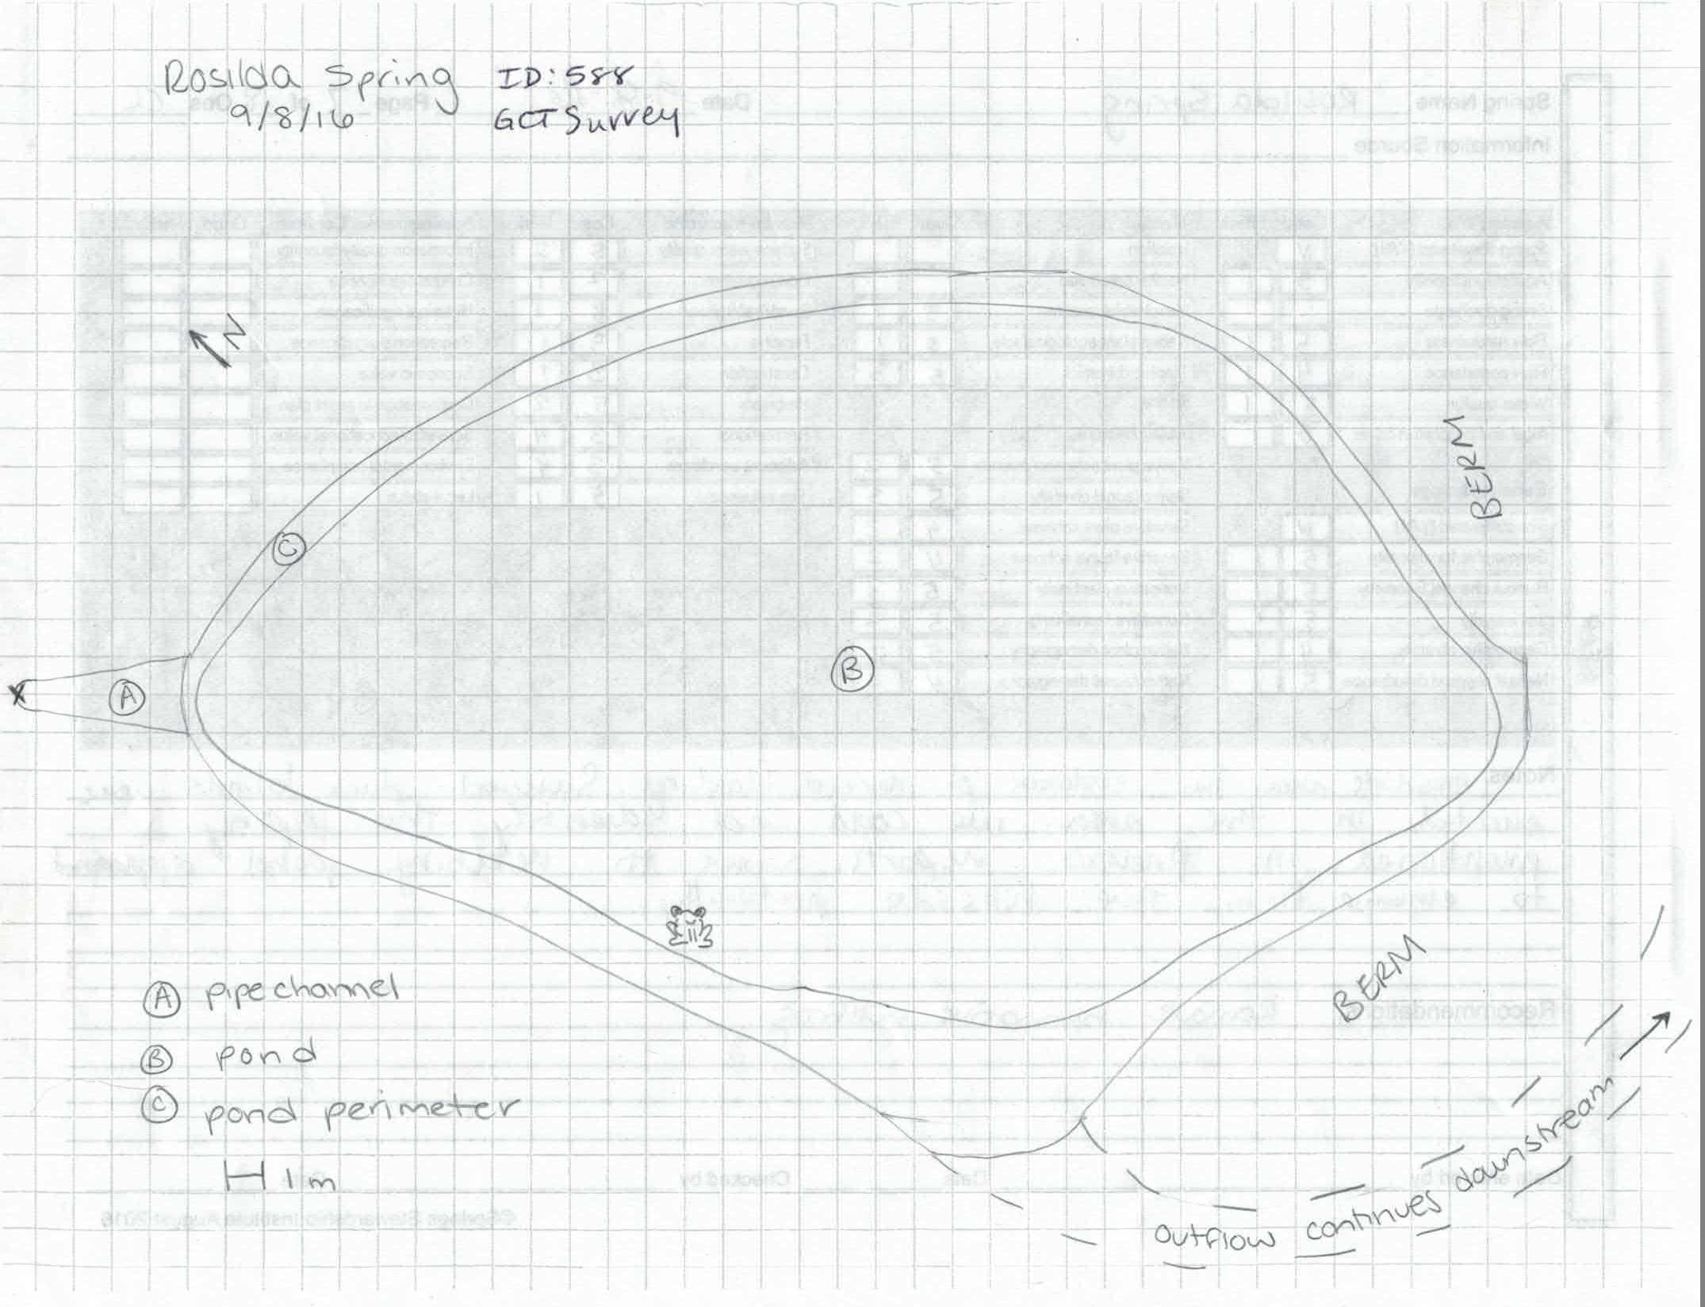
Fig 40.2 Rosilda Spring Sketchmap.

1. Sawmill Spring
41. Sawmill Spring
Survey Summary Report, Site ID 782
Submitted June 3, 2019 by Springs Stewardship Institute
Location: The Sawmill Spring ecosystem is located in Coconino County in the Upper Verde Arizona 15060202 HUC, managed by the US Forest Service. The spring is located in the Kaibab NF, Williams RD, in the Parks USGS Quad, at 35.28784, -111.95983 measured using a map (NAD83). The elevation is approximately 2211 meters. Stasia Begley and Volunteers surveyed the site on 7/18/16, and collected data in 5 of 10 categories. This survey was conducted under the NEPA Cleared List project using the Stevens et al. Level 1 protocol.

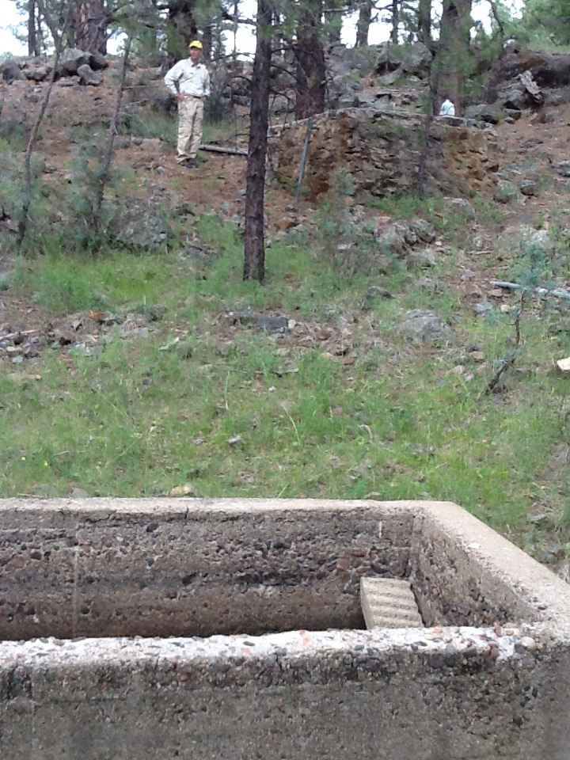
Fig 41.1 Sawmill Spring: View of spring trough

Physical Description: Sawmill Spring is a hillslope spring. The spring discharges out of a basalt outcrop into two spring boxes, with the lower spring box feeding a stock tank with water. This named spring is depicted on the DRG, and was included in the AZ State Land Office shapefile.

Geomorphology: Sawmill Spring emerges as a contact spring from an igneous, basalt rock layer in an unknown unit. The emergence environment is subaerial, with a gravity flow force mechanism.

Access Directions: From exit 178 on I-40, travel NW on County Rd 141 for 3.1 mi. Turn left on J Diamond Bell Ranch Rd and continue west for 0.5 mi. Turn left and south onto NF-3571 and travel for 0.7 mi. Spring is 280 m due SE.

Survey Notes: The upper catchment box was dry and partially filled with rocks. The lower box was mostly full of water. The trough was a quarter full. Sawmill Tank below was dry. This site would be a decent nominee for restoration.

Flow: No current overflow, but there is water in the trough.

Table 41.1 Sawmill Spring Water Quality with multiple readings averaged.
Characteristic Measured | Average Value | Site Number | Device | Comments
Dissolved oxygen (field) (mg/L) | 5.6 |  | YSI Multiprobe
pH (field) | 7.94 |  | YSI
Specific conductance (field) (uS/cm) | 286 |  | YSI | EC 228 adj for temp
Temperature, water C | 14.8 |  | YSI

Fauna: Surveyors collected or observed 3 vertebrate specimens.

Table 41.2 Sawmill Spring Vertebrates.
Vertebrate Species Common Name | Count | Detection | Comments
Elk |  | call | Heard elk ~1/4 mi away. No obvious signs at spring
Deer |  | sign | Deer scat present
Common Raven |  | call | Heard raven consistently with 100m during site visit

Assessment: Assessment scores were compiled in 4 categories and 0 subcategories, with 42 null condition scores, and 42 null risk scores. Aquifer functionality and water quality are undetermined due to null scores and there is undetermined risk due to null scores. Geomorphology condition is poor with limited restoration potential and there is undetermined risk due to null scores. Habitat condition is poor with limited restoration potential and there is undetermined risk due to null scores. Biotic integrity is poor with limited restoration potential and there is undetermined risk due to null scores. Human influence of site is poor with limited restoration potential and there is undetermined risk due to null scores. Administrative context status is undetermined due to null scores and there is undetermined risk due to null scores. Overall, the site condition is undetermined due to null scores and there is undetermined risk due to null scores.

Table 41.3 Sawmill Spring Assessment Scores.
Category | Condition | Risk
Aquifer Functionality & Water Quality | 0 | 0
Geomorphology | 2 | 0
Habitat | 2 | 0
Biota | 2 | 0
Human Influence | 2 | 0
Administrative Context | 0 | 0
Overall Ecological Score | 0 | 0

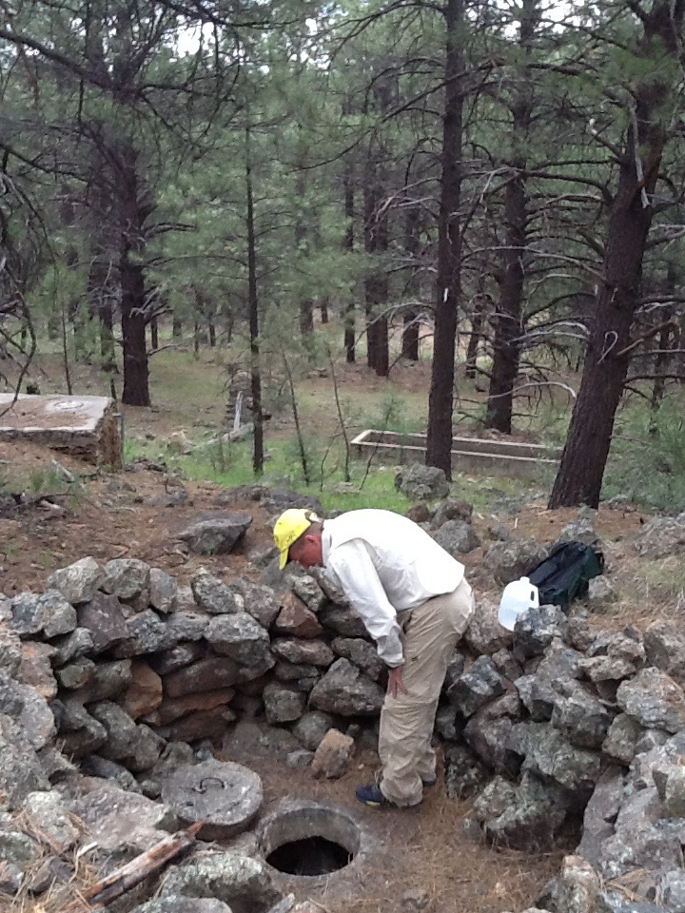
Fig 41.2 Sawmill Spring: Spring tank

42. Sawmill Springs
42. Sawmill Springs
Survey Summary Report, Site ID 1080
Submitted June 3, 2019 by Springs Stewardship Institute
Location: The Sawmill Springs ecosystem is located in Coconino County in the Canyon Diablo Arizona 15020015 HUC, managed by the US Forest Service. The spring is located in the Coconino NF, Mogollon Rim RD, in the Hutch Mountain USGS Quad, at 34.83713, -111.37793 measured using a GPS (WGS84, estimated position error 6 meters). The elevation is approximately 2259 meters. Krista Sparks and Vera Markgraf surveyed the site on 7/09/14 for 00:45 hours, beginning at 14:00, and collected data in 5 of 10 categories. This survey was conducted under the NEPA Cleared List project using the Stevens et al. Level 2 protocol.

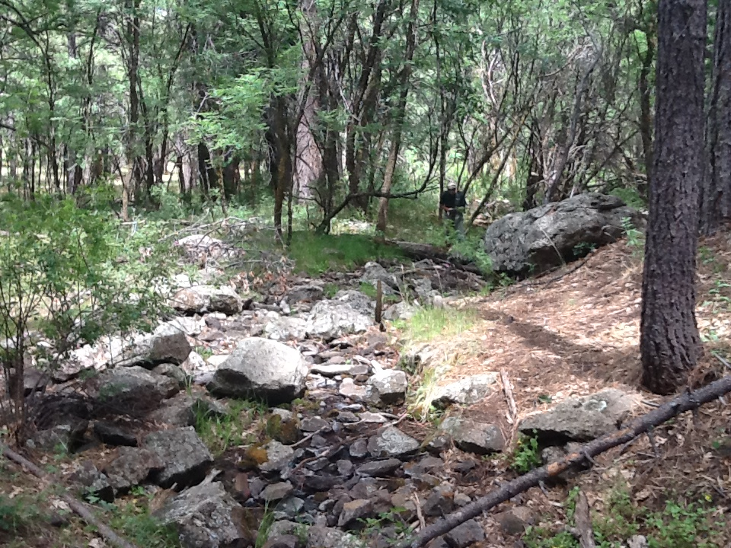
Fig 42.1 Sawmill Springs: Looking down from source

Physical Description: Sawmill Springs is a rheocrene spring. Flow emerges from a concrete spring box and runs along a channel with additional water input for 200 meters before flowing into a wet meadow.

Table 42.1 Sawmill Springs Microhabitat characteristics.
Code | X
Name | Entire Site
Area sqm
Surface type
Surface subtype
Slope variability
Aspect TN
Slope degrees
Moisture (scale 1-10)
Water depth cm
Area % open water
Substrate
1 - Clay % | 0
2 - Silt % | 0
3 - Sand % | 0
4 - Fine gravel % | 0
5 - Coarse gravel % | 0
6 - Cobble % | 0
7 - Boulder % | 0
8 - Bedrock % | 0
Organic % | 0
Other % (anthropogenic) | 0
Precipitate % | 0
Litter % | 0
Wood % | 0
Litter Depth (cm)

Geomorphology: Sawmill Springs emerges from an igneous, basalt rock layer in an unknown unit. The emergence environment is subaerial, with a gravity flow force mechanism.

Access Directions: Take COC-3 to Forest Rd 124, continue on Forest Rd 124H to Forest Rd 683. Walk up the drainage.

Survey Notes: This survey was conducted by Northern Arizona University students on the 4FRI project, under the direction of Dr. Abe Springer. Water is flowing from a concrete spring box and nearby seep. At this survey, flow was only measured at the source, but there seems to be at least one additional input along the channel. A portable flume is recommended for flow measurements here.

Flow: Surveyors measured a flow of 0.10 liters/second, using a timed flow volume capture method. Flow was adjusted for an estimate of 100% of site flow capture. Flow was measured at the seep from the spring box/source.

Water Quality: Water was collected in a volumetric container for quality measurements due to low flow.

Table 42.2 Sawmill Springs Water Quality with multiple readings averaged.
Characteristic Measured | Average Value | Site Number | Device | Comments
Alkalinity, Total (mg/L) | 84 |  | YSI Multiprobe
Dissolved oxygen (field) (mg/L) | 8.59 |  | YSI Multiprobe
pH (field) | 7.02 |  | YSI Multiprobe
Specific conductance (field) (uS/cm) | 179.6 |  | YSI Multiprobe
Temperature, water C | 8.7 |  | YSI Multiprobe

Flora: Surveyors identified 37 plant species at the site. These included 32 native and 5 nonnative species.

Table 42.3 Sawmill Springs Cover Type.
Cover Type | Species Count | Wetland Species Count
Ground | 33 | 22
Shrub | 3 | 1
Mid-canopy | 0 | 0
Tall canopy | 0 | 0
Basal | 0 | 0
Aquatic | 0 | 0
Non-vascular | 0 | 0

Table 42.4 Sawmill Springs Vegetation % Cover in Microhabitats.
Species | Cover Code | Native Status | Wetland Status | Comments | X
Agrostis exarata | GC | N | W | VM 337
Carex pellita | GC | N | W | VM 325
Carex simulata | GC | N | W | VM 338
Carex subfusca | GC | N | W
Eleocharis palustris | GC | N | W
Eleocharis parishii | GC | N | W
Epilobium ciliatum | GC | N | W
Frasera speciosa | GC | N | U
Geranium caespitosum | GC | N | F
Glyceria borealis | GC | N | W | VM 343
Hypericum scouleri | GC | N | WR
Iris missouriensis | GC | N | F
Juncus confusus | GC | N | W | VM 326
Juncus interior | GC | N |  | VM341/342
Juncus saximontanus | GC | N | W | VM 353
Juncus xiphioides | GC | N | W | VM 340
Medicago lupulina | GC | I | WR
Mentha arvensis | GC | N | WR
Mimulus guttatus | GC | N | W
Perideridia parishii | GC | N
Phleum pratense | GC | I | F
Plantago major | GC | I | WR
Poa pratensis | GC | I | F
Prunella vulgaris | GC | N | F
Ranunculus macounii | GC | N | W
Ribes cereum | SC | N | U
Ribes pinetorum |  | N
Rosa woodsii | SC | N | F
Rumex crispus | GC | I | WR
Salix bebbiana | SC | N | WR | VM 327
Scirpus microcarpus | GC | N | W
Sisyrinchium demissum | GC | N | W
Thalictrum fendleri | GC | N | F
Thermopsis montana | GC | N | U
Trifolium pinetorum | GC | N | WR
Veronica americana | GC | N | A
Viola canadensis | GC | N | F

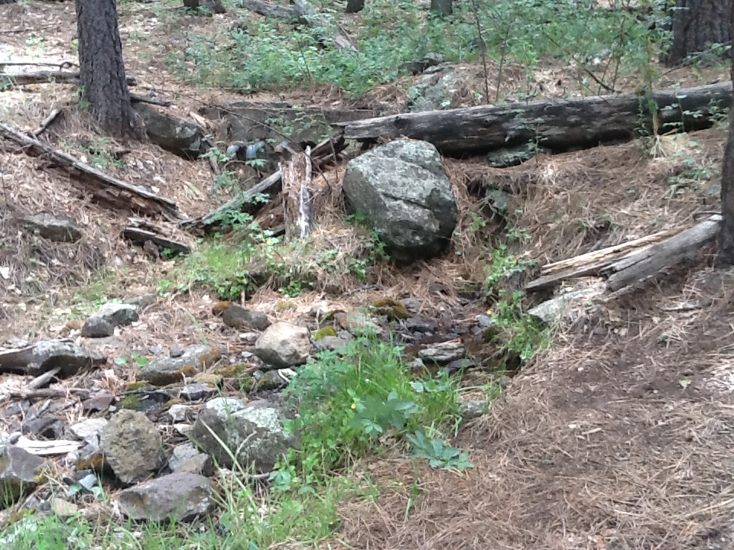
Fig 42.2 Sawmill Springs: Source

43. Scott Spring
43. Scott Spring
Survey Summary Report, Site ID 1083
Submitted June 3, 2019 by Springs Stewardship Institute
Location: The Scott Spring ecosystem is located in Coconino County in the Upper Verde Arizona 15060202 HUC, managed by the US Forest Service. The spring is located in the Coconino NF, Mormon Lake RD, in the Mountainaire USGS Quad, at 35.02612, -111.72134 measured using a Map (NAD83). The elevation is approximately 2014 meters. Krista Sparks, Spencer Harris, and Quintin Van Dyk surveyed the site on 7/19/13 for 00:25 hours, beginning at 12:15, and collected data in 3 of 10 categories. This survey was conducted under the NEPA Cleared List project using the Stevens et al. Level 2 protocol.

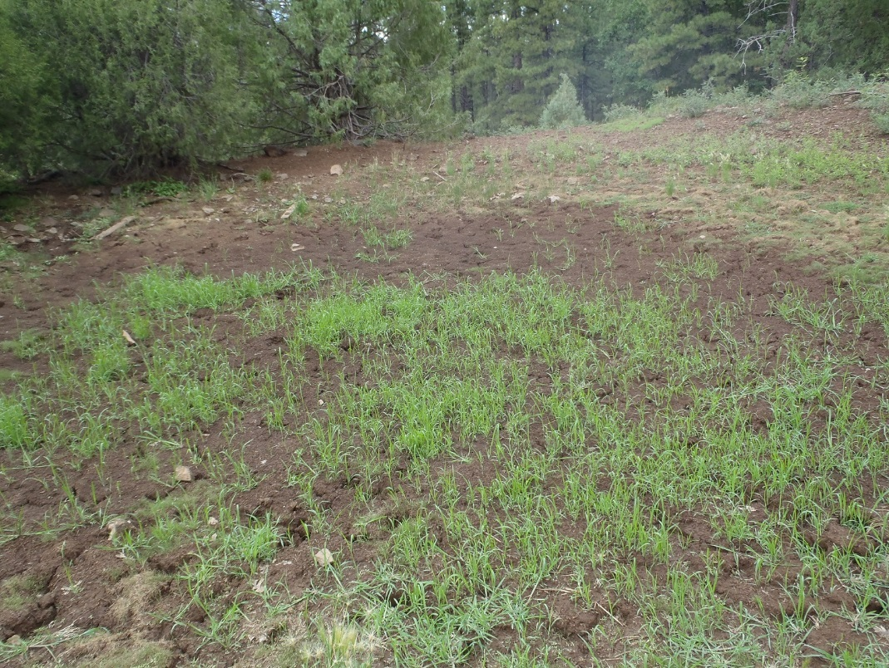
Fig 43.1 Scott Spring.

Physical Description: Scott Spring is a hillslope spring. This site was imported from the SSI geodatabase, a compilation from multiple sources. The spring discharges out of a hillslope and the source has been dug out with concrete stock tanks installed.

Geomorphology: Scott Spring emerges as a contact spring from an igneous, basalt rock layer in an unknown unit. The emergence environment is subaerial, with a gravity flow force mechanism.

Access Directions: From exit 328 on I-17, travel south to NF-9462G for 1 mi and continue NW to NF-253 for 1 mi. Bear right onto Scott Spring Rd (NF-253E) and head NW for 0.95 mi.

Survey Notes: This survey was conducted under the Pulliam project by students of Northern Arizona University and volunteers, under the direction of Dr. Abe Springer. Stock tanks are not in operation and no water was present at the spring.

Flow: No water was present at the time of the site visit. Surveyors were unable to measure flow due to spring is dry.

Water Quality: No water present at time of site visit.

Assessment: Assessment scores were compiled in 6 categories and 42 subcategories, with 0 null condition scores, and 1 null risk score. Aquifer functionality and water quality are eliminated with no restoration potential and there is moderate risk. Geomorphology condition is very poor with very limited restoration potential and there is moderate risk. Habitat condition is poor with limited restoration potential and there is moderate risk. Biotic integrity is very poor with very limited restoration potential and there is moderate risk. Human influence of site is moderate with some restoration potential and there is low risk. Administrative context status is poor with limited restoration potential and there is low risk. Overall, the site condition is very poor with very limited restoration potential and there is moderate risk.

Table 43.1 Scott Spring Assessment Scores.
Category | Condition | Risk
Aquifer Functionality & Water Quality | 0 | 3
Geomorphology | 1.8 | 3.2
Habitat | 2 | 3.5
Biota | 1.63 | 3.25
Human Influence | 3.75 | 2.57
Administrative Context | 2.56 | 2.44
Overall Ecological Score | 1.36 | 3.24

Management Recommendations: Surveyors did not note any management recommendations.

44. Seven Anchor Spring
44. Seven Anchor Spring
Survey Summary Report, Site ID 1086
Submitted June 3, 2019 by Springs Stewardship Institute
Location: The Seven Anchor Spring ecosystem is located in Coconino County in the Upper Verde Arizona 15060202 HUC, managed by the US Forest Service. The spring is located in the Coconino NF, Mogollon Rim RD, in the Hutch Mountain USGS Quad, at 34.81672, -111.41322 measured using a Map (NAD83). The elevation is approximately 2371 meters. Lisa Winters, Winnie Taney, and Kathy Morin surveyed the site on 9/06/16 for 01:25 hours, beginning at 14:20, and collected data in 8 of 10 categories. This survey was conducted under the NEPA Cleared List project using the Stevens et al. Level 2 protocol.

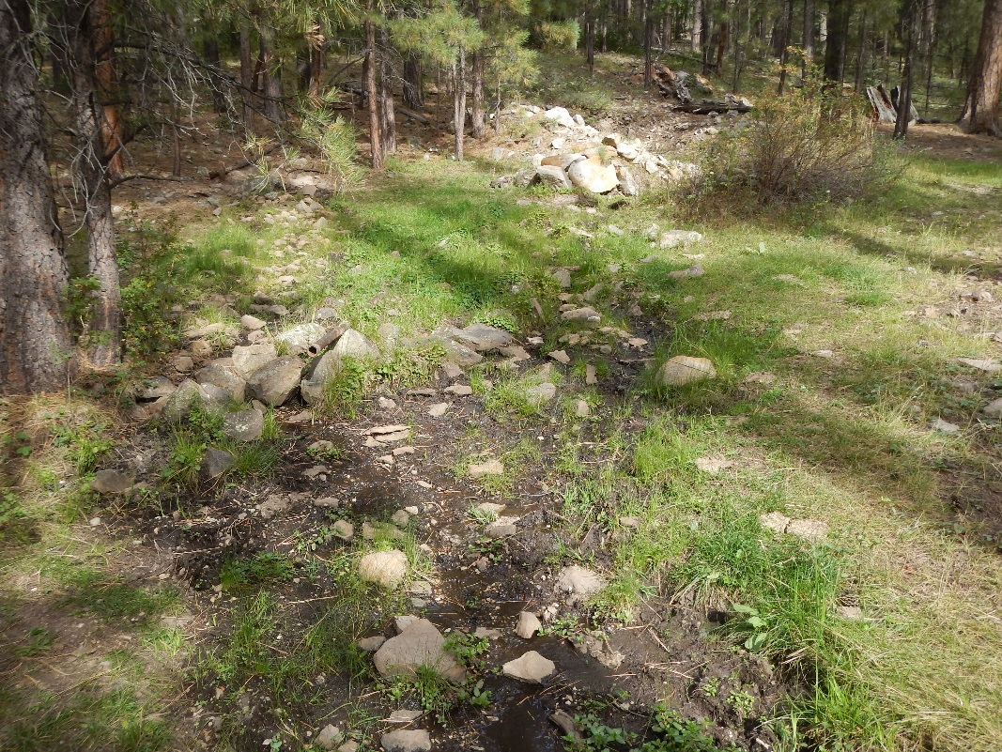
Fig 44.1 Seven Anchor Spring: Lower seepage (3rd channel)

Physical Description: Seven Anchor Spring is a rheocrene spring. This spring has been extensively manipulated with the construction of a large spring box and multiple piping outflows. This site was imported from the SSI geodatabase, a compilation from multiple sources. The site has 2 microhabitats, including A -- a 98 sqm channel, B -- a 32 sqm terrace.

Table 44.1 Seven Anchor Spring Microhabitat characteristics.
Code | A | B
Name | Channel | Margin
Area sqm | 98 | 32
Surface type | CH | TE
Surface subtype
Slope variability | Low | Low
Aspect TN | 310 | 310
Slope degrees | 14 | 28
Moisture (scale 1-10) | 8 | 3
Water depth cm | 1 | 0
Area % open water | 35 | 0
Substrate
1 - Clay % | 0 | 0
2 - Silt % | 0 | 0
3 - Sand % | 0 | 0
4 - Fine gravel % | 0 | 0
5 - Coarse gravel % | 0 | 0
6 - Cobble % | 0 | 0
7 - Boulder % | 0 | 0
8 - Bedrock % | 0 | 0
Organic % | 0 | 0
Other % (anthropogenic) | 0 | 0
Precipitate % | 0 | 0
Litter % | 0 | 0
Wood % | 0 | 0
Litter Depth (cm)

Access Directions: From Lake Mary Rd (CR-3) turn onto NF-92 and travel SE for 1.27 mi. Continue onto NF-6048 for 0.12 mi. Spring is 270 m due SE.

Survey Notes: The majority of the spring water is human-directed to outside of the spring-area. Elk were observed browsing outside of fencing. There are 3 main channels from the concrete spring box, one of which begins outside the fenced area and is trampled by ungulates.

Flow: Surveyors measured a flow of 0.069 liters/second, using a timed flow volume capture method. Flow was adjusted for an estimate of 99% of site flow capture. Flow was measured from the outflow pipe. Discharge seemed to be pulsing.

Water Quality: The DigitalAid meter was calibrated on the day of the survey.

Table 44.2 Seven Anchor Spring Water Quality with multiple readings averaged.
Characteristic Measured | Average Value | Site Number | Device | Comments
pH (field) | 5.6 |  | DigitalAid meter
Specific conductance (field) (uS/cm) | 85 |  | DigitalAid meter
Temperature, water C | 18 |  | DigitalAid meter

Flora: Surveyors identified 17 plant species at the site, with 0.1308 species/sqm. These included 12 native and 5 nonnative species.

Table 44.3 Seven Anchor Spring Cover Type.
Cover Type | Species Count | Wetland Species Count
Ground | 10 | 1
Shrub | 3 | 1
Mid-canopy | 0 | 0
Tall canopy | 1 | 0
Basal | 0 | 0
Aquatic | 1 | 1
Non-vascular | 2 | 0

Table 44.4 Seven Anchor Spring Vegetation % Cover in Microhabitats.
Species | Cover Code | Native Status | Wetland Status | Comments | A | B
Antennaria | GC | N | U |  | 0 | 1
Carex | GC |  |  |  | 0 | 5
Castilleja | GC | N | U |  | 0 | 1
Cirsium vulgare | GC | I | F |  | 0 | 1
Geranium caespitosum | GC | N | F |  | 1 | 60
Geranium richardsonii | GC | N | F |  | 10 | 3
Lichen | NV | N | U |  | 1 | 1
Mimulus guttatus | AQ | N | W |  | 70 | 0
Polygonatum | GC |  | U |  | 8 | 10
Quercus gambelii | TC | N | F |  | 0 | 2
Ribes | SC | N | F |  | 0 | 1
Rosa woodsii | SC | N | F |  | 1 | 1
Rumex | GC |  | WR |  | 1 | 0
Salix | SC | N | WR |  | 0 | 1
Sidalcea | GC | I | F |  | 2 | 1
Thalictrum | GC | N | U |  | 0 | 1
unknown Bryophyte (moss, liverwort, hornwort) | NV | N | F |  | 1 | 1

Fauna: Surveyors collected or observed 1 terrestrial invertebrates and 2 vertebrate specimens.

Table 44.5 Seven Anchor Spring Invertebrates.
Species | Lifestage | Habitat | Method | Rep# | Count | Species Detail
Hymenoptera Apidae | Ad | T | Spot |  |  | many

Table 44.6 Seven Anchor Spring Vertebrates.
Vertebrate Species Common Name | Count | Detection | Comments
Elk | 3 | obs | Outside enclosure
Steller's Jay | 4 | obs

Assessment: Assessment scores were compiled in 5 categories and 29 subcategories, with 13 null condition scores, and 10 null risk scores. Aquifer functionality and water quality are very poor with very limited restoration potential and there is moderate risk. Geomorphology condition is moderate with some restoration potential and there is low risk. Habitat condition is moderate with some restoration potential and there is high risk. Biotic integrity is moderate with some restoration potential and there is low risk. Human influence of site is moderate with some restoration potential and there is negligible risk. Administrative context status is undetermined due to null scores and there is undetermined risk due to null scores. Overall, the site condition is moderate with some restoration potential and there is low risk.

Table 44.7 Seven Anchor Spring Assessment Scores.
Category | Condition | Risk
Aquifer Functionality & Water Quality | 1.8 | 3.3
Geomorphology | 3.6 | 2.6
Habitat | 3.3 | 4
Biota | 3.3 | 2.4
Human Influence | 3.4 | 1.6
Administrative Context | 0 | 0
Overall Ecological Score | 3.2 | 2.6

Management Recommendations: Managers should consider cleaning up old barbed wire fencing and remove pipes that are no longer in use. They should consider the effects of removing the spring box and lower filtration system, and consider restoring a portion of the water to the immediate landscape.

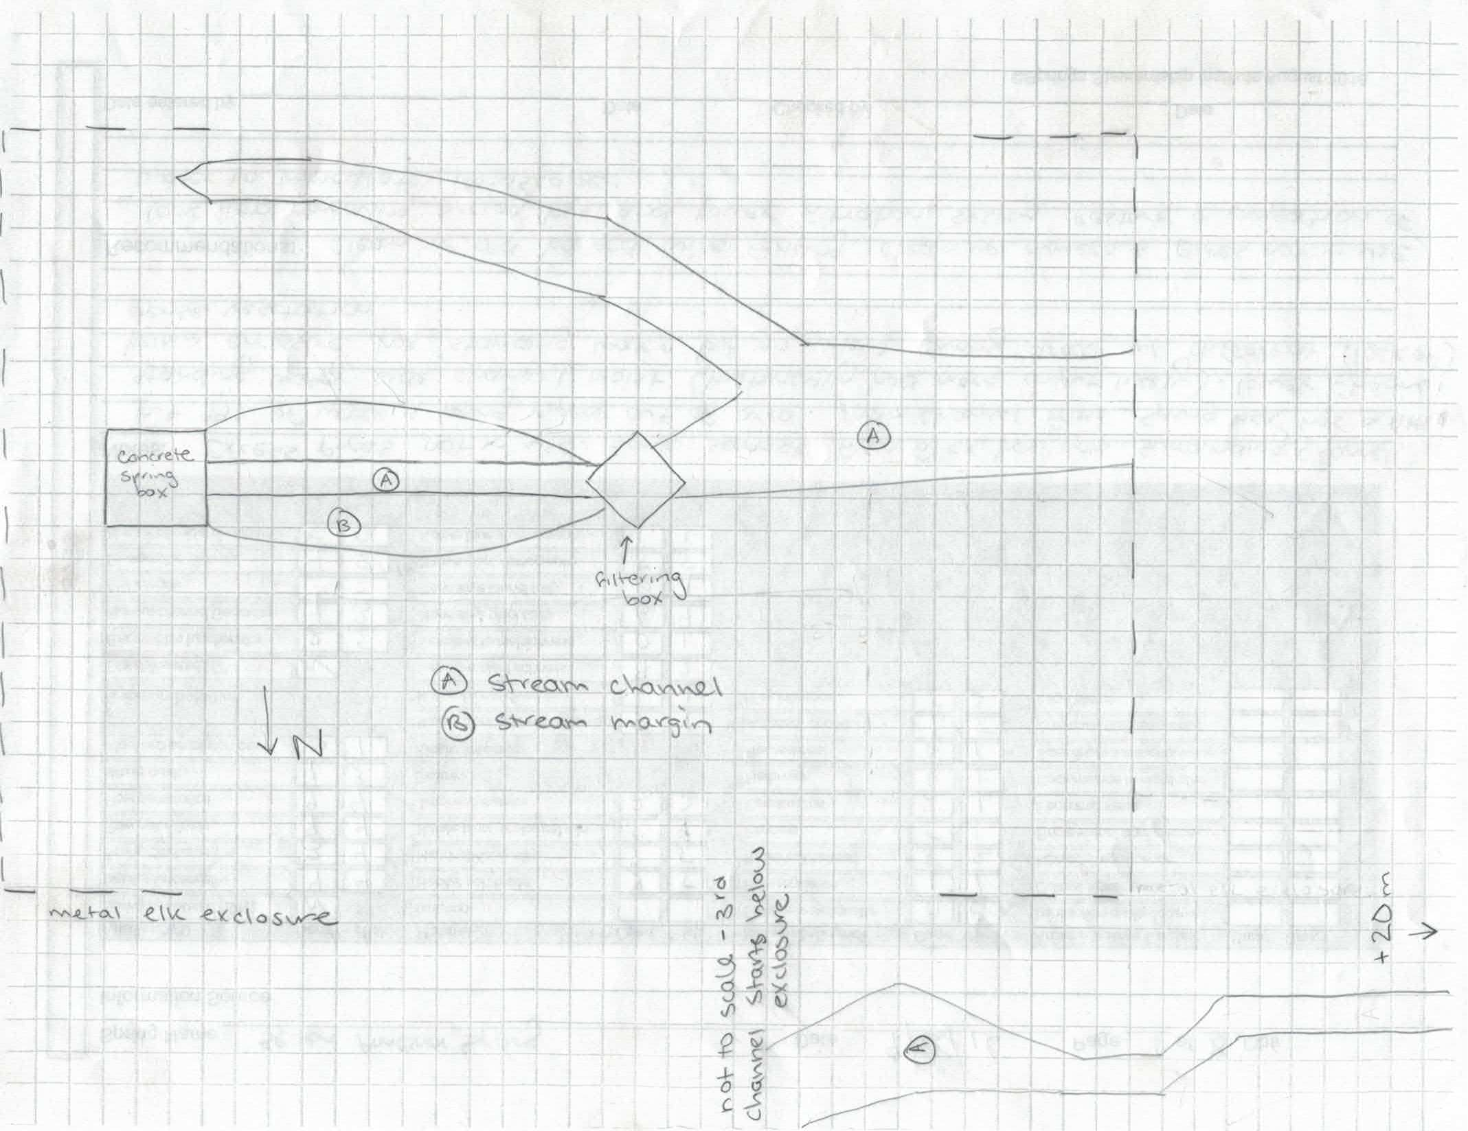
Fig 44.2 Seven Anchor Spring Sketchmap.

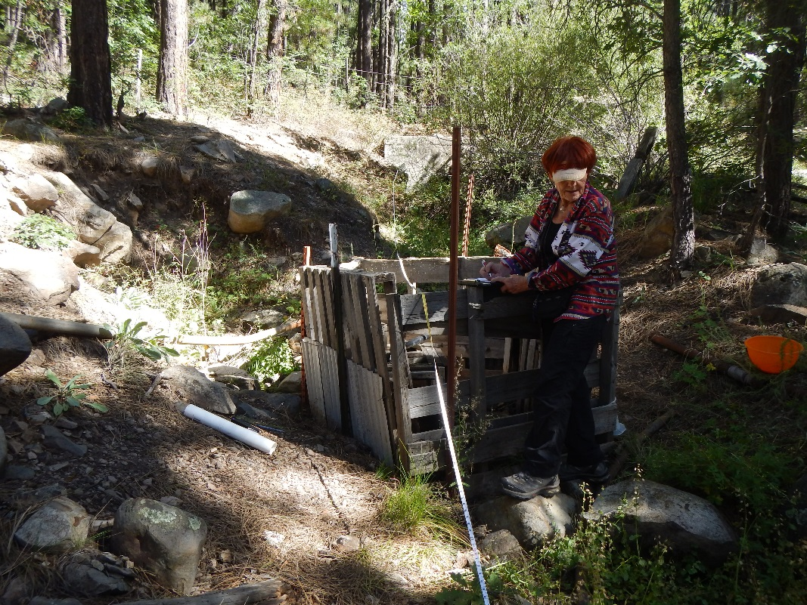
Fig 44.3 Seven Anchor Spring: View upstream towards water filter box

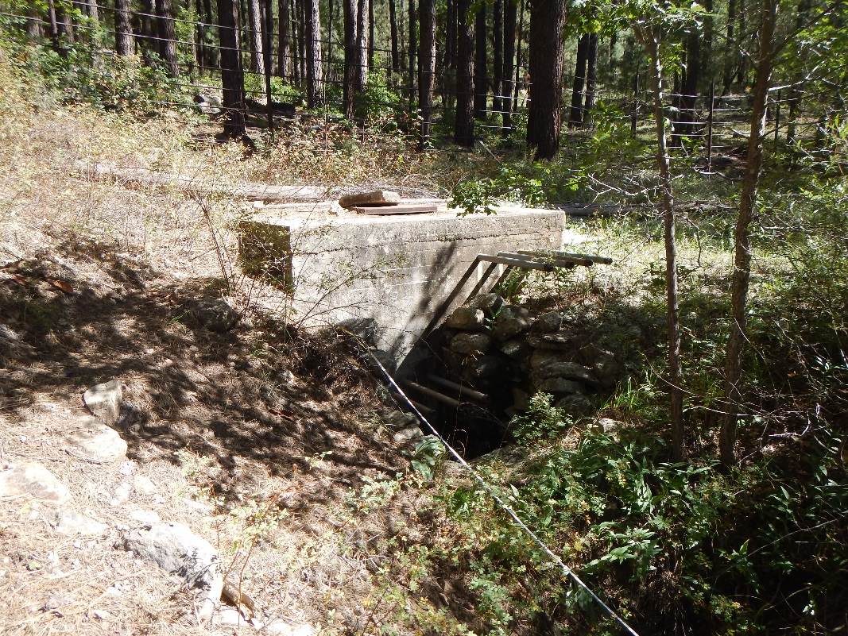
Fig 44.4 Seven Anchor Spring: Concrete source box

45. Sheep Spring
45. Sheep Spring
Survey Summary Report, Site ID 1087
Submitted June 3, 2019 by Springs Stewardship Institute
Location: The Sheep Spring ecosystem is located in Coconino County in the Upper Verde Arizona 15060202 HUC, managed by the US Forest Service. The spring is located in the Coconino NF, Mormon Lake RD, in the Mormon Mountain USGS Quad, at 34.91612, -111.53712 measured using a Map (NAD83). The elevation is approximately 2189 meters. Larry Stevens, Jeri Ledbetter, Gloria Hardwick, Joseph Holway, David Sabata, and Leanne Begay surveyed the site on 10/12/16 for 01:30 hours, beginning at 13:20, and collected data in 10 of 10 categories. This survey was conducted under the NEPA Cleared List project using the Stevens et al. Level 2 protocol.

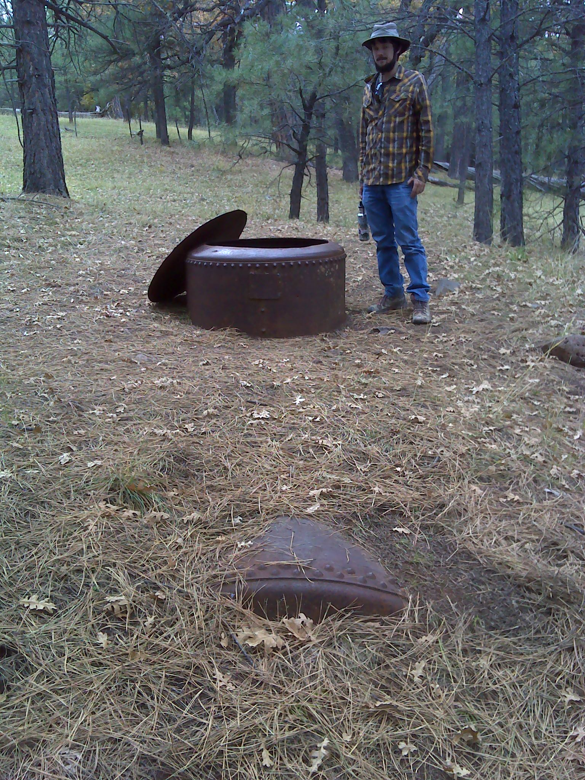
Fig 45.1 Sheep Spring: Source tank contained 1.5 m of water, with audible inflow.

Physical Description: Sheep Spring is a helocrene spring. This site was imported from the SSI geodatabase, a compilation from multiple sources. This spring emerges from a hillslope into a broad meadow. It has been extensively modified, with all flow captured in a constructed tank. Flow emerges from a broken pipe 400 m downslope of the site. The microhabitat associated with the spring covers 150 sqm. The site has 1 microhabitat, A -- a 150 sqm colluvial slope.

Table 45.1 Sheep Spring Microhabitat characteristics.
Code | A
Name | Anthropogenic hillside.
Area sqm | 150
Surface type | CS
Surface subtype | anthro
Slope variability | Low
Aspect TN
Slope degrees | 10
Moisture (scale 1-10) | 2
Water depth cm | 0
Area % open water | 0
Substrate
1 - Clay % | 0
2 - Silt % | 0
3 - Sand % | 10
4 - Fine gravel % | 3
5 - Coarse gravel % | 3
6 - Cobble % | 1
7 - Boulder % | 0
8 - Bedrock % | 0
Organic % | 80
Other % (anthropogenic) | 3
Precipitate % | 0
Litter % | 95
Wood % | 2
Litter Depth (cm) | 2

Geomorphology: The site receives approximately 100% of available solar radiation, with 6969 Mj annually.

Access Directions: From Mormon Lake Rd (CR-90) turn onto NF-90H and travel SW for 2.9 mi. Turn onto NF-219B and continue for 1.6 mi. Turn onto NF-91 and head NW for 1 mile. Spring is 120 m due SW.

Survey Notes: The lid on the tank is effective. There was water in several of the lower troughs. Soil moisture and troughs were likely influenced by recent heavy rain. Flow in the tank was audible and there was water 1.05 m from the top. Barbed wire surrounds a forest/meadow area and some of the troughs. There was much evidence of old logging activity. Water depth was 1.8 m. A four inch metal pipe that was broken was discovered leaking 280 m east southeast of the spring.

Flow: Surveyors measured a flow of 0.4 liters/second, using a timed flow volume capture method. Flow was adjusted for an estimate of 95% of site flow capture. Flow was measured 280m ESE from spring as leakage from a broken 4&quot; steel pipe. This spring is perennial, with a neorefugium persistence.

Water Quality: Surveyors collected water chemistry from inside the historical spring tank.

Table 45.2 Sheep Spring Water Quality with multiple readings averaged.
Characteristic Measured | Average Value | Site Number | Device | Comments
Alkalinity, Total (mg/L) | 116 |  | LaMotte
Dissolved oxygen (field) (mg/L) | 7.52 |  | YSI Multiprobe
Dissolved oxygen (lab) % saturation | 67.6 |  | YSI Multiprobe
pH (field) | 6.96 |  | YSI Multiprobe
Salinity (field) (ppt) | 129 |  | Hanna Combo
Specific conductance (field) (uS/cm) | 370 |  | Hanna Combo | Corrected for temperature.

Flora: Surveyors identified 7 plant species at the site, with 0.0467 species/sqm. These included 5 native and 2 nonnative species.

Table 45.3 Sheep Spring Cover Type.
Cover Type | Species Count | Wetland Species Count
Ground | 5 | 1
Shrub | 1 | 0
Mid-canopy | 1 | 0
Tall canopy | 1 | 0
Basal | 0 | 0
Aquatic | 0 | 0
Non-vascular | 0 | 0

Table 45.4 Sheep Spring Vegetation % Cover in Microhabitats.
Species | Cover Code | Native Status | Wetland Status | Comments | A
Carex subfusca | GC | N | W | 290 m downstream at wet area | 0
Cirsium | GC |  | F |  | 0
Dieteria canescens | GC |  |  |  | 0
Pascopyrum smithii | GC | N | F |  | 0.1
Pinus ponderosa | MC | N | F |  | 10
Pinus ponderosa | TC | N | F |  | 60
Prunella vulgaris | GC | N | F |  | 0
Quercus gambelii | SC | N | F |  | 1

Fauna: Meadow area is grazed and browsed by elk. Surveyors collected or observed 3 terrestrial invertebrates and 8 vertebrate specimens.

Table 45.5 Sheep Spring Invertebrates.
Species | Lifestage | Habitat | Method | Rep# | Count | Species Detail
Coleoptera Tenebrionidae Eleodes longicollis | Ad | T | Spot |  | 1
Lepidoptera Pieridae Colias eurytheme | Ad | T | Spot |  | 2
Odonata Libellulidae Sympetrum | Ad | T | Spot |  | 1

Table 45.6 Sheep Spring Vertebrates.
Vertebrate Species Common Name | Count | Detection | Comments
Elk |  | sign
Domestic Cow |  | sign
Abert's Squirrel | 3 | obs
Common Raven | 1 | call
Steller's Jay | 1 | obs
Pocket Gopher |  | sign
Botta's Pocket Gopher |  | sign
Mule Deer |  | sign

Assessment: Assessment scores were compiled in 5 categories and 31 subcategories, with 11 null condition scores, and 10 null risk scores. Aquifer functionality and water quality are moderate with some restoration potential and there is low risk. Geomorphology condition is very poor with very limited restoration potential and there is high risk. Habitat condition is poor with limited restoration potential and there is moderate risk. Biotic integrity is poor with limited restoration potential and there is high risk. Human influence of site is good with significant restoration potential and there is moderate risk. Administrative context status is undetermined due to null scores and there is undetermined risk due to null scores. Overall, the site condition is poor with limited restoration potential and there is moderate risk.

Table 45.7 Sheep Spring Assessment Scores.
Category | Condition | Risk
Aquifer Functionality & Water Quality | 3.2 | 2
Geomorphology | 1 | 4.6
Habitat | 2.8 | 3.8
Biota | 2.5 | 4.1
Human Influence | 3.9 | 3.2
Administrative Context | 0 | 0
Overall Ecological Score | 2.8 | 3.6

Management Recommendations: The springs have been excavated and likely piped into a likely old train water car that has been buried on the hillside. The water historically was piped 100 m to sheep watering troughs, now dry. Assess the restoration potential of the site, including breaching the tank and allowing the water to flow onto the meadow, re-wetting the meadow surface, and exposing it from grazing.

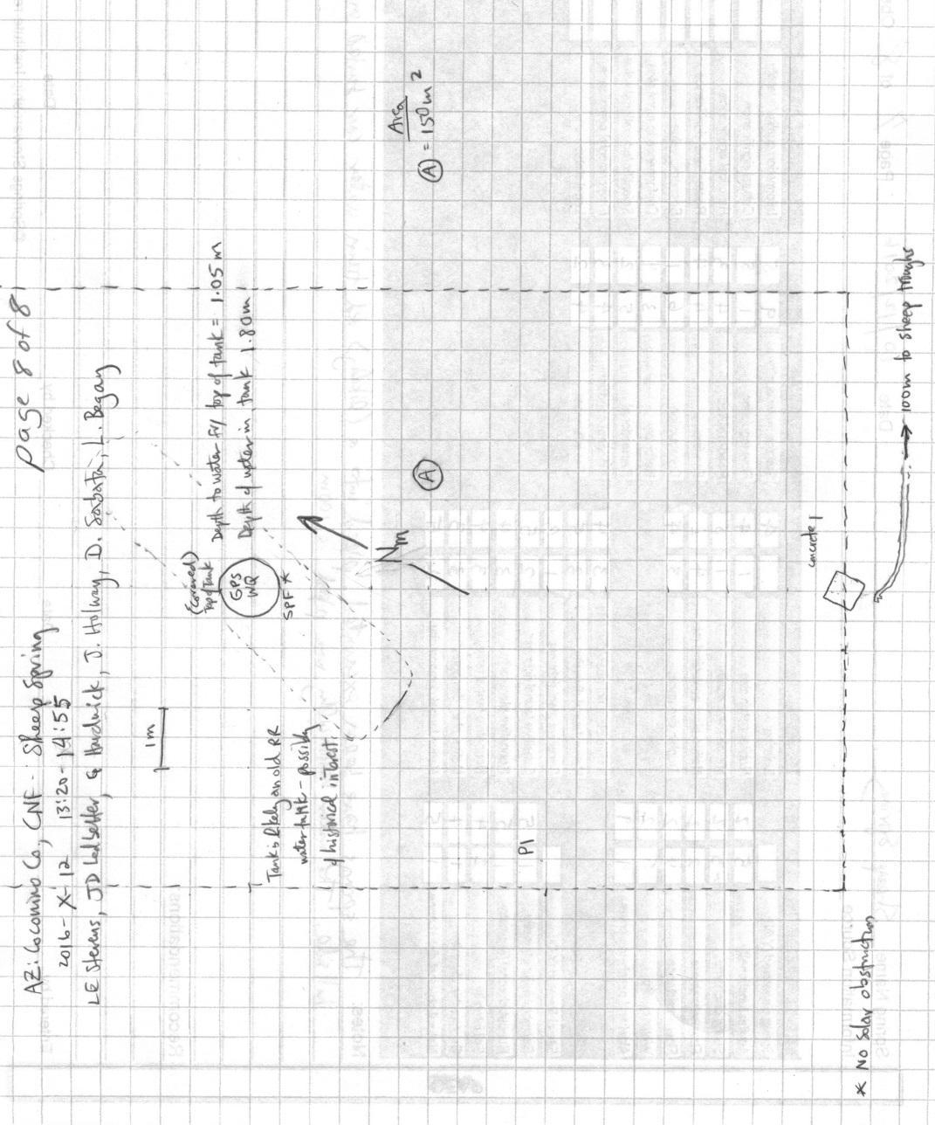
Fig 45.2 Sheep Spring Sketchmap.

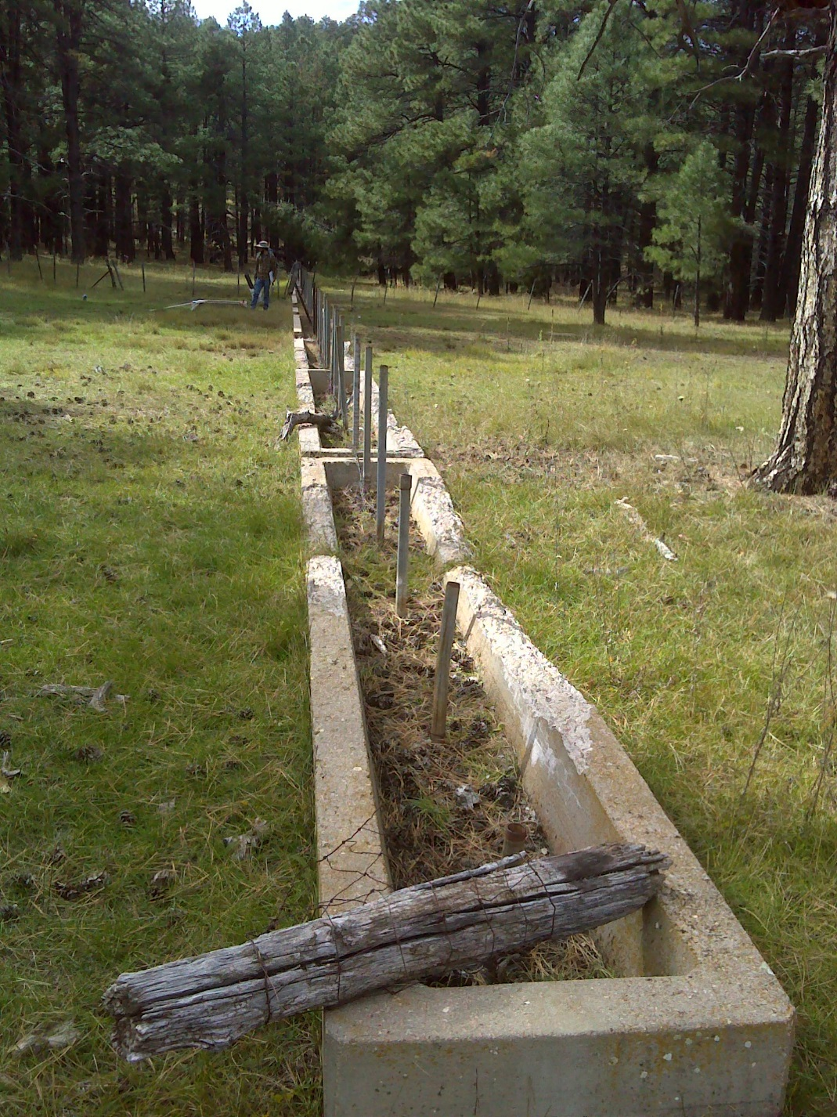
Fig 45.3 Sheep Spring: Troughs at Sheep Spring, 150 m downslope of the source tank.

46. Smith Spring
46. Smith Spring
Survey Summary Report, Site ID 1089
Submitted June 3, 2019 by Springs Stewardship Institute
Location: The Smith Spring ecosystem is located in Coconino County in the Canyon Diablo Arizona 15020015 HUC, managed by the US Forest Service. The spring is located in the Coconino NF, Mormon Lake RD, in the Mormon Lake USGS Quad, at 34.93643, -111.48602 (NAD83, estimated position error 3 meters). The elevation is approximately 2164 meters. Chantel Cook, Sue Ordway, Emily Thompson, and Irene Hamilton surveyed the site on 9/07/16 for 01:20 hours, beginning at 8:40, and collected data in 6 of 10 categories. This survey was conducted under the NEPA Cleared List project using the Stevens et al. Level 2 protocol.

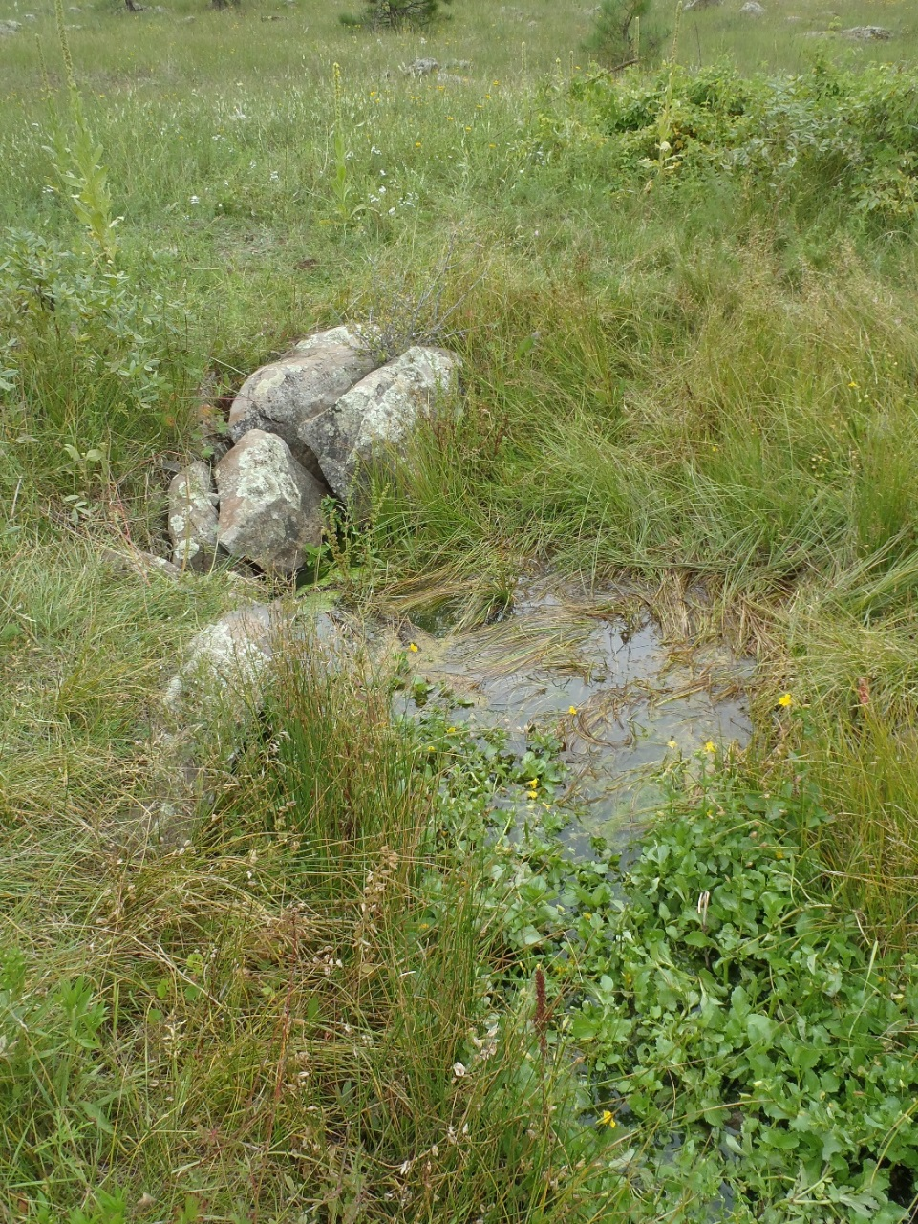
Fig 46.1 Smith Spring: Source

Physical Description: Smith Spring is a rheocrene/helocrene spring. This site was imported from the geodatabase, a compilation from multiple sources. Flow emerges from a source pipe down a channel to a marshy meadow. There is a stone well 30 meters from the source. The microhabitats associated with the spring cover 134.5 sqm. The site has 5 microhabitats, including A -- a 5 sqm pool, B -- a 37 sqm channel, C -- a 29 sqm low gradient cienega, D -- a 5 sqm backwall, E -- a 60 sqm terrace. The geomorphic diversity is 0.55, based on the Shannon-Weiner diversity index.

Table 46.1 Smith Spring Microhabitat characteristics.
Code | A | B | C | D | E
Name | Pool | Channel | Low grade cienega | Backwall | Terrace
Area sqm | 4.5 | 36.5 | 29 | 4.5 | 60
Surface type | P | CH | LGC | BW | TE
Surface subtype
Slope variability | Low | Low | Low | Med | Low
Aspect TN | 10 | 10 | 10 | 10 | 10
Slope degrees | 0 | 6 | 3 | 60 | 3
Moisture (scale 1-10) | 10 | 8 | 6 | 2 | 3
Water depth cm | 25 | 2 | 0 | 0 | 0
Area % open water | 50 | 30 | 0 | 0 | 0
Substrate
1 - Clay % | 0 | 0 | 0 | 0 | 0
2 - Silt % | 0 | 0 | 0 | 0 | 0
3 - Sand % | 0 | 0 | 0 | 0 | 0
4 - Fine gravel % | 0 | 0 | 0 | 0 | 0
5 - Coarse gravel % | 0 | 0 | 0 | 0 | 0
6 - Cobble % | 0 | 0 | 0 | 0 | 0
7 - Boulder % | 0 | 0 | 0 | 0 | 0
8 - Bedrock % | 0 | 0 | 0 | 0 | 0
Organic % | 0 | 0 | 0 | 0 | 0
Other % (anthropogenic) | 0 | 0 | 0 | 0 | 0
Precipitate % | 0 | 0 | 0 | 0 | 0
Litter % | 0 | 0 | 0 | 0 | 0
Wood % | 0 | 0 | 0 | 0 | 0
Litter Depth (cm)

Geomorphology: Smith Spring emerges from an igneous, basalt rock layer in an unknown unit. The emergence environment is subaerial, with a gravity flow force mechanism.

Access Directions: From Lake Mary Rd (CR-3), travel onto Mormon Lake Rd (CR-90) for 5.45 miles. Spring is located 100 m due east.

Survey Notes: There was evidence of herbivory (slight trampling) at the time of the survey. Old piping was scattered around the perimeter, but did not appear to affect any flow. The pipe source mentioned in the 7/14/14 survey could not be located. Vegetation was dense and appeared vigorous.

Flow: Surveyors measured a flow of 0.100 liters/second, using a timed flow volume capture method. Flow was adjusted for an estimate of 100% of site flow capture. Flow was measured 7.5 meters down stream of source in channel. This spring is perennial, with a neorefugium persistence.

Water Quality: Water quality measurements were collected at the source.

Table 46.2 Smith Spring Water Quality with multiple readings averaged.
Characteristic Measured | Average Value | Site Number | Device | Comments
pH (field) | 5.6 |  | DigitalAid meter
Specific conductance (field) (uS/cm) | 152 |  | DigitalAid meter
Temperature, air C | 12.78 |  | candy thermometer
Temperature, water C | 12.78 |  | DigitalAid meter

Fauna: Surveyors collected or observed 6 vertebrate specimens.

Table 46.3 Smith Spring Vertebrates.
Vertebrate Species Common Name | Count | Detection | Comments
Western Bluebird | 6 | obs
Yellow-rumped Warbler | 2 | obs
Grace's Warbler | 1 | obs
Western Wood-Pewee | 1 | obs
Chipping Sparrow | 1 | obs
Plumbeous Vireo | 1 | obs

Assessment: Assessment scores were compiled in 5 categories and 30 subcategories, with 12 null condition scores, and 12 null risk scores. Aquifer functionality and water quality are moderate with some restoration potential and there is low risk. Geomorphology condition is moderate with some restoration potential and there is low risk. Habitat condition is moderate with some restoration potential and there is low risk. Biotic integrity is moderate with some restoration potential and there is low risk. Human influence of site is good with significant restoration potential and there is low risk. Administrative context status is undetermined due to null scores and there is undetermined risk due to null scores. Overall, the site condition is moderate with some restoration potential and there is low risk.

Table 46.4 Smith Spring Assessment Scores.
Category | Condition | Risk
Aquifer Functionality & Water Quality | 3.7 | 2.5
Geomorphology | 3.8 | 2.2
Habitat | 3.8 | 2.2
Biota | 3.8 | 2.8
Human Influence | 4 | 2.6
Administrative Context | 0 | 0
Overall Ecological Score | 3.8 | 2.5

Management Recommendations: Fencing from the road appears to keep people from driving too near and impacting the spring. We recommend considering removing old metal pipe in stream channel (7m from source) and other PVC piping laying around. There is an old well that is a potential hazard to humans and wildlife as it is difficult to see in tall grasses. We also suggest fencing or filling the well in, and removing the moderate mullein infestation.

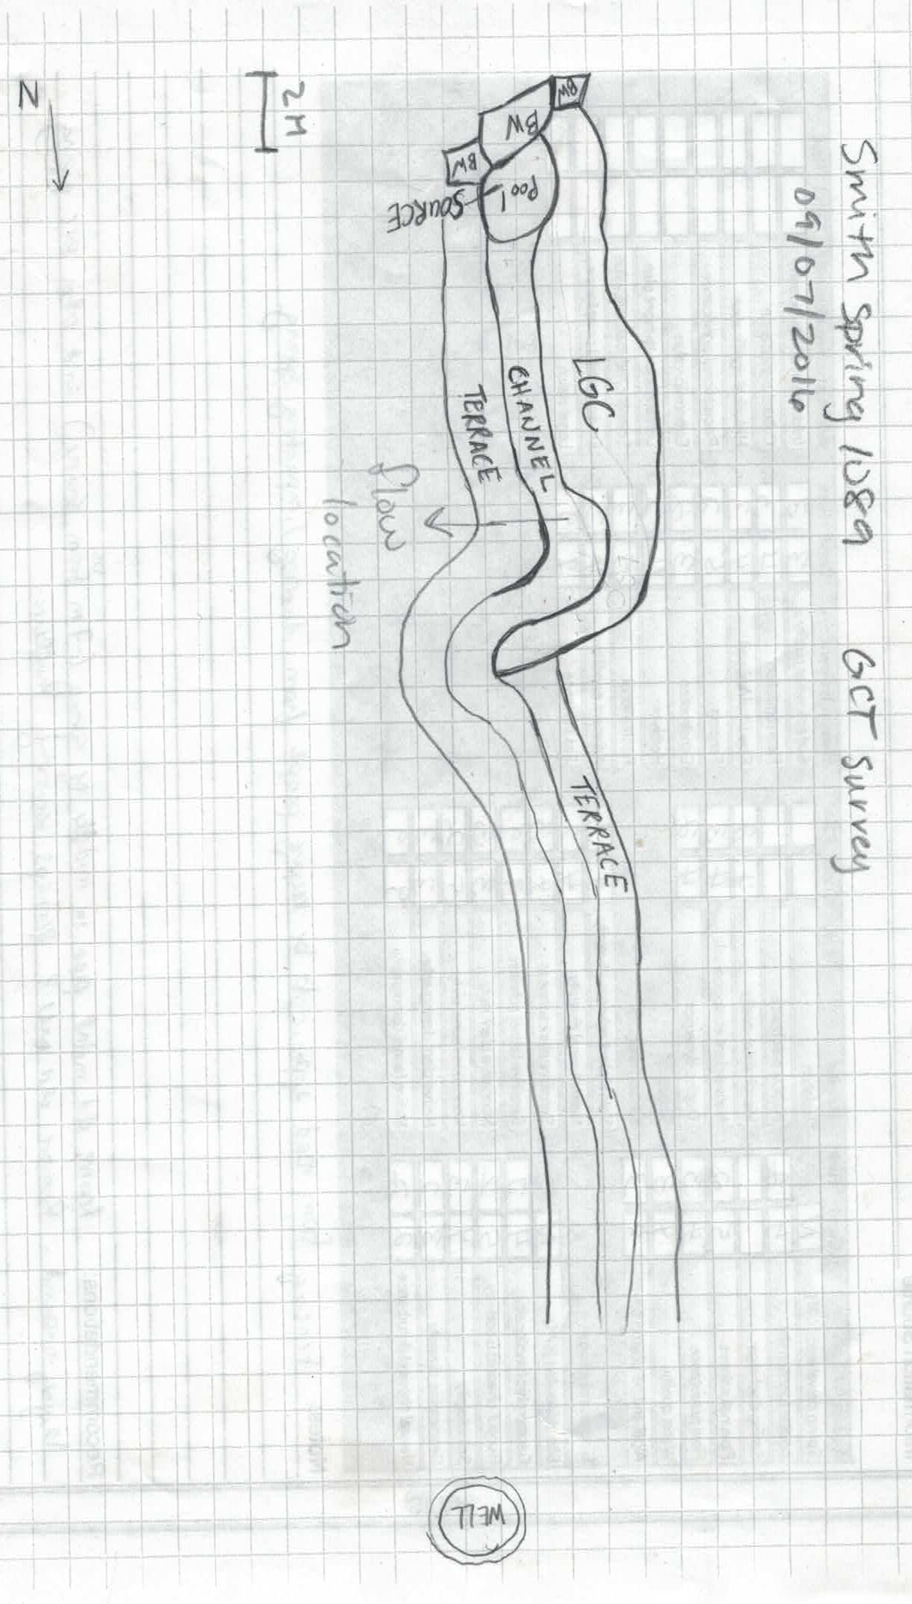
Fig 46.2 Smith Spring Sketchmap.

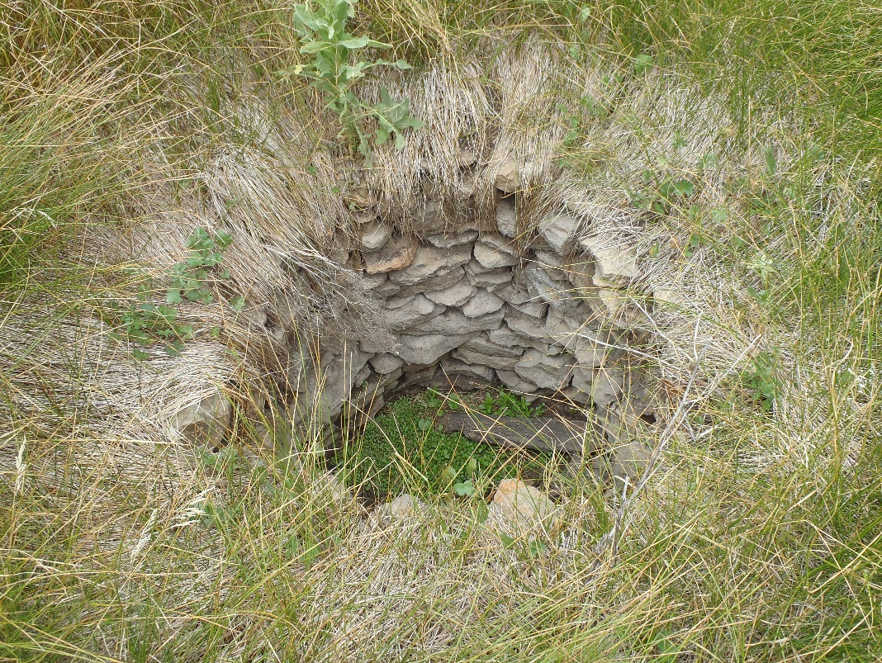
Fig 46.3 Smith Spring: Well

47. Spikerush Spring
47. Spikerush Spring
Survey Summary Report, Site ID 226652
Submitted June 3, 2019 by Springs Stewardship Institute
Location: The Spikerush Spring ecosystem is located in Coconino County in the Middle Little Colorado Arizona 15020008 HUC, managed by the US Forest Service. The spring is located in the Coconino NF, Mogollon Rim RD, in the Dane Canyon USGS Quad, at 34.42360, -111.19143 measured using a GPS (WGS84, estimated position error 4 meters). The elevation is approximately 2321 meters. Jeri Ledbetter, Larry Stevens, Glenn Rink, and Mellisa Yin surveyed the site on 7/08/17 for 01:30 hours, beginning at 12:15, and collected data in 10 of 10 categories. This survey was conducted under the NEPA Cleared List project using the Stevens et al. Level 2 protocol.

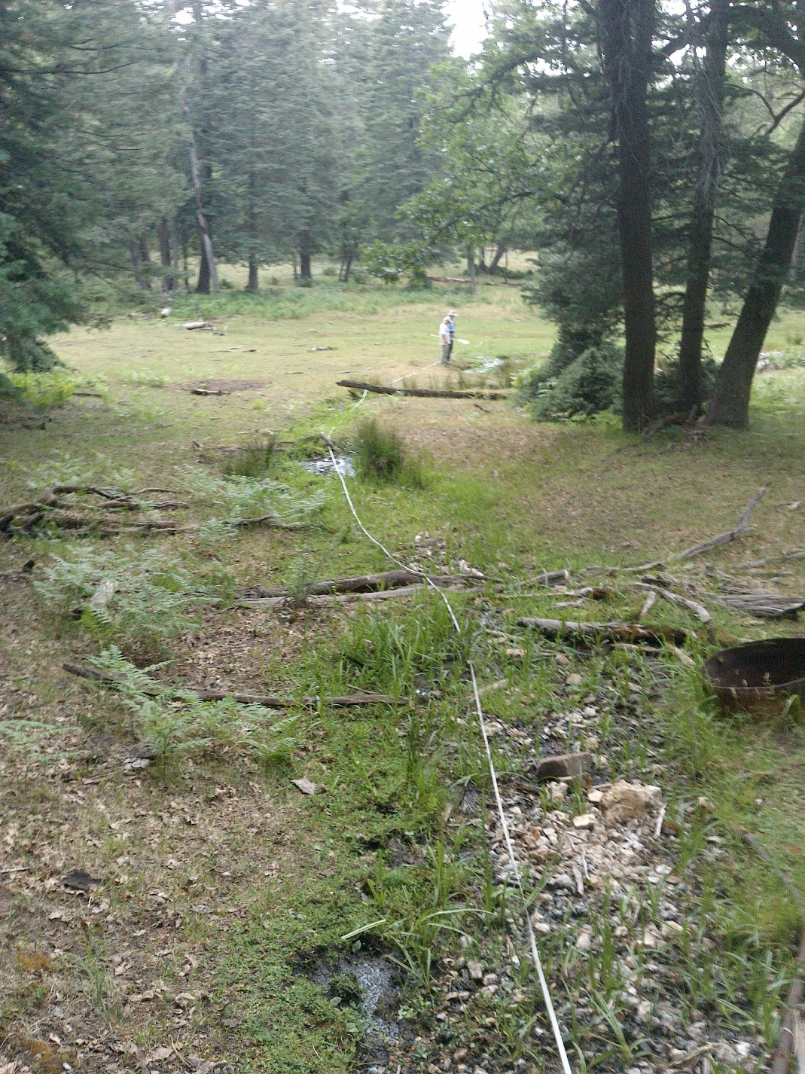
Fig 47.1 Spikerush Spring: Taken at the source, viewing downslope.

Physical Description: Spikerush Spring is a hillslope spring. A SSI survey crew found this site during an unsuccessful search for Turkey Spring. The flow emerges into a shallow, narrow, and rocky channel and flows downslope through two excavated pools into an open meadow. The surrounding area consists of a dense conifer forest. The spring has been developed, excavated, and piped. However, the development is largely dysfunctional. The microhabitats associated with the spring cover 262 sqm. The site has 3 microhabitats, including A -- a 100 sqm channel, B -- a 120 sqm terrace, C -- a 42 sqm pool. The geomorphic diversity is 0.44, based on the Shannon-Weiner diversity index.

Table 47.1 Spikerush Spring Microhabitat characteristics.
Code | A | B | C
Name | Source Channel | Terraces | Excavated Pool
Area sqm | 100 | 120 | 42
Surface type | CH | TE | P
Surface subtype
Slope variability | Low | Low | Low
Aspect TN
Slope degrees | 5 | 5 | 0
Moisture (scale 1-10) | 8 | 4 | 10
Water depth cm | 2 | 0 | 6
Area % open water | 75 | 0 | 90
Substrate
1 - Clay % | 8 | 20 | 20
2 - Silt % | 8 | 10 | 10
3 - Sand % | 8 | 10 | 10
4 - Fine gravel % | 40 | 15 | 2
5 - Coarse gravel % | 10 | 10 | 2
6 - Cobble % | 0 | 0 | 0
7 - Boulder % | 0 | 0 | 0
8 - Bedrock % | 0 | 0 | 0
Organic % | 24 | 33 | 56
Other % (anthropogenic) | 2 | 2 | 0
Precipitate % | 0 | 0 | 0
Litter % | 5 | 15 | 15
Wood % | 10 | 10 | 1
Litter Depth (cm) | 0.5 | 1 | 1

Geomorphology: Spikerush Spring emerges as a contact spring from the Kaibab Limestone, a sedimentary, limestone rock layer. The emergence environment is subaerial, with a gravity flow force mechanism.

Survey Notes: The lower, less rocky section of the channel has cutbanks due to elk trampling, and the excavated pond is also heavily trampled. The area is heavily grazed by elk, with stunted trees from severe ungulate browsing. The piping is non-functional and the trough is destroyed. Surveyors found abundant aquatic invertebrate life, and a relatively high bird diversity. The survey crew completed flow, water chemistry, and soils inventory prior to a heavy rainstorm.

Flow: Surveyors measured a flow of 0.033 liters/second, using a timed flow volume capture method. Flow was adjusted for an estimate of 90% of site flow capture. Surveyors measured flow 25 meters below the uppermost source.

Water Quality: Surveyors measured water chemistry at the first emergence of the spring. The YSI and Hanna Combo were calibrated 7/8/2017, prior to use. Location 1: at the spring source in flowing water at 00:00:00.

Table 47.2 Spikerush Spring Water Quality with multiple readings averaged.
Characteristic Measured | Average Value | Site Number | Device | Comments
Alkalinity, Total (mg/L) | 123 | 1 | LaMotte
Dissolved oxygen (field) % saturation | 36.8 | 1 | YSI Multiprobe
Dissolved oxygen (field) (mg/L) | 3.53 | 1 | YSI Multiprobe
pH (field) | 7.63 | 1 | YSI Multiprobe
Salinity (field) (ppt) | 0.209 | 1 | Hanna Combo
Specific conductance (field) (uS/cm) | 487 | 1 | Hanna Combo | Adjusted for temp from 415 EC
Temperature, air C | 25 |  | Handheld therm
Temperature, water C | 17.6 | 1 | YSI Multiprobe

Flora: Glenn Rink was the botanist for this survey. Surveyors identified 27 plant species at the site, with 0.1031 species/sqm. These included 19 native and 8 nonnative species.

Table 47.3 Spikerush Spring Cover Type.
Cover Type | Species Count | Wetland Species Count
Ground | 20 | 13
Shrub | 0 | 0
Mid-canopy | 0 | 0
Tall canopy | 0 | 0
Basal | 0 | 0
Aquatic | 7 | 7
Non-vascular | 0 | 0

Table 47.4 Spikerush Spring Vegetation % Cover in Microhabitats.
Species | Cover Code | Native Status | Wetland Status | Comments | A | B | C
algae | AQ | N | A |  | 0 | 0 | 12
Callitriche | AQ |  | A |  | 0 | 0 | 2
Carex microptera | GC | N | W |  | 2 | 1 | 0
Carex pachystachya | GC | N | W |  | 2 | 2 | 0
Carex pellita | GC | N | W |  | 0.01 | 0.02 | 0
Carex stipata | AQ | N | W |  | 0.1 | 0 | 0
Cerastium | GC |  | WR | #14770 | 0.1 | 0.1 | 0
Dactylis glomerata | GC | I | W |  | 0 | 0.1 | 0
Eleocharis | AQ | N | W | #14786 | 0.05 | 0 | 20
Epilobium ciliatum | GC | N | W |  | 0.02 | 0.03 | 0
Geranium caespitosum | GC | N | F |  | 0 | 2 | 0
Juncus laccatus | GC | N | W |  | 15 | 5 | 6
Juncus saximontanus | AQ | N | W |  | 1 | 0 | 0
Medicago lupulina | GC | I | WR |  | 0 | 50 | 0
Perideridia | GC |  | U |  | 0 | 0.2 | 0
Plantago major | GC | I | WR |  | 1 | 1 | 0
Poa pratensis | GC | NI | F |  | 2 | 1 | 0
Polygonum | GC | N | WR | Douglasii or sawatchense #14786 | 0 | 1 | 0
Polygonum aviculare | GC | I | W |  | 0 | 0.1 | 0
Polygonum douglasii | GC | N | W |  | 0.01 | 0 | 0
Scirpus microcarpus | AQ | N | W |  | 8 | 0 | 0
Taraxacum officinale | GC | NI | F |  | 0 | 0.1 | 0
Trifolium longipes | GC | N |  |  | 1 | 5 | 0
Trifolium repens | GC | I | WR |  | 0 | 2 | 0
unknown moss | GC | N | F |  | 0.5 | 0 | 0
Veronica americana | AQ | N | A |  | 2 | 0 | 15
Viola | GC | N | F |  | 0 | 0.1 | 0

Fauna: Surveyors collected or observed 9 aquatic and 5 terrestrial invertebrates and 5 vertebrate specimens.

Table 47.5 Spikerush Spring Invertebrates.
Species | Lifestage | Habitat | Method | Rep# | Count | Species Detail
Coleoptera Dytiscidae Agabus | Ad | A | Spot |  | 2
Coleoptera Gyrinidae Gyrinus plicifer | Ad | A | Spot
Coleoptera Hydraenidae | Ad | A |  |  | 1
Coleoptera Scirtidae | L | A | Spot |  | 1
Diptera Dolichopodidae | Ad | T | Spot |  | 2
Diptera Sepsidae | Ad | T | Spot |  | 3
Diptera Stratiomyidae | L | A | Spot |  | 2
Gordioidea | Ad | A | Spot |  | 1
Hemiptera Gerridae Aquarius remigis | Ad | A |  |  | 6 | Some larvae observed as well.
Hemiptera Pentatomidae | Ad | T | Spot |  | 1
Lepidoptera Nymphalidae Speyeria hesperis | Ad | T | Spot
Odonata Coenagrionidae | Ad | T | Spot |  | 2
Plecoptera Chloroperlidae | M | A | Spot |  |  | Larvae and adults observed.
Trichoptera |  |  |  |  |  | Unknown #1
Trichoptera |  |  |  |  |  | Unknown #2
Trichoptera Limnephilidae | L | A | Spot |  | 1

Table 47.6 Spikerush Spring Vertebrates.
Vertebrate Species Common Name | Count | Detection | Comments
Hermit Thrush |  | call
Terrestrial Gartersnake |  | obs
Red-breasted Nuthatch |  | call
White-breasted Nuthatch |  | call
Elk |  | sign | Scat and browsing observed.

Assessment: Assessment scores were compiled in 5 categories and 33 subcategories, with 9 null condition scores, and 9 null risk scores. Aquifer functionality and water quality are good with significant restoration potential and there is negligible risk. Geomorphology condition is moderate with some restoration potential and there is moderate risk. Habitat condition is good with significant restoration potential and there is low risk. Biotic integrity is good with significant restoration potential and there is moderate risk. Human influence of site is good with significant restoration potential and there is low risk. Administrative context status is undetermined due to null scores and there is undetermined risk due to null scores. Overall, the site condition is good with significant restoration potential and there is low risk.

Table 47.7 Spikerush Spring Assessment Scores.
Category | Condition | Risk
Aquifer Functionality & Water Quality | 4 | 1.7
Geomorphology | 3.6 | 3
Habitat | 4 | 2.8
Biota | 4.1 | 3
Human Influence | 4 | 2.8
Administrative Context | 0 | 0
Overall Ecological Score | 3.9 | 2.7

Management Recommendations: This site is a good candidate for management action, with a relatively high ecological condition but high risk from human impacts. First, conduct a land survey to develop an on-site map for planning and monitoring purposes. Then remove, and replace if needed, flow diversion piping and berming. Then re-contour the lower channel to expand the helocrene, fence the site, and make sure to guarantee access to water for wildlife. Monitoring and protecting the flow and habitat areas are vital. Additionally, monitoring and protecting Eleocharis, stonefly, and caddisfly populations are important.

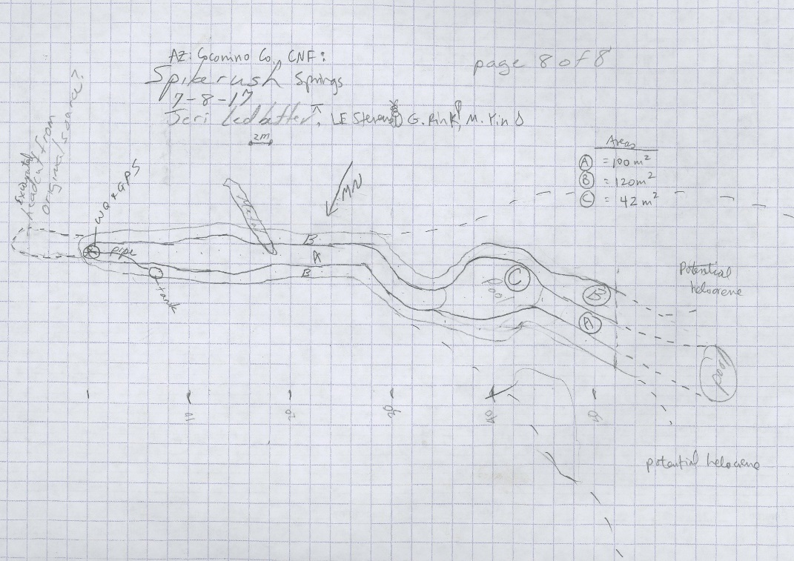
Fig 47.2 Spikerush Spring Sketchmap.

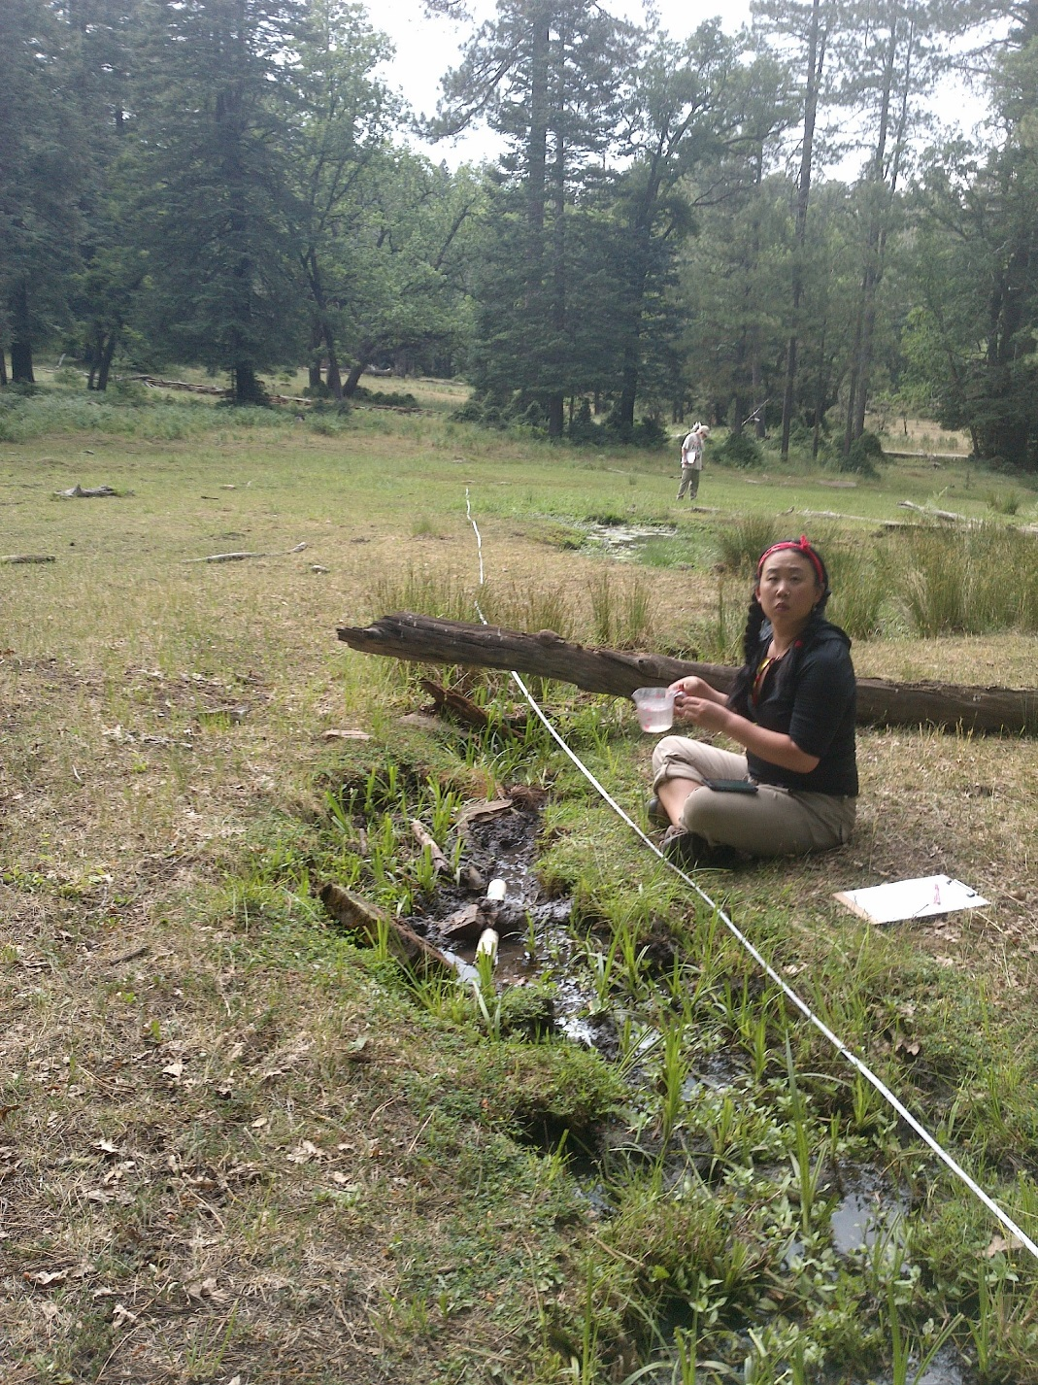
Fig 47.3 Spikerush Spring: Flow measurement location at the site.

48. Spitz Spring lower
48. Spitz Spring lower
Survey Summary Report, Site ID 770
Submitted June 3, 2019 by Springs Stewardship Institute
Location: The Spitz Spring lower ecosystem is located in Coconino County in the Upper Verde Arizona 15060202 HUC, managed by the US Forest Service. The spring is located in the Kaibab NF, Williams RD, in the Parks USGS Quad, at 35.26033, -111.97510 measured using a GPS (WGS84). The elevation is approximately 2136 meters. John Moeny, Tierney Schipper, Susan Ossim, Emile Sawyer, and Larry Stevens surveyed the site on 6/11/18 for 00:57 hours, beginning at 14:55, and collected data in 8 of 10 categories. This survey was conducted under the NEPA Cleared List project using the Stevens et al. Level 2 protocol.

Physical Description: Spitz Spring lower is a helocrene/anthropogenic spring. This spring is the lower of two named springs depicted on the DRG, and included in the AZ State Land Office layer. The spring was a wet meadow where a concrete stock tank (dry) was constructed to collect water. The site has 2 microhabitats, including A -- a 3 sqm other, B -- a 79 sqm low gradient cienega.

Table 48.1 Spitz Spring lower Microhabitat characteristics.
Code | A | B
Name | Concrete Tank | Wet meadow
Area sqm | 3 | 79
Surface type | OTH | LGC
Surface subtype | anthro
Slope variability | Low | Low
Aspect TN |  | 179
Slope degrees | 0 | 3
Moisture (scale 1-10) | 10 | 8
Water depth cm | 45 | 3
Area % open water | 90 | 2
Substrate
1 - Clay % | 0 | 10
2 - Silt % | 0 | 30
3 - Sand % | 0 | 0
4 - Fine gravel % | 0 | 0
5 - Coarse gravel % | 0 | 0
6 - Cobble % | 0 | 0.5
7 - Boulder % | 0 | 0
8 - Bedrock % | 0 | 0
Organic % | 90 | 59.5
Other % (anthropogenic) | 10 | 0
Precipitate % | 0 | 0
Litter % | 5 | 5
Wood % | 0 | 15
Litter Depth (cm) | 1 | 3

Geomorphology: Spitz Spring lower emerges as a contact spring from an igneous, rhyolite rock layer in an unknown unit. The emergence environment is subaerial, with a gravity flow force mechanism. The site receives approximately 100% of available solar radiation, with 6838 Mj annually.

Access Directions: From exit 178 on I-40, travel west onto Brannigan Park Rd and continue on E Old Highway 66 for 2.1 miles. Turn onto N Spitz Spring Rd.

Survey Notes: Dry, drought-stressed forest with sunny and warm conditions during the survey. Wind-thrown ponderosa pine in microhabitat B at approximately 13 meters on the survey tape. Soil trampling and plant pedestalling in microhabitat B.

Flow: Surveyors measured a flow of 0.0027 liters/second, using a timed flow volume capture method. Flow was adjusted for an estimate of 100% of site flow capture. Flow was measured at outflow of concrete tank, discharge gathered at pipe. This spring is perennial.

Water Quality: There was a stagnant tank water with mixed inflow. The water quality was collected at the concrete tank. Location 1: at another location in other at 15:00:00.

Table 48.2 Spitz Spring lower Water Quality with multiple readings averaged.
Characteristic Measured | Average Value | Site Number | Device | Comments
Alkalinity, Total (mg/L) | 80 | 1 | LaMotte
Dissolved oxygen (field) (mg/L) | 12 | 1 | CHEMets DO kit
pH (field) | 6.08 | 1 | Hanna Combo
Specific conductance (field) (uS/cm) | 172 | 1 | Hanna Combo
Temperature, water C | 21.2 | 1 | Hanna Combo

Flora: Surveyors identified 11 plant species at the site, with 0.1341 species/sqm. These included 8 native and 3 nonnative species.

Table 48.3 Spitz Spring lower Cover Type.
Cover Type | Species Count | Wetland Species Count
Ground | 10 | 5
Shrub | 0 | 0
Mid-canopy | 0 | 0
Tall canopy | 0 | 0
Basal | 0 | 0
Aquatic | 1 | 0
Non-vascular | 0 | 0

Table 48.4 Spitz Spring lower Vegetation % Cover in Microhabitats.
Species | Cover Code | Native Status | Wetland Status | Comments | A | B
Agrostis | GC | I | W |  | 0 | 3
Bouteloua gracilis | GC | N | U |  | 0 | 1
Carex praegracilis | GC | N | W |  | 0 | 7
Cladophora | AQ |  |  |  | 95 | 0
Eleocharis | GC | N | W |  | 0 | 12
Elymus elymoides | GC | N | F |  | 0 | 0.01
Hordeum | GC |  | WR |  | 0 | 3
Iris missouriensis | GC | N | F |  | 0 | 5
Mimulus | GC | N | W |  | 0 | 3
Poa pratensis | GC | NI | F |  | 0 | 66
Rumex | GC | NI | F |  | 0 | 0.1

Fauna: Surveyors collected or observed 2 terrestrial invertebrates and 5 vertebrate specimens.

Table 48.5 Spitz Spring lower Invertebrates.
Species | Lifestage | Habitat | Method | Rep# | Count | Species Detail
Diptera Tabanidae Tabanus fulvicallus | Ad |  |  |  | 5
Lepidoptera | Ad | T |  |  | 6
Odonata Libellulidae Libellula saturata | Ad |  |  |  | 1
Orthoptera Acrididae | Ad | T |  |  | 5

Table 48.6 Spitz Spring lower Vertebrates.
Vertebrate Species Common Name | Count | Detection | Comments
Elk
Deer
Red-winged Blackbird
Steller's Jay
Western Tanager

Assessment: Assessment scores were compiled in 5 categories and 28 subcategories, with 14 null condition scores, and 9 null risk scores. Aquifer functionality and water quality are moderate with some restoration potential and there is low risk. Geomorphology condition is poor with limited restoration potential and there is moderate risk. Habitat condition is moderate with some restoration potential and there is moderate risk. Biotic integrity is moderate with some restoration potential and there is moderate risk. Human influence of site is moderate with some restoration potential and there is moderate risk. Administrative context status is undetermined due to null scores and there is undetermined risk due to null scores. Overall, the site condition is moderate with some restoration potential and there is moderate risk.

Table 48.7 Spitz Spring lower Assessment Scores.
Category | Condition | Risk
Aquifer Functionality & Water Quality | 3.3 | 2.8
Geomorphology | 2.3 | 3.8
Habitat | 3.3 | 3
Biota | 3.3 | 3
Human Influence | 3.7 | 3
Administrative Context | 0 | 0
Overall Ecological Score | 3.3 | 3.1

Management Recommendations: Occasional monitoring can help determine the climate sensitivity and reproductive quality of the springs ecosystem.

49. Spitz Spring upper
49. Spitz Spring upper
Survey Summary Report, Site ID 771
Submitted June 3, 2019 by Springs Stewardship Institute
Location: The Spitz Spring upper ecosystem is located in Coconino County in the Upper Verde Arizona 15060202 HUC, managed by the US Forest Service. The spring is located in the Kaibab NF, Williams RD, in the Parks USGS Quad, at 35.26135, -111.97436 measured using a map (NAD83). The elevation is approximately 2130 meters. Kyle Paffett and Vera Markgraf surveyed the site on 6/02/12 for 01:00 hours, beginning at 11:00, and collected data in 6 of 10 categories. This survey was conducted under the NEPA Cleared List project using the Stevens et al. Level 2 protocol.

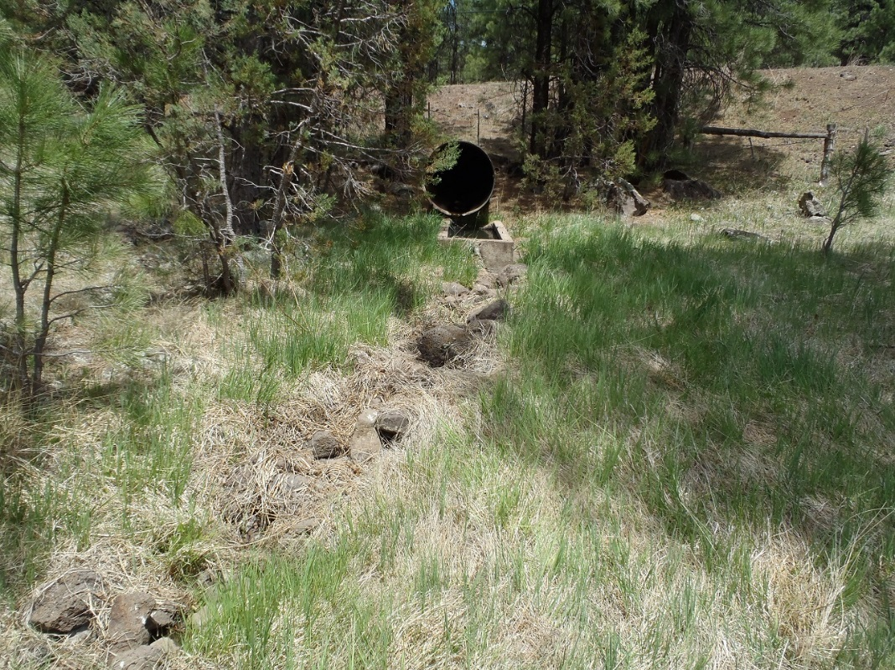
Fig 49.1 Spitz Spring upper: View of site

Physical Description: Spitz Spring upper is an anthropogenic spring. This spring is the lower of two named springs depicted on the DRG, and included in the AZ State Land Office layer. Spring source has been covered by a paved two lane state road. Culvert diverts spring discharge from under road to stock tank about 5 meters from road.

Table 49.1 Spitz Spring upper Microhabitat characteristics.
Code | X
Name | Entire Site
Area sqm
Surface type
Surface subtype
Slope variability
Aspect TN
Slope degrees
Moisture (scale 1-10)
Water depth cm
Area % open water
Substrate
1 - Clay % | 0
2 - Silt % | 0
3 - Sand % | 0
4 - Fine gravel % | 0
5 - Coarse gravel % | 0
6 - Cobble % | 0
7 - Boulder % | 0
8 - Bedrock % | 0
Organic % | 0
Other % (anthropogenic) | 0
Precipitate % | 0
Litter % | 0
Wood % | 0
Litter Depth (cm)

Geomorphology: Spitz Spring upper emerges as a fracture spring from an igneous, basalt rock layer in an unknown unit. The emergence environment is cave, with a gravity flow force mechanism.

Access Directions: From exit 178 on I-40, travel west onto Brannigan Park Rd and continue on E Old Highway 66 for 2.1 miles. Turn onto N Spitz Spring Rd.

Flow: Surveyors measured a flow of 0.05 liters/second, using a timed flow volume capture method. Flow was adjusted for an estimate of 1.00% of site flow capture. Flow was measured from culvert diverting spring discharge from under the road. This spring is perennial.

Water Quality: Measurements were taken from the concrete stock tank.

Table 49.2 Spitz Spring upper Water Quality with multiple readings averaged.
Characteristic Measured | Average Value | Site Number | Device | Comments
Dissolved oxygen (field) (mg/L) | 10.2 |  | YSI Multiprobe
Oxygen Reduction Potential in mV | 286.2 |  | YSI Multiprobe
pH (field) | 7.85 |  | YSI Multiprobe
Specific conductance (field) (uS/cm) | 140.8 |  | YSI Multiprobe

Flora: Pinus Ponderosa woodlands. Vera Markgraf was the botanist; the ID numbers from the Deaver NAU herbarium. Surveyors identified 9 plant species at the site. These included 7 native and 2 nonnative species.

Table 49.3 Spitz Spring upper Cover Type.
Cover Type | Species Count | Wetland Species Count
Ground | 6 | 4
Shrub | 0 | 0
Mid-canopy | 0 | 0
Tall canopy | 0 | 0
Basal | 0 | 0
Aquatic | 0 | 0
Non-vascular | 0 | 0

Table 49.4 Spitz Spring upper Vegetation % Cover in Microhabitats.
Species | Cover Code | Native Status | Wetland Status | Comments | X
Carex microptera | GC | N | W
Carex subfusca |  | N | W | VM 182, 181
Carex vallicola |  | N | W | VM 118
Eleocharis palustris |  | N | W | VM 117
Iris missouriensis | GC | N | F
Juncus ensifolius | GC | N | W
Poa pratensis | GC | I | F
Rumex crispus | GC | I | WR
Sidalcea neomexicana | GC | N | WR

Assessment: Assessment scores were compiled in 6 categories and 42 subcategories, with 0 null condition scores, and 1 null risk score. Aquifer functionality and water quality are good with significant restoration potential and there is low risk. Geomorphology condition is moderate with some restoration potential and there is low risk. Habitat condition is moderate with some restoration potential and there is low risk. Biotic integrity is poor with limited restoration potential and there is low risk. Human influence of site is good with significant restoration potential and there is low risk. Administrative context status is poor with limited restoration potential and there is moderate risk. Overall, the site condition is moderate with some restoration potential and there is low risk.

Table 49.5 Spitz Spring upper Assessment Scores.
Category | Condition | Risk
Aquifer Functionality & Water Quality | 4.17 | 2
Geomorphology | 3.4 | 2.2
Habitat | 3.4 | 2.25
Biota | 2.38 | 2.38
Human Influence | 3.88 | 2.14
Administrative Context | 2.78 | 2.89
Overall Ecological Score | 3.34 | 2.21

Management Recommendations: Remove concrete stock tanks from the site.

50. Stewart Spring
50. Stewart Spring
Survey Summary Report, Site ID 781
Submitted June 3, 2019 by Springs Stewardship Institute
Location: The Stewart Spring ecosystem is located in Coconino County in the Upper Verde Arizona 15060202 HUC, managed by the US Forest Service. The spring is located in the Kaibab NF, Williams RD, in the May Tank Pocket USGS Quad, at 35.10703, -112.15789 measured using a GPS (NAD83, estimated position error 3 meters). The elevation is approximately 2135 meters. Stasia Begley and Volunteers surveyed the site on 5/26/16, and collected data in 5 of 10 categories. This survey was conducted under the NEPA Cleared List project using the Stevens et al. Level 1 protocol.

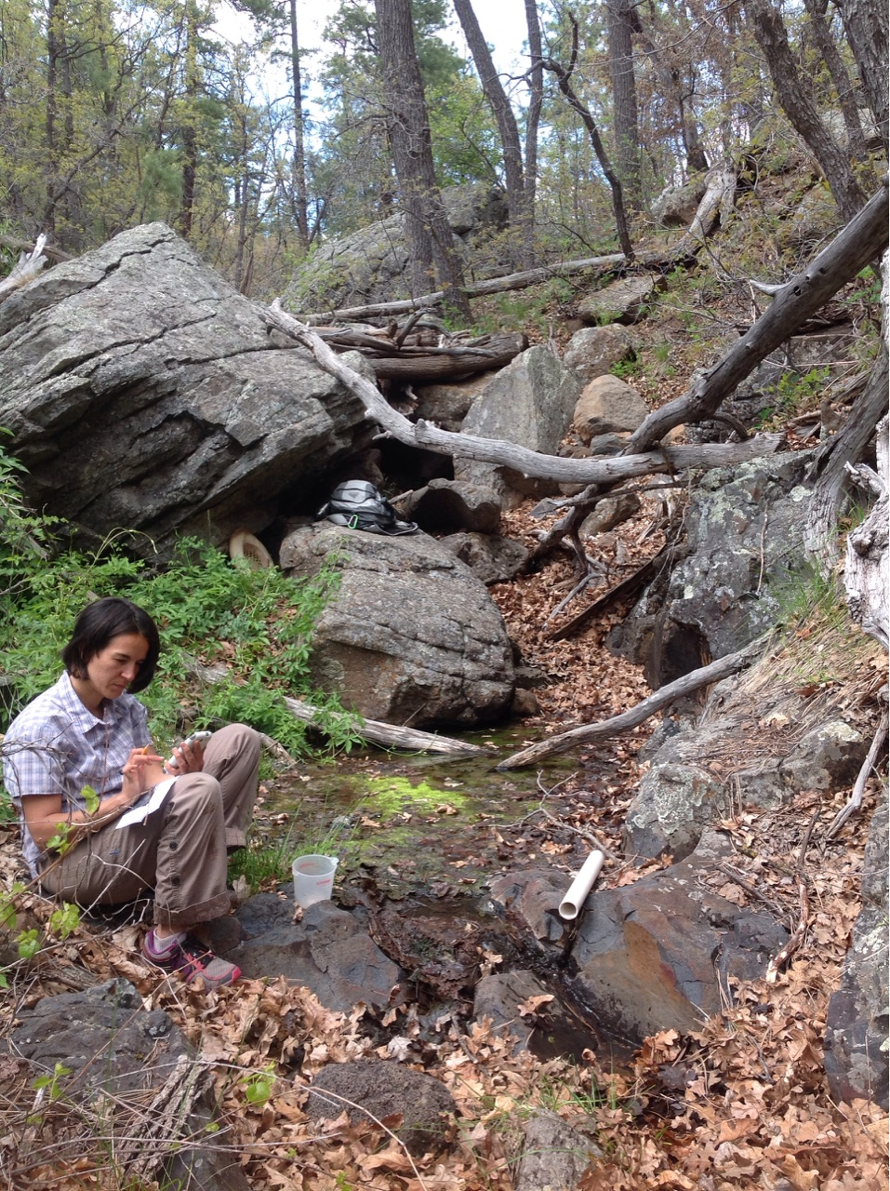
Fig 50.1 Stewart Spring: View of site

Physical Description: Stewart Spring is a rheocrene/hillslope spring. This named spring is depicted on the DRG, and was included in the AZ State Land Office shapefile. The spring discharges from a hillside into a main drainage channel. Two separate seeps are present.

Geomorphology: Stewart Spring emerges as a fracture spring from an igneous, basalt rock layer in an unknown unit. The emergence environment is subaerial, with a gravity flow force mechanism.

Access Directions: From S Perkinsville Rd (CR-73), turn onto NF-354 and travel south for 1 mi to NF-57. Continue on NF-57 for 1.2 miles keeping south. Spring is located 180 m due SE in the drainage.

Survey Notes: The actual coordinates were different from the published location. This spring was previously reported as a hillslope, but surveyors described it as a rheocrene.

Flow: Surveyors measured a flow of 0.021 liters/second, using a timed flow volume capture method. Volumetric flow measurement taken 3 m from source.

Table 50.1 Stewart Spring Water Quality with multiple readings averaged.
Characteristic Measured | Average Value | Site Number | Device | Comments
pH (field) | 6.43 |  | YSI
Specific conductance (field) (uS/cm) | 160 |  | YSI | EC 114 adj for temp
Temperature, water C | 10.7 |  | YSI

Fauna: Surveyors collected or observed 2 vertebrate specimens.

Table 50.2 Stewart Spring Vertebrates.
Vertebrate Species Common Name | Count | Detection | Comments
Steller's Jay | 1 | obs
Canyon Wren |  | call

Assessment: Assessment scores were compiled in 4 categories and 0 subcategories, with 42 null condition scores, and 42 null risk scores. Aquifer functionality and water quality are undetermined due to null scores and there is undetermined risk due to null scores. Geomorphology condition is excellent with no need for restoration and there is undetermined risk due to null scores. Habitat condition is excellent with no need for restoration and there is undetermined risk due to null scores. Biotic integrity is good with significant restoration potential and there is undetermined risk due to null scores. Human influence of site is very good with excellent restoration potential and there is undetermined risk due to null scores. Administrative context status is undetermined due to null scores and there is undetermined risk due to null scores. Overall, the site condition is undetermined due to null scores and there is undetermined risk due to null scores.

Table 50.3 Stewart Spring Assessment Scores.
Category | Condition | Risk
Aquifer Functionality & Water Quality | 0 | 0
Geomorphology | 6 | 0
Habitat | 6 | 0
Biota | 4 | 0
Human Influence | 5 | 0
Administrative Context | 0 | 0
Overall Ecological Score | 0 | 0

