Contents

1. T-Six Spring 2
2. Thomas Spring 8
3. Tinny Spring 10
4. Tree Spring 15
5. Twin Tanks 17
6. Upper Hull Spring 24
7. Upper McDermit Spring 28
8. Van Deren Spring 30
9. Weimer Spring 37
10. Wild Horse Spring 40
11. Willard Spring 46

1. T-Six Spring
1. T-Six Spring
Survey Summary Report, Site ID 1113
Submitted June 3, 2019 by Springs Stewardship Institute
Location: The T-Six Spring ecosystem is located in Coconino County in the Upper Verde Arizona 15060202 HUC, managed by the US Forest Service. The spring is located in the Coconino NF, Mormon Lake RD, in the Mormon Mountain USGS Quad, at 34.90741, -111.59618 measured using a GPS (WGS84, estimated position error 3 meters). The elevation is approximately 2092 meters. Larry Stevens, Jeri Ledbetter, Ed Schenk, Tierney Schipper, Alek Mendoza, Emile Sawyer, Tanner Carothers, John Moeny, Susan Ossim, et al. surveyed the site on 6/12/18 for 01:30 hours, beginning at 15:10, and collected data in 9 of 10 categories. This survey was conducted under the NEPA Cleared List project using the Stevens et al. Level 2 protocol.

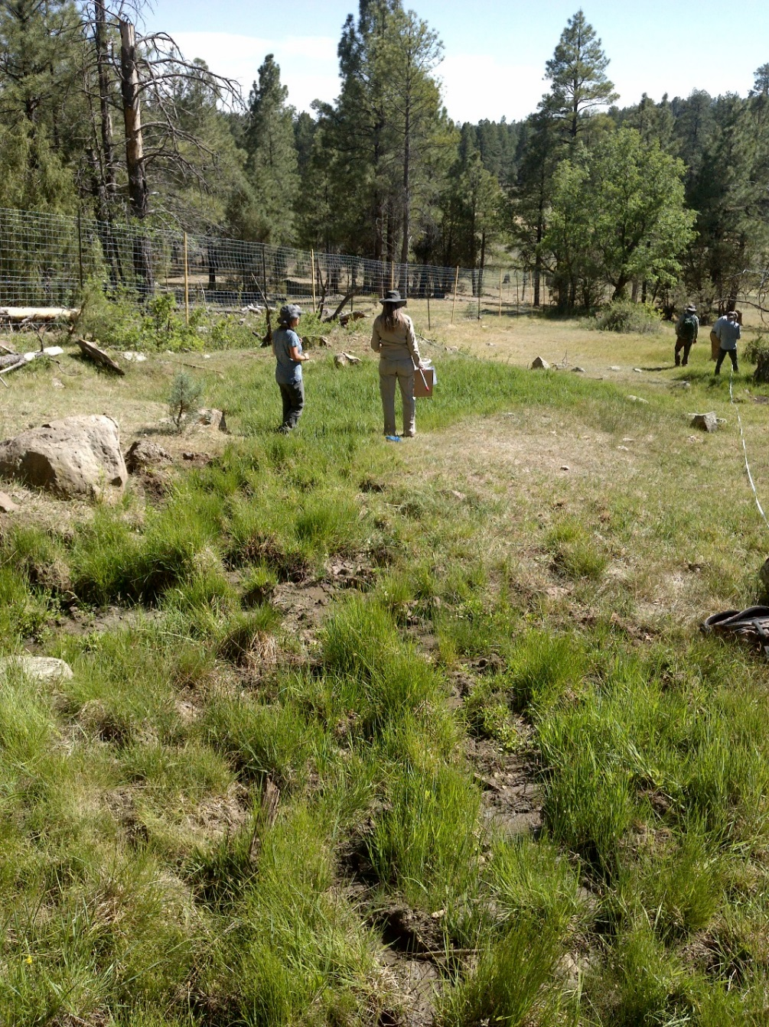
Fig 1.1 T-Six Spring: View of site looking downslope

Physical Description: T-Six Spring is a hillslope/helocrene spring. This spring has been heavily excavated and manipulated over time. The upper hillslope section has been excavated and diverted, forming a berm between it and the helocrene below. The helocrene has been fenced. On the upper end, the fencing is below the berm. The trench circles around the fence line, with one channel returning to the meadow. The microhabitats associated with the spring cover 420 sqm. The site has 3 microhabitats, including C -- a 288 sqm terrace, D -- a 48 sqm low gradient cienega, E -- an 84 sqm channel. The geomorphic diversity is 0.36, based on the Shannon-Weiner diversity index.

Table 1.1 T-Six Spring Microhabitat characteristics.
Code | C | D | E
Name | Dry meadow | Wet channel | Wet channel (new)
Area sqm | 288 | 48 | 84
Surface type | TE | LGC | CH
Surface subtype | anthro |  | eph
Slope variability | Low | Low | Low
Aspect TN | 220 | 220 | 220
Slope degrees | 10 | 10 | 10
Moisture (scale 1-10) | 1 | 9 | 7
Water depth cm | 0 | 1 | 1
Area % open water | 0 | 10 | 1
Substrate
1 - Clay % | 20 | 10 | 15
2 - Silt % | 45 | 30 | 45
3 - Sand % | 5 | 4 | 6
4 - Fine gravel % | 2 | 2 | 2
5 - Coarse gravel % | 2 | 2 | 2
6 - Cobble % | 5 | 10 | 5
7 - Boulder % | 1 | 1 | 0
8 - Bedrock % | 0 | 0 | 0
Organic % | 20 | 40 | 25
Other % (anthropogenic) | 0 | 1 | 0
Precipitate % | 0 | 0 | 0
Litter % | 60 | 15 | 10
Wood % | 1 | 2 | 5
Litter Depth (cm) | 2 | 1 | 2

Geomorphology: T-Six Spring emerges as a contact spring from an igneous, basalt rock layer in an unknown unit. The emergence environment is subaerial, with a gravity flow force mechanism. The site receives approximately 95% of available solar radiation, with 6647 Mj annually.

Access Directions: From exit 320 on I-17, travel SE onto Schnebly Hill Rd (NF-226) for 2.7 mi. Turn left onto NF-226B and continue to the right on NF-9468K for 0.8 miles. The site is located above a large fenced meadow.

Survey Notes: Plants are starting to populate through the erosion fabric in the restored meadow. Fence is in good condition. No flowing water is evident today and the spring has been trampled by elk and cattle.

Flow: The measurement location is at slight discharge occurring 10 m down slope from fence at the bottom of polygon D. This spring is ephemeral.

Water Quality: Location 1: at 00:00:00.

Table 1.2 T-Six Spring Water Quality with multiple readings averaged.
Characteristic Measured | Average Value | Site Number | Device | Comments
pH (field) | 6.29 | 1 | Hanna Combo
Specific conductance (field) (uS/cm) | 476 | 1
Temperature, air C | 31 | 1
Temperature, water C | 28.6 | 1 | Hanna Combo

Flora: Glenn Rink was the botanist. Surveyors identified 38 plant species at the site, with 0.0905 species/sqm. These included 28 native and 10 nonnative species.

Table 1.3 T-Six Spring Cover Type.
Cover Type | Species Count | Wetland Species Count
Ground | 35 | 16
Shrub | 1 | 0
Mid-canopy | 1 | 0
Tall canopy | 0 | 0
Basal | 0 | 0
Aquatic | 1 | 1
Non-vascular | 0 | 0

Table 1.4 T-Six Spring Vegetation % Cover in Microhabitats.
Species | Cover Code | Native Status | Wetland Status | Comments | C | D | E
Achillea millefolium | GC | NI | U |  | 7 | 0.2 | 1
algae | AQ | N | A |  | 0 | 0.01 | 0.5
Bromus tectorum | GC | I | F |  | 0 | 0 | 0.01
Carex nebrascensis | GC | N | W |  | 1 | 30 | 16
Carex simulata | GC | N | W |  | 3 | 0 | 16
Carex subfusca | GC | N | W |  | 2 | 10 | 7
Cirsium vulgare | GC | I | F |  | 0.2 | 0 | 0.01
Eleocharis palustris | GC | N | W |  | 0 | 0.5 | 0
Eleocharis pauciflora | GC | N | W |  | 0 | 0.5 | 6
Geranium | GC | N | F |  | 0.01 | 0 | 0
Hymenoxys acaulis | GC |  |  |  | 0.01 | 0 | 0
Hypericum scouleri | GC | N | WR |  | 0 | 0.01 | 0
Juncus balticus | GC | N | W |  | 3 | 0 | 0.01
Juncus interior | GC | N | U | GR 15073 | 1 | 40 | 20
Juncus saximontanus | GC | N | W |  | 0 | 0 | 1
Juniperus deppeana | GC | N | U |  | 0.2 | 0 | 0
Lactuca serriola | GC | I | WR |  | 0 | 0.01 | 0
Lichen | GC | N | U |  | 3 | 0.2 | 2
Medicago lupulina | GC | I | WR |  | 0 | 0.1 | 2
Mimulus guttatus | GC | N | W |  | 0 | 0.01 | 0.05
Pinus ponderosa | MC | N | F |  | 2 | 0 | 0
Poa pratensis | GC | NI | F |  | 50 | 10 | 15
Quercus gambelii | GC | N | F |  | 0.01 | 0.01 | 0.5
Ranunculus hydrocharoides | GC | N | W |  | 0 | 3 | 5
Ranunculus macounii | GC | N | W |  | 0 | 0.01 | 0
Robinia neomexicana | GC | N | F |  | 1 | 0 | 0
Rosa woodsii | SC | N | F |  | 3 | 0 | 2
Rumex crispus | GC | I | WR |  | 0 | 0.1 | 0
Salix exigua | GC | N | WR |  | 0 | 0.3 | 0.5
Sidalcea neomexicana | GC | N | WR |  | 0.01 | 0.01 | 0
Taraxacum officinale | GC | NI | F |  | 0.5 | 0.01 | 0.7
Thermopsis pinetorum | GC | N | F |  | 1 | 0.01 | 0
Tragopogon dubius | GC | I | F |  | 0.01 | 0 | 0
Trifolium spinulosum | GC |  |  |  | 0 | 0.01 | 0
unknown dicot | GC | NI |  |  | 0 | 0 | 0.01
unknown dicot | GC | NI |  | Cambrosia? | 0.01 | 0 | 0.01
unknown moss | GC |  |  |  | 0 | 0.04 | 0
Verbascum thapsus | GC | I | F |  | 0.01 | 0 | 0.01

Fauna: Surveyors collected or observed 12 terrestrial invertebrates and 14 vertebrate specimens.

Table 1.5 T-Six Spring Invertebrates.
Species | Lifestage | Habitat | Method | Rep# | Count | Species Detail
Coleoptera Lampyridae | Ad | T | Spot |  | 2
Coleoptera Lycidae | Ad | T | Spot |  | 1
Collembola | Ad | T | Spot |  | 1
Diptera Asilidae | Ad | T | Spot |  | 1
Hemiptera Cicadellidae | Ad | T | Spot |  | 1
Hymenoptera Chrysididae | Ad | T | Spot |  | 1
Hymenoptera Vespidae | Ad | T | Spot |  | 3
Hymenoptera Vespidae Vespula vulgaris | Ad | T | Spot |  | 3
Lepidoptera | L | T | Spot |  | 1 | Erebidae
Lepidoptera Lycaenidae Plebejus | Ad | T | Spot |  | 1
Lepidoptera Lycaenidae Plebejus | Ad | T | Spot |  | 2 | captured
Orthoptera | Ad | T | Spot |  | 2

Table 1.6 T-Six Spring Vertebrates.
Vertebrate Species Common Name | Count | Detection | Comments
Red-tailed Hawk | 1 | call
Steller's Jay | 1 | obs
Violet-green Swallow | 1 | obs
Rock Squirrel | 1 | obs
Elk |  | sign | abundant fresh and old, throughout restoration area including restoration fabric
Domestic Cow |  | sign
Northern Flicker | 2 | obs
Bobcat |  | sign | Scat with fur? cat
Plateau Fence Lizard | 1 | obs
American Robin |  | sign | feathers
Northern Leopard Frog | 1 | obs
Townsend's Solitaire |  | call | Plumias verna?
Mountain Garter Snake | 1 | obs
Western Bluebird | 2 | obs

Assessment: Assessment scores were compiled in 3 categories and 10 subcategories, with 32 null condition scores, and 32 null risk scores. Aquifer functionality and water quality are good with significant restoration potential and there is moderate risk. Geomorphology condition is undetermined due to null scores and there is undetermined risk due to null scores. Habitat condition is good with significant restoration potential and there is undetermined risk due to null scores. Biotic integrity is undetermined due to null scores and there is undetermined risk due to null scores. Human influence of site is good with significant restoration potential and there is low risk. Administrative context status is undetermined due to null scores and there is undetermined risk due to null scores. Overall, the site condition is good with significant restoration potential and there is low risk.

Table 1.7 T-Six Spring Assessment Scores.
Category | Condition | Risk
Aquifer Functionality & Water Quality | 4 | 3
Geomorphology | 0 | 0
Habitat | 4 | 0
Biota | 0 | 0
Human Influence | 4.1 | 2.7
Administrative Context | 0 | 0
Overall Ecological Score | 4.1 | 2.7

Management Recommendations: Brink the base level of the channel back-up, and monitor occasionally.

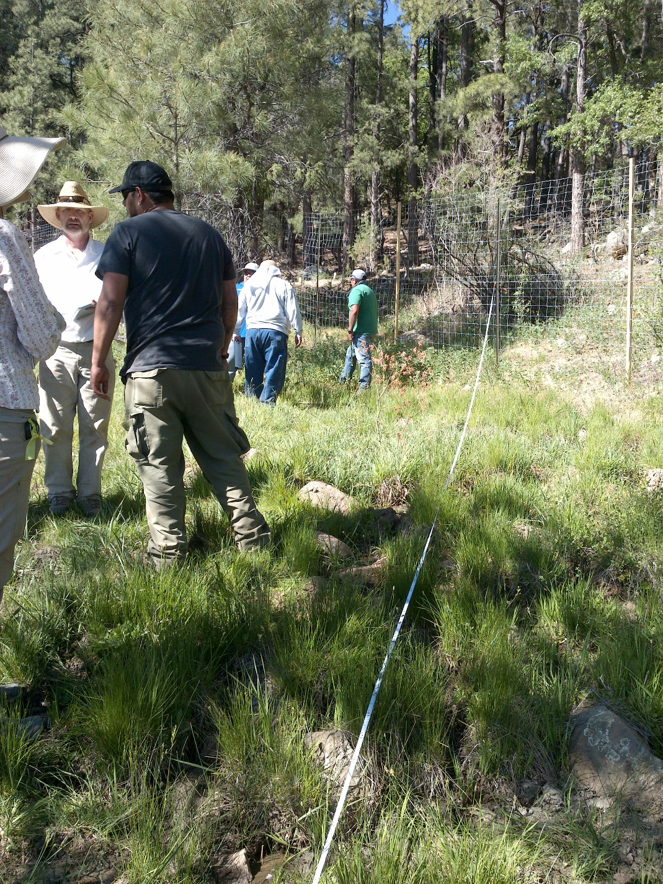
Fig 1.2 T-Six Spring: Surveyors conducting springs survey

2. Thomas Spring
2. Thomas Spring
Survey Summary Report, Site ID 1108
Submitted June 3, 2019 by Springs Stewardship Institute
Location: The Thomas Spring ecosystem is located in Coconino County in the Canyon Diablo Arizona 15020015 HUC, managed by the US Forest Service. The spring is located in the Coconino NF, Mormon Lake RD, in the Lower Lake Mary USGS Quad, at 35.03722, -111.60742 measured using a Map (NAD83). The elevation is approximately 2235 meters. Stasia Begley and volunteers surveyed the site on 5/24/16, and collected data in 5 of 10 categories. This survey was conducted under the NEPA Cleared List project using the Stevens et al. Level 1 protocol.

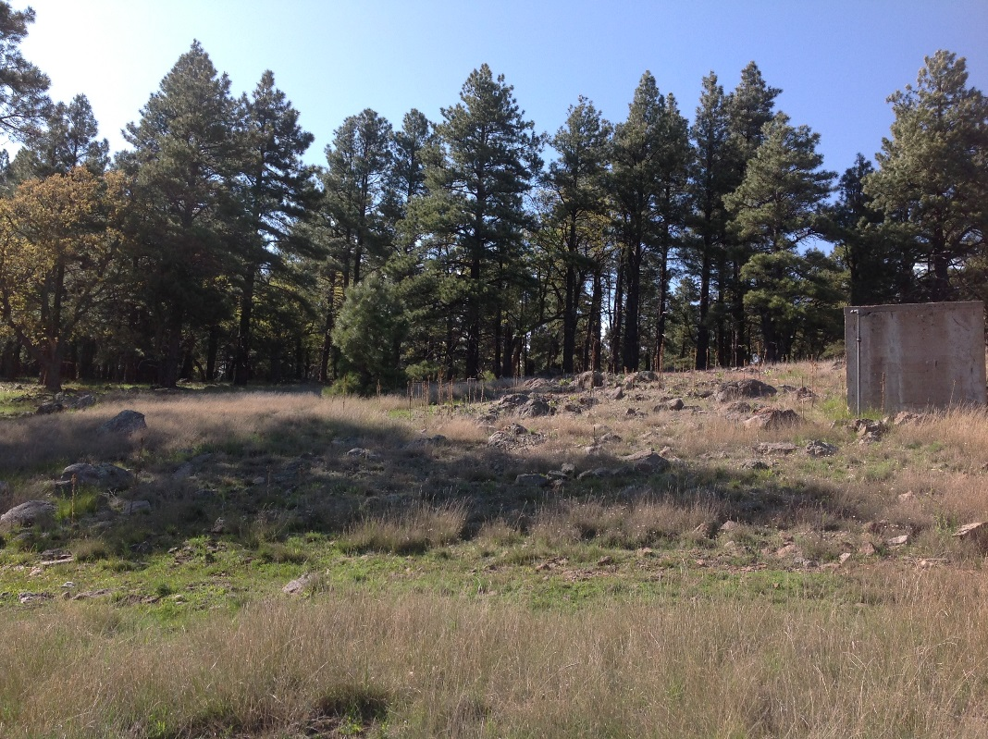
Fig 2.1 Thomas Spring: Thomas Spring 5-24-2016

Physical Description: Thomas Spring is a hillslope/helocrene spring. This site was imported from the SSI geodatabase, a compilation from multiple sources. There are at least three sources. One is a cement spring box, and two are hillslope-type channels. Piping is set up for 10 troughs.

Geomorphology: Thomas Spring emerges from an igneous, basalt rock layer in an unknown unit. The emergence environment is subaerial, with a gravity flow force mechanism.

Access Directions: From Lake Mary Rd (CR-3), turn onto Crimson Rd (NF-132) and travel south for 7.35 miles. Turn onto NF-8487X and continue for 0.3 mi. Spring is located 200 m due north.

Flow: Surveyors were unable to measure flow because of concrete springbox. Surveyors were unable to measure flow due to other.

Table 2.1 Thomas Spring Water Quality with multiple readings averaged.
Characteristic Measured | Average Value | Site Number | Device | Comments
Alkalinity, Total (mg/L) | 130
Dissolved oxygen (field) % saturation | 31.4 |  | YSI Multiprobe
pH (field) | 7.42 |  | YSI
Specific conductance (field) (uS/cm) | 319 |  | YSI | EC 233 adj for temp
Temperature, water C | 11.5 |  | YSI

Fauna: Old and fresh elk scat and tracks observed. Surveyors collected or observed 2 vertebrate specimens.

Table 2.2 Thomas Spring Vertebrates.
Vertebrate Species Common Name | Count | Detection | Comments
Elk |  | sign | Old and new sign.
Desert Mule Deer |  | sign | Old and new sign.

Assessment: Assessment scores were compiled in 3 categories and 0 subcategories, with 42 null condition scores, and 42 null risk scores. Aquifer functionality and water quality are undetermined due to null scores and there is undetermined risk due to null scores. Geomorphology condition is poor with limited restoration potential and there is undetermined risk due to null scores. Habitat condition is poor with limited restoration potential and there is undetermined risk due to null scores. Biotic integrity is undetermined due to null scores and there is undetermined risk due to null scores. Human influence of site is very poor with very limited restoration potential and there is undetermined risk due to null scores. Administrative context status is undetermined due to null scores and there is undetermined risk due to null scores. Overall, the site condition is undetermined due to null scores and there is undetermined risk due to null scores.

Table 2.3 Thomas Spring Assessment Scores.
Category | Condition | Risk
Aquifer Functionality & Water Quality | 0 | 0
Geomorphology | 2 | 0
Habitat | 2 | 0
Biota | 0 | 0
Human Influence | 1 | 0
Administrative Context | 0 | 0
Overall Ecological Score | 0 | 0

3. Tinny Spring
3. Tinny Spring
Survey Summary Report, Site ID 1109
Submitted June 3, 2019 by Springs Stewardship Institute
Location: The Tinny Spring ecosystem is located in Coconino County in the Canyon Diablo Arizona 15020015 HUC, managed by the US Forest Service. The spring is located in the Coconino NF, Mormon Lake RD, in the Hutch Mountain USGS Quad, at 34.83675, -111.42578 measured using a GPS (WGS84, estimated position error 8 meters). The elevation is approximately 2330 meters. Lisa Winters, Winnie Taney, and Cathy Morin surveyed the site on 9/08/16 for 00:30 hours, beginning at 16:45, and collected data in 6 of 10 categories. This survey was conducted under the NEPA Cleared List project using the Stevens et al. Level 2 protocol.

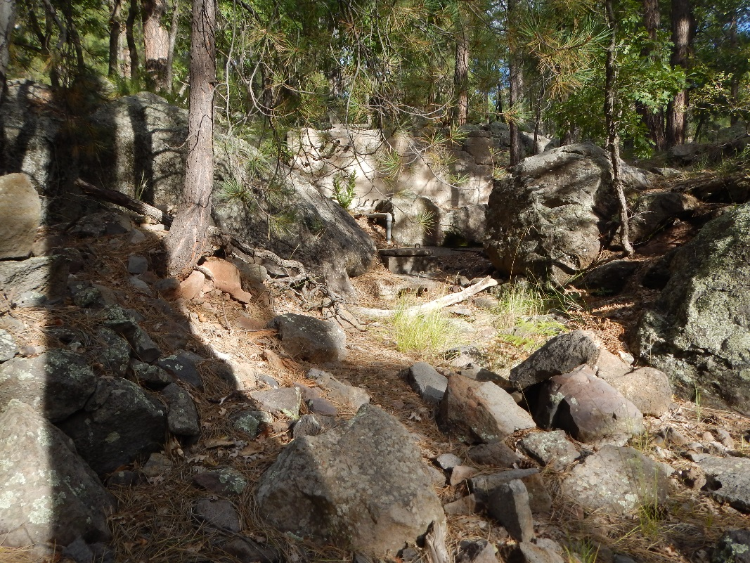
Fig 3.1 Tinny Spring: Recreation of Figure 1.1 from previous report

Physical Description: Tinny Spring is a hillslope spring. This site was imported from the geodatabase, a compilation from multiple sources. There are at least two sources. One is a channel, one is a cement spring box. There is a metal tank nearby (diameter ~ 3 m). The microhabitats associated with the spring cover 43 sqm. The site has 3 microhabitats, including A -- a 17 sqm pool, B -- a 21 sqm pool margin, C -- a 5 sqm channel. The geomorphic diversity is 0.42, based on the Shannon-Weiner diversity index.

Table 3.1 Tinny Spring Microhabitat characteristics.
Code | A | B | C
Name | Pond | Pond Margin | Channel
Area sqm | 17 | 21 | 5
Surface type | P | PM | CH
Surface subtype
Slope variability | Low | Low | Low
Aspect TN | 290 | 290 | 290
Slope degrees | 9 | 9 | 9
Moisture (scale 1-10) | 3 | 2 | 2
Water depth cm | 0 | 0 | 0
Area % open water | 0 | 0 | 0
Substrate
1 - Clay % | 0 | 0 | 0
2 - Silt % | 0 | 0 | 0
3 - Sand % | 0 | 0 | 0
4 - Fine gravel % | 0 | 0 | 0
5 - Coarse gravel % | 0 | 0 | 0
6 - Cobble % | 0 | 0 | 0
7 - Boulder % | 0 | 0 | 0
8 - Bedrock % | 0 | 0 | 0
Organic % | 0 | 0 | 0
Other % (anthropogenic) | 0 | 0 | 0
Precipitate % | 0 | 0 | 0
Litter % | 0 | 0 | 0
Wood % | 0 | 0 | 0
Litter Depth (cm)

Geomorphology: Tinny Spring emerges from an igneous, basalt rock layer in an unknown unit. The emergence environment is subaerial, with a gravity flow force mechanism.

Access Directions: From Lake Mary Rd (CR-3), turn onto NF-725 and travel NE for 0.8 mi. Spring is 460 m due SE.

Survey Notes: Surveyors found that aquifer functioning is poor with a lack of water and no clear springs-influenced habitat at the time of the survey.

Flow: There was no water to measure. Surveyors were unable to measure flow due to spring is dry.

Flora: Surveyors identified 7 plant species at the site, with 0.1628 species/sqm. These included 7 native and 0 nonnative species.

Table 3.2 Tinny Spring Cover Type.
Cover Type | Species Count | Wetland Species Count
Ground | 4 | 2
Shrub | 2 | 0
Mid-canopy | 0 | 0
Tall canopy | 0 | 0
Basal | 0 | 0
Aquatic | 1 | 1
Non-vascular | 0 | 0

Table 3.3 Tinny Spring Vegetation % Cover in Microhabitats.
Species | Cover Code | Native Status | Wetland Status | Comments | A | B | C
Carex nebrascensis | GC | N | W |  | 10 | 2 | 2
Geranium caespitosum | GC | N | F |  | 10 | 5 | 1
Juncus | GC | N | W |  | 5 | 5 | 2
Mimulus guttatus | AQ | N | W |  | 5 | 0 | 0
Poa pratensis | GC | NI | F |  | 20 | 10 | 10
Ribes cereum | SC | N | U |  | 0 | 1 | 0
Rosa woodsii | SC | N | F |  | 0 | 20 | 5

Fauna: Surveyors collected or observed 1 vertebrate specimens.

Table 3.4 Tinny Spring Vertebrates.
Vertebrate Species Common Name | Count | Detection | Comments
Elk |  | sign

Assessment: Assessment scores were compiled in 4 categories and 32 subcategories, with 10 null condition scores, and 10 null risk scores. Aquifer functionality and water quality are undetermined due to null scores and there is negligible risk. Geomorphology condition is poor with limited restoration potential and there is low risk. Habitat condition is poor with limited restoration potential and there is moderate risk. Biotic integrity is very poor with very limited restoration potential and there is negligible risk. Human influence of site is moderate with some restoration potential and there is low risk. Administrative context status is undetermined due to null scores and there is undetermined risk due to null scores. Overall, the site condition is poor with limited restoration potential and there is negligible risk.

Table 3.5 Tinny Spring Assessment Scores.
Category | Condition | Risk
Aquifer Functionality & Water Quality | 0 | 1
Geomorphology | 2 | 2.2
Habitat | 2 | 3.3
Biota | 1.5 | 1
Human Influence | 3.6 | 2.1
Administrative Context | 0 | 0
Overall Ecological Score | 1.9 | 1.8

Management Recommendations: There is a large scotch thistle infestation which could be removed. We also recommend further examination of the possible second channel that is not functioning anymore.

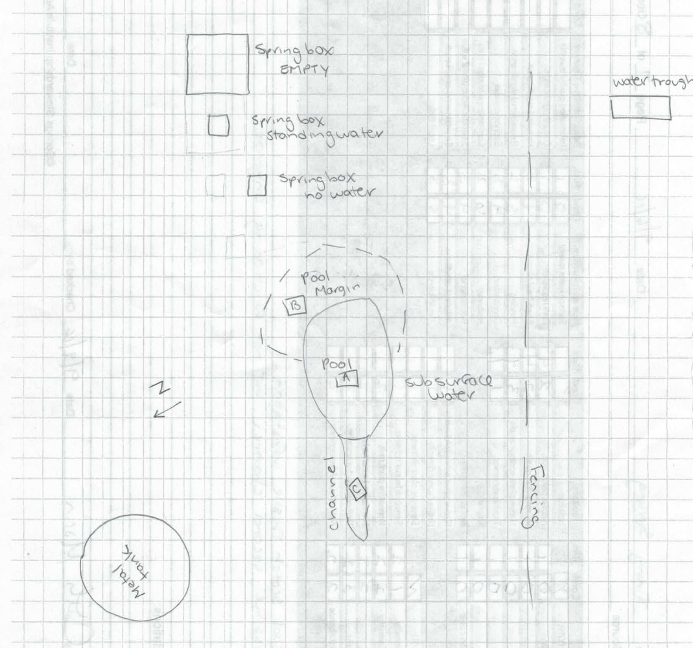
Fig 3.2 Tinny Spring Sketchmap.

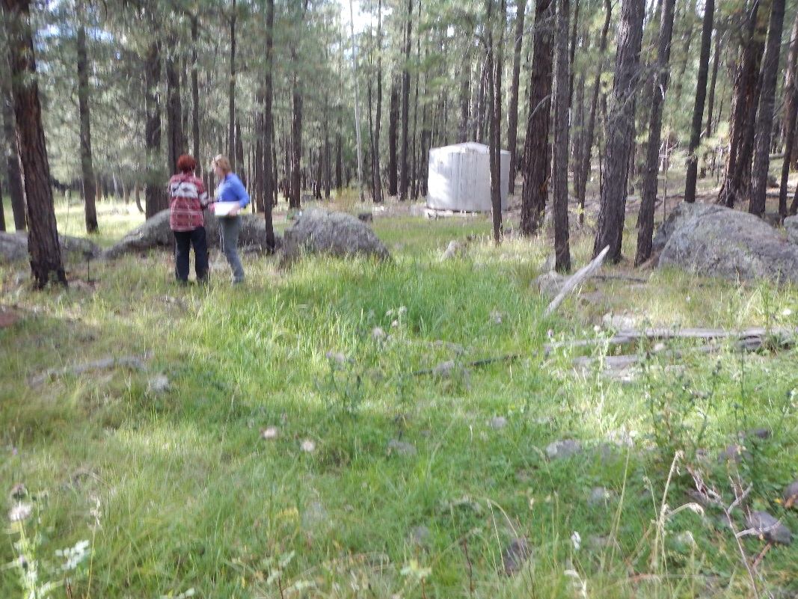
Fig 3.3 Tinny Spring: Water tank with moist area in foreground, downslope from spring site

4. Tree Spring
4. Tree Spring
Survey Summary Report, Site ID 1111
Submitted June 3, 2019 by Springs Stewardship Institute
Location: The Tree Spring ecosystem is located in Coconino County in the Upper Verde Arizona 15060202 HUC, managed by the US Forest Service. The spring is located in the Coconino NF, Mormon Lake RD, in the Stoneman Lake USGS Quad, at 34.86942, -111.50040 measured using a Map (NAD83). The elevation is approximately 2209 meters. Stephen Flora and Lanya Ross surveyed the site on 6/27/02, and collected data in 2 of 10 categories. This survey was conducted under the NEPA Cleared List project using the Unknown protocol.

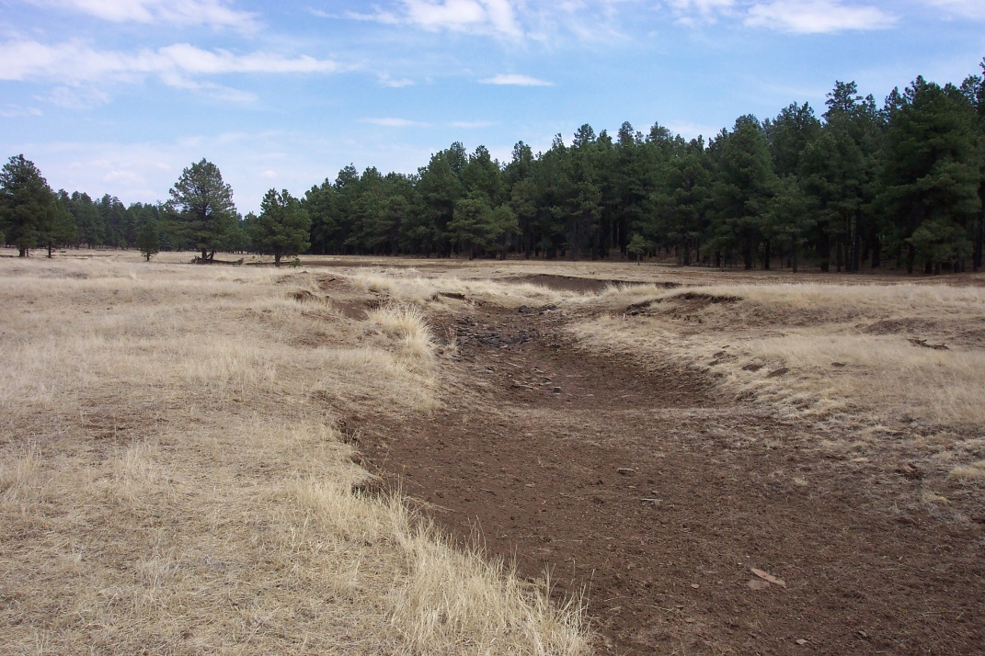
Fig 4.1 Tree Spring: Channel in park at spring source

Physical Description: Tree Spring is a helocrene spring. This spring emerges in a shallow drainage. A concrete tank has been built over the source.

Access Directions: From Mormon Lake Rd (CR-90), turn onto NF-219 and travel south for 3.4 mi. Turn right onto NF-91 for 0.6 mi and turn left onto NF-863 for 1.1 mi.

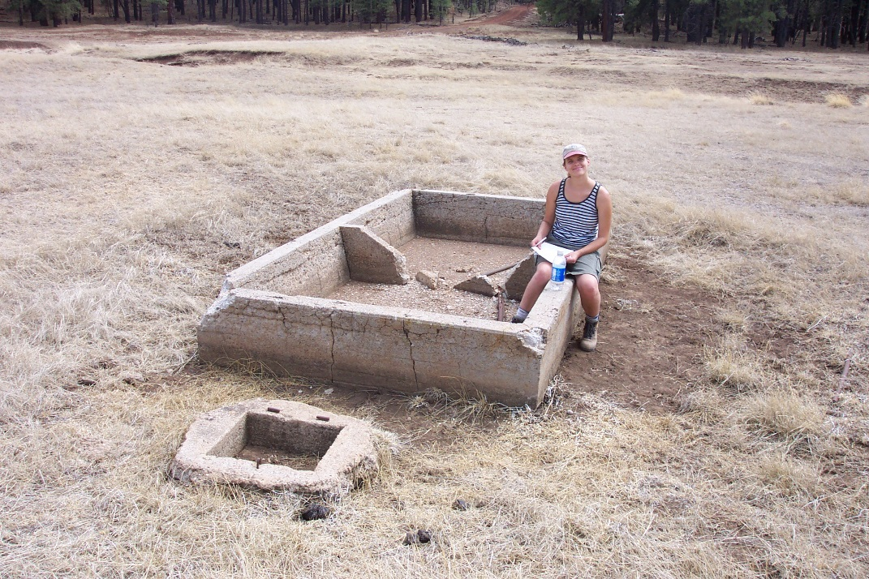
Fig 4.2 Tree Spring: Cement tank at spring source

5. Twin Tanks
5. Twin Tanks
Survey Summary Report, Site ID 1116
Submitted June 3, 2019 by Springs Stewardship Institute
Location: The Twin Tanks ecosystem is located in Coconino County in the Middle Little Colorado Arizona 15020008 HUC, managed by the US Forest Service. The spring is located in the Coconino NF, Mogollon Rim RD, in the Dane Canyon USGS Quad, at 34.43588, -111.17643 measured using a GPS (WGS84, estimated position error 5 meters). The elevation is approximately 2347 meters. Jeri Ledbetter, Gloria Hardwick, Mellisa Yin, and Joseph Holway surveyed the site on 7/21/17 for 12:00 hours, beginning at 12:00, and collected data in 10 of 10 categories. This survey was conducted under the NEPA Cleared List project using the Stevens et al. Level 2 protocol.

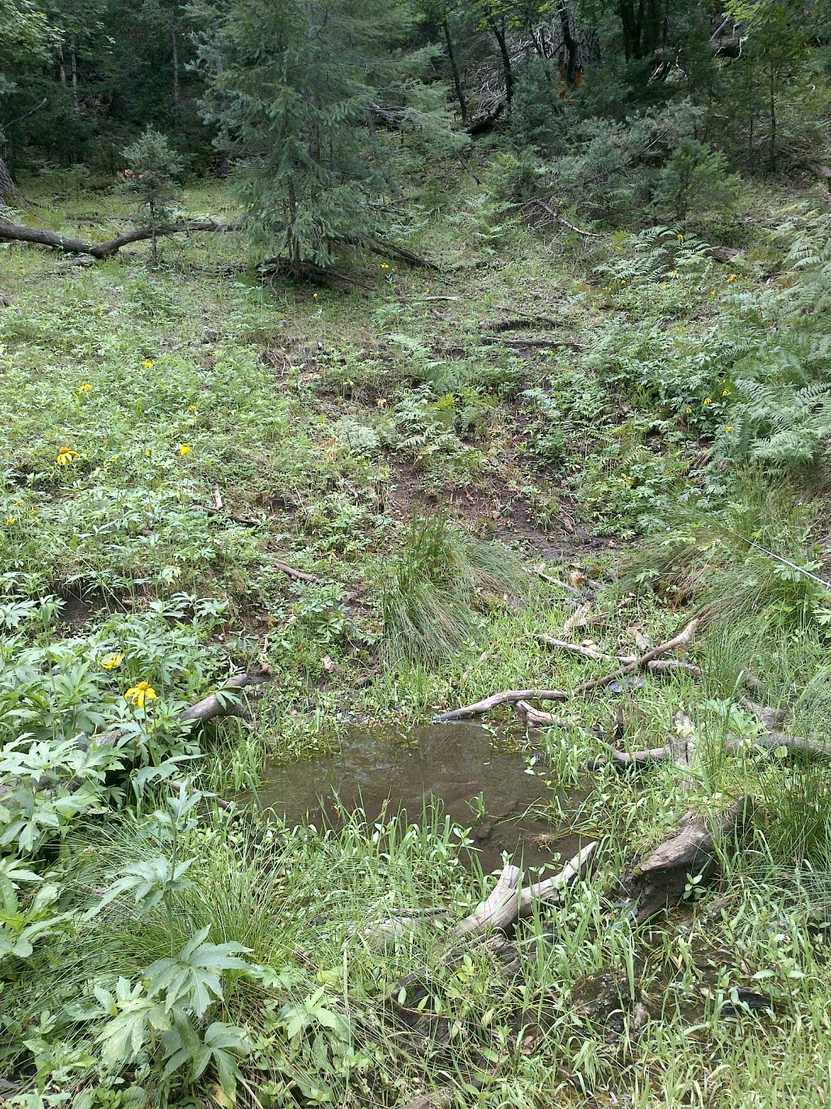
Fig 5.1 Twin Tanks: View upslope from 8.5 meters below the source

Physical Description: Twin Tanks is a hillslope spring. Flow emerges at a headcut at the base of a 45 degree slope in a side drainage to Dane Canyon. The name of this spring is derived from two bermed pools below the source. The dense surrounding forest is mixed conifer and maple. The site has been manipulated and heavily tramped by ungulates. The microhabitats associated with the spring cover 215 sqm. The site has 4 microhabitats, including A -- a 30 sqm channel, B -- a 130 sqm terrace, C -- a 23 sqm pool, D -- a 32 sqm low gradient cienega. The geomorphic diversity is 0.48, based on the Shannon-Weiner diversity index.

Table 5.1 Twin Tanks Microhabitat characteristics.
Code | A | B | C | D
Name | Channel | Terraces | Pools | Low Gradient Cienega
Area sqm | 30 | 130 | 23 | 32
Surface type | CH | TE | P | LGC
Surface subtype |  |  | anthro
Slope variability | Low | Low | Low | Low
Aspect TN
Slope degrees | 6 | 6 | 0 | 6
Moisture (scale 1-10) | 9 | 3 | 10 | 8
Water depth cm | 3 |  | 11
Area % open water | 75 |  | 90
Substrate
1 - Clay % | 10 | 2 | 0 | 2
2 - Silt % | 10 | 2 | 20 | 2
3 - Sand % | 5 | 2 | 0 | 2
4 - Fine gravel % | 30 | 5 | 2 | 2
5 - Coarse gravel % | 35 | 5 | 2 | 2
6 - Cobble % | 0 | 0 | 0 | 0
7 - Boulder % | 0 | 0 | 0 | 0
8 - Bedrock % | 0 | 0 | 0 | 0
Organic % | 10 | 84 | 76 | 90
Other % (anthropogenic) | 0 | 0 | 0 | 0
Precipitate % | 0 | 0 | 0 | 0
Litter % | 20 | 15 | 20 | 20
Wood % | 5 | 5 | 10 | 3
Litter Depth (cm) | 1 | 1.5 | 1 | 1

Geomorphology: Twin Tanks emerges as a contact spring from the Kaibab Limestone, a sedimentary, limestone rock layer. The emergence environment is subaerial, with a gravity flow force mechanism. The site receives approximately 87% of available solar radiation, with 6049 Mj annually.

Survey Notes: A constructed berm forms a pool (about 3 meters in diameter and 12 cm deep) 3.7 m below the source. Flow continues into a low gradient cienega for 4.5 meters, then enters a second larger pool about 3.5 m in diameter and 10 cm deep; this is also formed by a berm. The left side of the berm opens into a channel that flows into and past a low gradient cienega. Flow continues for 160 meters to the closed forest road 9707L and passes under it through a log bridge. The pools, channels, terraces, and low gradient cienega are moderately trampled and grazed by elk. The upper channel and pools are downcut and incised.

Flow: Surveyors measured a flow of 0.12 liters/second, using a timed flow volume capture method. Flow was adjusted for an estimate of 90% of site flow capture. Surveyors measured flow in the channel about 76 meters downstream from the source. This spring is perennial.

Water Quality: Surveyors measured water chemistry in flowing water 1.25 meters below the first emergence. The Hanna Combo was calibrated the day of the survey. Location 1: down-gradient from the spring source in flowing water at 00:00:00.

Table 5.2 Twin Tanks Water Quality with multiple readings averaged.
Characteristic Measured | Average Value | Site Number | Device | Comments
Alkalinity, Total (mg/L) | 143 | 1 | LaMotte
Dissolved oxygen (field) (mg/L) | 6.75 | 1 | CHEMets DO kit
pH (field) | 7.24 | 1 | Hanna Combo
Salinity (field) (ppt) | 0.138 | 1 | Hanna Combo
Specific conductance (field) (uS/cm) | 366 | 1 | Hanna Combo | Adjusted for temp from 252 EC
Temperature, air C | 29.75 |  | Handheld therm
Temperature, water C | 9.4 | 1 | Hanna Combo

Flora: Surveyors identified 32 plant species at the site, with 0.1488 species/sqm. These included 22 native and 10 nonnative species.

Table 5.3 Twin Tanks Cover Type.
Cover Type | Species Count | Wetland Species Count
Ground | 26 | 10
Shrub | 1 | 0
Mid-canopy | 3 | 0
Tall canopy | 0 | 0
Basal | 2 | 0
Aquatic | 1 | 1
Non-vascular | 2 | 1

Table 5.4 Twin Tanks Vegetation % Cover in Microhabitats.
Species | Cover Code | Native Status | Wetland Status | Comments | A | B | C | D
Acer grandidentatum | MC | N | F |  | 0 | 0.4 | 0 | 0
Androsace | GC | N | WR | Androsaceae | 0 | 0 | 0 | 0.01
Apiaceae | GC |  |  | Same as maple, coralily | 10 | 0 | 0 | 0
Aquilegia chrysantha | GC | N | W | No blooms | 0 | 0.01 | 0 | 0
Cerastium | GC |  | WR | Collected at source | 0 | 0 | 0 | 0.01
Cerastium arvense | GC | NI | F |  | 0 | 0 | 0 | 0.01
Epilobium ciliatum | GC | N | W |  | 0.02 | 0.01 | 0 | 0.06
Fragaria | GC | N | U |  | 0 | 0.04 | 0 | 0
Geranium richardsonii | GC | N | F |  | 0 | 0.09 | 0 | 0.01
Glyceria | GC |  | W | Collected | 0 | 0 | 3 | 0.02
Helenium hoopesii | GC | N | F |  | 0 | 0.09 | 0 | 0
Juncus laccatus | GC | N | W |  | 0.4 | 25 | 0.02 | 2
Lichen | NV | N | U | In trees too | 0.01 | 0.01 | 0 | 0
Marchantia polymorpha | NV | N | WR | Lots of fruit. Same as maple | 30 | 0 | 0 | 0
Medicago | GC |  | F |  | 0 | 3 | 0 | 50
Perideridia parishii | GC | N | F | ? | 0.5 | 0 | 0 | 0.5
Plantago | GC |  | WR |  | 0 | 0 | 0 | 0.03
Plantago | GC |  | WR | No blooms | 0 | 0.05 | 0 | 0
Prunella vulgaris | GC | N | F |  | 0 | 0.04 | 0 | 0.02
Pseudotsuga menziesii var. glauca | BC | N | U |  | 0 | 0.06 | 0 | 0
Pseudotsuga menziesii var. glauca | MC | N | U |  | 0.2 | 0.08 | 0.2 | 0.05
Pseudotsuga menziesii var. glauca | SC | N | U |  | 0 | 0.3 | 0 | 0
Pteridium aquilinum | GC | N | U |  | 0 | 1.5 | 0 | 2
Quercus gambelii | BC | N | F |  | 0 | 0.06 | 0 | 0
Quercus gambelii | MC | N | F |  | 0 | 0 | 0.02 | 0.03
Rudbeckia laciniata | GC | N | F |  | 0 | 20 | 3 | 0
Scirpus microcarpus | GC | N | W |  | 0 | 0 | 0.5 | 0.05
Taraxacum | GC |  | F |  | 0 | 0.01 | 0 | 0.03
Trifolium wormskioldii | GC | N | WR |  | 0 | 0.01 | 0 | 1
unknown Fungus | GC |  |  |  | 0 | 0.01 | 0 | 0
unknown Graminoid (grass or grasslike) | GC |  |  | Brn florets- mid-strn coll | 0.08 | 0.01 | 0 | 0.01
unknown Moss | GC |  |  |  | 10 | 0.5 | 2 | 30
Veratrum californicum | GC | N | W |  | 0 | 1 | 0 | 0.03
Veronica americana | AQ | N | A |  | 8 | 0 | 10 | 0.02
Viola | GC | N | F |  | 0.01 | 0.02 | 0 | 15

Fauna: Surveyors collected or observed 2 aquatic and 3 terrestrial invertebrates and 3 vertebrate specimens.

Table 5.5 Twin Tanks Invertebrates.
Species | Lifestage | Habitat | Method | Rep# | Count | Species Detail
Lepidoptera Nymphalidae | Ad | T | Spot |  | 10 | Various fritillary butterflies observed.
Odonata Coenagrionidae Argia | Ad | T | Spot
Trichoptera | Ad | T | Spot
Turbellaria | Ad | A | Spot

Table 5.6 Twin Tanks Vertebrates.
Vertebrate Species Common Name | Count | Detection | Comments
Elk |  | sign | Tracks and scat
Red Squirrel |  | call
Common Raven |  | call

Assessment: Assessment scores were compiled in 5 categories and 33 subcategories, with 9 null condition scores, and 9 null risk scores. Aquifer functionality and water quality are good with significant restoration potential and there is low risk. Geomorphology condition is good with significant restoration potential and there is low risk. Habitat condition is good with significant restoration potential and there is low risk. Biotic integrity is good with significant restoration potential and there is low risk. Human influence of site is good with significant restoration potential and there is low risk. Administrative context status is undetermined due to null scores and there is undetermined risk due to null scores. Overall, the site condition is good with significant restoration potential and there is low risk.

Table 5.7 Twin Tanks Assessment Scores.
Category | Condition | Risk
Aquifer Functionality & Water Quality | 4.3 | 2.2
Geomorphology | 4.2 | 2.4
Habitat | 4.2 | 2
Biota | 4.6 | 2
Human Influence | 4.7 | 2.1
Administrative Context | 0 | 0
Overall Ecological Score | 4.5 | 2.1

Management Recommendations: The site would benefit from thinning of the surrounding forest. Also, removing the berms and filling in the excavated tanks would allow the spring to return to something resembling its natural geomorphic functionality. Monitor regularly.

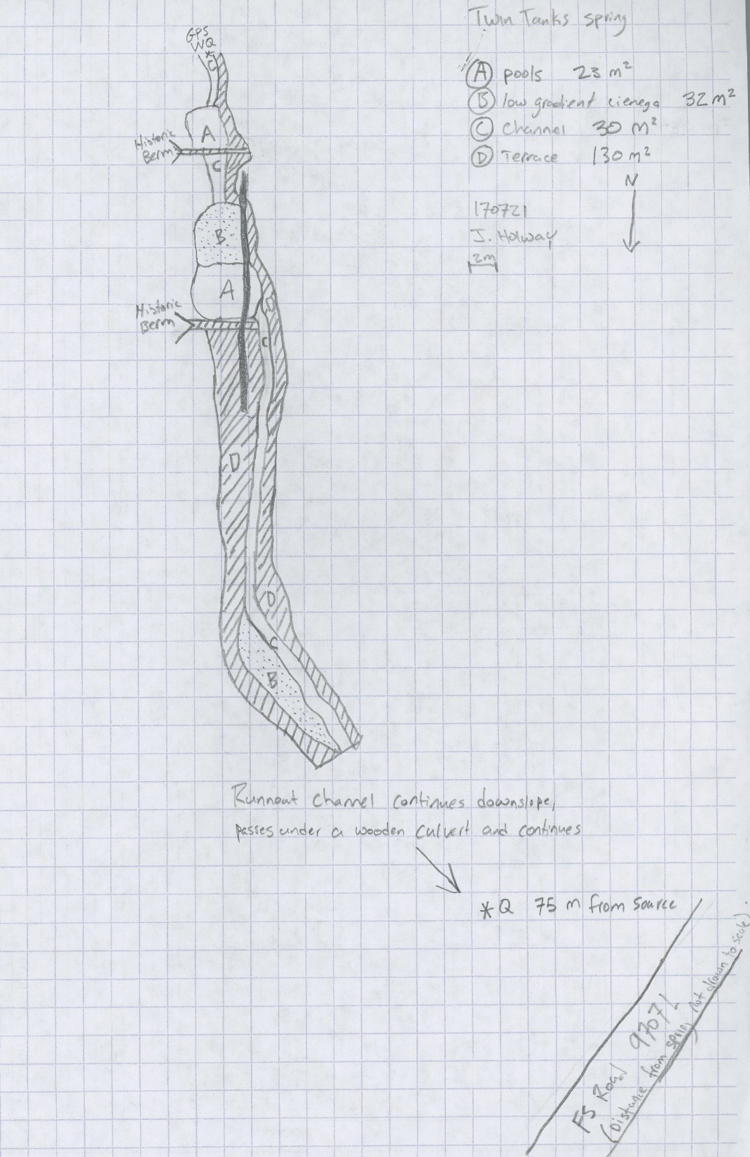
Fig 5.2 Twin Tanks Sketchmap.

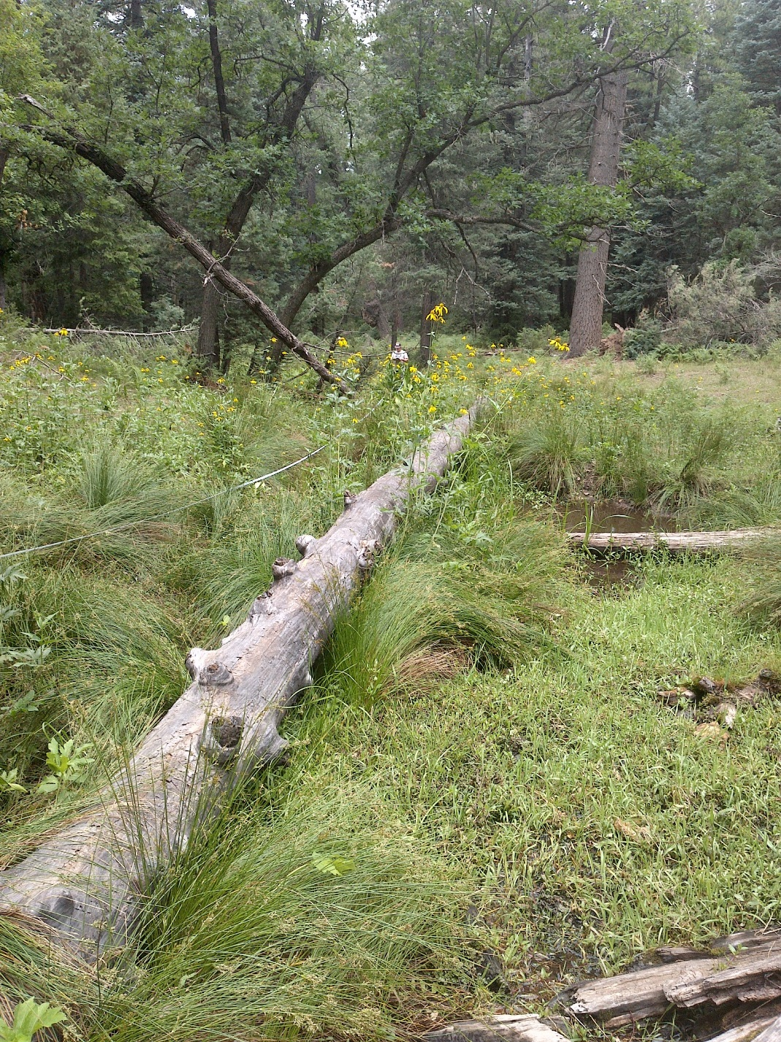
Fig 5.3 Twin Tanks: View downslope from 8.5 meters below the source

6. Upper Hull Spring
6. Upper Hull Spring
Survey Summary Report, Site ID 1120
Submitted June 3, 2019 by Springs Stewardship Institute
Location: The Upper Hull Spring ecosystem is located in Coconino County in the Upper Verde Arizona 15060202 HUC, managed by the US Forest Service. The spring is located in the Coconino NF, Peaks RD, in the Garland Prairie USGS Quad, at 35.14441, -111.96433 measured using a Map (NAD83). The elevation is approximately 2055 meters. Lisa Winters, Winnie Taney, Irene Hamilton, and Chantel Cook surveyed the site on 9/08/16 for 01:00 hours, beginning at 10:00, and collected data in 7 of 10 categories. This survey was conducted under the NEPA Cleared List project using the Stevens et al. Level 2 protocol.

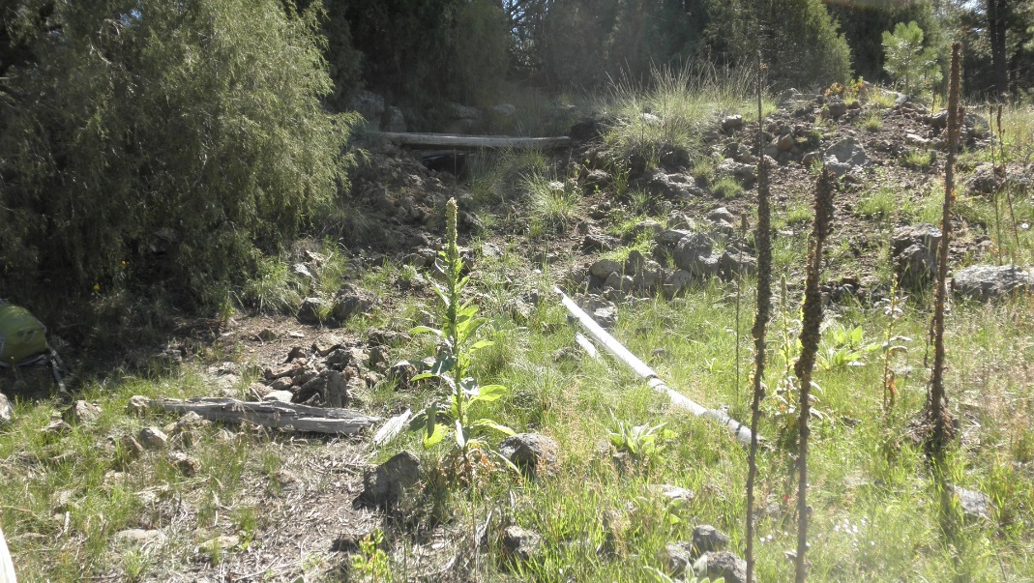
Fig 6.1 Upper Hull Spring: Looking towards source

Physical Description: Upper Hull Spring is a rheocrene spring. This spring emerges from the base of a basalt outcropping and has been piped and trenched. This site was imported from the geodatabase, a compilation from multiple sources. The microhabitats associated with the spring cover 488 sqm. The site has 2 microhabitats, including A -- a 50 sqm channel, B -- a 438 sqm pool. The geomorphic diversity is 0.14, based on the Shannon-Weiner diversity index.

Table 6.1 Upper Hull Spring Microhabitat characteristics.
Code | A | B
Name | Channel | Pond
Area sqm | 50 | 438
Surface type | CH | P
Surface subtype
Slope variability | Low | Low
Aspect TN
Slope degrees | 8 | 0
Moisture (scale 1-10) | 1 | 1
Water depth cm | 0 | 0
Area % open water | 0 | 0
Substrate
1 - Clay % | 0 | 0
2 - Silt % | 0 | 0
3 - Sand % | 0 | 0
4 - Fine gravel % | 0 | 0
5 - Coarse gravel % | 0 | 0
6 - Cobble % | 0 | 0
7 - Boulder % | 0 | 0
8 - Bedrock % | 0 | 0
Organic % | 0 | 0
Other % (anthropogenic) | 0 | 0
Precipitate % | 0 | 0
Litter % | 0 | 0
Wood % | 0 | 0
Litter Depth (cm)

Access Directions: Take County Rd 141 south from Parks, AZ. Turn left onto County Rd 527 (Scout Camp Rd). Turn left onto County Rd 131, then right onto S Manterola Ranch Rd. Follow this road for approximately 0.25 miles. The site is due west of the road, approximately 60 meters.

Survey Notes: The source is partially covered by corrugated metal and wood planks. There is a large tank (45 x 20 m) that has been excavated and is dry. Surveyors note observed flora is typical of disturbed soils. There is no water present at the time of the survey.

Flow: No measurable flow or water present. Surveyors were unable to measure flow due to spring is dry.

Flora: Surveyors identified 7 plant species at the site, with 0.0143 species/sqm. These included 4 native and 3 nonnative species.

Table 6.2 Upper Hull Spring Cover Type.
Cover Type | Species Count | Wetland Species Count
Ground | 7 | 2
Shrub | 0 | 0
Mid-canopy | 0 | 0
Tall canopy | 0 | 0
Basal | 0 | 0
Aquatic | 0 | 0
Non-vascular | 0 | 0

Table 6.3 Upper Hull Spring Vegetation % Cover in Microhabitats.
Species | Cover Code | Native Status | Wetland Status | Comments | A | B
Bouteloua gracilis | GC | N | U |  | 0 | 4
Cirsium vulgare | GC | I | F |  | 2 | 0
Geranium caespitosum | GC | N | F |  | 0 | 3
Juncus effusus | GC | N | W |  | 0 | 3
Rumex densiflorus | GC | N | W |  | 0 | 2
Tragopogon | GC |  | F |  | 0 | 1
Verbascum | GC | I | F |  | 0 | 2

Fauna: Surveyors collected or observed 2 terrestrial invertebrates and 2 vertebrate specimens.

Table 6.4 Upper Hull Spring Invertebrates.
Species | Lifestage | Habitat | Method | Rep# | Count | Species Detail
Araneae |  | T |  |  | 2
Orthoptera | Ad | T |  |  | 4

Table 6.5 Upper Hull Spring Vertebrates.
Vertebrate Species Common Name | Count | Detection | Comments
Mourning Dove | 1 | obs
Elk |  | sign

Assessment: Assessment scores were compiled in 3 categories and 31 subcategories, with 11 null condition scores, and 11 null risk scores. Aquifer functionality and water quality are undetermined due to null scores and there is extreme risk. Geomorphology condition is undetermined due to null scores and there is extreme risk. Habitat condition is very poor with very limited restoration potential and there is low risk. Biotic integrity is very poor with very limited restoration potential and there is low risk. Human influence of site is moderate with some restoration potential and there is low risk. Administrative context status is undetermined due to null scores and there is undetermined risk due to null scores. Overall, the site condition is very poor with very limited restoration potential and there is moderate risk.

Table 6.6 Upper Hull Spring Assessment Scores.
Category | Condition | Risk
Aquifer Functionality & Water Quality | 0 | 6
Geomorphology | 0 | 6
Habitat | 1.3 | 2
Biota | 1.6 | 2
Human Influence | 3.1 | 2
Administrative Context | 0 | 0
Overall Ecological Score | 1.5 | 3.4

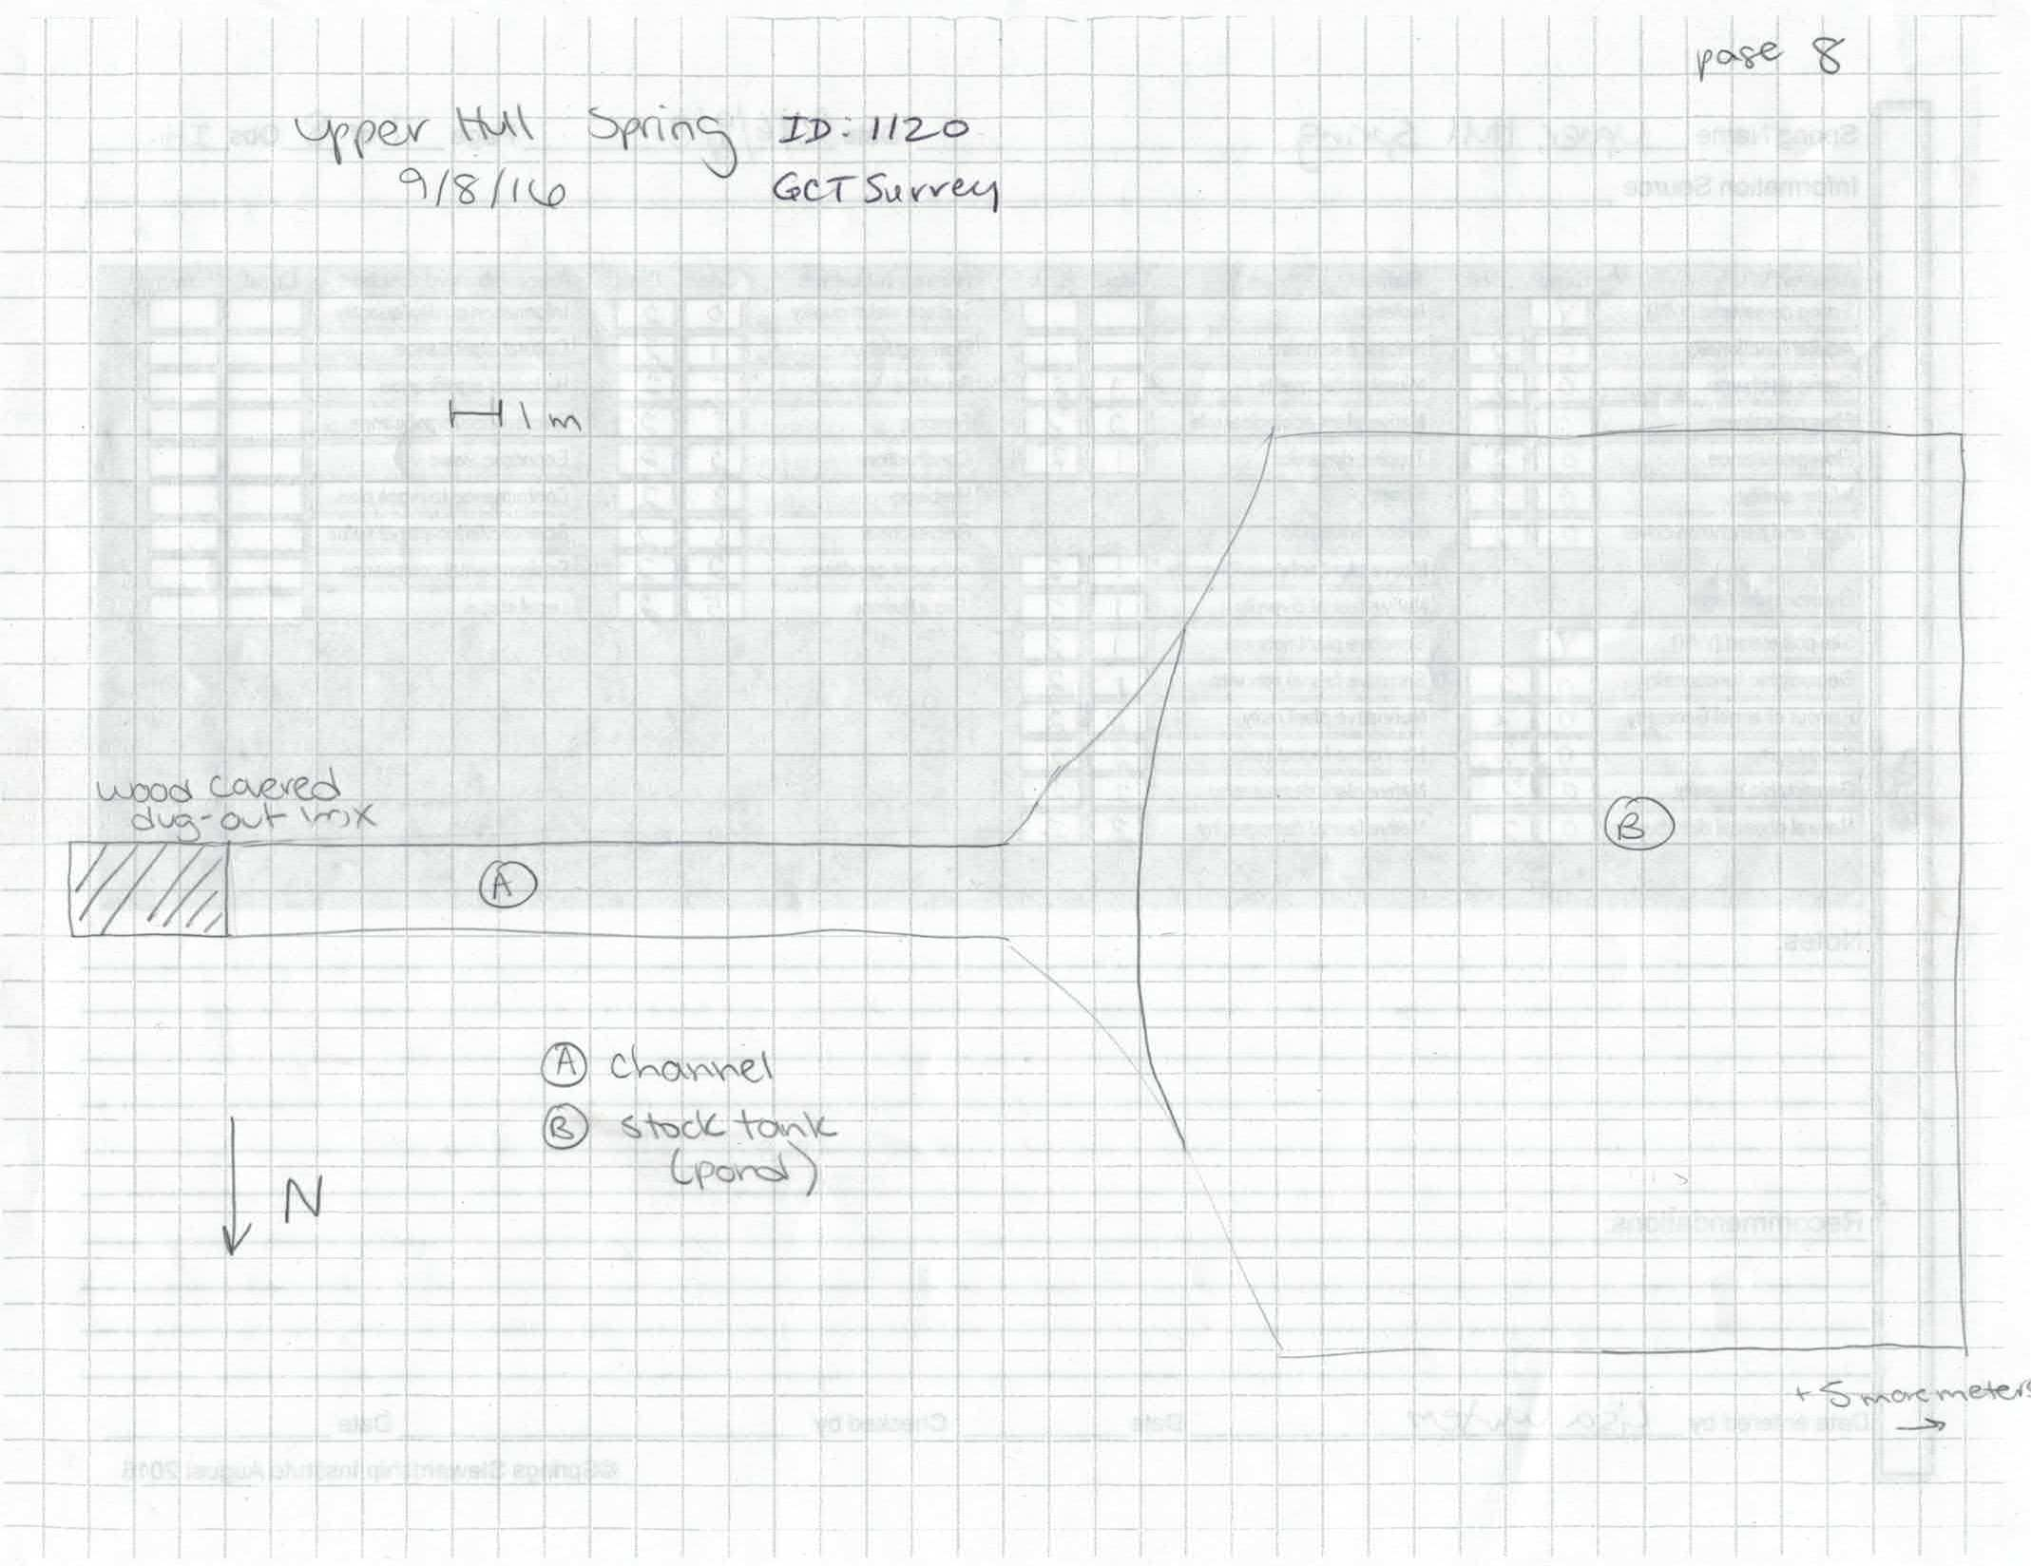
Fig 6.2 Upper Hull Spring Sketchmap.

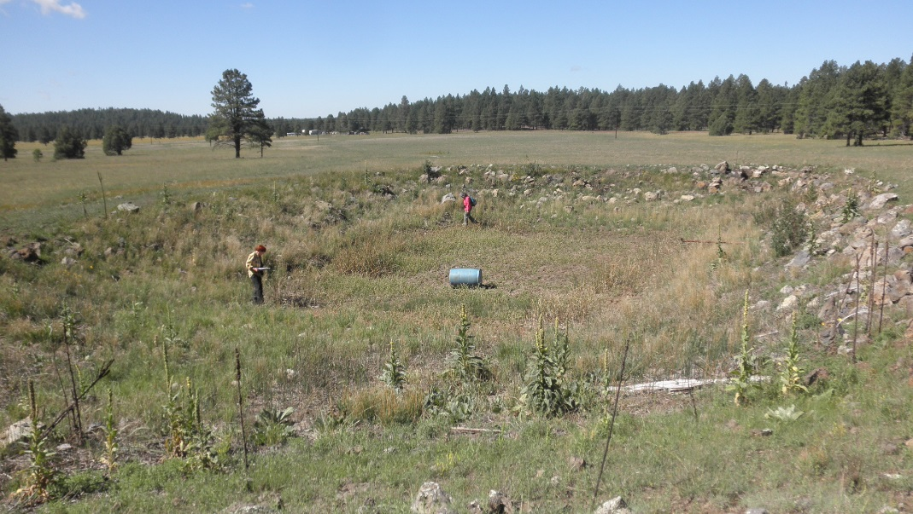
Fig 6.3 Upper Hull Spring: Upper Hull Spring tank

7. Upper McDermit Spring
7. Upper McDermit Spring
Survey Summary Report, Site ID 589
Submitted June 3, 2019 by Springs Stewardship Institute
Location: The Upper McDermit Spring ecosystem is located in Coconino County in the Upper Verde Arizona 15060202 HUC, managed by the US Forest Service. The spring is located in the Kaibab NF, Williams RD, in the Parks USGS Quad, at 35.27366, -111.91382 measured using a map (NAD83). The elevation is approximately 2207 meters. Stasia Begley and volunteers surveyed the site on 6/07/16, and collected data in 3 of 10 categories. This survey was conducted under the NEPA Cleared List project using the Stevens et al. Level 1 protocol.

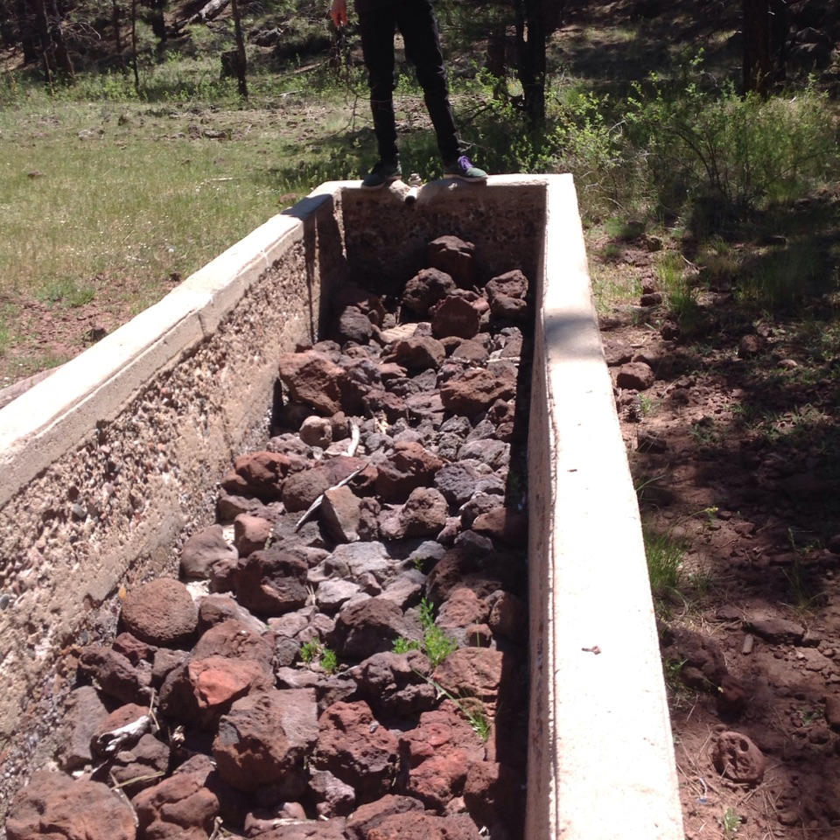
Fig 7.1 Upper McDermit Spring.

Physical Description: There is a cement trough at the spring source.

Geomorphology: Upper McDermit Spring emerges from an igneous, basalt rock layer in an unknown unit.

Access Directions: From Parks, AZ, go east on E Old Hwy 66 (County Rd 141). Turn left on Government Prairie Rd and continue for 1 mile. The site is located approximately 300 meters east of the road.

Survey Notes: There was damp soil underneath about 4 inches of duff.

Flow: Surveyors were unable to measure flow due to no outflow.

Fauna: Elk and deer scat, stellar jay feather, cow dung Surveyors collected or observed 4 vertebrate specimens.

Table 7.1 Upper McDermit Spring Vertebrates.
Vertebrate Species Common Name | Count | Detection | Comments
Elk |  | sign | Scat
Domestic Cow |  | sign | Scat
Steller's Jay |  | sign | Feather
Deer |  | sign | Scat

Assessment: Assessment scores were compiled in 4 categories and 0 subcategories, with 42 null condition scores, and 42 null risk scores. Aquifer functionality and water quality are undetermined due to null scores and there is undetermined risk due to null scores. Geomorphology condition is poor with limited restoration potential and there is undetermined risk due to null scores. Habitat condition is moderate with some restoration potential and there is undetermined risk due to null scores. Biotic integrity is good with significant restoration potential and there is undetermined risk due to null scores. Human influence of site is moderate with some restoration potential and there is undetermined risk due to null scores. Administrative context status is undetermined due to null scores and there is undetermined risk due to null scores. Overall, the site condition is undetermined due to null scores and there is undetermined risk due to null scores.

Table 7.2 Upper McDermit Spring Assessment Scores.
Category | Condition | Risk
Aquifer Functionality & Water Quality | 0 | 0
Geomorphology | 2 | 0
Habitat | 3 | 0
Biota | 4 | 0
Human Influence | 3 | 0
Administrative Context | 0 | 0
Overall Ecological Score | 0 | 0

8. Van Deren Spring
8. Van Deren Spring
Survey Summary Report, Site ID 1121
Submitted June 3, 2019 by Springs Stewardship Institute
Location: The Van Deren Spring ecosystem is located in Coconino County in the Upper Verde Arizona 15060202 HUC, managed by the US Forest Service. The spring is located in the Coconino NF, Mormon Lake RD, in the Hutch Mountain USGS Quad, at 34.83563, -111.44602 measured using a Map (NAD83). The elevation is approximately 2282 meters. Winnie Taney, Kathy Morin, and Lisa Winters surveyed the site on 9/06/16 for 02:35 hours, beginning at 9:55, and collected data in 9 of 10 categories. This survey was conducted under the NEPA Cleared List project using the Stevens et al. Level 2 protocol.

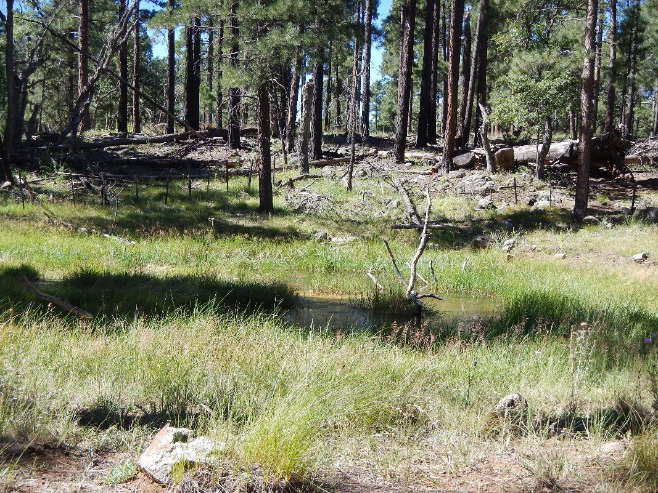
Fig 8.1 Van Deren Spring: Overview of pond

Physical Description: Van Deren Spring is a Helocrene spring. This site was imported from the SSI geodatabase, a compilation from multiple sources. The spring discharges out of a basalt outcrop into a bermed stock tank. There is typically no flow beyond the stock tank. Previous surveyors reported Pinus ponderosa revegetation/encroachment near the spring. There is no path to the spring (a road berm blocks view). The microhabitats associated with the spring cover 254 sqm. The site has 2 microhabitats, including A -- a 189 sqm pool, B -- a 65 sqm terrace. The geomorphic diversity is 0.25, based on the Shannon-Weiner diversity index.

Table 8.1 Van Deren Spring Microhabitat characteristics.
Code | A | B
Name | Pond | Terrace
Area sqm | 189 | 65
Surface type | P | TE
Surface subtype
Slope variability | Low | Low
Aspect TN
Slope degrees | 0 | 3
Moisture (scale 1-10) | 10 | 9
Water depth cm | 60 | 2
Area % open water | 50 | 5
Substrate
1 - Clay % | 0 | 0
2 - Silt % | 0 | 0
3 - Sand % | 0 | 0
4 - Fine gravel % | 0 | 0
5 - Coarse gravel % | 0 | 0
6 - Cobble % | 0 | 0
7 - Boulder % | 0 | 0
8 - Bedrock % | 0 | 0
Organic % | 0 | 0
Other % (anthropogenic) | 0 | 0
Precipitate % | 0 | 0
Litter % | 0 | 0
Wood % | 0 | 0
Litter Depth (cm)

Geomorphology: Van Deren Spring emerges as a contact spring from an igneous, basalt rock layer in an unknown unit. The emergence environment is subaerial, with a gravity flow force mechanism.

Access Directions: Take Coconino County Rd 3 (Lake Mary Rd) south from Flagstaff for approximately 30.6 miles. The spring is west of CR-3 approximately 0.45 miles.

Survey Notes: There is revegetation and encroachment near the spring (ponderosas). Surveyors did not observe any evidence of litter or well-worn path to spring (likely because the road berm blocks view of spring). There is no discernible flow. A barbed wire fence is broken on north end providing access to spring. There is a berm on the north side preventing water from flowing downhill. Surveyors note evidence of cattle within fencing (cowpies). Surveyors also found (and ate) lobster mushrooms nearby.

Flow: No water flow, but a large pool of water was present.

Water Quality: Equipment calibrated on 9/6/16. Measurements taken by rocks (on the SW/uphill side of pond).

Table 8.2 Van Deren Spring Water Quality with multiple readings averaged.
Characteristic Measured | Average Value | Site Number | Device | Comments
pH (field) | 5.65 |  | DigitalAid meter
Specific conductance (field) (uS/cm) | 116 |  | DigitalAid meter
Temperature, air C | 18 |  | DigitalAid meter
Temperature, water C | 19 |  | DigitalAid meter

Flora: Surveyors identified 11 plant species at the site, with 0.0433 species/sqm. These included 3 native and 8 nonnative species.

Table 8.3 Van Deren Spring Cover Type.
Cover Type | Species Count | Wetland Species Count
Ground | 8 | 3
Shrub | 0 | 0
Mid-canopy | 0 | 0
Tall canopy | 0 | 0
Basal | 0 | 0
Aquatic | 3 | 3
Non-vascular | 0 | 0

Table 8.4 Van Deren Spring Vegetation % Cover in Microhabitats.
Species | Cover Code | Native Status | Wetland Status | Comments | A | B
Abildgaardia | GC |  |  |  | 15 | 40
Achillea millefolium var. millefolium | GC | I |  |  | 0 | 1
algae | AQ | N | A |  | 50 | 0
Cirsium vulgare | GC | I | F |  | 0 | 1
Juncus | GC | N | W |  | 10 | 40
Linaria dalmatica | GC | I | F |  | 0 | 1
Medicago lupulina | GC | I | WR |  | 0 | 1
Mimulus guttatus | AQ | N | W |  | 2 | 1
Onopordum acanthium | GC | I | WR |  | 0 | 4
Poa pratensis ssp. pratensis | GC | I | F |  | 0.5 | 0
Potamogeton | AQ |  | A |  | 10 | 0

Fauna: Surveyors collected or observed 4 aquatic and 1 terrestrial invertebrates and 6 vertebrate specimens.

Table 8.5 Van Deren Spring Invertebrates.
Species | Lifestage | Habitat | Method | Rep# | Count | Species Detail
Hemiptera Gerridae | Ad | A | Spot |  | 6
Lepidoptera | Ad | T | Spot |  | 1 | Yellow, small
Odonata | Ad | A | Spot |  | 10
Odonata | Ad | A | Spot |  | 2 | Little blue species 1
Odonata | Ad | A | Spot |  | 2 | Little red species 2

Table 8.6 Van Deren Spring Vertebrates.
Vertebrate Species Common Name | Count | Detection | Comments
Chipmunk | 1 | obs
Deer | 1 | obs
Turkey Vulture | 2 | obs
Northern Leopard Frog | 3 | obs | Maybe lots more!
Broad-tailed Hummingbird | 1 | obs | female
Terrestrial Gartersnake | 1 | obs

Assessment: Assessment scores were compiled in 5 categories and 32 subcategories, with 10 null condition scores, and 15 null risk scores. Aquifer functionality and water quality are poor with limited restoration potential and there is moderate risk. Geomorphology condition is poor with limited restoration potential and there is low risk. Habitat condition is good with significant restoration potential and there is very high risk. Biotic integrity is good with significant restoration potential and there is very high risk. Human influence of site is good with significant restoration potential and there is moderate risk. Administrative context status is undetermined due to null scores and there is undetermined risk due to null scores. Overall, the site condition is moderate with some restoration potential and there is moderate risk.

Table 8.7 Van Deren Spring Assessment Scores.
Category | Condition | Risk
Aquifer Functionality & Water Quality | 2 | 3
Geomorphology | 2.4 | 2
Habitat | 4 | 5
Biota | 4 | 5
Human Influence | 4.2 | 3.5
Administrative Context | 0 | 0
Overall Ecological Score | 3.4 | 3.8

Management Recommendations: We suggest removing the 10 scotch thistle plants before they become established in the area. We also recommend fixing the fence to keep cattle out, and possibly removing the berm to restore natural spring flows.

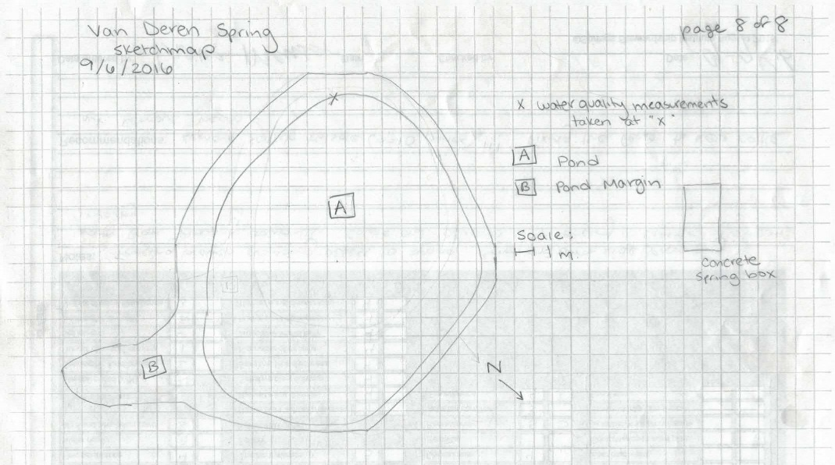
Fig 8.2 Van Deren Spring Sketchmap: Sept. 2016

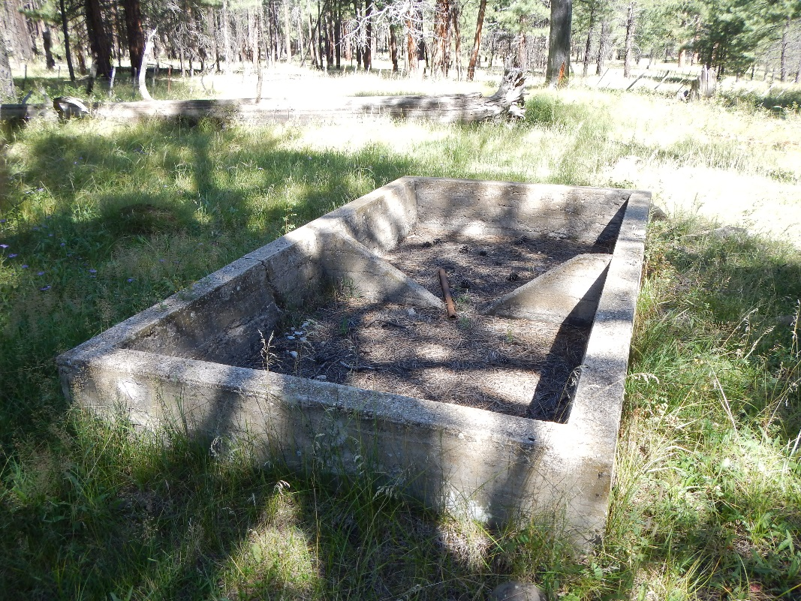
Fig 8.3 Van Deren Spring: Dry cattle trough downstream of pond

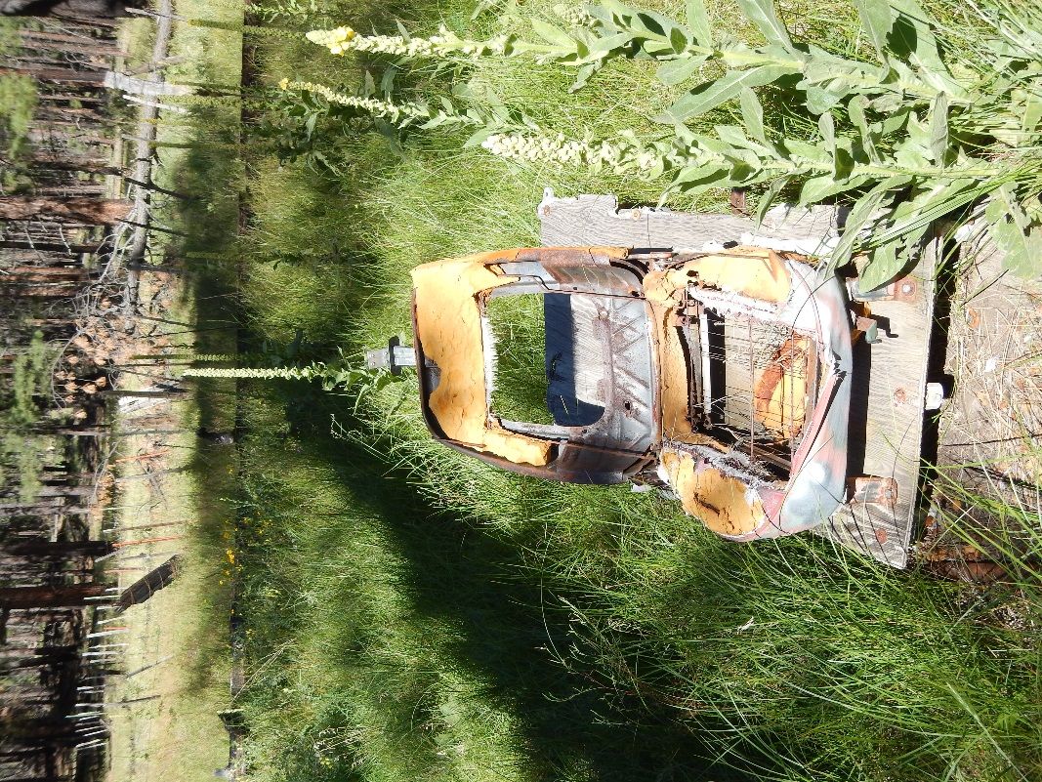
Fig 8.4 Van Deren Spring: Old car seat debris

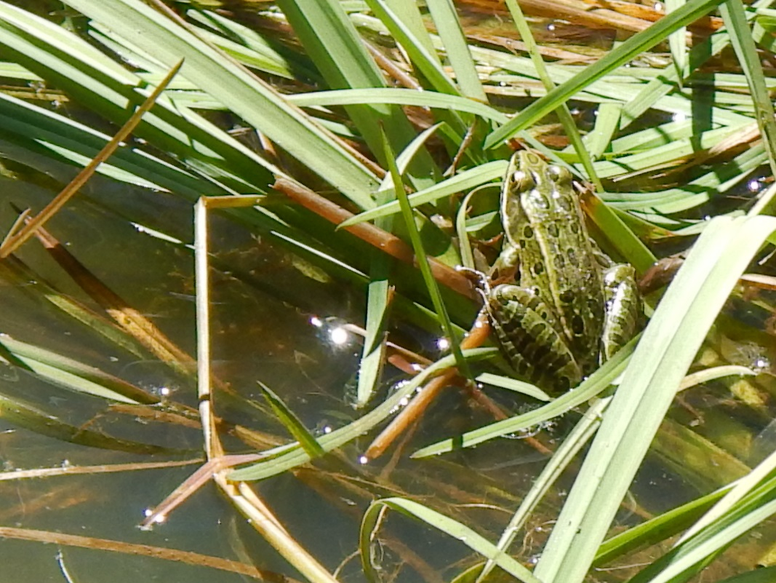
Fig 8.5 Van Deren Spring: Northern Leopard Frog observed at site

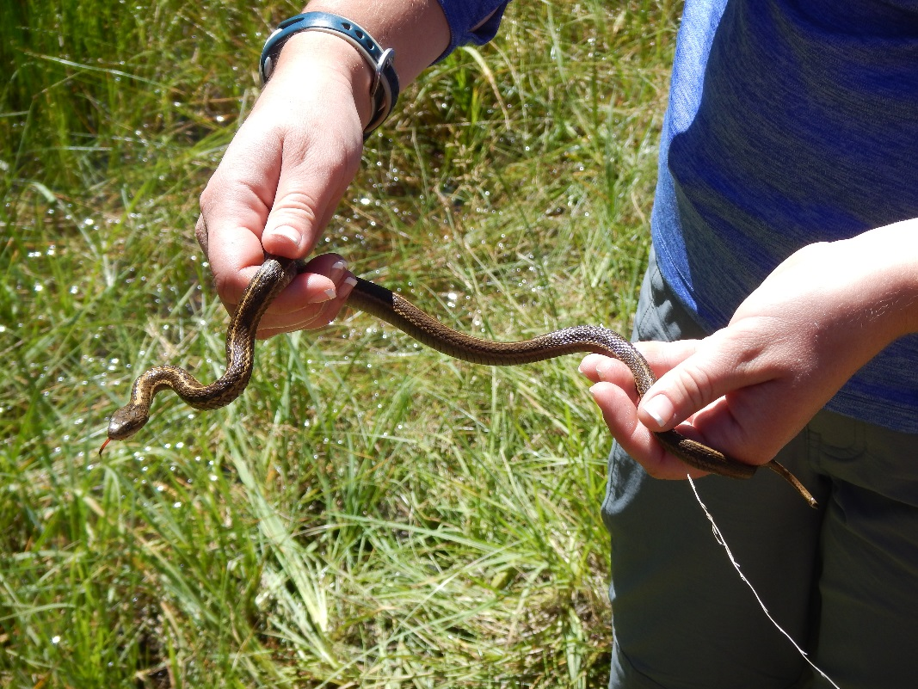
Fig 8.6 Van Deren Spring: Northwestern Garter Snake?

9. Weimer Spring
9. Weimer Spring
Survey Summary Report, Site ID 1125
Submitted June 3, 2019 by Springs Stewardship Institute
Location: The Weimer Spring ecosystem is located in Coconino County in the Canyon Diablo Arizona 15020015 HUC, managed by the US Forest Service. The spring is located in the Coconino NF, Mormon Lake RD, in the Mormon Mountain USGS Quad, at 34.97373, -111.52850 measured using a GPS (WGS84, estimated position error 6 meters). The elevation is approximately 2263 meters. Stasia Begley and volunteers surveyed the site on 8/13/16, and collected data in 6 of 10 categories. This survey was conducted under the NEPA Cleared List project using the Stevens et al. Level 1 protocol.

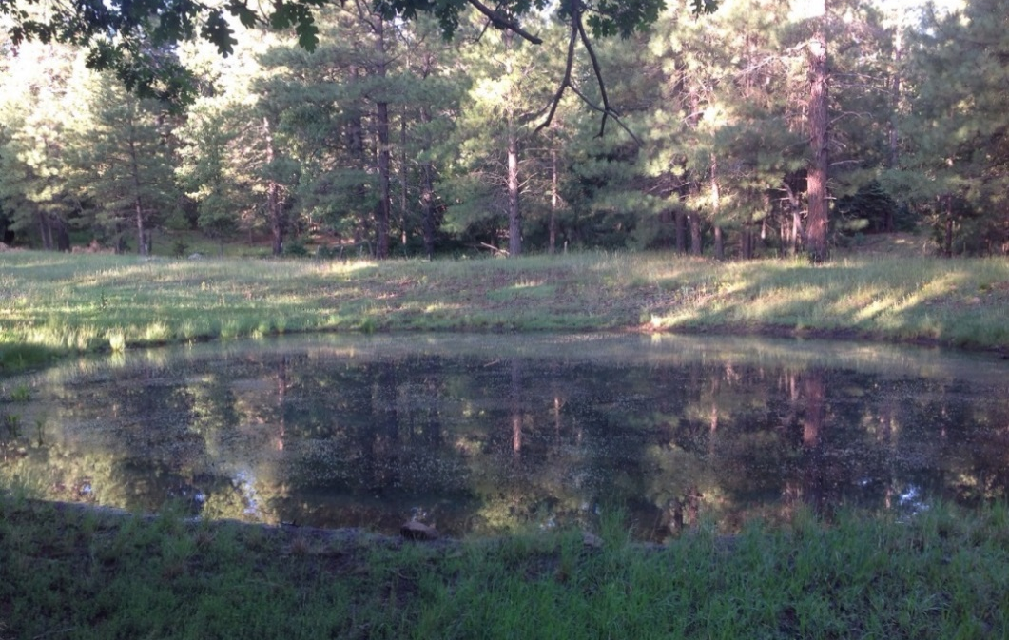
Fig 9.1 Weimer Spring: View of site

Physical Description: Weimer Spring is a rheocrene/helocrene spring. This site was imported from the SSI geodatabase, a compilation from multiple sources. Water seeps from/around two metal cylindrical tanks into a channel that joins a larger drainage and flows into Weimer Tank.

Geomorphology: Weimer Spring emerges from an igneous, basalt rock layer in an unknown unit. The emergence environment is subaerial, with a gravity flow force mechanism.

Access Directions: Take Coconino County Rd 3 to Coconino County Rd 90 to Forest Rd 132 to Forest Rd 132A. A sign along the road marks the spring.

Flow: Tank holding water, but there was no outflow. Surveyors were unable to measure flow due to no outflow.

Water Quality: Surveyors measured water quality 1 m from the edge of the tank.

Table 9.1 Weimer Spring Water Quality with multiple readings averaged.
Characteristic Measured | Average Value | Site Number | Device | Comments
Dissolved oxygen (field) % saturation | 6.22 |  | YSI Multiprobe
pH (field) | 6.1 |  | YSI
Specific conductance (field) (uS/cm) | 74 |  | YSI | EC 59 adj for temp
Temperature, water C | 15 |  | YSI

Fauna: Water striders, bees, and flies observed by surveyors and added to Invert list. Surveyors collected or observed 1 aquatic and 1 terrestrial invertebrates and 1 vertebrate specimens.

Table 9.2 Weimer Spring Invertebrates.
Species | Lifestage | Habitat | Method | Rep# | Count | Species Detail
Diptera |  |  |  |  |  | Flies
Hemiptera Gerridae |  | A |  |  |  | Water striders
Hymenoptera |  | T |  |  |  | Bees

Table 9.3 Weimer Spring Vertebrates.
Vertebrate Species Common Name | Count | Detection | Comments
Raccoon |  | sign | Tracks around tank edge

Assessment: Assessment scores were compiled in 4 categories and 0 subcategories, with 42 null condition scores, and 42 null risk scores. Aquifer functionality and water quality are undetermined due to null scores and there is undetermined risk due to null scores. Geomorphology condition is moderate with some restoration potential and there is undetermined risk due to null scores. Habitat condition is good with significant restoration potential and there is undetermined risk due to null scores. Biotic integrity is moderate with some restoration potential and there is undetermined risk due to null scores. Human influence of site is moderate with some restoration potential and there is undetermined risk due to null scores. Administrative context status is undetermined due to null scores and there is undetermined risk due to null scores. Overall, the site condition is undetermined due to null scores and there is undetermined risk due to null scores.

Table 9.4 Weimer Spring Assessment Scores.
Category | Condition | Risk
Aquifer Functionality & Water Quality | 0 | 0
Geomorphology | 3 | 0
Habitat | 4 | 0
Biota | 3 | 0
Human Influence | 3 | 0
Administrative Context | 0 | 0
Overall Ecological Score | 0 | 0

10. Wild Horse Spring

10. Wild Horse Spring
Survey Summary Report, Site ID 779
Submitted June 3, 2019 by Springs Stewardship Institute
Location: The Wild Horse Spring ecosystem is located in Coconino County in the Upper Verde Arizona 15060202 HUC, managed by the US Forest Service. The spring is located in the Kaibab NF, Williams RD, in the May Tank Pocket USGS Quad, at 35.09095, -112.16450 measured using a GPS (NAD83, estimated position error 4 meters). The elevation is approximately 2041 meters. Larry Stevens, Jeri Ledbetter, Anya Fayfer, and Marguerite Hendrie surveyed the site on 5/11/12 for 01:10 hours, beginning at 13:05, and collected data in 10 of 10 categories. This survey was conducted under the NEPA Cleared List project using the Stevens et al. Level 2 protocol.

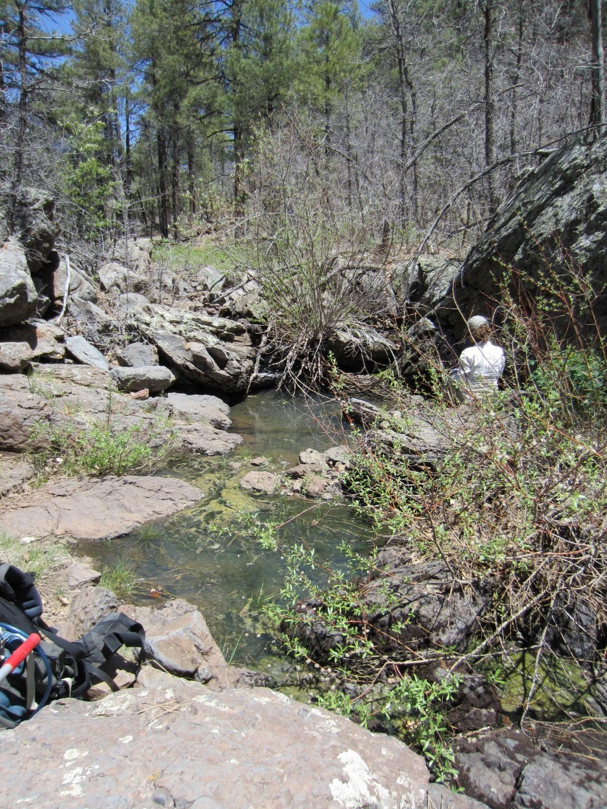
Fig 10.1 Wild Horse Spring: View of site

Physical Description: Wild Horse Spring is a rheocrene spring. This rheocrene spring emerges from a basalt flow in a primarily bedrock runoff-dominated channel in a rocky-forested canyon. The microhabitats associated with the spring cover 77 sqm. The site has 2 microhabitats, including A -- a 7 sqm channel, B -- a 70 sqm terrace. The geomorphic diversity is 0.13, based on the Shannon-Weiner diversity index.

Table 10.1 Wild Horse Spring Microhabitat characteristics.
Code | A | B
Name | Source Channel | Terrace
Area sqm | 7.00 | 70.00
Surface type | CH | TE
Surface subtype | run | LRZ
Slope variability | Med | High
Aspect TN | 222 | 222
Slope degrees | 3 | 3
Moisture (scale 1-10) | 10 | 0
Water depth cm | 20.00
Area % open water | 40.00
Substrate
1 - Clay % | 0 | 0
2 - Silt % | 0 | 0
3 - Sand % | 0 | 0
4 - Fine gravel % | 10 | 5
5 - Coarse gravel % | 10 | 10
6 - Cobble % | 10 | 5
7 - Boulder % | 10 | 10
8 - Bedrock % | 55 | 70
Organic % | 5 | 0
Other % (anthropogenic) | 0 | 0
Precipitate % | 0.00 | 0.00
Litter % | 10.00 | 5.00
Wood % | 2.00 | 8.00
Litter Depth (cm) | 0.50 | 1.00

Geomorphology: Wild Horse Spring emerges as a seepage or filtration spring from an igneous, basalt rock layer in an unknown unit. The emergence environment is subaerial, with a gravity flow force mechanism. The site receives approximately 82% of available solar radiation, with 5657 Mj annually.

Access Directions: Please examine a map closely before proceeding to this site. Some of the roads listed below may be closed or not accessible. Take County Rd 73 (S Perkinsville Rd) south from Williams, AZ to Forest Rd 57. Turn left on FR 57 (Bear Springs Rd). Turn right onto FR 4216A (Overland Rd), then right onto FR 4218G, then right onto FR 417H (to stay on FR 4218G. Turn right onto FR 4219. Continue on FR 4219A for ~0.6 miles. Spring is south of the road, approximately 0.25 miles.

Survey Notes: This spring is subject to heavy runoff. There is little evidence of human activities at the site, but trails and roads nearby are heavily logged and burned 50-100 years ago.

Flow: Surveyors measured a flow of 0.03400 liters/second, using a timed flow volume capture method. Flow was adjusted for an estimate of 1.00% of site flow capture. Flow measurements were taken in channel constriction, 10 m from upper pool.

Water Quality: Water quality measurements were taken in the upper pool at a 2.5 cm depth.

Table 10.2 Wild Horse Spring Water Quality with multiple readings averaged.
Characteristic Measured | Average Value | Site Number | Device | Comments
Alkalinity, Total (mg/L) | 40 |  | test strips
Hardness, Ca + Mg (mg/L) | 0 |  | test strips
Nitrogen, Nitrate (NO3) as NO3 (mg/L) | 0 |  | test strips
Nitrogen, Nitrite (NO2) as NO2 (mg/L) | 0 |  | test strips
pH (field) | 6.615 |  | Hanna/Ph Spear
Specific conductance (field) (uS/cm) | 75 |  | Hanna/Ph Spear
Temperature, air C | 26.7
Temperature, water C | 14.6 |  | Hanna/Ph Spear

Flora: Larry Stevens was the botanist. Surveyors identified 18 plant species at the site, with 0.2338 species/sqm. These included 15 native and 2 nonnative species; the native status of 1 species remains unknown.

Table 10.3 Wild Horse Spring Cover Type.
Cover Type | Species Count | Wetland Species Count
Ground | 10 | 3
Shrub | 4 | 1
Mid-canopy | 1 | 0
Tall canopy | 0 | 0
Basal | 1 | 0
Aquatic | 1 | 1
Non-vascular | 2 | 0

Table 10.4 Wild Horse Spring Vegetation % Cover in Microhabitats.
Species | Cover Code | Native Status | Wetland Status | Comments | A | B
Ambrosia | GC | I | F | annual | 0 | 0.3
Carex aurea | GC | N | U |  | 3 | 2
Cladophora glomerata | AQ | N | A |  | 30 | 0
Iris missouriensis | GC | N | F |  | 0 | 2
Lathyrus | GC | N | R |  | 0 | 8
Lichen | NV | N | U |  | 0 | 3
Prunus virginiana | SC | N | F |  | 0 | 5
Quercus gambelii | BC | N | F | 5 cm | 0 | 0.01
Quercus gambelii | MC | N | F |  | 0 | 2
Quercus gambelii | SC | N | F |  | 1 | 10
Robinia neomexicana | SC | N | F |  | 0 | 0.1
Salix lasiolepis | SC | N | R |  | 8 | 12
Solidago | GC | N | F |  | 0 | 0.2
Sporobolus contractus | GC | N | F | ? | 0 | 2
Symphoricarpos | GC | N | U |  | 0 | 10
Toxicodendron radicans | GC | N | WR |  | 0 | 1
Trifolium repens | GC | I | WR |  | 0 | 0.1
unknown Bryophyte (moss, liverwort, hornwort) | NV | N | F |  | 0 | 3
unknown grass | GC |  |  | spikey | 1 | 0

Fauna: Surveyors collected or observed 16 aquatic and 38 terrestrial invertebrates and 2 vertebrate specimens.

Table 10.5 Wild Horse Spring Invertebrates.
Species | Lifestage | Habitat | Method | Rep# | Count | Species Detail
Araneae | Ad | T | Spot |  | 1
Coleoptera | Ad |  | Spot |  | 1
Coleoptera Coccinellidae | Ad | T | Spot |  | 1
Coleoptera Dermestidae | Ad | T | Spot |  | 1
Coleoptera Dytiscidae | Ad | A | Spot |  | 1
Coleoptera Dytiscidae Agabus | Ad | A | Spot |  | 1
Coleoptera Dytiscidae Laccophilus | Ad | A | Spot |  | 1
Coleoptera Hydrophilidae | Ad | A | Spot |  | 1
Coleoptera Hydrophilidae Enochrus | Ad | A | Spot |  | 1
Coleoptera Hydrophilidae Tropisternus affinis | Ad | A | Spot |  | 1
Diptera | Ad | T | Spot |  | 1
Diptera Culicidae | L | A | Spot |  | 2
Diptera Sarcophagidae | Ad | T | Spot |  | 1
Hemiptera Cydnidae |  |  | Spot |  | 1
Hemiptera Lygaeidae Geocoris | Ad | T | Spot |  | 1
Hemiptera Notonectidae Notonecta kirbyi | Ad | A | Spot |  | 1
Hemiptera Pentatomidae | Ad | T | Spot |  | 1
Hemiptera Pyrrhocoridae | Ad | T | Spot |  | 1
Hymenoptera | Ad | T | Spot |  | 2
Lepidoptera Hesperiidae Amblyscirtes aenus | Ad | T | Spot |  | 1
Lepidoptera Hesperiidae Epargyreus clarus | Ad | T | Spot |  | 1
Lepidoptera Hesperiidae Erynnis meridianus | Ad | T | Spot |  | 1
Lepidoptera Hesperiidae Heliopetes ericetorum | Ad | T | Spot |  | 1
Lepidoptera Lycaenidae Callophrys eryphon | Ad | T | Spot |  | 1
Lepidoptera Lycaenidae Glaucopsyche lygdamus | Ad | T | Spot |  | 1
Lepidoptera Nymphalidae Chlosyne acastus | Ad | T | Spot |  | 1
Lepidoptera Nymphalidae Junonia coenia | Ad | T | Spot |  | 1
Lepidoptera Nymphalidae Phyciodes | Ad | T | Spot |  | 1
Lepidoptera Nymphalidae Speyeria nokomis | Ad | T | Spot |  | 1
Lepidoptera Papilionidae Papilio rutulus | Ad | T | Spot |  | 1
Lepidoptera Pieridae Pontia sisymbrii | Ad | T | Spot |  | 1
Mollusca | Ad |  | Spot |  | 1
Odonata Coenagrionidae Argia | Ad | T | Spot |  | 1
Odonata Libellulidae Libellula saturata | Ad | T | Spot |  | 1 | female
Odonata Libellulidae Sympetrum | Ad | T | Spot |  | 1
Orthoptera Acrididae Xanthippus corallipes | Ad | T | Spot |  | 1

Table 10.6 Wild Horse Spring Vertebrates.
Vertebrate Species Common Name | Count | Detection | Comments
Broad-billed Hummingbird |  | obs
western tanager |  | obs

Assessment: Assessment scores were compiled in 6 categories and 42 subcategories, with 0 null condition scores, and 1 null risk score. Aquifer functionality and water quality are good with significant restoration potential and there is negligible risk. Geomorphology condition is good with significant restoration potential and there is negligible risk. Habitat condition is good with significant restoration potential and there is negligible risk. Biotic integrity is good with significant restoration potential and there is low risk. Human influence of site is very good with excellent restoration potential and there is negligible risk. Administrative context status is moderate with some restoration potential and there is low risk. Overall, the site condition is good with significant restoration potential and there is negligible risk.

Table 10.7 Wild Horse Spring Assessment Scores.
Category | Condition | Risk
Aquifer Functionality & Water Quality | 4.17 | 1
Geomorphology | 4.4 | 1.8
Habitat | 4 | 1.8
Biota | 4.63 | 1.88
Human Influence | 5.25 | 1.57
Administrative Context | 3.67 | 2.5
Overall Ecological Score | 4.3 | 1.62

Management Recommendations: This is likely a naturally ephemeral spring, and therefore of lower significance to management.

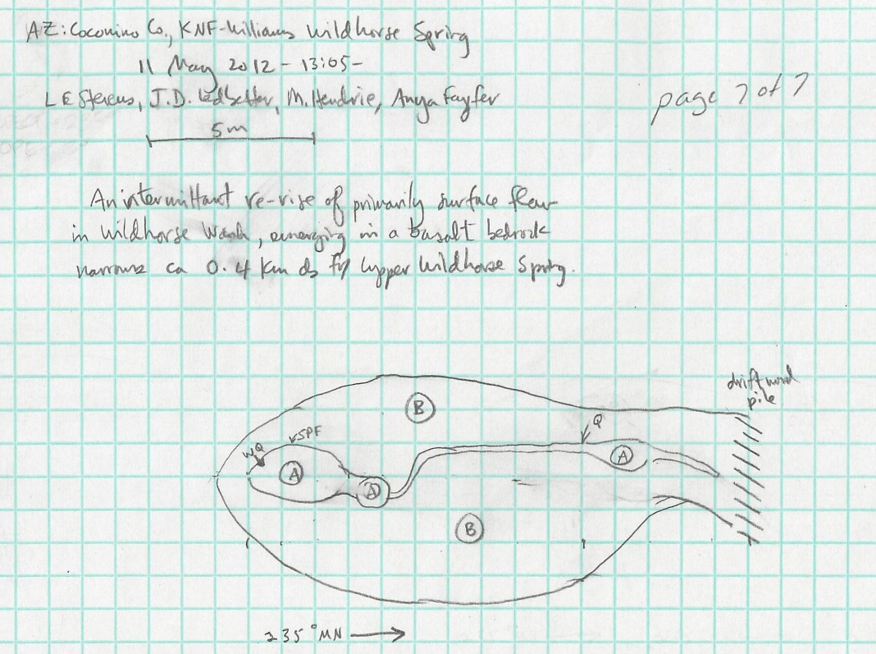
Fig 10.2 Wild Horse Spring Sketchmap.

11. Willard Spring
11. Willard Spring
Survey Summary Report, Site ID 1131
Submitted June 3, 2019 by Springs Stewardship Institute
Location: The Willard Spring ecosystem is located in Coconino County in the Upper Verde Arizona 15060202 HUC, managed by the US Forest Service. The spring is located in the Coconino NF, Mormon Lake RD, in the Munds Park USGS Quad, at 34.97356, -111.68139 measured using a GPS (WGS84, estimated position error 2 meters). The elevation is approximately 2062 meters. Emily Thompson, Sue Ordway, Roy May, Winnie Tanney surveyed the site on 9/20/17 for 01:15 hours, beginning at 11:15, and collected data in 5 of 10 categories. This survey was conducted under the NEPA Cleared List project using the Stevens/GDE hybrid protocol.

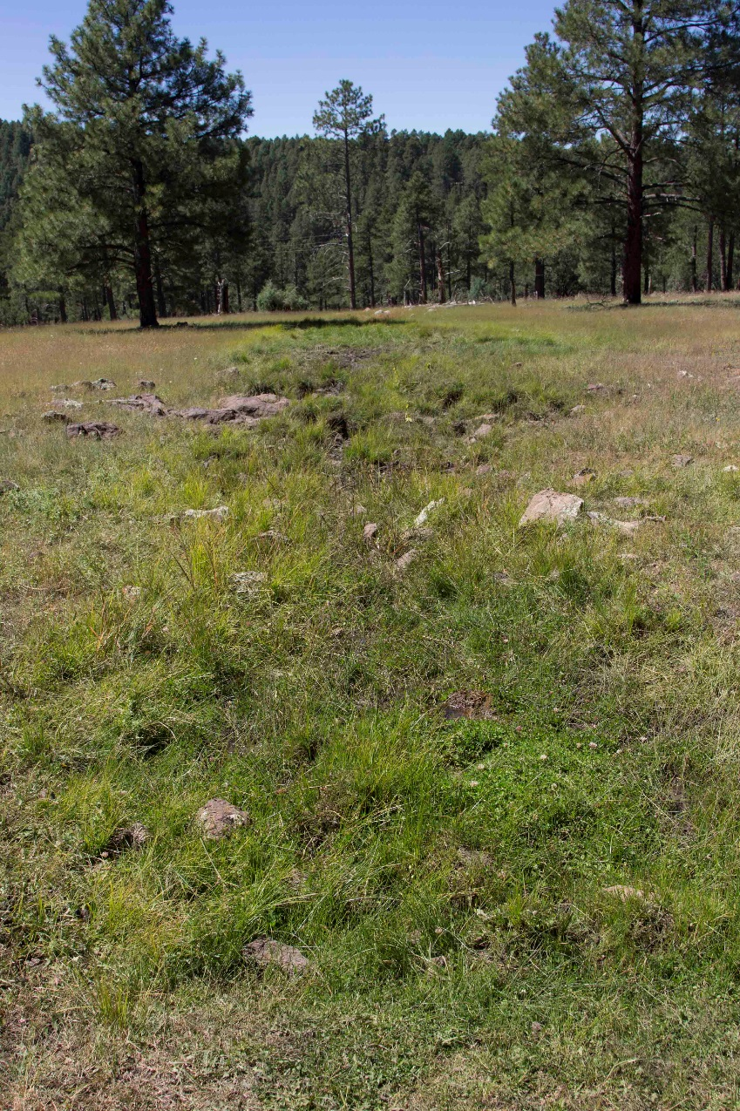
Fig 11.1 Willard Spring: North channel looking southwest

Physical Description: Willard Spring is a helocrene spring. The original site is dry. This spring emerges into two channels and then into a broad meadow. One channel is approximately 20 meters east of the dry spring box. Second channel is approximately 25 m west of the dry spring box. There are large gamble oak trees on the site. White marks on trees indicate this a historical (Old Homestead) or archaeological site. It is piped downstream about 100 meters. Basalt cobble is found throughout the site.

Geomorphology: Willard Spring emerges as a seepage or filtration spring from an igneous, basalt rock layer in an unknown unit. The emergence environment is subaerial, with a gravity flow force mechanism. The site receives approximately 100% of available solar radiation, with 6969 Mj annually.

Access Directions: From I-17, take the Willard Springs exit and park on the east side of the exit where the road is closed. Walk south about 1 km. After about 600 m you will pass the outflow from another spring.

Survey Notes: Water is easily accessible by wildlife. Surface water is present in channels below old spring source but is extremely trampled.

Water Quality: Location 1: at the spring source in standing water at 11:45:00.

Table 11.1 Willard Spring Water Quality with multiple readings averaged.
Characteristic Measured | Average Value | Site Number | Device | Comments
Dissolved Solids (field) | 83 | 1 | DigitalAid meter
pH (field) | 7.22 | 1 | DigitalAid meter | 2nd measurement
Specific conductance (field) (uS/cm) | 177.33333333333 | 1 | DigitalAid meter | 1st measurement
Temperature, air C | 17 | 1 | DigitalAid meter

Fauna: Surveyors collected or observed 8 vertebrate specimens.

Table 11.2 Willard Spring Vertebrates.
Vertebrate Species Common Name | Count | Detection | Comments
Wild Turkey | 18 | obs
Western Bluebird | 8 | obs
Cooper's Hawk | 1 | obs
Steller's Jay | 1 | obs
Abert's Squirrel | 1 | obs
Elk |  | sign
Coyote |  | sign
Red-tailed Hawk | 1 | obs

Management Recommendations: This site is heavily trampled by cattle and elk. It is a candidate for restoration as the water is used by wildlife; keeping livestock out would improve the site condition.

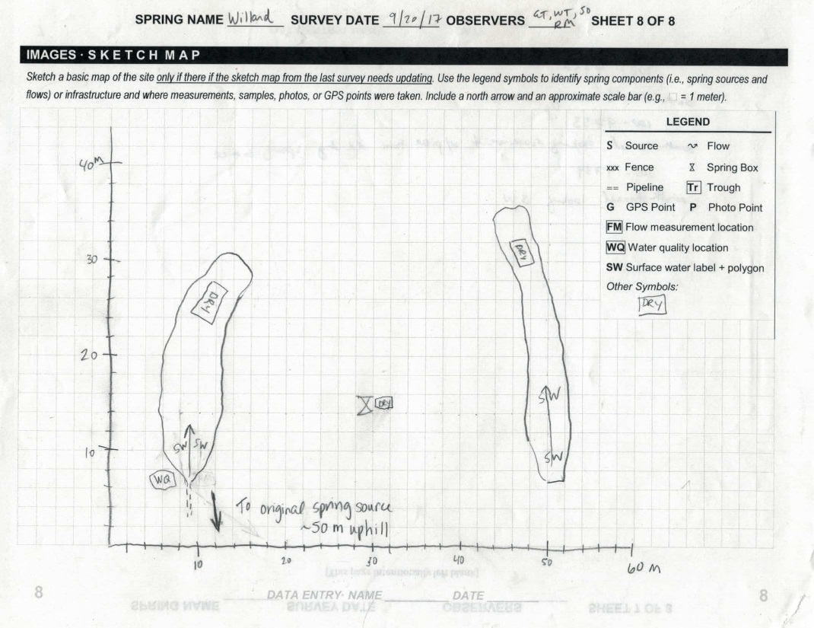
Fig 11.2 Willard Spring Sketchmap.

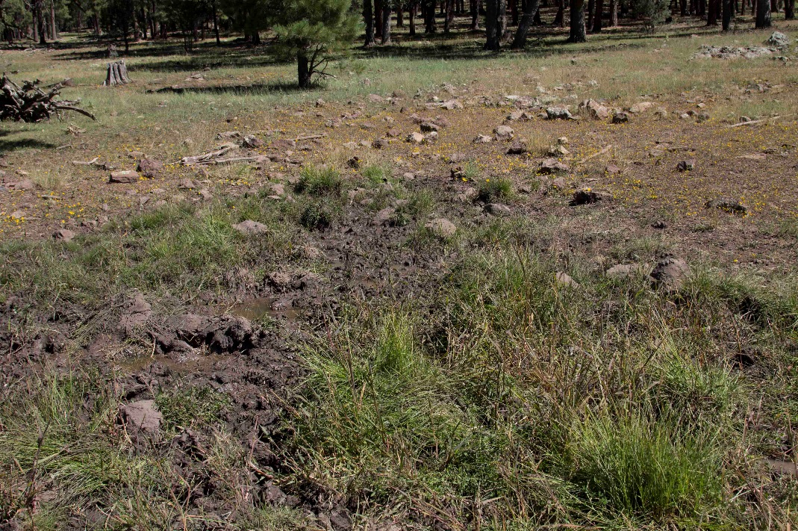
Fig 11.3 Willard Spring: South channel looking northeast toward pipe

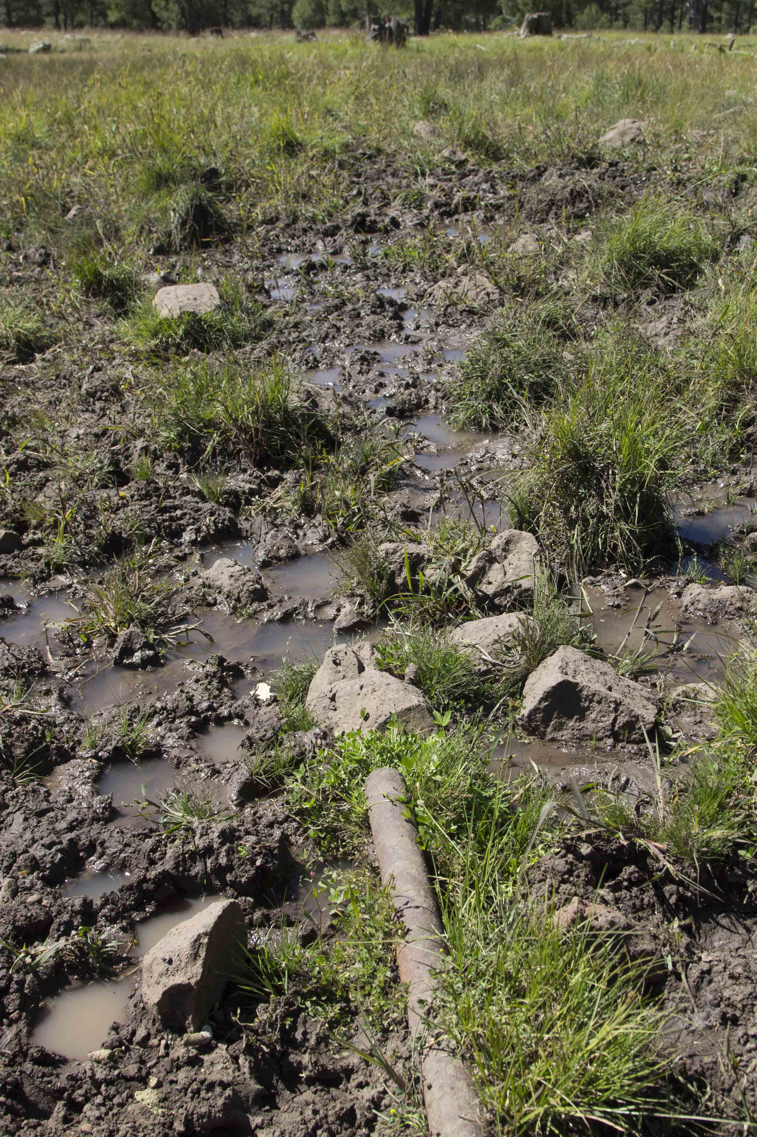
Fig 11.4 Willard Spring: South channel looking southwest with pipe from old spring source

