Contents

1. Babbitt Spring
2. Ritter Spring
3. Willow Spring

1. Babbitt Spring
1. Babbitt Spring
Survey Summary Report, Site ID 805
Submitted June 3, 2019 by Springs Stewardship Institute
Location: The Babbitt Spring ecosystem is located in Coconino County in the Canyon Diablo Arizona 15020015 HUC, managed by the US Forest Service. The spring is located in the Coconino NF, Mormon Lake RD, in the Lower Lake Mary USGS Quad, at 35.06692, -111.53853 measured using a GPS (NAD83, estimated position error 8 meters). The elevation is approximately 2107 meters. V. Markgraf, S. Ordway, and J. Norris surveyed the site on 8/31/10 for 01:25 hours, beginning at 15:40, and collected data in 7 of 10 categories. This survey was conducted under the NEPA Cleared List project using the Stevens et al. Level 2 protocol.

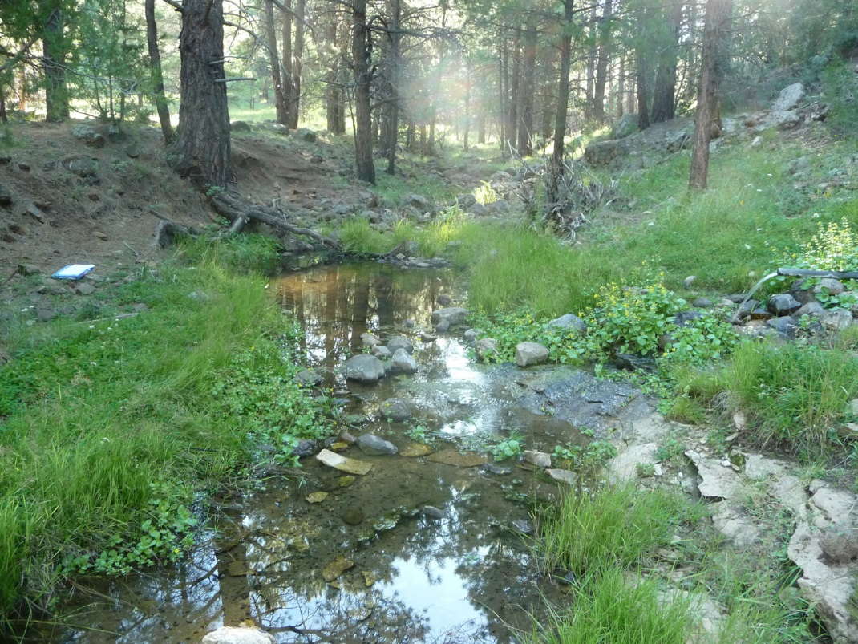
Fig 1.1 Babbitt Spring: CNF Volunteers photo 5/2011

Physical Description: Babbitt Spring is a rheocrene/hillslope spring. The source of this rheocrenic hillslope is piped and outflows into a well-defined channel of volcanic bedrock and boulders. The channel extends greater than 60 m from the springs. There are 2 small pools above the source. A dry drainage channel comes in upstream of the source and there are ruins of a historic cabin nearby. SSI was informed that archaeology at the site is monitored by the Arizona Site Stewards (volunteer site monitoring with Arizona State Parks). The site has 2 microhabitats.

Table 1.1 Babbitt Spring Microhabitat characteristics.
Code | A | B
Name | Channel | Meadow
Area sqm
Surface type | CH | HGC
Surface subtype
Slope variability
Aspect TN
Slope degrees
Moisture (scale 1-10)
Water depth cm
Area % open water
Substrate
1 - Clay % | 0 | 0
2 - Silt % | 0 | 0
3 - Sand % | 0 | 0
4 - Fine gravel % | 0 | 0
5 - Coarse gravel % | 0 | 0
6 - Cobble % | 0 | 0
7 - Boulder % | 0 | 0
8 - Bedrock % | 0 | 0
Organic % | 0 | 0
Other % (anthropogenic) | 0 | 0
Precipitate % | 0 | 0
Litter % | 0 | 0
Wood % | 0 | 0
Litter Depth (cm)

Geomorphology: Babbitt Spring emerges from the Kaibab Limestone, a sedimentary, limestone rock layer. The emergence environment is subaerial, with a gravity flow force mechanism.

Access Directions: From the Crimson Rd exit of Lake Mary Rd (CR-3), head southeast on Crimson Rd to 132D, turn left and continue on 132D to 9420J, where you turn left and continue to the spring, where there is a sign and a short walk down to the spring.

Survey Notes: This survey was conducted by volunteers under the CNF volunteers project, under the direction of Steve Monroe. All flow is piped, and there is some moisture above the pipe where monkeyflower is growing. Pipe is PVC extending into slope. There is a limestone outcrop just behind - 2-3 m from orifice. The pipe area has been excavated some. It is difficult to tell what kind of spring it was originally. The spring flows out of the pipe and hits main runoff channel within 2 m. The channel below spring is wider and flat (3 m) with mostly fine sediment. The runoff channel upstream is mostly volcanic cobbles and boulders. The channel joins another channel about 5 m below spring reach. The length of the channel is greater than 60 m. There were roads/OHV trails at the site, and there was evidence of recreational use and historic human occupation/use. There was flow modification (pipe diversion and excavation). There was a fence preventing vehicle access to the spring; this has been knocked down, and there were vehicle tracks crossing the spring channel. A sign barring motorized vehicles has also been knocked down.
Flow: Surveyors measured a flow of 0.46661 liters/second, using a timed flow volume capture method. The discharge measurement was taken from pipe; small amount of seeping around pipe. The pipe is 2&quot; PVC, so may not last forever.

Water Quality: Measurements were made from a Tupperware put under the pipe. The instrument used was a Hanna Combo.

Table 1.2 Babbitt Spring Water Quality with multiple readings averaged.
Characteristic Measured | Average Value | Site Number | Device | Comments
pH (field) | 7.3033333333333
Specific conductance (field) (uS/cm) | 624
Temperature, water C | 8.9333333333333

Flora: Surveyors identified 29 plant species at the site. These included 21 native and 8 nonnative species.

Table 1.3 Babbitt Spring Cover Type.
Cover Type | Species Count | Wetland Species Count
Ground | 28 | 17
Shrub | 1 | 0
Mid-canopy | 0 | 0
Tall canopy | 0 | 0
Basal | 0 | 0
Aquatic | 0 | 0
Non-vascular | 0 | 0

Table 1.4 Babbitt Spring Vegetation % Cover in Microhabitats.
Species | Cover Code | Native Status | Wetland Status | Comments | A | B
Agrostis scabra | GC | N | W |  | 0 | 30
Carex siccata | GC | N | W |  | 0 | 1
Eleocharis palustris | GC | N | W |  | 5 | 0
Epilobium ciliatum | GC | N | W |  | 0 | 2
Equisetum laevigatum | GC | N | WR |  | 0 | 0.5
Geranium caespitosum | GC | N | F |  | 0 | 0.5
Geranium richardsonii | GC | N | F |  | 0 | 0.5
Glyceria striata | GC | N | W |  | 0 | 0.5
Iris missouriensis | GC | N | F |  | 0 | 1
Juncus ensifolius | GC | N | W |  | 25 | 25
Linaria dalmatica | GC | I | F |  | 0 | 1
Lomatium nevadense var. parishii | GC | N | U | collected with sein net | 0 | 0
Medicago lupulina | GC | I | WR |  | 0 | 1
Mentha arvensis | GC | N | WR |  | 0 | 0.5
Mimulus guttatus | GC | N | W |  | 5 | 0
Monarda fistulosa | GC | N | F |  | 0 | 1
Onopordum acanthium | GC | I | WR |  | 0 | 0.5
Perideridia parishii | GC | N | F |  | 0.5 | 0
Phalaris arundinacea | GC | N | WR |  | 0 | 0.5
Plantago major | GC | I | WR |  | 0 | 0.5
Poa pratensis | GC | I | F |  | 0 | 1
Prunella vulgaris | GC | N | F |  | 0 | 1
Ranunculus cymbalaria | GC | N | W |  | 5 | 0
Rosa woodsii | SC | N | F |  | 1 | 0
Rumex crispus | GC | I | WR |  | 0 | 0.5
Solidago canadensis | GC | N | WR | var. lepidus-Canada? | 0 | 1
Taraxacum officinale | GC | I | F |  | 0 | 3
Veronica anagallis-aquatica | GC | I | A |  | 1 | 0
Viola | GC | N | F |  | 0 | 3

Fauna: Surveyors collected or observed 3 aquatic and 1 terrestrial invertebrates and 1 vertebrate specimens.

Table 1.5 Babbitt Spring Invertebrates.
Species | Lifestage | Habitat | Method | Rep# | Count | Species Detail
Coleoptera |  | A | Spot |  |  | lots of small water beetles
Hemiptera Gerridae |  | A | Spot |  |  | water striders
Mollusca |  | A | Spot |  |  | Many snails - limnec?
Odonata | Ad | T | Spot

Table 1.6 Babbitt Spring Vertebrates.
Vertebrate Species Common Name | Count | Detection | Comments
bird

Assessment: Assessment scores were compiled in 3 categories and 4 subcategories, with 38 null condition scores, and 38 null risk scores. Aquifer functionality and water quality are poor with limited restoration potential and there is high risk. Geomorphology condition is poor with limited restoration potential and there is very high risk. Habitat condition is undetermined due to null scores and there is undetermined risk due to null scores. Biotic integrity is undetermined due to null scores and there is undetermined risk due to null scores. Human influence of site is poor with limited restoration potential and there is very high risk. Administrative context status is undetermined due to null scores and there is undetermined risk due to null scores. Overall, the site condition is poor with limited restoration potential and there is high risk.

Table 1.7 Babbitt Spring Assessment Scores.
Category | Condition | Risk
Aquifer Functionality & Water Quality | 2 | 4
Geomorphology | 2 | 5
Habitat | 0 | 0
Biota | 0 | 0
Human Influence | 2 | 5
Administrative Context | 0 | 0
Overall Ecological Score | 2 | 4.67

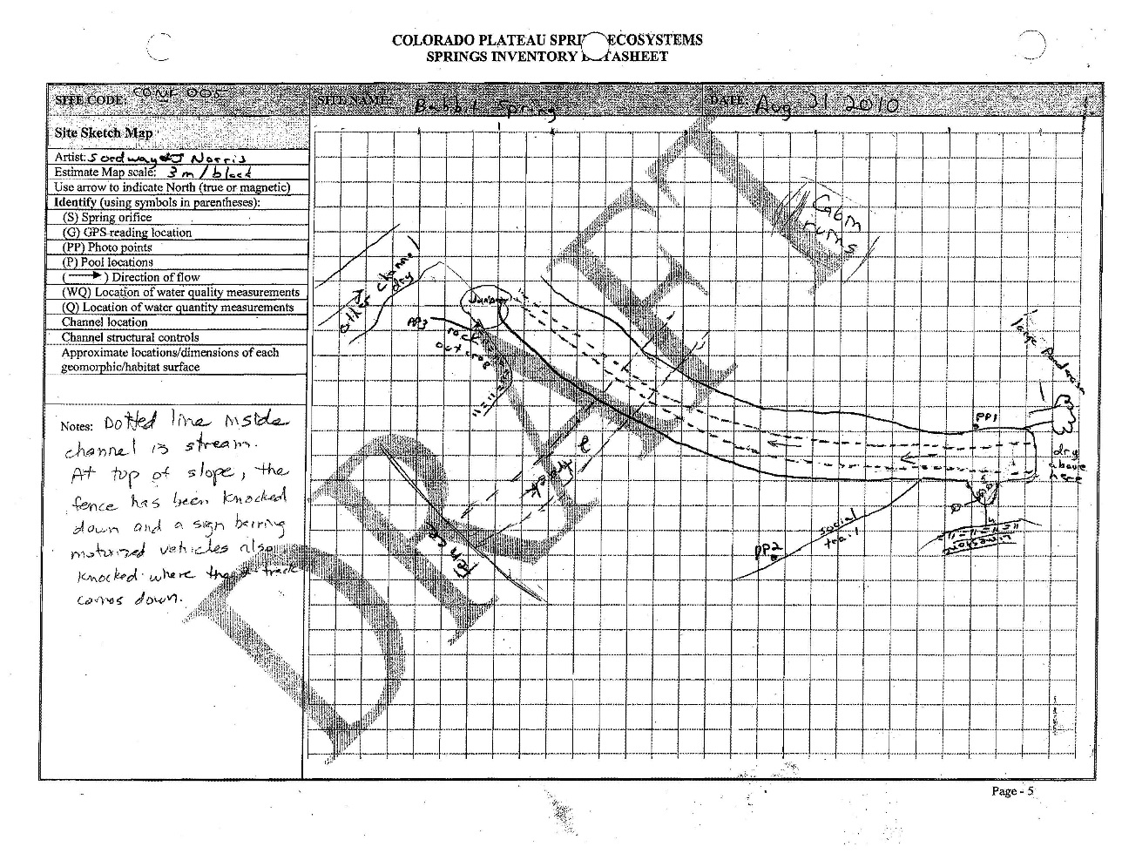
Fig 1.2 Babbitt Spring Sketchmap.

2. Ritter Spring
2. Ritter Spring
Survey Summary Report, Site ID 1073
Submitted June 3, 2019 by Springs Stewardship Institute
Location: The Ritter Spring ecosystem is located in Coconino County in the Upper Verde Arizona 15060202 HUC, managed by the US Forest Service. The spring is located in the Coconino NF, Mormon Lake RD, in the Mountainaire USGS Quad, at 35.00157, -111.70653 measured using a GPS (WGS84). The elevation is approximately 2077 meters. Emily Thompson, Sue Ordway, Winnie Taney, and Roy May surveyed the site on 9/20/17 for 00:55 hours, beginning at 13:45, and collected data in 5 of 10 categories. This survey was conducted under the NEPA Cleared List project using the Stevens/GDE hybrid protocol.

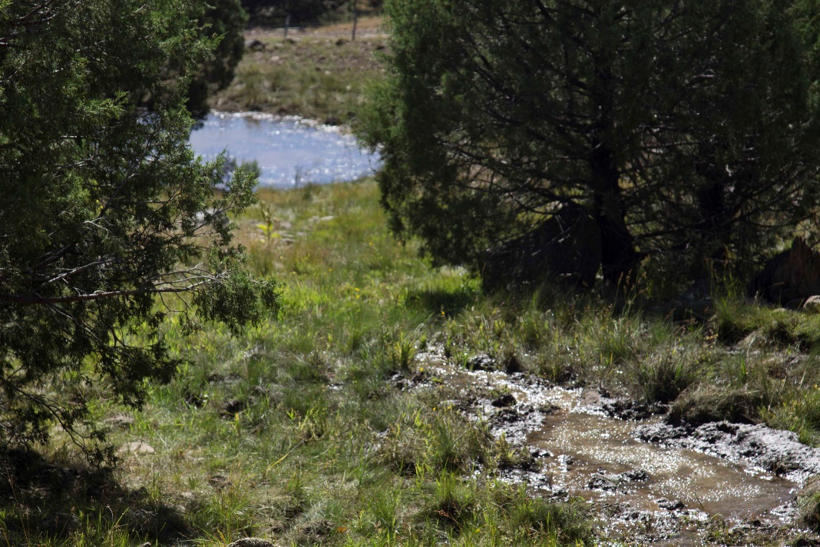
Fig 2.1 Ritter Spring: View from springbox looking downhill

Physical Description: Ritter Spring is a helocrene spring. This spring appears to have been diverted to a holding tank. This site was imported from the geodatabase, a compilation from multiple sources. This is a helocrene spring with a springbox and a non-functioning trough approximately 15 meters below the springbox. Water emerges approximately 20 meters below the springbox, and then pools in a cattle holding tank approximately 75 meters downslope.

Access Directions: From exit 328 on I-17, travel south to NF-9462G via Newman Park Rd. Continue for 1 mi before turning onto NF-253 and continuing for 0.85 mi. Turn right onto NF-9457U and travel NW for 350 m.

Survey Notes: There was extensive standing water at the site, but no flow. There was no cover on the springbox, and no escape ramp for wildlife.

Flow: Flow was adjusted for an estimate of 100% of site flow capture. This spring is perennial.

Water Quality: Water was collected from the springbox. Location 1: at the spring source in other at 00:00:00.

Table 2.1 Ritter Spring Water Quality with multiple readings averaged.
Characteristic Measured | Average Value | Site Number | Device | Comments
Dissolved Solids (field) | 98 | 1 | DigitalAid meter
pH (field) | 6.89 | 1 | DigitalAid meter
Specific conductance (field) (uS/cm) | 241 | 1 | DigitalAid meter
Temperature, air C | 23 | 1 | DigitalAid meter

Fauna: There were numerous cows in the area near the spring. Surveyors collected or observed 5 vertebrate specimens.

Table 2.2 Ritter Spring Vertebrates.
Vertebrate Species Common Name | Count | Detection | Comments
Chipping Sparrow | 3 | obs
Lesser Goldfinch | 1 | obs
Savannah Sparrow | 2 | obs
Coyote |  | sign | Scat
Domestic Cow |  | sign | Scat

Management Recommendations: This would be a great candidate for restoration. The spring has much surface water along the hillslope, but it is heavily trampled by cattle. One possibility is to fence off the spring ecosystem on the hillslope, while allowing cattle and wildlife to access the water in the holding tank below. Another possible restoration effort could be to remove the old fencing. The springbox needs a cover. The non-functioning trough and piping could be removed.

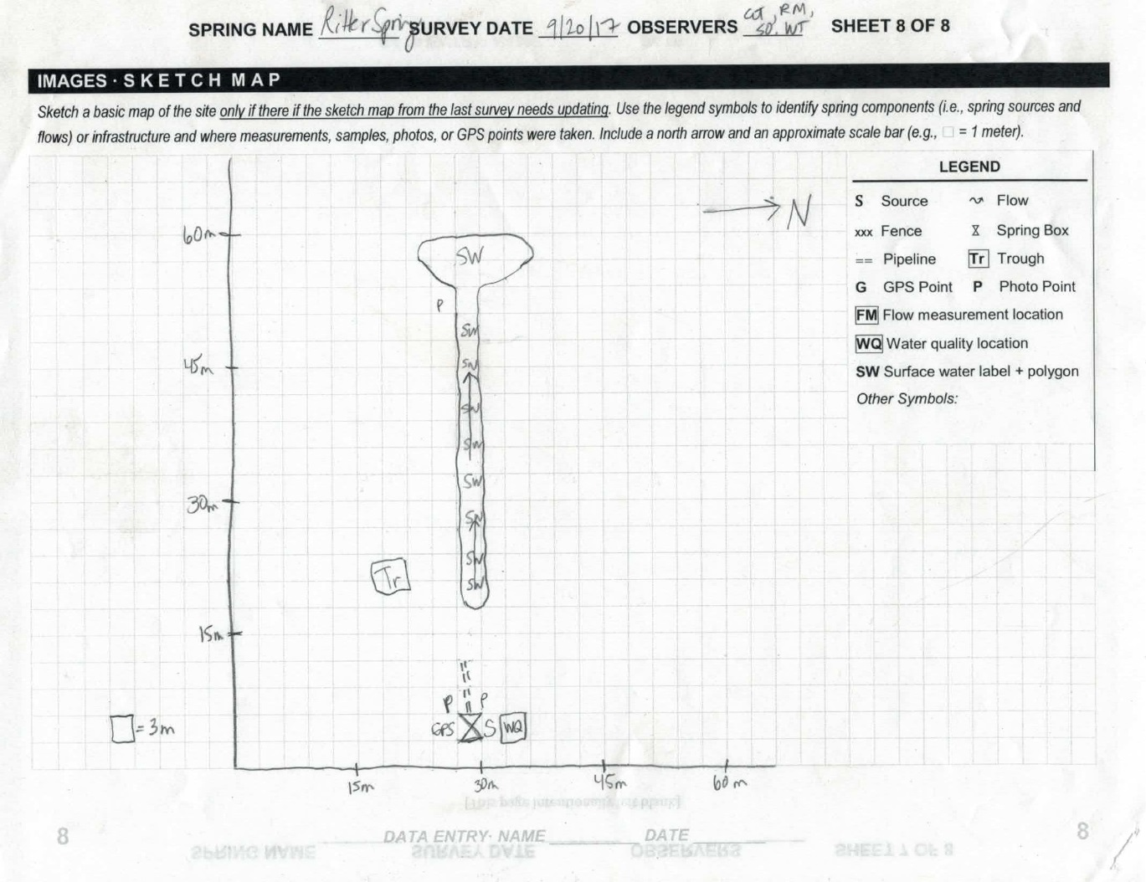
Fig 2.2 Ritter Spring Sketchmap.

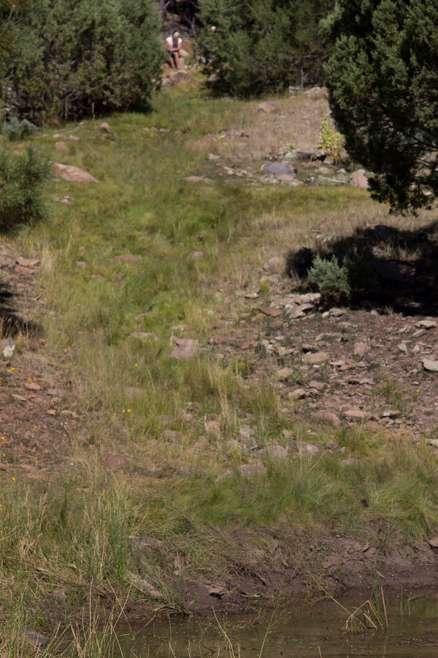
Fig 2.3 Ritter Spring: View from holding tank looking uphill toward springbox

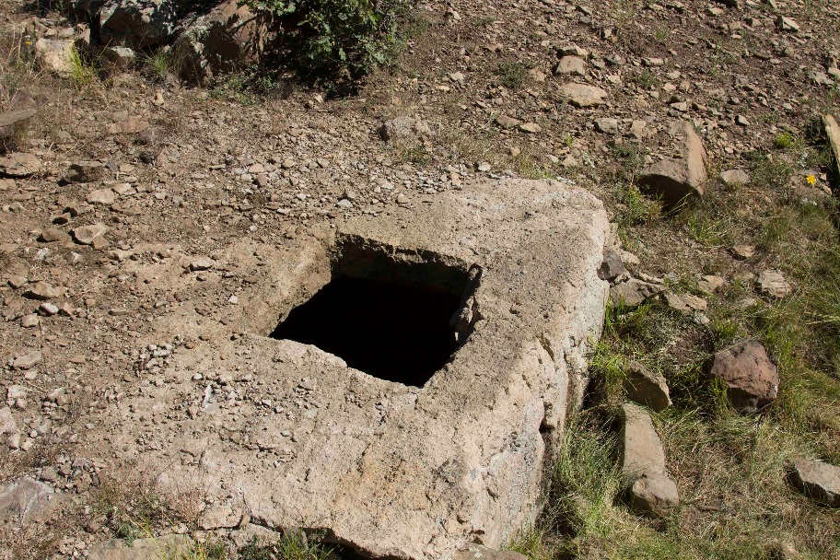
Fig 2.4 Ritter Spring: View of springbox with no cover

3. Willow Spring
3. Willow Spring
Survey Summary Report, Site ID 640
Submitted June 3, 2019 by Springs Stewardship Institute
Location: The Willow Spring ecosystem is located in Coconino County in the Upper Verde Arizona 15060202 HUC, managed by the US Forest Service. The spring is located in the Kaibab NF, Williams RD, in the Davenport Hill USGS Quad, at 35.13389, -112.02822 measured using a GPS (NAD83, estimated position error 3 meters). The elevation is approximately 1980 meters. Lisa Winters, Chantel Cook, Winnie Taney, and Irene Hamilton surveyed the site on 9/08/16 for 03:00 hours, beginning at 13:30, and collected data in 8 of 10 categories. This survey was conducted under the NEPA Cleared List project using the Stevens et al. Level 2 protocol.

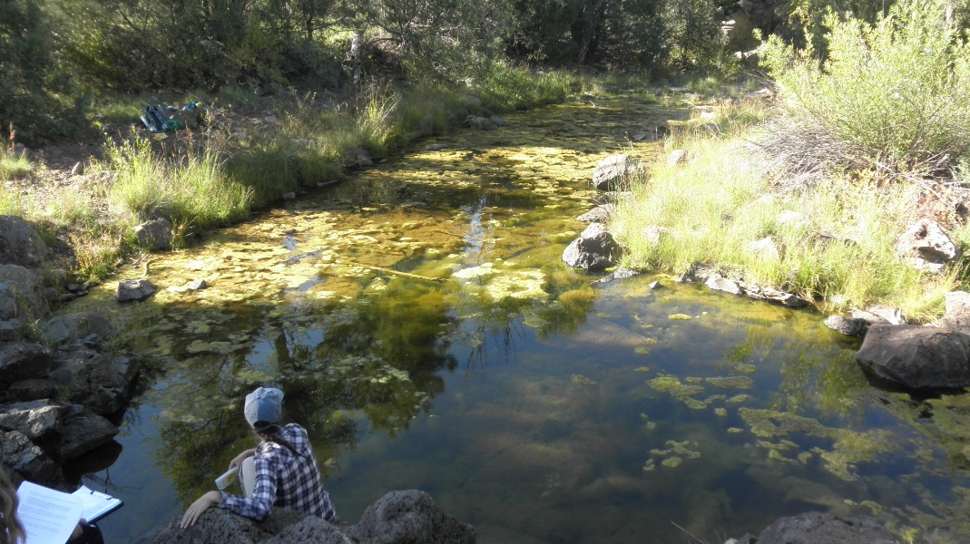
Fig 3.1 Willow Spring: Looking downstream from source

Physical Description: Willow Spring is a rheocrene/limnocrene spring. This is a small pool-forming perennial spring, or a tinaja, emerging from a basalt ledge orifice. It emerges in a dynamic channel that is subject to heavy surface runoff that flows into Sycamore Canyon. The microhabitats associated with the spring cover 182 sqm. The site has 3 microhabitats, including A -- a 182 sqm pool, B -- a 0 sqm backwall, D -- a 0 sqm terrace.

Table 3.1 Willow Spring Microhabitat characteristics.
Code | A | B | D
Name | Source Pool | Dry Backwall | LRZ Terrace
Area sqm | 182
Surface type | P | BW | TE
Surface subtype
Slope variability | Low | Low | Low
Aspect TN | 340
Slope degrees | 0
Moisture (scale 1-10) | 6 | 0 | 2
Water depth cm | 76.2
Area % open water | 45
Substrate
1 - Clay % | 0 | 0 | 0
2 - Silt % | 0 | 0 | 0
3 - Sand % | 0 | 0 | 0
4 - Fine gravel % | 0 | 0 | 0
5 - Coarse gravel % | 0 | 0 | 0
6 - Cobble % | 0 | 0 | 0
7 - Boulder % | 0 | 0 | 0
8 - Bedrock % | 0 | 0 | 0
Organic % | 0 | 0 | 0
Other % (anthropogenic) | 0 | 0 | 0
Precipitate % | 0 | 0 | 0
Litter % | 0 | 0 | 0
Wood % | 0 | 0 | 0
Litter Depth (cm)

Geomorphology: Willow Spring emerges as a seepage or filtration spring from the basalt flow, an igneous, basalt rock layer. The emergence environment is subaerial, with a gravity flow force mechanism. The site receives approximately 100% of available solar radiation, with 7324 Mj annually.

Access Directions: Please examine a map closely before proceeding to this site. Some of the roads listed below may be closed or not accessible. Take County Rd 73 (S Perkinsville Rd) south from Williams, AZ to Forest Rd 110 (Prairie Edge Rd). Turn left onto Forest Rd 110. Turn left onto Forest Rd 747. Turn right onto Forest Rd 14. Turn left onto Davenport Hill Rd (Forest Rd 109). Continue ~100 meters; the spring is east of Davenport Hill Rd, approximately 200 meters.

Survey Notes: There is more algae cover present at the time of this survey than previously surveyed. High water levels may be present from recent monsoon rains, as there are numerous small pockets/pools of water in cracks of basalt boulders above back wall.
Surveyors also observed crayfish and algae present in the main pool.

Flow: No flow to measure, but there is a large pool of water.

Water Quality: There was no observable flow at time of survey. Monitoring instruments were calibrated on 2016/9/8.

Table 3.2 Willow Spring Water Quality with multiple readings averaged.
Characteristic Measured | Average Value | Site Number | Device | Comments
pH (field) | 9.77 |  | DigitalAid meter
Specific conductance (field) (uS/cm) | 57 |  | DigitalAid meter
Temperature, air C | 27 |  | DigitalAid meter
Temperature, water C | 24 |  | DigitalAid meter

Flora: Algae covers 55% of the pool polygon.

Fauna: Surveyors collected or observed 2 aquatic and 2 terrestrial invertebrates and 5 vertebrate specimens.

Table 3.3 Willow Spring Invertebrates.
Species | Lifestage | Habitat | Method | Rep# | Count | Species Detail
Decapoda Cambaridae Procambarus | Ad | A | Spot |  |  | many
Hemiptera Gerridae | Ad | A | Spot |  |  | more than 50
Lepidoptera | Ad | T | Spot
Odonata | Ad | T | Spot |  | 1

Table 3.4 Willow Spring Vertebrates.
Vertebrate Species Common Name | Count | Detection | Comments
Frog | 3 | obs
Steller's Jay | 1 | obs
Common Raven | 1 | call
Domestic Cow | 1 | sign
American Crow | 1 | obs

Assessment: Assessment scores were compiled in 5 categories and 33 subcategories, with 9 null condition scores, and 9 null risk scores. Aquifer functionality and water quality are moderate with some restoration potential and there is low risk. Geomorphology condition is good with significant restoration potential and there is moderate risk. Habitat condition is good with significant restoration potential and there is low risk. Biotic integrity is moderate with some restoration potential and there is low risk. Human influence of site is good with significant restoration potential and there is negligible risk. Administrative context status is undetermined due to null scores and there is undetermined risk due to null scores. Overall, the site condition is good with significant restoration potential and there is low risk.

Table 3.5 Willow Spring Assessment Scores.
Category | Condition | Risk
Aquifer Functionality & Water Quality | 3.7 | 2
Geomorphology | 4.6 | 3
Habitat | 4.2 | 2.6
Biota | 3.6 | 2
Human Influence | 4.7 | 1.7
Administrative Context | 0 | 0
Overall Ecological Score | 4.2 | 2.2

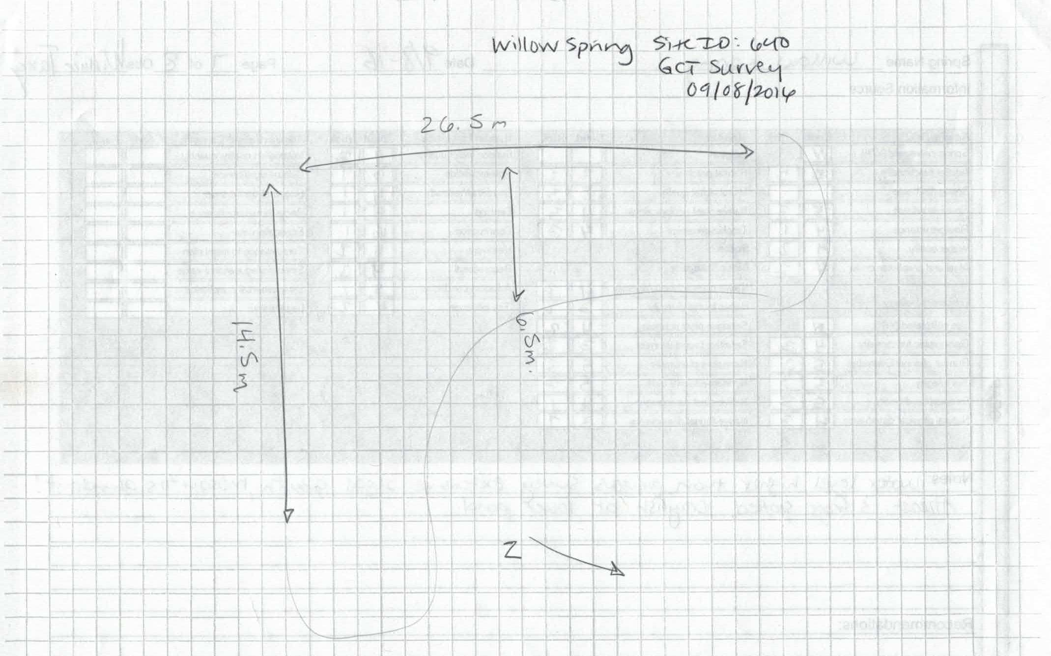
Fig 3.2 Willow Spring Sketchmap.

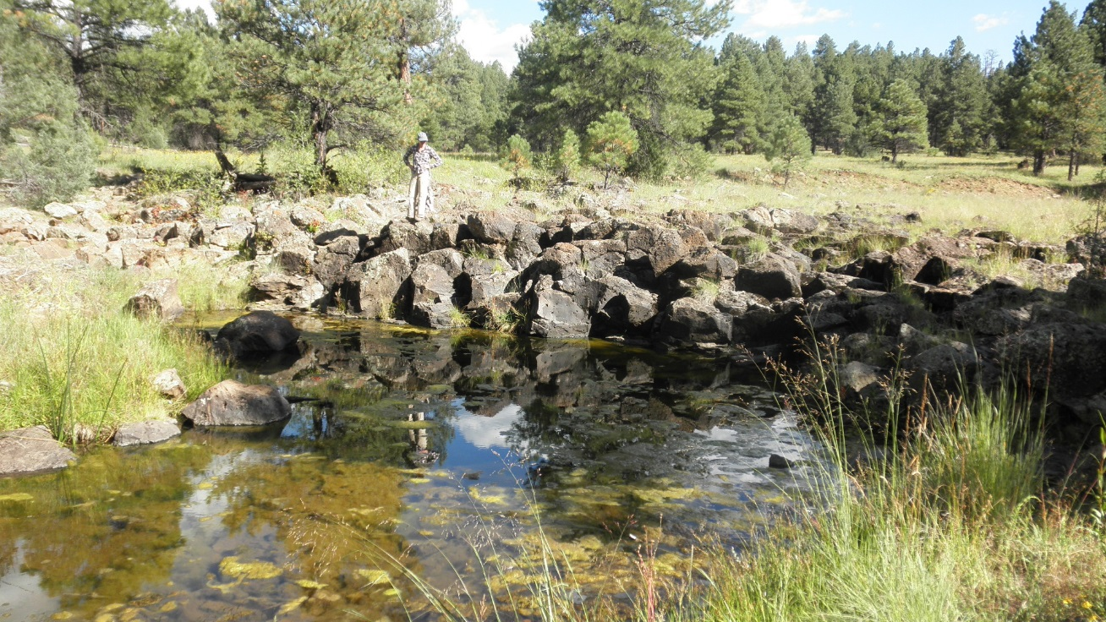
Fig 3.3 Willow Spring: Looking towards source

