Kaibab Springs Summary Report Volume 1

1. Bear Canyon upper spring, 8/28/18 2
2. Big Ridge Tank, 9/09/18 3
3. Big Spring, 6/11/18 4
4. Buck Spring, 8/02/19 11
5. Campbell Spring, 8/28/18 19
6. Clover Spring, 5/19/19 25
7. Dow Spring, 5/13/16 28
8. East Elk Spring, 7/05/17 32
9. East Twin Spring, 7/29/19 41
10. Hat Tank lower, 5/08/12 49
11. Hat Tank upper, 5/08/12 55
12. Hell Canyon Spring, 8/28/18 62
13. Klostermeyer Spring, 6/09/18 63
14. L O Spring, 5/26/15 65
15. Lee Canyon Upper Spring, 9/19/19 74
16. Lower McDermit Spring, 9/19/19 79
17. Mineral Spring, 8/27/20 86
18. Mud Springs, 7/29/19 97
19. Rocky LO Lower, 6/08/18 104
20. Rosilda Spring, 7/29/19 109

1. Bear Canyon upper spring, 8/28/18
1. Bear Canyon upper spring, 8/28/18
Survey Summary Report, Site ID 784
Submitted 6/01/21 by Springs Stewardship Institute

This location was previously reported as a spring, but on 8/28/18 surveyors determined that there is no spring at this location.

Location: The Bear Canyon upper spring ecosystem is located in Coconino County in the Upper Verde Arizona 15060202 HUC, managed by the US Forest Service. The site is located in the Kaibab NF, Williams RD, in the May Tank Pocket USGS Quad, at 35.09952, -112.17826 measured using a GPS (WGS84). The elevation is approximately 2062 meters. Jeri Ledbetter, Alek Mendoza, and Gloria Hardwick verified the site on 8/28/18 at 16:00. This survey was conducted under a Kaibab Springs project using the Stevens et al. Level 1 protocol.

Physical Description: Bear Canyon upper spring is a rheocrene spring. This unnamed spring is depicted on the DRG and is included in the NHD database. The site is located in a drainage channel where surface water pools, but no groundwater influence is apparent. Surveyors in 2012, 2013, and 2018 found no evidence of a spring.

Geomorphology: Bear Canyon upper spring emerges from a igneous, basalt rock layer.

Survey Notes: This site is mapped in the middle of a channel and there was no spring apparent. Surveyors did not find any sign of water. Chickadees and corn woodpeckers were observed in the area.

2. Big Ridge Tank, 9/09/18
2. Big Ridge Tank, 9/09/18
Survey Summary Report, Site ID 237699
Submitted 6/01/21 by Springs Stewardship Institute

Location: The Big Ridge Tank ecosystem is located in Coconino County in the Kanab Arizona, Utah 15010003 HUC, managed by the US Forest Service. The spring is located in the Kaibab NF, North Kaibab RD, in the Jacob Lake USGS Quad, at 36.71499, -112.18795 (WGS84). The elevation is approximately 2362 meters. Nataly Levine, Sarah Armanovs verified the site on 9/09/18 at 12:00. This survey was conducted under a Kaibab Springs project using the Stevens et al. Level 1 protocol.

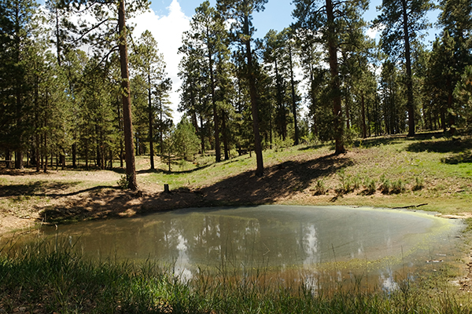
Fig 2.1 Big Ridge Tank.

Physical Description: Big Ridge Tank is a anthropogenic spring.

Survey Notes: There is evidence of cattle around the tank. However the tank bed does not seem to be trampled.

3. Big Spring, 6/11/18
3. Big Spring, 6/11/18
Survey Summary Report, Site ID 739
Submitted 6/01/21 by Springs Stewardship Institute

Location: The Big Spring ecosystem is located in Coconino County in the Upper Verde Arizona 15060202 HUC, managed by the US Forest Service. The spring is located in the Kaibab NF, Williams RD, in the Davenport Hill USGS Quad, at 35.15812, -112.08072 measured using a GPS (WGS84, estimated position error 2 meters). The elevation is approximately 2088 meters. Andrea Hazelton, Alek Mendoza, Tierney Schipper, and Jenna Norris surveyed the site on 7/30/19 for 01:25 hours, beginning at 11:40, and collected data in 10 of 10 categories. This survey was conducted under the 4FRI 5-year Monitoring project using the Stevens et al. Level 2 protocol.

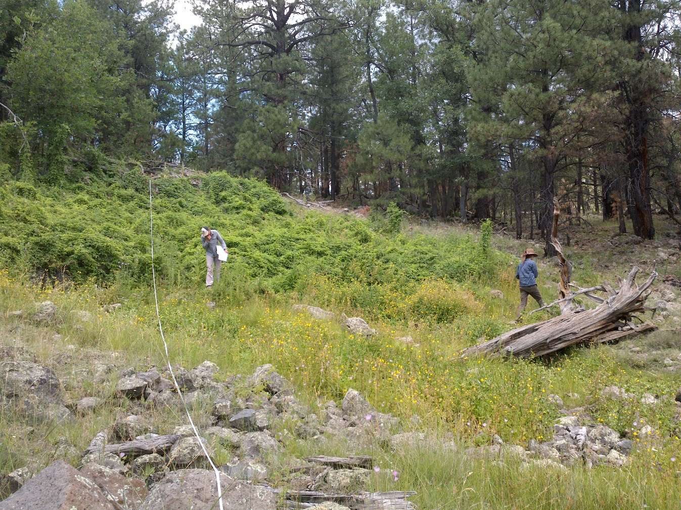
Fig 1.1 Big Spring: View from 11 meters on the transect tape in the channel, facing upstream towards the colluvial slope.

Physical Description: Big Spring is a hillslope spring. This spring is part of the SSI 4FRI Springs Monitoring Project and is located within a control area. Flow emerges from boulders in an eroding basalt flow margin. Surveyors found multiple seepage points located along the base of the colluvial slope. Flow converges and forms a channel downslope of the source. The surrounding area is heavily forested. The source has been manipulated with piping and subjected to long-term trampling. The site appears to have been fenced in the past, however as of 2019 surveyors noted that both the fencing and piping appeared to have been dysfunctional for some time. On October 12, 2019, Ed Schenk installed a Hobo Tidbit MX2203 data logger at the southern (smaller) source under a rock. The sensor was in 4 mm of water. A stream gauge (Troll) exists about 100 meters downstream of the source and is maintained by NAU. On May 6, 2020, surveyors secured the device to rebar at the original location. On May 23, 2021, a surveyor could not locate the Hobo device, and re-deployed a new one at the same location, secured to a PVC and longer rebar with heavy wire. The microhabitats associated with the spring cover 359 sqm. The site has 3 microhabitats, including A -- a 109 sqm channel, B -- a 32 sqm terrace, C -- a 218 sqm colluvial slope. The geomorphic diversity is 0.38, based on the Shannon-Weiner diversity index.

Table 1.1 Big Spring Microhabitat characteristics.
Code | A | B | C
Name | Source Channel | Terrace | Colluvial slope
Area sqm | 109 | 32 | 218
Surface type | CH | TE | CS
Surface subtype
Slope variability | Low | Low | Med
Aspect TN | 131 |  | 131
Slope degrees | 5 | 2 | 12
Moisture (scale 1-10) | 9 | 2 | 0
Water depth cm | 14 | 0 | 1
Area % open water | 85 | 0 | 1
Substrate
1 - Clay % | 4 | 3 | 2
2 - Silt % | 45 | 30 | 25
3 - Sand % | 10 | 5 | 3
4 - Fine gravel % | 5 | 4 | 2
5 - Coarse gravel % | 0 | 10 | 3
6 - Cobble % | 24 | 35 | 31
7 - Boulder % | 2 | 3 | 20
8 - Bedrock % | 0 | 0 | 7
Organic % | 10 | 5 | 7
Other % (anthropogenic) | 0 | 5 | 0
Precipitate % | 0 | 0 | 0
Litter % | 1 | 2 | 1
Wood % | 9 | 3 | 0
Litter Depth (cm) | 0.01 | 0.3 | 0.1

Geomorphology: Big Spring emerges as a contact from a igneous, basalt rock layer. The emergence environment is subaerial, with a gravity flow force mechanism. The site receives approximately 95% of available solar radiation, with 6510 Mj annually.

Access Directions: From the town of Williams, travel south on County Rd 73 (Perkinsville Rd) for 7.15 mi. Turn left and head east onto NF-139 (Overland) for 4.5 miles. Follow an unmarked dirt road to the south until it becomes too rough. Hike 800 m to the spring.

Survey Notes: The rusted and buried pipe on the north side of the site where the colluvial slope (C) meets the channel (A) still produces a trickle of flow. The site is in a healthy condition with minimal signs of recent grazing. Surveyors observed fire scarring in the area that had not been noted during previous surveys.

Flow: Surveyors measured a flow of 1 liters/second, using a timed flow volume capture method. Flow was measured about 60 meters downstream of the outflow pipe (75 meters on the transect tape). This spring is perennial.

Water Quality: Surveyors collected water quality less than one meter downstream of the outflow pipe. Location 1: at the spring source in flowing water at 12:12.

Table 1.2 Big Spring Water Quality Measurements.
Characteristic Measured | Value | Location Number | Device
Alkalinity, Total (mg/L) | 60 | 1 | LaMotte
Dissolved oxygen (field) (mg/L) | 3.5 | 1 | CHEMets DO kit
Dissolved Solids (field) (ppt) | 0.062 | 1 | Hanna Multi 98194
pH (field) | 7.42 | 1 | Hanna Combo
pH (field) | 7.1 | 1 | Hanna Multi 98194
Specific conductance (field) (uS/cm) | 124 | 1 | Hanna Combo
Specific conductance (field) (uS/cm) | 124 | 1 | Hanna Multi 98194
Temperature, air C | 24 | 1 | Handheld therm
Temperature, water C | 12.2 | 1 | Hanna Combo
Temperature, water C | 10.7 | 1 | Hanna Multi 98194

Flora: Andrea Hazelton was the botanist for this survey. Surveyors identified 34 plant species at the site, with 0.0947 species/sqm. These included 27 native and 7 nonnative species.

Table 1.3 Big Spring Cover Type.
Cover Type | Species Count | Wetland Species Count
Ground | 29 | 10
Shrub | 4 | 0
Mid-canopy | 2 | 0
Tall canopy | 0 | 0
Basal | 0 | 0
Aquatic | 0 | 0
Non-vascular | 1 | 0

Table 1.4 Big Spring Vegetation % Cover in Microhabitats.
Plant Species | Cover Code | Native Status | Wetland Status | Comments | A | B | C
Achillea millefolium | GC | NI | U |  | 0 | 5 | 0
Brassicaceae | GC | NI |  | annual; cf. Arabis | 0 | 0.1 | 0.1
Bromus tectorum | GC | I | U |  | 0 | 1 | 3
Cirsium arvense | GC | I | F |  | 0.1 | 2 | 2
Dracocephalum parviflorum | GC | N | WR |  | 0 | 0 | 1
Eleocharis | GC | N | W |  | 5 | 0 | 0
Epilobium ciliatum | GC | N | W |  | 0.1 | 0.1 | 0
Geranium caespitosum | GC | N | F |  | 0 | 5 | 0.5
Hypericum scouleri | GC | N | WR |  | 0.1 | 1 | 0
Iris missouriensis | GC | N | F |  | 0 | 5 | 0
Juncus interior | GC | N | WR |  | 2 | 5 | 0
Juncus xiphioides | GC | N | W |  | 2 | 1 | 0
Lactuca serriola | GC | I | F |  | 0 | 0 | 0.1
Lepidium | GC | NI | F |  | 0 | 0.1 | 0.1
Mimulus guttatus | GC | N | WR |  | 50 | 0.1 | 0
Monardella odoratissima | GC | N | F |  | 0.1 | 1 | 0.5
Muhlenbergia | GC | N | U |  | 0.5 | 20 | 0
Parthenocissus quinquefolia | SC | N | F |  | 0.1 | 0 | 90
Perideridia parishii | GC | N | F |  | 0 | 2 | 0
Pinus ponderosa | MC | N | U |  | 0 | 0 | 1
Pinus ponderosa | SC | N | U |  | 0 | 0.5 | 2
Poa pratensis | GC | NI | F |  | 0.5 | 15 | 2
Prunella vulgaris | GC | N | F |  | 0.1 | 1 | 0
Quercus gambelii | MC | N | U |  | 0 | 0 | 2
Quercus gambelii | SC | N | U |  | 0 | 0 | 6
Ranunculus cymbalaria | GC | N | W |  | 30 | 0 | 0
Rosa woodsii | SC | N | F |  | 0.1 | 0 | 2
Rumex crispus | GC | I | WR |  | 0.1 | 1 | 1
Sidalcea neomexicana | GC | N | WR |  | 0.1 | 2 | 2
Solidago | GC | N | F |  | 0 | 0.5 | 0.1
Taraxacum officinale | GC | NI | F |  | 0 | 0.5 | 0
Tragopogon dubius | GC | I | F |  | 0 | 0 | 0.1
Trifolium | GC | I | WR |  | 0 | 2 | 0
unknown Bryophyte (moss, liverwort, hornwort) | NV | N? | WR |  | 0.1 | 0 | 0
Verbascum thapsus | GC | I | U |  | 0 | 0.1 | 0.1
Viola nephrophylla | GC | N | WR |  | 0 | 1 | 0

Fauna: Surveyors collected or observed 9 aquatic and 3 terrestrial invertebrate taxa and 2 vertebrate taxa.

Table 1.5 Big Spring Invertebrates.
Species | Lifestage | Habitat | Method | Rep# | Count | Species Detail
Basommatophora Physidae | Ad | A | Collected spot |  | 1
Diptera Chironomidae | L | A | Collected spot |  | 1
Diptera Dolichopodidae | Ad | T | Collected spot |  | 1
Diptera Simuliidae Simulium | L | A | Collected spot |  | 2
Hemiptera Belostomatidae Abedus | L | A | Collected spot |  | 2
Hemiptera Gerridae Aquarius remigis | Ad | A | Collected spot |  | 1 | male
Lepidoptera Papilionidae Papilio rutulus | Ad | T | Spot |  | 1
Lumbriculida | Ad | A | Collected spot |  | 1
Odonata | Ad | T | Spot |  |  | many damsel flies
Odonata Coenagrionidae Argia | L | A | Collected spot |  | 6
Sphaeriida Sphaeriidae Pisidium | Ad | A | Collected spot |  | 1
Trichoptera Hydropsychidae Hydropsyche | L | A | Collected spot |  | 1

Table 1.6 Big Spring Vertebrates.
Vertebrate Species Common Name | Count | Detection | Comments
Elk |  | sign | scat
Steller's Jay | 1 | obs

Assessment: Assessment scores were compiled in 5 categories and 33 subcategories, with 9 null condition scores, and 9 null risk scores. Aquifer functionality and water quality are good with significant restoration potential (average condition score 4.5) and there is moderate risk (average risk score 3.2). Geomorphology condition is good with significant restoration potential (average condition score 4.2) and there is moderate risk (average risk score 3.8). Habitat condition is good with significant restoration potential (average condition score 4.2) and there is low risk (average risk score 2.4). Biotic integrity is good with significant restoration potential (average condition score 4) and there is low risk (average risk score 2.1). Human influence of site is good with significant restoration potential (average condition score 4.4) and there is moderate risk (average risk score 3). Overall, the site condition is good with significant restoration potential and there is low risk.

Table 1.7 Big Spring Assessment Scores. Condition scores range from 0 (extremely poor condition) to 6 (pristine condition) and risk scores range from 0 (no risk to the site) to 6 (extreme risk to the site).
Category | Condition | Risk
Aquifer Functionality & Water Quality | 4.5 | 3.2
Geomorphology | 4.2 | 3.8
Habitat | 4.2 | 2.4
Biota | 4 | 2.1
Human Influence | 4.4 | 3
Overall Ecological Score | 4.3 | 2.8

Management Recommendations: The surveyors recommend removing the non-functioning metal piping and down barbed wire. Surveyors also recommend re-fencing the source to maintain the integrity of the spring and vegetation.

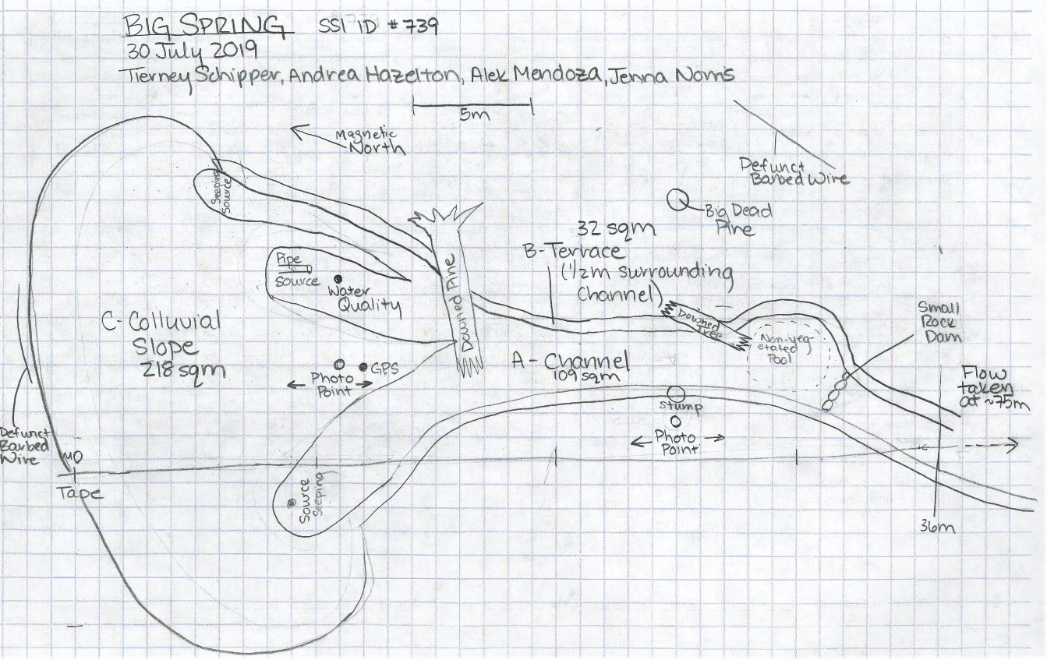
Fig 1.2 Big Spring Sketchmap.

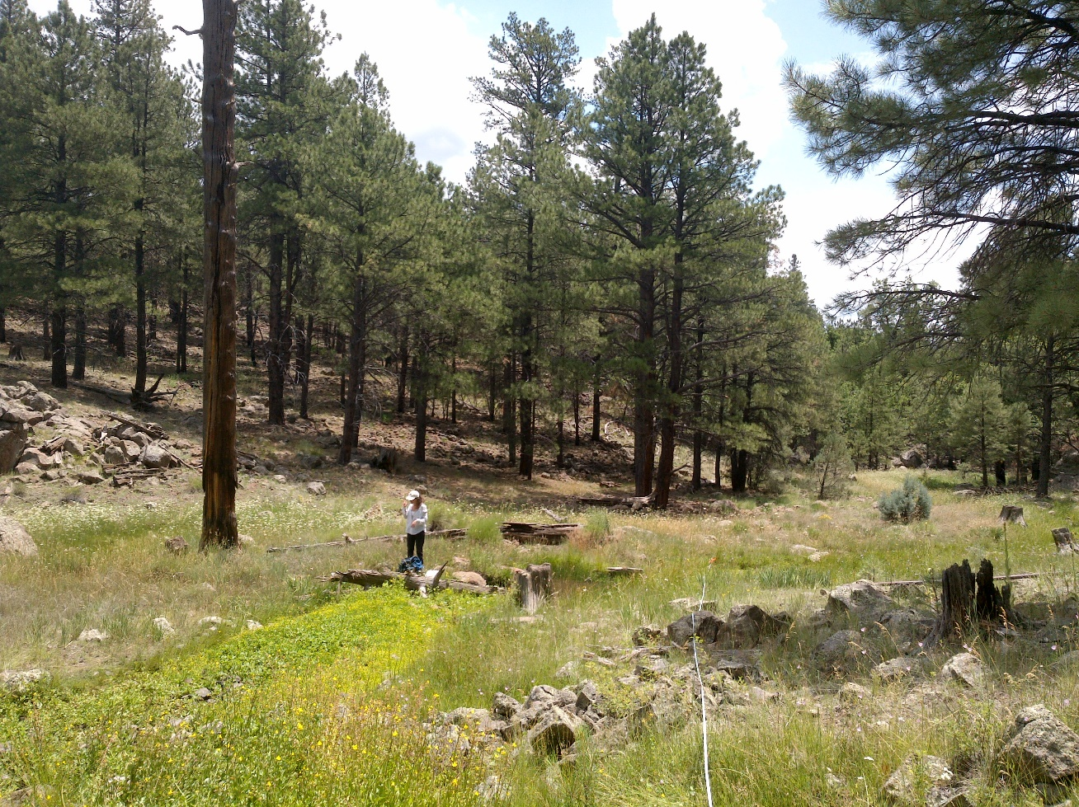
Fig 1.3 Big Spring: View from 25 meters on the transect tape, downstream of the channel.

4. Buck Spring, 8/02/19
4. Buck Spring, 8/02/19
Survey Summary Report, Site ID 741
Submitted 6/01/21 by Springs Stewardship Institute

Location: The Buck Spring ecosystem is located in Coconino County in the Upper Verde Arizona 15060202 HUC, managed by the US Forest Service. The spring is located in the Kaibab NF, Williams RD, in the Davenport Hill USGS Quad, at 35.18881, -112.04959 measured using a GPS (WGS84, estimated position error 2 meters). The elevation is approximately 2077 meters. Jeri Ledbetter, Andrea Hazelton, and Alek Mendoza surveyed the site on 8/02/19 for 01:25 hours, beginning at 12:15, and collected data in 8 of 10 categories. This survey was conducted under a Kaibab Springs project using the Stevens et al. Level 2 protocol.

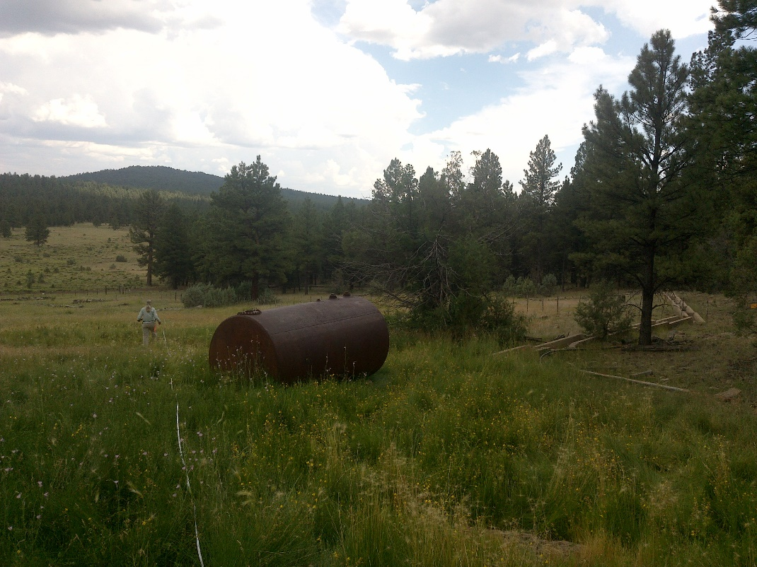
Fig 4.1 Buck Spring: View facing downhill taken ten meters above the tank.

Physical Description: Buck Spring is a helocrene spring. This is a medium-sized east-facing helocrene spring on a 9 degree slope. It has been manipulated and piped for livestock use. There is a well upslope of the spring, and troughs below and to the right. The microhabitat associated with the spring covers 508 sqm. The site has 1 microhabitat, A -- a 508 sqm low gradient cienega.

Table 4.1 Buck Spring Microhabitat characteristics.
Code | A
Name | LGC Upper
Area sqm | 508
Surface type | LGC
Surface subtype
Slope variability | Low
Aspect TN | 11
Slope degrees | 9
Moisture (scale 1-10) | 2
Water depth cm | 0
Area % open water | 0
Substrate
1 - Clay % | 0
2 - Silt % | 2
3 - Sand % | 0
4 - Fine gravel % | 0.5
5 - Coarse gravel % | 0.5
6 - Cobble % | 1
7 - Boulder % | 0
8 - Bedrock % | 1
Organic % | 94
Other % (anthropogenic) | 1
Precipitate % | 0
Litter % | 90
Wood % | 0.5
Litter Depth (cm) | 3

Geomorphology: Buck Spring emerges as a seepage or filtration from a igneous, basalt rock layer. The emergence environment is subaerial, with a gravity flow force mechanism. The site receives approximately 100% of available solar radiation, with 6877 Mj annually.

Access Directions: From exit 167 on I-40, travel south on S Garland Prairie Rd (NF-141) for 7 mi. Turn right on NF-18 and continue for 0.3 mi. Spring is located 180 m due west.

Survey Notes: Surveyors observed no open water in the low gradient cienega, with only some standing water found in an upper, uncovered spring-box. The piping in the site area is dysfunctional and the metal tank is empty. The sheep troughs are also dry. The wooden lid from the upper tank is broken and scattered on the ground, presenting a hazard to wildlife. The fencing is marginally functional and a sign posted on the fence states that the area is closed to sheep grazing. Several recent elk beds were found in the cienega. The water and soil moisture are likely to be influenced by recent rain. Surveyors in 2012 found the lower section to have moist soil, but it is now (08/2019) dry and vegetation does not indicate influence of recent water.

Flow: This spring is ephemeral. Surveyors were unable to measure flow because there was no outflow.

Water Quality: Surveyors collected the water quality in the open spring box. Location 1: at another location in standing water at 12:12.

Table 4.2 Buck Spring Water Quality Measurements.
Characteristic Measured | Value | Location Number | Device
Alkalinity, Total (mg/L) | 40 | 1 | LaMotte
Dissolved oxygen (field) (mg/L) | 3.5 | 1 | CHEMets DO kit
Dissolved Solids (field) | 62 | 1 | Hanna Combo
pH (field) | 7.82 | 1 | Hanna Combo
Specific conductance (field) (uS/cm) | 150 | 1 | Hanna Combo
Temperature, air C | 30 | 1 | Handheld therm
Temperature, water C | 18.2 | 1 | Hanna Combo

Flora: Andrea Hazelton was the botanist for this survey. Surveyors identified 31 plant species at the site, with 0.061 species/sqm. These included 25 native and 6 nonnative species.

Table 4.3 Buck Spring Cover Type.
Cover Type | Species Count | Wetland Species Count
Ground | 26 | 9
Shrub | 3 | 0
Mid-canopy | 2 | 0
Tall canopy | 0 | 0
Basal | 0 | 0
Aquatic | 0 | 0
Non-vascular | 1 | 0

Table 4.4 Buck Spring Vegetation % Cover in Microhabitats.
Plant Species | Cover Code | Native Status | Wetland Status | Comments | A
Achillea millefolium | GC | NI | U |  | 0.1
Acmispon americanus | GC | N | F |  | 15
Agrostis scabra | GC | N | W | diffuse panicle | 1
Bromus tectorum | GC | I | U |  | 5
Carex praegracilis | GC | N | W |  | 0.5
Chamaesyce | GC | N | U |  | 0.01
Cirsium arvense | GC | I | F |  | 0.25
Coreopsis tinctoria | GC | N | F |  | 0.1
Eleocharis | GC | N | W |  | 40
Elymus elymoides | GC | N | F |  | 5
Elymus trachycaulus | GC | N | F |  | 1
Epilobium ciliatum | GC | N | W |  | 5
Iris missouriensis | GC | N | F |  | 0.1
Juncus arcticus | GC | N | W |  | 0.1
Juncus interior | GC | N | U |  | 0.5
Juncus xiphioides | GC | N | W |  | 0.1
Juniperus deppeana | MC | N | U |  | 0.5
Juniperus deppeana | SC | N | U |  | 1
Lactuca serriola | GC | I | F |  | 0.01
Machaeranthera gracilis | GC | N | U |  | 0.1
Mimulus guttatus | GC | N | WR |  | 15
Muhlenbergia wrightii | GC | N | U | spike inflorescence | 0.5
Navarretia intertexta |  | N |  | no flowers | 0.01
Perideridia parishii | GC | N | F |  | 1
Poa pratensis | GC | NI | F |  | 3
Quercus gambelii | MC | N | U |  | 0.1
Quercus gambelii | SC | N | U |  | 0.5
Ribes cereum | SC | N | U |  | 0.25
Rumex crispus | GC | I | WR |  | 1
Sidalcea neomexicana | GC | N | WR |  | 5
Trifolium | GC | I | WR |  | 0.1
unknown Bryophyte (moss, liverwort, hornwort) | NV | N? | WR | moss | 40
Verbascum thapsus | GC | I | U |  | 0.1

Fauna: There was no surface water present, so surveyors did not collect aquatic invertebrates. Surveyors collected or observed

Table 4.5 Buck Spring Vertebrates.
Vertebrate Species Common Name | Count | Detection | Comments
Elk |  | sign | Recent sign of beds
Common Raven |  | call
Domestic Cow |  | sign

Assessment: Assessment scores were compiled in 5 categories and 33 subcategories, with 9 null condition scores, and 9 null risk scores. Aquifer functionality and water quality are very poor with very limited restoration potential (average condition score 1.7) and there is high risk (average risk score 4). Geomorphology condition is moderate with some restoration potential (average condition score 3.4) and there is low risk (average risk score 2). Habitat condition is moderate with some restoration potential (average condition score 3.8) and there is low risk (average risk score 2.8). Biotic integrity is moderate with some restoration potential (average condition score 3.4) and there is low risk (average risk score 2.5). Human influence of site is good with significant restoration potential (average condition score 4) and there is low risk (average risk score 2.4). Overall, the site condition is moderate with some restoration potential and there is low risk.

Table 4.6 Buck Spring Assessment Scores. Condition scores range from 0 (extremely poor condition) to 6 (pristine condition) and risk scores range from 0 (no risk to the site) to 6 (extreme risk to the site).
Category | Condition | Risk
Aquifer Functionality & Water Quality | 1.7 | 4
Geomorphology | 3.4 | 2
Habitat | 3.8 | 2.8
Biota | 3.4 | 2.5
Human Influence | 4 | 2.4
Overall Ecological Score | 3.3 | 2.7

Management Recommendations: Surveyors recommend removing dysfunctional piping, troughs, and tank.

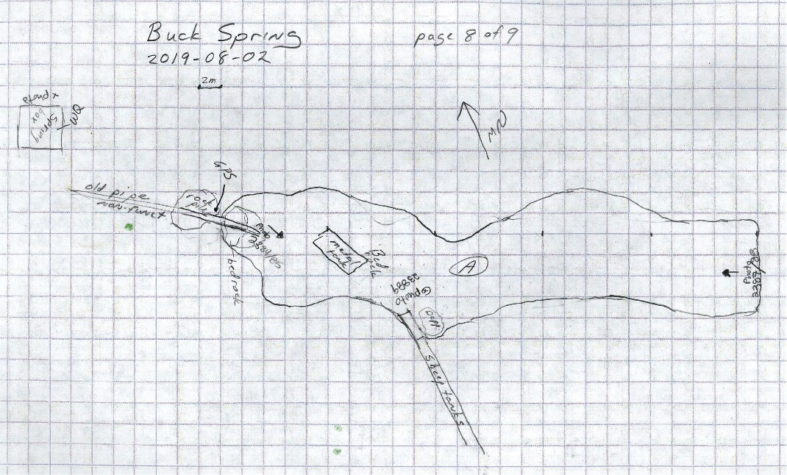
Fig 4.2 Buck Spring Sketchmap.

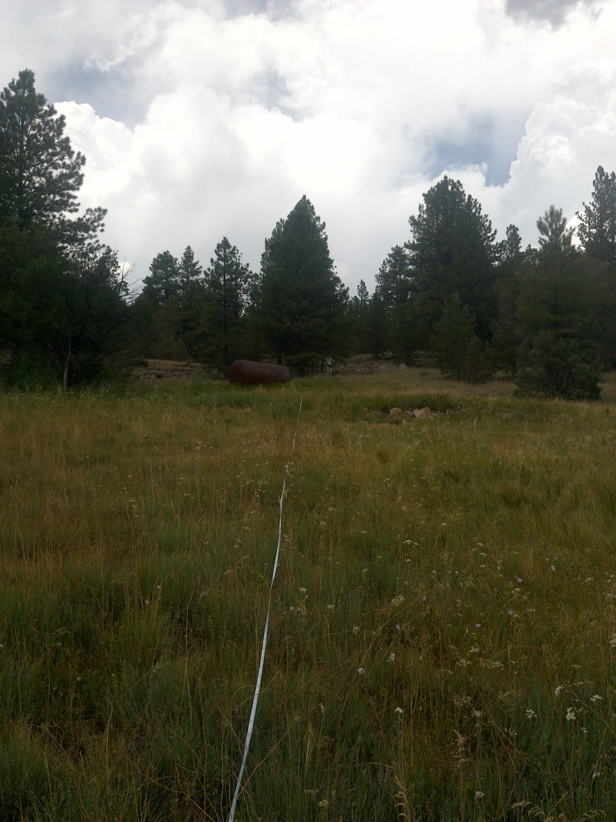
Fig 4.3 Buck Spring: View looking uphill taken forty meters below the tank.

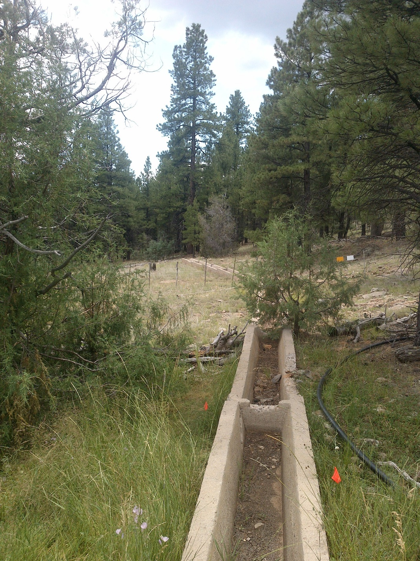
Fig 4.4 Buck Spring: View of the dry sheep troughs.

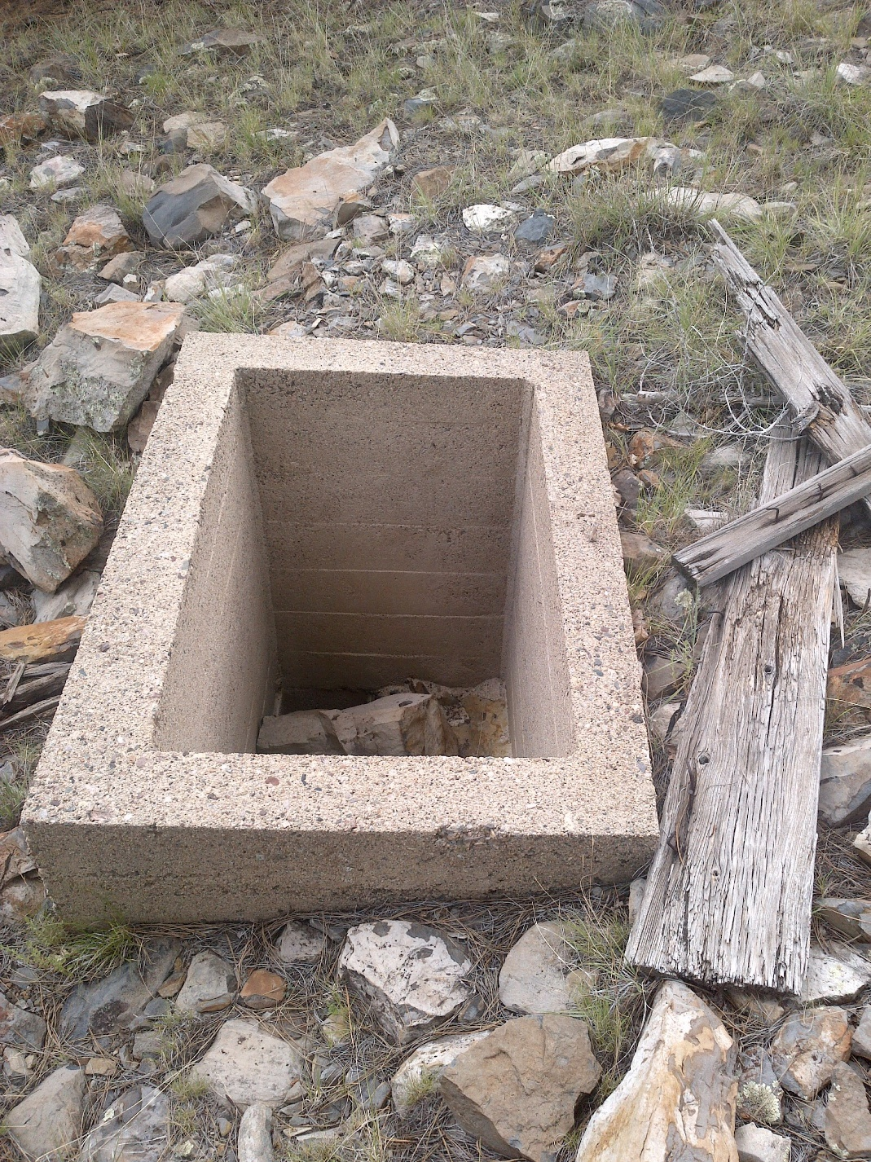
Fig 4.5 Buck Spring: Open springbox without a lid

5. Campbell Spring, 8/28/18
5. Campbell Spring, 8/28/18
Survey Summary Report, Site ID 750
Submitted 6/01/21 by Springs Stewardship Institute

Location: The Campbell Spring ecosystem is located in Coconino County in the Upper Verde Arizona 15060202 HUC, managed by the US Forest Service. The spring is located in the Kaibab NF, Williams RD, in the Williams South USGS Quad, at 35.15014, -112.23558 measured using a GPS (WGS84, estimated position error 4 meters). The elevation is approximately 1985 meters. Jeri Ledbetter, Gloria Hardwick, Alek Mendoza, Tanner Carothers, and Nataly Levine surveyed the site on 8/28/18 for 01:25 hours, beginning at 11:00, and collected data in 8 of 10 categories. This survey was conducted under a Kaibab Springs project using the Stevens et al. Level 2 protocol.

Physical Description: Campbell Spring is a rheocrene spring. Campbell Spring was depicted on the DRG. In 2014 it was said to be in Proper Functioning Condition by a hydrologist. It is located in a channel, with several sources emerging from fractured rock. According to Kit Macdonald, the USFS has introduced northern leopard frog here. The site has 4 microhabitats, including A -- a 60 sqm pool, B -- a 90 sqm channel, C -- a 150 sqm terrace, D -- a 40 sqm terrace.

Table 5.1 Campbell Spring Microhabitat characteristics.
Code | A | B | C | D
Name | Pool | Channel | Left Terrace | Seeping Right Terrace
Area sqm | 60 | 90 | 150 | 40
Surface type | P | CH | TE | TE
Surface subtype |  | riffle | LRZ | LRZ
Slope variability |  | Low | Low | Med
Aspect TN | 223 | 223 | 320 | 161
Slope degrees |  | 1 | 8 | 10
Moisture (scale 1-10) | 10 | 9 | 4 | 0
Water depth cm | 40 | 30
Area % open water | 95 | 70
Substrate
1 - Clay % | 0 | 5 | 0 | 0
2 - Silt % | 5 | 5 | 5 | 20
3 - Sand % | 10 | 10 | 5 | 15
4 - Fine gravel % | 5 | 15 | 15 | 5
5 - Coarse gravel % | 5 | 10 | 15 | 5
6 - Cobble % | 5 | 10 | 50 | 5
7 - Boulder % | 1 | 0 | 0 | 0
8 - Bedrock % | 49 | 25 | 0 | 5
Organic % | 20 | 20 | 10 | 45
Other % (anthropogenic) | 0 | 0 | 0 | 0
Precipitate % | 0 | 0 | 0 | 0
Litter % | 10 | 20 | 15 | 80
Wood % | 1 | 1 | 2 | 1
Litter Depth (cm) | 2 | 3 | 2 | 3

Geomorphology: Campbell Spring emerges as a seepage or filtration from the basalt flow, a igneous, basalt rock layer. The emergence environment is subaerial, with a gravity flow force mechanism. The site receives approximately 99% of available solar radiation, with 6789 Mj annually.

Access Directions: From exit 157 on I-70, follow Devil Dog Rd for 0.7 mi and turn left on W Pine Springs Rd. for 1.2 mi. Make a sharp left on NF-798 and sharp right on S Hat Rand Rd. Continue south for 2 mi. Turn right on NF-274S for 0.7 mi and make sharp left on NF-42 for 2 mi. Spring is located 200 m due south. Access to this site is on a fairly rough road and the short hike is relatively easy. Alternately drive south from Williams on the Perkinsville Road and turn west on Forest Road 122. This road get progressively rougher and can be slick in wet weather. The spring is south of this road.

Survey Notes: This survey was completed towards the end of monsoon season and at the time of survey there was much more standing water at the site than encountered during previous surveys. The standing water filled previous pool micro-habitats and was also standing on a portion of the channel micro-habitat. There was green algae covering about 25 percent of the standing water. There was also lush green wetland vegetation that continues slightly upstream of source and 100 plus meters downstream.

Flow: During the time of the survey the main pool (polygon A) was the only standing water. This spring is perennial. Surveyors were unable to measure flow because there was no outflow.

Water Quality: Surveyors collected the water quality down slope 15 meters along the right side of channel at the base of a bedrock outcropping. Location 1: in a pool in standing water at 11:11.

Table 5.2 Campbell Spring Water Quality Measurements.
Characteristic Measured | Value | Location Number | Device
Alkalinity (Lab) (meq/L) | 78 | 1 | LaMotte
Dissolved oxygen (field) (mg/L) | 10 | 1 | CHEMets DO kit
pH (field) | 6.59 | 1 | Hanna Combo
Specific conductance (field) (uS/cm) | 135 | 1 | Hanna Combo
Temperature, air C | 29 | 1 | handheld therm
Temperature, water C | 21.4 | 1 | Hanna Combo

Flora: The botanist for this survey was Gloria Hardwick. Surveyors identified 41 plant species at the site, with 0.1206 species/sqm. These included 36 native and 5 nonnative species.

Table 5.3 Campbell Spring Cover Type.
Cover Type | Species Count | Wetland Species Count
Ground | 31 | 9
Shrub | 3 | 0
Mid-canopy | 0 | 0
Tall canopy | 0 | 0
Basal | 0 | 0
Aquatic | 1 | 1
Non-vascular | 3 | 2

Table 5.4 Campbell Spring Vegetation % Cover in Microhabitats.
Plant Species | Cover Code | Native Status | Wetland Status | Comments | A | B | C | D
Achillea millefolium | GC | NI | U |  | 0 | 0.01 | 0.3 | 0.1
algae | NV | N | A |  | 15 | 0 | 0 | 0
Amaranthus | GC | NI | F |  | 0 | 0.01 | 0 | 0
Ambrosia | GC | N | F |  | 0 | 0.02 | 2 | 0
Amorpha fruticosa | SC | N | F |  | 0 | 0 | 0.3 | 0.5
Apocynum cannabinum | GC | N | WR |  | 0 | 0.01 | 0 | 0
Astragalus | GC | N | U |  | 0 | 0 | 0.02 | 0.01
Bouteloua curtipendula | GC | N | U |  | 0 | 0 | 0 | 0.07
Carex | GC | N | W |  | 0 | 0.03 | 0.02 | 0
Coreopsis tinctoria | GC | N | F |  | 0 | 0 | 0.01 | 0
Cosmos parviflorus | GC | N | F |  | 0 | 0 | 0.01 | 0
Desmodium grahamii |  | N |  |  | 0 | 0 | 0 | 0.9
Digitaria sanguinalis | GC | I | F |  | 0 | 0.2 | 5 | 2
Echinochloa crus-galli | GC | I | W |  | 0.01 | 0.01 | 0.5 | 0
Eleocharis palustris | GC | N | W |  | 2 | 1 | 1 | 0
Epilobium ciliatum | GC | N | W | Pink flower | 0 | 0 | 0 | 0.02
Ipomoea costellata | GC | N | F |  | 0 | 0 | 0 | 0.01
Ipomoea cristulata |  | N | F | Red flower | 0 | 0 | 0 | 0.01
Iris missouriensis | GC | N | F |  | 0 | 0.02 | 0.6 | 0
Juncus | GC | N | W |  | 0.5 | 0.01 | 0.2 | 0.4
Koeleria macrantha | GC | N | F |  | 0 | 0.02 | 0.8 | 0.6
Lichen | NV | N | U |  | 0 | 0.01 | 0.3 | 0.5
Mentha arvensis | GC | N | WR |  | 0 | 0 | 0.3 | 0
Muhlenbergia rigens | GC | N | U |  | 0 | 0.5 | 8 | 1
Oxalis decaphylla | GC | N | F |  | 0 | 0 | 0 | 0.2
Oxalis stricta | GC | N | F |  | 0 | 0 | 1 | 0.03
Polygonum | GC | N | WR |  | 0 | 0 | 0.3 | 0
Polygonum amphibium | GC | N | W |  | 0 | 0.02 | 0.4 | 0
Potamogeton nodosus | AQ | N | A |  | 0.02 | 0 | 0 | 0
Rosa woodsii | SC | N | F | Dead and dying | 0 | 0 | 0.2 | 0.1
Rumex californicus | GC | N | F |  | 0 | 0 | 0.5 | 0.3
Rumex crispus | GC | I | WR |  | 0 | 0.3 | 1.5 | 0.5
Solanum jamesii |  | N |  | White flower | 0 | 0 | 0 | 1
Sphaeralcea ambigua | SC | N | U |  | 0 | 0 | 0 | 0.03
Tagetes micrantha |  | N | F |  | 0 | 0 | 3 | 0
Tagetes micrantha | GC | N | F |  | 0 | 0 | 0 | 1
Taraxacum officinale | GC | NI | F |  | 0 | 0.1 | 3 | 1
Thalictrum fendleri | GC | N | F |  | 0 | 0 | 0.01 | 0.01
Thermopsis pinetorum | GC | N | F |  | 0 | 0 | 0.5 | 0.3
Trifolium repens | GC | I | WR |  | 0 | 0 | 0.02 | 0.05
unknown moss | NV | N? |  |  | 0.01 | 0.03 | 0.01 | 0
Vinca major | GC | I | F |  | 0 | 0 | 0.5 | 0.4

Fauna: Surveyors collected or observed 5 aquatic and 16 terrestrial invertebrate taxa and 8 vertebrate taxa.

Table 5.5 Campbell Spring Invertebrates.
Species | Lifestage | Habitat | Method | Rep# | Count | Species Detail
Araneae | Ad | T | Collected spot |  | 1
Coleoptera | Ad |  | Collected spot |  | 1
Coleoptera Buprestidae | Ad | T | Collected spot |  | 1
Coleoptera Cantharidae Chauliognathus opacus | Ad |  | Collected spot |  | 1
Coleoptera Coccinellidae | Ad | T | Collected spot |  | 1
Coleoptera Coccinellidae | Ad | T | Spot |  | 30 | Approximately 30
Coleoptera Curculionidae | Ad | T | Collected spot |  | 1
Coleoptera Dytiscidae | Ad | A | Collected spot |  | 1
Coleoptera Melyridae Collops vittatus | Ad | T | Collected spot |  | 1
Coleoptera Scarabaeidae | Ad | T | Collected spot |  | 1
Diptera Bombyliidae | Ad | T | Collected spot |  | 1
Hemiptera Gerridae | Ad | A | Collected spot |  | 1
Hemiptera Gerridae Aquarius remigis | Ad | A | Spot |  | 10 | Several
Hemiptera Notonectidae | Ad | A | Collected spot |  | 1
Hemiptera Notonectidae Notonecta kirbyi | Ad | A | Spot |  | 10 | Abundant
Hymenoptera Apoidea | Ad | T | Collected spot |  | 1
Hymenoptera Sphecidae Ammophila | Ad | T | Collected spot |  | 1
Hymenoptera Sphecidae Sceliphron caementarium | Ad | T | Collected spot |  | 1
Lepidoptera Pieridae Colias eurytheme | Ad | T | Collected spot |  | 1
Mollusca | Ad |  | Collected spot |  | 2
Odonata Libellulidae Erythemis collocata | Ad | T | Spot |  | 1 | female laying eggs
Odonata Libellulidae Libellula saturata | Ad | T | Collected spot |  | 1
Odonata Libellulidae Libellula saturata | Ad | T | Spot |  | 1 | Collected - (male and female)
Odonata Libellulidae Sympetrum pallipes | Ad | T | Collected spot |  | 1

Table 5.6 Campbell Spring Vertebrates.
Vertebrate Species Common Name | Count | Detection | Comments
Tree Lizard | 2 | obs
Elk |  | sign | A lot of scat on site.
Spiny Lizard | 1 | obs
Common Raven | 1 | call
Acorn Woodpecker | 1 | call
Western Scrub-jay | 1 | call
Frog | 1 | obs | Many adults and tadpoles.
White-breasted Nuthatch | 1 | obs

Assessment: Assessment scores were compiled in 5 categories and 32 subcategories, with 10 null condition scores, and 9 null risk scores. Aquifer functionality and water quality are moderate with some restoration potential (average condition score 3.5) and there is low risk (average risk score 2). Geomorphology condition is good with significant restoration potential (average condition score 4.4) and there is negligible risk (average risk score 1.6). Habitat condition is moderate with some restoration potential (average condition score 3.5) and there is low risk (average risk score 2). Biotic integrity is moderate with some restoration potential (average condition score 3.6) and there is low risk (average risk score 2). Human influence of site is good with significant restoration potential (average condition score 4.6) and there is negligible risk (average risk score 1.7). Overall, the site condition is good with significant restoration potential and there is negligible risk.

Table 5.7 Campbell Spring Assessment Scores. Condition scores range from 0 (extremely poor condition) to 6 (pristine condition) and risk scores range from 0 (no risk to the site) to 6 (extreme risk to the site).
Category | Condition | Risk
Aquifer Functionality & Water Quality | 3.5 | 2
Geomorphology | 4.4 | 1.6
Habitat | 3.5 | 2
Biota | 3.6 | 2
Human Influence | 4.6 | 1.7
Overall Ecological Score | 4 | 1.8

Management Recommendations: A down fence is located approximately 150 meters away from the channel, which it parallels. Surveyors recommend removing the fence if it is not being utilized. The site has been heavily trampled due to the significant elk presence. Information was given to SSI that a leopard frog species was introduced at this site sometime last year (2017). During the time of survey several tadpoles were observed.

6. Clover Spring, 5/19/19
6. Clover Spring, 5/19/19
Survey Summary Report, Site ID 738
Submitted 6/01/21 by Springs Stewardship Institute

Location: The Clover Spring ecosystem is located in Coconino County in the Havasu Canyon Arizona 15010004 HUC, managed by the US Forest Service. The spring is located in the Kaibab NF, Williams RD, in the Williams South USGS Quad, at 35.23152, -112.20360 measured using a GPS (WGS84). The elevation is approximately 2198 meters. Alek Mendoza verified the site on 5/19/19 at 15:10. This survey was conducted under a Kaibab Springs project using the Stevens et al. Level 1 protocol.

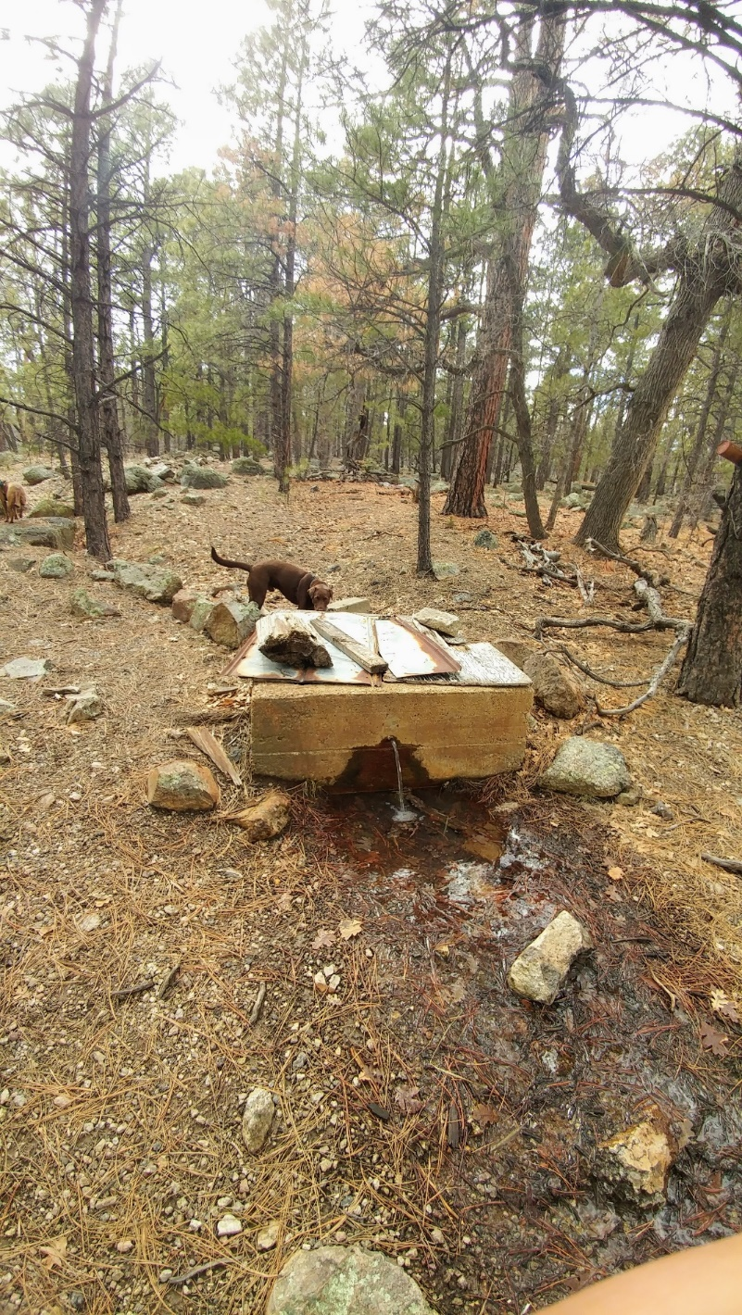
Fig 6.1 Clover Spring: View approximately 1.5 meters downstream of the tank with flowing water.

Physical Description:

Geomorphology: Clover Spring emerges from the basalt flow, a igneous, basalt rock layer.

Access Directions: Take exit 161 from I-40 and travel east toward the Town of Williams and Old Route 66 for 0.3 mi. Turn right on W Old Route 66 and continue SW for 0.65 mi. Turn left on S Clover Rd for 0.25 mi and continue onto NF-258B for 0.5 mi. Turn right on City of W for 100 m before turning left and heading south on Buckskinn for 0.35 mi. Hike due south for 135 m.

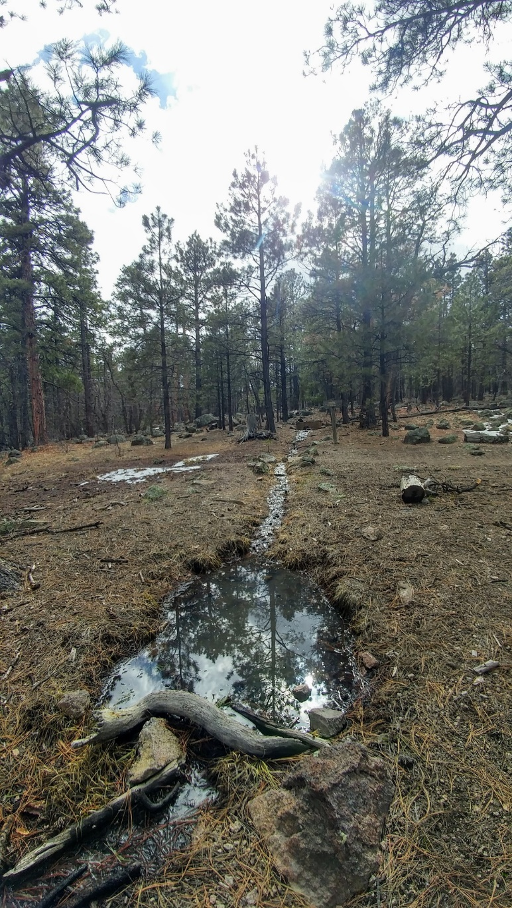
Fig 6.2 Clover Spring: This photo was taken approximately 15 meters
downstream of the tank: view upstream towards tank and trail.

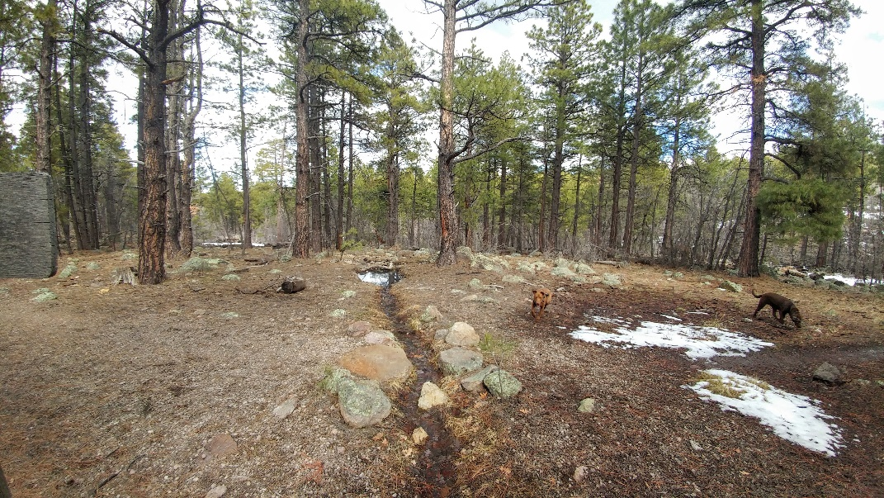
Fig 6.3 Clover Spring: Taken from the springbox: view downstream towards the pool.

7. Dow Spring, 5/13/16
7. Dow Spring, 5/13/16
Survey Summary Report, Site ID 746
Submitted 6/01/21 by Springs Stewardship Institute

Location: The Dow Spring ecosystem is located in Coconino County in the Upper Verde Arizona 15060202 HUC, managed by the US Forest Service. The spring is located in the Kaibab NF, Williams RD, in the Garland Prairie USGS Quad, at 35.15499, -111.98573 measured using a GPS (WGS84, estimated position error 3 meters). The elevation is approximately 2058 meters. Jeri Ledbetter, Gloria Hardwick, Jenn Chavez, and Courtney McDaniel surveyed the site on 5/13/16 for 01:45 hours, beginning at 14:30, and collected data in 9 of 10 categories. This survey was conducted under the Kaibab Springs 2018-19 project using the Stevens et al. Level 2 protocol.

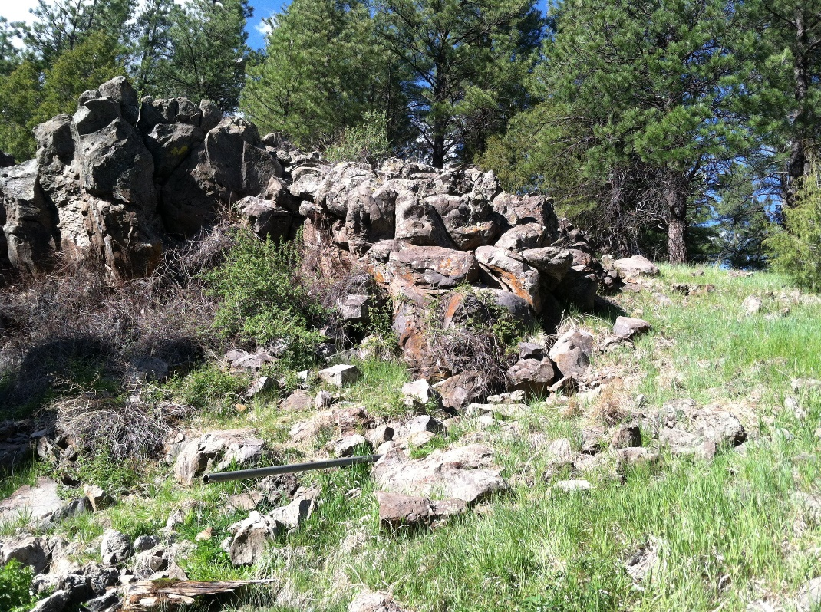
Fig 7.1 Dow Spring: View up toward the source from the main channel below

Physical Description: Dow Spring is a hillslope/rheocrene spring. This named site is located in the headwaters of Sycamore Canyon, emerging from a basalt outcrop on the side of the drainage. Adjacent to the Sycamore trail, it is about 250 m from a small parking area. It is depicted on the DRG, and has been piped. The outflow is subject to surface runoff. The microhabitats associated with the spring cover 137 sqm. The site has 4 microhabitats, including A -- a 29 sqm channel, B -- a 39 sqm colluvial slope, C -- a 46 sqm channel, D -- a 23 sqm terrace. The geomorphic diversity is 0.59, based on the Shannon-Weiner diversity index.

Table 7.1 Dow Spring Microhabitat characteristics.
Code | A | B | C | D
Name | Source Channel | Colluvial slope | Creek Channel | Creek terraces
Area sqm | 29 | 39 | 46 | 23
Surface type | CH | CS | CH | TE
Surface subtype | riffle |  | run | LRZMRZ
Slope variability | Med | Med | Low | Low
Aspect TN | 256 | 256 | 169 | 169
Slope degrees | 18 | 18 | .5 | .5
Moisture (scale 1-10) | 6 | 0 | 10 | 1
Water depth cm | 5 | 0 | 3 | 0
Area % open water
Substrate
1 - Clay % | 0 | 0 | 0 | 0
2 - Silt % | 5 | 10 | 5 | 0
3 - Sand % | 5 | 10 | 5 | 0
4 - Fine gravel % | 20 | 20 | 20 | 0
5 - Coarse gravel % | 25 | 25 | 40 | 0
6 - Cobble % | 35 | 25 | 0 | 0
7 - Boulder % | 9 | 10 | 0 | 0
8 - Bedrock % | 0 | 0 | 30 | 0
Organic % | 0 | 0 | 0 | 0
Other % (anthropogenic) | 1 | 0 | 0 | 0
Precipitate % | 0 | 0 | 0 | 0
Litter % | 5 | 5 | 5 | 0
Wood % | 0 | 0 | 1 | 0
Litter Depth (cm) | 1 | 1 | 1

Geomorphology: Dow Spring emerges as a fracture from a igneous, basalt rock layer. The emergence environment is subaerial, with a gravity flow force mechanism. The site receives approximately 97% of available solar radiation, with 6664 Mj annually.

Access Directions: From exit 178 on I-40, travel south on County Rd 141 (E Parks Rd) toward Garland Prairie Rd for 0.08 mi. Continue south on S Garland Prairie Rd (CR-141) for 9.14 mi. Turn left and travel 0.58 mi south on S Thomas Loop Rd and park in a small lot. Hike due west 260 m along a trail then drop into the drainage.

Survey Notes: In spite of the past manipulation and proximity to the road, parking lot, trail, and signage, the site is in relatively good condition. Recent rain likely resulted in runoff in the creek channel. The only trash was a couple of water bottles.

Flow: Surveyors measured a flow of 0.13 liters/second, using a timed flow volume capture method. Flow was adjusted for an estimate of 98% of site flow capture. Surveyors measured flow in the channel below the pipe, as well as flow emerging from the pipe.

Water Quality: Water chemistry parameters were collected from a pool at the source.

Table 7.2 Dow Spring Water Quality Measurements.
Characteristic Measured | Value | Location Number | Device
Alkalinity, Total (mg/L) | 50
Dissolved oxygen (field) (mg/L) | 1.3 |  | YSI Multiprobe
Dissolved Solids (field) (ppt) | 5.0E-5 |  | YSI Multiprobe
Oxygen Reduction Potential in mV | 235 |  | Hanna ORP Meter
Oxygen Reduction Potential in mV | 155.8 |  | YSI Multiprobe
pH (field) | 6.65 |  | YSI Multiprobe
Specific conductance (field) (uS/cm) | 247 |  | DigitalAid meter
Specific conductance (field) (uS/cm) | 120 |  | YSI Multiprobe
Temperature, air C | 25.9 |  | YSI Multiprobe
Temperature, water C | 13 |  | DigitalAid meter
Temperature, water C | 10 |  | YSI Multiprobe

Flora: Surveyors identified 22 plant species at the site, with 0.1606 species/sqm. These included 18 native and 2 nonnative species; the native status of 2 species remains unknown.

Table 7.3 Dow Spring Cover Type.
Cover Type | Species Count | Wetland Species Count
Ground | 18 | 8
Shrub | 1 | 0
Mid-canopy | 0 | 0
Tall canopy | 0 | 0
Basal | 0 | 0
Aquatic | 1 | 1
Non-vascular | 2 | 1

Table 7.4 Dow Spring Vegetation % Cover in Microhabitats.
Plant Species | Cover Code | Native Status | Wetland Status | Comments | A | B | C | D
algae | NV | N | A |  | 0.5 | 0 | 0 | 0
Carex | GC | N | W | #2 | 2 | 0 | 0 | 0
Carex nebrascensis | GC | N | W | #2 | 0 | 2 | 4 | 2
Carex praegracilis | GC | N | R |  | 0 | 0 | 0 | 25
Cicuta | GC | N | W | no blooms | 40 | 2 | 12 | 2
Equisetum laevigatum | GC | N | WR |  | 0 | 0 | 0 | 0.1
Geranium | GC | N | F | no blooms | 0 | 2 | 0 | 0
Humulus lupulus | GC | NI | F |  | 0 | 8 | 0 | 0
Hypericum scouleri | GC | N | WR | no blooms | 0 | 0.1 | 0 | 0.1
Iris missouriensis | GC | N | F |  | 0 | 2 | 0 | 0
Juncus ensifolius var. montanus | GC | N | F | common; only old fruit | 0 | 10 | 0 | 20
Mimulus guttatus | AQ | N | W | below outflow pipe | 5 | 0 | 0 | 0
Potentilla | GC | N | F | no blooms | 0 | 2 | 0 | 2
Ribes cereum | SC | N | U |  | 1 | 0 | 0 | 0
Rumex | GC | N | WR | no blooms | 0 | 0.1 | 0 | 0
Sidalcea neomexicana | GC | I | F |  | 0 | 5 | 0 | 10
Taraxacum officinale | GC | NI | F |  | 0 | 0 | 0.1 | 0
Trifolium | GC | I | WR | no blooms | 0 | 0.1 | 0 | 0
unknown Bryophyte (moss, liverwort, hornwort) | NV | N | F |  | 2 | 0 | 0.1 | 0
unknown grass | GC |  |  |  | 20 | 2 | 2 | 1
unknown grass | GC |  |  | #1 | 15 | 10 | 2 | 2
Viola sororia var. affinis | GC | N | W |  | 0 | 4 | 0 | 20

Fauna: Surveyors collected or observed 1 aquatic and 4 terrestrial invertebrate taxa and 2 vertebrate taxa.

Table 7.5 Dow Spring Invertebrates.
Species | Lifestage | Habitat | Method | Rep# | Count | Species Detail
Annelida Clitellata | Ad | A | Collected spot |  | 1
Coleoptera Cantharidae Podabrus | Ad |  | Collected spot |  | 1
Diptera Asilidae | Ad | T | Collected spot |  | 1 | Trail
Hymenoptera Apidae Bombus | Ad | T | Collected spot |  | 1 | Queen
Lepidoptera Pieridae Colias eurytheme | Ad | T | Collected spot |  | 1 | Trail
Odonata Libellulidae Libellula | Ad | T | Spot |  | 1 | Saturata?

Table 7.6 Dow Spring Vertebrates.
Vertebrate Species Common Name | Count | Detection | Comments
Elk |  | sign | scat
Arizona Black Rattlesnake | 1 | obs

Assessment: Assessment scores were compiled in 5 categories and 33 subcategories, with 9 null condition scores, and 9 null risk scores. Aquifer functionality and water quality are good with significant restoration potential (average condition score 4.2) and there is low risk (average risk score 2). Geomorphology condition is good with significant restoration potential (average condition score 4.4) and there is negligible risk (average risk score 1.8). Habitat condition is good with significant restoration potential (average condition score 4) and there is low risk (average risk score 2). Biotic integrity is very good with excellent restoration potential (average condition score 4.9) and there is low risk (average risk score 2). Human influence of site is very good with excellent restoration potential (average condition score 4.9) and there is negligible risk (average risk score 1.8). Overall, the site condition is good with significant restoration potential and there is low risk.

Table 1.7 Dow Spring Assessment Scores. Condition scores range from 0 (extremely poor condition) to 6 (pristine condition) and risk scores range from 0 (no risk to the site) to 6 (extreme risk to the site).
Category | Condition | Risk
Aquifer Functionality & Water Quality | 4.2 | 2
Geomorphology | 4.4 | 1.8
Habitat | 4 | 2
Biota | 4.9 | 2
Human Influence | 4.9 | 1.8
Overall Ecological Score | 4.5 | 1.9

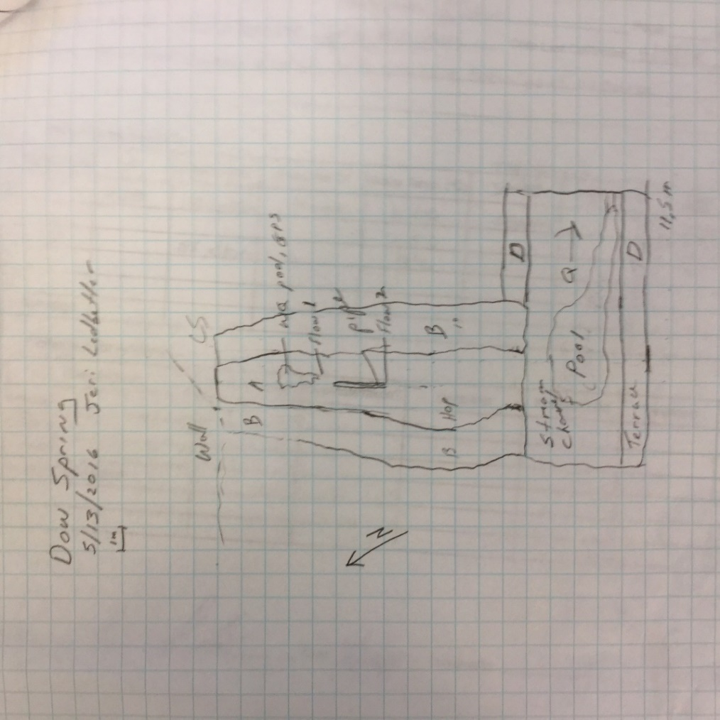
Fig 7.2 Dow Spring Sketchmap.

8. East Elk Spring, 7/05/17
8. East Elk Spring, 7/05/17
Survey Summary Report, Site ID 580
Submitted 6/01/21 by Springs Stewardship Institute

Location: The East Elk Spring ecosystem is located in Coconino County in the Havasu Canyon Arizona 15010004 HUC, managed by the US Forest Service. The spring is located in the Kaibab NF, Williams RD, in the Moritz Ridge USGS Quad, at 35.37604, -111.98617 measured using a GPS (WGS84, estimated position error 4 meters). The elevation is approximately 2239 meters. Jeri Ledbetter, Glenn Rink, Melissa Carrillo-Galaviz and Mellisa Yin surveyed the site on 7/05/17 for 02:20 hours, beginning at 11:10, and collected data in 10 of 10 categories. This survey was conducted under a Kaibab Springs project using the Stevens et al. Level 2 protocol.

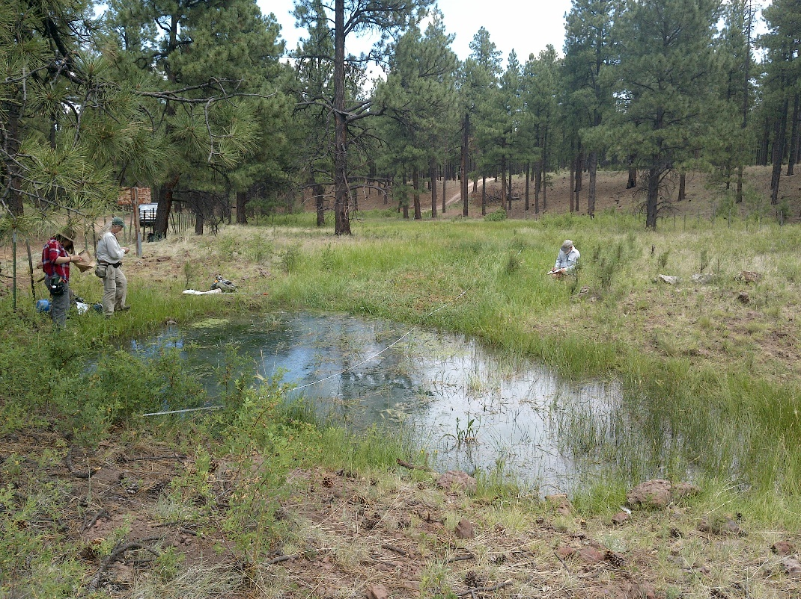
Fig 8.1 East Elk Spring: The spring pond and meadow, taken upslope at the site.

Physical Description: East Elk Spring is a helocrene/limnocrene spring. This named spring, depicted on the DRG, emerges in a meadow, surrounded by a thick ponderosa pine forest. A pond has been excavated at the upper end. The surrounding area was damaged by fire (Sitgreaves?). It is surrounded on 3 sides by dirt roads. There has been a great deal of confusion regarding the location of this spring. Elk Spring middle (175497) 100 meters west, has at times been surveyed as if it were this one. However, a USFS sign clearly labels this one as East Elk Spring. The microhabitats associated with the spring cover 993 sqm. The site has 5 microhabitats, including A -- a 28 sqm pool, B -- a 14 sqm pool margin, C -- a 215 sqm channel, D -- a 66 sqm terrace, E -- a 670 sqm low gradient cienega. The geomorphic diversity is 0.41, based on the Shannon-Weiner diversity index.

Table 8.1 East Elk Spring Microhabitat characteristics.
Code | A | B | C | D | E
Name | Source and Pond | Pond Perimeter | Channel | Terraces | Low Gradient Cienega
Area sqm | 28 | 14 | 215 | 66 | 670
Surface type | P | PM | CH | TE | LGC
Surface subtype | anthro | anthro
Slope variability | Low |  | Low | Low | Low
Aspect TN
Slope degrees | 0 | 5 | 5 | 5 | 5
Moisture (scale 1-10) | 10 | 2 | 8 | 2 | 8
Water depth cm | 15 | 0 | 3 | 0 | 4
Area % open water | 100 | 0 | 70 | 0 | 80
Substrate
1 - Clay % | 0 | 0 | 0 | 0 | 0
2 - Silt % | 20 | 25 | 10 | 10 | 10
3 - Sand % | 20 | 25 | 10 | 15 | 10
4 - Fine gravel % | 2 | 25 | 0 | 25 | 1
5 - Coarse gravel % | 5 | 10 | 25 | 25 | 1
6 - Cobble % | 5 | 10 | 5 | 25 | 2
7 - Boulder % | 0 | 0 | 0 | 0 | 0
8 - Bedrock % | 0 | 0 | 0 | 0 | 0
Organic % | 48 | 5 | 50 | 0 | 76
Other % (anthropogenic) | 0 | 0 | 0 | 0 | 0
Precipitate % | 0 | 0 | 0 | 0 | 0
Litter % | 20 | 80 | 70 | 70 | 80
Wood % | 1 | 0 | 1 | 1 | 0
Litter Depth (cm) | 2 |  | 1 | 2 | 3

Geomorphology: East Elk Spring emerges as a seepage or filtration from the Kaibab Limestone, a sedimentary, limestone rock layer. The emergence environment is subaerial, with a gravity flow force mechanism. The site receives approximately 100% of available solar radiation, with 6679 Mj annually.

Access Directions: I-40 to 141 (Spring Valley/Garland Prairie Loop) to Forest Rd 97 to Forest Rd 9531L. In other words, from FR 97, turn north on NF 4036 and follow it for about 600m. The spring and flow crosses the road.

Survey Notes: The wet meadow and pond are fenced. The fence is mostly effective for livestock, but not for elk. The meadow, channel, and pond perimeter are heavily trampled and browsed. The pond has many large tadpoles, which may be bull frogs. Upland species, including Pinus ponderosa and Rosa woodsii, are encroaching. Human feces were observed near the pond.

Flow: Surveyors measured a flow of 0.17 liters/second, using a timed flow volume capture method. Flow was adjusted for an estimate of 70% of site flow capture. Measurements were taken 96m down from the first pool emergence, where the outflow crosses a road. This spring is perennial.

Water Quality: Measurements were taken at the first emergence pool in standing water. There was much plant debris, which could affect measurements.Location 1: in a pool in standing water.

Table 8.2 East Elk Spring Water Quality Measurements.
Characteristic Measured | Value | Location Number | Device
Temperature, air C | 35 |  | Handheld therm
Alkalinity, Total (mg/L) | 38 | 1 | LaMotte
Dissolved oxygen (field) % saturation | 133.5 | 1 | YSI Multiprobe
Dissolved oxygen (field) (mg/L) | 12.82 | 1 | YSI Multiprobe
Dissolved Solids (field) (ppt) | 0.094 | 1 | Hanna Combo
pH (field) | 6.82 | 1 | YSI Multiprobe
Specific conductance (field) (uS/cm) | 153 | 1 | Hanna Combo
Temperature, water C | 17.1 | 1 | YSI Multiprobe

Flora: Surveyors identified 40 plant species at the site, with 0.0403 species/sqm. These included 35 native and 4 nonnative species; the native status of 1 species remains unknown.

Table 8.3 East Elk Spring Cover Type.
Cover Type | Species Count | Wetland Species Count
Ground | 23 | 8
Shrub | 2 | 0
Mid-canopy | 0 | 0
Tall canopy | 1 | 0
Basal | 0 | 0
Aquatic | 13 | 11
Non-vascular | 0 | 0

Table 8.4 East Elk Spring Vegetation % Cover in Microhabitats.
Plant Species | Cover Code | Native Status | Wetland Status | Comments | A | B | C | D | E
Achillea millefolium | GC | NI | U |  | 0 | 0 | 0 | 2 | 0
Agrostis gigantea | GC | I | F | #14753 | 0.2 | 0.1 | 0 | 0 | 0
algae | AQ | N | A |  | 10 | 0 | 0 | 0 | 0
Alopecurus aequalis | GC | N | U | #14752 | 5 | 0 | 0 | 0 | 0
Antennaria parvifolia | GC | N | U |  | 0 | 0 | 0 | 0.03 | 0
Callitriche verna |  | N | A | #14754 | 0.5 | 0 | 0 | 0 | 0
Carex occidentalis | GC | N | W |  | 0 | 0 | 0 | 1 | 0
Carex pellita | AQ | N | W |  | 2 | 0.02 | 0.3 | 0 | 2
Cirsium vulgare | GC | I | F |  | 0.1 | 0.3 | 0.5 | 1 | 0.01
Convolvulus arvensis | GC | I | F |  | 0 | 0 | 0 | 0.01 | 0
Eleocharis palustris | AQ | N | W |  | 5 | 0.1 | 2 | 0 | 4
Epilobium ciliatum | AQ | N | W |  | 0 | 0 | 0.02 | 0 | 0.01
Hordeum brachyantherum | GC | N | F | #14755 | 0 | 0 | 0.01 | 0 | 0
Hordeum jubatum | GC | N | F |  | 0.2 | 0.1 | 0.2 | 0 | 0
Hymenoxys richardsonii | GC | N | F |  | 0 | 0.01 | 0 | 0 | 0
Hypericum scouleri | GC | N | WR |  | 0 | 0 | 0.01 | 0.1 | 0
Juncus balticus | AQ | N | W |  | 0 | 0 | 70 | 2 | 40
Juncus interior | GC | N | U |  | 2 | 10 | 10 | 30 | 2
Juncus longistylis | GC | N | W |  | 0 | 0 | 0.1 | 0.1 | 1
Juncus nevadensis | AQ | N | WR | #14750 | 0 | 0 | 3 | 1 | 4
Juncus saximontanus | AQ | N | W |  | 0 | 0 | 0 | 0 | 0.03
Mentha arvensis | GC | N | WR |  | 0 | 0 | 0 | 0 | 7
Mimulus guttatus | AQ | N | W |  | 0.1 | 0.01 | 1 | 0 | 0
Montia chamissoi | AQ | N | W |  | 0 | 0 | 25 | 0 | 0
Muhlenbergia wrightii | GC | N | U |  | 0 | 0 | 0 | 1 | 0.01
Pinus ponderosa | SC | N | U |  | 0 | 0 | 0.5 | 0.5 | 0
Pinus ponderosa | TC | N | U |  | 20 | 30 | 0 | 0 | 0
Poa pratensis | GC | NI | F |  | 0.2 | 0.5 | 40 | 40 | 30
Potentilla biennis | GC | N | F | #14756 | 0 | 0 | 0 | 0.1 | 0.01
Potentilla norvegica | GC | N | F | #14758. Not rooted in pond. | 0.1 | 0 | 0 | 0 | 0
Ranunculus aquatilis | AQ | N | A |  | 0.01 | 0 | 0 | 0 | 0
Ranunculus hydrocharoides | GC | N | W | #14757 | 0 | 0 | 0 | 0 | 0.01
Rosa | SC | N | F |  | 0.1 | 6 | 1 | 6 | 0.01
Rumex crispus | AQ | I | WR |  | 1 | 0.3 | 0.1 | 0 | 0.01
Rumex triangulivalvis |  |  |  | #14759 | 0.02 | 0 | 0 | 0 | 0
Sidalcea neomexicana | AQ | N | WR |  | 0 | 0 | 0 | 0 | 0.1
Sisyrinchium demissum | GC | N | W |  | 0 | 0 | 0 | 0.01 | 0
Taraxacum officinale | GC | NI | F |  | 0.01 | 0.1 | 2 | 0.5 | 2
Trifolium wormskioldii | GC | N | WR | #14751 | 0.01 | 0.1 | 0.1 | 0.1 | 1
unknown Bryophyte (moss, liverwort, hornwort) | AQ | N | F |  | 0 | 0 | 1 | 0 | 1
Vicia americana | GC | N | F |  | 0 | 0 | 0 | 0.01 | 0

Fauna: Surveyors collected or observed 4 aquatic and 8 terrestrial invertebrate taxa and 7 vertebrate taxa.

Table 8.5 East Elk Spring Invertebrates.
Species | Lifestage | Habitat | Method | Rep# | Count | Species Detail
Coleoptera | Ad |  | Collected spot |  | 1
Coleoptera Chrysomelidae | Ad | T | Collected spot |  | 1
Coleoptera Dytiscidae Agabus disintegratus | Ad | A | Collected spot |  | 1
Coleoptera Dytiscidae Neobidessus | Ad |  | Collected spot |  | 1
Coleoptera Staphylinidae | Ad | T | Collected spot |  | 1
Diptera Tipulidae | Ad | T | Collected spot |  | 1
Hemiptera | Ad | T | Collected spot |  | 1
Hemiptera Gerridae | Ad | A | Collected spot |  | 1
Hemiptera Notonectidae | Ad | A | Collected spot |  | 1
Hemiptera Veliidae | Ad | A | Collected spot |  | 1
Hymenoptera Pompilidae Pepsis | Ad | T | Spot |  | 1 | Also known as a tarantula hawk. Specimen collected.
Lepidoptera Nymphalidae Junonia | Ad | T | Spot |  | 1
Odonata Aeshnidae Aeshna | Ad | T | Spot |  | 1
Odonata Coenagrionidae Argia | Ad | T | Spot |  | 6 | These could be of the vivida species.

Table 8.6 East Elk Spring Vertebrates.
Vertebrate Species Common Name | Count | Detection | Comments
Elk |  | sign | Fresh tracks and scat were observed.
salamander | 3 | obs | several
Frog |  | obs | many tadpoles
Mountain Chickadee |  | call
Northern Flicker | 1 | obs
Common Raven | 1 | obs
American Robin | 1 | obs

Assessment: Assessment scores were compiled in 5 categories and 33 subcategories, with 9 null condition scores, and 9 null risk scores. Aquifer functionality and water quality are moderate with some restoration potential (average condition score 3.8) and there is low risk (average risk score 2.2). Geomorphology condition is moderate with some restoration potential (average condition score 3.8) and there is low risk (average risk score 2.2). Habitat condition is moderate with some restoration potential (average condition score 3.6) and there is low risk (average risk score 2.4). Biotic integrity is good with significant restoration potential (average condition score 4.4) and there is low risk (average risk score 2). Human influence of site is good with significant restoration potential (average condition score 4) and there is low risk (average risk score 2.8). Overall, the site condition is good with significant restoration potential and there is low risk.

Table 8.7 East Elk Spring Assessment Scores. Condition scores range from 0 (extremely poor condition) to 6 (pristine condition) and risk scores range from 0 (no risk to the site) to 6 (extreme risk to the site).
Category | Condition | Risk
Aquifer Functionality & Water Quality | 3.8 | 2.2
Geomorphology | 3.8 | 2.2
Habitat | 3.6 | 2.4
Biota | 4.4 | 2
Human Influence | 4 | 2.8
Overall Ecological Score | 4 | 2.3

Management Recommendations: Repairing the fence, monitoring after tree thinning, and removing potential bull frogs are recommended. Maintaining the pool and monitoring regularly would be beneficial to this spring.

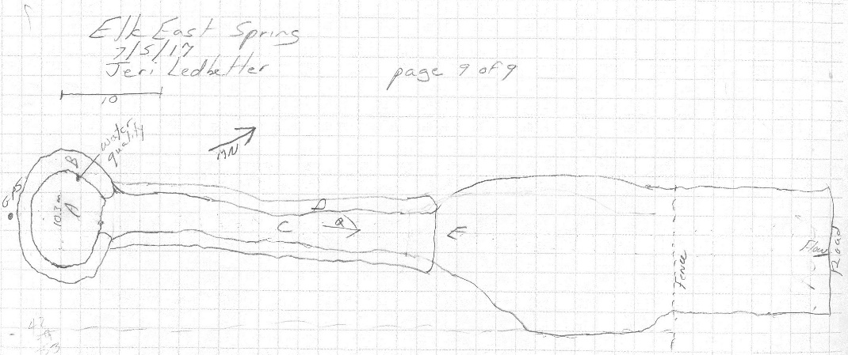
Fig 8.2 East Elk Spring Sketchmap: East Elk Spring Sketch Map

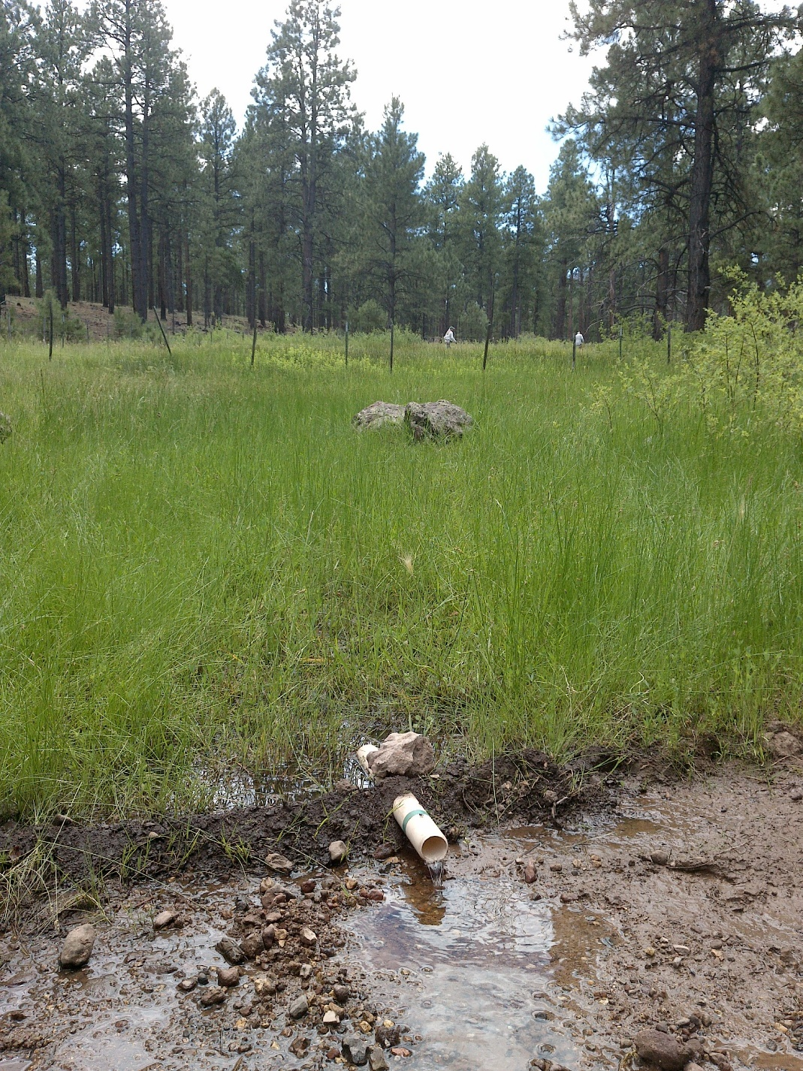
Fig 8.3 East Elk Spring: The flow measurement location near a road, viewing upslope.

9. East Twin Spring, 7/29/19
9. East Twin Spring, 7/29/19
Survey Summary Report, Site ID 776
Submitted 6/01/21 by Springs Stewardship Institute

Location: The East Twin Spring ecosystem is located in Coconino County in the Upper Verde Arizona 15060202 HUC, managed by the US Forest Service. The spring is located in the Kaibab NF, Williams RD, in the Williams South USGS Quad, at 35.16906, -112.21548 measured using a GPS (WGS84, estimated position error 4 meters). The elevation is approximately 2155 meters. Alek Mendoza, Gloria Hardwick, and Jenna Norris surveyed the site on 7/29/19 for 01:5 hours, beginning at 13:35, and collected data in 9 of 10 categories. This survey was conducted under a Kaibab Springs project using the Stevens et al. Level 2 protocol.

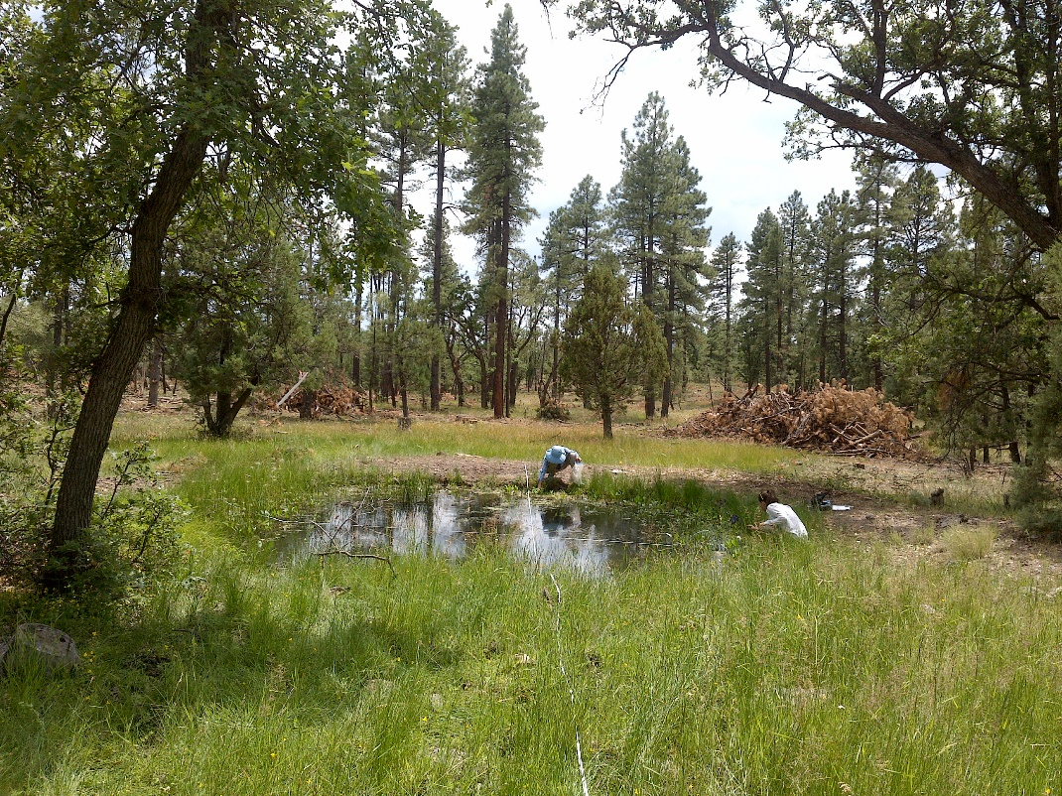
Fig 9.1 East Twin Spring: View from the top of the low gradient cienega, looking downhill at the pond.

Physical Description: East Twin Spring is a helocrene/anthropogenic spring. This spring is part of the SSI 4FRI Springs Monitoring Project and is located within a treatment area. This spring was formerly a low gradient cienega that has been excavated to form a bermed pool. Seepage emerges from a patch of cienega habitat on the upslope side of the pool next to the road, and seepage from the cienega collects in the pool. The pool has a wide marshy outflow channel on the southeast side, just east of the berm. The outflow channel immediately widens into a low gradient cienega that extends 50 meters downslope. On October 3, 2019, the surveyor installed a Hobo Tidbit MX2203 data logger in the middle of the excavated pool. The microhabitats associated with the spring cover 335 sqm. The site has 4 microhabitats, including A -- a 83 sqm pool, B -- a 18 sqm pool margin, C -- a 42 sqm low gradient cienega, D -- a 192 sqm low gradient cienega. The geomorphic diversity is 0.47, based on the Shannon-Weiner diversity index.

Table 9.1 East Twin Spring Microhabitat characteristics.
Code | A | B | C | D
Name | Muddy area | Pond Perimeter | Uphill LGC | Dry LGC
Area sqm | 83 | 18 | 42 | 192
Surface type | P | PM | LGC | LGC
Surface subtype | anthro
Slope variability | Low | Low | Low | Low
Aspect TN | 11 |  | 191 | 191
Slope degrees | 0 | 2 | 2 | 5
Moisture (scale 1-10) | 10 | 2 | 5 | 1
Water depth cm | 70 | 0 | 2 | 0
Area % open water | 97 | 0 | 3 | 0
Substrate
1 - Clay % | 5 | 5 | 5 | 5
2 - Silt % | 30 | 30 | 30 | 30
3 - Sand % | 20 | 25 | 25 | 25
4 - Fine gravel % | 2 | 5 | 5 | 5
5 - Coarse gravel % | 20 | 15 | 10 | 10
6 - Cobble % | 0 | 15 | 15 | 15
7 - Boulder % | 0 | 0 | 0 | 0
8 - Bedrock % | 0 | 0 | 0 | 0
Organic % | 23 | 5 | 10 | 10
Other % (anthropogenic) | 0 | 0 | 0 | 0
Precipitate % | 0 | 0 | 0 | 0
Litter % | 60 | 40 | 20 | 30
Wood % | 5 | 3 | 30 | 15
Litter Depth (cm) | 5 | 1 | 0.01 | 2

Geomorphology: East Twin Spring emerges as a seepage or filtration from a igneous, basalt rock layer. The emergence environment is subaerial, with a gravity flow force mechanism. The site receives approximately 100% of available solar radiation, with 6877 Mj annually.

Access Directions: From the town of Willams, drive south on Perkinsville Rd (County Rd 73) for 6 miles. Turn west FR 122 (Twin Springs Rd) and drive 3.2 miles. The spring is located 15 m left (SW) of the road. FR 122 becomes slick when it is raining. Please use caution when precipitation is in the forecast. There is a 1984 Forest Service sign identifying this site as Twin Spring.

Survey Notes: Surveyors found no signs of recent grazing. The area was extensively thinned in 2018, and there are 3 large slash piles within 30m of the spring. Several Ponderosa pines near the spring were cut during this most recent thinning project. Surveyors found a game camera mounted to a juniper tree and located 20 meters south of the excavated pond. The site appears to have made a healthy recovery since the last survey in 2013, which surveyors attributed to a combination of the thinning efforts and a very wet 2018-19 winter. According to FS personnel the site has had standing water continuously for the past year.

Flow: Surveyors were unable to measure flow; inflow was diffuse throughout the low gradient cienega and there was no outflow at the time of the survey. Surveyors were unable to measure flow because the outflow was too diffuse to capture.

Water Quality: Surveyors measured the water quality on the west side of the pond. Location 1: in a pool in standing water at 14:14.

Table 9.2 East Twin Spring Water Quality Measurements.
Characteristic Measured | Value | Location Number | Device
Alkalinity, Total (mg/L) | 76 | 1 | LaMotte
Dissolved oxygen (field) (mg/L) | 7 | 1 | CHEMets DO kit
Dissolved Solids (field) (ppt) | 0.094 | 1 | Hanna Combo
Dissolved Solids (field) (ppt) | 0.093 | 1 | Hanna Multi 98194
pH (field) | 8.5 | 1 | Hanna Multi 98194
pH (lab) | 8.06 | 1 | Hanna Combo
Specific conductance (field) (uS/cm) | 188 | 1 | Hanna
Temperature, air C | 32 | 1 | Handheld therm
Temperature, water C | 28.1 | 1 | Hanna Combo
Temperature, water C | 26.6 | 1 | Hanna Multi 98194

Flora: Gloria Hardwick was the botanist for this survey. Surveyors identified 27 plant species at the site, with 0.0806 species/sqm. These included 22 native and 5 nonnative species.

Table 9.3 East Twin Spring Cover Type.
Cover Type | Species Count | Wetland Species Count
Ground | 20 | 11
Shrub | 2 | 0
Mid-canopy | 1 | 0
Tall canopy | 0 | 0
Basal | 0 | 0
Aquatic | 3 | 3
Non-vascular | 2 | 1

Table 9.4 East Twin Spring Vegetation % Cover in Microhabitats.
Plant Species | Cover Code | Native Status | Wetland Status | Comments | A | B | C | D
Achillea millefolium | GC | NI | U |  | 0 | 0.02 | 0.03 | 0.01
Agrostis stolonifera | GC | I | W |  | 0 | 0.01 | 3 | 0.5
algae | AQ | N | A |  | 0.5 | 0 | 0 | 0
Alisma triviale | AQ | N | W |  | 0.8 | 0 | 0 | 0
Alopecurus geniculatus | GC | I | W |  | 0 | 0.01 | 0 | 0.02
Callitriche palustris | AQ | N | A |  | 0.06 | 0 | 0 | 0
Eleocharis palustris | GC | N | W |  | 0.07 | 0.03 | 0.3 | 50
Geranium caespitosum | GC | N | F |  | 0 | 0.01 | 0 | 0
Gratiola neglecta | GC | N | W | in shallow water | 0.02 | 0 | 0 | 0
Hordeum jubatum | GC | N | F |  | 0 | 0.02 | 0 | 0.02
Iris missouriensis | GC | N | F |  | 0 | 0.03 | 0 | 0
Juncus bufonius | GC | N | W |  | 0.01 | 0.02 | 0 | 0
Juncus interior | GC | N | WR |  | 0 | 0.01 | 0.01 | 0.02
Juncus longistylis | GC | N | W | brown heads | 0 | 0.02 | 0 | 0.03
Lichen | NV | N | U |  | 0 | 0 | 0.01 | 0.02
Lotus unifoliolatus | GC | N | U |  | 0 | 0.02 | 0.01 | 0.02
Medicago sativa | GC | I | WR | one plant | 0 | 0.02 | 0 | 0
Mimulus guttatus | GC | N | W |  | 0.02 | 0.1 | 0.7 | 0.2
Perideridia parishii | GC | N | F |  | 0 | 0.02 | 0 | 0.01
Poa pratensis | GC | NI | F |  | 0 | 0.01 | 0 | 0.01
Quercus gambelii | MC | N | U |  | 0 | 0 | 2 | 4
Quercus gambelii | SC | N | U |  | 0 | 0 | 1 | 0
Ranunculus macounii | GC | N | W | emergent aquatic | 0.01 | 0 | 0 | 0
Rosa woodsii | SC | N | F |  | 0 | 0.02 | 0.01 | 0
Rumex crispus | GC | I | WR |  | 0.4 | 0.02 | 0 | 0.01
Sidalcea neomexicana | GC | N | WR |  | 0 | 0 | 0.02 | 0.02
unknown moss | NV | N? | WR |  | 0 | 0.03 | 0.01 | 0.01
Verbascum thapsus | GC | I | U | a single plant | 0 | 0 | 0.02 | 0

Fauna: This site is within 15 m of a major forest service road. Extensive thinning has been conducted in the past year and there are still large slash piles adjacent to the site. Surveyors collected or observed 4 aquatic and 6 terrestrial invertebrate taxa and 3 vertebrate taxa.

Table 9.5 East Twin Spring Invertebrates.
Species | Lifestage | Habitat | Method | Rep# | Count | Species Detail
Araneae Tetragnathidae | Ad | T | Collected spot |  | 1
Coleoptera Dytiscidae Agabus | Ad | A | Collected spot |  | 1
Coleoptera Hydrophilidae Tropisternus affinis | Ad | A | Collected spot |  | 1
Coleoptera Scarabaeidae Polyphylla | Ad | T | Collected spot |  | 1
Ephemeroptera | L | T | Collected spot |  | 2
Hemiptera Gerridae | I | A | Collected spot |  | 1
Hemiptera Gerridae Aquarius remigis | L | A | Collected spot |  | 1
Odonata | Ad | T | Spot |  |  | many damsel filies
Odonata Libellulidae Libellula saturata | Ad | T | Spot |  | 1
Odonata Libellulidae Plathemis lydia | Ad | T | Spot |  | 1

Table 9.6 East Twin Spring Vertebrates.
Vertebrate Species Common Name | Count | Detection | Comments
Mourning Dove | 2 | obs
Garter Snake | 1 | obs
Mule Deer |  | sign | scat and tracks

Assessment: Assessment scores were compiled in 5 categories and 33 subcategories, with 9 null condition scores, and 9 null risk scores. Aquifer functionality and water quality are moderate with some restoration potential (average condition score 3.7) and there is low risk (average risk score 2.5). Geomorphology condition is moderate with some restoration potential (average condition score 3) and there is moderate risk (average risk score 3). Habitat condition is moderate with some restoration potential (average condition score 3.8) and there is moderate risk (average risk score 3). Biotic integrity is good with significant restoration potential (average condition score 4.8) and there is low risk (average risk score 2). Human influence of site is good with significant restoration potential (average condition score 4.6) and there is low risk (average risk score 2.3). Overall, the site condition is good with significant restoration potential and there is low risk.

Table 9.7 East Twin Spring Assessment Scores. Condition scores range from 0 (extremely poor condition) to 6 (pristine condition) and risk scores range from 0 (no risk to the site) to 6 (extreme risk to the site).
Category | Condition | Risk
Aquifer Functionality & Water Quality | 3.7 | 2.5
Geomorphology | 3 | 3
Habitat | 3.8 | 3
Biota | 4.8 | 2
Human Influence | 4.6 | 2.3
Overall Ecological Score | 4.1 | 2.5

Management Recommendations: Surveyors recommend continued occasional monitoring of the site.

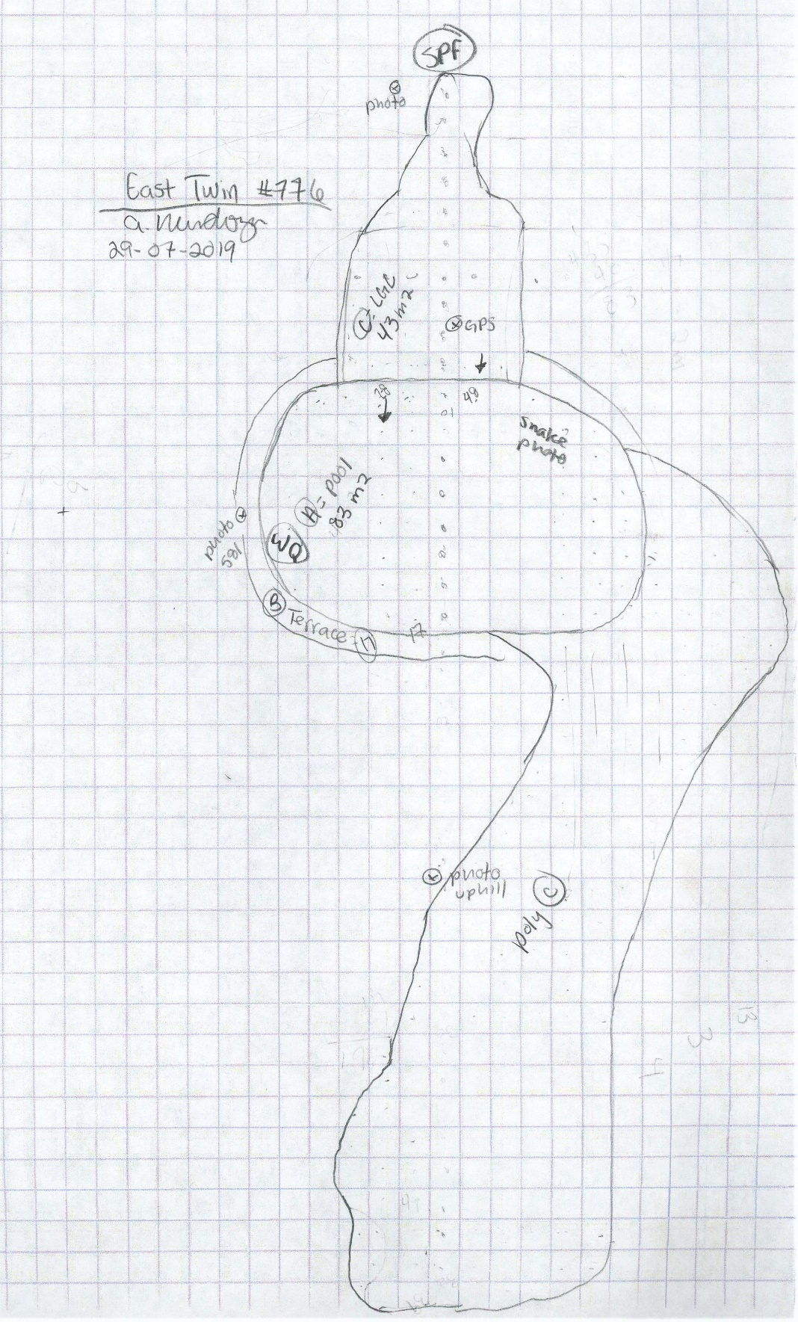
Fig 9.2 East Twin Spring Sketchmap.

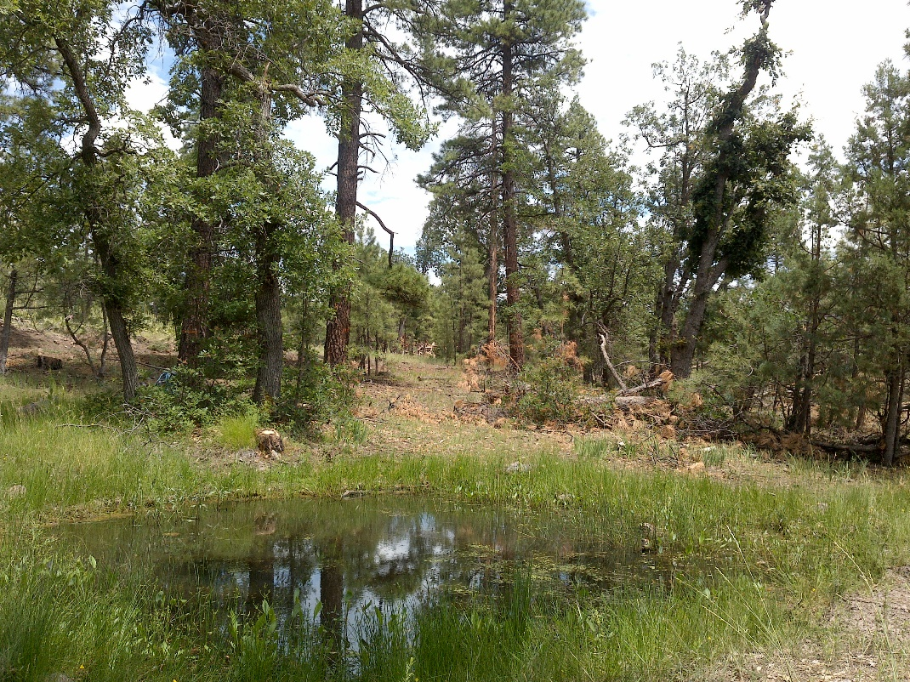
Fig 9.3 East Twin Spring: View from the bermed terrace, looking uphill towards the low gradient cienega, pond, and road.

10. Hat Tank lower, 5/08/12
10. Hat Tank lower, 5/08/12
Survey Summary Report, Site ID 765
Submitted 6/01/21 by Springs Stewardship Institute

Location: The Hat Tank lower ecosystem is located in Coconino County in the Upper Verde Arizona 15060202 HUC, managed by the US Forest Service. The spring is located in the Kaibab NF, Williams RD, in the May Tank Pocket USGS Quad, at 35.09281, -112.17659 measured using a GPS (NAD83, estimated position error 2 meters). The elevation is approximately 2036 meters. Larry Stevens, Jeri Ledbetter, and Anya Fayfer surveyed the site on 5/08/12 for 02:20 hours, beginning at 10:50, and collected data in 10 of 10 categories. This survey was conducted under a Kaibab Springs project using the Stevens et al. Level 2 protocol.

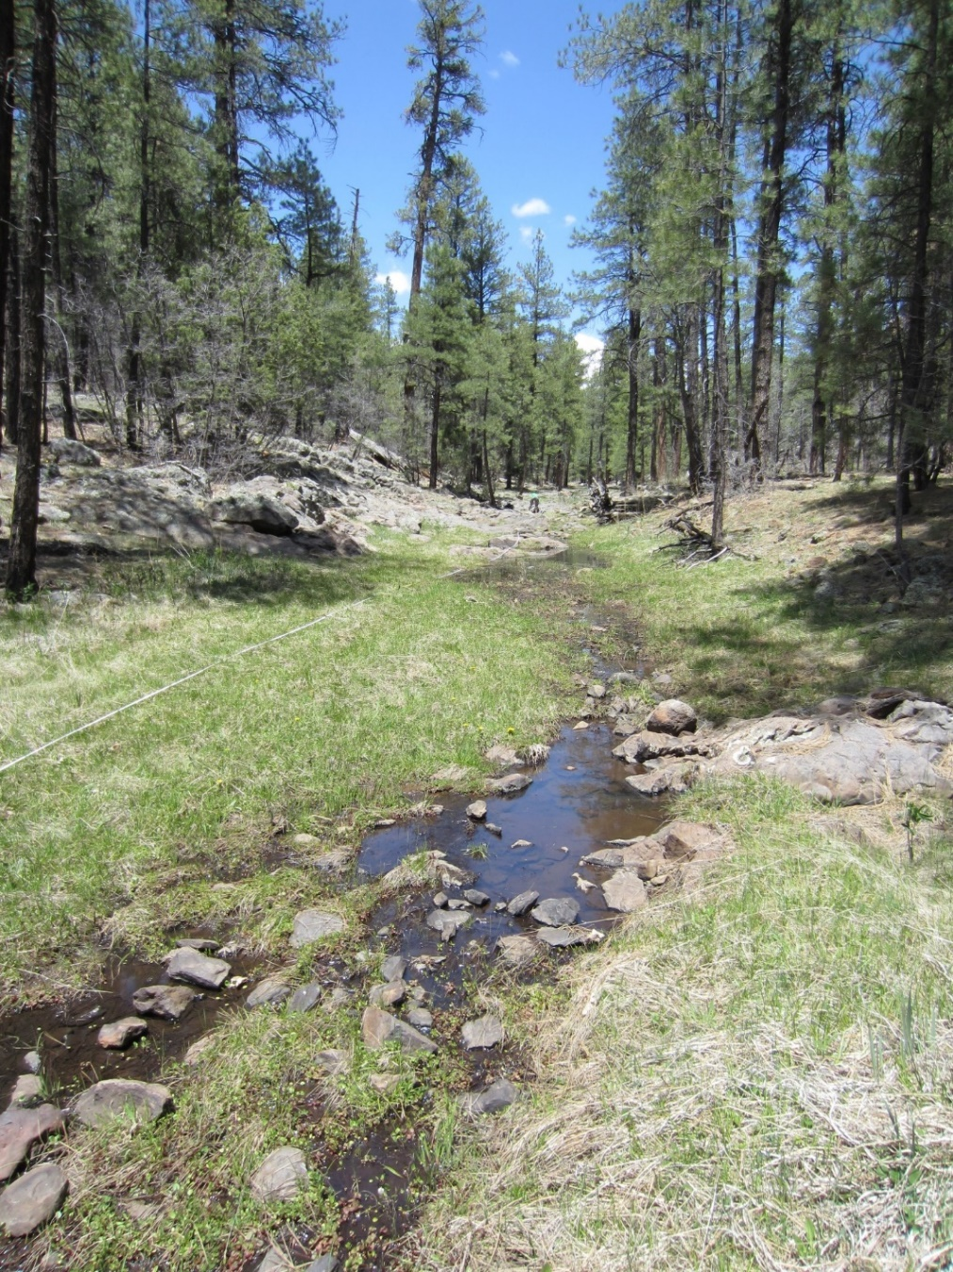
Fig 10.1 Hat Tank lower.

Physical Description: Hat Tank lower is a rheocrene spring. This rheocrene spring emerges in a small runoff-dominated channel in a heavily forested area. From 8/27/19 - Ephemeral/seasonal spring, 30' by 100' area of rush and grass. The microhabitats associated with the spring cover 674 sqm. The site has 2 microhabitats, including A -- a 114 sqm channel, B -- a 560 sqm terrace. The geomorphic diversity is 0.20, based on the Shannon-Weiner diversity index.

Table 10.1 Hat Tank lower Microhabitat characteristics.
Code | A | B
Name | Source Channel | Terrace
Area sqm | 114.00 | 560.00
Surface type | CH | TE
Surface subtype | run | LRZ
Slope variability | Low | Low
Aspect TN | 163 | 163
Slope degrees | 1 | 1
Moisture (scale 1-10) | 10 | 5
Water depth cm | 4.00
Area % open water | 50.00 | 0.00
Substrate
1 - Clay % | 0 | 0
2 - Silt % | 0 | 30
3 - Sand % | 2 | 25
4 - Fine gravel % | 13 | 20
5 - Coarse gravel % | 30 | 10
6 - Cobble % | 25 | 0
7 - Boulder % | 5 | 5
8 - Bedrock % | 0 | 5
Organic % | 25 | 5
Other % (anthropogenic) | 0 | 0
Precipitate % | 0.00 | 0.00
Litter % | 25.00 | 65.00
Wood % | 0.00 | 1.00
Litter Depth (cm) | 1.00 | 3.00

Geomorphology: Hat Tank lower emerges as a contact from a igneous, basalt rock layer. The emergence environment is subaerial, with a gravity flow force mechanism. The site receives approximately 95% of available solar radiation, with 6495 Mj annually.

Access Directions: From the town of Williams, travel south on County Rd 73 for 12.3 mi. Turn left on NF-57 (Bear Springs Rd) and continue for 0.32 mi before turning right on NF-4218A and traveling south for 0.45 mi. Continue left onto Overland Rd for 0.3 mi. Spring is 430 m due east.

Survey Notes: Water at the spring during the survey was likely heaviliy influenced by recent precipitation, but the vegetetion indicates that flow is more continuous than that provided only by runoff. There is little evidence of human use; however, the site is heavily grazed and trampled by elk. There are several natural pools, and the flow continues 260 m downstream.

Flow: Surveyors measured a flow of 21 liters/second, using a timed flow volume capture method. Flow was adjusted for an estimate of 1.00% of site flow capture. Flow was measured 59 m downstream from "source pool". Site is likely ephemeral. This spring is ephemeral, with a neorefugium persistence.

Water Quality: Measurement device was the Hanna. Measurements were taken at a depth of 10cm. The EC calibration standard at 1413 microS/cm as 1630 on Hanna Combo EC & pH; pH standard @ 7.00, read as 7.07 Standing water, likely rainwater.

Table 10.2 Hat Tank lower Water Quality Measurements.
Characteristic Measured | Value | Location Number | Device
pH (field) | 7.38 |  | Hanna/Ph Spear
Specific conductance (field) (uS/cm) | 95 |  | Hanna/Ph Spear
Temperature, air C | 20 |  | Handheld therm
Temperature, water C | 10.8 |  | Hanna/Ph Spear

Flora: Larry Stevens was the botanist. Surveyors identified 27 plant species at the site, with 0.0401 species/sqm. These included 21 native and 6 nonnative species.

Table 10.3 Hat Tank lower Cover Type.
Cover Type | Species Count | Wetland Species Count
Ground | 19 | 6
Shrub | 3 | 0
Mid-canopy | 1 | 0
Tall canopy | 1 | 0
Basal | 0 | 0
Aquatic | 3 | 3
Non-vascular | 2 | 0

Table 10.4 Hat Tank lower Vegetation % Cover in Microhabitats.
Plant Species | Cover Code | Native Status | Wetland Status | Comments | A | B
Achillea millefolium | GC | NI | U |  | 0.1 | 5
Agrostis stolonifera | GC | I | W |  | 10 | 2
Artemisia ludoviciana | GC | N | F |  | 0 | 0.1
Carex aurea | GC | N | W |  | 2 | 15
Cirsium | GC | N | F |  | 0 | 1
Geranium richardsonii | GC | N | F |  | 0 | 0.1
Iris missouriensis | GC | N | F |  | 0 | 0.2
Juniperus | GC | N | U |  | 0 | 0.2
Juniperus deppeana | SC | N | U |  | 0 | 1
Lathyrus | GC | N | R |  | 0 | 3
Lichen | NV | N | U |  | 0 | 2
Mentha arvensis | GC | N | WR |  | 1 | 0.1
Mimulus | AQ | N | W |  | 0.2 | 0
Pinus ponderosa | MC | N | U |  | 1 | 7
Pinus ponderosa | SC | N | U |  | 0 | 8
Pinus ponderosa | TC | N | U |  | 1 | 5
Poa pratensis | GC | I | F |  | 1 | 20
Quercus gambelii | SC | N | U |  | 0 | 0.1
Ranunculus | AQ | N | WR |  | 2 | 0.1
Rumex | GC | I | WR | old | 0 | 1
Sidalcea neomexicana | GC | N | WR |  | 0 | 0.5
Taraxacum officinale | GC | I | F |  | 0 | 10
Thalictrum | GC | N | U |  | 0 | 0.1
Trifolium | GC | I | WR |  | 2 | 20
unknown Bryophyte (moss, liverwort, hornwort) | NV | N | F |  | 3 | 0
unknown dicot | GC | NI |  | last year's | 0 | 0.1
Verbascum | GC | I | F |  | 0 | 0.1
Veronica | AQ | N | A |  | 3 | 0
Viola | GC | N | F |  | 0.1 | 3

Fauna: Surveyors collected or observed 11 aquatic and 31 terrestrial invertebrate taxa and 8 vertebrate taxa.

Table 10.5 Hat Tank lower Invertebrates.
Species | Lifestage | Habitat | Method | Rep# | Count | Species Detail
Coleoptera | Ad |  | Collected spot |  | 8
Coleoptera Carabidae | Ad | T | Collected spot |  | 1
Coleoptera Chrysomelidae Altica | Ad | T | Collected spot |  | 1
Coleoptera Dytiscidae | Ad | A | Collected spot |  | 1
Coleoptera Dytiscidae Agabus lugens | Ad | A | Collected spot |  | 1
Coleoptera Haliplidae Peltodytes dispersus | Ad | A | Collected spot |  | 1
Diplopoda | Ad | T | Collected spot |  | 1
Diptera | Ad | T | Collected spot |  | 1
Diptera Conopidae | Ad | T | Collected spot |  | 1
Diptera Sepsidae | Ad | T | Collected spot |  | 1
Diptera Stratiomyidae | Ad | T | Collected spot |  | 1
Diptera Tachinidae | Ad | T | Collected spot |  | 1
Ephemeroptera | L | A | Collected spot |  | 2
Hemiptera Cicadellidae | Ad | T | Collected spot |  | 1
Hemiptera Cixiidae | Ad | T | Collected spot |  | 1
Hemiptera Gerridae Aquarius remigis | Ad | A | Spot
Hemiptera Gerridae Aquarius remigis | Ad | A | Collected spot |  | 1
Hemiptera Saldidae | Ad | A | Collected spot |  | 1 | Along channel
Hymenoptera Apidae Bombus fervidus | Ad | T | Collected spot |  | 1 | Queen Taraxacum officinale
Hymenoptera Halictidae Augochlorella pomoniella | Ad | T | Collected spot |  | 1
Lepidoptera | Ad | T | Collected spot |  | 1
Lepidoptera Hesperiidae Erynnis brizo | Ad | T | Collected spot |  | 1
Lepidoptera Hesperiidae Erynnis icelus | Ad | T | Collected spot |  | 1
Lepidoptera Hesperiidae Erynnis meridianus | Ad | T | Spot |  | 1
Lepidoptera Hesperiidae Erynnis meridianus | Ad | T | Collected spot |  | 1
Lepidoptera Hesperiidae Erynnis telemachus | Ad | T | Collected spot |  | 1
Lepidoptera Hesperiidae Zestusa dorus | Ad | T | Collected spot |  | 1
Lepidoptera Lycaenidae Callophrys eryphon | Ad | T | Collected spot |  | 1
Lepidoptera Nymphalidae Nymphalis antiopa | Ad | T | Spot |  | 1
Lepidoptera Nymphalidae Speyeria | Ad | T | Spot |  | 1
Lepidoptera Nymphalidae Vanessa annabella | Ad | T | Spot |  | 1
Lepidoptera Papilionidae Papilio rutulus | Ad | T | Spot |  | 1
Lepidoptera Pieridae Pontia sisymbrii | Ad | T | Spot |  | 1
Mollusca | Ad |  | Collected spot |  | 1
Odonata | L | A | Collected spot |  | 1
Odonata Aeshnidae | L | A | Collected spot |  | 1
Odonata Coenagrionidae Argia nahuana | Ad | T | Collected spot |  | 1
Odonata Coenagrionidae Argia vivida | Ad | T | Collected spot |  | 1
Odonata Coenagrionidae Hesperagrion heterodoxum | Ad | T | Collected spot |  | 1
Odonata Libellulidae Libellula saturata | Ad | T | Spot |  | 1
Orthoptera Acrididae | Ad | T | Collected spot |  | 1
Sphaeriida Sphaeriidae Pisidium | Ad | A | Collected spot |  | 4
Trichoptera | L | A | Collected spot |  | 3
Trichoptera Limnephilidae | Ad | T | Spot

Table 10.6 Hat Tank lower Vertebrates.
Vertebrate Species Common Name | Count | Detection | Comments
hairy woodpecker | 1 | call
elk |  | sign | scat
chorus frog |  | call
deer |  | sign | jawbone
gopher |  | sign | holes
Virginia's warbler |  | obs
American robin |  | obs
domestic cow |  | sign | scat nearby

Assessment: Assessment scores were compiled in 6 categories and 41 subcategories, with 1 null condition scores, and 1 null risk scores. Aquifer functionality and water quality are good with significant restoration potential (average condition score 4) and there is low risk (average risk score 2). Geomorphology condition is good with significant restoration potential (average condition score 4.2) and there is low risk (average risk score 2.6). Habitat condition is moderate with some restoration potential (average condition score 3.8) and there is low risk (average risk score 2.6). Biotic integrity is good with significant restoration potential (average condition score 3.9) and there is moderate risk (average risk score 3). Human influence of site is good with significant restoration potential (average condition score 4.6) and there is negligible risk (average risk score 1.6). Administrative context status is moderate with some restoration potential and there is low risk. Overall, the site condition is good with significant restoration potential and there is low risk.

Table 10.7 Hat Tank lower Assessment Scores. Condition scores range from 0 (extremely poor condition) to 6 (pristine condition) and risk scores range from 0 (no risk to the site) to 6 (extreme risk to the site).
Category | Condition | Risk
Aquifer Functionality & Water Quality | 4 | 2
Geomorphology | 4.2 | 2.6
Habitat | 3.8 | 2.6
Biota | 3.88 | 3
Human Influence | 4.56 | 1.63
Administrative Context | 3.67 | 2.5
Overall Ecological Score | 3.97 | 2.55

Management Recommendations: This site is subject to substantial natural flood flows, and therefore management priority is low. However, occasional monitoring is warranted.

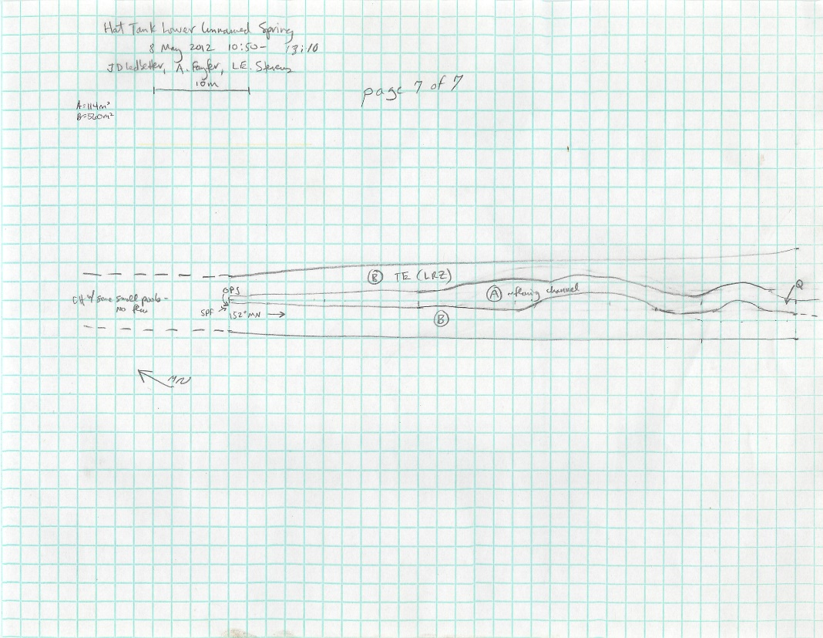
Fig 10.2 Hat Tank lower Sketchmap.

11. Hat Tank upper, 5/08/12
11. Hat Tank upper, 5/08/12
Survey Summary Report, Site ID 764
Submitted 6/01/21 by Springs Stewardship Institute

Location: The Hat Tank upper ecosystem is located in Coconino County in the Upper Verde Arizona 15060202 HUC, managed by the US Forest Service. The spring is located in the Kaibab NF, Williams RD, in the May Tank Pocket USGS Quad, at 35.09550, -112.17070 measured using a GPS (NAD83, estimated position error 3 meters). The elevation is approximately 2065 meters. Larry Stevens, Jeri Ledbetter, and Anya Fayfer surveyed the site on 5/08/12 for 01:20 hours, beginning at 13:50, and collected data in 9 of 10 categories. This survey was conducted under a Kaibab Springs project using the Stevens et al. Level 2 protocol.

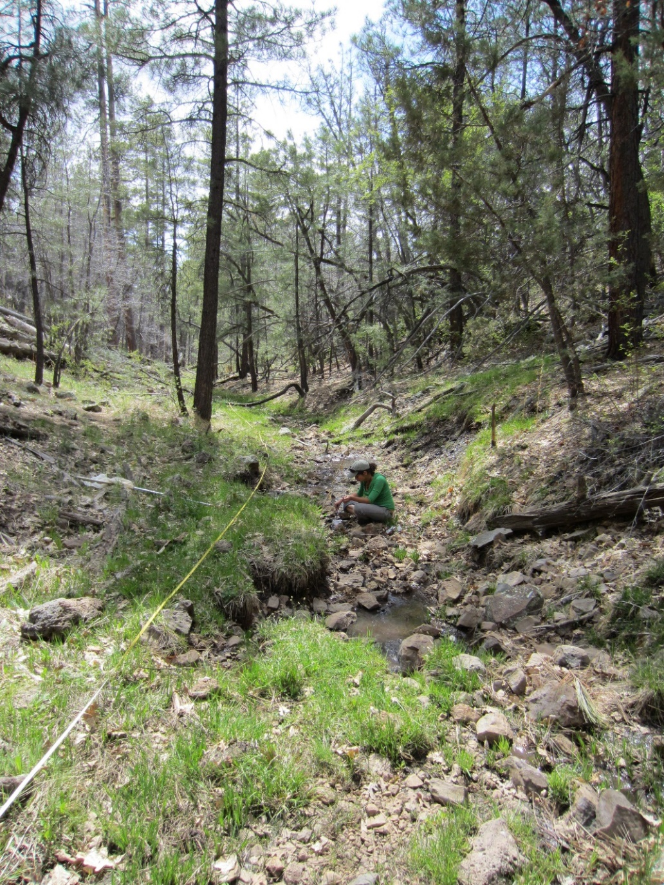
Fig 11.1 Hat Tank upper.

Physical Description: Hat Tank upper is a rheocrene/hillslope spring. This is a small rheocrene hillslope spring. There is some seepage in the channel and some from the bank. Two hundred meters downstream is Hat Tank that has been excavated to capture flow. From 8/27/19: Distributary spring in narrow wooded valley. Springs emerge from multiple outlets along eastern bank, along a ~200' section. Occasional small pools. Small amount of current in main channel and some permanent pools below last outlet. The microhabitats associated with the spring cover 178 sqm. The site has 3 microhabitats, including A -- a 38 sqm channel, B -- a 36 sqm colluvial slope, C -- a 104 sqm terrace. The geomorphic diversity is 0.42, based on the Shannon-Weiner diversity index.

Table 11.1 Hat Tank upper Microhabitat characteristics.
Code | A | B | C
Name | Source Channel | Source Seeping Bank | Terrace
Area sqm | 38.00 | 36.00 | 104.00
Surface type | CH | CS | TE
Surface subtype | run |  | LRZ
Slope variability | Low | Med | Med
Aspect TN | 266 | 336 | 266
Slope degrees | 2 | 60 | 2
Moisture (scale 1-10) | 10 | 8 | 1
Water depth cm | 2.00
Area % open water | 80.00
Substrate
1 - Clay % | 0 | 0 | 0
2 - Silt % | 0 | 0 | 0
3 - Sand % | 0 | 0 | 0
4 - Fine gravel % | 5 | 0 | 5
5 - Coarse gravel % | 35 | 10 | 25
6 - Cobble % | 10 | 5 | 10
7 - Boulder % | 0 | 0 | 0
8 - Bedrock % | 0 | 0 | 0
Organic % | 50 | 85 | 60
Other % (anthropogenic) | 0 | 0 | 0
Precipitate % | 0.00 | 0.00 | 0.00
Litter % | 5.00 | 0.00 | 0.00
Wood % | 1.00 | 5.00 | 3.00
Litter Depth (cm) | 0.50 | 1.00 | 1.00

Geomorphology: Hat Tank upper emerges as a seepage or filtration from a igneous, basalt rock layer. The emergence environment is subaerial, with a gravity flow force mechanism. The site receives approximately 98% of available solar radiation, with 6717 Mj annually.

Access Directions: From the town of Williams, travel south on County Rd 73 for 12.3 mi. Turn left on NF-57 (Bear Springs Rd) and continue for 0.54 mi before turning right on NF-4216A and traveling SE for 0.2 mi. Turn right on NF-4217 and travel south for 0.7 mi. Spring is 150 m due SE.

Survey Notes: There has been some trailing by animals and maybe humans. The recent rain/snow is likely influencing water quality values.

Flow: Surveyors measured a flow of 11 liters/second, using a timed flow volume capture method. Flow was adjusted for an estimate of 1.00% of site flow capture. Flow was measured 40 m below first emergence. This spring is perennial, with a neorefugium persistence.

Water Quality: Water quality measurements were taken at the top end of source pool and in a hillslope tributary seep at about 28 m on main transect. The first point was at 1.5 cm depth and the second two in the tributary were at 2.0 cm.

Table 11.2 Hat Tank upper Water Quality Measurements.
Characteristic Measured | Value | Location Number | Device
Alkalinity, Total (mg/L) | 30 |  | test strips
Hardness, Ca + Mg (mg/L) | 20 |  | test strips
pH (field) | 6.97 |  | Hanna/Ph Spear
Specific conductance (field) (uS/cm) | 108.5 |  | Hanna/Ph Spear
Temperature, air C | 20 |  | Handheld therm
Temperature, water C | 10.1 |  | Hanna/Ph Spear

Flora: Larry Stevens was the botanist. Surveyors identified 25 plant species at the site, with 0.1404 species/sqm. These included 20 native and 4 nonnative species; the native status of 1 species remains unknown.

Table 11.3 Hat Tank upper Cover Type.
Cover Type | Species Count | Wetland Species Count
Ground | 21 | 7
Shrub | 3 | 0
Mid-canopy | 1 | 0
Tall canopy | 1 | 0
Basal | 0 | 0
Aquatic | 0 | 0
Non-vascular | 0 | 0

Table 11.4 Hat Tank upper Vegetation % Cover in Microhabitats.
Plant Species | Cover Code | Native Status | Wetland Status | Comments | A | B | C
Achillea millefolium | GC | N | U |  | 0 | 0 | 5
Agrostis stolonifera | GC | I | W |  | 10 | 15 | 20
Carex aurea | GC | N | W |  | 5 | 5 | 15
Cirsium | GC | N | F |  | 0 | 0 | 0.3
Geranium | GC | N | F |  | 0 | 0 | 1
Gnaphalium chilense | GC | N | WR | question mark on species | 0 | 0 | 0.1
Iris missouriensis | GC | N | F |  | 0.1 | 1 | 2
Juniperus deppeana | SC | N | U |  | 3 | 20 | 4
Lupinus | GC | N | F |  | 0 | 0 | 0.2
Mimulus guttatus | GC | N | W |  | 1 | 1 | 0
Pinus ponderosa | MC | N | U |  | 6 | 25 | 15
Pinus ponderosa | TC | N | U |  | 5 | 30 | 15
Polygonum | GC | N | WR |  | 0 | 0 | 0.1
Quercus gambelii | SC | N | U |  | 1 | 0 | 3
Ranunculus | GC | N | WR |  | 0.2 | 0.2 | 1
Rosa woodsii | SC | N | F |  | 1 | 8 | 5
Solidago | GC | N | F |  | 0 | 0 | 0.2
Taraxacum officinale | GC | I | F |  | 0 | 0 | 8
Thalictrum | GC | N | U |  | 0 | 0 | 1
Trifolium | GC | I | WR |  | 0.1 | 5 | 8
unknown grass | GC |  |  | poa? | 5 | 20 | 20
Verbascum | GC | I | F |  | 0 | 0 | 1
Veronica | GC | N | A |  | 1 | 1 | 0
Vicia | GC | N | WR | species 2 | 0 | 0 | 2
Vicia | GC | N | WR | unknown vetch | 0 | 0 | 0.5
Viola | GC | N | F |  | 0 | 0 | 0.1

Fauna: Surveyors collected or observed 5 terrestrial invertebrate taxa and 9 vertebrate taxa.

Table 11.5 Hat Tank upper Invertebrates.
Species | Lifestage | Habitat | Method | Rep# | Count | Species Detail
Diptera Syrphidae | Ad | T | Collected spot |  | 1
Lepidoptera Hesperiidae Epargyreus clarus | Ad | T | Collected spot |  | 1
Lepidoptera Hesperiidae Erynnis icelus | Ad | T | Collected spot |  | 1
Lepidoptera Hesperiidae Zestusa dorus | Ad | T | Collected spot |  | 1 | Taraxacum officinale
Lepidoptera Pieridae Pontia sisymbrii | Ad | T | Collected spot |  | 1 | Taraxacum officinale

Table 11.6 Hat Tank upper Vertebrates.
Vertebrate Species Common Name | Count | Detection | Comments
American robin | 1 | obs
white-breasted nuthatch |  | call
elk |  | sign | scat
Common raven |  | call
hermit thrush |  | obs
warbler |  | call
hummingbird |  | call
domestic cow |  | sign | scat
Terrestrial Gartersnake |  | obs

Assessment: Assessment scores were compiled in 6 categories and 42 subcategories, with 0 null condition scores, and 1 null risk scores. Aquifer functionality and water quality are good with significant restoration potential (average condition score 4.2) and there is low risk (average risk score 1.8). Geomorphology condition is moderate with some restoration potential (average condition score 3.6) and there is low risk (average risk score 2.8). Habitat condition is moderate with some restoration potential (average condition score 3.8) and there is moderate risk (average risk score 3). Biotic integrity is good with significant restoration potential (average condition score 4.5) and there is low risk (average risk score 2.1). Human influence of site is good with significant restoration potential (average condition score 4.4) and there is low risk (average risk score 1.9). Administrative context status is good with significant restoration potential and there is moderate risk. Overall, the site condition is good with significant restoration potential and there is low risk.

Table 11.7 Hat Tank upper Assessment Scores. Condition scores range from 0 (extremely poor condition) to 6 (pristine condition) and risk scores range from 0 (no risk to the site) to 6 (extreme risk to the site).
Category | Condition | Risk
Aquifer Functionality & Water Quality | 4.17 | 1.83
Geomorphology | 3.6 | 2.8
Habitat | 3.8 | 3
Biota | 4.5 | 2.13
Human Influence | 4.44 | 1.88
Administrative Context | 3.89 | 3.38
Overall Ecological Score | 4.02 | 2.44

Management Recommendations: As a rheocrene, this spring is subject to natural flood disturbance. Elk fencing would prevent trampling and allow regrowth of riparian vegetation. As Hat Tank is just downstream, faunal species will still have access to water. Monitoring is appropriate.

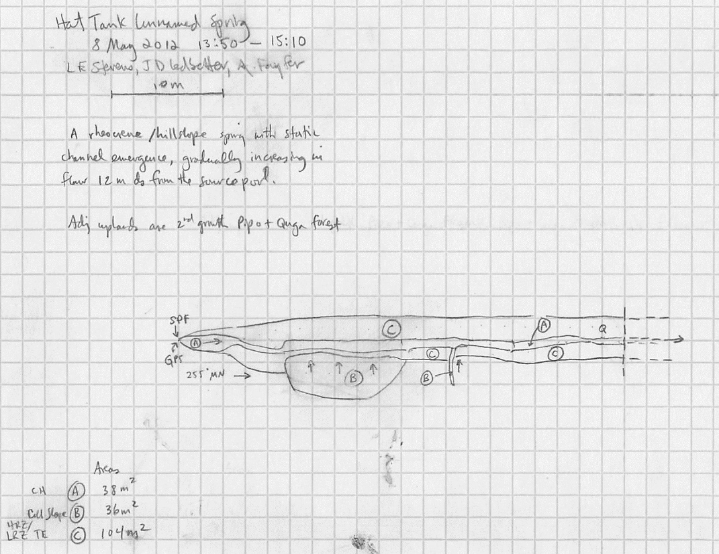
Fig 11.2 Hat Tank upper Sketchmap.

12. Hell Canyon Spring, 8/28/18
12. Hell Canyon Spring, 8/28/18
Survey Summary Report, Site ID 19259
Submitted 6/01/21 by Springs Stewardship Institute

Location: The Hell Canyon Spring ecosystem is located in Coconino County in the Upper Verde Arizona 15060202 HUC, managed by the US Forest Service. The spring is located in the Kaibab NF, Williams RD, in the Williams South USGS Quad, at 35.15263, -112.22294 measured using a GPS (WGS84). The elevation is approximately 2015 meters. Jeri Ledbetter, Alek Mendoza, and Gloria Hardwick verified the site on 8/28/18 at 13:20. This survey was conducted under a Kaibab Springs project using the Stevens et al. Level 1 protocol.

Physical Description: Hell Canyon Spring is a rheocrene spring. This site is located in a steep, heavily forested drainage.

Geomorphology: Hell Canyon Spring emerges from the basalt flow, a igneous, basalt rock layer. The site receives approximately 93% of available solar radiation, with 6377 Mj annually.

Access Directions: Go south on Perkinsville Road out of Williams for approximately 7.5 miles. Take a right turn onto NF 122. There will be a sign for Twin Springs (actually located at Twin Springs Rd Unnamed) and then road to the south at approximately 4.7 miles from the Perkinsville Road turn. Continue on Rt 122 past Twin Springs for about 1.5 miles on a rough road. The spring is in Hell Canyon, about 0.2 miles south of where the road takes a sharp turn to the right.

Survey Notes: During the time of the survey, there was no sign of water at the site and the surrounding area was entirely dry. The tank labeled Bear Tank #2, located downstream of the mapped spring, had minimal water present.

13. Klostermeyer Spring, 6/09/18
13. Klostermeyer Spring, 6/09/18
Survey Summary Report, Site ID 753
Submitted 6/01/21 by Springs Stewardship Institute

Location: The Klostermeyer Spring ecosystem is located in Coconino County in the Upper Verde Arizona 15060202 HUC, managed by the US Forest Service. The spring is located in the Kaibab NF, Williams RD, in the Parks USGS Quad, at 35.30421, -111.89514 measured using a map (NAD83). The elevation is approximately 2264 meters. Jeri Ledbetter verified the site on 6/09/18 at 16:45. This survey was conducted under a Kaibab Springs project using the Stevens et al. Level 1 protocol.

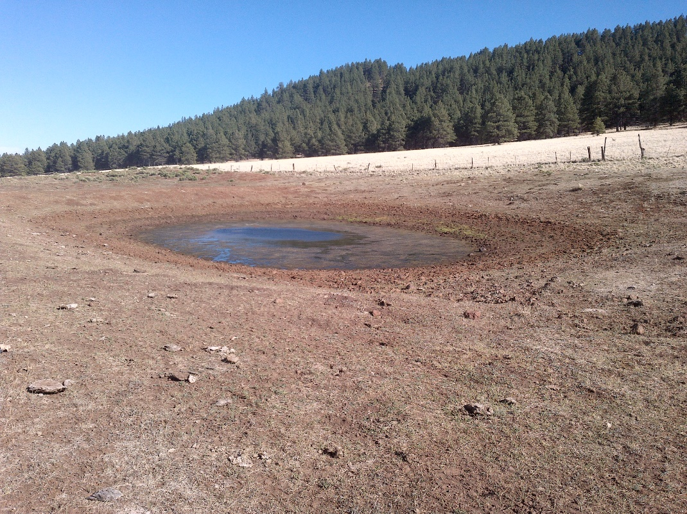
Fig 13.1 Klostermeyer Spring.

Physical Description: This named site is depicted on the DRG, on the northeast base of Klostermeyer Hill.

Geomorphology: Klostermeyer Spring emerges from a igneous, basalt rock layer.

Access Directions: From Parks, drive east on old Hwy 66 for 0.5 miles. Continue on Brannigan Park Rd. for 4 miles. Turn left on Transwestern Rd/CR171C and follow it for 1.7 miles. Transwestern Road turns left; follow it for 0.5 more miles. Turn left on NF 9001N and follow it for 0.4 miles. Turn left on NF 9005U and follow it for 0.6 miles. Continue on 3592 for 0.5 miles, and then 3601 for 0.5 miles. Tank is on the left side of the road.

Survey Notes: The site is heavily grazed and trampled by livestock, and the fencing is down.

14. L O Spring, 5/26/15
14. L O Spring, 5/26/15
Survey Summary Report, Site ID 747
Submitted 6/01/21 by Springs Stewardship Institute

Location: The L O Spring ecosystem is located in Coconino County in the Upper Verde Arizona 15060202 HUC, managed by the US Forest Service. The spring is located in the Kaibab NF, Williams RD, in the Garland Prairie USGS Quad, at 35.15335, -111.98434 (NAD83). The elevation is approximately 2041 meters. Jeri Ledbetter, Larry Stevens, Glenn Rink, Gary Alpert, Molly Joyce, Jenn Chavez, Jeff Jenness and Gloria Hardwick surveyed the site on 5/26/15 for 04:10 hours, beginning at 9:55, and collected data in 10 of 10 categories. This survey was conducted under a Kaibab Springs project using the Stevens et al. Level 2 protocol.

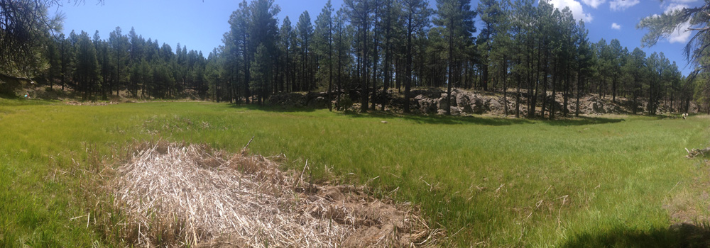
Fig 14.1 L O Spring.

Physical Description: L O Spring is a helocrene/rheocrene spring. This named site is located in the headwaters of Sycamore Canyon, and is depicted on the DRG. Surveyed by Flora in 2004, it was reported to be a limnocrene spring emerging from a basalt layer. In 2014, SSI surveyors found a large springs complex with four discreet hillslope sources, and probably diffuse emergence, in a wide, shallow channel, heavily influenced by runoff. The site is in a forested area, within 500 meters of a parking lot, and houses scattered within the surrounding five to ten miles. The flow was reported in 1949 as 0.0631 in the Arizona GWSI database. The microhabitats associated with the spring cover 6533 sqm. The site has 8 microhabitats, including A -- a 22 sqm channel, B -- a 21 sqm channel, C -- a 19 sqm channel, D -- a 22 sqm channel, E -- a 5553 sqm channel, F -- a 443 sqm pool, G -- a 227 sqm channel, H -- a 226 sqm pool. The geomorphic diversity is 0.27, based on the Shannon-Weiner diversity index.

Table 14.1 L O Spring Microhabitat characteristics.
Code | A | B | C | D | E | F | G | H
Name | Source | Source | Source | Source | Stream Channel | Ponds | Runout Channel | Lower Pool
Area sqm | 22 | 21 | 19 | 22 | 5553 | 443 | 227 | 226
Surface type | CH | CH | CH | CH | CH | P | CH | P
Surface subtype | run | margin | run | run | riffle |  | run
Slope variability | Low | Low | Low | Low | Low | Low | Low | Low
Aspect TN | 176 | 121 | 293 | 221 | 191 |  | 206
Slope degrees | 9 | 15 | 5 | 4 | 1 | 0.0 | 2 | 0.0
Moisture (scale 1-10) | 8 | 7 | 8 | 7 | 9 | 9 | 9 | 9
Water depth cm | 1 | .5 | 5 | 3 |  | 31 | 5 | 40
Area % open water | 20 | 8 | 40 | 10 |  | 60 | 40 | 95
Substrate
1 - Clay % | 0 | 0 | 0 | 0 | 0 | 0 | 0 | 0
2 - Silt % | 5 | 0 | 5 | 5 | 5 | 5 | 7 | 5
3 - Sand % | 5 | 5 | 5 | 5 | 5 | 5 | 8 | 5
4 - Fine gravel % | 60 | 10 | 10 | 5 | 5 | 5 | 10 | 25
5 - Coarse gravel % | 25 | 40 | 60 | 55 | 25 | 20 | 45 | 55
6 - Cobble % | 5 | 35 | 20 | 30 | 5 | 5 | 30 | 10
7 - Boulder % | 0 | 10 | 0 | 0 | 5 | 0 | 0 | 0
8 - Bedrock % | 0 | 0 | 0 | 0 | 0 | 0 | 0 | 0
Organic % | 0 | 0 | 0 | 0 | 50 | 60 | 0 | 0
Other % (anthropogenic) | 0 | 0 | 0 | 0 | 0 | 0 | 0 | 0
Precipitate % | 0 | 0 | 0 | 0 | 0 | 0 | 0 | 0
Litter % | 8 | 12 | 5 | 15 | 80 | 40 | 5 | 10
Wood % | 3 | 7 | 1 | 2 | 1 | 3 | 0 | 2
Litter Depth (cm) | .1 | .5 | 1 | 2 | 3 | 15 | .5 | 1

Geomorphology: L O Spring emerges as a seepage or filtration from the Igneous colluvium, a igneous, basalt rock layer. The emergence environment is subaerial, with a gravity flow force mechanism.

Access Directions: From exit 178 on I-40, travel south on County Rd 141 (E Parks Rd) toward Garland Prairie Rd for 0.08 mi. Continue south on S Garland Prairie Rd (CR-141) for 9.14 mi. Turn left and travel 0.58 mi south on S Thomas Loop Rd and park in a small lot. Hike due west 260 m along a trail then drop into the drainage.

Survey Notes: Recent snow, rain, and associated runoff have left the main channel very moist, with large pools upstream of the site that were not present in August 2014. Small fish were spotted in the lower pool and a large amount of the typha in the upper pool was dead and fallen over, covering the lower part of the upper pool. There was evidence of occasional significant runoff. The survey of this large site took just over 4 hours with a crew of eight surveyors, less a 30 minute lunch break. This springs complex shows evidence of a long history of use, with old piping and a cable crossing or bridge. Nonetheless it is in very good geomorphic condition, with flow provided by four sources, and upstream flow delivered by the channel.

Flow: Surveyors measured a flow of 0.19 liters/second, using a timed flow volume capture method. Flow was adjusted for an estimate of 90% of site flow capture. Surveyors measured flow using a volume method at Source Channels A (pt 1) and B (pt 2). It was not possible to measure flow at source Channels C and D, as they were rocky with very little gradient. Surveyors estimated flow at these channels.

Water Quality: Surveyors measured water chemistry at 1 m below the source in polygons A and B, at the source in polygon C, and 4 m below the source in polygon D.

Table 14.2 L O Spring Water Quality Measurements.
Characteristic Measured | Value | Location Number | Device
Alkalinity, Total (mg/L) | 116.5 |  | LaMotte
Dissolved oxygen (field) (mg/L) | 5 |  | CHEMets DO kit
Dissolved oxygen (field) (mg/L) | 4 |  | Hanna Combo
Dissolved Solids (field) (ppt) | 0.10275 |  | Hanna Combo
pH (field) | 7.43 |  | Hanna Combo
Specific conductance (field) (uS/cm) | 289 |  | Hanna Combo
Temperature, air C | 24 |  | Handheld therm
Temperature, water C | 10.225 |  | Hanna Combo

Flora: Surveyors identified 41 plant species at the site, with 0.0063 species/sqm. These included 32 native and 9 nonnative species.

Table 14.3 L O Spring Cover Type.
Cover Type | Species Count | Wetland Species Count
Ground | 30 | 14
Shrub | 3 | 1
Mid-canopy | 1 | 0
Tall canopy | 1 | 0
Basal | 0 | 0
Aquatic | 4 | 4
Non-vascular | 2 | 0

Table 14.4 L O Spring Vegetation % Cover in Microhabitats.
Plant Species | Cover Code | Native Status | Wetland Status | Comments | A | B | C | D | E | F | G | H
Achillea millefolium | GC | N | U |  | 0 | 0.01 | 0 | 0 | 0 | 0 | 0 | 0
Agrostis | GC | I | W |  | 0 | 0.01 | 0 | 0 | 0 | 0 | 0 | 0
algae | AQ | N | A |  | 4 | 0 | 0 | 0 | 0 | 25 | 10 | 100
Ambrosia | GC | I? | F |  | 0 | 0.01 | 0 | 0 | 0 | 0 | 0 | 0
Carex | GC | N | W | sp.nov. aff Klamathensis | 0 | 0 | 0 | 0 | 0.5 | 0 | 0 | 0
Carex nebrascensis | GC | N | W |  | 2 | 2 | 1 | 0 | 10 | 0 | 60 | 3
Carex ovalis | GC | N | F | sec. several species | 0 | 0 | 0 | 0 | 8 | 0 | 0 | 0
Carex pellita | GC | N | W |  | 0 | 0 | 0 | 0 | 7 | 0 | 1 | 1
Carex simulata | GC | N | W |  | 0.25 | 0 | 0 | 0 | 14 | 0 | 0.4 | 1
Cicuta | GC | N | W |  | 6 | 50 | 60 | 60 | 0.5 | 15 | 8 | 2
Cirsium vulgare | GC | I | F |  | 0 | 2 | 0 | 0 | 0 | 0 | 0 | 0
Fragaria | GC | N | U |  | 0 | 0 | 0 | 0 | 0.05 | 0 | 0 | 0
Geranium | GC | N | F |  | 0 | 0 | 0 | 0 | 0.5 | 0 | 0 | 0
Geum triflorum | GC | N | U | ?? | 0 | 0 | 0 | 0 | 0.2 | 0 | 0 | 0
Hierochloe odorata | GC | N | WR |  | 0 | 0 | 0 | 0 | 0.5 | 0 | 0 | 0
Hypericum | GC | NI | F |  | 0 | 0.2 | 0 | 0 | 0.3 | 0 | 0 | 0
Iris missouriensis | GC | N | F |  | 0 | 0 | 0 | 0 | 0.5 | 0 | 0 | 0
Juncus balticus | GC | N | W |  | 0.5 | 2 | 0 | 0 | 15 | 0 | 0 | 0
Juncus saximontanus | GC | N | W |  | 8 | 2 | 0 | 0 | 0 | 0 | 0 | 0
Juniperus scopulorum | MC | N | U |  | 0 | 80 | 100 | 0 | 0 | 0 | 0 | 0
Lichen | NV | N | U |  | 0.001 | 0.02 | 1 | 0 | 0 | 0 | 0.5 | 0
Melilotus officinalis | GC | I | WR |  | 0 | 0 | 0 | 0 | 0.2 | 0 | 0 | 0
Mimulus | GC | N | W |  | 0 | 4.5 | 0 | 0 | 0 | 0 | 0 | 0
Nasturtium officinale | AQ | I | W |  | 25 | 0 | 0 | 0.01 | 0 | 0.1 | 0.3 | 0
Nuphar lutea ssp. polysepala | AQ | N | WR |  | 0 | 0 | 0 | 0 | 0 | 1 | 0 | 0
Nuphar lutea ssp. polysepala | AQ | N | WR | in flower | 0 | 0 | 0 | 0 | 0 | 0 | 0 | 15
Pinus ponderosa | TC | N | U |  | 0 | 0 | 0 | 0 | 0 | 1 | 0 | 1
Poa pratensis | GC | I | F |  | 0 | 6 | 0 | 0 | 15 | 0 | 0 | 0
Polygonum bistortoides | GC | N | W |  | 0 | 0 | 0 | 0 | 0.5 | 0 | 0 | 0
Potentilla hippiana | GC | N | U |  | 0 | 0 | 0 | 0 | 0.2 | 0 | 0 | 0
Ribes cereum | SC | N | U |  | 0 | 1 | 0 | 0 | 0 | 0 | 0 | 0
Rosa woodsii | SC | N | F |  | 0 | 0.02 | 0 | 0 | 0 | 0 | 0 | 0
Rumex crispus | GC | I | WR |  | 0.01 | 0.02 | 0 | 0 | 0.3 | 0 | 0 | 0
Salix lasiolepis | SC | N | R |  | 0 | 0 | 0 | 0 | 1 | 0 | 0 | 0.5
Sidalcea nelsoniana | GC | N | F |  | 0.01 | 0.1 | 0 | 0 | 0.5 | 0 | 0 | 0
Taraxacum officinale | GC | I | F |  | 0 | 0 | 0 | 0 | 0.05 | 0 | 0 | 0
Trifolium | GC | I | WR |  | 0.5 | 0 | 1 | 0 | 0 | 0 | 0 | 0
Typha latifolia | GC | N | A |  | 0 | 0 | 0 | 0 | 0 | 75 | 0 | 8
unknown Bryophyte (moss, liverwort, hornwort) | NV | N | F |  | 0.25 | 0.02 | 2 | 0 | 0 | 0 | 4 | 0.5
unknown dicot | GC | NI |  | pointed leaves, mounds | 0 | 0 | 0 | 0 | 0.2 | 0 | 0 | 0
Viola nephrophylla | GC | N | WR |  | 0 | 0 | 0 | 0 | 1 | 0 | 0 | 0

Fauna: Surveyors collected or observed 32 aquatic and 49 terrestrial invertebrate taxa and 13 vertebrate taxa.

Table 14.5 L O Spring Invertebrates.
Species | Lifestage | Habitat | Method | Rep# | Count | Species Detail
Amphipoda Gammaridae Gammarus | Ad | A | Spot |  | 12
Amphipoda Gammaridae Gammarus | Ad | A | Collected spot |  | 15
Annelida Clitellata |  |  | Collected spot |  | 1
Annelida Clitellata | I |  | Collected spot |  | 8 | leeches
Araneae | Ad | T | Collected spot |  | 1
Araneae | M | T | Spot |  | 3
Araneae | Ad | T | Spot |  | 1 | Tetragnatha
Araneae Agelenidae | Ad | T | Spot |  | 1
Araneae Gnaphosidae | I | T | Spot |  | 1
Araneae Lycosidae | I | T | Spot |  | 1
Araneae Pisauridae Dolomedes triton | L | A | Spot |  | 1 | observed
Basommatophora Physidae | Ad | A | Spot |  | 2
Basommatophora Physidae Physella gyrina | M |  | Collected spot |  | 2
Chilopoda | Ad | T | Collected spot |  | 1
Chilopoda Scolopendridae Scolopendra viridis | I | T | Spot |  | 1
Coleoptera Cantharidae Podabrus pruinosus | Ad | T | Collected spot |  | 1
Coleoptera Carabidae | Ad | T | Collected spot |  | 1
Coleoptera Chrysomelidae | Ad | T | Collected spot |  | 1
Coleoptera Chrysomelidae Altica | Ad | T | Collected spot |  | 1
Coleoptera Chrysomelidae Kuschelina aemula | Ad |  | Collected spot |  | 1
Coleoptera Chrysomelidae Kuschelina lugens | Ad | T | Collected spot |  | 1
Coleoptera Coccinellidae Hippodamia convergens | Ad | T | Collected spot |  | 1
Coleoptera Curculionidae | Ad | T | Collected spot |  | 1
Coleoptera Dytiscidae | Ad | A | Spot |  | 2
Coleoptera Dytiscidae | Ad | A | Collected spot |  | 1
Coleoptera Haliplidae | Ad | A | Collected spot |  | 1
Coleoptera Haliplidae Haliplus | Ad | A | Spot |  | 1
Coleoptera Hydrophilidae | Ad | A | Collected spot |  | 1
Coleoptera Hydrophilidae | Ad | A | Spot |  | 5
Coleoptera Tenebrionidae | Ad | T | Collected spot |  | 1
Diptera | Ad | T | Collected spot |  | 1
Diptera Bombyliidae | Ad | T | Collected spot |  | 1
Diptera Ceratopogonidae | L | A | Spot |  | 1
Diptera Chaoboridae | L | A | Collected spot |  | 1
Diptera Dolichopodidae | Ad | T | Collected spot |  | 1
Diptera Dolichopodidae | Ad | T | Spot |  | 1
Diptera Tabanidae | L | A | Spot |  | 1
Diptera Tipulidae | Ad | T | Collected spot |  | 1
Diptera Tipulidae Tipula | L | A | Spot |  | 1
Ephemeroptera Baetidae | Ad | T | Collected spot |  | 3
Ephemeroptera Baetidae | Ad | T | Spot |  | 3
Hemiptera Belostomatidae | Ad | A | Collected spot |  | 2 | collected dead
Hemiptera Belostomatidae Abedus herberti | L | A | Spot |  | 1
Hemiptera Cicadellidae | Ad | T | Collected spot |  | 1
Hemiptera Cicadidae Platypedia | Ad | T | Collected spot |  | 1
Hemiptera Corixidae Corisella | Ad | A | Collected spot |  | 1
Hemiptera Corixidae Corisella | Ad | A | Spot |  | 14
Hemiptera Corixidae Hesperocorixa laevigata | Ad | A | Spot |  | 4
Hemiptera Corixidae Hesperocorixa laevigata | Ad | A | Collected spot |  | 1
Hemiptera Gerridae Aquarius remigis | Ad | A | Spot |  | 1
Hemiptera Gerridae Aquarius remigis | Ad | A | Collected spot |  | 1
Hemiptera Lygaeidae | Ad | T | Collected spot |  | 1
Hemiptera Membracidae | Ad | T | Collected spot |  | 1
Hemiptera Miridae | Ad | T | Collected spot |  | 1
Hemiptera Notonectidae Notonecta kirbyi | Ad | A | Collected spot |  | 1
Hemiptera Notonectidae Notonecta kirbyi | Ad | A | Spot |  | 1
Hemiptera Pentatomidae | Ad | T | Collected spot |  | 1
Hirudinida Erpobdellidae | M | A | Spot |  | 4
Hymenoptera Apidae Apis mellifera | Ad | T | Collected spot |  | 1 | Nuphar polysepala flower
Hymenoptera Sphecidae | Ad | T | Collected spot |  | 1
Isopoda | Ad | T | Collected spot |  | 2
Isopoda | Ad | T | Spot |  | 2
Isoptera | Ad | T | Collected spot |  | 2
Lepidoptera | Ad | T | Spot |  | 1
Lepidoptera | P |  | Collected spot |  | 1 | half pupated larvae
Lepidoptera Hesperiidae Erynnis | Ad | T | Spot |  | 1
Lepidoptera Hesperiidae Erynnis meridianus | Ad | T | Spot |  | 1
Lepidoptera Hesperiidae Erynnis telemachus | Ad | T | Collected spot |  | 1
Lepidoptera Hesperiidae Pyrgus communis complex | Ad | T | Collected spot |  | 1
Lepidoptera Hesperiidae Pyrgus communis complex | Ad | T | Spot |  | 1
Lepidoptera Moth | Ad | T | Collected spot |  | 1
Lepidoptera Noctuidae Euxoa | Ad | T | Collected spot |  | 1
Lepidoptera Nymphalidae Nymphalis antiopa | Ad | T | Spot |  | 1
Lepidoptera Nymphalidae Phyciodes | Ad | T | Spot |  | 1
Lepidoptera Nymphalidae Phyciodes campestris | Ad | T | Spot |  | 1
Lepidoptera Nymphalidae Phyciodes tharos | Ad | T | Collected spot |  | 1
Lepidoptera Nymphalidae Vanessa atalanta | Ad | T | Spot |  | 1
Lepidoptera Pieridae Colias eurytheme | Ad | T | Spot |  | 1
Lepidoptera Pieridae Nathalis iole | Ad | T | Spot |  | 1
Neuroptera Hemerobiidae | Ad | T | Collected spot |  | 1
Odonata Coenagrionidae | Ad | T | Spot |  | 8
Odonata Coenagrionidae Argia | L | A | Spot |  | 3
Odonata Coenagrionidae Ischnura | L | A | Spot |  | 9
Odonata Libellulidae Sympetrum pallipes | Ad | T | Spot |  | 1
Odonata Zygoptera | L | A | Collected spot |  | 8
Opisthopora Lumbricidae | M | A | Collected spot |  | 3
Opisthopora Lumbricidae Lumbricus terrestris | Ad | A | Spot |  | 3
Orthoptera Acrididae | Ad | T | Collected spot |  | 1
Orthoptera Tetrigidae | Ad | A | Spot |  | 1
Orthoptera Tetrigidae | Ad | A | Collected spot |  | 1
Plecoptera | L | A | Collected spot |  | 2
Plecoptera | L | A | Spot |  | 2
Sphaeriida Sphaeriidae Pisidium | M | A | Spot |  | 16
Sphaeriida Sphaeriidae Pisidium casertanum | M |  | Collected spot |  | 18
Trichoptera | L | A | Collected spot |  | 4
Trichoptera Limnephilidae | L | A | Spot |  | 5

Table 14.6 L O Spring Vertebrates.
Vertebrate Species Common Name | Count | Detection | Comments
common raven | 2 | obs
elk |  | sign | tracks and scat
Terrestrial Gartersnake | 6 | obs
chipmunk
fence lizard |  | obs | several
tree lizard | 2 | obs
bullfrog | 2 | obs
red-winged blackbird | 2 | obs
mountain chickadee | 1 | obs
coyote |  | sign | scat
fathead minnow | 2 | obs | 2 collected; many observed
Acadian Flycatcher |  | call
western tanager | 1 | obs

Table 1.7 L O Spring Assessment Scores. Condition scores range from 0 (extremely poor condition) to 6 (pristine condition) and risk scores range from 0 (no risk to the site) to 6 (extreme risk to the site).
Category | Condition | Risk
Aquifer Functionality & Water Quality | 5 | 2
Geomorphology | 4.4 | 1.4
Habitat | 4.6 | 2.6
Biota | 4.9 | 1.6
Human Influence | 4.7 | 1.8
Overall Ecological Score | 4.7 | 1.8

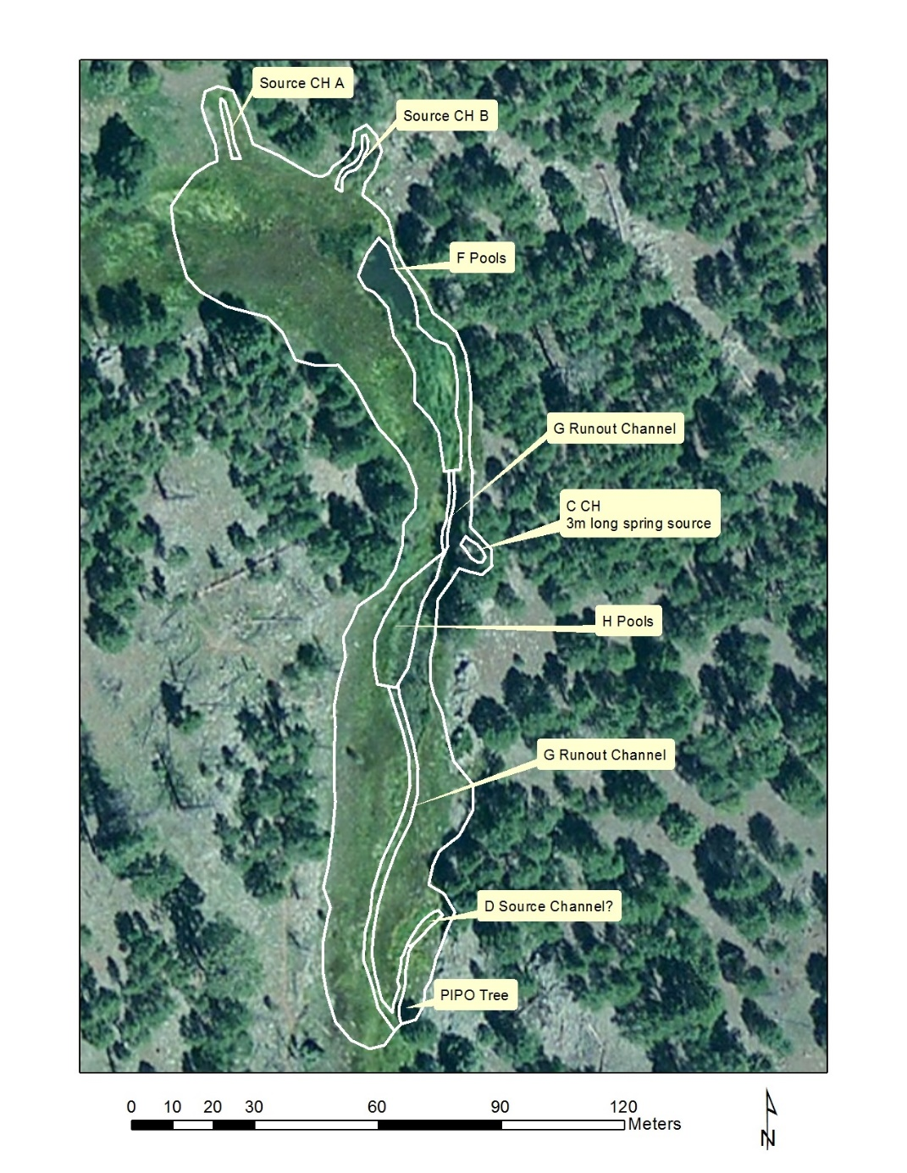
Fig 14.2 L O Spring Sketchmap: May 2015 Sketch map

15. Lee Canyon Upper Spring, 9/19/19
15. Lee Canyon Upper Spring, 9/19/19
Survey Summary Report, Site ID 649
Submitted 6/01/21 by Springs Stewardship Institute

Location: The Lee Canyon Upper Spring ecosystem is located in Coconino County in the Upper Verde Arizona 15060202 HUC, managed by the US Forest Service. The site is located in the Kaibab NF, Williams RD, in the White Horse Lake USGS Quad, at 35.10140, -112.11275 measured using a map (NAD83, estimated position error 1 meters). The elevation is approximately 2140 meters. Jenna Norris and Gloria Hardwick surveyed the site on 9/19/19 for 01:5 hours, beginning at 10:40, and collected data in 5 of 10 categories. This survey was conducted under a Kaibab Springs project using the Stevens et al. Level 2 protocol.

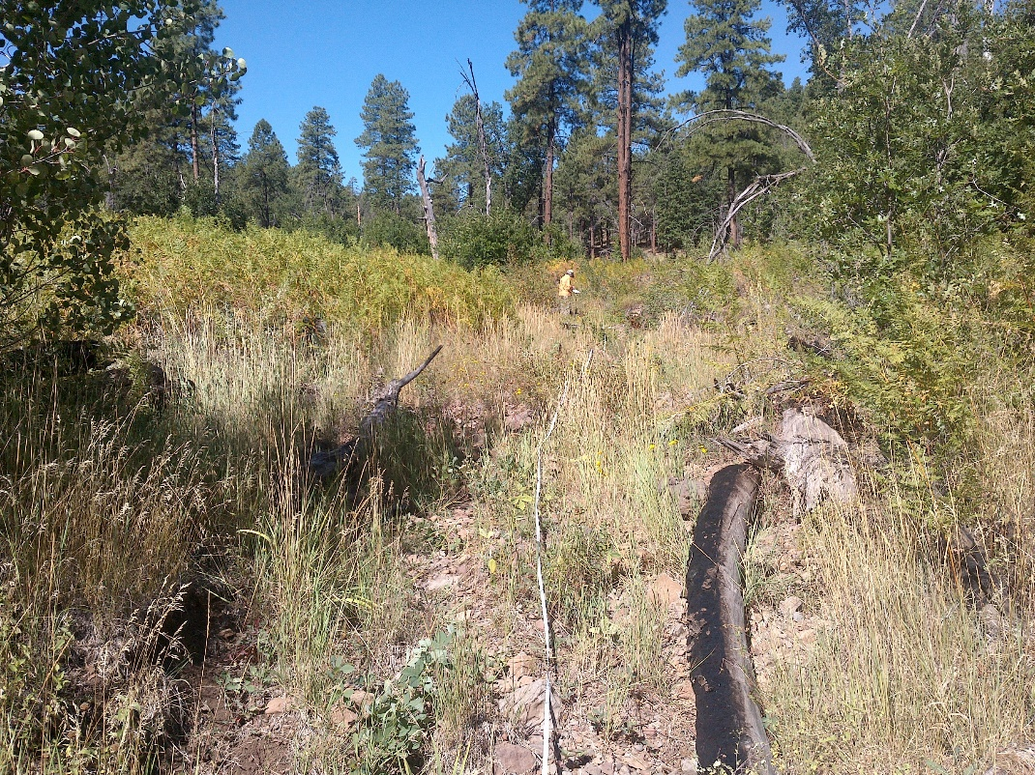
Fig 15.1 Lee Canyon Upper Spring: View facing upstream from about 30 meters downstream from the GPS point.

Physical Description: Lee Canyon Upper Spring is a helocrene/hypocrene spring. There are two large elk exclosures in this meadow. The site is mapped directly adjacent to the rocky runout channel. The site has 2 microhabitats, including A -- a 65 sqm channel, B -- a 62 sqm terrace.

Table 15.1 Lee Canyon Upper Spring Microhabitat characteristics.
Code | A | B
Name | Rocky Channel | Terraces
Area sqm | 65 | 62
Surface type | CH | TE
Surface subtype
Slope variability | Med | Med
Aspect TN | 115 | 115
Slope degrees | 5 | 4
Moisture (scale 1-10)
Water depth cm
Area % open water
Substrate
1 - Clay % | 0 | 0
2 - Silt % | 24 | 75
3 - Sand % | 0 | 0
4 - Fine gravel % | 4 | 5
5 - Coarse gravel % | 33 | 18
6 - Cobble % | 37 | 2
7 - Boulder % | 2 | 0
8 - Bedrock % | 0 | 0
Organic % | 0 | 0
Other % (anthropogenic) | 0 | 0
Precipitate % | 0 | 0
Litter % | 2 | 60
Wood % | 20 | 15
Litter Depth (cm) |  | 2

Geomorphology: Lee Canyon Upper Spring emerges from the basalt flow, a igneous, basalt rock layer. The site receives approximately 21% of available solar radiation, with 1237 Mj annually.

Access Directions: Follow COC-73 to Forest Rd 110 to Forest Rd 147 to Forest Rd 3225.

Survey Notes: Surveyors found this site to be totally dry. The site is heavily vegetated. The surveyors did a walk around the area and found no sign of surface water. Surveyors ran a 36 m tape from the GPS point and surveyed the channel. The field of ferns is found on the river right, slightly upslope of the channel. The large elk exclosure appears to be functioning.

Flow: This spring is ephemeral. Surveyors were unable to measure flow because there was no outflow.

Flora: Gloria Hardwick was the botanist for this survey. Surveyors identified 23 plant species at the site. These included 16 native and 3 nonnative species; the native status of 4 species remains unknown.

Table 15.2 Lee Canyon Upper Spring Cover Type.
Cover Type | Species Count | Wetland Species Count
Ground | 19 | 1
Shrub | 4 | 1
Mid-canopy | 0 | 0
Tall canopy | 0 | 0
Basal | 0 | 0
Aquatic | 0 | 0
Non-vascular | 0 | 0

Table 15.3 Lee Canyon Upper Spring Vegetation % Cover in Microhabitats.
Plant Species | Cover Code | Native Status | Wetland Status | Comments | A | B
Achillea millefolium | GC | NI | U |  | 1 | 0.5
Ambrosia psilostachya | GC | N | F |  | 3 | 1
Chenopodium | GC |  | F | mostly dead | 0.2 | 0.1
Eriogonum | GC |  | F | coll. white flower | 0.1 | 0.1
Fragaria | GC | N | U |  | 0.1 | 0
Geranium | GC | N | F | purple flower | 0.5 | 1
Heliomeris | GC | N | U |  | 2 | 0.5
Iris missouriensis | GC | N | F | dying | 0.1 | 0.1
Lactuca serriola | GC | I | F |  | 0.1 | 0.2
Lathyrus | GC | N | R |  | 0.1 | 0.1
Muhlenbergia | GC | N | U | coll rue clump | 0.1 | 0
Poa | GC |  | F | coll. dry | 0 | 0.3
Poaceae | GC | NI |  | wht. grass | 0.4 | 0.1
Populus | SC |  | WR |  | 0.01 | 1
Populus tremuloides | GC | N | U |  | 0.2 | 0.1
Pteridium aquilinum | GC | N | U |  | 0.1 | 0.2
Quercus gambelii | SC | N | U |  | 0.2 | 0.5
Robinia neomexicana | SC | N | F |  | 2 | 1
Rosa woodsii | SC | N | F |  | 5 | 2
Rumex crispus | GC | I | WR |  | 0.2 | 0.1
Thalictrum fendleri | GC | N | F | dying | 0.2 | 0.2
Thermopsis pinetorum | GC | N | F |  | 1 | 0
Verbascum thapsus | GC | I | U |  | 0.2 | 0.1

Fauna: Surveyors collected or observed

Table 15.4 Lee Canyon Upper Spring Vertebrates.
Vertebrate Species Common Name | Count | Detection | Comments
Hummingbird | 1 | obs
Hawk | 1 | sign | call
Spiny Lizard |  | obs
Western Bluebird |  | obs | many spotted driving to the site
American Crow |  | call

Assessment: Assessment scores were compiled in 5 categories and 30 subcategories, with 12 null condition scores, and 9 null risk scores. Aquifer functionality and water quality are very poor with very limited restoration potential (average condition score 1.5) and there is low risk (average risk score 2). Geomorphology condition is moderate with some restoration potential (average condition score 3) and there is low risk (average risk score 2). Habitat condition is moderate with some restoration potential (average condition score 3.3) and there is low risk (average risk score 2). Biotic integrity is good with significant restoration potential (average condition score 4.1) and there is low risk (average risk score 2). Human influence of site is excellent with no need for restoration (average condition score 6.2) and there is low risk (average risk score 2). Overall, the site condition is good with significant restoration potential and there is low risk.

Table 15.5 Lee Canyon Upper Spring Assessment Scores. Condition scores range from 0 (extremely poor condition) to 6 (pristine condition) and risk scores range from 0 (no risk to the site) to 6 (extreme risk to the site).
Category | Condition | Risk
Aquifer Functionality & Water Quality | 1.5 | 2
Geomorphology | 3 | 2
Habitat | 3.3 | 2
Biota | 4.1 | 2
Human Influence | 6.2 | 2
Overall Ecological Score | 4.1 | 2

Management Recommendations: Surveyors recommend maintaining the elk exclosure and monitoring occasionally.

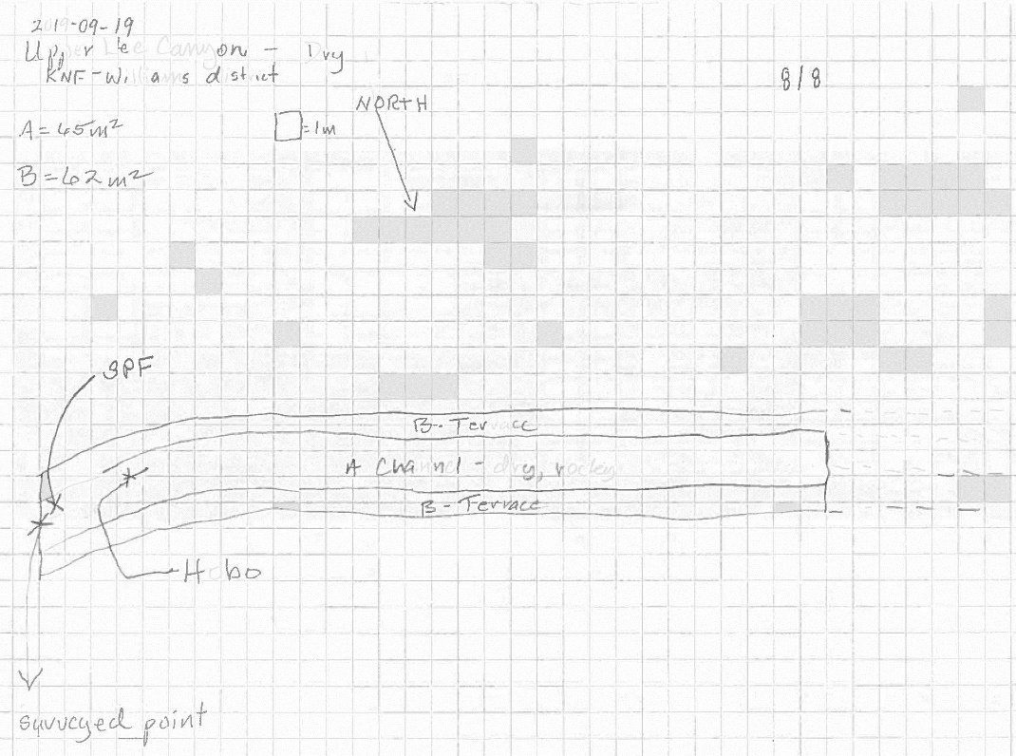
Fig 15.2 Lee Canyon Upper Spring Sketchmap.

16. Lower McDermit Spring, 9/19/19
16. Lower McDermit Spring, 9/19/19
Survey Summary Report, Site ID 582
Submitted 6/01/21 by Springs Stewardship Institute

Location: The Lower McDermit Spring ecosystem is located in Coconino County in the Upper Verde Arizona 15060202 HUC, managed by the US Forest Service. The spring is located in the Kaibab NF, Williams RD, in the Parks USGS Quad, at 35.25786, -111.91766 measured using a GPS (WGS84, estimated position error 3 meters). The elevation is approximately 2165 meters. Jenna Norris and Gloria Hardwick surveyed the site on 9/19/19 for 01:10 hours, beginning at 14:20, and collected data in 8 of 10 categories. This survey was conducted under a Kaibab Springs project using the Stevens et al. Level 2 protocol.

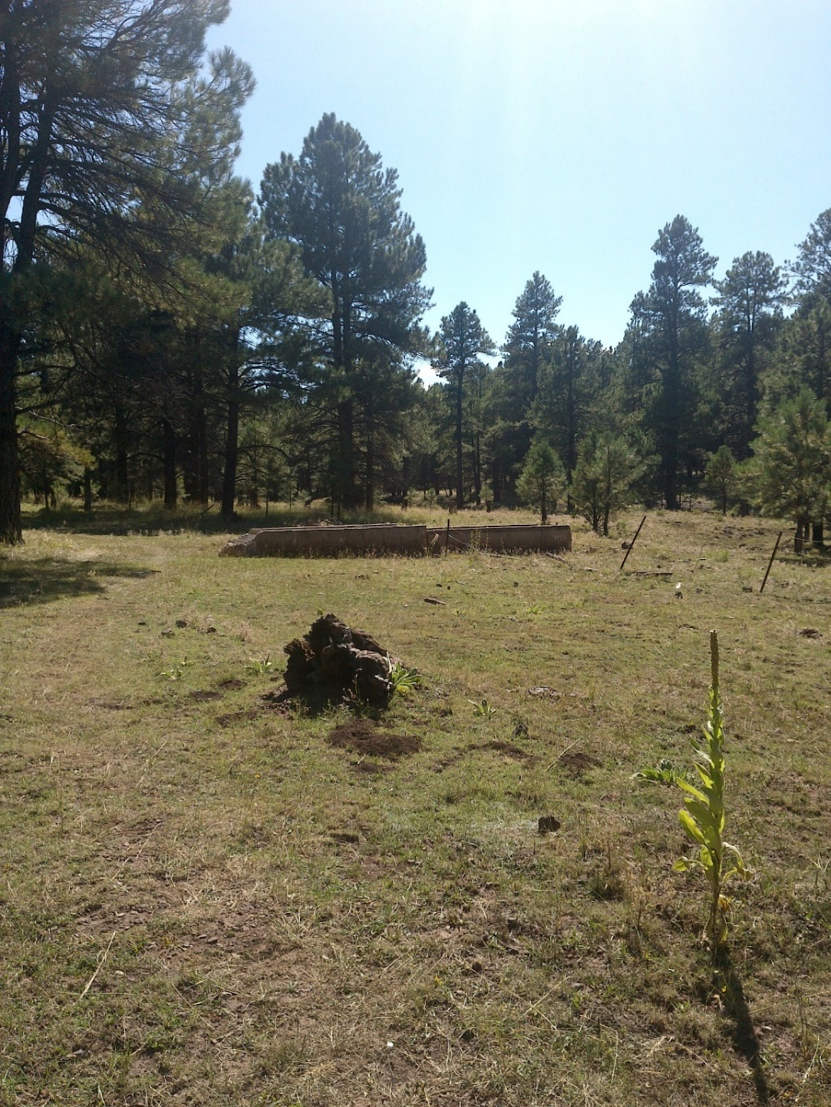
Fig 16.1 Lower McDermit Spring: View of the middle of the low gradient cienega, facing downstream toward the cattle trough.
Physical Description: Lower McDermit Spring is a helocrene/anthropogenic spring. This spring is part of the SSI 4FRI Springs Monitoring Project and is located within a treatment area. This site was likely a hillslope spring that has been heavily manipulated over the past century or so. Six wells have been installed with piping leading to a trough. This spring is currently functioning as a helocrene because leaking infrastructure is creating cienega-like conditions surrounding the trough. The site has been heavily logged in the past, probably clear-cut. This site was formerly fenced but the fencing appears to be very old. On September 19, 2019, SSI surveyors installed a HOBO MX2203 data logger in a small, depressed area of the low gradient cienega that appeared to have had surface water earlier in the season. The Hobo was attached to a piece of rebar and pounded into ground, until the device was flush with the ground. The rebar was covered by cinder rocks in order to deter cows from crushing it. The microhabitats associated with the spring cover 1670 sqm. The site has 2 microhabitats, including A -- a 552 sqm other, B -- a 1118 sqm low gradient cienega. The geomorphic diversity is 0.28, based on the Shannon-Weiner diversity index.

Table 16.1 Lower McDermit Spring Microhabitat characteristics.
Code | A | B
Name | Well Pit | Low gradient cienega
Area sqm | 552 | 1118
Surface type | OTH | LGC
Surface subtype | anthro
Slope variability | Low | Low
Aspect TN | 251 | 251
Slope degrees | 2 | 8
Moisture (scale 1-10) | 5 | 0
Water depth cm | 15 | 0
Area % open water | 1 | 0
Substrate
1 - Clay % | 0 | 0
2 - Silt % | 15 | 15
3 - Sand % | 44 | 15
4 - Fine gravel % | 34 | 50
5 - Coarse gravel % | 4 | 15
6 - Cobble % | 1 | 5
7 - Boulder % | 0 | 0
8 - Bedrock % | 0 | 0
Organic % | 0 | 0
Other % (anthropogenic) | 2 | 0
Precipitate % | 0 | 0
Litter % | 85 | 70
Wood % | 10 | 2
Litter Depth (cm) | 5

Geomorphology: Lower McDermit Spring emerges as a seepage or filtration from a igneous, basalt rock layer. The emergence environment is subaerial, with a gravity flow force mechanism. The site receives approximately 100% of available solar radiation, with 7333 Mj annually.

Access Directions: From exit 178 on I-40, travel north on Parks Rd for 0.15 mi. Turn right (east) onto Old Highway 66. Drive about 0.7 miles and park on the side of the highway. Walk south to the site. There are remnants of FR 2328 about 150 m after the end of the pavement of Old Hwy 66 at 35.26155, -111.91988, from which you may be able to get closer to the spring.

Survey Notes: During this survey, surveyors observed a dark-eyed junco and a nuthatch dipping into a springbox with standing water. This appears to be an important water source for wildlife. Two of six springboxes appeared to have water and are indicated on the sketchmap. The area has been moderately grazed by cattle. The surveyor installed a HOBO MX2203 data logger in a small, depressed area of the low gradient cienega (microhabitat B).

Flow: The only surface water at this spring was inside the springboxes. Surveyors were unable to measure flow because there was no outflow.

Water Quality: Surveyors measured water quality in a springbox, indicated in the sketchmap. The water is suspected to be influenced by surface flow. Location 1: in a pool in standing water at 15:15.

Table 16.2 Lower McDermit Spring Water Quality Measurements.
Characteristic Measured | Value | Location Number | Device
Alkalinity, Total (mg/L) | 140 | 1 | LaMotte
Dissolved oxygen (field) (mg/L) | 1 | 1 | CHEMets DO kit
Dissolved Solids (field) (ppt) | 0.156 | 1 | Hanna 9828 Multi
pH (field) | 5.98 | 1 | Hanna 9828 Multi
Specific conductance (field) (uS/cm) | 312 | 1 | Hanna 9828 Multi
Temperature, air C | 15.6 | 1 | Handheld therm
Temperature, water C | 11.83 | 1 | Hanna 9828 Multi

Flora: Gloria Hardwick was the botanist for this survey. The site is an old homestead. Surveyors identified 23 plant species at the site, with 0.0138 species/sqm. These included 20 native and 3 nonnative species.

Table 16.3 Lower McDermit Spring Cover Type.
Cover Type | Species Count | Wetland Species Count
Ground | 15 | 0
Shrub | 5 | 0
Mid-canopy | 1 | 0
Tall canopy | 1 | 0
Basal | 2 | 0
Aquatic | 0 | 0
Non-vascular | 2 | 0

Table 16.4 Lower McDermit Spring Vegetation % Cover in Microhabitats.
Plant Species | Cover Code | Native Status | Wetland Status | Comments | A | B
Achillea millefolium | GC | NI | U |  | 0.2 | 2
Bouteloua curtipendula | BC | N | U |  | 0 | 0.01
Bouteloua gracilis | GC | N | U |  | 0 | 0.01
Cirsium | GC | N | F |  | 0.1 | 0.3
Coreopsis tinctoria | GC | N | F |  | 0.01 | 2
Elymus elymoides | GC | N | F |  | 0.4 | 0
Ericameria nauseosa | SC | N | F |  | 2 | 0
Erigeron | GC | N | F |  | 0 | 0.02
Gutierrezia sarothrae | GC | N | U |  | 0 | 0.1
Juniperus scopulorum | SC | N | U |  | 0.2 | 0.1
Lichen | NV | N | U |  | 0.01 | 0.02
Machaeranthera canescens | GC | N | U |  | 0 | 0.01
Pinus ponderosa | BC | N | U |  | 1 | 0.3
Pinus ponderosa | MC | N | U |  | 60 | 20
Pinus ponderosa | SC | N | U |  | 37 | 8
Pinus ponderosa | TC | N | U |  | 15 | 4
Plantago | GC | NI |  |  | 0 | 0.5
Poa pratensis | GC | NI | F |  | 0.5 | 30
Potentilla hippiana | GC | N | U |  | 0.2 | 0.7
Rheum rhabarbarum | GC | I | U | ID based on a single leaf. | 0 | 0.2
Rosa woodsii | SC | N | F |  | 1 | 0
Rumex crispus | GC | I | WR |  | 0 | 0.02
Symphoricarpos rotundifolius | SC | N | U |  | 0.2 | 0
Taraxacum officinale | GC | NI | F |  | 0 | 0.1
unknown Bryophyte (moss, liverwort, hornwort) | NV | N? | WR | moss | 0.03 | 0.02
Verbascum thapsus | GC | I | U |  | 0 | 0.1

Fauna: No aquatic invertebrates were observed. The only accessible water was in the springbox with no sunlight. Surveyors collected or observed

Table 16.5 Lower McDermit Spring Vertebrates.
Vertebrate Species Common Name | Count | Detection | Comments
Dark-eyed Junco | many | obs | drinking from springbox
Pygmy Nuthatch | 1 | obs
Steller's Jay |  | call

Assessment: Assessment scores were compiled in 5 categories and 31 subcategories, with 11 null condition scores, and 10 null risk scores. Aquifer functionality and water quality are poor with limited restoration potential (average condition score 2) and there is very high risk (average risk score 5). Geomorphology condition is moderate with some restoration potential (average condition score 3) and there is moderate risk (average risk score 3.8). Habitat condition is moderate with some restoration potential (average condition score 3.4) and there is high risk (average risk score 4). Biotic integrity is moderate with some restoration potential (average condition score 3.3) and there is moderate risk (average risk score 3). Human influence of site is moderate with some restoration potential (average condition score 3) and there is moderate risk (average risk score 3.3). Overall, the site condition is moderate with some restoration potential and there is moderate risk.

Table 16.6 Lower McDermit Spring Assessment Scores. Condition scores range from 0 (extremely poor condition) to 6 (pristine condition) and risk scores range from 0 (no risk to the site) to 6 (extreme risk to the site).
Category | Condition | Risk
Aquifer Functionality & Water Quality | 2 | 5
Geomorphology | 3 | 3.8
Habitat | 3.4 | 4
Biota | 3.3 | 3
Human Influence | 3 | 3.3
Overall Ecological Score | 3 | 3.7

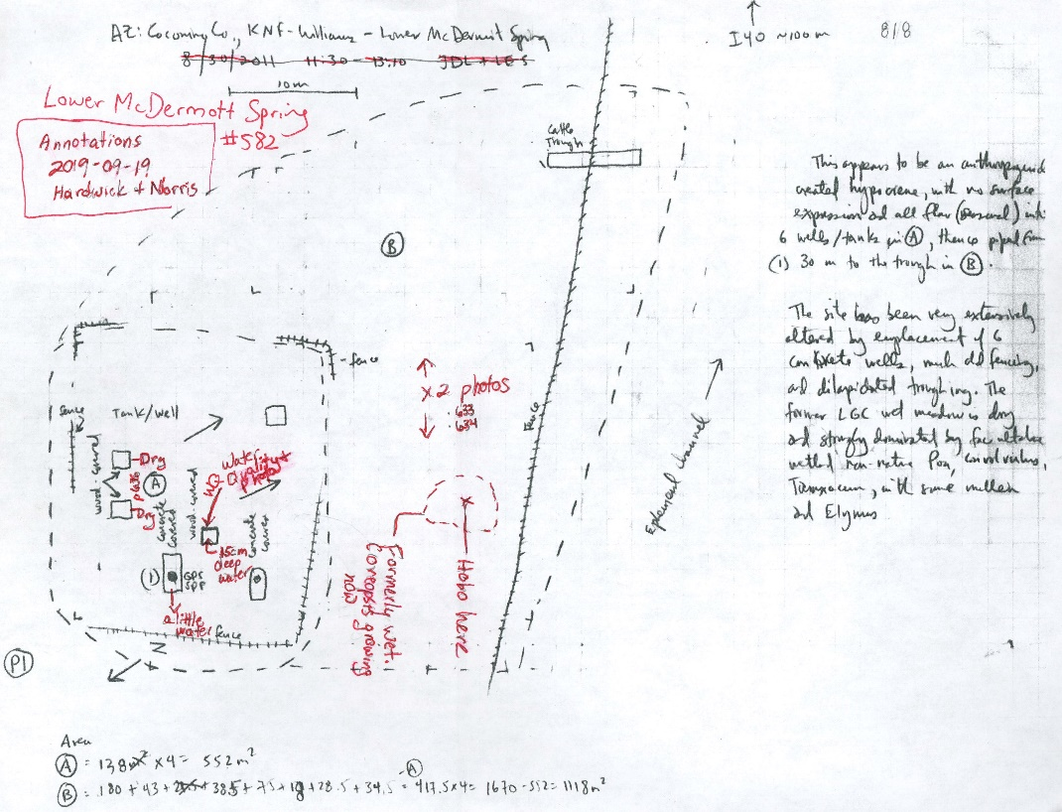
Fig 16.2 Lower McDermit Spring Sketchmap: Sketchmap from a previous survey, with added annotations.

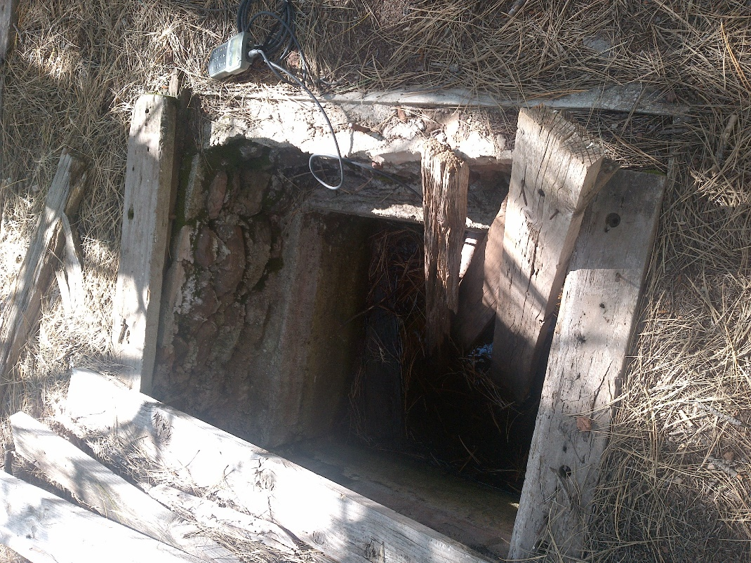
Fig 16.3 Lower McDermit Spring: View of the springbox with open water, where water quality was measured.

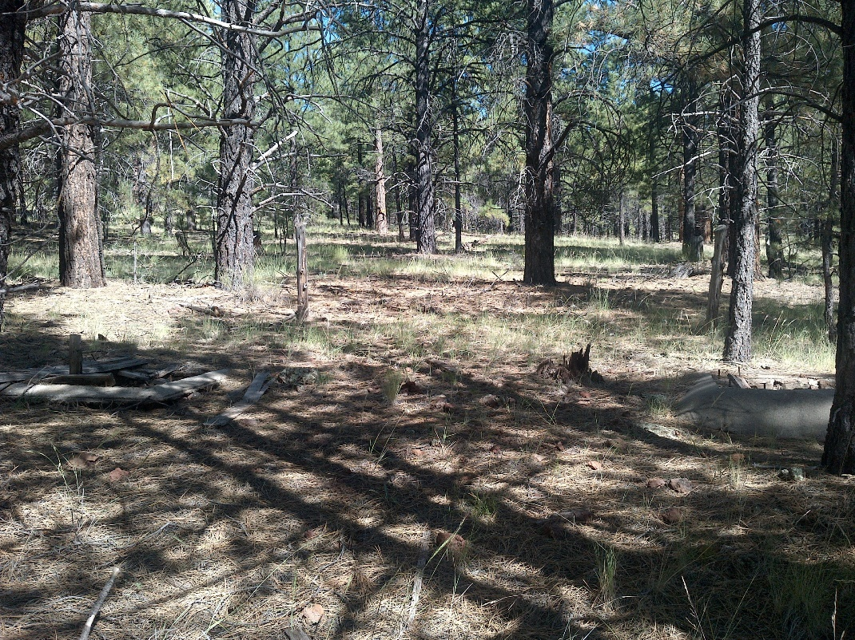
Fig 16.4 Lower McDermit Spring: View facing upstream toward the parallel springboxes.

17. Mineral Spring, 8/27/20
17. Mineral Spring, 8/27/20
Survey Summary Report, Site ID 768
Submitted 6/01/21 by Springs Stewardship Institute

Location: The Mineral Spring ecosystem is located in Coconino County in the Upper Verde Arizona 15060202 HUC, managed by the US Forest Service. The spring is located in the Kaibab NF, Williams RD, in the Parks USGS Quad, at 35.25188, -111.99940 measured using a GPS (WGS84, estimated position error 3 meters). The elevation is approximately 2124 meters. Larry Stevens and Jeri Ledbetter surveyed the site on 8/27/20 for 03:10 hours, beginning at 10:55, and collected data in 10 of 10 categories. This survey was conducted under a Kaibab Springs project using the Stevens et al. Level 2 protocol.

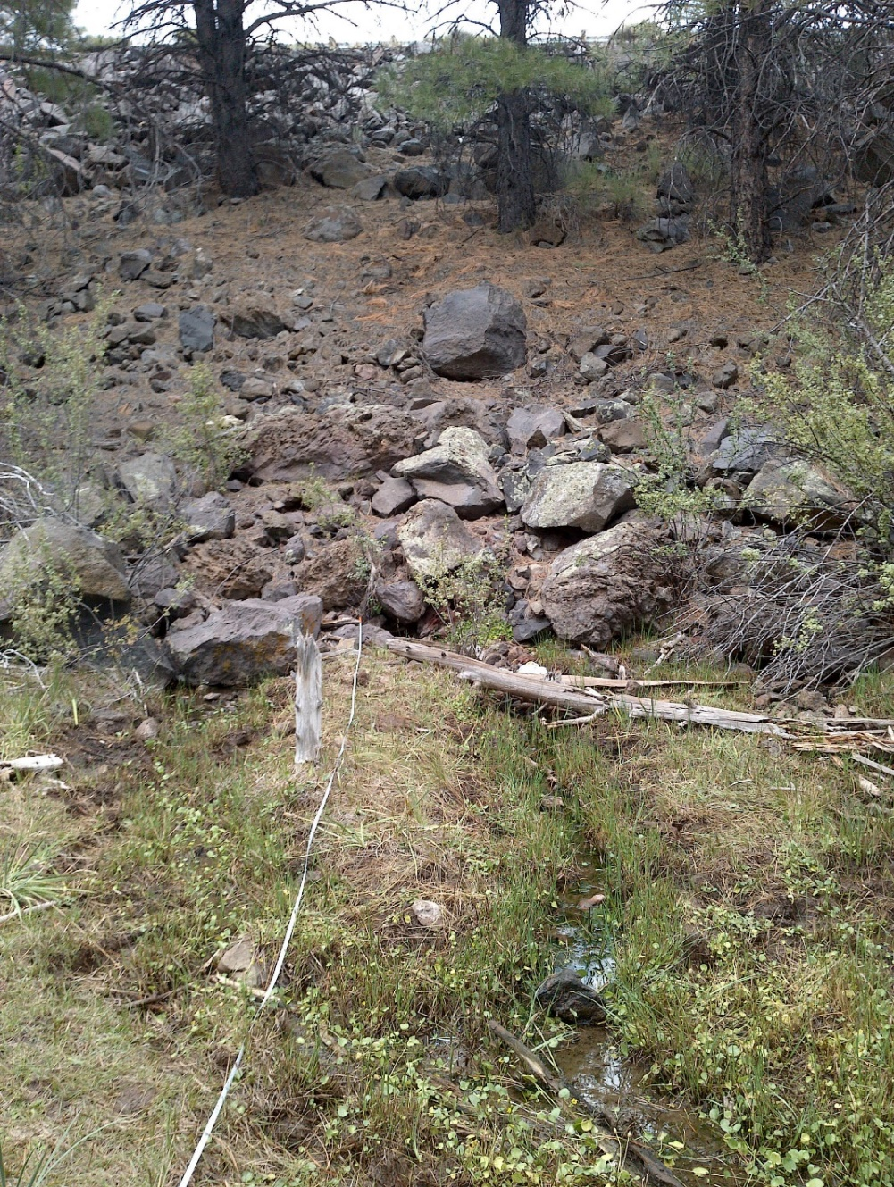
Fig 17.1 Mineral Spring: The spring sources, emerging from the base of the highway berm. The guard rail for Interstate 40 is barely visible along the top of the photo.
Physical Description: Mineral Spring is a helocrene spring. This spring is part of the SSI 4FRI Springs Monitoring Project and is located within a control area. The spring is located in a ponderosa pine forest, immediately south of Interstate 40. The interstate was constructed over the spring source and the outflow emerges from below the highway, on the south side. During dry years, seepage emerges from 3 distinct sources at the base of the colluvial slope that leads up to the interstate. The sources are 4 meters apart, and their outflow channels converge after 6 meters and pass under an exclosure fence. During wet years, the area surrounding the sources has diffuse, helocrenic seepage. Spring outflow continues down channel for approximately 85 meters into an excavated tank. On June 26, 2020, an SSI surveyor installed a HOBO MX2203 data logger 2 meters downstream from the highway berm in the middle of the center channel, just upslope from a fallen tree that crosses the left 2 channels. It was attached to rebar in PVC, with the rebar hammered in vertically. The microhabitats associated with the spring cover 178 sqm. The site has 4 microhabitats, including A -- a 20 sqm low gradient cienega, B -- a 44 sqm channel, C -- a 64 sqm channel, D -- a 50 sqm terrace. The geomorphic diversity is 0.57, based on the Shannon-Weiner diversity index.

Table 17.1 Mineral Spring Microhabitat characteristics.
Code | A | B | C | D
Name | Wet meadow | Upper channels | Lower Channel | Lower Terrace
Area sqm | 20 | 44 | 64 | 50
Surface type | LGC | CH | CH | TE
Surface subtype
Slope variability | Low | Low | Low | Low
Aspect TN | 192 | 192 | 192 | 192
Slope degrees | 1 | 1 | 1 | 1
Moisture (scale 1-10) | 3 | 9 | 9 | 3
Water depth cm | 0 | 3 | 2 | 0
Area % open water | 0 | 20 | 20 | 0
Substrate
1 - Clay % | 20 | 6 | 10 | 10
2 - Silt % | 30 | 37 | 10 | 25
3 - Sand % | 30 | 21 | 10 | 20
4 - Fine gravel % | 2 | 10 | 2 | 5
5 - Coarse gravel % | 2 | 0 | 25 | 10
6 - Cobble % | 5 | 6 | 15 | 9
7 - Boulder % | 1 | 0 | 0 | 0
8 - Bedrock % | 0 | 0 | 0 | 0
Organic % | 9 | 19 | 27 | 20
Other % (anthropogenic) | 1 | 1 | 1 | 1
Precipitate % | 0 | 0 | 0 | 0
Litter % | 70 | 20 | 20 | 60
Wood % | 2 | 6 | 4 | 6
Litter Depth (cm) | 1 | 0.5 | 0.5 | 1

Geomorphology: Mineral Spring emerges as a seepage or filtration from a igneous, basalt rock layer. The emergence environment is subaerial, with a gravity flow force mechanism. The site receives approximately 100% of available solar radiation, with 6019 Mj annually.

Access Directions: From I-40, exit at Parks, and turn north onto Parks Road. After 1/4 mi, the road ends at a T. Turn left (west) onto Old Rte 66. Drive about 2 mi and then turn south (left) onto Spitz Spring Road. After about 3/4 mile it is necessary to turn right and then left to stay on Spitz Spring Road. Follow it over I-40 and then turn right (west) on Somerset Ranch Road. After 1 mile, turn right on FR 781 J. Follow this bumpy dirt road west, then north toward the interstate until it is too rough to drive. Park and walk the rest of the way to the spring, which emerges from below the interstate.

Survey Notes: The fence is not keeping domestic cows away from the sources. The emergence area and outflow both outside and inside the fence is heavily grazed and trampled. There is a lot of trash, most likely from the interstate. The low gradient cienega has dried out and shrunk significantly since the last full survey in 2014, possibly in part due to the channel becoming more entrenched from trampling. Recent rain affected the soil moisture, water quality, and flow. There is an extraordinary amount of cow scat along the channel and terrace at the downstream end of the site, with associated trampling. Many trees in the area are dead or dying, likely due to the salt on the interstate, which is also likely responsible for the high salinity and specific conductance of the spring water. The Hobo installed in June 2020 is intact and surveyors did not disturb it to download data.

Flow: Surveyors measured a flow of 0.042 liters/second, using a timed flow volume capture method. Surveyors measured flow 17 meters below the emergence, adjacent to a fallen tree. This spring is perennial.

Water Quality: Source 1 was under the boulders at the base of a colluvial slope, above the trampled area in the center source. Source 2 was under the boulders at the base of a colluvial slope, above the trampled area in the right source. Location 1: at the spring source in flowing water at 11:11. Location 2: at the spring source in flowing water at 11:11.

Table 17.2 Mineral Spring Water Quality Measurements.
Characteristic Measured | Value | Location Number | Device
Temperature, air C | 30
Dissolved oxygen (field) (mg/L) | 6 | 1 | CHEMets DO kit
Dissolved Solids (field) (ppt) | 1555 | 1 | Hanna Multi 98194
pH (field) | 7.05 | 1 | Hanna Multi 98194
Specific conductance (field) (uS/cm) | 3115 | 1 | Hanna Multi 98194
Temperature, water C | 10.04 | 1 | Hanna Multi 98194
Dissolved Solids (field) (ppt) | 1580 | 2 | Hanna Multi 98194
pH (field) | 7.32 | 2 | Hanna Multi 98194
Specific conductance (field) (uS/cm) | 3159 | 2 | Hanna Multi 98194
Temperature, water C | 17.89 | 2 | Hanna Multi 98194

Flora: Surveyors identified 27 plant species at the site, with 0.1517 species/sqm. These included 23 native and 3 nonnative species; the native status of 1 species remains unknown.

Table 17.3 Mineral Spring Cover Type.
Cover Type | Species Count | Wetland Species Count
Ground | 21 | 8
Shrub | 4 | 0
Mid-canopy | 1 | 0
Tall canopy | 0 | 0
Basal | 0 | 0
Aquatic | 1 | 1
Non-vascular | 1 | 0

Table 17.4 Mineral Spring Vegetation % Cover in Microhabitats.
Plant Species | Cover Code | Native Status | Wetland Status | Comments | A | B | C | D
Achillea millefolium | GC | NI | U |  | 0.1 | 0 | 0 | 3
Agrostis scabra | GC | N | W |  | 2 | 0 | 4 | 1
algae | AQ | N? | A |  | 5 | 0 | 15 | 0
Allium cernuum | GC | N | U |  | 0 | 0 | 0 | 0.01
Carex praegracilis | GC | N | W |  | 4 | 2 | 0 | 0
Eleocharis | GC | N | W |  | 0 | 0 | 20 | 2
Elymus elymoides | GC | N | F |  | 0.1 | 0 | 0 | 0
Elymus trachycaulus | GC | N | F | 5 barley | 3 | 3 | 0 | 0
Iris missouriensis | GC | N | F |  | 8 | 1 | 0 | 10
Juncus saximontanus | GC | N | W |  | 8 | 25 | 1 | 0
Juniperus deppeana | SC | N | U |  | 0 | 0 | 0 | 1
Lactuca | GC |  | WR |  | 2 | 0 | 0 | 0
Lichen | NV | N | U |  | 0.2 | 0.1 | 0 | 0.01
Melilotus officinalis | GC | I | WR |  | 0 | 0 | 0 | 0.1
Pinus ponderosa | MC | N | U |  | 5 | 10 | 2 | 4
Pinus ponderosa | SC | N | U |  | 5 | 8 | 1 | 2
Poa pratensis | GC | NI | F |  | 25 | 3 | 5 | 40
Polygonum | GC | N |  |  | 0 | 0 | 0.1 | 0
Ranunculus cymbalaria | GC | N | W |  | 3 | 35 | 20 | 1
Ribes cereum | SC | N | U |  | 5 | 3 | 0 | 0
Rosa woodsii | SC | N | F |  | 0.1 | 0 | 0 | 0
Rumex | GC | NI |  |  | 0.1 | 0.2 | 0 | 0
Symphyotrichum falcatum | GC | N | F |  | 4 | 0 | 0 | 0
Taraxacum officinale | GC | NI | F |  | 0.1 | 0 | 0.01 | 1
Tragopogon dubius | GC | I | F |  | 0.1 | 0 | 0 | 0
unknown dicot | GC | NI |  | minute blanket flower m 40. photo | 0 | 0 | 0 | 0.01
Verbascum | GC | I | F |  | 0 | 0 | 0 | 0.01
Veronica anagallis-aquatica | GC | N | A |  | 1 | 0 | 0.3 | 0

Fauna: Larry Stevens was the wildlife biologist. Surveyors collected or observed 22 aquatic and 4 terrestrial invertebrate taxa and 12 vertebrate taxa. Surveyors conducted quantitative benthic sampling at this spring.

Table 17.5 Mineral Spring Invertebrates.
Species | Lifestage | Habitat | Method | Rep# | Count | Species Detail
Amphipoda Hyalellidae Hyalella | L | A | Uncollected benthic | 2 | 3
Amphipoda Hyalellidae Hyalella | Ad | A | Preserved benthic | 3 | 1
Araneae Lycosidae | Ad | T | Preserved benthic | 3 | 1
Araneae Lycosidae | Ad | T | Preserved benthic | 1 | 2
Basommatophora Physidae | L | A | Collected spot |  | 1
Basommatophora Physidae Physa | Ad | A | Uncollected benthic | 2 | 19
Basommatophora Physidae Physa | Ad | A | Preserved benthic | 3 | 47
Basommatophora Physidae Physa | E | A | Preserved benthic | 3 | 4 | egg mass
Coleoptera Dytiscidae | Ad | A | Collected spot |  | 1 | small black
Coleoptera Dytiscidae Agabus | Ad | A | Collected spot |  | 1
Coleoptera Dytiscidae Laccophilus | Ad | A | Spot
Coleoptera Haliplidae | Ad | A | Preserved benthic | 3 | 2
Coleoptera Hydrophilidae Enochrus | Ad | A | Collected spot
Collembola | Ad | A | Preserved benthic | 1 | 8 | springtails
Diptera Chironomidae | L | A | Preserved benthic | 1 | 1
Diptera Chironomidae Chironomus | L | A | Preserved benthic | 3 | 3
Diptera Chironomidae Chironomus | L | A | Uncollected benthic | 2 | 7
Diptera Culicidae | L | A | Preserved benthic | 3 | 4
Diptera Tipulidae | L | A | Preserved benthic | 3 | 2
Diptera Tipulidae Tipula | L | A | Collected spot |  | 1
Hemiptera Veliidae Microvelia | L | A | Preserved benthic | 1 | 2
Isopoda | M | T | Collected spot
Isopoda | Ad | T | Preserved benthic | 2 | 1
Odonata Coenagrionidae | Ad | T | Spot |  | 1
Odonata Coenagrionidae Argia | L | A | Preserved benthic | 2 | 2
Odonata Coenagrionidae Argia | M | A | Collected spot |  |  | many
Odonata Libellulidae Plathemis lydia | Ad | T | Spot |  | 8
Prostigmata Hydrachnidae | Ad | A | Preserved benthic | 2 | 4
Trichoptera Limnephilidae | Ad | A | Preserved benthic | 3 | 1
Zooplankton Ostracoda | Ad | A | Preserved benthic | 1 | 150
Zooplankton Ostracoda | Ad | A | Preserved benthic | 3 | 13
Zooplankton Ostracoda | Ad | A | Uncollected benthic | 2 | 170

Table 17.6 Mineral Spring Benthic Invertebrate Sampling.
Rep# | Velocity (m/sec) | Depth (cm) | Area (sq m) | Time (sec) | Location | Substrate | Comments
1 | 0.03 | 3 | 0.09 | 60 | 35.5 m | 50% 6, 10% 5, 40% org
2 | 0.01 | 1 | 0.09 | 60 | 50 m | 100% org
3 | 0.01 | 3 | 0.02 | 60 | 6 m | 40% 6, 60% org

Table 17.7 Mineral Spring Vertebrates.
Vertebrate Species Common Name | Count | Detection | Comments
Mountain Chickadee |  | call
Great Blue Heron | 1 | obs
Lesser Goldfinch |  | call
Domestic Cow |  | sign | scat, tracks
Turkey Vulture | 3 | obs
Violet-green Swallow | 1 | obs
Woodpecker |  | sign | holes in trees
Fence Lizard | 1 | obs | immature
Pygmy Nuthatch | 2 | obs
Common Raven | 2 | obs | juvenile
Deer Mouse |  | sign | scat
Elk |  | sign | tracks and scat

Assessment: Assessment scores were compiled in 5 categories and 33 subcategories, with 9 null condition scores, and 9 null risk scores. Aquifer functionality and water quality are poor with limited restoration potential (average condition score 2.7) and there is moderate risk (average risk score 3.3). Geomorphology condition is poor with limited restoration potential (average condition score 2.8) and there is high risk (average risk score 4.4). Habitat condition is moderate with some restoration potential (average condition score 3.2) and there is high risk (average risk score 4). Biotic integrity is moderate with some restoration potential (average condition score 3.5) and there is moderate risk (average risk score 3.5). Human influence of site is moderate with some restoration potential (average condition score 3.1) and there is moderate risk (average risk score 3.4). Overall, the site condition is moderate with some restoration potential and there is moderate risk.

Table 17.8 Mineral Spring Assessment Scores. Condition scores range from 0 (extremely poor condition) to 6 (pristine condition) and risk scores range from 0 (no risk to the site) to 6 (extreme risk to the site).
Category | Condition | Risk
Aquifer Functionality & Water Quality | 2.7 | 3.3
Geomorphology | 2.8 | 4.4
Habitat | 3.2 | 4
Biota | 3.5 | 3.5
Human Influence | 3.1 | 3.4
Overall Ecological Score | 3.1 | 3.7

Management Recommendations: Investigate the salt contamination. Repair and maintain the fencing to limit cow access to the source. Continue to monitor occasionally.

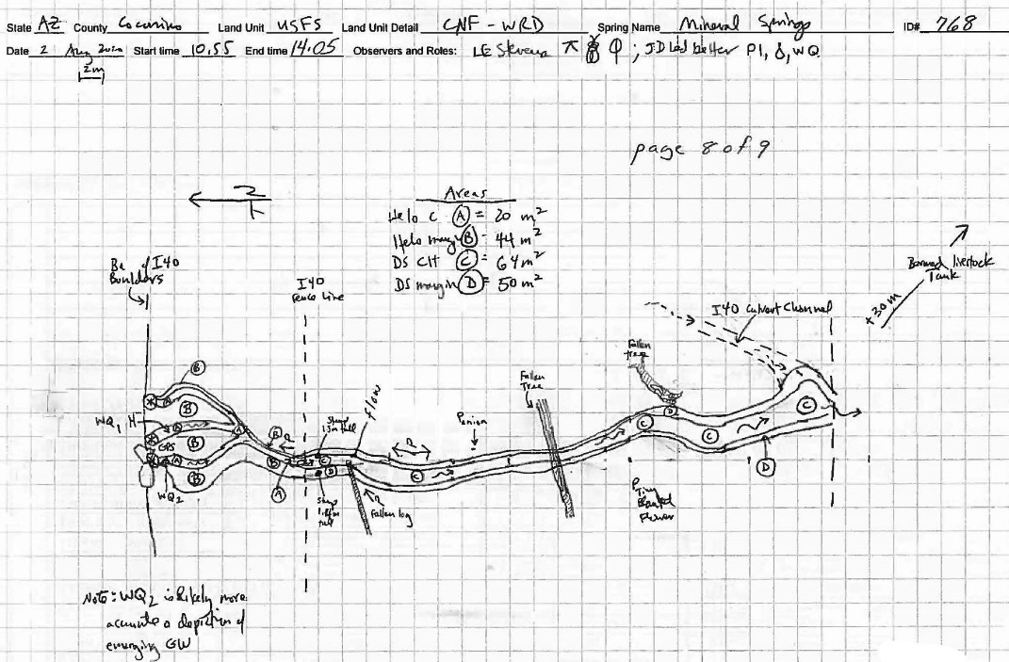
Fig 17.2 Mineral Spring Sketchmap.

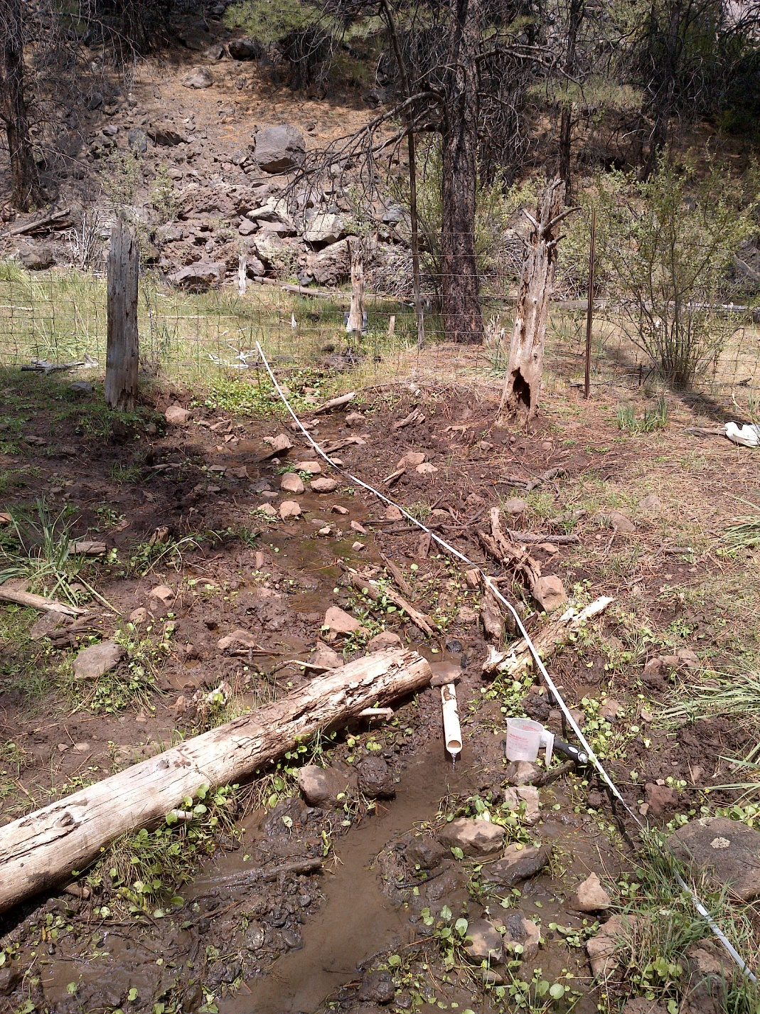
Fig 17.3 Mineral Spring: The flow measurement location, 17 meters downstream from the sources.

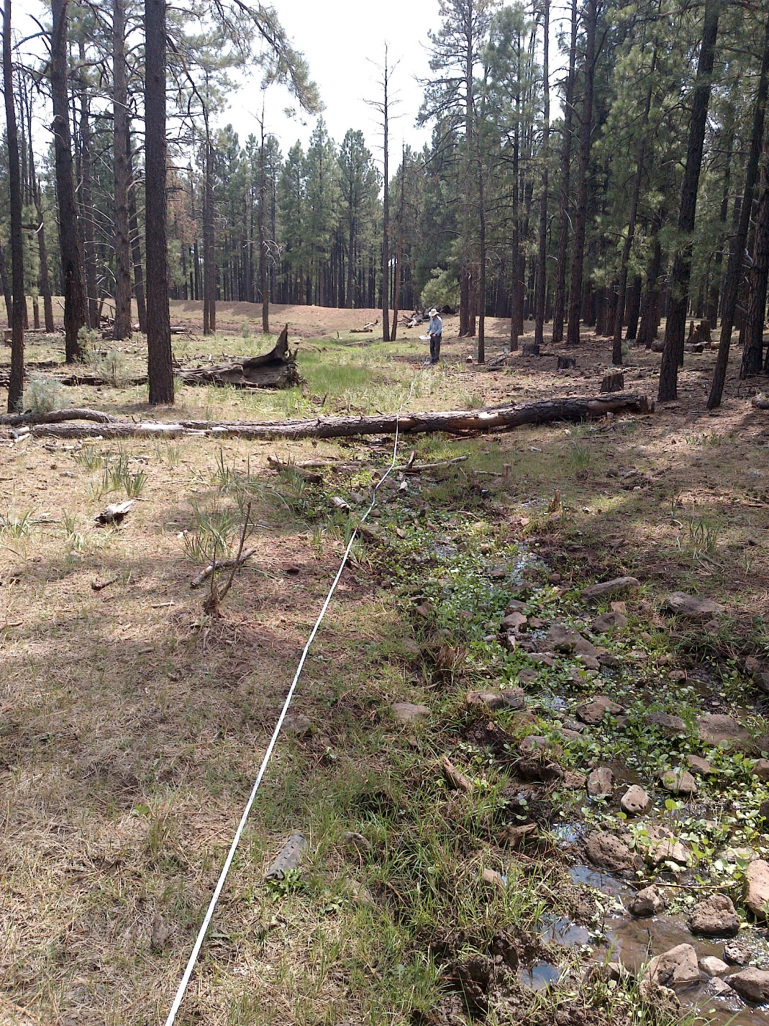
Fig 17.4 Mineral Spring: Larry Stevens records data next to the springs outflow channel, about 50 meters downstream of the spring sources. Farther downstream, just beyond Dr. Stevens, the berm marking the edge the excavated cattle tank is visible.

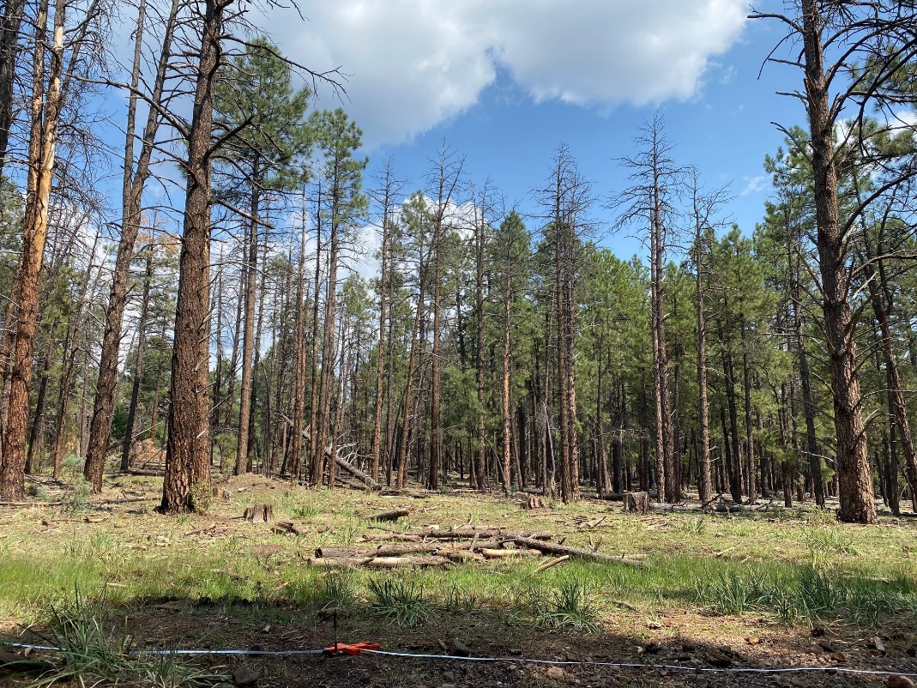
Fig 17.5 Mineral Spring: Die-off of ponderosa pine around the Mineral Spring springbrook.

18. Mud Springs, 7/29/19
18. Mud Springs, 7/29/19
Survey Summary Report, Site ID 729
Submitted 6/01/21 by Springs Stewardship Institute

Location: The Mud Springs ecosystem is located in Coconino County in the Upper Verde Arizona 15060202 HUC, managed by the US Forest Service. The spring is located in the Kaibab NF, Williams RD, in the May Tank Pocket USGS Quad, at 35.11495, -112.18680 measured using a GPS (WGS84, estimated position error 2 meters). The elevation is approximately 2115 meters. Alek Mendoza, Gloria Hardwick, and Jenna Norris surveyed the site on 7/29/19 for 02:30 hours, beginning at 10:20, and collected data in 9 of 10 categories. This survey was conducted under a Kaibab Springs project using the Stevens et al. Level 2 protocol.

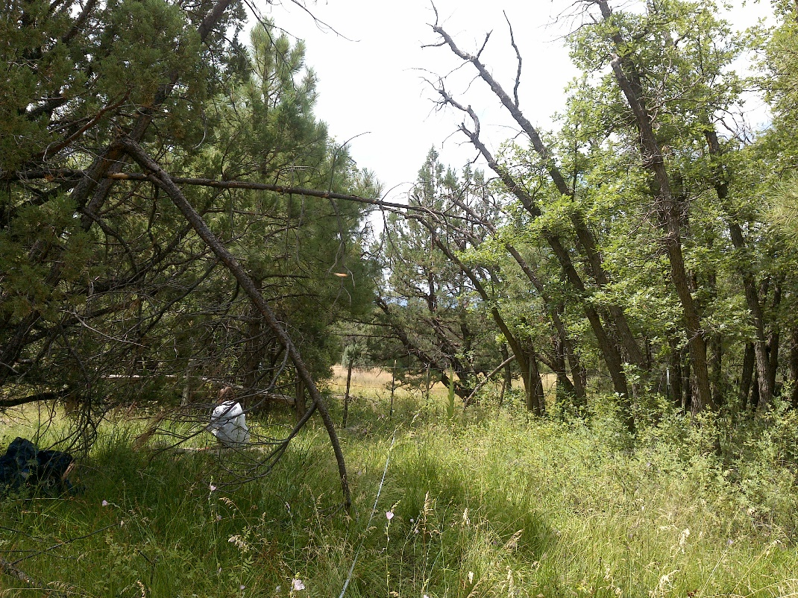
Fig 18.1 Mud Springs: View from 5 meters below the first springbox, looking downhill towards the lower low gradient cienega.

Physical Description: Mud Springs is a helocrene/anthropogenic spring. This spring is part of the SSI 4FRI Springs Monitoring Project and is located within a control area. This spring emerges from the base of a basalt flow and would naturally seep broadly across a wet meadow if flow were not captured into two springboxes and piped down-gradient to a trough. In October 2019, a surveyor installed a Hobo Tidbit MX2203 data logger in the uppermost springbox. In May 2021, a surveyor secured it with heavy wire to PVC and rebar, and covered it with three rocks. Future surveyors should bring plastic and use it to construct a dam on the trough upon arrival to better measure flow. The microhabitats associated with the spring cover 640 sqm. The site has 2 microhabitats, including A -- a 90 sqm low gradient cienega, B -- a 550 sqm low gradient cienega. The geomorphic diversity is 0.18, based on the Shannon-Weiner diversity index.

Table 18.1 Mud Springs Microhabitat characteristics.
Code | A | B
Name | Source with boxes | Source LGC
Area sqm | 90 | 550
Surface type | LGC | LGC
Surface subtype
Slope variability | Low | Low
Aspect TN | 196 | 196
Slope degrees | 5 | 7
Moisture (scale 1-10) | 3 | 4
Water depth cm | 4 | 2
Area % open water | 15 | 10
Substrate
1 - Clay % | 5 | 3
2 - Silt % | 25 | 20
3 - Sand % | 3 | 2
4 - Fine gravel % | 5 | 5
5 - Coarse gravel % | 2 | 10
6 - Cobble % | 2 | 3
7 - Boulder % | 3 | 1
8 - Bedrock % | 2 | 6
Organic % | 33 | 47
Other % (anthropogenic) | 20 | 3
Precipitate % | 0 | 0
Litter % | 50 | 60
Wood % | 5 | 4
Litter Depth (cm) | 2 | 2

Geomorphology: Mud Springs emerges as a contact from the basalt flow, a igneous, basalt rock layer. The emergence environment is subaerial, with a gravity flow force mechanism. The site receives approximately 100% of available solar radiation, with 6871 Mj annually.

Access Directions: From the town of Williams, travel south on County Rd 73 (Perkinsville Rd) for 12.5 mi. Turn west onto a minor, rough dirt road and park immediately. The spring is 500 m due west of Perkinsville Road.

Survey Notes: The upper springbox has a concrete lid with rebar sticking up vertically. The lower springbox is covered with a flat rock. The open concrete trough is full, with very slight overflow (not enough to measure). Deer and elk tracks and scat are present at the site but there is no evidence of livestock grazing. Surveyors did not find the tree blind noted in the 2012 survey, but there is a game camera set up near the trough. An abandoned camp with excess trash, was noted at the NW edge of the lower low gradient cienega. The trash is scattered throughout the west side of the site. Surveyors estimate it will take about 8 large trash bags to dispose of the waste. The previously mapped dry area appears to have expanded in the lower low gradient cienega when compared to the 2012 survey. Seepage into the lower portion of the low gradient cienega also seems to be less than 2012. The sketchmap during this survey estimates the current size of the dry area.

Flow: In past surveys at this site, surveyors measured flow where it overflowed a springbox. However, at the time of this 2019 survey, there was no overflow from the spring boxes, and the only other surface water was diffuse seepage through the wet meadow. Surveyors were unable to measure flow because there was no outflow.

Water Quality: The surveyors measured water quality in the lower spring box, which was partially covered with a flat rock. The surveyors covered the opening more completely after collecting measurements. Location 1: in a pool in standing water at 11:11.

Table 18.2 Mud Springs Water Quality Measurements.
Characteristic Measured | Value | Location Number | Device
Alkalinity, Total (mg/L) | 64 | 1 | LaMotte
Dissolved oxygen (field) (mg/L) | 4.5 | 1 | CHEMets DO kit
Dissolved Solids (field) (ppt) | 0.074 | 1 | Hanna Combo
Dissolved Solids (field) (ppt) | 0.075 | 1 | Hanna Multi 98194
pH (field) | 6.74 | 1 | Hanna Combo
pH (field) | 6.55 | 1 | Hanna Multi 98194
Specific conductance (field) (uS/cm) | 143 | 1 | Hanna Combo
Specific conductance (field) (uS/cm) | 151 | 1 | Hanna Multi 98194
Temperature, air C | 31 | 1 | Handheld therm
Temperature, water C | 18.4 | 1 | Hanna Combo
Temperature, water C | 17.75 | 1 | Hanna Multi 98194

Flora: Gloria Hardwick was the botanist for this survey. Surveyors identified 28 plant species at the site, with 0.0438 species/sqm. These included 22 native and 6 nonnative species.

Table 18.3 Mud Springs Cover Type.
Cover Type | Species Count | Wetland Species Count
Ground | 22 | 11
Shrub | 3 | 0
Mid-canopy | 3 | 0
Tall canopy | 0 | 0
Basal | 1 | 0
Aquatic | 3 | 3
Non-vascular | 0 | 0

Table 18.4 Mud Springs Vegetation % Cover in Microhabitats.
Plant Species | Cover Code | Native Status | Wetland Status | Comments | A | B
Achillea millefolium | GC | NI | U |  | 0.5 | 2
Agrostis stolonifera | GC | I | W |  | 0.6 | 0.2
algae | AQ | N | A |  | 0.01 | 0.02
Artemisia ludoviciana | GC | N | F |  | 0.01 | 0.01
Bromus inermis | GC | NI | F |  | 1 | 0.5
Callitriche palustris | AQ | N | A | trough only | 0 | 0.01
Carex occidentalis | GC | N | W |  | 0.2 | 0.01
Eleocharis palustris | GC | N | W |  | 0 | 0.3
Hordeum jubatum | GC | N | F |  | 1 | 2
Iris missouriensis | GC | N | F |  | 0.3 | 0
Juncus interior | GC | N | WR |  | 0.1 | 4
Juncus longistylis | GC | N | W |  | 0 | 0.01
Juncus saximontanus | GC | N | W |  | 0.1 | 0.1
Juniperus deppeana | MC | N | U |  | 0 | 0.1
Juniperus deppeana | SC | N | U |  | 0.3 | 0
Lactuca serriola | GC | I | F |  | 0 | 0.3
Melilotus officinalis | GC | I | WR |  | 10 | 2
Mimulus guttatus | GC | N | W |  | 2 | 1
Perideridia parishii | GC | N | F |  | 0.5 | 2
Pinus ponderosa | BC | N | U |  | 0.1 | 0.1
Pinus ponderosa | MC | N | U |  | 0.5 | 0.1
Poa pratensis | GC | NI | F |  | 0.1 | 0.5
Quercus gambelii | GC | N | U |  | 0.3 | 0
Quercus gambelii | MC | N | U |  | 0.2 | 0.5
Quercus gambelii | SC | N | U |  | 0.1 | 0.3
Ranunculus aquatilis | AQ | N | A | only in trough | 0 | 0.01
Rosa woodsii | SC | N | F |  | 5 | 0
Rumex crispus | GC | I | WR |  | 0.2 | 0.3
Sidalcea neomexicana | GC | N | WR |  | 8 | 12
Trifolium pratense | GC | I | WR |  | 5 | 15
Trifolium wormskioldii | GC | N | WR |  | 0 | 0.03
Verbascum thapsus | GC | I | U |  | 0.2 | 0

Fauna: Surveyors collected or observed 6 aquatic and 4 terrestrial invertebrate taxa and 5 vertebrate taxa.

Table 18.5 Mud Springs Invertebrates.
Species | Lifestage | Habitat | Method | Rep# | Count | Species Detail
Basommatophora Physidae | L | A | Collected spot |  | 2
Coleoptera | L | A | Collected spot |  | 4
Coleoptera Dytiscidae | Ad | A | Collected spot |  | 2
Diptera Culicidae Culiseta | L | A | Collected spot |  | 2
Diptera Ephydridae | Ad | T | Collected spot |  | 1
Ephemeroptera | Ex | A | Collected spot |  | 1
Hemiptera Gerridae Aquarius remigis | L | A | Collected spot |  | 1
Lepidoptera Nymphalidae Junonia | Ad | T | Spot |  |  | several
Lepidoptera Papilionidae Papilio multicaudata |  | T | Spot |  | 1
Odonata | Ad | T | Spot |  |  | several damsel flies

Table 18.6 Mud Springs Vertebrates.
Vertebrate Species Common Name | Count | Detection | Comments
Elk |  | sign | scat and tracks; several
Garter Snake | 1 | obs
Kaibab Squirrel | 1 | obs
Mountain Chickadee | 5 | obs
Mule Deer | 1 | obs

Assessment: Assessment scores were compiled in 5 categories and 33 subcategories, with 9 null condition scores, and 9 null risk scores. Aquifer functionality and water quality are moderate with some restoration potential (average condition score 3.2) and there is low risk (average risk score 2.5). Geomorphology condition is moderate with some restoration potential (average condition score 3.4) and there is low risk (average risk score 2). Habitat condition is moderate with some restoration potential (average condition score 3.8) and there is low risk (average risk score 2.6). Biotic integrity is good with significant restoration potential (average condition score 4.8) and there is low risk (average risk score 2.3). Human influence of site is good with significant restoration potential (average condition score 4) and there is low risk (average risk score 2.4). Overall, the site condition is good with significant restoration potential and there is low risk.

Table 18.7 Mud Springs Assessment Scores. Condition scores range from 0 (extremely poor condition) to 6 (pristine condition) and risk scores range from 0 (no risk to the site) to 6 (extreme risk to the site).
Category | Condition | Risk
Aquifer Functionality & Water Quality | 3.2 | 2.5
Geomorphology | 3.4 | 2
Habitat | 3.8 | 2.6
Biota | 4.8 | 2.3
Human Influence | 4 | 2.4
Overall Ecological Score | 3.9 | 2.4

Management Recommendations: Surveyors recommend fixing the down fencing surrounding the 2 spring boxes and cleaning up the trash around the abandoned campsite at the edge of the lower low gradient cienega.

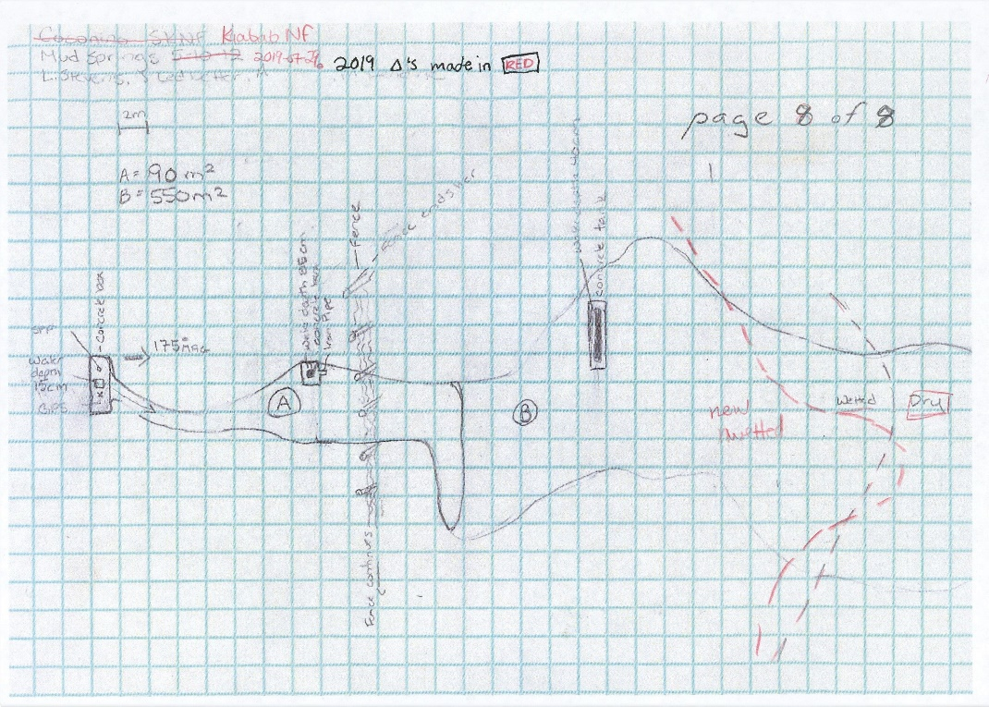
Fig 18.2 Mud Springs Sketchmap.

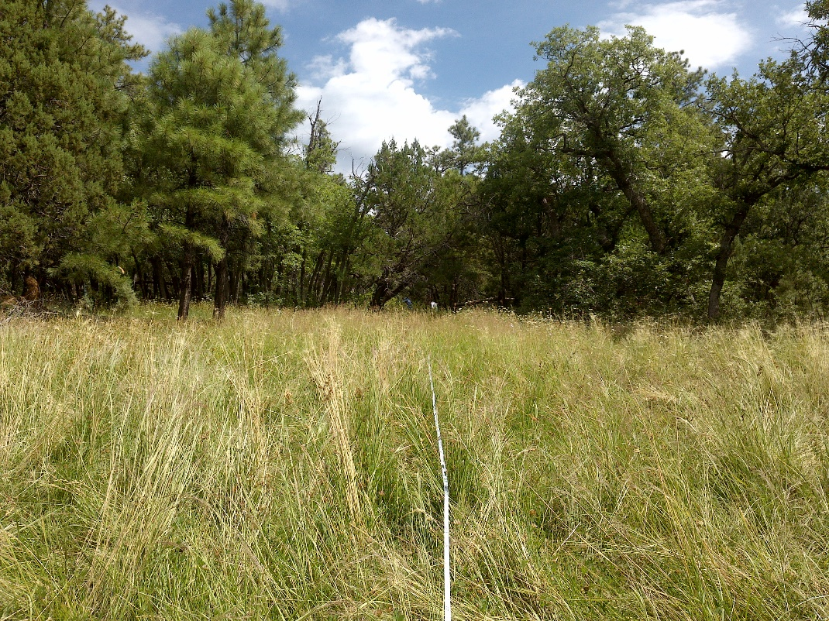
Fig 18.3 Mud Springs: View from 50 meters down from the first springbox, facing uphill towards the source.

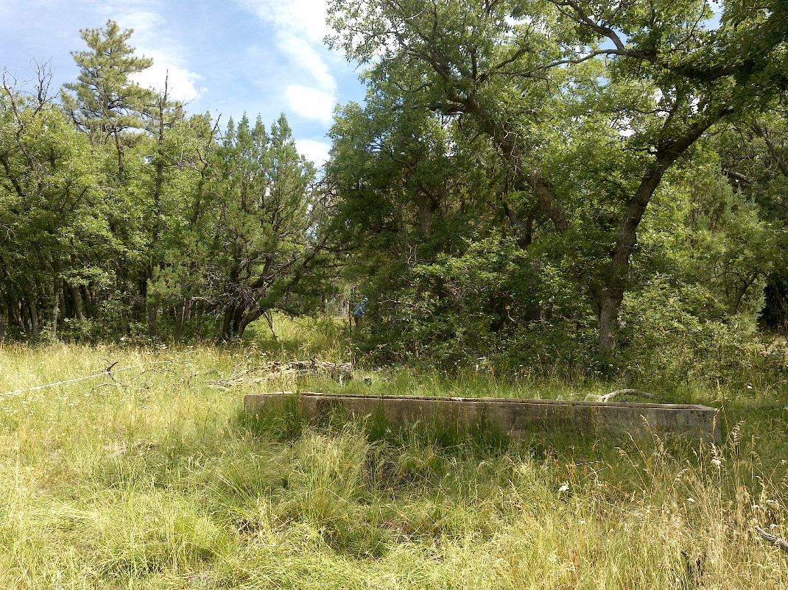
Fig 18.4 Mud Springs: View uphill at the water trough.

19. Rocky LO Lower, 6/08/18
19. Rocky LO Lower, 6/08/18
Survey Summary Report, Site ID 237570
Submitted 6/01/21 by Springs Stewardship Institute

Location: The Rocky LO Lower ecosystem is located in Coconino County in the Upper Verde Arizona 15060202 HUC, managed by the US Forest Service. The spring is located in the Kaibab NF, Williams RD, in the Garland Prairie USGS Quad, at 35.15246, -111.98233 (WGS84). The elevation is approximately 2039 meters. L.E. Stevens, A.E. Springer, T. Schipper, B. Murrieta, and SSI workshop class surveyed the site on 6/08/18 for 02:00 hours, beginning at 14:30, and collected data in 8 of 10 categories. This survey was conducted under a Kaibab Springs project using the Stevens et al. Level 2 protocol.

Physical Description: Rocky LO Lower is a hillslope/rheocrene spring. The site is located as part of a larger springs complex. Only one of the emergence locations in this multi-source emergence was surveyed. The Site is located at the base of a basalt rock face in a small valley. There is a forest road and parking lot within 300 meters. The larger area (within 5-10 miles) has a scattering of houses. The microhabitats associated with the spring cover 147 sqm. The site has 3 microhabitats, including A -- a 33 sqm channel, B -- a 67 sqm terrace, C -- a 47 sqm terrace. The geomorphic diversity is 0.46, based on the Shannon-Weiner diversity index.

Table 19.1 Rocky LO Lower Microhabitat characteristics.
Code | A | B | C
Name | Channel | Terrace to 4 m | Terrace to 4 m, center
Area sqm | 33 | 67 | 47
Surface type | CH | TE | TE
Surface subtype | run | LRZ | LRZ
Slope variability | Low | Low | Low
Aspect TN | 204 | 263 | 204
Slope degrees | 1 | 2 | 1
Moisture (scale 1-10) | 10 | 4 | 6
Water depth cm | 3 | 0 | 0
Area % open water | 95 | 0 | 0
Substrate
1 - Clay % | 6 | 10 | 15
2 - Silt % | 8 | 15 | 15
3 - Sand % | 1 | 2 | 1
4 - Fine gravel % | 9 | 13 | 2
5 - Coarse gravel % | 6 | 10 | 2
6 - Cobble % | 30 | 15 | 5
7 - Boulder % | 0 | 2 | 0
8 - Bedrock % | 0 | 0 | 0
Organic % | 40 | 33 | 60
Other % (anthropogenic) | 0 | 0 | 0
Precipitate % | 0 | 0 | 0
Litter % | 5 | 25 | 30
Wood % | 0.1 | 1 | 0.1
Litter Depth (cm) | 1 | 3 | 3

Geomorphology: Rocky LO Lower emerges as a fracture from a metamorphic rock layer. The emergence environment is subaerial, with a gravity flow force mechanism.

Survey Notes: The forest appears very dry with large amounts of dried grass in the area. A group of children walked through during the survey. The site is largely untrampled by livestock. There is no obvious litter. The survey was conducted from the source to approximately 35 meters downstream.

Water Quality: Surveyors measured the water quality just below the source. Location 1: at the spring source at 15:15.

Table 19.2 Rocky LO Lower Water Quality Measurements.
Characteristic Measured | Value | Location Number | Device
pH (field) | 6.49 | 1 | YSI Multiprobe
Specific conductance (field) (uS/cm) | 186.4 | 1 | YSI Multiprobe
Temperature, water C | 10.1 | 1 | YSI Multiprobe

Flora: Larry Stevens was the botanist, with assistance from Carl S. Surveyors identified 31 plant species at the site, with 0.2109 species/sqm. These included 18 native and 5 nonnative species; the native status of 8 species remains unknown.

Table 19.3 Rocky LO Lower Cover Type.
Cover Type | Species Count | Wetland Species Count
Ground | 23 | 7
Shrub | 2 | 0
Mid-canopy | 2 | 0
Tall canopy | 1 | 0
Basal | 0 | 0
Aquatic | 1 | 1
Non-vascular | 2 | 1

Table 19.4 Rocky LO Lower Vegetation % Cover in Microhabitats.
Plant Species | Cover Code | Native Status | Wetland Status | Comments | A | B | C
 | GC |  |  | Eudicot with square stem | 0 | 0.1 | 0.1
Abildgaardia | GC |  |  | sp. 1, with dark heads | 0 | 15 | 0
Achillea millefolium | GC | NI | U |  | 0 | 0.1 | 0.1
Berula | GC |  | W | check. why so much? | 85 | 15 | 10
Carex nebrascensis | GC | N | W |  | 8 | 1 | 0
Cirsium lactucinum | GC |  |  |  | 0 | 0 | 0.01
Cirsium vulgare | GC | I | F |  | 0 | 0 | 0.3
Conyza canadensis |  | N | R | last year's | 0 | 1 | 1
Eleocharis | GC | N | W |  | 0 | 20 | 10
Geranium | GC | N | F |  | 2 | 0 | 2
Iris missouriensis | GC | N | F |  | 0 | 0 | 5
Juncus balticus | GC | N | W |  | 0 | 10 | 3
Juniperus scopulorum | MC | N | U | off site | 0 | 0 | 0.5
Lotus | GC |  | U | blue | 0 | 0 | 0.01
Medicago | GC | I | F |  | 0 | 0 | 0.1
Melilotus | GC | I | WR |  | 0 | 0 | 0.1
Mimulus guttatus | AQ | N | W |  | 0 | 0 | 0.009
Nasturtium | GC |  | W | watercress - outside of site | 0 | 0 | 0
Nuphar lutea | GC | N |  | off-site | 0 | 0 | 0
Pinus ponderosa | MC | N | U |  | 2 | 0 | 0
Pinus ponderosa | SC | N | U |  | 0.1 | 0 | 0.1
Pinus ponderosa | TC | N | U |  | 0.1 | 0 | 0.1
Poa | GC | I | F |  | 0 | 35 | 45
Potentilla | GC | N | F |  | 0 | 0.2 | 0
Quercus gambelii |  | N | U |  | 0 | 0.5 | 0.5
Ribes | SC | N | F |  | 0.01 | 0 | 0.5
Rumex | GC | NI | F |  | 0 | 0 | 0.5
Thalictrum | GC | N | U |  | 0 | 0 | 0.01
unknown | GC |  |  | checker mallow? | 0 | 0 | 5
unknown Lichen | NV |  |  |  | 0 | 0 | 1.5
unknown moss | NV | N? |  |  | 0.1 | 0 | 0
Verbascum thapsus | GC | I | U |  | 0 | 0 | 0.2
Viola | GC | N | F |  | 0 | 0.2 | 0

Fauna: Surveyors collected or observed 5 aquatic and 8 terrestrial invertebrate taxa and 8 vertebrate taxa.

Table 19.5 Rocky LO Lower Invertebrates.
Species | Lifestage | Habitat | Method | Rep# | Count | Species Detail
Amphipoda |  | A | Collected spot |  | 2 | collected
Coleoptera Coccinellidae |  | T | Spot |  | 1
Coleoptera Huleechis |  | A | Collected spot |  | 2 | collected
Diptera Asilidae |  | T | Collected spot |  | 1 | collected
Hemiptera Belostomatidae |  | A | Spot |  | 1
Hemiptera Cicadellidae |  | T | Spot
Hemiptera Gerridae |  | A | Collected spot |  | 1 | collected
Hymenoptera |  | T | Spot |  | 10 | wasp
Hymenoptera Apidae |  | T | Spot
Lepidoptera Moth |  | T | Spot
Odonata |  |  | Collected spot |  |  | collected
Odonata Libellulidae |  |  | Spot |  | 3 | crimson
Orthoptera Acrididae |  | T | Spot
Trichoptera | L |  | Spot |  | 3 | casing
Unknown |  | T | Spot |  |  | black spiders, collected
Unknown |  | A | Spot |  |  | fresh water clam

Table 19.6 Rocky LO Lower Vertebrates.
Vertebrate Species Common Name | Count | Detection | Comments
Common Raven |  | call
Red-winged Blackbird | 5 | obs
Deer |  | sign
Elk |  | sign
Yellow-rumped Warbler
Garter Snake |  | obs
Frog |  | obs
Tadpole |  | obs | over 20

Assessment: Assessment scores were compiled in 4 categories and 23 subcategories, with 19 null condition scores, and 18 null risk scores. Aquifer functionality and water quality are good with significant restoration potential (average condition score 4.8) and there is negligible risk (average risk score 1.8). Geomorphology condition is good with significant restoration potential (average condition score 4.2) and there is low risk (average risk score 2). Habitat condition is good with significant restoration potential (average condition score 4.3) and there is negligible risk (average risk score 1.4). Biotic integrity is undetermined due to null scores (average condition score 0) and there is undetermined risk due to null scores (average risk score 0). Human influence of site is very good with excellent restoration potential (average condition score 5) and there is low risk (average risk score 2). Overall, the site condition is good with significant restoration potential and there is negligible risk.

Table 19.7 Rocky LO Lower Assessment Scores. Condition scores range from 0 (extremely poor condition) to 6 (pristine condition) and risk scores range from 0 (no risk to the site) to 6 (extreme risk to the site).
Category | Condition | Risk
Aquifer Functionality & Water Quality | 4.8 | 1.8
Geomorphology | 4.2 | 2
Habitat | 4.3 | 1.4
Biota | 0 | 0
Human Influence | 5 | 2
Overall Ecological Score | 4.7 | 1.8

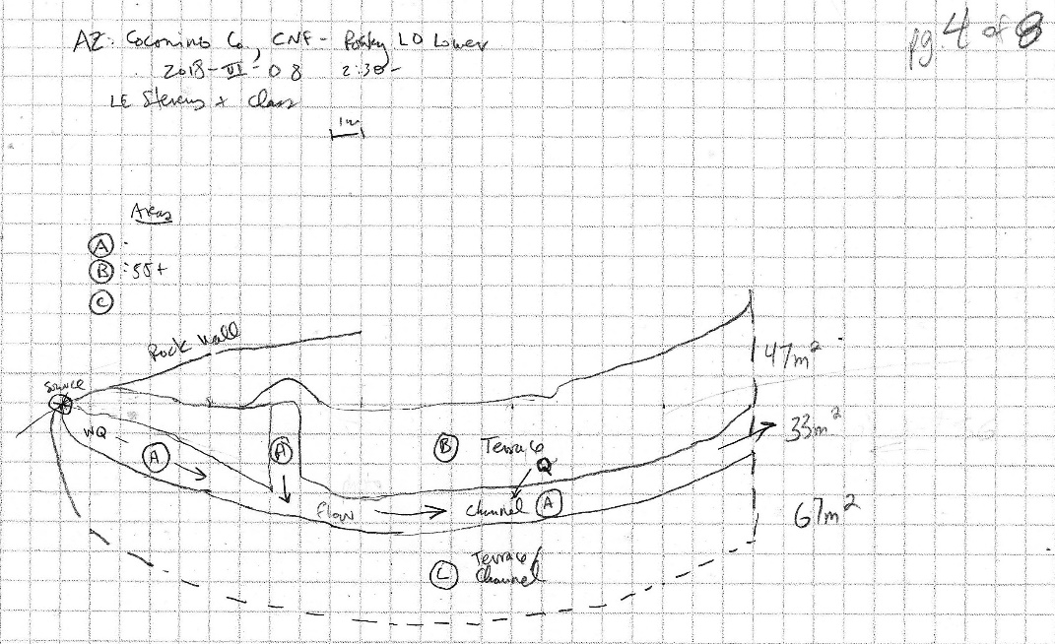
Fig 19.1 Rocky LO Lower Sketchmap.

20. Rosilda Spring, 7/29/19
20. Rosilda Spring, 7/29/19
Survey Summary Report, Site ID 588
Submitted 6/01/21 by Springs Stewardship Institute

Location: The Rosilda Spring ecosystem is located in Coconino County in the Upper Verde Arizona 15060202 HUC, managed by the US Forest Service. The spring is located in the Kaibab NF, Williams RD, in the Davenport Hill USGS Quad, at 35.17467, -112.06092 measured using a GPS (WGS84, estimated position error 2 meters). The elevation is approximately 2051 meters. Alek Mendoza, Andrea Hazelton, Tierney Schipper, and Jenna Norris surveyed the site on 7/29/19 for 01:20 hours, beginning at 15:20, and collected data in 9 of 10 categories. This survey was conducted under a Kaibab Springs project using the Stevens et al. Level 2 protocol.

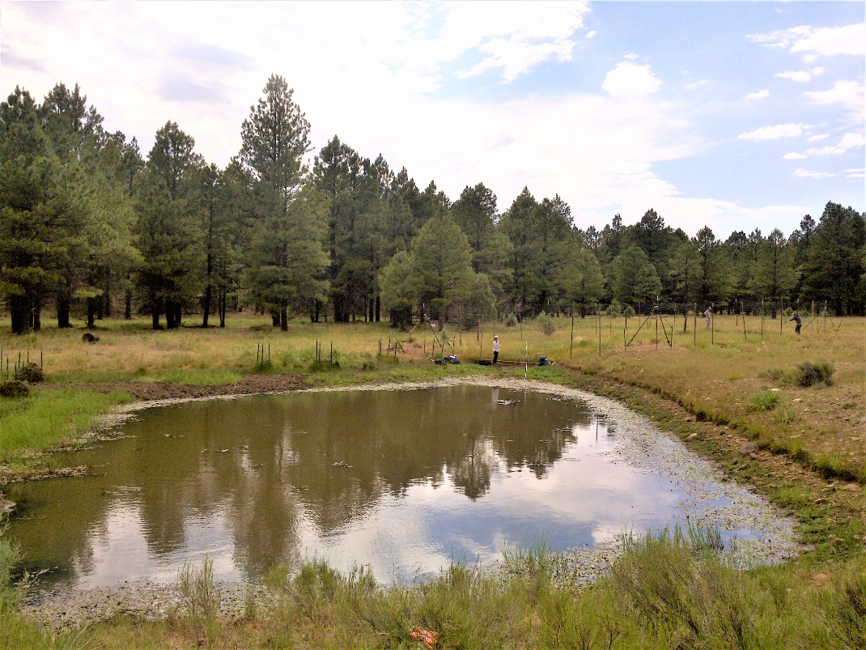
Fig 20.1 Rosilda Spring: View from the berm facing towards the fenced enclosure that contains the source well.

Physical Description: Rosilda Spring is a helocrene/anthropogenic spring. This spring is part of the SSI 4FRI Springs Monitoring Project and is located within a treatment area. This site is a low gradient cienega, the downstream end of which was excavated to form a bermed pond. There is an outflow channel exiting the pond on its south side. East of the berm that forms the main pond, there are two additional small (4 m x 1 m) excavated pools (outside survey area). At the upper end of the cienega, there is a rocked-in 3 meter-diameter well. There was formerly a pipe delivering water from this well into the pond. Between June 2018 and July 2019, a rehabilitation crew (probably Grand Canyon Trust) installed a 12 x 25 meter fence around the cienega and well. This crew likely removed the piping, as 2019 surveyors were unable to locate the pipe that formerly provided water to the pond. Six (0.5 x 0.5 m) vegetation exclosures protect planted willow saplings along the south side of the pond. This spring has a wooden sign with its name on it, and additional signage detailing the restoration efforts. The south side of the pond appears be influenced by floods. On September 22, 2019, Ed Schenk installed a Hobo Tidbit MX2203 data logger on a rebar along the fenceline where it crosses the runout channel linking the cienega to the excavated tank. On May 6, 2020, the survey crew re-installed it within 15 cm of the original location. On May 23, 2020, a surveyor replaced it, securing it with heavy to PVC and rebar, and covered it with rocks. The microhabitats associated with the spring cover 654 sqm. The site has 3 microhabitats, including B -- a 472 sqm pool, C -- a 152 sqm pool margin, G -- a 30 sqm low gradient cienega. The geomorphic diversity is 0.31, based on the Shannon-Weiner diversity index.

Table 20.1 Rosilda Spring Microhabitat characteristics.
Code | B | C | G
Name | Pond | Pond Perimeter | Low Gradient Cienega
Area sqm | 472 | 152 | 30
Surface type | P | PM | LGC
Surface subtype | anthro
Slope variability | Low | Low | Low
Aspect TN |  | 11 | 106
Slope degrees | 0 | 1 | 2
Moisture (scale 1-10) | 9 | 3 | 1
Water depth cm | 60 | 0 | 0
Area % open water | 95 | 0 | 0
Substrate
1 - Clay % | 2 | 14 | 18
2 - Silt % | 15 | 30 | 35
3 - Sand % | 5 | 3 | 5
4 - Fine gravel % | 3 | 7 | 7
5 - Coarse gravel % | 10 | 15 | 15
6 - Cobble % | 5 | 10 | 10
7 - Boulder % | 0 | 0 | 0
8 - Bedrock % | 0 | 0 | 0
Organic % | 60 | 14 | 5
Other % (anthropogenic) | 0 | 7 | 5
Precipitate % | 0 | 0 | 0
Litter % | 15 | 2 | 15
Wood % | 5 | 3 | 1
Litter Depth (cm) | 4 | 0.1 | 3

Geomorphology: Rosilda Spring emerges as a seepage or filtration from a igneous, basalt rock layer. The emergence environment is subaerial, with a gravity flow force mechanism. The site receives approximately 100% of available solar radiation, with 6862 Mj annually.

Access Directions: From I-40 take exit 165 Williams/Grand Canyon. Turn left to stay on Historic Route 66 East for 2.5 miles. Then turn left onto 4th street. This road will turn into Perkinsville Rd, which you will follow for approximately 7.2 miles. Turn left onto RS 139 (AKA Fire Rd 14) and follow it for about 6 miles. Park off the road and hike about 600 m north.

Survey Notes: The fenced off area that previously functioned as the spring source is currently dry. The spring has no visible signs of flow due to the piping being removed and the rock well being filled in. This removal seems to be slowly creating a low gradient cienega within the fenced area, indicated by the higher proportion of wetland vegetation within the fence compared to previous surveys. The south side of the pool has an excess of pine needles and flood debris along the pool margin from past flood events.

Flow: The only surface water is located in the excavated and bermed pond, which has no outflow. Surveyors were unable to measure flow because there was no outflow.

Water Quality: The surveyors measured water quality in the excavated pool. Location 1: in a pool in standing water at 15:15.

Table 20.2 Rosilda Spring Water Quality Measurements.
Characteristic Measured | Value | Location Number | Device
Alkalinity, Total (mg/L) | 84 | 1 | LaMotte
Dissolved oxygen (field) (mg/L) | 4.5 | 1 | CHEMets DO kit
Dissolved Solids (field) (ppt) | 0.102 | 1 | Hanna Multi 98194
pH (field) | 7.41 | 1 | Hanna Combo
pH (field) | 7.18 | 1 | Hanna Multi 98194
Specific conductance (field) (uS/cm) | 200 | 1 | Hanna Combo
Specific conductance (field) (uS/cm) | 210 | 1 | Hanna Multi 98194
Temperature, air C | 27.5 | 1 | Handheld therm
Temperature, water C | 26.9 | 1 | Hanna Combo
Temperature, water C | 26.55 | 1 | Hanna Multi 98194

Flora: Andrea Hazelton was the botanist for this survey. Surveyors identified 23 plant species at the site, with 0.0352 species/sqm. These included 19 native and 4 nonnative species.

Table 20.3 Rosilda Spring Cover Type.
Cover Type | Species Count | Wetland Species Count
Ground | 21 | 7
Shrub | 1 | 1
Mid-canopy | 0 | 0
Tall canopy | 0 | 0
Basal | 0 | 0
Aquatic | 3 | 3
Non-vascular | 0 | 0

Table 20.4 Rosilda Spring Vegetation % Cover in Microhabitats.
Plant Species | Cover Code | Native Status | Wetland Status | Comments | B | C | G
Acmispon americanus | GC | N | F |  | 0 | 0 | 2
Alopecurus aequalis | GC | N | U |  | 0 | 0.1 | 0
Bromus | GC | NI | F |  | 0 | 0 | 2
Coreopsis tinctoria | GC | N | F |  | 0 | 0.1 | 1
Eleocharis | GC | N | W |  | 0 | 10 | 20
Elymus elymoides | GC | N | F |  | 0 | 0 | 10
Frasera speciosa | GC | N | U |  | 0 | 0.5 | 0.5
Glyceria borealis | AQ | N | W |  | 5 | 0 | 0
Glyceria borealis | GC | N | W |  | 0 | 20 | 0
Iris missouriensis | GC | N | F |  | 0 | 0.1 | 15
Juncus arcticus | GC | N | W |  | 0 | 0.5 | 0
Juncus interior | GC | N | WR |  | 0.1 | 25 | 20
Lupinus | GC | N | F |  | 0 | 0 | 0.1
Marsilea | AQ | I | W |  | 10 | 0 | 0
Marsilea | GC | I | W |  | 0 | 10 | 0
Medicago lupulina | GC | I | WR |  | 0 | 0.1 | 10
Muhlenbergia | GC | N | U |  | 0 | 2 | 1
Perideridia parishii | GC | N | F |  | 0 | 0.5 | 0
Poa pratensis | GC | NI | F |  | 0 | 0 | 5
Polygonum aviculare | GC | I | F |  | 0 | 0 | 0.5
Potamogeton nodosus | AQ | N | A |  | 10 | 0.1 | 0
Rumex crispus | GC | I | WR |  | 0 | 0.1 | 1
Salix | SC | N | WR |  | 0 | 1 | 0.5
Sisyrinchium demissum | GC | N | W |  | 0 | 0.1 | 0.1
Stephanomeria pauciflora | GC | N | U |  | 0 | 0.1 | 0.5

Fauna: Surveyors collected or observed 2 terrestrial invertebrate taxa and 4 vertebrate taxa.

Table 20.5 Rosilda Spring Invertebrates.
Species | Lifestage | Habitat | Method | Rep# | Count | Species Detail
Odonata | M |  | Spot
Odonata Libellulidae Libellula saturata | Ad | T | Spot
Odonata Libellulidae Plathemis lydia | Ad | T | Spot

Table 20.6 Rosilda Spring Vertebrates.
Vertebrate Species Common Name | Count | Detection | Comments
Hummingbird |  | call
Sparrow |  | obs
American Bullfrog |  | obs | Many
Black Phoebe | 1 | obs

Assessment: Assessment scores were compiled in 5 categories and 33 subcategories, with 9 null condition scores, and 9 null risk scores. Aquifer functionality and water quality are very poor with very limited restoration potential (average condition score 1.8) and there is moderate risk (average risk score 3.3). Geomorphology condition is poor with limited restoration potential (average condition score 2.2) and there is high risk (average risk score 4.2). Habitat condition is moderate with some restoration potential (average condition score 3) and there is moderate risk (average risk score 3.6). Biotic integrity is moderate with some restoration potential (average condition score 3.4) and there is low risk (average risk score 2.6). Human influence of site is moderate with some restoration potential (average condition score 3.3) and there is moderate risk (average risk score 3.1). Overall, the site condition is poor with limited restoration potential and there is moderate risk.

Table 20.7 Rosilda Spring Assessment Scores. Condition scores range from 0 (extremely poor condition) to 6 (pristine condition) and risk scores range from 0 (no risk to the site) to 6 (extreme risk to the site).
Category | Condition | Risk
Aquifer Functionality & Water Quality | 1.8 | 3.3
Geomorphology | 2.2 | 4.2
Habitat | 3 | 3.6
Biota | 3.4 | 2.6
Human Influence | 3.3 | 3.1
Overall Ecological Score | 2.8 | 3.3

Management Recommendations: Surveyors recommend periodically monitoring the newly installed fenced enclosure.

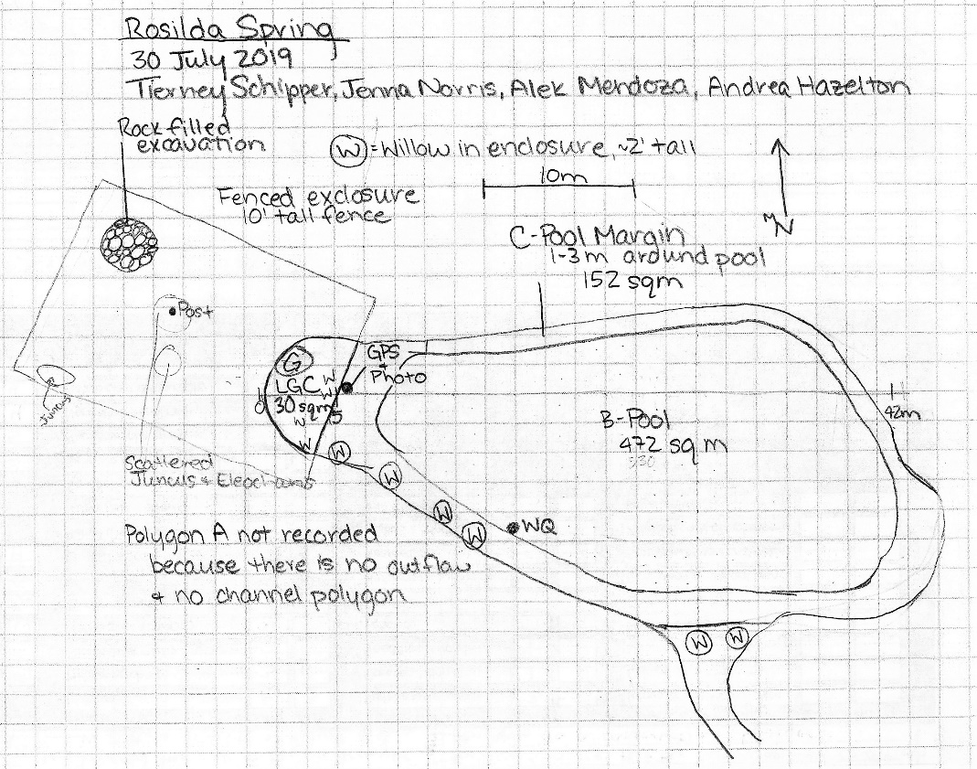
Fig 20.2 Rosilda Spring Sketchmap.

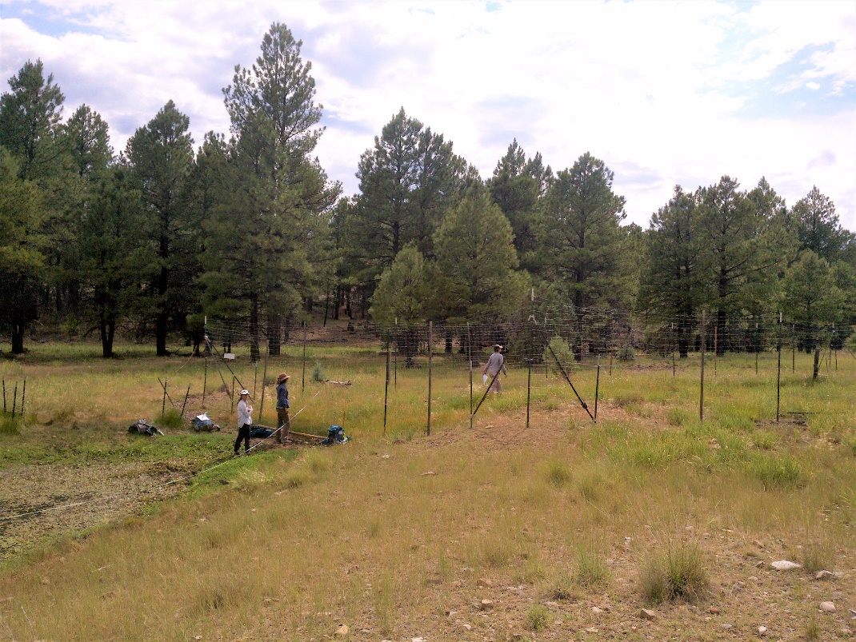
Fig 20.3 Rosilda Spring: View from the north side of the pond, facing the fenced enclosure.

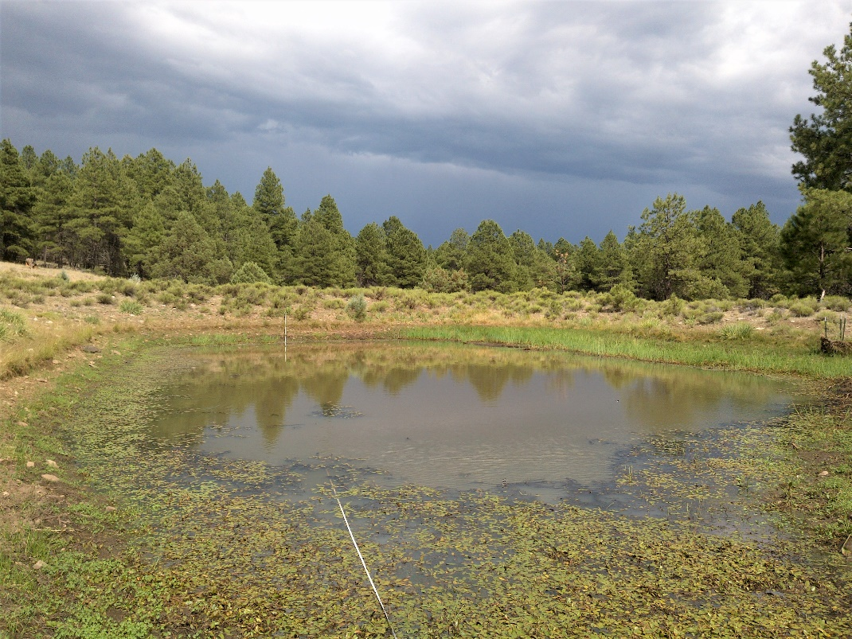
Fig 20.4 Rosilda Spring: View facing east towards the berm.

