Kaibab Springs Summary Report Volume 2

1. Sawmill Spring, 8/02/19 2
2. Spitz Spring Lower, 6/11/18 4
3. Stewart Spring, 8/21/19 12
4. Wild Horse Spring, 5/11/12 14
5. Willow Spring, 8/29/11 21

1. Sawmill Spring, 8/02/19
1. Sawmill Spring, 8/02/19
Survey Summary Report, Site ID 782
Submitted 6/01/21 by Springs Stewardship Institute

Location: The Sawmill Spring ecosystem is located in Coconino County in the Upper Verde Arizona 15060202 HUC, managed by the US Forest Service. The spring is located in the Kaibab NF, Williams RD, in the Parks USGS Quad, at 35.28865, -111.95994 measured using a GPS (WGS84, estimated position error 2.13 meters). The elevation is approximately 2219 meters. Andrea Hazelton and Jeri Ledbetter verified the site on 8/02/19 at 10:30. This survey was conducted under a Kaibab Springs project using the Stevens et al. Level 1 protocol.

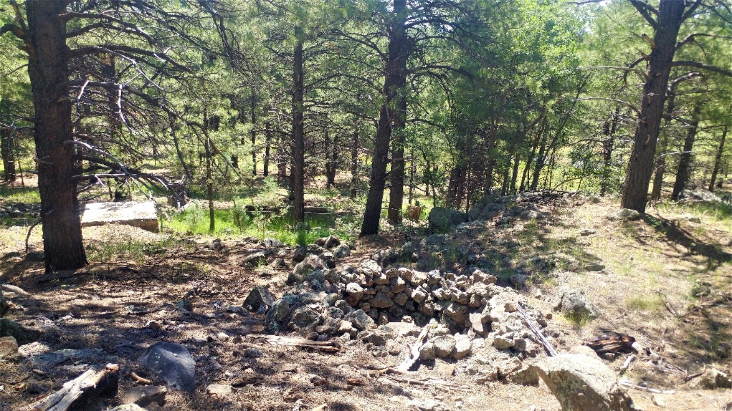
Fig 1.1 Sawmill Spring: Standing above rock catchment: view downhill.
Physical Description: Sawmill Spring is a hillslope/anthropogenic spring. This spring is part of the SSI 4FRI Springs Monitoring Project and is located within a treatment area. This often dry spring emerges from the base of a small basalt escarpment. When this spring is flowing, the seepage fills two cisterns and also emerges from several points along the hillside surrounding the cisterns, supporting two small patches of cienega habitat and sometimes trickling down the rocky hillside. The lower cistern feeds a concrete trough. There is an excavated stock tank approximately 50 meters below the trough, in the draw at the base of the hillslope. As of 2019 it does not appear that any functional infrastructure links the spring to the excavated tank. In September 2019, the surveyor installed a HOBO MX2203 data logger in the upper patch of cienega, approximately 9.2 meters downslope from the uppermost cistern. In May 2020, surveyors secured it to rebar with wire and protected it with PVC. There is a rock covering it.

Geomorphology: Sawmill Spring emerges as a seepage or filtration from a igneous, basalt rock layer. The emergence environment is subaerial, with a gravity flow force mechanism. The site receives approximately 97% of available solar radiation, with 6682 Mj annually.
Access Directions: From I-40, exit at Parks Road (exit 178) and drive north on Parks Road for 1/4 mile until it ends in a T. Turn left (west) onto Brannigan Park Rd, which merges with Old Highway 66 after 1/2 mile. Continue west on Old Highway 66 for less than 1/2 mile and turn north onto County Road 141 (Spring Valley Rd). Travel north on 141 for about 1.3 miles and turn left (west) on E. Lillie J. Ranch Rd. Drive about 1/4 mile and park near the building at the end of the road. Walk north and then west along the old dirt road on the north side of the building. The road leads to the stock tank below the spring, and the hike is about 1 km.

Survey Notes: The upper rock catchment has a small amount of standing water. The lids to the catchment and springbox are functioning. The water levels in the functioning springbox are 28 cm below the lower lip. The water levels in the open trough are 42 cm below the top and full of algae. All piping that surveyors observed at this site is dysfunctional. The lowest excavated catchment pond is currently full and occupied by cattle.

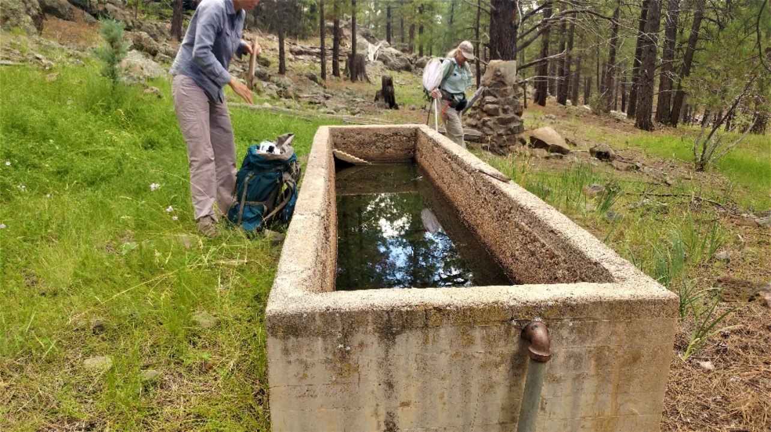
Fig 1.2 Sawmill Spring: View of open water trough with algae

2. Spitz Spring Lower, 6/11/18
2. Spitz Spring Lower, 6/11/18
Survey Summary Report, Site ID 770
Submitted 6/01/21 by Springs Stewardship Institute

Location: The Spitz Spring Lower ecosystem is located in Coconino County in the Upper Verde Arizona 15060202 HUC, managed by the US Forest Service. The spring is located in the Kaibab NF, Williams RD, in the Parks USGS Quad, at 35.26033, -111.97510 measured using a GPS (WGS84). The elevation is approximately 2136 meters. John Moeny, Tierney Schipper, Susan Ossim, Emile Sawyer, and Larry Stevens surveyed the site on 6/11/18 for 00:57 hours, beginning at 14:55, and collected data in 10 of 10 categories. This survey was conducted under a Kaibab Springs project using the Stevens et al. Level 2 protocol.

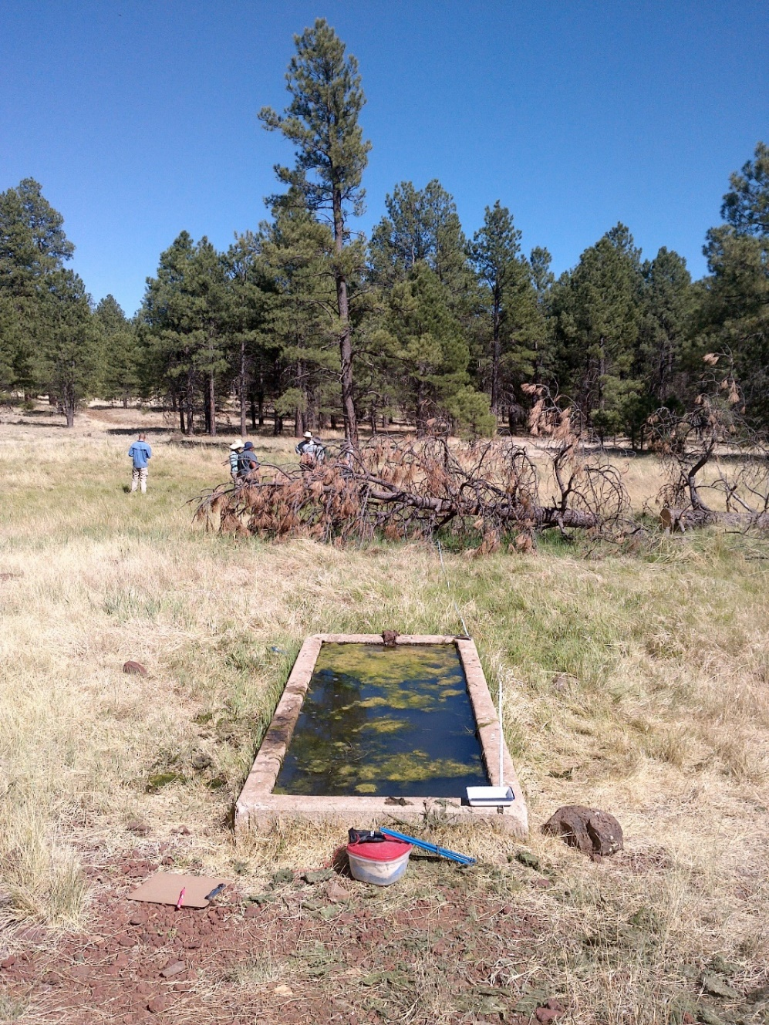
Fig 2.1 Spitz Spring Lower: Looking downslope at the concrete trough, with the wet meadow and wind-blown Ponderosa pine tree in the background.

Physical Description: Spitz Spring Lower is a helocrene/anthropogenic spring. This spring is part of the SSI 4FRI Springs Monitoring Project and is located within a treatment area. The spring is near a roadside, in a grassy meadow with ponderosa pines. This spring is developed with a concrete trough, as well as an open round metal tank about 50 meters northeast of the trough. Both of these structures presumably receive water piped from the the springbox 40 meters north of the concrete trough, though there is no piping visible within the site. Outflow from the overflowing concrete trough supports low gradient cienega habitat downslope, as well as a shallow pool when flow is sufficient. On September 22, 2019 a surveyor installed a HOBO MX2203 data logger under a basalt rock at the base of the concrete trough where flow spills over. In May 2020, surveyors secured the Hobo it to rebar with wire about 40 cm downstream of the trough outflow. The microhabitats associated with the spring cover 82 sqm. The site has 2 microhabitats, including A -- a 3 sqm other, B -- a 79 sqm low gradient cienega. The geomorphic diversity is 0.07, based on the Shannon-Weiner diversity index.

Table 2.1 Spitz Spring Lower Microhabitat characteristics.
Code | A | B
Name | Concrete Tank | Wet meadow
Area sqm | 3 | 79
Surface type | OTH | LGC
Surface subtype | anthro
Slope variability | Low | Low
Aspect TN | 11 | 201
Slope degrees | 0 | 3
Moisture (scale 1-10) | 10 | 8
Water depth cm | 45 | 3
Area % open water | 90 | 2
Substrate
1 - Clay % | 0 | 10
2 - Silt % | 0 | 30
3 - Sand % | 0 | 0
4 - Fine gravel % | 0 | 0
5 - Coarse gravel % | 0 | 0
6 - Cobble % | 0 | 0.5
7 - Boulder % | 0 | 0
8 - Bedrock % | 0 | 0
Organic % | 90 | 59.5
Other % (anthropogenic) | 10 | 0
Precipitate % | 0 | 0
Litter % | 5 | 5
Wood % | 0 | 15
Litter Depth (cm) | 1 | 3

Geomorphology: Spitz Spring Lower emerges as a contact from a igneous, rhyolite rock layer. The emergence environment is subaerial, with a gravity flow force mechanism. The site receives approximately 100% of available solar radiation, with 6838 Mj annually.

Access Directions: From I-40, exit at Parks Road (exit 178) and drive north on Parks Road for 1/4 mile until it ends in a T. Turn left (west) onto Brannigan Park Rd, which merges with Old Highway 66 after 1/2 mile. Continue west on Old Highway 66 for 2.1 miles. Turn south onto Spitz Spring Rd and park immediately on the side of the road. The spring is immediately southwest of this intersection.

Survey Notes: This site is in a dry, drought-stressed forest. Surveyors observed a wind-thrown ponderosa pine in the wet meadow about 13 m downslope of the spring box. There was trampled soil and pedestals throughout the wet meadow.

Flow: Surveyors measured a flow of 0.0027 liters/second, using a timed flow volume capture method. Flow was measured at the outflow of concrete tank, where discharge was gathered at the pipe. This spring is perennial.

Water Quality: There was stagnant tank water with mixed inflow. The water quality was collected at the concrete tank. Location 1: at another location in other at 15:15.

Table 2.2 Spitz Spring Lower Water Quality Measurements.
Characteristic Measured | Value | Location Number | Device
Alkalinity, Total (mg/L) | 80 | 1 | LaMotte
Dissolved oxygen (field) (mg/L) | 12 | 1 | CHEMets DO kit
pH (field) | 6.08 | 1 | Hanna Combo
Specific conductance (field) (uS/cm) | 159 | 1 | Hanna Combo
Temperature, water C | 21.2 | 1 | Hanna Combo

Flora: Surveyors identified 11 plant species at the site, with 0.1341 species/sqm. These included 9 native and 1 nonnative species; the native status of 1 species remains unknown.

Table 2.3 Spitz Spring Lower Cover Type.
Cover Type | Species Count | Wetland Species Count
Ground | 10 | 5
Shrub | 0 | 0
Mid-canopy | 0 | 0
Tall canopy | 0 | 0
Basal | 0 | 0
Aquatic | 1 | 0
Non-vascular | 0 | 0

Table 2.4 Spitz Spring Lower Vegetation % Cover in Microhabitats.
Plant Species | Cover Code | Native Status | Wetland Status | Comments | A | B
Agrostis | GC | I | W |  | 0 | 3
Bouteloua gracilis | GC | N | U |  | 0 | 1
Carex praegracilis | GC | N | W |  | 0 | 7
Cladophora | AQ | N? | A |  | 95 | 0
Eleocharis | GC | N | W |  | 0 | 12
Elymus elymoides | GC | N | F |  | 0 | 0.01
Hordeum | GC |  | WR |  | 0 | 3
Iris missouriensis | GC | N | F |  | 0 | 5
Mimulus | GC | N | W |  | 0 | 3
Poa pratensis | GC | NI | F |  | 0 | 66
Rumex | GC | NI | F |  | 0 | 0.1

Fauna: Surveyors collected or observed 4 terrestrial invertebrate taxa and 6 vertebrate taxa.

Table 2.5 Spitz Spring Lower Invertebrates.
Species | Lifestage | Habitat | Method | Rep# | Count | Species Detail
Araneae |  | T |  |  | 3 | black
Coleoptera Coccinellidae | Ad | T | Collected spot |  | 1
Diptera Tabanidae Tabanus fulvicallus | Ad |  |  |  | 5
Lepidoptera | Ad | T |  |  | 6
Mollusca | Ad |  | Collected spot |  | 2
Odonata Libellulidae Libellula saturata | Ad |  |  |  | 1
Orthoptera Acrididae | Ad | T |  |  | 5

Table 2.6 Spitz Spring Lower Vertebrates.
Vertebrate Species Common Name | Count | Detection | Comments
Elk
Deer
Red-winged Blackbird | 2
Steller's Jay
Western Tanager
Dark-eyed Junco

Assessment: Assessment scores were compiled in 5 categories and 33 subcategories, with 9 null condition scores, and 9 null risk scores. Aquifer functionality and water quality are poor with limited restoration potential (average condition score 2.8) and there is low risk (average risk score 2.8). Geomorphology condition is poor with limited restoration potential (average condition score 2) and there is moderate risk (average risk score 3.8). Habitat condition is moderate with some restoration potential (average condition score 3) and there is moderate risk (average risk score 3). Biotic integrity is moderate with some restoration potential (average condition score 3.3) and there is moderate risk (average risk score 3). Human influence of site is moderate with some restoration potential (average condition score 3.7) and there is moderate risk (average risk score 3). Overall, the site condition is moderate with some restoration potential and there is moderate risk.

Table 2.7 Spitz Spring Lower Assessment Scores. Condition scores range from 0 (extremely poor condition) to 6 (pristine condition) and risk scores range from 0 (no risk to the site) to 6 (extreme risk to the site).
Category | Condition | Risk
Aquifer Functionality & Water Quality | 2.8 | 2.8
Geomorphology | 2 | 3.8
Habitat | 3 | 3
Biota | 3.3 | 3
Human Influence | 3.7 | 3
Overall Ecological Score | 3.1 | 3.1

Management Recommendations: Surveyors recommend occasional monitoring to help determine the climate sensitivity and sustainability of the springs ecosystem.

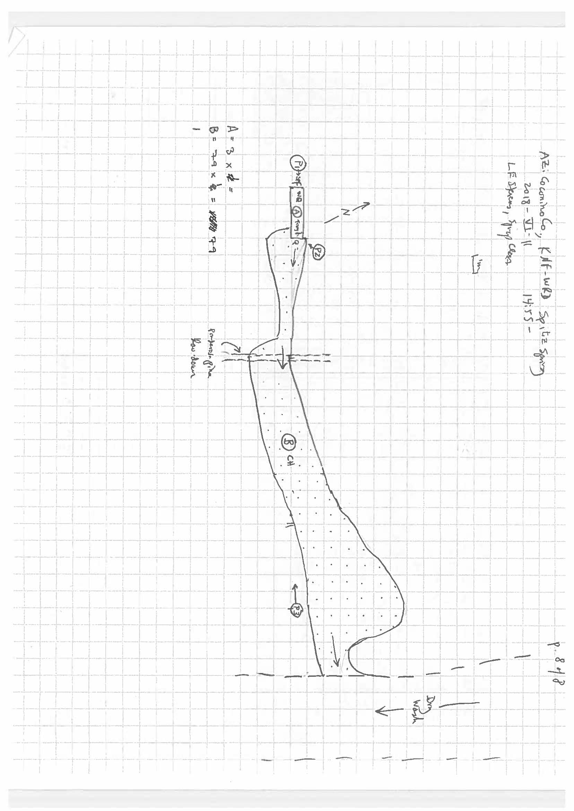
Fig 2.2 Spitz Spring Lower Sketchmap.

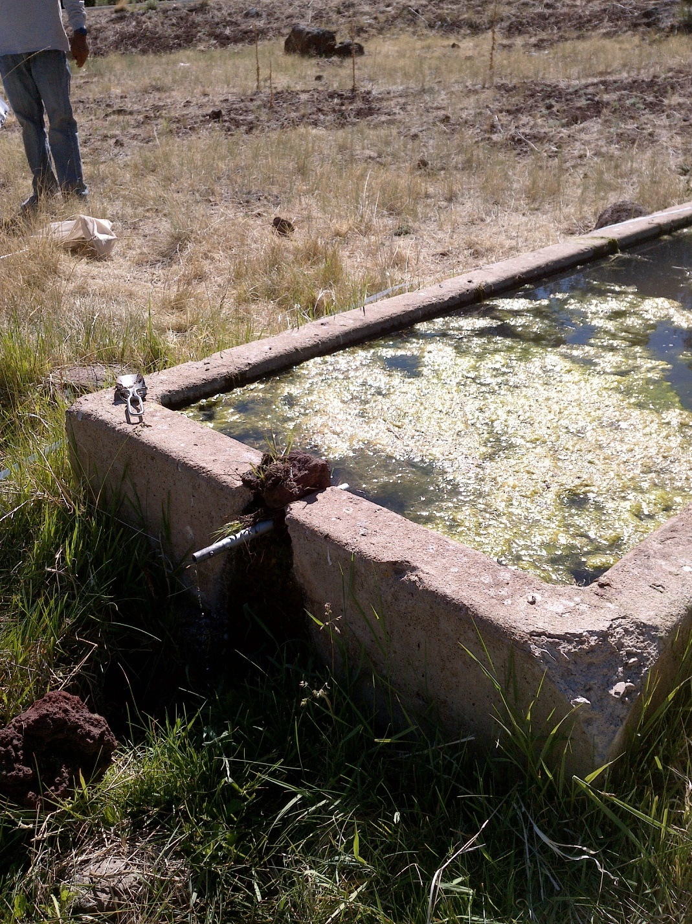
Fig 2.3 Spitz Spring Lower: View of the tank water volume.

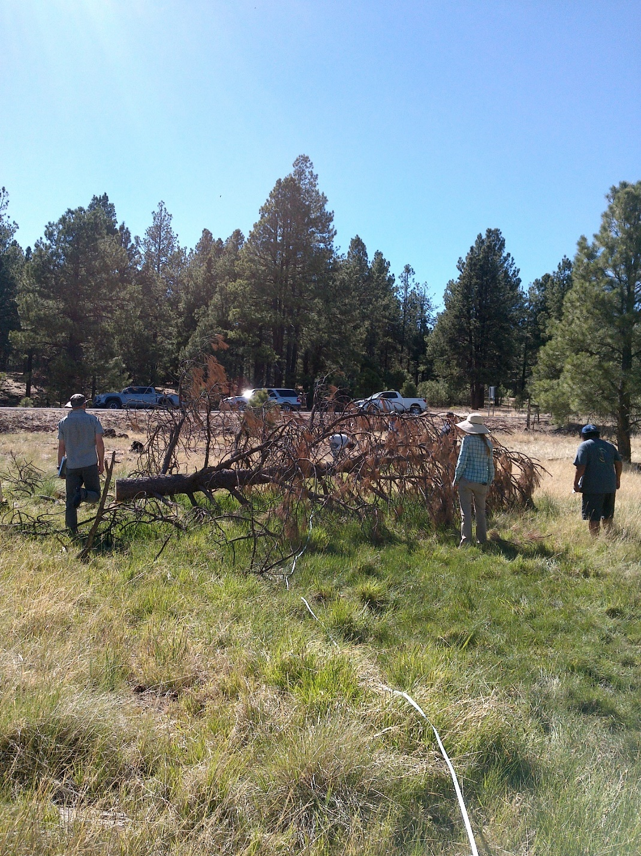
Fig 2.4 Spitz Spring Lower: View of the wet meadow from 25 meters downslope of the concrete trough.

3. Stewart Spring, 8/21/19
3. Stewart Spring, 8/21/19
Survey Summary Report, Site ID 781
Submitted 6/01/21 by Springs Stewardship Institute

Location: The Stewart Spring ecosystem is located in Coconino County in the Upper Verde Arizona 15060202 HUC, managed by the US Forest Service. The spring is located in the Kaibab NF, Williams RD, in the May Tank Pocket USGS Quad, at 35.10677, -112.15804 measured using a GPS (WGS84, estimated position error 3 meters). The elevation is approximately 1962 meters. Alek Mendoza, Katherine Williams, and Emma Williams verified the site on 8/21/19 at 16:50. This survey was conducted under a Kaibab Springs project using the Stevens et al. Level 1 protocol.

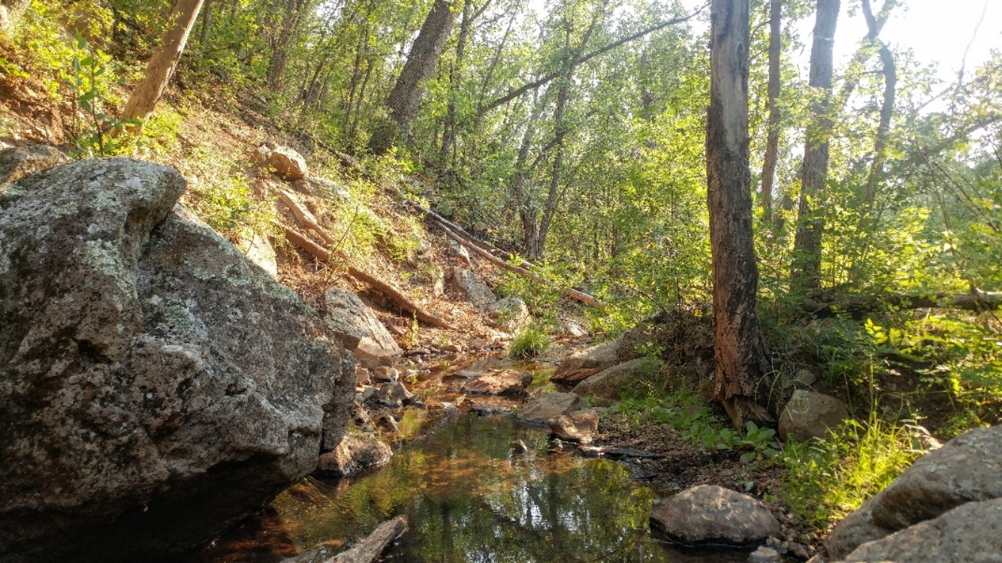
Fig 3.1 Stewart Spring: View from the first pool in the channel looking downstream.

Physical Description: Stewart Spring is a hillslope/rheocrene spring. This named spring is depicted on the DRG, and was included in the AZ State Land Office shapefile. The spring discharges from a hillside into a main drainage channel. Two separate seeps are present. There is dysfunctional piping coming from the hillside that crossed the channel.

Geomorphology: Stewart Spring emerges as a fracture from a igneous, basalt rock layer. The emergence environment is subaerial, with a gravity flow force mechanism.

Access Directions: From S Perkinsville Rd (CR-73), turn onto NF-354 and travel south for 1 mi to NF-57. Continue on NF-57 for 1.2 miles keeping south. The spring is located 180 m due SE in the drainage.

Survey Notes: After assessing the site, surveyors found the spring source to be on the hillslope. The primary spring type is now changed from a rheocrene to a hillslope.

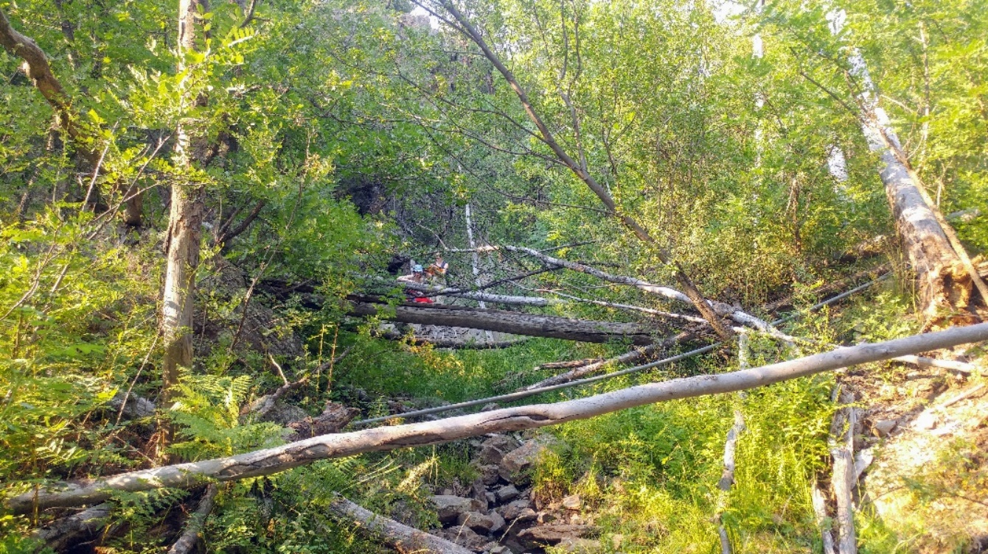
Fig 3.2 Stewart Spring: View approximately 10 meters down the first source pool looking upstream.

4. Wild Horse Spring, 5/11/12
4. Wild Horse Spring, 5/11/12
Survey Summary Report, Site ID 779
Submitted 6/01/21 by Springs Stewardship Institute

Location: The Wild Horse Spring ecosystem is located in Coconino County in the Upper Verde Arizona 15060202 HUC, managed by the US Forest Service. The spring is located in the Kaibab NF, Williams RD, in the May Tank Pocket USGS Quad, at 35.09095, -112.16450 measured using a GPS (NAD83, estimated position error 4 meters). The elevation is approximately 2041 meters. Larry Stevens, Jeri Ledbetter, Anya Fayfer, and Marguerite Hendrie surveyed the site on 5/11/12 for 01:10 hours, beginning at 13:05, and collected data in 9 of 10 categories. This survey was conducted under a Kaibab Springs project using the Stevens et al. Level 2 protocol.

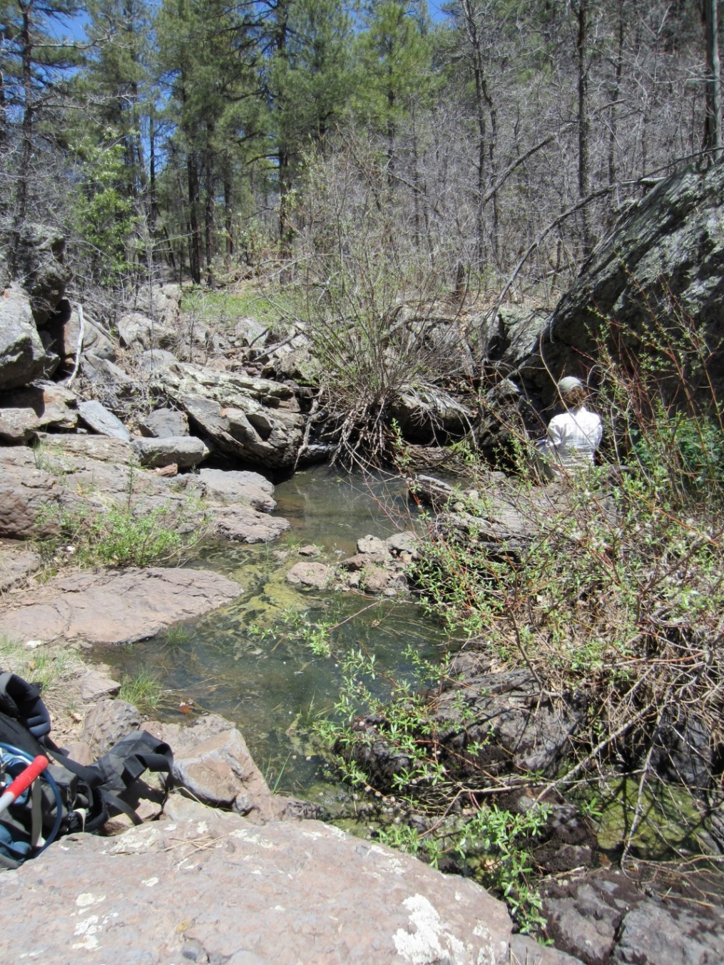
Fig 4.1 Wild Horse Spring: View of the pool

Physical Description: Wild Horse Spring is a rheocrene spring that emerges from a basalt flow in a primarily bedrock runoff-dominated channel in a rocky-forested canyon. The microhabitats associated with the spring cover 77 sqm. The site has 2 microhabitats, including A -- a 7 sqm channel, B -- a 70 sqm terrace. The geomorphic diversity is 0.13, based on the Shannon-Weiner diversity index.

Table 4.1 Wild Horse Spring Microhabitat characteristics.
Code | A | B
Name | Source Channel | Terrace
Area sqm | 7.00 | 70.00
Surface type | CH | TE
Surface subtype | run | LRZ
Slope variability | Med | High
Aspect TN | 246 | 246
Slope degrees | 3 | 3
Moisture (scale 1-10) | 10 | 0
Water depth cm | 20.00
Area % open water | 40.00
Substrate
1 - Clay % | 0 | 0
2 - Silt % | 0 | 0
3 - Sand % | 0 | 0
4 - Fine gravel % | 10 | 5
5 - Coarse gravel % | 10 | 10
6 - Cobble % | 10 | 5
7 - Boulder % | 10 | 10
8 - Bedrock % | 55 | 70
Organic % | 5 | 0
Other % (anthropogenic) | 0 | 0
Precipitate % | 0.00 | 0.00
Litter % | 10.00 | 5.00
Wood % | 2.00 | 8.00
Litter Depth (cm) | 0.50 | 1.00

Geomorphology: Wild Horse Spring emerges as a seepage or filtration from a igneous, basalt rock layer. The emergence environment is subaerial, with a gravity flow force mechanism. The site receives approximately 82% of available solar radiation, with 5657 Mj annually.

Access Directions: Please examine a map closely before proceeding to this site. Some of the roads listed below may be closed or not accessible. Take County Rd 73 (S Perkinsville Rd) south from Williams, AZ to Forest Rd 57. Turn left on FR 57 (Bear Springs Rd). Turn right onto FR 4216A (Overland Rd), then right onto FR 4218G, then right onto FR 417H (to stay on FR 4218G. Turn right onto FR 4219. Continue on FR 4219A for ~0.6 miles. Spring is south of the road, approximately 0.25 miles.

Survey Notes: This spring is subject to heavy runoff. There is little evidence of human activities at the site, but trails and roads nearby are heavily logged and burned 50-100 years ago.

Flow: Surveyors measured a flow of 0.03400 liters/second, using a timed flow volume capture method. Flow was adjusted for an estimate of 1.00% of site flow capture. Flow measurements were taken in channel constriction, 10 m from upper pool.

Water Quality: Water quality measurements were taken in the upper pool at a 2.5 cm depth.

Table 4.2 Wild Horse Spring Water Quality Measurements.
Characteristic Measured | Value | Location Number | Device
Alkalinity, Total (mg/L) | 40 |  | test strips
Hardness, Ca + Mg (mg/L) | 0 |  | test strips
Nitrogen, Nitrate (NO3) as NO3 (mg/L) | 0 |  | test strips
Nitrogen, Nitrite (NO2) as NO2 (mg/L) | 0 |  | test strips
pH (field) | 6.73 |  | Hanna/Ph Spear
pH (field) | 6.5 |  | test strips
Specific conductance (field) (uS/cm) | 75 |  | Hanna/Ph Spear
Temperature, air C | 26.7 |  | Handheld therm
Temperature, water C | 14.6 |  | Hanna/Ph Spear

Flora: Larry Stevens was the botanist. Surveyors identified 18 plant species at the site, with 0.2338 species/sqm. These included 15 native and 2 nonnative species; the native status of 1 species remains unknown.

Table 4.3 Wild Horse Spring Cover Type.
Cover Type | Species Count | Wetland Species Count
Ground | 10 | 4
Shrub | 4 | 1
Mid-canopy | 1 | 0
Tall canopy | 0 | 0
Basal | 1 | 0
Aquatic | 1 | 1
Non-vascular | 2 | 0

Table 4.4 Wild Horse Spring Vegetation % Cover in Microhabitats.
Plant Species | Cover Code | Native Status | Wetland Status | Comments | A | B
Ambrosia | GC | I | F | annual | 0 | 0.3
Carex aurea | GC | N | W |  | 3 | 2
Cladophora glomerata | AQ | N | A |  | 30 | 0
Iris missouriensis | GC | N | F |  | 0 | 2
Lathyrus | GC | N | R |  | 0 | 8
Lichen | NV | N | U |  | 0 | 3
Prunus virginiana | SC | N | F |  | 0 | 5
Quercus gambelii | BC | N | U | 5 cm | 0 | 0.01
Quercus gambelii | MC | N | U |  | 0 | 2
Quercus gambelii | SC | N | U |  | 1 | 10
Robinia neomexicana | SC | N | F |  | 0 | 0.1
Salix lasiolepis | SC | N | R |  | 8 | 12
Solidago | GC | N | F |  | 0 | 0.2
Sporobolus contractus | GC | N | F | ? | 0 | 2
Symphoricarpos | GC | N | U |  | 0 | 10
Toxicodendron radicans | GC | N | WR |  | 0 | 1
Trifolium repens | GC | I | WR |  | 0 | 0.1
unknown Bryophyte (moss, liverwort, hornwort) | NV | N | F |  | 0 | 3
unknown grass | GC |  |  | spikey | 1 | 0

Fauna: Surveyors collected or observed 8 aquatic and 26 terrestrial invertebrate taxa and 2 vertebrate taxa.

Table 4.5 Wild Horse Spring Invertebrates.
Species | Lifestage | Habitat | Method | Rep# | Count | Species Detail
Araneae | Ad | T | Collected spot |  | 1
Coleoptera | Ad |  | Collected spot |  | 1
Coleoptera Carabidae Bembidion subangustatum | Ad |  | Collected spot |  | 1
Coleoptera Coccinellidae | Ad | T | Collected spot |  | 1
Coleoptera Dermestidae | Ad | T | Collected spot |  | 1
Coleoptera Dytiscidae | Ad | A | Collected spot |  | 6
Coleoptera Dytiscidae Agabus | Ad | A | Collected spot |  | 1
Coleoptera Dytiscidae Laccophilus | Ad | A | Collected spot |  | 1
Coleoptera Haliplidae Peltodytes dispersus | Ad | A | Collected spot |  | 1
Coleoptera Hydrophilidae | Ad | A | Collected spot |  | 1
Coleoptera Hydrophilidae Tropisternus affinis | Ad | A | Collected spot |  | 1
Diptera | Ad | T | Collected spot |  | 1
Diptera Culicidae | L | A | Collected spot |  | 2
Diptera Sarcophagidae | Ad | T | Collected spot |  | 1
Hemiptera Cydnidae |  |  | Collected spot |  | 1
Hemiptera Lygaeidae Geocoris | Ad | T | Collected spot |  | 1
Hemiptera Notonectidae Notonecta kirbyi | Ad | A | Collected spot |  | 1
Hemiptera Pentatomidae Thyanta pallidovirens | Ad | T | Collected spot |  | 1
Hemiptera Pyrrhocoridae | Ad | T | Collected spot |  | 1
Hymenoptera | Ad | T | Collected spot |  | 2
Lepidoptera Hesperiidae Amblyscirtes aenus | Ad | T | Collected spot |  | 1
Lepidoptera Hesperiidae Epargyreus clarus | Ad | T | Spot |  | 1
Lepidoptera Hesperiidae Erynnis meridianus | Ad | T | Spot |  | 1
Lepidoptera Hesperiidae Heliopetes ericetorum | Ad | T | Spot |  | 1
Lepidoptera Lycaenidae Callophrys eryphon | Ad | T | Collected spot |  | 1
Lepidoptera Lycaenidae Glaucopsyche lygdamus | Ad | T | Spot |  | 1
Lepidoptera Nymphalidae Chlosyne acastus | Ad | T | Spot |  | 1
Lepidoptera Nymphalidae Junonia coenia | Ad | T | Spot |  | 1
Lepidoptera Nymphalidae Phyciodes | Ad | T | Spot |  | 1
Lepidoptera Nymphalidae Speyeria nokomis | Ad | T | Spot |  | 1
Lepidoptera Papilionidae Papilio rutulus | Ad | T | Spot |  | 1
Lepidoptera Pieridae Pontia sisymbrii | Ad | T | Spot |  | 1
Mollusca | Ad |  | Collected spot |  | 1
Odonata Coenagrionidae Argia | Ad | T | Spot |  | 1
Odonata Libellulidae Libellula saturata | Ad | T | Spot |  | 1 | female
Odonata Libellulidae Sympetrum | Ad | T | Spot |  | 1
Orthoptera Acrididae Xanthippus corallipes | Ad | T | Collected spot |  | 1

Table 4.6 Wild Horse Spring Vertebrates.
Vertebrate Species Common Name | Count | Detection | Comments
Broad-billed Hummingbird |  | obs
western tanager |  | obs

Assessment: Assessment scores were compiled in 6 categories and 42 subcategories, with 0 null condition scores, and 1 null risk scores. Aquifer functionality and water quality are good with significant restoration potential (average condition score 4.2) and there is negligible risk (average risk score 1). Geomorphology condition is good with significant restoration potential (average condition score 4.4) and there is negligible risk (average risk score 1.8). Habitat condition is good with significant restoration potential (average condition score 4) and there is negligible risk (average risk score 1.8). Biotic integrity is good with significant restoration potential (average condition score 4.6) and there is low risk (average risk score 1.9). Human influence of site is very good with excellent restoration potential (average condition score 5.3) and there is negligible risk (average risk score 1.6). Administrative context status is moderate with some restoration potential and there is low risk. Overall, the site condition is good with significant restoration potential and there is negligible risk.

Table 4.7 Wild Horse Spring Assessment Scores. Condition scores range from 0 (extremely poor condition) to 6 (pristine condition) and risk scores range from 0 (no risk to the site) to 6 (extreme risk to the site).
Category | Condition | Risk
Aquifer Functionality & Water Quality | 4.17 | 1
Geomorphology | 4.4 | 1.8
Habitat | 4 | 1.8
Biota | 4.63 | 1.88
Human Influence | 5.25 | 1.57
Administrative Context | 3.67 | 2.5
Overall Ecological Score | 4.3 | 1.62

Management Recommendations: This is likely a naturally ephemeral spring, and therefore of lower significance to management.

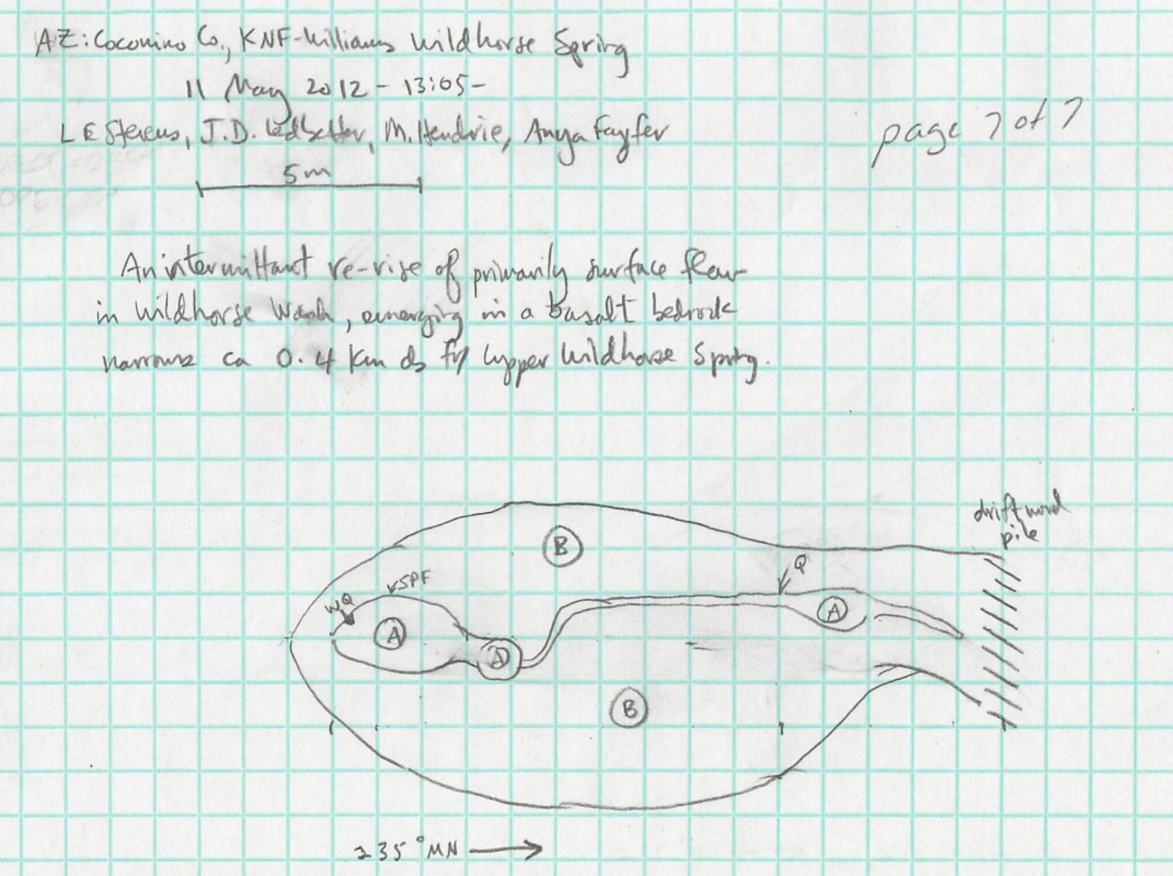
Fig 4.2 Wild Horse Spring Sketchmap.

5. Willow Spring, 8/29/11
5. Willow Spring, 8/29/11
Survey Summary Report, Site ID 640
Submitted 6/01/21 by Springs Stewardship Institute

Location: The Willow Spring ecosystem is located in Coconino County in the Upper Verde Arizona 15060202 HUC, managed by the US Forest Service. The spring is located in the Kaibab NF, Williams RD, in the Davenport Hill USGS Quad, at 35.13389, -112.02822 measured using a GPS (NAD83, estimated position error 3 meters). The elevation is approximately 1980 meters. Larry Stevens and Jeri Ledbetter surveyed the site on 8/29/11 for 02:00 hours, beginning at 13:15, and collected data in 7 of 10 categories. This survey was conducted under a Kaibab Springs project using the Stevens et al. Level 2 protocol.

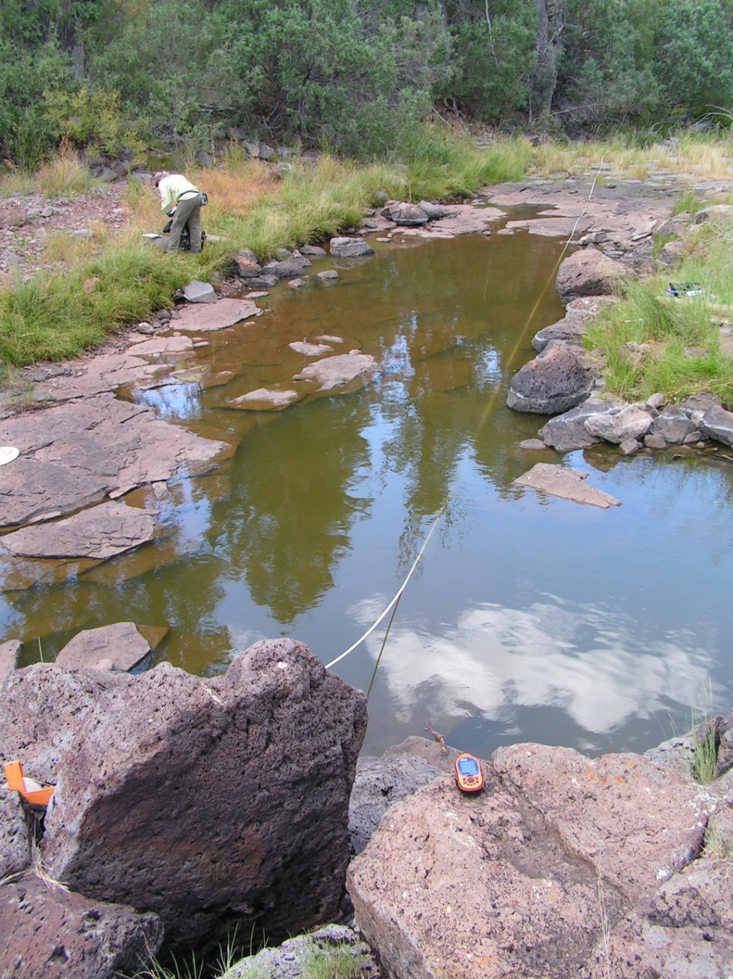
Fig 5.1 Willow Spring.

Physical Description: Willow Spring is a rheocrene/limnocrene spring. This is a small pool-forming perennial spring, or a tinaja, emerging from a basalt ledge orifice. It emerges in a dynamic channel that is subject to heavy surface runoff that flows into Sycamore Canyon. The microhabitats associated with the spring cover 720 sqm. The site has 4 microhabitats, including A -- a 100 sqm pool, B -- a 75 sqm backwall, C -- a 190 sqm terrace, D -- a 355 sqm terrace. The geomorphic diversity is 0.53, based on the Shannon-Weiner diversity index.

Table 5.1 Willow Spring Microhabitat characteristics.
Code | A | B | C | D
Name | Source Pool | Dry Backwall | HRZ Channel | LRZ Terrace
Area sqm | 100.00 | 75.00 | 190.00 | 355.00
Surface type | P | BW | TE | TE
Surface subtype |  |  | HRZ | LRZ
Slope variability | Low | Med | Med | Med
Aspect TN |  | 241 | 241 | 241
Slope degrees |  | 18 | 3 | 5
Moisture (scale 1-10) | 10 | 0 | 0 | 0
Water depth cm | 40.00
Area % open water | 98.00
Substrate
1 - Clay % | 0 | 0 | 0 | 0
2 - Silt % | 0 | 0 | 20 | 20
3 - Sand % | 0 | 0 | 10 | 30
4 - Fine gravel % | 0 | 0 | 40 | 30
5 - Coarse gravel % | 0 | 0 | 10 | 10
6 - Cobble % | 10 | 1 | 10 | 10
7 - Boulder % | 10 | 0 | 0 | 0
8 - Bedrock % | 80 | 98 | 10 | 0
Organic % | 0 | 0 | 0 | 0
Other % (anthropogenic) | 0 | 0 | 0 | 0
Precipitate % | 0.00 | 0.00 | 0.00 | 0.00
Litter % | 0.00 | 0.10 | 65.00 | 15.00
Wood % | 0.00 | 0.10 | 0.00 | 5.00
Litter Depth (cm) | 0.00 | 0.10 | 2.00 | 2.00

Geomorphology: Willow Spring emerges as a seepage or filtration from the basalt flow, a igneous, basalt rock layer. The emergence environment is subaerial, with a gravity flow force mechanism. The site receives approximately 100% of available solar radiation, with 7324 Mj annually.
Access Directions: Please examine a map closely before proceeding to this site. Some of the roads listed below may be closed or not accessible. Take County Rd 73 (S Perkinsville Rd) south from Williams, AZ to Forest Rd 110 (Prairie Edge Rd). Turn left onto Forest Rd 110. Turn left onto Forest Rd 747. Turn right onto Forest Rd 14. Turn left onto Davenport Hill Rd (Forest Rd 109). Continue ~100 meters; the spring is east of Davenport Hill Rd, approximately 200 meters.
Survey Notes: The water is murky with suspended algal growth, and the pool shows signs of having been 10 cm deeper in the past two months, and flowing out the downstream end. The spring inflow if any, must be subaqueous, but water is likely surface dominated. Crayfish are abundant.

Flow: There was no outflow from this spring at the time, but there was evidence of recent outflow. This spring is perennial, with a neorefugium persistence. Surveyors were unable to measure flow because there was no outflow.

Water Quality: There were no water quality measurements taken as the water was probably heavily influenced by surface flow.

Flora: Larry Stevens was the botanist. Surveyors identified 49 plant species at the site, with 0.0681 species/sqm. These included 34 native and 11 nonnative species; the native status of 4 species remains unknown.

Table 5.2 Willow Spring Cover Type.
Cover Type | Species Count | Wetland Species Count
Ground | 38 | 14
Shrub | 7 | 2
Mid-canopy | 3 | 1
Tall canopy | 2 | 1
Basal | 0 | 0
Aquatic | 0 | 0
Non-vascular | 4 | 1

Table 5.3 Willow Spring Vegetation % Cover in Microhabitats.
Plant Species | Cover Code | Native Status | Wetland Status | Comments | A | B | C | D
Agropyron | GC | I | F |  | 0 | 0 | 0 | 0.1
algae | NV | N | A | biofilm | 95 | 0 | 0 | 0
Ambrosia | GC | I | F | annual | 0 | 0 | 2 | 4
Apocynum | GC | N | F |  | 0 | 0.2 | 1 | 0
aster | GC | N |  | comutatus? | 0 | 0 | 0.2 | 0.3
Bouteloua curtipendula | GC | N | U |  | 0 | 0 | 0 | 0.5
Carex | GC | N | W | with tall spray inflor. | 0 | 0.5 | 3 | 0
Eleocharis | GC | N | W |  | 0 | 0 | 1 | 0
Elymus elymoides | GC | N | F |  | 0 | 0.1 | 0.1 | 0.2
Epilobium ciliatum | GC | I | W |  | 0 | 0.2 | 8 | 0.1
Equisetum laevigatum | GC | N | WR |  | 0 | 0 | 0.2 | 0
Erigeron | GC | N | F |  | 0 | 0 | 0.2 | 1
Galium | GC | I | F | European | 0 | 0 | 0.2 | 0
Gaura | GC | N | F |  | 0 | 0.2 | 1 | 0.1
Geranium richardsonii | GC | N | F | pink and red | 0 | 0 | 0.1 | 0
Gypsophila | GC | N | U |  | 0 | 0 | 0.3 | 0.5
Heliomeris | GC | N | U |  | 0 | 0 | 0.3 | 0.5
Iris missouriensis | GC | N | F |  | 0 | 0 | 0.1 | 0.2
Juncus balticus | GC | N | W | question mark on species | 0 | 0.1 | 0 | 0
Juncus ensifolius | GC | N | W |  | 0 | 0.1 | 1 | 0
Juniperus scopulorum | MC | N | U |  | 0 | 0 | 0.1 | 15
Juniperus scopulorum | SC | N | U |  | 0 | 0.2 | 3 | 10
Koeleria macrantha | GC | N | F |  | 0 | 0 | 0.1 | 2
Lathyrus | GC | N | R |  | 0 | 0 | 1 | 2
Lichen | NV | N | U |  | 0 | 8 | 0 | 2
Melilotus albus | GC | I | WR |  | 0 | 0.1 | 3 | 1
Melilotus officinalis | GC | I | WR |  | 0 | 0 | 0.2 | 0.2
Mentha arvensis | GC | N | WR |  | 0 | 0 | 1.3 | 0.01
Phleum | GC | I | F | long inflorescence | 0 | 0 | 1 | 2
Pinus ponderosa | MC | N | U |  | 0 | 0 | 0 | 3
Pinus ponderosa | SC | N | U |  | 0 | 0 | 0 | 4
Pinus ponderosa | TC | N | U |  | 0 | 0 | 0 | 3
Poa pratensis | GC | I | F |  | 0 | 0.01 | 2 | 4
Populus angustifolia | MC | N | R |  | 0 | 0 | 3 | 10
Populus angustifolia | SC | N | R |  | 0 | 0 | 2 | 5
Populus angustifolia | TC | N | R |  | 0 | 0 | 0 | 10
Ribes cereum | SC | N | U | spineless (cereum?) | 0 | 0 | 0 | 2
Rosa woodsii | SC | N | F |  | 0 | 0.01 | 0.5 | 0.5
Salix lasiolepis | SC | N | R |  | 0 | 2 | 3 | 8
Schizachyrium scoparium | GC | N | F |  | 0 | 0.3 | 0.3 | 2
Sidalcea neomexicana | GC | N | WR |  | 0 | 0.1 | 2 | 0.1
Solidago canadensis | GC | N | WR |  | 0 | 0 | 0 | 1
Toxicodendron rydbergii | SC | N | F |  | 0 | 0 | 0 | 1
Trifolium | GC | I | WR | white | 0 | 0 | 3 | 0
Triticum aestivum | GC | I | F |  | 0 | 0 | 0.1 | 0
unknown | GC |  |  | "long panicle grass" | 0 | 1 | 30 | 10
unknown | GC |  |  | "Red rockweed" | 0 | 0.01 | 2 | 0
unknown Bryophyte (moss, liverwort, hornwort) | NV | N | F | "black" | 0 | 5 | 0.01 | 0
unknown Bryophyte (moss, liverwort, hornwort) | NV | N | F | "green" | 0 | 1 | 1 | 0
unknown grass | GC |  |  | large red grass panicum? | 0 | 0 | 2 | 0
unknown grass | GC |  |  | perennial | 0 | 1 | 5 | 0
Verbascum | GC | I | F |  | 0 | 0 | 0.1 | 0.1
Viola | GC | N | F |  | 0 | 0.1 | 0.2 | 0
Zinnia | GC | N | U |  | 0 | 0 | 0.1 | 0.1

Fauna: Surveyors collected or observed 14 aquatic and 33 terrestrial invertebrate taxa and 6 vertebrate taxa.

Table 5.4 Willow Spring Invertebrates.
Species | Lifestage | Habitat | Method | Rep# | Count | Species Detail
Basommatophora Planorbidae Gyraulus | Ad | A | Collected spot |  | 5
Coleoptera Cantharidae Chauliognathus | Ad | T | Collected spot |  | 1
Coleoptera Chrysomelidae | Ad | T | Collected spot |  | 1
Coleoptera Coccinellidae Hippodamia convergens | Ad | T | Collected spot |  | 1
Coleoptera Dytiscidae Laccophilus | Ad | A | Collected spot |  | 1
Coleoptera Dytiscidae Thermonectus nigrofasciatus nigrofasciatus | Ad | A | Collected spot |  | 1
Coleoptera Hydrophilidae Tropisternus | Ad | A | Collected spot |  | 1
Coleoptera Melyridae | Ad | T | Collected spot |  | 1
Decapoda Cambaridae Orconectes virilis | Ad | A | Collected spot |  | 2
Diptera | Ad | T | Collected spot |  | 1
Diptera Bombyliidae | Ad | T | Collected spot |  | 1
Diptera Dolichopodidae | Ad | T | Collected spot |  | 1
Hemiptera Corixidae | Ad | A | Collected spot |  | 1
Hemiptera Corixidae Corisella | Ad | A | Collected spot |  | 1
Hemiptera Corixidae Hesperocorixa laevigata | Ad | A | Collected spot |  | 1
Hemiptera Gerridae Aquarius remigis | Ad | A | Collected spot |  | 1
Hemiptera Notonectidae Notonecta kirbyi | Ad | A | Collected spot |  | 1
Hemiptera Notonectidae Notonecta kirbyi | Ad | A | Collected spot |  | 1 | Photographed
Hemiptera Notonectidae Notonecta undulata | Ad | A | Collected spot |  | 1
Hemiptera Pentatomidae Thyanta custator | Ad | T | Collected spot |  | 1
Homoptera | Ad | T | Collected spot |  | 1
Hymenoptera Crabronidae Tachytes | Ad | T | Collected spot |  | 1
Hymenoptera Sphecidae Ammophila varipes | Ad | T | Collected spot |  | 1
Hymenoptera Sphecidae Ammophila varipes | Ad | T | Collected spot |  | 1 | Photographed.
Hymenoptera Sphecidae Palmodes | Ad | T | Collected spot |  | 1
Hymenoptera Tiphiidae Myzinum maculatum | Ad | T | Collected spot |  | 1
Hymenoptera Vespidae Polistes comanchus | Ad |  | Collected spot |  | 1
Hymenoptera Vespidae Vespula atropilosa | Ad | T | Collected spot |  | 1 | Worker.
Hymenoptera Vespidae Vespula pensylvanica | Ad | T | Collected spot |  | 1
Lepidoptera | L | T | Collected spot |  | 1
Lepidoptera Hesperiidae Pyrgus communis |  | T | Spot
Lepidoptera Nymphalidae Chlosyne |  | T | Spot |  |  | campestis
Lepidoptera Nymphalidae Danaus plexippus |  | T | Spot
Lepidoptera Nymphalidae Limenitis weidemeyerii |  | T | Spot |  | 2
Lepidoptera Nymphalidae Phyciodes campestris | Ad | T | Collected spot |  | 1
Lepidoptera Nymphalidae Vanessa cardui |  | T | Spot
Lepidoptera Pieridae Nathalis iole |  | T | Spot
Odonata Lestidae Archilestes grandis |  | A | Spot
Odonata Lestidae Lestes congener | Ad | T | Collected spot |  | 1
Odonata Libellulidae Libellula luctuosa |  | T | Spot
Odonata Libellulidae Libellula pulchella | Ad | T | Collected spot |  | 1
Odonata Libellulidae Libellula quadrimaculata |  | T | Spot
Odonata Libellulidae Libellula saturata |  | T | Spot
Odonata Libellulidae Pantala flavescens |  | T | Spot |  |  | Spotless?
Odonata Libellulidae Plathemis lydia |  | T | Spot
Odonata Libellulidae Sympetrum pallipes | Ad | T | Collected spot |  | 1
Orthoptera Acrididae Melanoplus sanguinipes | Ad | T | Collected spot |  | 1
Orthoptera Tetrigidae | Ad | A | Collected spot |  | 1

Table 5.5 Willow Spring Vertebrates.
Vertebrate Species Common Name | Count | Detection | Comments
American crow |  |  | nearby
lesser goldfinch
lazuli bunting |  |  | female
hairy woodpecker | 1
turkey vulture
American robin
Assessment: Assessment scores were compiled in 6 categories and 42 subcategories, with 0 null condition scores, and 1 null risk scores. Aquifer functionality and water quality are good with significant restoration potential (average condition score 4.3) and there is moderate risk (average risk score 3). Geomorphology condition is good with significant restoration potential (average condition score 4.8) and there is negligible risk (average risk score 1.4). Habitat condition is good with significant restoration potential (average condition score 4.2) and there is negligible risk (average risk score 1.6). Biotic integrity is moderate with some restoration potential (average condition score 3.4) and there is moderate risk (average risk score 3.8). Human influence of site is good with significant restoration potential (average condition score 4.6) and there is negligible risk (average risk score 1.6). Administrative context status is good with significant restoration potential and there is negligible risk. Overall, the site condition is good with significant restoration potential and there is low risk.
Table 5.6 Willow Spring Assessment Scores. Condition scores range from 0 (extremely poor condition) to 6 (pristine condition) and risk scores range from 0 (no risk to the site) to 6 (extreme risk to the site).
Category | Condition | Risk
Aquifer Functionality & Water Quality | 4.33 | 3
Geomorphology | 4.8 | 1.4
Habitat | 4.2 | 1.6
Biota | 3.38 | 3.75
Human Influence | 4.56 | 1.63
Administrative Context | 4.11 | 1.63
Overall Ecological Score | 4.18 | 2.44

Management Recommendations: This site needs no immediate attention, but occasional monitoring, particularly late in the summer during dry years, would help determine groundwater influence.

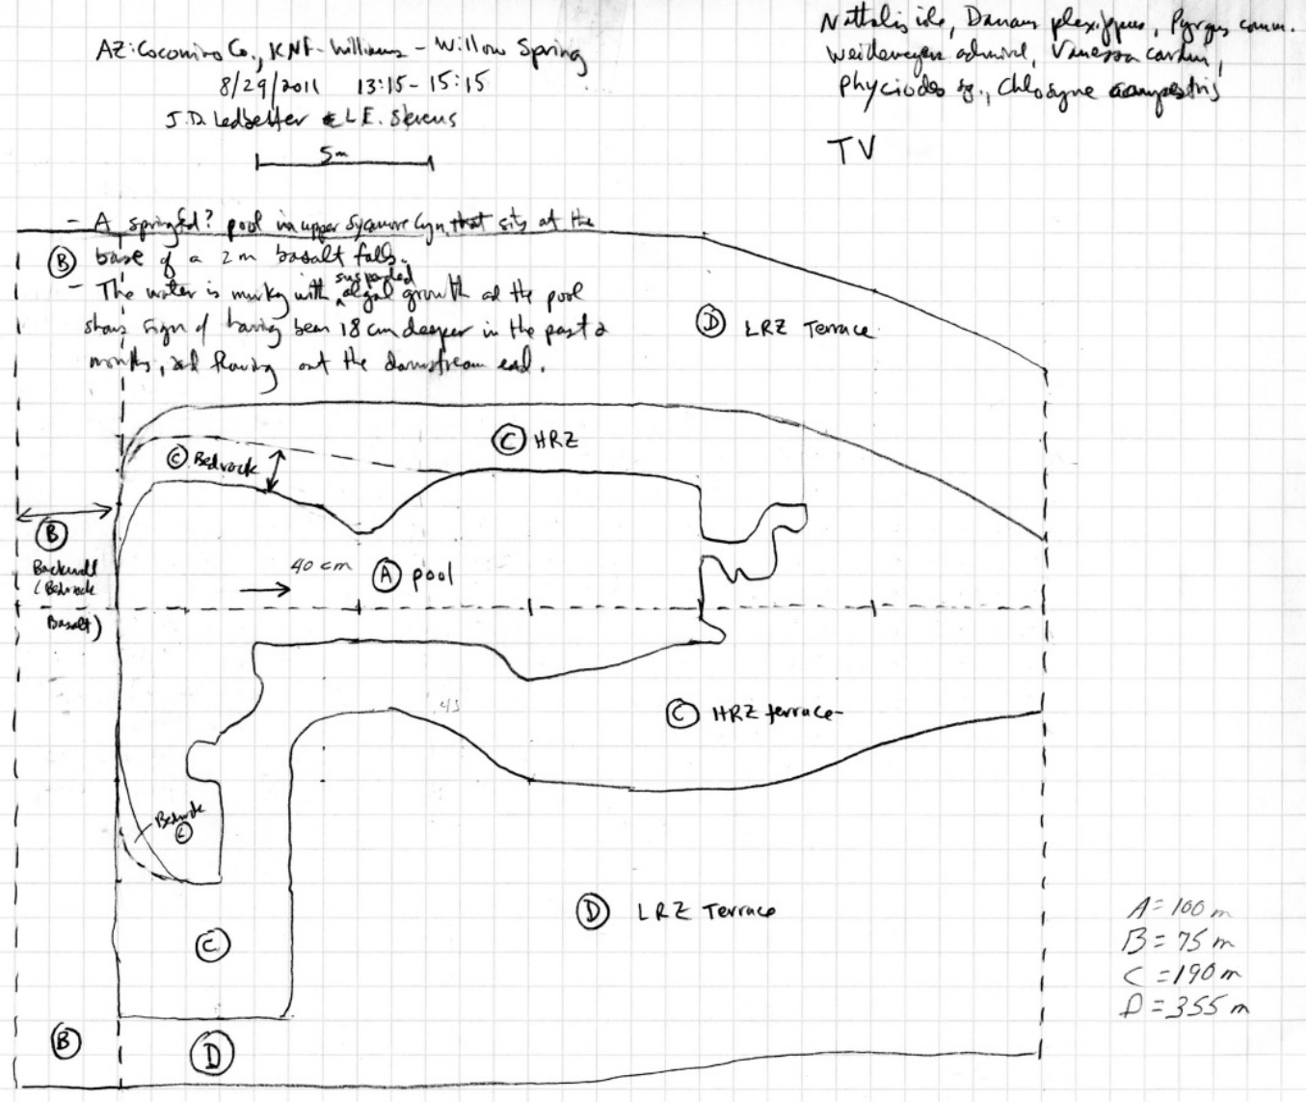
Fig 5.2 Willow Spring Sketchmap.

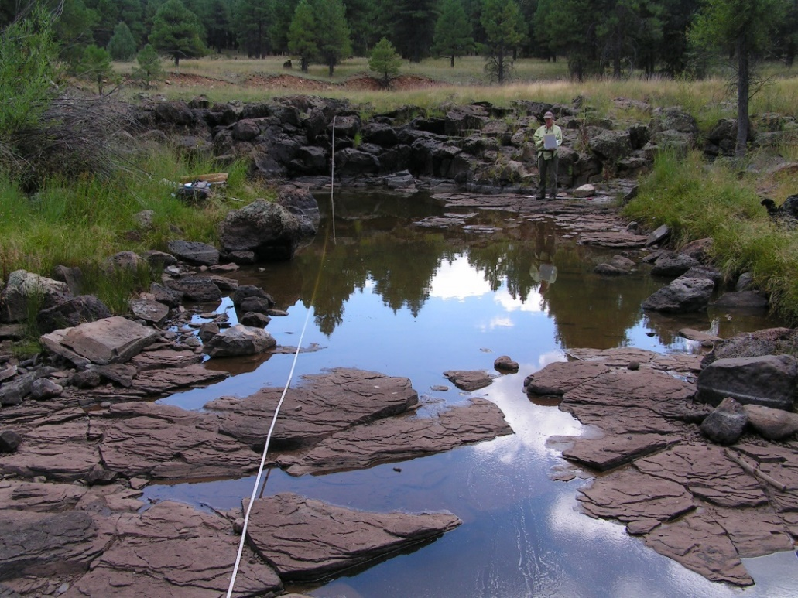
Fig 5.3 Willow Spring.

